1. Gourad Shading is the lighting calculations at the vertex level and Phong Shading is calculated at the fragment level. Phong shading appears to be more circular and gives an illusion of a smoother surface vs the gourad shading where it appears to be harsh.

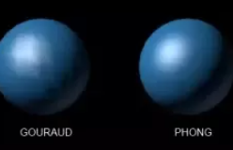

1. The three components used to make the phong reflection model are:
   1. Ambient: uniform light level in the room
   2. Diffuse: reflects light from the object
   3. Specular: “highlights” makes the object look shiny.

These components are used because in order to produce a perfectly photo symmetric image, would take a absurd amount of computational power since light bounces off objects in real life, instead we emulate what the “reflections” would look like.