**Connect Goblin 2 Plus to Azure IoT Hub in the cloud**

**Table of Contents**

* Introduction
* Step 1: Prerequisites
* Step 2: Prepare your Device
* Step 3: Build and Run the Sample
* Next Steps

**Introduction**

**About this document**

The following document describes the process of connecting a Goblin 2 Plus system to Azure IoT Hub. This multi-step process includes:

* Configuring Azure IoT Hub
* Registering your IoT device and get your SAS Token
* Send messages to IoT Hub

**Step 1: Prerequisites**

You should have the following items ready before beginning the process:

* Computer with a Git client installed so that you can access the azure-iot-sdk-c code on GitHub.
* [Arduino IDE](https://www.arduino.cc/en/main/software) version 1.6.8 or later.
* [Setup your IoT hub](https://catalog.azureiotsolutions.com/docs?title=Azure/azure-iot-device-ecosystem/setup_iothub)
* [Provision your device and get its credentials](https://github.com/Azure/azure-iot-device-ecosystem/blob/master/manage_iot_hub.md)

**Step 2: Prepare your Device**

* Connect the Goblin 2 Plus using the mini-USB cable.
* Select the Arduino/Genuino ZERO board in tools.

**Step 3: Build and Run the sample**

**Setup the development environment**

In this section we are going to run a sample application that send different values, these values are random.

**Get the SAS Token**

You can get the SAS (SharedAccessSignature) Token through this methods: [iothub-explorer](https://github.com/Azure/iothub-explorer), [Device Explorer](https://github.com/Azure/azure-iot-sdk-csharp/releases) or running the following [code](https://gitlab.com/joserey/sastoken-generator/blob/master/index.js) that is based on this [article of microsoft](https://docs.microsoft.com/en-us/azure/iot-hub/iot-hub-devguide-security#security-tokens)

**NOTE:** requires Node.js 4.x or later to work properly.

1. Download the code
2. You need to fill the following lines

var host = ""; //Hostname, {your-iothub-name}.azure-devices.net

var device = ""; //Your device

//any symmetric key for the {device id} identity

var signingKey = "";

var days = 365; //Valid days

You can see the hostname here [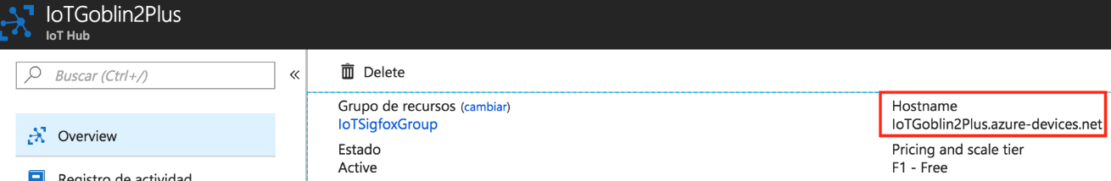](https://github.com/jose-verse/goblin2plus-get-started/blob/master/media/hostname.png)

You can see the symmetric key here at the moment of create your device [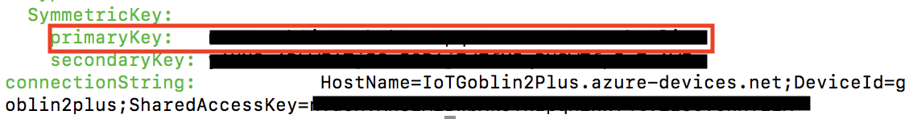](https://github.com/jose-verse/goblin2plus-get-started/blob/master/media/symmetric_key.png)

1. Run the file and copy the output (your SAS Token).

SharedAccessSignature sr=XXXXXXXXXXXX.azure-devices.net%2Fdevices%2FXXXXXXXXXXX&sig=XXXXXXXXXXXXXXXXXXXXXXXXXXXXXXXXXXXXXXXXXXXXX&se=1562285589

**Get the sample application from GitHub**

The sample application is hosted on GitHub. Clone the sample repository that contains the sample application from GitHub. To clone the sample repository, follow these steps:

1. Open a command prompt or a terminal window.
2. Go to a folder where you want the sample application to be stored.
3. Run the following command:

git clone https://github.com/jose-verse/goblin2plus-get-started.git

1. In these lines you need to put your information
2. String host = ""; //Hostname, {your-iothub-name}.azure-devices.net
3. String deviceid = ""; //Your device
4. String api = "2018-06-30"; //API version
5. String SASToken = ""; //SAS Token

You can watch the api-version following this [link](https://docs.microsoft.com/en-us/azure/iot-hub/iot-hub-devguide-security)

1. Compile and run in your goblin 2 plus.

**Verify the sample application is running successfully**

You can use the monitor of iothub-explorer to watch your messages comming to IoT Hub.

$ iothub-explorer monitor-events myDevice --login "connection-string"

[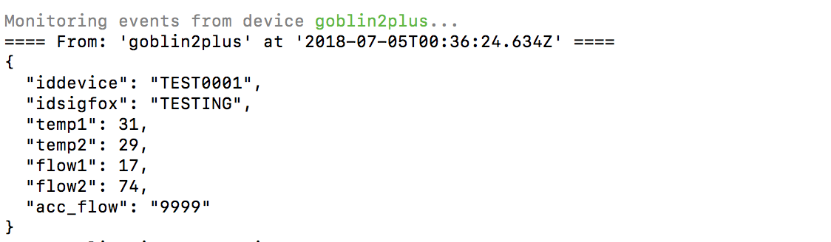](https://github.com/jose-verse/goblin2plus-get-started/blob/master/media/monitor.png)

**Next Steps**

You have now learned how to run a sample application that collects sensor data and sends it to your IoT hub. To explore how to store, analyze and visualize the data from this application in Azure using a variety of different services, please click on the following lessons:

* [Manage cloud device messaging with iothub-explorer](https://docs.microsoft.com/en-us/azure/iot-hub/iot-hub-explorer-cloud-device-messaging)
* [Save IoT Hub messages to Azure data storage](https://docs.microsoft.com/en-us/azure/iot-hub/iot-hub-store-data-in-azure-table-storage)
* [Use Power BI to visualize real-time sensor data from Azure IoT Hub](https://docs.microsoft.com/en-us/azure/iot-hub/iot-hub-live-data-visualization-in-power-bi)
* [Use Azure Web Apps to visualize real-time sensor data from Azure IoT Hub](https://docs.microsoft.com/en-us/azure/iot-hub/iot-hub-live-data-visualization-in-web-apps)
* [Weather forecast using the sensor data from your IoT hub in Azure Machine Learning](https://docs.microsoft.com/en-us/azure/iot-hub/iot-hub-weather-forecast-machine-learning)
* [Remote monitoring and notifications with Logic Apps](https://docs.microsoft.com/en-us/azure/iot-hub/iot-hub-monitoring-notifications-with-azure-logic-apps)