JavaScript Exercises

Exercise 1. Basics.
<!DOCTYPE html>
<html>
<head>
<script>
function myFunction() {
document.getElementById("demo").innerHTML = "Paragraph changed.";
}
</script>
</head>
<body>
<h1>My Web Page</h1>
<p id="demo">A Paragraph</p>
<button type="button" onclick="myFunction()">Try it</button>
</body>
</html>

Modify the code for:
- Add a button (and a function) to clear the p demo.
- Place the script in an external file called MyJS.js.

solución

js01.html
<!DOCTYPE html>
<html>
<head>
<script src="js01.js"></script>
</head>
<body>
<h1>Mi página</h1>
<p id="demo">Un párrafo</p>
<button type="button" onclick="cambiaParrafo()">Cambiar párrafo</button>
<button type="button" onclick="borraParrafo()">Borra párrafo</button>
</body>
</html>
js01.js
function cambiaParrafo() {
// document.getElementById("demo").style.display = 'block';
document.getElementById("demo").innerHTML = "Párrafo cambiado.";
}
function borraParrafo() {
document.getElementById("demo").style.display = 'none';
}

Exercise 2. Showing messages.

<!DOCTYPE html>
<html>
<body>

<h1>My First Web Page</h1>
<p>My First Paragraph</p>

<p id="demo"></p>

<script>
document.getElementById("demo").innerHTML = “Hello world!”;
</script>

</body>
</html>

Modify the code for:
- Add a button (and a function) which writes into the p demo when clicked.
- Place the script in an external file called js02.js.
(Solucionado en el ejercicio anterior)

Exercise 3.
In this file you will find images about cars. In this other file you will find images about Spiderman. You will write a web page where you could display different images of cars or Spiderman by clicking on buttons (1 for each image).
- You can also build two different areas in the same page one for each group of images. Finally, write two stylesheets and add two buttons for changing between styles.
- Modify last exercise by using a “select” element instead of buttons:
https://www.w3schools.com/html/html_form_elements.asp
- We are going to use “onchange”, like the following example:
https://www.w3schools.com/jsref/tryit.asp?filename=tryjsref_onchange

Solución parcial
js03.html
<!DOCTYPE html>
<html>
<head>
<script>
function cambiaCoche(nombre) {
document.getElementById('miImagen').src = nombre;
}
</script>
</head>
<body>
<h2>Imágenes de coches</h2>

<p>Ejemplo de JavaScript en el que cambiamos las imágenes mostradas el pulsar un botón</p>

<img id="miImagen" src="coche1.jpg" style="height:300px"><br>

<button onclick="cambiaCoche('coche1.jpg')">Coche 1</button>
<button onclick="cambiaCoche('coche2.jpg')">Coche 2</button>
<button onclick="cambiaCoche('coche3.jpg')">Coche 3</button>
<button onclick="cambiaCoche('coche4.jpg')">Coche 4</button>
<button onclick="cambiaCoche('coche5.jpg')">Coche 5</button>
<button onclick="cambiaCoche('coche6.jpg')">Coche 6</button>
</body>
</html>

Exercise 4. Working with variables.
Create a HTML document which will declare a variable, will assign a value from an input and finally display it using the innerHTML property. Do it several times using numbers and text. You can be inspire by this:
<!DOCTYPE html>
<html>
<body>

<p>Create a variable, assign a value to it, and display it:</p>

<p id="demo"></p>

<script>
var carName = "Volvo";
document.getElementById("demo").innerHTML = carName;
</script>

</body>
</html>

Enlaces:
Puedes usar cómo dato de entrada un campo de un formulario, tal cómo se muestra a continuación
https://www.w3schools.com/Js/tryit.asp?filename=tryjs_form_elements
Aquí puedes ver varios ejemplos de entrada de datos:
https://www.w3schools.com/Js/js_input_examples.asp

Excercise 5. Basics.
Create a HTML document from scratch with three groups of buttons. Each group will be focused on three differents issues:
a. Changing the style of a paragraph: choosing between three different font styles.
b. Changing the attribute src from the img tag.
c. Showing three different messages in a <div> tag.

Excercise 6. Random Quotes.
Create a HTML document from scratch similar to the following:
https://js-beginners.github.io/random-quotes-project/

Excercise 7. Image Slider.
Create a HTML document from scratch similar to the following:
https://js-beginners.github.io/background-image-slider-project/

Excercise 8. Calculator.
Create a HTML document from scratch similar to the following:
https://js-beginners.github.io/Calculator-JavaScript-Project/

Excercise 9. Convert from Celsius to Fahrenheit.
Modify the following exercises so that we can convert temperature from Celsius to Fahrenheit and viceversa

<!DOCTYPE html>
<html>
<head>
<script>

function muestra() {
f = document.getElementById("tbf").value;
c = toCelsius(f)
document.getElementById("tbc").value = c;
}

function toCelsius(f) {
return (5/9) * (f-32);
}
</script>
</head>
<body>

<h2>JavaScript Functions</h2>

<p>This example calls a function to convert from Fahrenheit to Celsius:</p>
<label for="tbf">Fahrenheit : </label>
<input type="text" id="tbf" name="tbf">
<br>
<label for="tbc">Celcius : </label>
<input type="text" id="tbc" name="tbc">
<br>
<button type="button" onclick="muestra()">Convierte</button>
</body>
</html>

Exercise 10. Functions.
Create a html document and use input tags to enter data for the following functions. Use a paragraf and innerHTML property to display the result.
- Define a function max() that takes two numbers as arguments and returns the largest of them. Use the if-then-else construct available in Javascript.

- Define a function maxOfThree() that takes three numbers as arguments and returns the largest of them.

- Write a function that takes a character (i.e. a string of length 1) and returns true if it is a vowel, false otherwise.

- Rövarspråket is a Swedish children-slang where by tongue-twisted what you say like this you can basically talk to someone else who understands the "codec" with someone who doesn't unable to comprehend. Write a function translate() that will translate a text into "rövarspråket". That is, double every consonant and place an occurrence of "o" in between. For example, translate("this is fun") should return the string "tothohisos isos fofunon". Note: You could visit for an example.

- Define a function sum() and a function multiply() that sums and multiplies (respectively) all the numbers in an array of numbers. For example, sum([1,2,3,4]) should return 10, and multiply([1,2,3,4]) should return 24.

- Define a function reverse() that computes the reversal of a string. For example, reverse("jag testar") should return the string "ratset gaj".

- Write a function to sort a list of words (an array) in alphabetical order

- Write a function findLongestWord() that takes an array of words and returns the length of the longest one.

- Write a function filterLongWords() that takes an array of words and an integer i and returns the array of words that are longer than i.

- Write a function charFreq() that takes a string and builds a frequency listing of the characters contained in it. Represent the frequency listing as a Javascript object. Try it with something like charFreq("abbabcbdbabdbdbabababcbcbab").

Soluciones al ejercicio 10

- Define a function max() that takes two numbers as arguments and returns the largest of them. Use the if-then-else sentence.

<!DOCTYPE html>
<html>
<head>
<script>

function mayor(n1,n2) {
var m;
if (n1 > n2)
m = n1;
else
m = n2;
return m;
}

function muestraMayor() {
var n1 = document.getElementById('n1').value;
var n2 = document.getElementById('n2').value;
document.getElementById("res").innerHTML = mayor(n1,n2);
}

</script>

</head>
<body>
<h2>JavaScript Functions</h2>
<p>Muestra el maryor de dos números</p><br>
<label for="n1">Número 1 : </label>
<input type="text" id="n1" name="n1"> <br>
<label for="n1">Número 2 : </label>
<input type="text" id="n2" name="n2"> <br>
<button type="button" onclick="muestraMayor()">Mostrar Mayor</button><br>
<p id="res"></p>
</body>
</html>

- Define a function maxOfThree() that takes three numbers as arguments and returns the largest of them.

- Write a function that takes a character (i.e. a string of length 1) and returns true if it is a vowel, false otherwise.

<!DOCTYPE html>
<html>
<script>
function isVowel(x) {
return x == "A" || x == "E" || x == "I" || x == "O" || x == "U" || x == "a" || x == "e" || x == "i" || x == "o" || x == "u";
}

function mostrar() {
c = document.getElementById("text").value;
if (c.length > 1)
document.getElementById("res").innerHTML = "Debe introducir un carácter solo";
else if (isVowel(c))
document.getElementById("res").innerHTML = "Es Vocal";
else
document.getElementById("res").innerHTML = "NO Es Vocal";
}
</script>

<body>
<p>Introduzca un carácter y pulse el botón para comprobar si es vocal</p><br>
<input type="text" id="text" name="text"><br>
<button onclick="mostrar()">Pulse</button><br>
<p id="res"></p>
</body>
</html>

- Rövarspråket is a Swedish children-slang where by tongue-twisted what you say like this you can basically talk to someone else who understands the "codec" with someone who doesn't unable to comprehend. Write a function translate() that will translate a text into "rövarspråket". That is, double every consonant and place an occurrence of "o" in between. For example, translate("this is fun") should return the string "tothohisos isos fofunon". Note: You could visit for an example.

- Define a function sum() and a function multiply() that sums and multiplies (respectively) all the numbers in an array of numbers. For example, sum([1,2,3,4]) should return 10, and multiply([1,2,3,4]) should return 24.

<!DOCTYPE html>
<html>
<head>
<script>

function sum() {
var str = document.getElementById('su').value;
var n = str.split(',');
var suma = 0;
for(i = 0; i < n.length; i++) {
suma += parseInt(n[i]);
}
document.getElementById("res").innerHTML = suma;
}

function mul() {
var str = document.getElementById('su').value;
var n = str.split(',');
var mult = 1;
for(i = 0; i < n.length; i++) {
mult *= parseInt(n[i]);
}
document.getElementById("res").innerHTML = mult;
}
</script>

</head>
<body>
<h2>JavaScript Functions</h2>
<p> multiplica y suma tus numeros completamente gratis:</p>
<label for="su">Lista de número separados por coma : </label>
<input type="text" id="su" name="su"> <br>
<button type="button" onclick="sum()">sumar</button>
<button type="button" onclick="mul()">multiplicar</button>
<p id="res"></p>
</body>
</html>

- Define a function reverse() that computes the reversal of a string. For example, reverse("jag testar") should return the string "ratset gaj".

- Write a function to sort a list of words (an array) in alphabetical order

- Write a function findLongestWord() that takes an array of words and returns the length of the longest one.

- Write a function filterLongWords() that takes an array of words and an integer i and returns the array of words that are longer than i.

- Write a function charFreq() that takes a string and builds a frequency listing of the characters contained in it. Represent the frequency listing as a Javascript object. Try it with something like charFreq("abbabcbdbabdbdbabababcbcbab").

DOM Exercises

Excercise 1. Basics.
Crea una página web que contenga varios párrafos. Mediante Javascript accede al DOM y muestra el contenido de dichos párrafos en un div
https://www.w3schools.com/js/js_htmldom_document.asp
https://www.w3schools.com/jsref/met_document_getelementsbyclassname.asp
https://www.w3schools.com/jsref/dom_obj_htmlcollection.asp
https://www.w3schools.com/jsref/met_document_getelementsbytagname.asp

Excercise 2. Create elements.
Crea una página y mediante Javascript agrega imagen a un div
https://www.w3schools.com/jsref/met_document_createelement.asp
https://www.w3schools.com/jsref/met_node_appendchild.asp

Excercise 3. Removing elements.
Crea una página con una lista y borra los elementos de dicha lista tal como se muestra en el siguiente ejemplo:
https://www.w3schools.com/jsref/met_node_removechild.asp

Excercise 4. Html document properties.
Usando la consola del navegador muestra: título, imágenes y los enlaces de una página de tu elección:
https://www.w3schools.com/js/js_htmldom_document.asp

Advanced apps with JavaScript (Optional)

Excercise 1. HTML&CSS editor.

Create a HTML page where users write code and display the result in a little area next to the code. Use a textarea for writing the code and a DIV for the result.

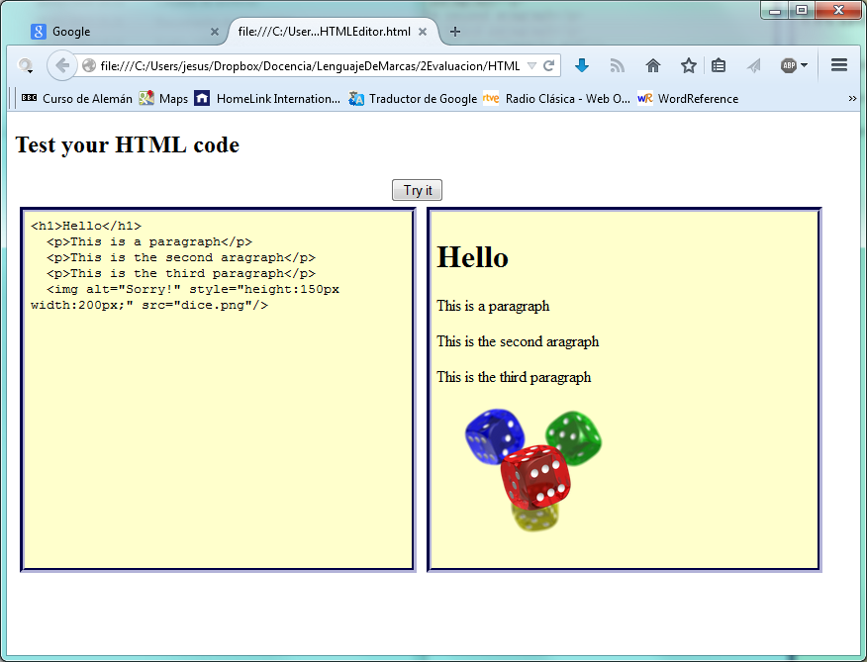

Tip: Style the textarea with the rule “resize:none”.

Excercise 2. Changing styles.

Write a web page where you can change the font size, the background color, the text color, etc in a specific area which will be fixed in a determined place.
You should display the page as the following:

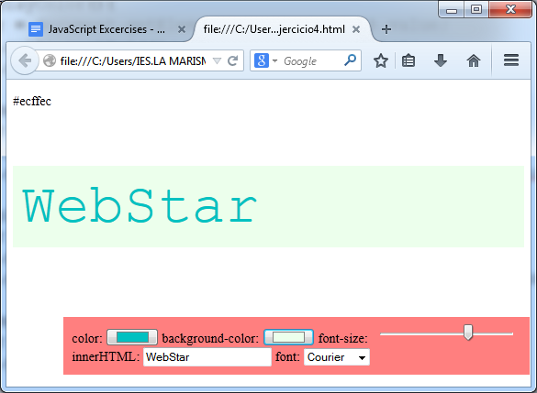

Tip: Use new HTML5 input types color and range and try with the onchange event.

Excercise 3. Changing the style sheet.

Build a web page and add a type select input where you could choose between at least three different kind of style sheets. You should choose one of them and apply immediately modifying the attribute href in the link tag.
The page’s code without styling could be something like this:

<!DOCTYPE html>
<html>
<body>

<div id="container" style="width:500px">

<div id="header">
<h1>Main Title of Web Page</h1></div>

<div id="menu">
<b>Menu</b><br>
HTML<br>
CSS<br>
JavaScript</div>

<div id="content">
Content goes here</div>

<div id="footer">
Copyright © W3Schools.com</div>

</div>

</body>
</html>

After choosing this would be one of the result:

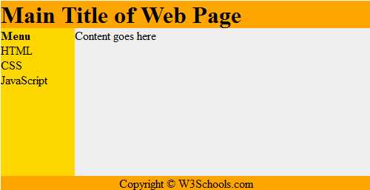

Note: You can find the CSS specification at http://www.w3schools.com/html/tryit.asp?filename=tryhtml_layout_divs

Exercise 4. HTML DOM.

Write a HTML document which has to generate the times table of a number write into a input type text. You have to display the table properly styled.

Exercise 5. Memory game.

Design a web page where users could test their memory. Choose the four chinese words you prefer from the image and transform it on a 200x200 pixels image. Users will click on two pictures and it will turn over, showing a chinese word in each image. If the word is the same then both of it will keep on displaying. In other case, after three seconds it will hide again. You could try to count the spent time until the user got the goal and offer different combinations each time users reloaded the page.

Exercise 6. Generating Captchas

Write a HTML document to generate and evaluate captchas.
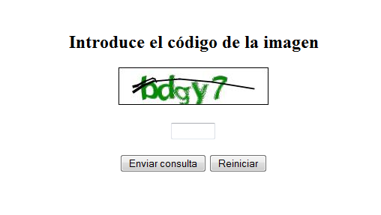

You can get the images here.

Exercise 7. Caesar Cypher +4

PIEOI KVEUY IEOKY QSWHI ZSWSX VSWLE OOEMW MQZIV XMHSX MIPTS IQHIW GMJVE VIWXI PIQWE NIOEG YVMSW MHEHI WYQEH IOEWP ECSVI WZMVX YHIWH IOWIV LYPEQ SCSOI
Some ideas

Exercise #3.

<!DOCTYPE html>
<html>
<head>
<style>
* {font-family:Arial;}
h1{
text-shadow: 2px 2px 5px #888888;
}

#botones{
height:50px;
width:1px;
padding:20px;
border-radius:25px;
position:fixed;
top:350px;
border:1px solid black;
background-color:rgba(181,181,219,0.7);
box-shadow: 5px 5px 2px #000000;
/* transition:width 2s;*/
-webkit-transition: width 1s;
overflow:hidden;
}

#botones:hover
{
width:500px;
}

#demo{
padding:20px;
width:80%;
margin:auto;
}
#mensaje{
font-weight:bold;
}
</style>
<script>
tam=12;

function Aumenta()
{
tam=tam+5;
x=document.getElementById("demo");
x.style.font=tam+"px Arial";
}

function Disminuye()
{
tam=tam-5;
x=document.getElementById("demo");
x.style.font=tam+"px Arial";
}

function ColorFondo()
{
nuevoColor=document.getElementById("Fondo").value;
x=document.getElementById("demo");
x.style.background=nuevoColor;
document.getElementById("mensaje").innerHTML="El color del fondo es "+nuevoColor;
}

function ColorTexto()
{
nuevoColor=document.getElementById("Texto").value;
x=document.getElementById("demo");
x.style.color=nuevoColor;
document.getElementById("mensaje").innerHTML="El color del texto es "+nuevoColor;
}
</script>

</head>
<body>

<h1>Changing font colors and size</h1>

<div id="demo">JavaScript can change the content of an HTML element.</div>

<div id="botones" >
<div id="mensaje">Choose your favorite color!</div>
<button type="button" onclick="Aumenta()">Aumenta</button>
<button type="button" onclick="Disminuye()">Disminuye</button>

Color del texto: <input type="color" onchange="ColorTexto()" id="Texto"/>
Color del fondo: <input type="color" onchange="ColorFondo()" id="Fondo"/>
</div>
</body>
</html>

Exercise #6

<!DOCTYPE html>
<head>
<style>
.col
{background-color:silver;}
</style>
</head>
<html>
<body>

<p>Hello World!</p>
<p>The DOM is very useful!</p>
<p>This example demonstrates the <b>length</b> property.</p><div id="ss"></div>

<script>
x=document.getElementsByTagName("p");
resul=("<table border=1>");
for (i=0;i<x.length;i++)
{
resul=resul+("<tr><td class=col>");
resul=resul+("Párrafo "+i+"</td><td>");
resul=resul+(x[i].innerHTML.length+"</td><td>");
resul=resul+(x[i].innerHTML);
resul=resul+("</td></tr>");

}
resul=resul+("</table>");
document.getElementById("ss").innerHTML=resul;

</script>
</body>
</html>

