LUSC_CCA

Jose Tamez

2022-09-17

# Effect of GDSTM based decorrelation of feature discovery

library("FRESA.CAD")

## Loading required package: Rcpp

## Loading required package: stringr

## Loading required package: miscTools

## Loading required package: Hmisc

## Loading required package: lattice

## Loading required package: survival

## Loading required package: Formula

## Loading required package: ggplot2

##   
## Attaching package: 'Hmisc'

## The following objects are masked from 'package:base':  
##   
## format.pval, units

## Loading required package: pROC

## Type 'citation("pROC")' for a citation.

##   
## Attaching package: 'pROC'

## The following objects are masked from 'package:stats':  
##   
## cov, smooth, var

library(readxl)  
op <- par(no.readonly = TRUE)

### Sigend Log Transform

signedlog <- function(x) { return (sign(x)*log(abs(x)+1.0e-12))}

## The parkison dataset

pd_speech_features <- as.data.frame(read_excel("~/GitHub/FCA/Data/pd_speech_features.xlsx",sheet = "pd_speech_features", range = "A2:ACB758"))  
  
trainFraction=0.65;

## The average of the three repetitions

rep1Parkison <- subset(pd_speech_features,RID==1)  
rownames(rep1Parkison) <- rep1Parkison$id  
rep1Parkison$id <- NULL  
rep1Parkison$RID <- NULL  
rep1Parkison[,1:ncol(rep1Parkison)] <- sapply(rep1Parkison,as.numeric)  
  
rep2Parkison <- subset(pd_speech_features,RID==2)  
rownames(rep2Parkison) <- rep2Parkison$id  
rep2Parkison$id <- NULL  
rep2Parkison$RID <- NULL  
rep2Parkison[,1:ncol(rep2Parkison)] <- sapply(rep2Parkison,as.numeric)  
  
rep3Parkison <- subset(pd_speech_features,RID==3)  
rownames(rep3Parkison) <- rep3Parkison$id  
rep3Parkison$id <- NULL  
rep3Parkison$RID <- NULL  
rep3Parkison[,1:ncol(rep3Parkison)] <- sapply(rep3Parkison,as.numeric)  
  
whof <- !(colnames(rep1Parkison) %in% c("gender","class"));  
avgParkison <- rep1Parkison;  
avgParkison[,whof] <- (rep1Parkison[,whof] + rep2Parkison[,whof] + rep3Parkison[,whof])/3  
avgParkison[,whof] <- signedlog(avgParkison[,whof])  
pander::pander(table(avgParkison$class))

| 0 | 1 |
| --- | --- |
| 64 | 188 |

## Correlation Matrix of the Parkinson Data

cormat <- cor(avgParkison,method="spearman")  
gplots::heatmap.2(abs(cormat),  
 trace = "none",  
 scale = "none",  
 mar = c(10,10),  
 col=rev(heat.colors(5)),  
 main = "Raw Correlation",  
 cexRow = 0.75,  
 cexCol = 0.75,  
 key.title=NA,  
 key.xlab="Spearman Correlation",  
 xlab="Feature", ylab="Feature")

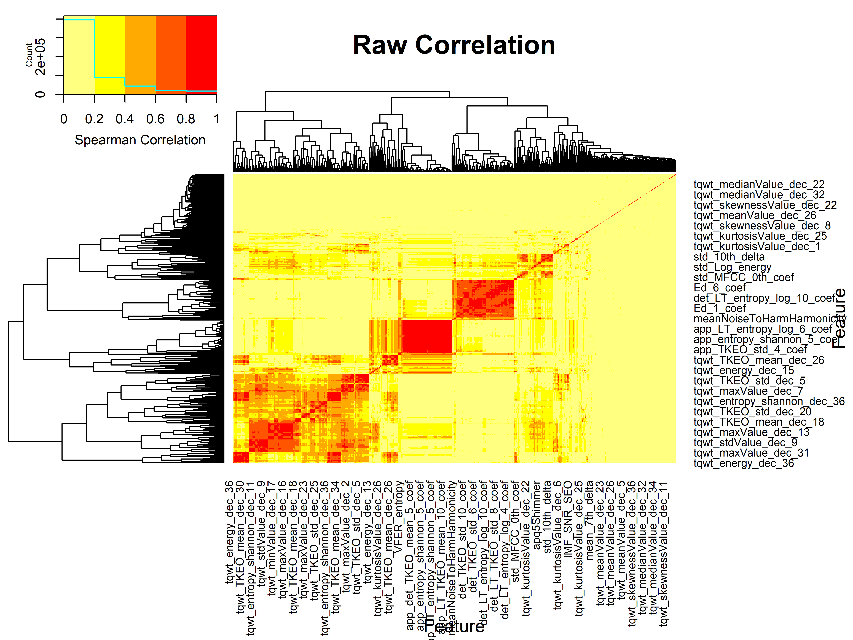

## Train and test set

set.seed(2)  
caseSet <- subset(avgParkison, class == 1)  
controlSet <- subset(avgParkison, class == 0)  
caseTrainSize <- nrow(caseSet)*trainFraction;  
controlTrainSize <- nrow(controlSet)*trainFraction;  
sampleCaseTrain <- sample(nrow(caseSet),caseTrainSize)  
sampleControlTrain <- sample(nrow(controlSet),controlTrainSize)  
trainSet <- rbind(caseSet[sampleCaseTrain,], controlSet[sampleControlTrain,])  
testSet <- rbind(caseSet[-sampleCaseTrain,],controlSet[-sampleControlTrain,])  
pander::pander(table(trainSet$class))

| 0 | 1 |
| --- | --- |
| 41 | 122 |

pander::pander(table(testSet$class))

| 0 | 1 |
| --- | --- |
| 23 | 66 |

## Decorrelation of train and test set creation

deTrain <- GDSTMDecorrelation(trainSet,Outcome="class",thr=0.8,verbose = TRUE)

Included: 568 , Uni p: 0.01824379 To Outcome: 297 , Base: 10 , In Included: 10 , Base Cor: 48 1 , Top: 44 < 0.8 >( 75 )[1 : 1 : 0.792](41%20,%20373%20,%200),<|>Tot Used: 414 , Added: 373 , Zero Std: 0 , Max Cor: 0.9999993 2 , Top: 72 < 0.8 >[TRUE](13)[1 : 0 : 0.792](70%20,%20227%20,%2041),<|>Tot Used: 482 , Added: 227 , Zero Std: 0 , Max Cor: 0.9999985 3 , Top: 54 < 0.8 >( 1 )[1 : 0 : 0.792](52%20,%20145%20,%20100),<|>Tot Used: 519 , Added: 145 , Zero Std: 0 , Max Cor: 0.9999451 4 , Top: 48 < 0.8 >[TRUE](9)[1 : 0 : 0.792](45%20,%2084%20,%20149),<|>Tot Used: 523 , Added: 84 , Zero Std: 0 , Max Cor: 0.9849464 5 , Top: 17 < 0.8 >( 1 )[1 : 0 : 0](17%20,%2019%20,%20185),<|>Tot Used: 523 , Added: 19 , Zero Std: 0 , Max Cor: 0.8934041 6 , Top: 4 < 0.8 >( 1 )[1 : 0 : 0](4%20,%204%20,%20198),<|>Tot Used: 523 , Added: 4 , Zero Std: 0 , Max Cor: 0.9672175 7 , Top: 1 < 0.8 >( 1 )[1 : 0 : 0.8](1%20,%201%20,%20200),<|>Tot Used: 523 , Added: 1 , Zero Std: 0 , Max Cor: 0.7998894 [ 8 ], 0.7998894 . Cor to Base: 415 , ABase: 65

deTest <- predictDecorrelate(deTrain,testSet)

## Correlation Matrix of the Decorrelated Test Data

cormat <- cor(deTest,method="spearman")  
gplots::heatmap.2(abs(cormat),  
 trace = "none",  
 scale = "none",  
 mar = c(10,10),  
 col=rev(heat.colors(5)),  
 main = "Test Set Correlation after GDSTM",  
 cexRow = 0.75,  
 cexCol = 0.75,  
 key.title=NA,  
 key.xlab="Spearman Correlation",  
 xlab="Feature", ylab="Feature")

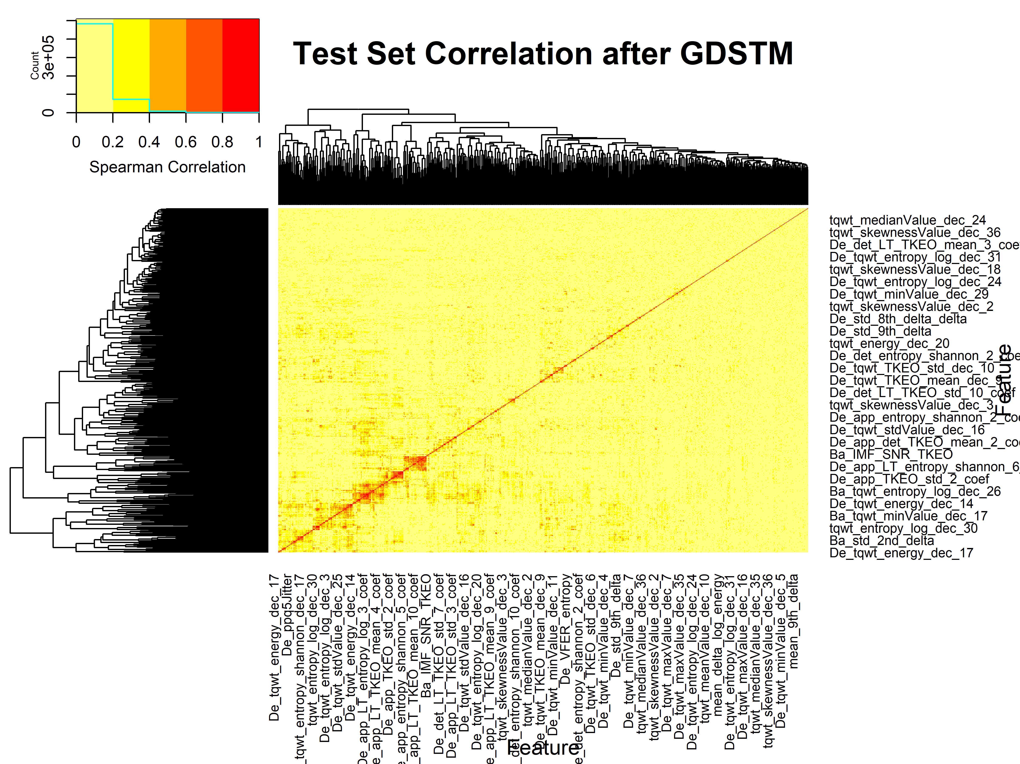

## Cross Validation

par(op)  
par(mfrow=c(1,2))  
  
cvBSWiMSRaw <- randomCV(avgParkison,  
 "class",  
 fittingFunction= BSWiMS.model,  
 classSamplingType = "Pro",  
 trainFraction = trainFraction,  
 repetitions = 150  
)

.[+++++++++++++++++++-]..[++++++++++++++++++++]…[++++++++++++-+–+]..[++++++++-+-].[++++++++++++++++++++]…[++++++++++++++++++-]..[++++++++++++++++++-]..[++++++++++++++-++++]..[++++++++++—+–]..[+++++++++-]10 Tested: 248 Avg. Selected: 36.7 Min Tests: 1 Max Tests: 7 Mean Tests: 3.58871 . MAD: 0.3211527 .[++++++++++++++++++++]…[+++++++++-].[+++–+-+++-++-].[++++++++++++++++-]..[++++++++++++++++++++]…[++++++++++++-+-++-]..[++++++++++-+-]..[++++++++++++++++++++]…[++++++++++++-]..[++++++-+–+++–].20 Tested: 251 Avg. Selected: 36.1 Min Tests: 1 Max Tests: 14 Mean Tests: 7.091633 . MAD: 0.3164924 .[++++++++++++++++++++]…[+++++++++++++++–]..[++++++-+++++-]..[+++++++++-+++++-++]..[++++++++++++++++++++]…[++++++++++++++++++++]…[++++++++++-++++++-]..[++++++++++++++++++++]…[++++++++++++++-++++]..[++++++–]30 Tested: 252 Avg. Selected: 37.16667 Min Tests: 3 Max Tests: 21 Mean Tests: 10.59524 . MAD: 0.3153027 .[++++++++++++++++++-]..[++++++++++++++++++++]…[++++++++++-+++-+-]..[++++++++++-++++-]..[++++++++++++++++++++]…[+++++++++++++++-+++]..[++++++++++++++++++++]…[++++-].[++++++++++++++++++++]…[++++++++++++++++++++]..40 Tested: 252 Avg. Selected: 37.625 Min Tests: 4 Max Tests: 23 Mean Tests: 14.12698 . MAD: 0.3176441 .[+++++++++++++-]..[++++++++++—-]..[++++++-].[++++++++++++++++++++]…[+++++++-++++-]..[++++++++++++++-]..[+++++++++++++++++++-]..[++++-+-].[++++++++++–]..[++++++-+++++-].50 Tested: 252 Avg. Selected: 36.28 Min Tests: 7 Max Tests: 26 Mean Tests: 17.65873 . MAD: 0.3142469 .[++++++++++++++++-++]..[++++++++++++-+-]..[+++++++-++++-]..[++++++++++++++++++++]…[++++++++++++++++++++]…[+++++++-+++-+-+++]..[++++++++++++-++-]..[++++++++++++++++-]..[++++++++++++++-++-]..[++++++++++++++++++++]..60 Tested: 252 Avg. Selected: 36.78333 Min Tests: 11 Max Tests: 32 Mean Tests: 21.19048 . MAD: 0.3133266 .[++++++++++++-]..[++++++++++++++++++++]…[++++++++++++-]..[++++++++++++++++–]..[+++++++++++++++++++-]..[+++++-+-++++-]..[++++++++++-+-+-]..[+++++++++++++-]..[+++-+++-].[+++++++++++++-+++++].70 Tested: 252 Avg. Selected: 36.11429 Min Tests: 14 Max Tests: 37 Mean Tests: 24.72222 . MAD: 0.3141363 .[+++++++++++++-++++-]..[++++++++++++++++++++]…[+++++++++++-++-]..[+++-+++++++-+-]..[++++++++++-+++++++-]..[++++–++-++++-+-]..[++++++++++++++++++++]…[++++++++-].[+++++-].[+++++++++-]80 Tested: 252 Avg. Selected: 35.675 Min Tests: 15 Max Tests: 41 Mean Tests: 28.25397 . MAD: 0.3114737 .[++++++++-+-].[+++++++++++++++++++-]..[+++-+++++-+++-+-]..[++++++++++++++++++++]…[++++++++++++++–]..[++++++++++++++++++++]…[+++++++++++++++–+]..[+++–++++++++++–]..[++++++++++++++++++++]…[++++++++++++++++++++]..90 Tested: 252 Avg. Selected: 36.03333 Min Tests: 20 Max Tests: 46 Mean Tests: 31.78571 . MAD: 0.3116505 .[+++-++++++-].[+++++++++++++++++–]..[++–++-].[++++++++++++++–++]..[++++-++-++++-]..[++++++++++++++++++++]…[++++++++++++++++++++]…[++++++++++++++++++++]…[++++++++++++++++++++]…[++++++++++++++++++++]..100 Tested: 252 Avg. Selected: 36.11 Min Tests: 23 Max Tests: 48 Mean Tests: 35.31746 . MAD: 0.3115633 .[++++++++++++++++++++]…[++++++++++++++++++++]…[+++++++++++—]..[++++++++-++–]..[+++++++++++++++-++-]..[++++++++++++-+++-+]..[+++++++++++-]..[+++++-++-].[++++++++++++++++-++]..[++++++++++++++++++++]..110 Tested: 252 Avg. Selected: 36.24545 Min Tests: 27 Max Tests: 54 Mean Tests: 38.84921 . MAD: 0.3117658 .[+++++++-+-].[++++++++++++++–+-]..[++++++++++++++++++++]…[+++-].[+++++-].[++++++++++++++++++++]…[++++++++++++-++++++]..[++++++++++++++++++++]…[++++++-++++++-]..[++++++++++++++++++++]..120 Tested: 252 Avg. Selected: 35.95 Min Tests: 30 Max Tests: 57 Mean Tests: 42.38095 . MAD: 0.3109799 .[++++++-++++-]..[+++++++++++++++++++-]..[+++++++++++++++–]..[++++++++++++++++-]..[++++++++++++++++++++]…[++++++++++++++++++++]…[+++++++++-++++-+-]..[++++++++-++++++++++]..[++++++++++++++++–]..[++++++++++++++++++++]..130 Tested: 252 Avg. Selected: 36.18462 Min Tests: 35 Max Tests: 64 Mean Tests: 45.9127 . MAD: 0.3116394 .[++++++++++++++++++++]…[++++++++++++++++-++]..[++++++++++++++++-]..[++++++++++++++-+-+]..[++++++++++++++++-]..[++++++++++++++++++++]…[+++++++++++++++-]..[+++++++++++++-+++++]..[++-+++++++-].[++++++++++++++++++++]..140 Tested: 252 Avg. Selected: 36.34286 Min Tests: 37 Max Tests: 71 Mean Tests: 49.44444 . MAD: 0.3124999 .[+++++++++-+—-]..[+++++++++++++++++-]..[++++++++++-+-+–]..[++++++++++++++++++++]…[++++++++++++++++++++]…[+++++++—].[+++++++++++-+++-++]..[++++++++++++++++++++]…[+++++++-++–].[++++++++++++++++++++]..150 Tested: 252 Avg. Selected: 36.18 Min Tests: 39 Max Tests: 72 Mean Tests: 52.97619 . MAD: 0.3123417

bpraw <- predictionStats_binary(cvBSWiMSRaw$medianTest,"BSWiMS RAW",cex=0.80)

BSWiMS RAW

cvBSWiMSDeCor <- randomCV(avgParkison,  
 "class",  
 trainSampleSets= cvBSWiMSRaw$trainSamplesSets,  
 fittingFunction= filteredFit,  
 fitmethod=BSWiMS.model,  
 filtermethod=NULL,  
 DECOR = TRUE,  
 DECOR.control=list(Outcome="class",thr=0.8)  
)

.[+++++++-].[+++++++++-].[+++++-].[+++-].[++++++++++++-++-++]..[+++++++-].[++++-].[++++++++++-++++-]..[++++++++++-]..[++++-+–++++-+-].10 Tested: 248 Avg. Selected: 22.8 Min Tests: 1 Max Tests: 7 Mean Tests: 3.58871 . MAD: 0.3122597 .[++++++++++–]..[+++++++++-].[+++++–].[+++++++++++++++-]..[++++++-+++++—]..[+++++-].[++++++++-++-]..[++-].[+++-+++++++-+–+]..[+–]20 Tested: 251 Avg. Selected: 22.25 Min Tests: 1 Max Tests: 14 Mean Tests: 7.091633 . MAD: 0.3078917 .[+-+—].[++++-].[+++++++–].[++++-++-].[+++-++++—-].[++++++–].[++++-].[+++-].[++-++++++++-]..[+++++++-]30 Tested: 252 Avg. Selected: 20.3 Min Tests: 3 Max Tests: 21 Mean Tests: 10.59524 . MAD: 0.2969094 .[++++—].[+++++++++-++-]..[++++++++-++-+-]..[++++-].[+++++-].[++++++++++-]..[+++-].[++++++++-].[++++++-++—].[+++++++–]40 Tested: 252 Avg. Selected: 20.525 Min Tests: 4 Max Tests: 23 Mean Tests: 14.12698 . MAD: 0.2969467 .[++++++++++-++++++++]..[+++++++++–].[++++++—+-].[++++++++-].[++++++++++-++-]..[+-++-++—-+-].[++++–].[++++++-].[++++++-].[++++++++-+++–].50 Tested: 252 Avg. Selected: 21.48 Min Tests: 7 Max Tests: 26 Mean Tests: 17.65873 . MAD: 0.2977912 .[++++++++++++-]..[++++-].[+++-].[+++++++++-].[+++++++++++–+–]..[++++–].[++-].[++++++++–].[++++++—].[++++++-+-]60 Tested: 252 Avg. Selected: 21.21667 Min Tests: 11 Max Tests: 32 Mean Tests: 21.19048 . MAD: 0.296405 .[++-].[+++++++++-].[+++++-].[++++-].[+++++++—].[+++++-].[+—-].[++++++-+–].[++++-+-].[++++++++++-].70 Tested: 252 Avg. Selected: 20.61429 Min Tests: 14 Max Tests: 37 Mean Tests: 24.72222 . MAD: 0.2942555 .[++++++++-].[++-++++++—].[++++++++++++++++-]..[++++++-].[+–].[+++–].[++++++-].[+++-].[++++-].[+++++++++-+++-++++].80 Tested: 252 Avg. Selected: 20.575 Min Tests: 15 Max Tests: 41 Mean Tests: 28.25397 . MAD: 0.2927092 .[++-].[++++++++-].[++++++++++-+–]..[++—].[++-++-].[+++++++++++-]..[++++–+-].[++–].[+++++++++++++-]..[++-]90 Tested: 252 Avg. Selected: 20.32222 Min Tests: 20 Max Tests: 46 Mean Tests: 31.78571 . MAD: 0.2913693 .[+++–].[++++-].[+++++-++–].[+++++++++++++++-]..[+++++++++-].[+++++++++++++-+-++]..[+++++—++++-].[+++++++-++-].[++++++-++–].[++++–]100 Tested: 252 Avg. Selected: 20.66 Min Tests: 23 Max Tests: 48 Mean Tests: 35.31746 . MAD: 0.2927001 .[++++-+-].[++++++-].[++++++-+++—+++]..[++++-+++-].[++++++++++++++-++++]..[+++++-].[+++++-].[++++++++++-+++-+-]..[+++++++-].[+++++-]110 Tested: 252 Avg. Selected: 20.96364 Min Tests: 27 Max Tests: 54 Mean Tests: 38.84921 . MAD: 0.2929631 .[+++++++++-].[+-++++-].[++++++-+-+-].[++++++++++-++++–]..[++++++++++++–]..[++-].[++++++++++-++-]..[+++-+—].[+++++–].[++++-++-]120 Tested: 252 Avg. Selected: 21.08333 Min Tests: 30 Max Tests: 57 Mean Tests: 42.38095 . MAD: 0.2924473 .[++++-].[+-].[++++++++-].[++-].[+++++++–].[++++++++-].[+++++-++–].[+++++++++-].[++++++++-+-].[+++++–]130 Tested: 252 Avg. Selected: 20.84615 Min Tests: 35 Max Tests: 64 Mean Tests: 45.9127 . MAD: 0.2918178 .[+++++-].[++++++++++—]..[++++++++++++-]..[+++++++-].[+++++-].[++++++—-].[++++++-].[++++++++++++++++-]..[++-].[++++++++-++++-].140 Tested: 252 Avg. Selected: 21.02857 Min Tests: 37 Max Tests: 71 Mean Tests: 49.44444 . MAD: 0.2924951 .[+++++-+++–+-+-]..[++—++-].[++++-+++–].[++-+-].[++++++++-++-]..[++++++++–].[+–].[+++++++++–].[+++–++-].[+—]150 Tested: 252 Avg. Selected: 20.76667 Min Tests: 39 Max Tests: 72 Mean Tests: 52.97619 . MAD: 0.2930844

bpDecor <- predictionStats_binary(cvBSWiMSDeCor$medianTest,"BSWiMS Decor",cex=0.80)

BSWiMS Decor 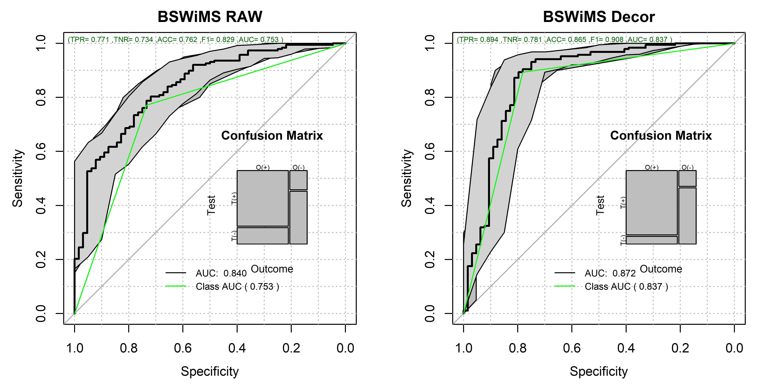

pander::pander(roc.test(bpDecor$ROC.analysis$roc.predictor,bpraw$ROC.analysis$roc.predictor))

DeLong’s test for two correlated ROC curves: bpDecor$ROC.analysis$roc.predictor and bpraw$ROC.analysis$roc.predictor

| Test statistic | P value | Alternative hypothesis | AUC of roc1 | AUC of roc2 |
| --- | --- | --- | --- | --- |
| 1.892 | 0.05848 | two.sided | 0.8724 | 0.8404 |

par(op)

## The Raw Model vs the Decorrelated-Based Model

par(op)  
par(mfrow=c(1,2))  
  
bm <- BSWiMS.model(class~.,trainSet,NumberofRepeats = 10)

[+++++++++++++++++++++++++++++++++++++++++++++++++++++++++++++++++++++++++++++++++++++++++++++++++++-++++++++++++++++++-+++++++++++++++++++++++++++++-+++++++++++++++++++++++++-++++++++++++++++++++++]……………….

bpraw <- predictionStats_binary(cbind(testSet$class,predict(bm,testSet)),"BSWiMS RAW",cex=0.75)

BSWiMS RAW

bmd <- BSWiMS.model(class~.,deTrain,NumberofRepeats = 10)

[+++++-++++++-+++++—+-+++++++-+++++-+++++++++-+++–+-++++++++-+++–+-+++++-++-++++++++++-]…….

bpdecor <- predictionStats_binary(cbind(deTest$class,predict(bmd,deTest)),"BSWiMS Decor",cex=0.75)

BSWiMS Decor 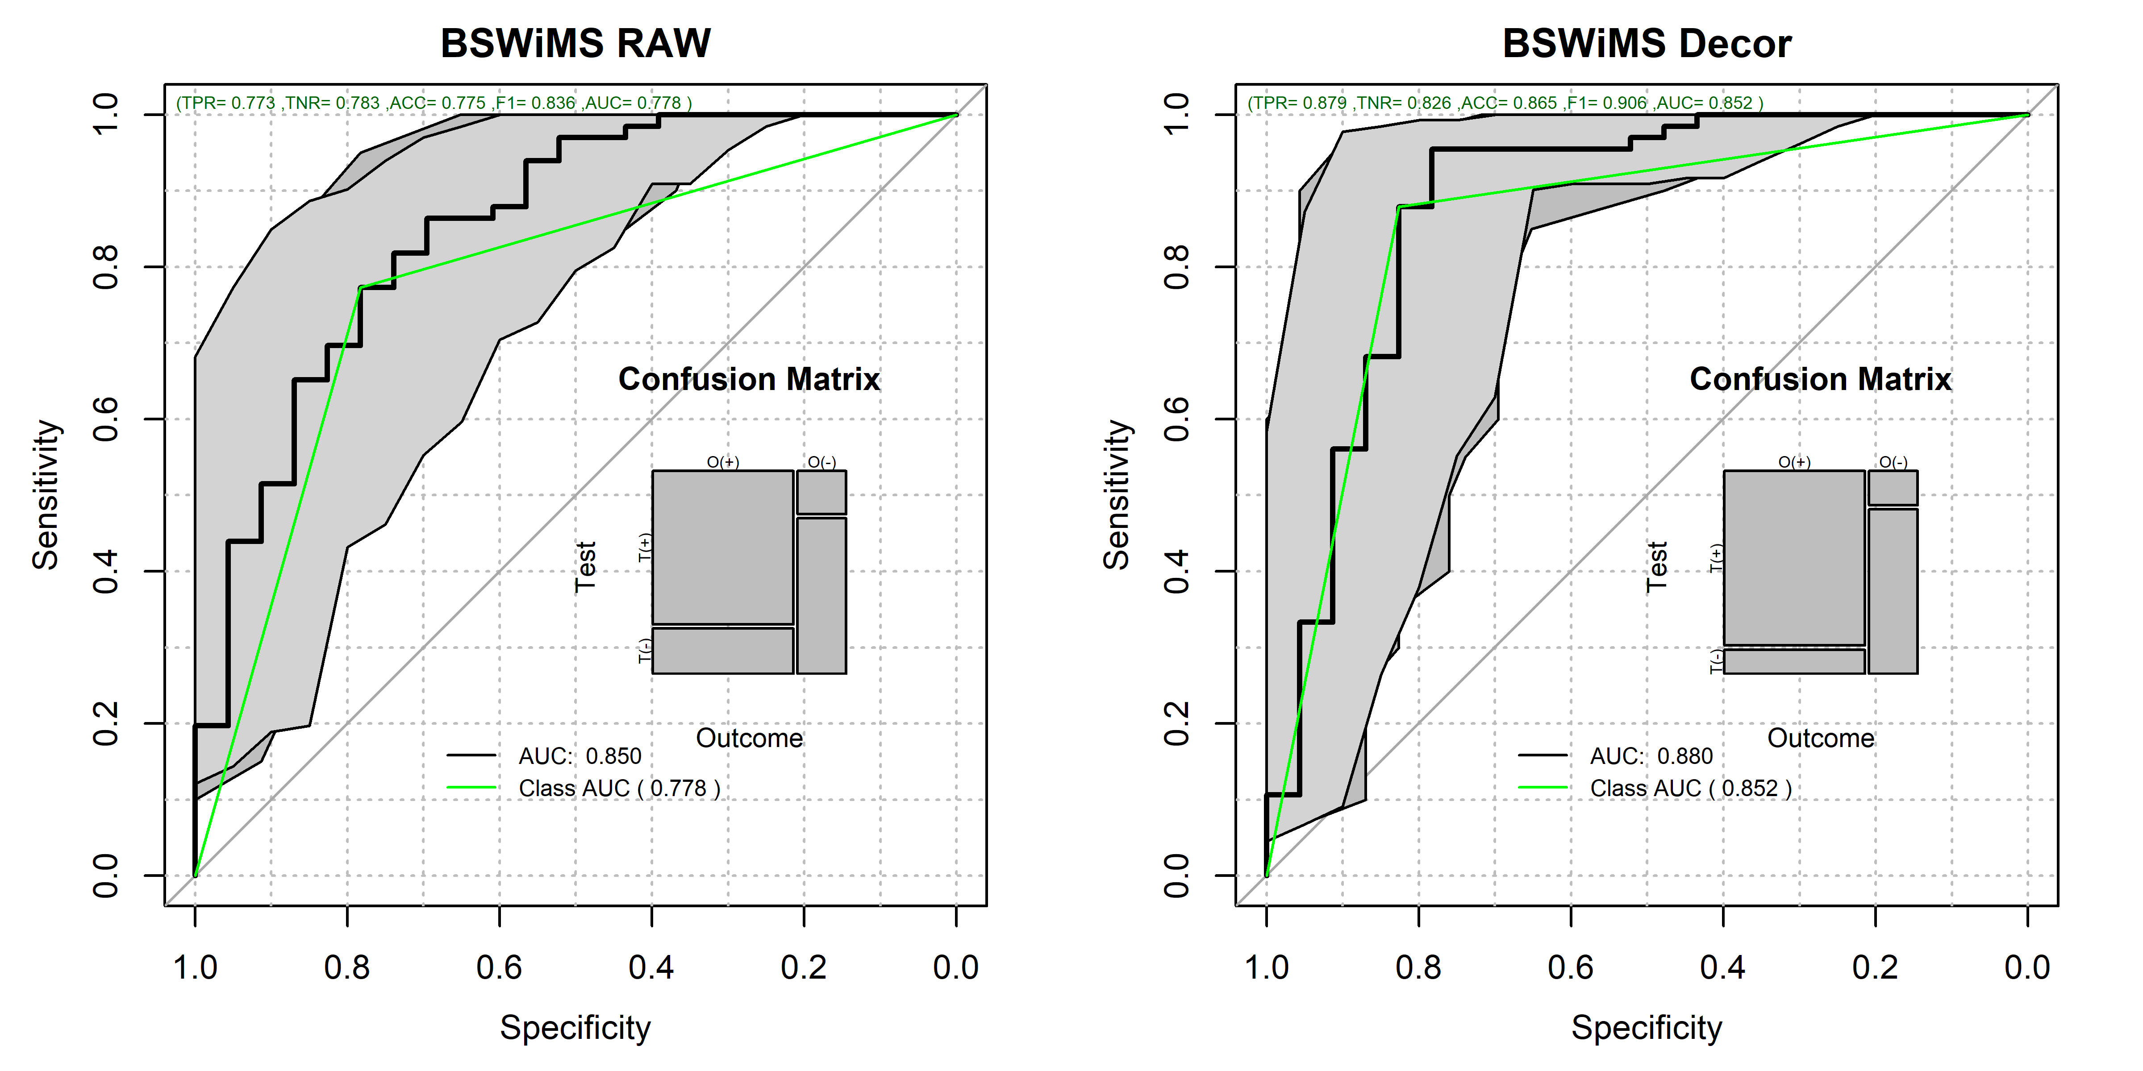

pander::pander(roc.test(bpraw$ROC.analysis$roc.predictor,bpdecor$ROC.analysis$roc.predictor))

DeLong’s test for two correlated ROC curves: bpraw$ROC.analysis$roc.predictor and bpdecor$ROC.analysis$roc.predictor

| Test statistic | P value | Alternative hypothesis | AUC of roc1 | AUC of roc2 |
| --- | --- | --- | --- | --- |
| -1.394 | 0.1633 | two.sided | 0.8505 | 0.8801 |

par(op)

## Feature Analysis of Both Models

par(op)  
par(mfrow=c(1,1))  
rawnames <- names(bm$bagging$bagged.model$coefficients)[-1]  
cnames <- names(bmd$bagging$bagged.model$coefficients)[-1]  
  
dc <- getDerivedCoefficients(deTrain)  
cnames_in_dc <- cnames[cnames %in% names(dc)]  
unamedlist <- dc[cnames_in_dc]  
pander::pander(unamedlist)

* **De_std_MFCC_2nd_coef**:

| * std_MFCC_2nd_coef | * std_2nd_delta |
| --- | --- |
| * 1 | * -0.8278 |

* **De_tqwt_kurtosisValue_dec_33**:

| * tqwt_kurtosisValue_dec_32 | * tqwt_kurtosisValue_dec_33 |
| --- | --- |
| * -0.8834 | * 1 |

* **De_tqwt_energy_dec_33**:

| * tqwt_energy_dec_31 | * tqwt_energy_dec_33 |
| --- | --- |
| * -0.907 | * 1 |

* **De_locDbShimmer**:

| * locDbShimmer | * ddaShimmer |
| --- | --- |
| * 1 | * -0.9626 |

* **De_tqwt_stdValue_dec_33**:

| * tqwt_TKEO_mean_dec_35 | * tqwt_stdValue_dec_32 | * tqwt_stdValue_dec_33 |
| --- | --- | --- |
| * -0.131 | * -0.7154 | * 1 |

* **De_tqwt_TKEO_mean_dec_17**:

| * tqwt_TKEO_mean_dec_17 | * tqwt_minValue_dec_17 |
| --- | --- |
| * 1 | * 2.316 |

* **De_tqwt_entropy_shannon_dec_17**:

| * tqwt_entropy_shannon_dec_17 | * tqwt_minValue_dec_17 |
| --- | --- |
| * 1 | * 1.616 |

* **De_std_12th_delta_delta**:

| * std_MFCC_12th_coef | * std_12th_delta_delta |
| --- | --- |
| * -0.9139 | * 1 |

* **De_det_LT_TKEO_mean_3_coef**:

| * Ed2_3_coef | * det_LT_TKEO_mean_1_coef | * det_LT_TKEO_mean_3_coef |
| --- | --- | --- |
| * -0.8897 | * -0.08343 | * 1 |

* **De_tqwt_TKEO_std_dec_36**:

| * tqwt_TKEO_mean_dec_35 | * tqwt_TKEO_std_dec_36 |
| --- | --- |
| * -0.9259 | * 1 |

* **De_tqwt_TKEO_std_dec_7**:

| * tqwt_TKEO_std_dec_7 | * tqwt_stdValue_dec_7 | * tqwt_minValue_dec_17 |
| --- | --- | --- |
| * 1 | * -1.662 | * 0.1454 |

* **De_tqwt_entropy_log_dec_35**:

| * tqwt_entropy_log_dec_35 | * tqwt_TKEO_mean_dec_35 |
| --- | --- |
| * 1 | * -0.1063 |

* **De_tqwt_TKEO_std_dec_11**:
* Table continues below

| * tqwt_TKEO_mean_dec_10 | * tqwt_TKEO_mean_dec_11 | * tqwt_TKEO_std_dec_11 |
| --- | --- | --- |
| * 0.7128 | * -0.6442 | * 1 |

| * tqwt_stdValue_dec_10 | * tqwt_minValue_dec_17 |
| --- | --- |
| * -1.64 | * 0.3142 |

* **De_tqwt_maxValue_dec_29**:

| * tqwt_stdValue_dec_28 | * tqwt_maxValue_dec_29 |
| --- | --- |
| * -0.5549 | * 1 |

* **De_std_MFCC_5th_coef**:

| * std_MFCC_5th_coef | * std_5th_delta |
| --- | --- |
| * 1 | * -0.8654 |

* **De_tqwt_kurtosisValue_dec_2**:

| * tqwt_kurtosisValue_dec_2 | * tqwt_kurtosisValue_dec_3 |
| --- | --- |
| * 1 | * -0.9796 |

* **De_tqwt_minValue_dec_7**:

| * tqwt_minValue_dec_7 | * tqwt_minValue_dec_17 | * tqwt_maxValue_dec_8 |
| --- | --- | --- |
| * 1 | * -0.01864 | * 0.967 |

* **De_tqwt_minValue_dec_11**:

| * tqwt_minValue_dec_11 | * tqwt_minValue_dec_17 |
| --- | --- |
| * 1 | * -0.9183 |

* **De_tqwt_maxValue_dec_28**:

| * tqwt_stdValue_dec_28 | * tqwt_maxValue_dec_28 |
| --- | --- |
| * -0.7034 | * 1 |

* **De_tqwt_TKEO_std_dec_17**:

| * tqwt_TKEO_std_dec_17 | * tqwt_minValue_dec_17 |
| --- | --- |
| * 1 | * 2.127 |

names(unamedlist) <- NULL  
  
allvar <- unique(c(names(unlist(unamedlist)),cnames))  
allvar <- allvar[!str_detect(allvar,"De_")]  
allvar <- str_remove(allvar,"Ba_")  
dvar <- allvar[!(allvar %in% rawnames)]   
pander::pander(dvar)

*std_MFCC_2nd_coef*, *std_2nd_delta*, *tqwt_kurtosisValue_dec_32*, *tqwt_energy_dec_31*, *tqwt_energy_dec_33*, *locDbShimmer*, *ddaShimmer*, *tqwt_TKEO_mean_dec_35*, *tqwt_stdValue_dec_32*, *tqwt_stdValue_dec_33*, *tqwt_TKEO_mean_dec_17*, *tqwt_minValue_dec_17*, *std_MFCC_12th_coef*, *Ed2_3_coef*, *det_LT_TKEO_mean_1_coef*, *det_LT_TKEO_mean_3_coef*, *tqwt_TKEO_std_dec_36*, *tqwt_stdValue_dec_7*, *tqwt_entropy_log_dec_35*, *tqwt_TKEO_mean_dec_10*, *tqwt_stdValue_dec_10*, *tqwt_stdValue_dec_28*, *tqwt_maxValue_dec_29*, *std_MFCC_5th_coef*, *tqwt_kurtosisValue_dec_2*, *tqwt_kurtosisValue_dec_3*, *tqwt_minValue_dec_7*, *tqwt_maxValue_dec_8*, *tqwt_minValue_dec_11*, *tqwt_maxValue_dec_28*, *tqwt_TKEO_std_dec_17*, *IMF_SNR_entropy* and *mean_MFCC_2nd_coef*

newvars <- character();  
for (cvar in cnames_in_dc)  
{  
 lvar <- dc[cvar]  
 names(lvar) <- NULL  
 lvar <- names(unlist(lvar))  
 if (length(lvar[lvar %in% dvar]) > 0)  
 {  
 newvars <- append(newvars,cvar)  
 }  
}  
  
pander::pander(bm$univariate[dvar,])

Table continues below

|  | Name |
| --- | --- |
| **std_MFCC_2nd_coef** | std_MFCC_2nd_coef |
| **std_2nd_delta** | std_2nd_delta |
| **tqwt_kurtosisValue_dec_32** | tqwt_kurtosisValue_dec_32 |
| **tqwt_energy_dec_31** | tqwt_energy_dec_31 |
| **tqwt_energy_dec_33** | tqwt_energy_dec_33 |
| **locDbShimmer** | locDbShimmer |
| **ddaShimmer** | ddaShimmer |
| **tqwt_TKEO_mean_dec_35** | tqwt_TKEO_mean_dec_35 |
| **tqwt_stdValue_dec_32** | tqwt_stdValue_dec_32 |
| **tqwt_stdValue_dec_33** | tqwt_stdValue_dec_33 |
| **tqwt_TKEO_mean_dec_17** | tqwt_TKEO_mean_dec_17 |
| **tqwt_minValue_dec_17** | tqwt_minValue_dec_17 |
| **std_MFCC_12th_coef** | std_MFCC_12th_coef |
| **Ed2_3_coef** | Ed2_3_coef |
| **det_LT_TKEO_mean_1_coef** | det_LT_TKEO_mean_1_coef |
| **det_LT_TKEO_mean_3_coef** | det_LT_TKEO_mean_3_coef |
| **tqwt_TKEO_std_dec_36** | tqwt_TKEO_std_dec_36 |
| **tqwt_stdValue_dec_7** | tqwt_stdValue_dec_7 |
| **tqwt_entropy_log_dec_35** | tqwt_entropy_log_dec_35 |
| **tqwt_TKEO_mean_dec_10** | tqwt_TKEO_mean_dec_10 |
| **tqwt_stdValue_dec_10** | tqwt_stdValue_dec_10 |
| **tqwt_stdValue_dec_28** | tqwt_stdValue_dec_28 |
| **tqwt_maxValue_dec_29** | tqwt_maxValue_dec_29 |
| **std_MFCC_5th_coef** | std_MFCC_5th_coef |
| **tqwt_kurtosisValue_dec_2** | tqwt_kurtosisValue_dec_2 |
| **tqwt_kurtosisValue_dec_3** | tqwt_kurtosisValue_dec_3 |
| **tqwt_minValue_dec_7** | tqwt_minValue_dec_7 |
| **tqwt_maxValue_dec_8** | tqwt_maxValue_dec_8 |
| **tqwt_minValue_dec_11** | tqwt_minValue_dec_11 |
| **tqwt_maxValue_dec_28** | tqwt_maxValue_dec_28 |
| **tqwt_TKEO_std_dec_17** | tqwt_TKEO_std_dec_17 |
| **IMF_SNR_entropy** | IMF_SNR_entropy |
| **mean_MFCC_2nd_coef** | mean_MFCC_2nd_coef |

|  | RName | ZUni |
| --- | --- | --- |
| **std_MFCC_2nd_coef** | std_MFCC_2nd_coef | 0.6278 |
| **std_2nd_delta** | std_2nd_delta | 1.942 |
| **tqwt_kurtosisValue_dec_32** | tqwt_kurtosisValue_dec_32 | 0.4326 |
| **tqwt_energy_dec_31** | tqwt_energy_dec_31 | 1.127 |
| **tqwt_energy_dec_33** | tqwt_energy_dec_33 | 0.9895 |
| **locDbShimmer** | locDbShimmer | 3.548 |
| **ddaShimmer** | ddaShimmer | 2.619 |
| **tqwt_TKEO_mean_dec_35** | tqwt_TKEO_mean_dec_35 | 3.488 |
| **tqwt_stdValue_dec_32** | tqwt_stdValue_dec_32 | 1.712 |
| **tqwt_stdValue_dec_33** | tqwt_stdValue_dec_33 | 2.81 |
| **tqwt_TKEO_mean_dec_17** | tqwt_TKEO_mean_dec_17 | 4.905 |
| **tqwt_minValue_dec_17** | tqwt_minValue_dec_17 | 4.068 |
| **std_MFCC_12th_coef** | std_MFCC_12th_coef | 2.009 |
| **Ed2_3_coef** | Ed2_3_coef | 2.109 |
| **det_LT_TKEO_mean_1_coef** | det_LT_TKEO_mean_1_coef | 1.697 |
| **det_LT_TKEO_mean_3_coef** | det_LT_TKEO_mean_3_coef | 1.767 |
| **tqwt_TKEO_std_dec_36** | tqwt_TKEO_std_dec_36 | 2.714 |
| **tqwt_stdValue_dec_7** | tqwt_stdValue_dec_7 | 4.436 |
| **tqwt_entropy_log_dec_35** | tqwt_entropy_log_dec_35 | 3.561 |
| **tqwt_TKEO_mean_dec_10** | tqwt_TKEO_mean_dec_10 | 3.95 |
| **tqwt_stdValue_dec_10** | tqwt_stdValue_dec_10 | 4.106 |
| **tqwt_stdValue_dec_28** | tqwt_stdValue_dec_28 | 2.695 |
| **tqwt_maxValue_dec_29** | tqwt_maxValue_dec_29 | 0.06766 |
| **std_MFCC_5th_coef** | std_MFCC_5th_coef | 2.208 |
| **tqwt_kurtosisValue_dec_2** | tqwt_kurtosisValue_dec_2 | 0.3412 |
| **tqwt_kurtosisValue_dec_3** | tqwt_kurtosisValue_dec_3 | 0.6517 |
| **tqwt_minValue_dec_7** | tqwt_minValue_dec_7 | 4.986 |
| **tqwt_maxValue_dec_8** | tqwt_maxValue_dec_8 | 4.201 |
| **tqwt_minValue_dec_11** | tqwt_minValue_dec_11 | 5.493 |
| **tqwt_maxValue_dec_28** | tqwt_maxValue_dec_28 | 0.9968 |
| **tqwt_TKEO_std_dec_17** | tqwt_TKEO_std_dec_17 | 4.631 |
| **IMF_SNR_entropy** | IMF_SNR_entropy | 3.218 |
| **mean_MFCC_2nd_coef** | mean_MFCC_2nd_coef | 3.538 |

pander::pander(bmd$univariate[newvars,])

Table continues below

|  | Name |
| --- | --- |
| **De_std_MFCC_2nd_coef** | De_std_MFCC_2nd_coef |
| **De_tqwt_kurtosisValue_dec_33** | De_tqwt_kurtosisValue_dec_33 |
| **De_tqwt_energy_dec_33** | De_tqwt_energy_dec_33 |
| **De_locDbShimmer** | De_locDbShimmer |
| **De_tqwt_stdValue_dec_33** | De_tqwt_stdValue_dec_33 |
| **De_tqwt_TKEO_mean_dec_17** | De_tqwt_TKEO_mean_dec_17 |
| **De_tqwt_entropy_shannon_dec_17** | De_tqwt_entropy_shannon_dec_17 |
| **De_std_12th_delta_delta** | De_std_12th_delta_delta |
| **De_det_LT_TKEO_mean_3_coef** | De_det_LT_TKEO_mean_3_coef |
| **De_tqwt_TKEO_std_dec_36** | De_tqwt_TKEO_std_dec_36 |
| **De_tqwt_TKEO_std_dec_7** | De_tqwt_TKEO_std_dec_7 |
| **De_tqwt_entropy_log_dec_35** | De_tqwt_entropy_log_dec_35 |
| **De_tqwt_TKEO_std_dec_11** | De_tqwt_TKEO_std_dec_11 |
| **De_tqwt_maxValue_dec_29** | De_tqwt_maxValue_dec_29 |
| **De_std_MFCC_5th_coef** | De_std_MFCC_5th_coef |
| **De_tqwt_kurtosisValue_dec_2** | De_tqwt_kurtosisValue_dec_2 |
| **De_tqwt_minValue_dec_7** | De_tqwt_minValue_dec_7 |
| **De_tqwt_minValue_dec_11** | De_tqwt_minValue_dec_11 |
| **De_tqwt_maxValue_dec_28** | De_tqwt_maxValue_dec_28 |
| **De_tqwt_TKEO_std_dec_17** | De_tqwt_TKEO_std_dec_17 |

|  | RName | ZUni |
| --- | --- | --- |
| **De_std_MFCC_2nd_coef** | De_std_MFCC_2nd_coef | 4.676 |
| **De_tqwt_kurtosisValue_dec_33** | De_tqwt_kurtosisValue_dec_33 | 4.48 |
| **De_tqwt_energy_dec_33** | De_tqwt_energy_dec_33 | 5.23 |
| **De_locDbShimmer** | De_locDbShimmer | 5.94 |
| **De_tqwt_stdValue_dec_33** | De_tqwt_stdValue_dec_33 | 4.433 |
| **De_tqwt_TKEO_mean_dec_17** | De_tqwt_TKEO_mean_dec_17 | 3.471 |
| **De_tqwt_entropy_shannon_dec_17** | De_tqwt_entropy_shannon_dec_17 | 2.776 |
| **De_std_12th_delta_delta** | De_std_12th_delta_delta | 4.471 |
| **De_det_LT_TKEO_mean_3_coef** | De_det_LT_TKEO_mean_3_coef | 3.076 |
| **De_tqwt_TKEO_std_dec_36** | De_tqwt_TKEO_std_dec_36 | 2.384 |
| **De_tqwt_TKEO_std_dec_7** | De_tqwt_TKEO_std_dec_7 | 2.165 |
| **De_tqwt_entropy_log_dec_35** | De_tqwt_entropy_log_dec_35 | 1.531 |
| **De_tqwt_TKEO_std_dec_11** | De_tqwt_TKEO_std_dec_11 | 3.935 |
| **De_tqwt_maxValue_dec_29** | De_tqwt_maxValue_dec_29 | 3.821 |
| **De_std_MFCC_5th_coef** | De_std_MFCC_5th_coef | 2.355 |
| **De_tqwt_kurtosisValue_dec_2** | De_tqwt_kurtosisValue_dec_2 | 2.809 |
| **De_tqwt_minValue_dec_7** | De_tqwt_minValue_dec_7 | 2.116 |
| **De_tqwt_minValue_dec_11** | De_tqwt_minValue_dec_11 | 3.383 |
| **De_tqwt_maxValue_dec_28** | De_tqwt_maxValue_dec_28 | 3.786 |
| **De_tqwt_TKEO_std_dec_17** | De_tqwt_TKEO_std_dec_17 | 3.14 |

zvalueNew <- bmd$univariate[newvars,]  
rownames(zvalueNew) <- str_remove(rownames(zvalueNew),"De_")  
rownames(zvalueNew) <- str_remove(rownames(zvalueNew),"Ba_")  
  
zvaluePrePost <- bm$univariate[rownames(zvalueNew),c(1,3)]  
zvaluePrePost$Name <- NULL  
zvaluePrePost$NewZ <- zvalueNew[rownames(zvaluePrePost),"ZUni"]  
pander::pander(zvaluePrePost)

|  | ZUni | NewZ |
| --- | --- | --- |
| **std_MFCC_2nd_coef** | 0.6278 | 4.676 |
| **tqwt_kurtosisValue_dec_33** | 2.06 | 4.48 |
| **tqwt_energy_dec_33** | 0.9895 | 5.23 |
| **locDbShimmer** | 3.548 | 5.94 |
| **tqwt_stdValue_dec_33** | 2.81 | 4.433 |
| **tqwt_TKEO_mean_dec_17** | 4.905 | 3.471 |
| **tqwt_entropy_shannon_dec_17** | 5.34 | 2.776 |
| **std_12th_delta_delta** | 4.566 | 4.471 |
| **det_LT_TKEO_mean_3_coef** | 1.767 | 3.076 |
| **tqwt_TKEO_std_dec_36** | 2.714 | 2.384 |
| **tqwt_TKEO_std_dec_7** | 4.872 | 2.165 |
| **tqwt_entropy_log_dec_35** | 3.561 | 1.531 |
| **tqwt_TKEO_std_dec_11** | 5.025 | 3.935 |
| **tqwt_maxValue_dec_29** | 0.06766 | 3.821 |
| **std_MFCC_5th_coef** | 2.208 | 2.355 |
| **tqwt_kurtosisValue_dec_2** | 0.3412 | 2.809 |
| **tqwt_minValue_dec_7** | 4.986 | 2.116 |
| **tqwt_minValue_dec_11** | 5.493 | 3.383 |
| **tqwt_maxValue_dec_28** | 0.9968 | 3.786 |
| **tqwt_TKEO_std_dec_17** | 4.631 | 3.14 |

plot(zvaluePrePost,  
 xlim=c(-0.5,6.5),  
 ylim=c(0,7),  
 xlab="Original Z",  
 ylab="Decorrelated Z",  
 main="Unviariate IDI Z Values",  
 pch=3,cex=0.5,  
 col="red")  
abline(v=1.96,col="blue")  
abline(h=1.96,col="blue")  
text(zvaluePrePost$ZUni,zvaluePrePost$NewZ,rownames(zvaluePrePost),srt=65,cex=0.75)

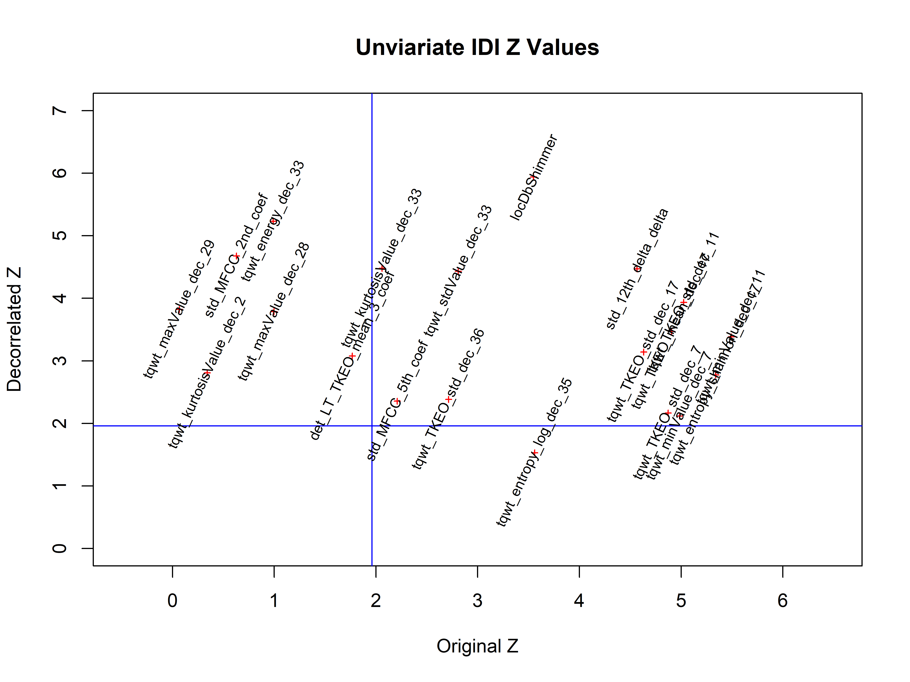

sm <- summary(bmd)  
  
pander::pander(sm$coefficients)

Table continues below

|  | Estimate | lower | OR | upper |
| --- | --- | --- | --- | --- |
| **Ba_tqwt_kurtosisValue_dec_36** | 0.1649 | 1.135 | 1.179 | 1.225 |
| **Ba_std_delta_delta_log_energy** | 0.4001 | 1.338 | 1.492 | 1.664 |
| **De_tqwt_kurtosisValue_dec_27** | -0.01059 | 0.9862 | 0.9895 | 0.9927 |
| **Ba_IMF_SNR_entropy** | 0.0368 | 1.026 | 1.037 | 1.049 |
| **Ba_locAbsJitter** | 0.05705 | 1.041 | 1.059 | 1.077 |
| **tqwt_kurtosisValue_dec_20** | 0.5034 | 1.411 | 1.654 | 1.94 |
| **De_tqwt_TKEO_std_dec_11** | -0.05022 | 0.9352 | 0.951 | 0.9671 |
| **De_tqwt_TKEO_std_dec_17** | -0.07466 | 0.9048 | 0.9281 | 0.9519 |
| **De_tqwt_stdValue_dec_33** | -0.8911 | 0.3079 | 0.4102 | 0.5466 |
| **De_std_MFCC_6th_coef** | 0.3692 | 1.273 | 1.447 | 1.644 |
| **De_std_MFCC_2nd_coef** | -1.262 | 0.182 | 0.2831 | 0.4401 |
| **Ba_std_5th_delta** | 0.3322 | 1.241 | 1.394 | 1.566 |
| **tqwt_energy_dec_11** | -0.007233 | 0.9902 | 0.9928 | 0.9953 |
| **De_tqwt_kurtosisValue_dec_2** | -0.06088 | 0.9208 | 0.9409 | 0.9615 |
| **De_tqwt_maxValue_dec_28** | -0.03574 | 0.9527 | 0.9649 | 0.9772 |
| **De_tqwt_energy_dec_33** | -0.1534 | 0.8132 | 0.8578 | 0.9048 |
| **De_std_12th_delta_delta** | 0.8305 | 1.715 | 2.294 | 3.07 |
| **Ba_tqwt_energy_dec_12** | -0.03377 | 0.9555 | 0.9668 | 0.9782 |
| **std_MFCC_8th_coef** | 0.4858 | 1.374 | 1.625 | 1.924 |
| **Ba_meanIntensity** | -0.9709 | 0.2669 | 0.3787 | 0.5375 |
| **Ba_tqwt_kurtosisValue_dec_28** | -0.04941 | 0.9362 | 0.9518 | 0.9676 |
| **Ba_tqwt_kurtosisValue_dec_17** | 0.3111 | 1.217 | 1.365 | 1.531 |
| **De_std_MFCC_5th_coef** | -0.1248 | 0.8426 | 0.8826 | 0.9246 |
| **De_tqwt_TKEO_mean_dec_11** | -0.03035 | 0.9593 | 0.9701 | 0.981 |
| **De_tqwt_maxValue_dec_29** | -0.06864 | 0.9103 | 0.9337 | 0.9577 |
| **De_tqwt_TKEO_std_dec_36** | 0.08247 | 1.053 | 1.086 | 1.12 |
| **De_tqwt_kurtosisValue_dec_33** | 0.5789 | 1.449 | 1.784 | 2.196 |
| **Ba_tqwt_entropy_log_dec_12** | -0.4424 | 0.5629 | 0.6425 | 0.7334 |
| **De_tqwt_entropy_shannon_dec_17** | -0.06454 | 0.9143 | 0.9375 | 0.9613 |
| **mean_MFCC_2nd_coef** | 0.02094 | 1.013 | 1.021 | 1.03 |
| **De_locDbShimmer** | 0.8239 | 1.697 | 2.279 | 3.062 |
| **De_tqwt_TKEO_mean_dec_17** | -0.09484 | 0.8769 | 0.9095 | 0.9433 |
| **Ba_tqwt_kurtosisValue_dec_26** | -0.006344 | 0.9911 | 0.9937 | 0.9962 |
| **De_tqwt_TKEO_std_dec_7** | -0.1316 | 0.8312 | 0.8767 | 0.9246 |
| **De_tqwt_minValue_dec_11** | 0.06686 | 1.04 | 1.069 | 1.1 |
| **tqwt_meanValue_dec_11** | 0.002207 | 1.001 | 1.002 | 1.003 |
| **De_tqwt_entropy_log_dec_35** | -0.06847 | 0.9071 | 0.9338 | 0.9613 |
| **De_det_LT_TKEO_mean_3_coef** | -0.3544 | 0.6036 | 0.7016 | 0.8156 |
| **De_tqwt_minValue_dec_7** | 0.08561 | 1.049 | 1.089 | 1.132 |
| **Ba_IMF_NSR_TKEO** | -0.01231 | 0.9822 | 0.9878 | 0.9934 |

Table continues below

|  | u.Accuracy | r.Accuracy | full.Accuracy |
| --- | --- | --- | --- |
| **Ba_tqwt_kurtosisValue_dec_36** | 0.679 | 0.6729 | 0.772 |
| **Ba_std_delta_delta_log_energy** | 0.719 | 0.7595 | 0.8142 |
| **De_tqwt_kurtosisValue_dec_27** | 0.692 | 0.6945 | 0.7583 |
| **Ba_IMF_SNR_entropy** | 0.6301 | 0.6761 | 0.7387 |
| **Ba_locAbsJitter** | 0.638 | 0.6739 | 0.7472 |
| **tqwt_kurtosisValue_dec_20** | 0.667 | 0.6735 | 0.7451 |
| **De_tqwt_TKEO_std_dec_11** | 0.6933 | 0.6994 | 0.7546 |
| **De_tqwt_TKEO_std_dec_17** | 0.6221 | 0.6785 | 0.7423 |
| **De_tqwt_stdValue_dec_33** | 0.6863 | 0.7242 | 0.7859 |
| **De_std_MFCC_6th_coef** | 0.5784 | 0.731 | 0.7652 |
| **De_std_MFCC_2nd_coef** | 0.7033 | 0.781 | 0.8179 |
| **Ba_std_5th_delta** | 0.6211 | 0.7227 | 0.758 |
| **tqwt_energy_dec_11** | 0.6613 | 0.7288 | 0.7546 |
| **De_tqwt_kurtosisValue_dec_2** | 0.6883 | 0.7025 | 0.7558 |
| **De_tqwt_maxValue_dec_28** | 0.6552 | 0.7031 | 0.7423 |
| **De_tqwt_energy_dec_33** | 0.7476 | 0.7393 | 0.7896 |
| **De_std_12th_delta_delta** | 0.6938 | 0.7231 | 0.7566 |
| **Ba_tqwt_energy_dec_12** | 0.6709 | 0.6842 | 0.7521 |
| **std_MFCC_8th_coef** | 0.6528 | 0.6714 | 0.737 |
| **Ba_meanIntensity** | 0.6094 | 0.6812 | 0.7213 |
| **Ba_tqwt_kurtosisValue_dec_28** | 0.6812 | 0.6969 | 0.7595 |
| **Ba_tqwt_kurtosisValue_dec_17** | 0.6325 | 0.7028 | 0.7518 |
| **De_std_MFCC_5th_coef** | 0.6025 | 0.7215 | 0.7546 |
| **De_tqwt_TKEO_mean_dec_11** | 0.6387 | 0.6706 | 0.7323 |
| **De_tqwt_maxValue_dec_29** | 0.638 | 0.6822 | 0.7243 |
| **De_tqwt_TKEO_std_dec_36** | 0.6445 | 0.7095 | 0.7715 |
| **De_tqwt_kurtosisValue_dec_33** | 0.6928 | 0.7717 | 0.8187 |
| **Ba_tqwt_entropy_log_dec_12** | 0.7401 | 0.7515 | 0.7849 |
| **De_tqwt_entropy_shannon_dec_17** | 0.5877 | 0.6822 | 0.7215 |
| **mean_MFCC_2nd_coef** | 0.6883 | 0.6785 | 0.7448 |
| **De_locDbShimmer** | 0.7155 | 0.7648 | 0.7904 |
| **De_tqwt_TKEO_mean_dec_17** | 0.6393 | 0.7215 | 0.7638 |
| **Ba_tqwt_kurtosisValue_dec_26** | 0.7706 | 0.6969 | 0.7546 |
| **De_tqwt_TKEO_std_dec_7** | 0.5939 | 0.7025 | 0.7402 |
| **De_tqwt_minValue_dec_11** | 0.6421 | 0.7129 | 0.7636 |
| **tqwt_meanValue_dec_11** | 0.6135 | 0.7099 | 0.7647 |
| **De_tqwt_entropy_log_dec_35** | 0.5718 | 0.6847 | 0.7178 |
| **De_det_LT_TKEO_mean_3_coef** | 0.608 | 0.6947 | 0.7393 |
| **De_tqwt_minValue_dec_7** | 0.5613 | 0.7521 | 0.7644 |
| **Ba_IMF_NSR_TKEO** | 0.6356 | 0.7804 | 0.7963 |

Table continues below

|  | u.AUC | r.AUC | full.AUC | IDI |
| --- | --- | --- | --- | --- |
| **Ba_tqwt_kurtosisValue_dec_36** | 0.7062 | 0.6872 | 0.7732 | 0.1654 |
| **Ba_std_delta_delta_log_energy** | 0.7268 | 0.7483 | 0.814 | 0.1499 |
| **De_tqwt_kurtosisValue_dec_27** | 0.6663 | 0.7052 | 0.7673 | 0.1373 |
| **Ba_IMF_SNR_entropy** | 0.6104 | 0.6889 | 0.7517 | 0.1412 |
| **Ba_locAbsJitter** | 0.6554 | 0.6741 | 0.7534 | 0.1251 |
| **tqwt_kurtosisValue_dec_20** | 0.6869 | 0.7049 | 0.7666 | 0.1212 |
| **De_tqwt_TKEO_std_dec_11** | 0.6979 | 0.6955 | 0.7745 | 0.1169 |
| **De_tqwt_TKEO_std_dec_17** | 0.6245 | 0.6897 | 0.7356 | 0.1158 |
| **De_tqwt_stdValue_dec_33** | 0.6864 | 0.7354 | 0.7781 | 0.1084 |
| **De_std_MFCC_6th_coef** | 0.6031 | 0.7348 | 0.7761 | 0.1113 |
| **De_std_MFCC_2nd_coef** | 0.6834 | 0.7769 | 0.8176 | 0.11 |
| **Ba_std_5th_delta** | 0.653 | 0.7228 | 0.7687 | 0.115 |
| **tqwt_energy_dec_11** | 0.6507 | 0.6666 | 0.7276 | 0.1071 |
| **De_tqwt_kurtosisValue_dec_2** | 0.638 | 0.7073 | 0.7608 | 0.1019 |
| **De_tqwt_maxValue_dec_28** | 0.6482 | 0.6931 | 0.7356 | 0.1131 |
| **De_tqwt_energy_dec_33** | 0.7402 | 0.7502 | 0.788 | 0.1107 |
| **De_std_12th_delta_delta** | 0.6753 | 0.7303 | 0.7637 | 0.1133 |
| **Ba_tqwt_energy_dec_12** | 0.6713 | 0.7084 | 0.7671 | 0.1019 |
| **std_MFCC_8th_coef** | 0.6734 | 0.6769 | 0.7541 | 0.1055 |
| **Ba_meanIntensity** | 0.69 | 0.6926 | 0.7533 | 0.1021 |
| **Ba_tqwt_kurtosisValue_dec_28** | 0.6734 | 0.7159 | 0.7733 | 0.09998 |
| **Ba_tqwt_kurtosisValue_dec_17** | 0.6756 | 0.7144 | 0.7763 | 0.09896 |
| **De_std_MFCC_5th_coef** | 0.5741 | 0.7411 | 0.7745 | 0.1012 |
| **De_tqwt_TKEO_mean_dec_11** | 0.6467 | 0.6826 | 0.7606 | 0.09832 |
| **De_tqwt_maxValue_dec_29** | 0.6675 | 0.6927 | 0.7457 | 0.1009 |
| **De_tqwt_TKEO_std_dec_36** | 0.6139 | 0.7266 | 0.7777 | 0.08412 |
| **De_tqwt_kurtosisValue_dec_33** | 0.6791 | 0.7684 | 0.8185 | 0.08831 |
| **Ba_tqwt_entropy_log_dec_12** | 0.7312 | 0.7228 | 0.7773 | 0.1052 |
| **De_tqwt_entropy_shannon_dec_17** | 0.6145 | 0.7116 | 0.7265 | 0.09537 |
| **mean_MFCC_2nd_coef** | 0.6558 | 0.7059 | 0.7437 | 0.09158 |
| **De_locDbShimmer** | 0.7361 | 0.7548 | 0.7842 | 0.08134 |
| **De_tqwt_TKEO_mean_dec_17** | 0.6659 | 0.7313 | 0.7653 | 0.09551 |
| **Ba_tqwt_kurtosisValue_dec_26** | 0.6686 | 0.6923 | 0.7276 | 0.08987 |
| **De_tqwt_TKEO_std_dec_7** | 0.5975 | 0.7235 | 0.754 | 0.08601 |
| **De_tqwt_minValue_dec_11** | 0.6098 | 0.724 | 0.7741 | 0.07544 |
| **tqwt_meanValue_dec_11** | 0.6527 | 0.7058 | 0.7748 | 0.0754 |
| **De_tqwt_entropy_log_dec_35** | 0.5601 | 0.7051 | 0.7386 | 0.07194 |
| **De_det_LT_TKEO_mean_3_coef** | 0.6215 | 0.7064 | 0.7459 | 0.07498 |
| **De_tqwt_minValue_dec_7** | 0.5863 | 0.7348 | 0.756 | 0.07094 |
| **Ba_IMF_NSR_TKEO** | 0.5979 | 0.7901 | 0.8073 | 0.06435 |

|  | NRI | z.IDI | z.NRI | Frequency |
| --- | --- | --- | --- | --- |
| **Ba_tqwt_kurtosisValue_dec_36** | 0.8469 | 7.013 | 7.53 | 1 |
| **Ba_std_delta_delta_log_energy** | 0.7967 | 6.615 | 6.887 | 1 |
| **De_tqwt_kurtosisValue_dec_27** | 0.7344 | 6.306 | 6.223 | 0.1 |
| **Ba_IMF_SNR_entropy** | 0.7016 | 6.254 | 5.928 | 0.2 |
| **Ba_locAbsJitter** | 0.6385 | 6.04 | 5.322 | 0.4 |
| **tqwt_kurtosisValue_dec_20** | 0.7721 | 5.857 | 6.641 | 0.8 |
| **De_tqwt_TKEO_std_dec_11** | 0.9508 | 5.851 | 8.493 | 0.1 |
| **De_tqwt_TKEO_std_dec_17** | 0.682 | 5.708 | 5.722 | 0.1 |
| **De_tqwt_stdValue_dec_33** | 0.6623 | 5.555 | 5.594 | 1 |
| **De_std_MFCC_6th_coef** | 0.6413 | 5.528 | 5.409 | 0.5 |
| **De_std_MFCC_2nd_coef** | 0.7016 | 5.502 | 5.955 | 1 |
| **Ba_std_5th_delta** | 0.6026 | 5.499 | 5.099 | 0.5 |
| **tqwt_energy_dec_11** | 0.6557 | 5.475 | 5.499 | 0.1 |
| **De_tqwt_kurtosisValue_dec_2** | 0.7525 | 5.464 | 6.543 | 0.2 |
| **De_tqwt_maxValue_dec_28** | 0.7639 | 5.454 | 6.536 | 0.1 |
| **De_tqwt_energy_dec_33** | 0.6731 | 5.453 | 5.695 | 1 |
| **De_std_12th_delta_delta** | 0.6536 | 5.448 | 5.496 | 0.9 |
| **Ba_tqwt_energy_dec_12** | 0.6216 | 5.439 | 5.215 | 0.5 |
| **std_MFCC_8th_coef** | 0.6383 | 5.334 | 5.322 | 0.9 |
| **Ba_meanIntensity** | 0.6273 | 5.297 | 5.49 | 0.6 |
| **Ba_tqwt_kurtosisValue_dec_28** | 0.6157 | 5.284 | 5.177 | 0.5 |
| **Ba_tqwt_kurtosisValue_dec_17** | 0.682 | 5.22 | 5.791 | 0.4 |
| **De_std_MFCC_5th_coef** | 0.5344 | 5.186 | 4.418 | 0.1 |
| **De_tqwt_TKEO_mean_dec_11** | 0.5897 | 5.185 | 4.878 | 0.7 |
| **De_tqwt_maxValue_dec_29** | 0.7475 | 5.17 | 6.405 | 0.3 |
| **De_tqwt_TKEO_std_dec_36** | 0.6189 | 5.169 | 5.16 | 0.4 |
| **De_tqwt_kurtosisValue_dec_33** | 0.5423 | 5.133 | 4.499 | 1 |
| **Ba_tqwt_entropy_log_dec_12** | 0.7111 | 5.102 | 6.094 | 1 |
| **De_tqwt_entropy_shannon_dec_17** | 0.7803 | 5.007 | 6.69 | 0.1 |
| **mean_MFCC_2nd_coef** | 0.6328 | 4.901 | 5.257 | 0.1 |
| **De_locDbShimmer** | 0.6964 | 4.878 | 6.044 | 1 |
| **De_tqwt_TKEO_mean_dec_17** | 0.7902 | 4.874 | 6.828 | 0.2 |
| **Ba_tqwt_kurtosisValue_dec_26** | 0.5607 | 4.797 | 4.989 | 0.1 |
| **De_tqwt_TKEO_std_dec_7** | 0.5943 | 4.681 | 4.938 | 0.4 |
| **De_tqwt_minValue_dec_11** | 0.5333 | 4.631 | 4.421 | 0.3 |
| **tqwt_meanValue_dec_11** | 0.6026 | 4.565 | 5.05 | 0.5 |
| **De_tqwt_entropy_log_dec_35** | 0.5738 | 4.509 | 4.73 | 0.1 |
| **De_det_LT_TKEO_mean_3_coef** | 0.6301 | 4.423 | 5.312 | 0.6 |
| **De_tqwt_minValue_dec_7** | 0.6213 | 4.237 | 5.137 | 0.2 |
| **Ba_IMF_NSR_TKEO** | 0.4525 | 4.234 | 3.716 | 0.1 |