Univariate: DARWIN

Jose Tamez

2023-01-31

Table of Contents

# DARWIN Univariate

### Loading the libraries

library("FRESA.CAD")  
library(readxl)  
op <- par(no.readonly = TRUE)  
pander::panderOptions('digits', 3)  
pander::panderOptions('table.split.table', 400)  
pander::panderOptions('keep.trailing.zeros',TRUE)

## The Data

DARWIN <- read.csv("~/GitHub/FCA/Data/DARWIN/DARWIN.csv")  
rownames(DARWIN) <- DARWIN$ID  
DARWIN$ID <- NULL  
DARWIN$class <- 1*(DARWIN$class=="P")  
print(table(DARWIN$class))  
#>   
#> 0 1   
#> 85 89  
  
DARWIN[,1:ncol(DARWIN)] <- sapply(DARWIN,as.numeric)

#### Standarize the names for the reporting

dataframe <- DARWIN  
outcome <- "class"

pander::pander(c(rows=nrow(dataframe),col=ncol(dataframe)-1))

| rows | col |
| --- | --- |
| 174 | 450 |

pander::pander(table(dataframe[,outcome]))

| 0 | 1 |
| --- | --- |
| 85 | 89 |

varlist <- colnames(dataframe)  
varlist <- varlist[varlist != outcome]  
varlist <- as.data.frame(cbind(name=varlist,desc=varlist))

## Univariate

univariate_columns <- c("caseMean","caseStd","controlMean","controlStd","controlKSP","ROCAUC","WilcoxRes.p","FRes.p")  
univar <- uniRankVar(varlist,  
 paste(outcome,"~1"),  
 outcome,  
 dataframe,  
 categorizationType = "Raw",  
 type = "LOGIT",  
 rankingTest = "AUC",  
 cateGroups = c(0.1, 0.9),  
 raw.dataFrame = NULL,  
 description = ".",  
 uniType = "Binary")

100 : mean_jerk_in_air6 200 : disp_index12 300 : mean_speed_in_air17 400 : gmrt_on_paper23

pander::pander(univar$orderframe[1:20,univariate_columns])

|  | caseMean | caseStd | controlMean | controlStd | controlKSP | ROCAUC | WilcoxRes.p | FRes.p |
| --- | --- | --- | --- | --- | --- | --- | --- | --- |
| **total_time23** | 1.70e+04 | 1.10e+04 | 1.18e+04 | 3.15e+04 | 4.26e-13 | 0.863 | 1.40e-13 | 9.35e-05 |
| **total_time15** | 5.34e+04 | 6.17e+04 | 1.48e+04 | 6.66e+03 | 1.42e-02 | 0.844 | 1.03e-15 | 0.00e+00 |
| **air_time23** | 9.79e+03 | 7.42e+03 | 7.38e+03 | 3.14e+04 | 5.73e-14 | 0.844 | 8.06e-11 | 1.57e-01 |
| **air_time15** | 4.38e+04 | 5.81e+04 | 9.39e+03 | 5.46e+03 | 3.71e-02 | 0.829 | 4.82e-15 | 0.00e+00 |
| **total_time17** | 7.44e+04 | 1.03e+05 | 3.50e+04 | 4.42e+04 | 1.39e-09 | 0.824 | 3.94e-12 | 6.39e-10 |
| **paper_time23** | 7.24e+03 | 4.56e+03 | 4.43e+03 | 1.08e+03 | 1.45e-01 | 0.814 | 2.38e-12 | 1.21e-14 |
| **air_time17** | 5.09e+04 | 1.01e+05 | 1.96e+04 | 4.39e+04 | 2.22e-11 | 0.806 | 9.81e-11 | 2.72e-07 |
| **paper_time17** | 2.35e+04 | 1.31e+04 | 1.54e+04 | 4.69e+03 | 2.55e-02 | 0.796 | 5.38e-11 | 2.65e-12 |
| **total_time6** | 1.77e+04 | 1.72e+04 | 6.93e+03 | 3.64e+03 | 1.14e-02 | 0.790 | 6.30e-12 | 7.99e-14 |
| **air_time16** | 1.03e+04 | 1.02e+04 | 2.91e+03 | 2.77e+03 | 2.89e-03 | 0.787 | 4.38e-12 | 5.01e-14 |
| **total_time2** | 2.20e+04 | 1.93e+04 | 9.97e+03 | 5.14e+03 | 4.98e-01 | 0.787 | 6.85e-12 | 1.88e-13 |
| **disp_index23** | 1.02e-05 | 2.08e-06 | 8.37e-06 | 1.45e-06 | 8.73e-02 | 0.787 | 4.15e-11 | 6.25e-12 |
| **total_time7** | 1.78e+04 | 1.52e+04 | 1.77e+04 | 5.43e+04 | 1.78e-15 | 0.785 | 6.24e-07 | 4.90e-01 |
| **total_time16** | 1.45e+04 | 1.24e+04 | 5.81e+03 | 4.54e+03 | 1.21e-03 | 0.784 | 5.32e-11 | 5.47e-12 |
| **air_time6** | 1.29e+04 | 1.43e+04 | 4.46e+03 | 3.39e+03 | 2.81e-03 | 0.784 | 2.18e-11 | 4.92e-13 |
| **total_time22** | 3.48e+04 | 1.56e+05 | 8.84e+03 | 3.29e+03 | 1.25e-01 | 0.780 | 1.31e-11 | 1.61e-13 |
| **air_time7** | 1.22e+04 | 1.14e+04 | 1.49e+04 | 5.40e+04 | 5.55e-16 | 0.779 | 1.00e+00 | 3.26e-01 |
| **total_time8** | 1.27e+04 | 1.34e+04 | 4.97e+03 | 3.15e+03 | 6.98e-03 | 0.776 | 1.06e-10 | 5.11e-12 |
| **gmrt_in_air7** | 2.21e+02 | 9.09e+01 | 3.39e+02 | 1.33e+02 | 5.14e-01 | 0.775 | 2.21e-10 | 1.53e-11 |
| **total_time9** | 1.68e+04 | 1.45e+04 | 6.72e+03 | 3.40e+03 | 2.69e-01 | 0.774 | 5.06e-12 | 1.23e-13 |

topfiveOrg <- rownames(univar$orderframe[1:5,])

## Decorrelation Analysis

DEdataframe <- GDSTMDecorrelation(dataframe,thr=0.80,verbose = TRUE)

Included: 450 , Uni p: 0.005342585 , Uncorrelated Base: 275 , Outcome-Driven Size: 0 , Base Size: 275

1 <R=1.000,w= 1,N= 116>, Top: 58( 1 )[1 : 58 : 0.975](58%20,%2058%20,%200),<|>Tot Used: 116 , Added: 58 , Zero Std: 0 , Max Cor: 1.000 2 <R=1.000,w= 1,N= 116>, Top: 7( 1 )[1 : 7 : 0.975](7%20,%207%20,%2058),<|>Tot Used: 123 , Added: 7 , Zero Std: 0 , Max Cor: 1.000 3 <R=1.000,w= 2,N= 59>, Top: 29( 1 )[1 : 29 : 0.950](29%20,%2030%20,%2065),<|>Tot Used: 166 , Added: 30 , Zero Std: 0 , Max Cor: 1.000 4 <R=1.000,w= 2,N= 59>, Top: 8( 1 )[1 : 8 : 0.950](8%20,%208%20,%2086),<|>Tot Used: 166 , Added: 8 , Zero Std: 0 , Max Cor: 1.000 5 <R=1.000,w= 2,N= 59>, Top: 8( 1 )[1 : 8 : 0.950](8%20,%208%20,%2086),<|>Tot Used: 166 , Added: 8 , Zero Std: 0 , Max Cor: 1.000 6 <R=1.000,w= 2,N= 59>, Top: 8( 1 )[1 : 8 : 0.950](8%20,%208%20,%2086),<|>Tot Used: 166 , Added: 8 , Zero Std: 0 , Max Cor: 1.000 7 <R=1.000,w= 2,N= 59>, Top: 8( 1 )[1 : 8 : 0.950](8%20,%208%20,%2086),<|>Tot Used: 166 , Added: 8 , Zero Std: 0 , Max Cor: 1.000 8 <R=1.000,w= 2,N= 59>, Top: 8( 1 )[1 : 8 : 0.950](8%20,%208%20,%2086),<|>Tot Used: 166 , Added: 8 , Zero Std: 0 , Max Cor: 1.000 9 <R=1.000,w= 2,N= 59>, Top: 8( 1 )[1 : 8 : 0.950](8%20,%208%20,%2086),<|>Tot Used: 166 , Added: 8 , Zero Std: 0 , Max Cor: 1.000 10 <R=1.000,w= 2,N= 59>, Top: 8( 1 )[1 : 8 : 0.950](8%20,%208%20,%2086),<|>Tot Used: 166 , Added: 8 , Zero Std: 0 , Max Cor: 1.000 11 <R=1.000,w= 2,N= 59>, Top: 7( 1 )[1 : 7 : 0.950](7%20,%207%20,%2086),<|>Tot Used: 166 , Added: 7 , Zero Std: 0 , Max Cor: 0.988 12 <R=0.988,w= 2,N= 59>, Top: 14( 1 )[1 : 14 : 0.944](14%20,%2014%20,%2086),<|>Tot Used: 176 , Added: 14 , Zero Std: 0 , Max Cor: 0.988 13 <R=0.988,w= 2,N= 59>, Top: 8( 1 )[1 : 8 : 0.944](8%20,%208%20,%2091),<|>Tot Used: 176 , Added: 8 , Zero Std: 0 , Max Cor: 0.988 14 <R=0.988,w= 2,N= 59>, Top: 8( 1 )[1 : 8 : 0.944](8%20,%208%20,%2091),<|>Tot Used: 176 , Added: 8 , Zero Std: 0 , Max Cor: 0.988 15 <R=0.988,w= 2,N= 59>, Top: 8( 1 )[1 : 8 : 0.944](8%20,%208%20,%2091),<|>Tot Used: 176 , Added: 8 , Zero Std: 0 , Max Cor: 0.988 16 <R=0.988,w= 2,N= 59>, Top: 8( 1 )[1 : 8 : 0.944](8%20,%208%20,%2091),<|>Tot Used: 176 , Added: 8 , Zero Std: 0 , Max Cor: 0.988 17 <R=0.988,w= 2,N= 59>, Top: 8( 1 )[1 : 8 : 0.944](8%20,%208%20,%2091),<|>Tot Used: 176 , Added: 8 , Zero Std: 0 , Max Cor: 0.988 18 <R=0.988,w= 2,N= 59>, Top: 8( 1 )[1 : 8 : 0.944](8%20,%208%20,%2091),<|>Tot Used: 176 , Added: 8 , Zero Std: 0 , Max Cor: 0.987 19 <R=0.987,w= 2,N= 59>, Top: 8( 1 )[1 : 8 : 0.944](8%20,%208%20,%2091),<|>Tot Used: 176 , Added: 8 , Zero Std: 0 , Max Cor: 0.985 20 <R=0.985,w= 2,N= 59>, Top: 8( 1 )[1 : 8 : 0.943](8%20,%208%20,%2091),<|>Tot Used: 176 , Added: 8 , Zero Std: 0 , Max Cor: 0.984 21 <R=0.984,w= 2,N= 59>, Top: 7( 1 )[1 : 7 : 0.942](7%20,%207%20,%2091),<|>Tot Used: 176 , Added: 7 , Zero Std: 0 , Max Cor: 0.983 22 <R=0.983,w= 2,N= 59>, Top: 7( 1 )[1 : 7 : 0.942](7%20,%207%20,%2091),<|>Tot Used: 176 , Added: 7 , Zero Std: 0 , Max Cor: 0.983 23 <R=0.983,w= 2,N= 59>, Top: 5( 1 )[1 : 5 : 0.941](5%20,%205%20,%2091),<|>Tot Used: 176 , Added: 5 , Zero Std: 0 , Max Cor: 0.971 24 <R=0.971,w= 3,N= 89>, Top: 43( 1 )[1 : 43 : 0.886](42%20,%2044%20,%2091),<|>Tot Used: 237 , Added: 44 , Zero Std: 0 , Max Cor: 0.992 25 <R=0.992,w= 3,N= 89>, Top: 12( 1 )[1 : 12 : 0.896](12%20,%2012%20,%20118),<|>Tot Used: 238 , Added: 12 , Zero Std: 0 , Max Cor: 0.992 26 <R=0.992,w= 3,N= 89>, Top: 12( 1 )[1 : 12 : 0.896](12%20,%2012%20,%20119),<|>Tot Used: 238 , Added: 12 , Zero Std: 0 , Max Cor: 0.992 27 <R=0.992,w= 3,N= 89>, Top: 12( 1 )[1 : 12 : 0.896](12%20,%2012%20,%20119),<|>Tot Used: 238 , Added: 12 , Zero Std: 0 , Max Cor: 0.992 28 <R=0.992,w= 3,N= 89>, Top: 11( 1 )[1 : 11 : 0.896](11%20,%2011%20,%20119),<|>Tot Used: 238 , Added: 11 , Zero Std: 0 , Max Cor: 0.992 29 <R=0.992,w= 3,N= 89>, Top: 10( 1 )[1 : 10 : 0.896](10%20,%2010%20,%20119),<|>Tot Used: 238 , Added: 10 , Zero Std: 0 , Max Cor: 0.992 30 <R=0.992,w= 3,N= 89>, Top: 10( 1 )[1 : 10 : 0.896](10%20,%2010%20,%20119),<|>Tot Used: 238 , Added: 10 , Zero Std: 0 , Max Cor: 0.992 31 <R=0.992,w= 3,N= 89>, Top: 10( 1 )[1 : 10 : 0.896](10%20,%2010%20,%20119),<|>Tot Used: 238 , Added: 10 , Zero Std: 0 , Max Cor: 0.992 32 <R=0.992,w= 3,N= 89>, Top: 10( 1 )[1 : 10 : 0.896](10%20,%2010%20,%20119),<|>Tot Used: 238 , Added: 10 , Zero Std: 0 , Max Cor: 0.992 33 <R=0.992,w= 3,N= 89>, Top: 10( 1 )[1 : 10 : 0.896](10%20,%2010%20,%20119),<|>Tot Used: 238 , Added: 10 , Zero Std: 0 , Max Cor: 0.986 34 <R=0.986,w= 3,N= 89>, Top: 10( 1 )[1 : 10 : 0.893](10%20,%2010%20,%20119),<|>Tot Used: 238 , Added: 10 , Zero Std: 0 , Max Cor: 0.984 35 <R=0.984,w= 3,N= 89>, Top: 9( 1 )[1 : 9 : 0.892](9%20,%209%20,%20119),<|>Tot Used: 238 , Added: 9 , Zero Std: 0 , Max Cor: 0.958 36 <R=0.958,w= 3,N= 89>, Top: 12( 1 )[1 : 12 : 0.879](12%20,%2012%20,%20119),<|>Tot Used: 240 , Added: 12 , Zero Std: 0 , Max Cor: 0.968 37 <R=0.968,w= 3,N= 89>, Top: 10( 1 )[1 : 10 : 0.884](10%20,%2010%20,%20120),<|>Tot Used: 240 , Added: 10 , Zero Std: 0 , Max Cor: 0.968 38 <R=0.968,w= 3,N= 89>, Top: 10( 1 )[1 : 10 : 0.884](10%20,%2010%20,%20120),<|>Tot Used: 240 , Added: 10 , Zero Std: 0 , Max Cor: 0.968 39 <R=0.968,w= 3,N= 89>, Top: 10( 1 )[1 : 10 : 0.884](10%20,%2010%20,%20120),<|>Tot Used: 240 , Added: 10 , Zero Std: 0 , Max Cor: 0.968 40 <R=0.968,w= 3,N= 89>, Top: 10( 1 )[1 : 10 : 0.884](10%20,%2010%20,%20120),<|>Tot Used: 240 , Added: 10 , Zero Std: 0 , Max Cor: 0.968 41 <R=0.968,w= 3,N= 89>, Top: 9( 1 )[1 : 9 : 0.884](9%20,%209%20,%20120),<|>Tot Used: 240 , Added: 9 , Zero Std: 0 , Max Cor: 0.968 42 <R=0.968,w= 3,N= 89>, Top: 8( 1 )[1 : 8 : 0.884](8%20,%208%20,%20120),<|>Tot Used: 240 , Added: 8 , Zero Std: 0 , Max Cor: 0.968 43 <R=0.968,w= 4,N= 91>, Top: 45( 1 )[1 : 45 : 0.834](44%20,%2045%20,%20120),<|>Tot Used: 289 , Added: 45 , Zero Std: 0 , Max Cor: 0.968 44 <R=0.968,w= 4,N= 91>, Top: 16( 1 )[1 : 16 : 0.834](16%20,%2016%20,%20144),<|>Tot Used: 289 , Added: 16 , Zero Std: 0 , Max Cor: 0.968 45 <R=0.968,w= 4,N= 91>, Top: 16( 1 )[1 : 16 : 0.834](16%20,%2016%20,%20144),<|>Tot Used: 289 , Added: 16 , Zero Std: 0 , Max Cor: 0.968 46 <R=0.968,w= 4,N= 91>, Top: 16( 1 )[1 : 16 : 0.834](16%20,%2016%20,%20144),<|>Tot Used: 289 , Added: 16 , Zero Std: 0 , Max Cor: 0.968 47 <R=0.968,w= 4,N= 91>, Top: 15( 1 )[1 : 15 : 0.834](15%20,%2015%20,%20144),<|>Tot Used: 289 , Added: 15 , Zero Std: 0 , Max Cor: 0.968 48 <R=0.968,w= 4,N= 91>, Top: 14( 1 )[1 : 14 : 0.834](14%20,%2014%20,%20144),<|>Tot Used: 289 , Added: 14 , Zero Std: 0 , Max Cor: 0.967 49 <R=0.967,w= 4,N= 91>, Top: 12( 1 )[1 : 12 : 0.834](12%20,%2012%20,%20144),<|>Tot Used: 289 , Added: 12 , Zero Std: 0 , Max Cor: 0.966 50 <R=0.966,w= 4,N= 91>, Top: 12( 1 )[1 : 12 : 0.833](12%20,%2012%20,%20144),<|>Tot Used: 289 , Added: 12 , Zero Std: 0 , Max Cor: 0.945 51 <R=0.945,w= 4,N= 91>, Top: 15( 1 )[1 : 15 : 0.823](15%20,%2015%20,%20144),<|>Tot Used: 292 , Added: 15 , Zero Std: 0 , Max Cor: 0.938 52 <R=0.938,w= 4,N= 91>, Top: 12( 1 )[1 : 12 : 0.819](12%20,%2012%20,%20145),<|>Tot Used: 292 , Added: 12 , Zero Std: 0 , Max Cor: 0.938 53 <R=0.938,w= 4,N= 91>, Top: 12( 1 )[1 : 12 : 0.819](12%20,%2012%20,%20145),<|>Tot Used: 292 , Added: 12 , Zero Std: 0 , Max Cor: 0.938 54 <R=0.938,w= 4,N= 91>, Top: 12( 1 )[1 : 12 : 0.819](12%20,%2012%20,%20145),<|>Tot Used: 292 , Added: 12 , Zero Std: 0 , Max Cor: 0.938 55 <R=0.938,w= 4,N= 91>, Top: 12( 1 )[1 : 12 : 0.819](12%20,%2012%20,%20145),<|>Tot Used: 292 , Added: 12 , Zero Std: 0 , Max Cor: 0.938 56 <R=0.938,w= 4,N= 91>, Top: 12( 1 )[1 : 12 : 0.819](12%20,%2012%20,%20145),<|>Tot Used: 292 , Added: 12 , Zero Std: 0 , Max Cor: 0.938 57 <R=0.938,w= 4,N= 91>, Top: 12( 1 )[1 : 12 : 0.819](12%20,%2012%20,%20145),<|>Tot Used: 292 , Added: 12 , Zero Std: 0 , Max Cor: 0.938 58 <R=0.938,w= 4,N= 91>, Top: 12( 1 )[1 : 12 : 0.819](12%20,%2012%20,%20145),<|>Tot Used: 292 , Added: 12 , Zero Std: 0 , Max Cor: 0.938 59 <R=0.938,w= 4,N= 91>, Top: 12( 1 )[1 : 12 : 0.819](12%20,%2012%20,%20145),<|>Tot Used: 292 , Added: 12 , Zero Std: 0 , Max Cor: 0.938 60 <R=0.938,w= 4,N= 91>, Top: 12( 1 )[1 : 12 : 0.819](12%20,%2012%20,%20145),<|>Tot Used: 292 , Added: 12 , Zero Std: 0 , Max Cor: 0.937 61 <R=0.937,w= 4,N= 91>, Top: 11( 1 )[1 : 11 : 0.819](11%20,%2011%20,%20145),<|>Tot Used: 292 , Added: 11 , Zero Std: 0 , Max Cor: 0.932 62 <R=0.932,w= 4,N= 91>, Top: 14( 1 )[1 : 14 : 0.816](14%20,%2014%20,%20145),<|>Tot Used: 298 , Added: 14 , Zero Std: 0 , Max Cor: 0.913 63 <R=0.913,w= 4,N= 91>, Top: 19( 1 )[1 : 19 : 0.806](19%20,%2020%20,%20148),<|>Tot Used: 305 , Added: 20 , Zero Std: 0 , Max Cor: 0.901 64 <R=0.901,w= 4,N= 91>, Top: 18( 1 )[1 : 18 : 0.801](18%20,%2019%20,%20151),<|>Tot Used: 312 , Added: 19 , Zero Std: 0 , Max Cor: 0.890 65 <R=0.890,w= 4,N= 91>, Top: 10( 1 )[1 : 10 : 0.800](10%20,%2010%20,%20154),<|>Tot Used: 312 , Added: 10 , Zero Std: 0 , Max Cor: 0.872 66 <R=0.872,w= 4,N= 91>, Top: 10( 1 )[1 : 10 : 0.800](10%20,%2010%20,%20154),<|>Tot Used: 312 , Added: 10 , Zero Std: 0 , Max Cor: 0.870 67 <R=0.870,w= 4,N= 91>, Top: 9( 1 )[1 : 9 : 0.800](9%20,%209%20,%20154),<|>Tot Used: 312 , Added: 9 , Zero Std: 0 , Max Cor: 0.869 68 <R=0.869,w= 5,N= 16>, Top: 8( 1 )[1 : 8 : 0.800](8%20,%208%20,%20154),<|>Tot Used: 312 , Added: 8 , Zero Std: 0 , Max Cor: 0.866 69 <R=0.866,w= 5,N= 16>, Top: 8( 1 )[1 : 8 : 0.800](8%20,%208%20,%20154),<|>Tot Used: 312 , Added: 8 , Zero Std: 0 , Max Cor: 0.861 70 <R=0.861,w= 5,N= 16>, Top: 8( 1 )[1 : 8 : 0.800](8%20,%208%20,%20154),<|>Tot Used: 312 , Added: 8 , Zero Std: 0 , Max Cor: 0.852 71 <R=0.852,w= 5,N= 16>, Top: 8( 1 )[1 : 8 : 0.800](8%20,%208%20,%20154),<|>Tot Used: 312 , Added: 8 , Zero Std: 0 , Max Cor: 0.846 72 <R=0.846,w= 5,N= 16>, Top: 7( 1 )[1 : 7 : 0.800](7%20,%207%20,%20154),<|>Tot Used: 312 , Added: 7 , Zero Std: 0 , Max Cor: 0.846 73 <R=0.846,w= 5,N= 16>, Top: 6( 1 )[1 : 6 : 0.800](6%20,%206%20,%20154),<|>Tot Used: 312 , Added: 6 , Zero Std: 0 , Max Cor: 0.846 74 <R=0.846,w= 5,N= 16>, Top: 6( 1 )[1 : 6 : 0.800](6%20,%206%20,%20154),<|>Tot Used: 312 , Added: 6 , Zero Std: 0 , Max Cor: 0.846 75 <R=0.846,w= 5,N= 16>, Top: 6( 1 )[1 : 6 : 0.800](6%20,%206%20,%20154),<|>Tot Used: 312 , Added: 6 , Zero Std: 0 , Max Cor: 0.846 76 <R=0.846,w= 5,N= 16>, Top: 6( 1 )[1 : 6 : 0.800](6%20,%206%20,%20154),<|>Tot Used: 312 , Added: 6 , Zero Std: 0 , Max Cor: 0.846 77 <R=0.846,w= 5,N= 16>, Top: 6( 1 )[1 : 6 : 0.800](6%20,%206%20,%20154),<|>Tot Used: 312 , Added: 6 , Zero Std: 0 , Max Cor: 0.846 78 <R=0.846,w= 5,N= 16>, Top: 6( 1 )[1 : 6 : 0.800](6%20,%206%20,%20154),<|>Tot Used: 312 , Added: 6 , Zero Std: 0 , Max Cor: 0.846 79 <R=0.846,w= 5,N= 16>, Top: 6( 1 )[1 : 6 : 0.800](6%20,%206%20,%20154),<|>Tot Used: 312 , Added: 6 , Zero Std: 0 , Max Cor: 0.846 80 <R=0.846,w= 5,N= 16>, Top: 6( 1 )[1 : 6 : 0.800](6%20,%206%20,%20154),<|>Tot Used: 312 , Added: 6 , Zero Std: 0 , Max Cor: 0.846 81 <R=0.846,w= 5,N= 16>, Top: 6( 1 )[1 : 6 : 0.800](6%20,%206%20,%20154),<|>Tot Used: 312 , Added: 6 , Zero Std: 0 , Max Cor: 0.846 82 <R=0.846,w= 5,N= 16>, Top: 6( 1 )[1 : 6 : 0.800](6%20,%206%20,%20154),<|>Tot Used: 312 , Added: 6 , Zero Std: 0 , Max Cor: 0.846 83 <R=0.846,w= 5,N= 16>, Top: 6( 1 )[1 : 6 : 0.800](6%20,%206%20,%20154),<|>Tot Used: 312 , Added: 6 , Zero Std: 0 , Max Cor: 0.846 84 <R=0.846,w= 5,N= 16>, Top: 6( 1 )[1 : 6 : 0.800](6%20,%206%20,%20154),<|>Tot Used: 312 , Added: 6 , Zero Std: 0 , Max Cor: 0.846 85 <R=0.846,w= 5,N= 16>, Top: 6( 1 )[1 : 6 : 0.800](6%20,%206%20,%20154),<|>Tot Used: 312 , Added: 6 , Zero Std: 0 , Max Cor: 0.846 86 <R=0.846,w= 5,N= 16>, Top: 6( 1 )[1 : 6 : 0.800](6%20,%206%20,%20154),<|>Tot Used: 312 , Added: 6 , Zero Std: 0 , Max Cor: 0.846 87 <R=0.846,w= 5,N= 16>, Top: 6( 1 )[1 : 6 : 0.800](6%20,%206%20,%20154),<|>Tot Used: 312 , Added: 6 , Zero Std: 0 , Max Cor: 0.846 88 <R=0.846,w= 5,N= 16>, Top: 6( 1 )[1 : 6 : 0.800](6%20,%206%20,%20154),<|>Tot Used: 312 , Added: 6 , Zero Std: 0 , Max Cor: 0.846 89 <R=0.846,w= 5,N= 16>, Top: 6( 1 )[1 : 6 : 0.800](6%20,%206%20,%20154),<|>Tot Used: 312 , Added: 6 , Zero Std: 0 , Max Cor: 0.846 90 <R=0.846,w= 5,N= 16>, Top: 6( 1 )[1 : 6 : 0.800](6%20,%206%20,%20154),<|>Tot Used: 312 , Added: 6 , Zero Std: 0 , Max Cor: 0.846 91 <R=0.846,w= 5,N= 16>, Top: 6( 1 )[1 : 6 : 0.800](6%20,%206%20,%20154),<|>Tot Used: 312 , Added: 6 , Zero Std: 0 , Max Cor: 0.846 92 <R=0.846,w= 5,N= 16>, Top: 6( 1 )[1 : 6 : 0.800](6%20,%206%20,%20154),<|>Tot Used: 312 , Added: 6 , Zero Std: 0 , Max Cor: 0.846 93 <R=0.846,w= 5,N= 16>, Top: 6( 1 )[1 : 6 : 0.800](6%20,%206%20,%20154),<|>Tot Used: 312 , Added: 6 , Zero Std: 0 , Max Cor: 0.846 94 <R=0.846,w= 5,N= 16>, Top: 6( 1 )[1 : 6 : 0.800](6%20,%206%20,%20154),<|>Tot Used: 312 , Added: 6 , Zero Std: 0 , Max Cor: 0.846 95 <R=0.846,w= 5,N= 16>, Top: 6( 1 )[1 : 6 : 0.800](6%20,%206%20,%20154),<|>Tot Used: 312 , Added: 6 , Zero Std: 0 , Max Cor: 0.845 96 <R=0.845,w= 5,N= 16>, Top: 6( 1 )[1 : 6 : 0.800](6%20,%206%20,%20154),<|>Tot Used: 312 , Added: 6 , Zero Std: 0 , Max Cor: 0.841 97 <R=0.841,w= 5,N= 16>, Top: 6( 1 )[1 : 6 : 0.800](6%20,%206%20,%20154),<|>Tot Used: 312 , Added: 6 , Zero Std: 0 , Max Cor: 0.837 98 <R=0.837,w= 5,N= 16>, Top: 6( 1 )[1 : 6 : 0.800](6%20,%206%20,%20154),<|>Tot Used: 312 , Added: 6 , Zero Std: 0 , Max Cor: 0.833 99 <R=0.833,w= 5,N= 16>, Top: 4( 1 )[1 : 4 : 0.800](4%20,%204%20,%20154),<|>Tot Used: 312 , Added: 4 , Zero Std: 0 , Max Cor: 0.824 100 <R=0.824,w= 5,N= 16>, Top: 4( 1 )[1 : 4 : 0.800](4%20,%204%20,%20154),<|>Tot Used: 312 , Added: 4 , Zero Std: 0 , Max Cor: 0.824 [ 100 ], 0.9949251 Decor Dimension: 312 . Cor to Base: 158 , ABase: 140 , Outcome Base: 0

demat <- attr(DEdataframe,"GDSTM")  
  
pander::pander(c(Cols=ncol(demat),Rows=nrow(demat)))

| Cols | Rows |
| --- | --- |
| 312 | 312 |

totFe <- ncol(DEdataframe)-1  
totBa <- sum(str_detect(colnames(DEdataframe),"Ba_"))  
totDe <- sum(str_detect(colnames(DEdataframe),"La_"))  
toUnmat <- sum(apply(demat!=0,2,sum)==1)  
unaltered <- totFe - ncol(demat) + toUnmat  
pander::pander(c(Features=totFe,totBa=totBa,totDe=totDe,unaltered=totFe-totBa-totDe,totuna=unaltered))

| Features | totBa | totDe | unaltered | totuna |
| --- | --- | --- | --- | --- |
| 450 | 0 | 167 | 283 | 283 |

pander::pander(c(Decorrleated_Fraction=sum(str_detect(colnames(DEdataframe),"La_"))/(ncol(DEdataframe)-1)))

| Decorrleated_Fraction |
| --- |
| 0.371 |

pander::pander(c(Base_Fraction=sum(str_detect(colnames(DEdataframe),"Ba_"))/(ncol(DEdataframe)-1)))

| Base_Fraction |
| --- |
| 0 |

pander::pander(c(Unaltered_Fraction=unaltered/totFe))

| Unaltered_Fraction |
| --- |
| 0.629 |

pander::pander(c(sparcity=(totFe-ncol(demat)+sum(abs(demat)!=0))/totFe/totFe))

| sparcity |
| --- |
| 0.00322 |

varlistDe <- colnames(demat)[apply(demat!=0,2,sum)>1];  
varlistDe <- as.data.frame(cbind(name=varlistDe,desc=varlistDe))

### The heat maps.

par(cex=0.6,cex.main=0.85,cex.axis=0.7)  
cormat <- cor(dataframe[,rownames(demat)],method="spearman")  
cormat[is.na(cormat)] <- 0  
gplots::heatmap.2(abs(cormat),  
 trace = "none",  
# scale = "row",  
 mar = c(5,5),  
 col=rev(heat.colors(5)),  
 main = "Spearman Correlation Original",  
 cexRow = 0.35,  
 cexCol = 0.35,  
 key.title=NA,  
 key.xlab="Spearman Correlation",  
 xlab="Feature", ylab="Feature")

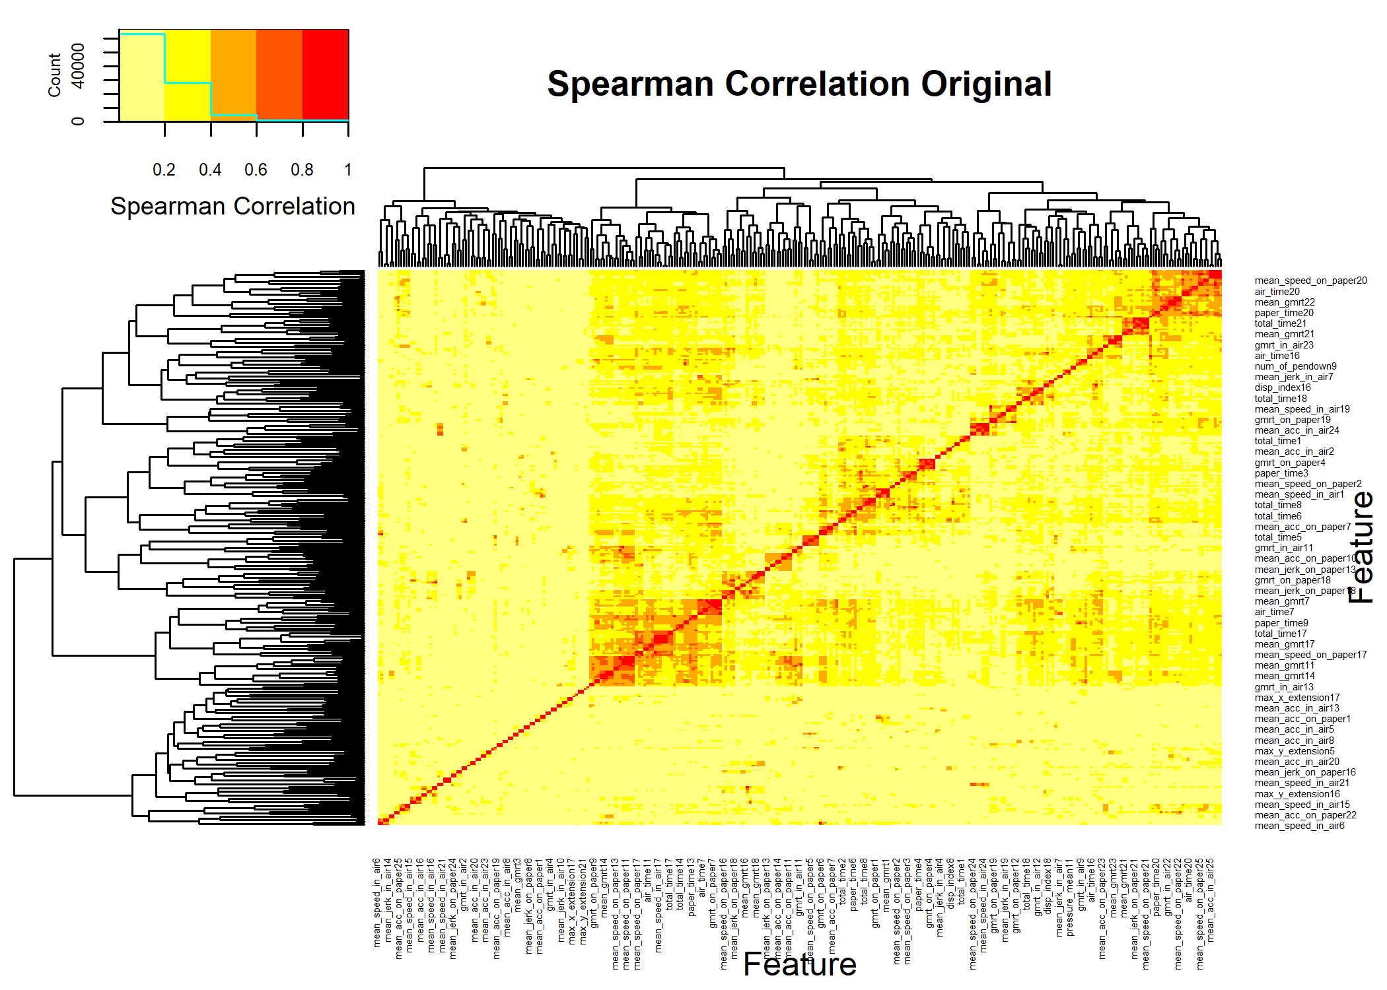

cormat <- cor(DEdataframe[,colnames(demat)],method="spearman")  
cormat[is.na(cormat)] <- 0  
gplots::heatmap.2(abs(cormat),  
 trace = "none",  
# scale = "none",  
 mar = c(5,5),  
 col=rev(heat.colors(5)),  
 main = "Spearman Correlation: After GDSTM",  
 cexRow = 0.35,  
 cexCol = 0.35,  
 key.title=NA,  
 key.xlab="Spearman Correlation",  
 xlab="Feature", ylab="Feature")

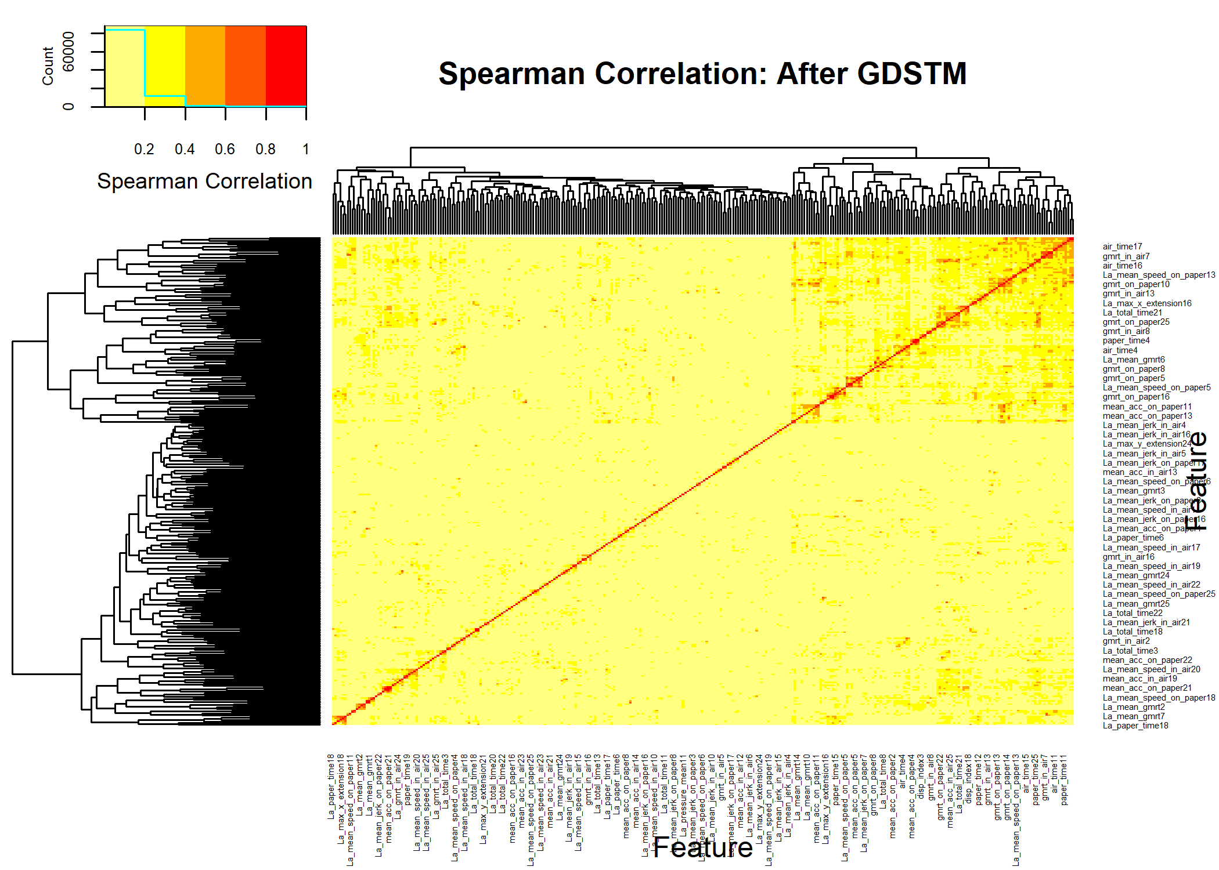

par(op)

## Univariate Decorrelated

univarDe <- uniRankVar(varlistDe,  
 paste(outcome,"~1"),  
 outcome,  
 DEdataframe,  
 categorizationType = "Raw",  
 type = "LOGIT",  
 rankingTest = "AUC",  
 cateGroups = c(0.1, 0.9),  
 raw.dataFrame = NULL,  
 description = ".",  
 uniType = "Binary")

100 : La_paper_time16

pander::pander(univarDe$orderframe[1:20,univariate_columns])

|  | caseMean | caseStd | controlMean | controlStd | controlKSP | ROCAUC | WilcoxRes.p | FRes.p |
| --- | --- | --- | --- | --- | --- | --- | --- | --- |
| **La_total_time9** | 5.78e-12 | 5.13e-12 | 2.47e-12 | 1.18e-12 | 1.88e-06 | 0.764 | 7.38e-11 | 5.79e-13 |
| **La_total_time7** | 3.96e-12 | 3.25e-12 | 3.70e-12 | 1.05e-11 | 1.11e-16 | 0.749 | 2.89e-06 | 4.05e-01 |
| **La_mean_speed_on_paper13** | -1.03e-01 | 1.67e-01 | 5.98e-04 | 3.03e-01 | 7.19e-05 | 0.739 | 2.39e-08 | 9.79e-06 |
| **La_total_time5** | 7.00e-12 | 7.86e-12 | 3.03e-12 | 2.41e-12 | 8.72e-08 | 0.720 | 7.76e-08 | 1.13e-08 |
| **La_mean_speed_on_paper2** | 1.03e-01 | 3.03e-01 | 2.71e-01 | 4.31e-01 | 2.26e-05 | 0.714 | 1.44e-06 | 2.00e-04 |
| **La_mean_speed_on_paper9** | -1.52e-01 | 3.35e-01 | 3.71e-02 | 8.29e-02 | 5.69e-02 | 0.710 | 2.53e-07 | 1.88e-08 |
| **La_mean_speed_on_paper3** | -2.62e-02 | 5.38e-01 | 2.76e-01 | 4.57e-01 | 5.50e-05 | 0.706 | 3.06e-06 | 1.48e-05 |
| **La_mean_speed_on_paper5** | -1.73e-03 | 1.49e-01 | 4.90e-02 | 5.20e-02 | 1.57e-04 | 0.706 | 6.43e-07 | 3.78e-05 |
| **La_mean_gmrt23** | 2.82e+01 | 2.28e+01 | 4.21e+01 | 2.28e+01 | 6.35e-01 | 0.700 | 3.66e-06 | 1.76e-05 |
| **La_mean_speed_on_paper12** | -8.58e-02 | 1.99e-01 | 3.05e-02 | 2.32e-01 | 8.71e-03 | 0.697 | 3.56e-06 | 1.23e-05 |
| **La_mean_speed_on_paper16** | 6.80e-02 | 5.18e-01 | 3.16e-01 | 4.52e-01 | 1.20e-02 | 0.690 | 8.74e-06 | 7.97e-05 |
| **La_total_time21** | 3.94e+02 | 1.22e+04 | -6.92e+03 | 6.10e+03 | 2.84e-01 | 0.679 | 3.36e-06 | 5.36e-07 |
| **La_max_x_extension16** | -1.57e+03 | 7.01e+02 | -1.23e+03 | 6.40e+02 | 3.66e-02 | 0.678 | 2.51e-05 | 2.89e-04 |
| **La_mean_speed_on_paper15** | -1.05e-01 | 4.58e-01 | 8.06e-02 | 2.82e-01 | 3.53e-01 | 0.677 | 3.20e-05 | 2.27e-04 |
| **La_paper_time17** | 9.43e+03 | 7.32e+03 | 6.89e+03 | 4.42e+03 | 1.63e-02 | 0.675 | 1.76e-05 | 2.08e-03 |
| **La_total_time1** | 5.59e+03 | 4.03e+03 | 3.61e+03 | 2.84e+03 | 9.60e-04 | 0.672 | 3.41e-05 | 2.32e-05 |
| **La_mean_jerk_on_paper15** | 3.22e-03 | 1.76e-03 | 4.24e-03 | 1.59e-03 | 9.49e-01 | 0.664 | 1.05e-04 | 4.16e-05 |
| **La_mean_jerk_on_paper5** | 6.60e-03 | 2.15e-03 | 5.76e-03 | 1.28e-03 | 7.08e-01 | 0.663 | 9.75e-05 | 6.15e-04 |
| **La_mean_gmrt11** | 5.49e+01 | 3.68e+01 | 7.65e+01 | 3.71e+01 | 6.73e-01 | 0.663 | 1.32e-04 | 6.76e-05 |
| **La_paper_time16** | 4.39e+02 | 2.11e+03 | -4.98e+02 | 9.82e+02 | 2.88e-03 | 0.663 | 5.19e-05 | 1.74e-05 |

### Comparing Decorrelation vs Original

pthr <- 0.20/(ncol(dataframe)-1)  
  
topDecorNames <- rownames(univarDe$orderframe[univarDe$orderframe$FRes.p<pthr,])  
topDecorNames <- unique(c(topDecorNames,rownames(univarDe$orderframe[1:5,])))  
  
#topDecorNames <- rownames(univarDe$orderframe[univarDe$orderframe$FRes.p<1.0e-5,])  
dc <- getLatentCoefficients(DEdataframe)  
### 2a Get only the ones that in the top features  
deNames_in_dc <- topDecorNames[topDecorNames %in% names(dc)]  
selectedlist <- dc[deNames_in_dc]  
theDeFormulas <- selectedlist  
  
rawuniv <- univariate_Wilcoxon(dataframe,outcome,limit=-1)  
deuniv <- univariate_Wilcoxon(DEdataframe,outcome,limit=-1)  
matsize <- (ncol(dataframe)-1)^2  
nocorrelated <- ncol(dataframe) - 1 - ncol(demat)  
pander::pander(c(sparse_Fraction=(sum(demat != 0) + nocorrelated)/matsize))

| sparse_Fraction |
| --- |
| 0.00322 |

pander::pander(c(raw=length(rawuniv),decor=length(deuniv)))

| raw | decor |
| --- | --- |
| 364 | 309 |

pander::pander(c(Number_Latent=length(dc)))

| Number_Latent |
| --- |
| 167 |

pander::pander(c(meanSize=mean(sapply(dc,length))))

| meanSize |
| --- |
| 2.21 |

## CV ROC Analysis

par(op)  
par(mfrow=c(1,2),cex=0.9)  
fraction <-0.70  
repetitions <- 100  
  
fcout <- round(fraction*nrow(dataframe)/15+1.0)  
pander::pander(c(NumberofFeatures=fcout))

| NumberofFeatures |
| --- |
| 9 |

cvRaw <- randomCV(dataframe,  
 outcome,  
 fittingFunction= filteredFit,  
 classSamplingType = "Pro",  
 trainFraction = fraction,  
 repetitions = repetitions,  
# fitmethod= glm,  
 fitmethod= KNN_method,  
 filtermethod=mRMR.classic_FRESA,  
 filtermethod.control=list(feature_count= fcout),  
# family="binomial"  
)

……….10 Tested: 171 Avg. Selected: 9 Min Tests: 1 Max Tests: 8 Mean Tests: 3.099415 . MAD: 0.2650827 ……….20 Tested: 174 Avg. Selected: 9 Min Tests: 2 Max Tests: 11 Mean Tests: 6.091954 . MAD: 0.2515682 ……….30 Tested: 174 Avg. Selected: 9 Min Tests: 3 Max Tests: 16 Mean Tests: 9.137931 . MAD: 0.2367929 ……….40 Tested: 174 Avg. Selected: 9 Min Tests: 4 Max Tests: 20 Mean Tests: 12.18391 . MAD: 0.2325302 ……….50 Tested: 174 Avg. Selected: 9 Min Tests: 6 Max Tests: 23 Mean Tests: 15.22989 . MAD: 0.2347674 ……….60 Tested: 174 Avg. Selected: 9 Min Tests: 6 Max Tests: 27 Mean Tests: 18.27586 . MAD: 0.2328545 ……….70 Tested: 174 Avg. Selected: 9 Min Tests: 8 Max Tests: 31 Mean Tests: 21.32184 . MAD: 0.2310167 ……….80 Tested: 174 Avg. Selected: 9 Min Tests: 11 Max Tests: 36 Mean Tests: 24.36782 . MAD: 0.2307372 ……….90 Tested: 174 Avg. Selected: 9 Min Tests: 15 Max Tests: 42 Mean Tests: 27.41379 . MAD: 0.2308844 ……….100 Tested: 174 Avg. Selected: 9 Min Tests: 17 Max Tests: 45 Mean Tests: 30.45977 . MAD: 0.2304751

bpraw <- predictionStats_binary(cvRaw$medianTest,"RAW",cex=0.75)

RAW

pander::pander(bpraw$CM.analysis$tab)

|  | Outcome + | Outcome - | Total |
| --- | --- | --- | --- |
| **Test +** | 65 | 4 | 69 |
| **Test -** | 24 | 81 | 105 |
| **Total** | 89 | 85 | 174 |

pander::pander(bpraw$accc)

| est | lower | upper |
| --- | --- | --- |
| 0.839 | 0.776 | 0.89 |

pander::pander(bpraw$aucs)

| est | lower | upper |
| --- | --- | --- |
| 0.927 | 0.888 | 0.965 |

pander::pander(bpraw$berror)

| 50% | 2.5% | 97.5% |
| --- | --- | --- |
| 0.159 | 0.104 | 0.212 |

cvDe <- randomCV(DEdataframe,  
 outcome,  
 fittingFunction= filteredFit,  
 trainSampleSets= cvRaw$trainSamplesSets,  
# fitmethod= glm,  
 fitmethod= KNN_method,  
 filtermethod=mRMR.classic_FRESA,  
 filtermethod.control=list(feature_count= fcout),  
# family="binomial"  
)

……….10 Tested: 171 Avg. Selected: 9 Min Tests: 1 Max Tests: 8 Mean Tests: 3.099415 . MAD: 0.2687203 ……….20 Tested: 174 Avg. Selected: 9 Min Tests: 2 Max Tests: 11 Mean Tests: 6.091954 . MAD: 0.2598336 ……….30 Tested: 174 Avg. Selected: 9 Min Tests: 3 Max Tests: 16 Mean Tests: 9.137931 . MAD: 0.2575381 ……….40 Tested: 174 Avg. Selected: 9 Min Tests: 4 Max Tests: 20 Mean Tests: 12.18391 . MAD: 0.2553981 ……….50 Tested: 174 Avg. Selected: 9 Min Tests: 6 Max Tests: 23 Mean Tests: 15.22989 . MAD: 0.2569355 ……….60 Tested: 174 Avg. Selected: 9 Min Tests: 6 Max Tests: 27 Mean Tests: 18.27586 . MAD: 0.2558827 ……….70 Tested: 174 Avg. Selected: 9 Min Tests: 8 Max Tests: 31 Mean Tests: 21.32184 . MAD: 0.2569716 ……….80 Tested: 174 Avg. Selected: 9 Min Tests: 11 Max Tests: 36 Mean Tests: 24.36782 . MAD: 0.252397 ……….90 Tested: 174 Avg. Selected: 9 Min Tests: 15 Max Tests: 42 Mean Tests: 27.41379 . MAD: 0.2509667 ……….100 Tested: 174 Avg. Selected: 9 Min Tests: 17 Max Tests: 45 Mean Tests: 30.45977 . MAD: 0.2526353

bpDecor <- predictionStats_binary(cvDe$medianTest,"Decorrelated",cex=0.75)

Decorrelated 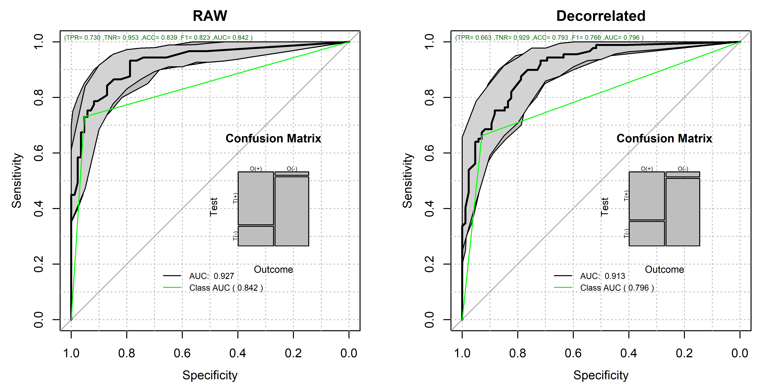

par(op)  
  
pander::pander(bpDecor$CM.analysis$tab)

|  | Outcome + | Outcome - | Total |
| --- | --- | --- | --- |
| **Test +** | 59 | 6 | 65 |
| **Test -** | 30 | 79 | 109 |
| **Total** | 89 | 85 | 174 |

pander::pander(bpDecor$accc)

| est | lower | upper |
| --- | --- | --- |
| 0.793 | 0.725 | 0.851 |

pander::pander(bpDecor$aucs)

| est | lower | upper |
| --- | --- | --- |
| 0.913 | 0.872 | 0.953 |

pander::pander(bpDecor$berror)

| 50% | 2.5% | 97.5% |
| --- | --- | --- |
| 0.203 | 0.153 | 0.259 |

### Here we compute the probability that the outcome-driven decorrelation ROC is superior to the RAW ROC.   
pander::pander(roc.test(bpDecor$ROC.analysis$roc.predictor,bpraw$ROC.analysis$roc.predictor,alternative = "greater"))

DeLong’s test for two correlated ROC curves: bpDecor$ROC.analysis$roc.predictor and bpraw$ROC.analysis$roc.predictor

| Test statistic | P value | Alternative hypothesis | AUC of roc1 | AUC of roc2 |
| --- | --- | --- | --- | --- |
| -1.4 | 0.92 | greater | 0.913 | 0.927 |

## Feature Frequency Plots

par(mfrow=c(2,1),cex=0.9,cex.axis=0.8)  
  
rawtopf <- cvRaw$featureFrequency/repetitions  
crawtopf <- rawtopf  
  
if (length(rawtopf) > 30)  
{  
 rawtopf <- rawtopf[1:30]  
}  
barplot(100*rawtopf,las=2,main="Raw Features",ylim=c(0,100.0),cex.names = 0.35,cex.axis = 0.35,ylab="Sel. %")  
  
detopf <- cvDe$featureFrequency/repetitions  
cdetopf <- detopf  
names(cdetopf) <- str_remove_all(names(cdetopf),"Ba_")  
names(cdetopf) <- str_remove_all(names(cdetopf),"La_")  
if (length(detopf) > 30)  
{  
 detopf <- detopf[1:30]  
}  
  
barplot(100*detopf,las=2,main="Decorrelated Features",ylim=c(0,100.0),cex.names = 0.35,cex.axis = 0.35,ylab="Sel. %")

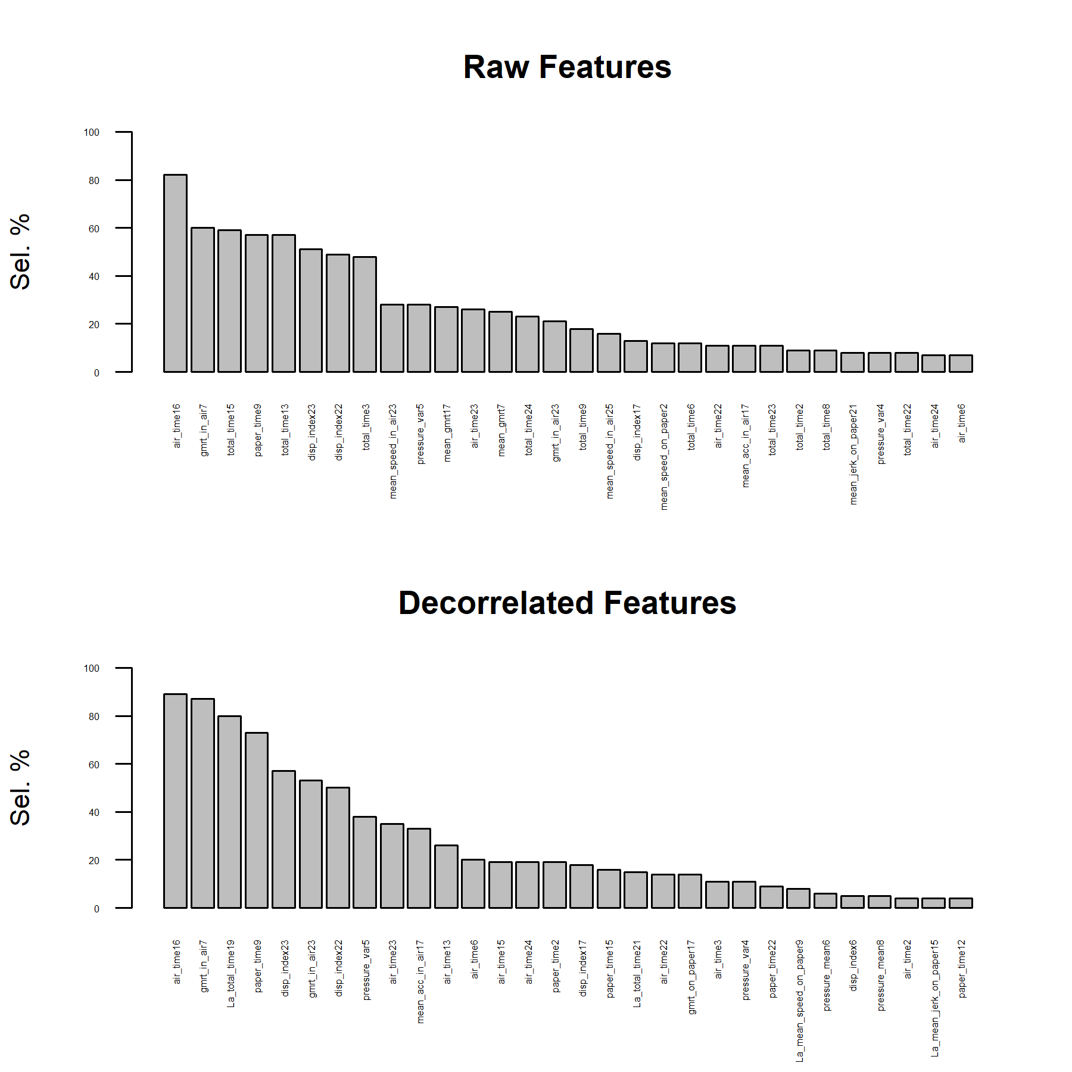

par(op)

### Final Table

unlistdecorr <- selectedlist  
names(unlistdecorr) <- NULL  
unlistdecorr <- unique(names(unlist(unlistdecorr)))  
  
finalTableDe <- univarDe$orderframe[deNames_in_dc,univariate_columns]  
  
finalTableOr <- univar$orderframe[unique(c(topfiveOrg,unlistdecorr,names(crawtopf)[1:2],names(cdetopf)[1:2])),univariate_columns]  
  
finalTable <- rbind(finalTableOr,finalTableDe)  
  
deFromula <- character(length(theDeFormulas))  
names(deFromula) <- names(theDeFormulas)  
  
for (dx in names(deFromula))  
{  
 coef <- theDeFormulas[[dx]]  
 cname <- names(theDeFormulas[[dx]])  
 names(cname) <- cname  
 for (cf in names(coef))  
 {  
 if (cf != dx)  
 {  
 if (coef[cf]>0)  
 {  
 deFromula[dx] <- paste(deFromula[dx],  
 sprintf("+ %5.3f*%s",coef[cf],cname[cf]))  
 }  
 else  
 {  
 deFromula[dx] <- paste(deFromula[dx],  
 sprintf("%5.3f*%s",coef[cf],cname[cf]))  
 }  
 }  
 }  
}  
orgnamez <- rownames(finalTable)  
orgnamez <- str_remove_all(orgnamez,"Ba_")  
orgnamez <- str_remove_all(orgnamez,"La_")  
finalTable$uAUC <- univar$orderframe[orgnamez,"ROCAUC"]  
finalTable$raw_Freq <- crawtopf[orgnamez]  
finalTable$La_Freq <- cdetopf[orgnamez]  
finalTable$DecorFormula <- deFromula[rownames(finalTable)]  
fscores <- attr(DEdataframe,"fscore")  
finalTable$fscores <- fscores[rownames(finalTable)]  
  
finalTable <- finalTable[order(-finalTable$ROCAUC),]  
  
pander::pander(finalTable)

|  | caseMean | caseStd | controlMean | controlStd | controlKSP | ROCAUC | WilcoxRes.p | FRes.p | uAUC | raw_Freq | La_Freq | DecorFormula | fscores |
| --- | --- | --- | --- | --- | --- | --- | --- | --- | --- | --- | --- | --- | --- |
| **total_time23** | 1.70e+04 | 1.10e+04 | 1.18e+04 | 3.15e+04 | 4.26e-13 | 0.863 | 1.40e-13 | 9.35e-05 | 0.863 | 0.11 | NA | NA | NA |
| **total_time15** | 5.34e+04 | 6.17e+04 | 1.48e+04 | 6.66e+03 | 1.42e-02 | 0.844 | 1.03e-15 | 0.00e+00 | 0.844 | 0.59 | NA | NA | NA |
| **air_time23** | 9.79e+03 | 7.42e+03 | 7.38e+03 | 3.14e+04 | 5.73e-14 | 0.844 | 8.06e-11 | 1.57e-01 | 0.844 | 0.26 | 0.35 | NA | 11 |
| **air_time15** | 4.38e+04 | 5.81e+04 | 9.39e+03 | 5.46e+03 | 3.71e-02 | 0.829 | 4.82e-15 | 0.00e+00 | 0.829 | NA | 0.19 | NA | 26 |
| **total_time17** | 7.44e+04 | 1.03e+05 | 3.50e+04 | 4.42e+04 | 1.39e-09 | 0.824 | 3.94e-12 | 6.39e-10 | 0.824 | 0.01 | NA | NA | NA |
| **air_time16** | 1.03e+04 | 1.02e+04 | 2.91e+03 | 2.77e+03 | 2.89e-03 | 0.787 | 4.38e-12 | 5.01e-14 | 0.787 | 0.82 | 0.89 | NA | 2 |
| **total_time7** | 1.78e+04 | 1.52e+04 | 1.77e+04 | 5.43e+04 | 1.78e-15 | 0.785 | 6.24e-07 | 4.90e-01 | 0.785 | NA | NA | NA | NA |
| **air_time7** | 1.22e+04 | 1.14e+04 | 1.49e+04 | 5.40e+04 | 5.55e-16 | 0.779 | 1.00e+00 | 3.26e-01 | 0.779 | NA | NA | NA | 11 |
| **total_time8** | 1.27e+04 | 1.34e+04 | 4.97e+03 | 3.15e+03 | 6.98e-03 | 0.776 | 1.06e-10 | 5.11e-12 | 0.776 | 0.09 | NA | NA | NA |
| **gmrt_in_air7** | 2.21e+02 | 9.09e+01 | 3.39e+02 | 1.33e+02 | 5.14e-01 | 0.775 | 2.21e-10 | 1.53e-11 | 0.775 | 0.60 | 0.87 | NA | 1 |
| **total_time9** | 1.68e+04 | 1.45e+04 | 6.72e+03 | 3.40e+03 | 2.69e-01 | 0.774 | 5.06e-12 | 1.23e-13 | 0.774 | 0.18 | 0.03 | NA | NA |
| **paper_time9** | 8.89e+03 | 5.33e+03 | 4.83e+03 | 2.14e+03 | 8.65e-02 | 0.774 | 1.00e-10 | 4.73e-12 | 0.774 | 0.57 | 0.73 | NA | 29 |
| **mean_gmrt7** | 2.53e+02 | 1.20e+02 | 3.76e+02 | 1.20e+02 | 7.55e-01 | 0.773 | 4.52e-10 | 9.44e-11 | 0.773 | 0.25 | NA | NA | NA |
| **La_total_time9** | 5.78e-12 | 5.13e-12 | 2.47e-12 | 1.18e-12 | 1.88e-06 | 0.764 | 7.38e-11 | 5.79e-13 | 0.774 | 0.18 | 0.03 | -1.000*air_time9 -1.000*paper_time9 + 1.000*total_time9 | -59 |
| **La_total_time7** | 3.96e-12 | 3.25e-12 | 3.70e-12 | 1.05e-11 | 1.11e-16 | 0.749 | 2.89e-06 | 4.05e-01 | 0.785 | NA | NA | -1.000*air_time7 -1.000*paper_time7 + 1.000*total_time7 | -21 |
| **paper_time7** | 5.64e+03 | 4.83e+03 | 2.72e+03 | 1.07e+03 | 7.26e-02 | 0.746 | 3.51e-09 | 1.68e-10 | 0.746 | 0.01 | NA | NA | NA |
| **air_time5** | 5.98e+03 | 9.38e+03 | 1.49e+03 | 2.17e+03 | 3.55e-09 | 0.744 | 2.23e-08 | 8.01e-09 | 0.744 | NA | NA | NA | 28 |
| **La_mean_speed_on_paper13** | -1.03e-01 | 1.67e-01 | 5.98e-04 | 3.03e-01 | 7.19e-05 | 0.739 | 2.39e-08 | 9.79e-06 | 0.626 | NA | 0.03 | -0.021*gmrt_on_paper13 + 1.000*mean_speed_on_paper13 | -1 |
| **gmrt_on_paper7** | 2.86e+02 | 1.71e+02 | 4.13e+02 | 1.46e+02 | 7.51e-01 | 0.738 | 4.66e-08 | 5.63e-08 | 0.738 | NA | 0.02 | NA | 2 |
| **mean_gmrt8** | 1.86e+02 | 1.27e+02 | 2.83e+02 | 2.15e+02 | 2.25e-02 | 0.725 | 8.88e-07 | 5.59e-06 | 0.725 | 0.01 | NA | NA | NA |
| **La_total_time5** | 7.00e-12 | 7.86e-12 | 3.03e-12 | 2.41e-12 | 8.72e-08 | 0.720 | 7.76e-08 | 1.13e-08 | 0.674 | NA | NA | -1.000*air_time5 -1.000*paper_time5 + 1.000*total_time5 | -57 |
| **mean_speed_on_paper2** | 1.35e+00 | 6.47e-01 | 1.96e+00 | 9.38e-01 | 1.63e-01 | 0.720 | 7.59e-07 | 3.39e-07 | 0.720 | 0.12 | NA | NA | NA |
| **gmrt_on_paper8** | 1.38e+02 | 9.79e+01 | 1.98e+02 | 9.36e+01 | 2.04e-01 | 0.716 | 6.00e-07 | 4.46e-06 | 0.716 | NA | 0.03 | NA | 13 |
| **paper_time3** | 8.64e+03 | 4.81e+03 | 5.68e+03 | 2.63e+03 | 4.72e-01 | 0.715 | 2.65e-07 | 9.87e-08 | 0.715 | NA | NA | NA | NA |
| **La_mean_speed_on_paper2** | 1.03e-01 | 3.03e-01 | 2.71e-01 | 4.31e-01 | 2.26e-05 | 0.714 | 1.44e-06 | 2.00e-04 | 0.720 | 0.12 | NA | -0.016*gmrt_on_paper2 + 1.000*mean_speed_on_paper2 | -1 |
| **mean_gmrt23** | 1.67e+02 | 6.03e+01 | 2.11e+02 | 5.26e+01 | 6.10e-01 | 0.711 | 7.47e-07 | 3.63e-07 | 0.711 | NA | NA | NA | NA |
| **air_time8** | 6.09e+03 | 9.41e+03 | 1.77e+03 | 2.34e+03 | 1.31e-05 | 0.710 | 3.46e-07 | 1.12e-07 | 0.710 | NA | NA | NA | 1 |
| **La_mean_speed_on_paper9** | -1.52e-01 | 3.35e-01 | 3.71e-02 | 8.29e-02 | 5.69e-02 | 0.710 | 2.53e-07 | 1.88e-08 | 0.703 | NA | 0.08 | -0.020*gmrt_on_paper9 + 1.000*mean_speed_on_paper9 | -1 |
| **mean_speed_on_paper3** | 1.99e+00 | 1.04e+00 | 2.74e+00 | 1.24e+00 | 3.62e-01 | 0.709 | 2.24e-06 | 5.39e-06 | 0.709 | NA | 0.02 | NA | NA |
| **paper_time16** | 4.21e+03 | 3.21e+03 | 2.90e+03 | 2.33e+03 | 4.33e-06 | 0.707 | 8.11e-06 | 2.84e-04 | 0.707 | NA | NA | NA | NA |
| **La_mean_speed_on_paper3** | -2.62e-02 | 5.38e-01 | 2.76e-01 | 4.57e-01 | 5.50e-05 | 0.706 | 3.06e-06 | 1.48e-05 | 0.709 | NA | 0.02 | -0.017*gmrt_on_paper3 + 1.000*mean_speed_on_paper3 | -1 |
| **La_mean_speed_on_paper5** | -1.73e-03 | 1.49e-01 | 4.90e-02 | 5.20e-02 | 1.57e-04 | 0.706 | 6.43e-07 | 3.78e-05 | 0.635 | NA | 0.01 | -0.019*gmrt_on_paper5 + 1.000*mean_speed_on_paper5 | -1 |
| **mean_speed_on_paper15** | 2.20e+00 | 1.26e+00 | 3.05e+00 | 1.26e+00 | 4.61e-01 | 0.705 | 2.51e-06 | 2.53e-06 | 0.705 | NA | NA | NA | NA |
| **mean_speed_on_paper9** | 2.49e+00 | 2.06e+00 | 3.28e+00 | 1.45e+00 | 6.11e-01 | 0.703 | 4.12e-06 | 2.61e-04 | 0.703 | NA | 0.08 | NA | NA |
| **La_mean_gmrt23** | 2.82e+01 | 2.28e+01 | 4.21e+01 | 2.28e+01 | 6.35e-01 | 0.700 | 3.66e-06 | 1.76e-05 | 0.711 | NA | NA | -0.749*gmrt_on_paper23 + 1.000*mean_gmrt23 | -1 |
| **air_time9** | 7.89e+03 | 1.12e+04 | 1.88e+03 | 1.97e+03 | 2.96e-03 | 0.699 | 4.74e-08 | 2.32e-09 | 0.699 | NA | NA | NA | 31 |
| **La_mean_speed_on_paper12** | -8.58e-02 | 1.99e-01 | 3.05e-02 | 2.32e-01 | 8.71e-03 | 0.697 | 3.56e-06 | 1.23e-05 | 0.658 | NA | NA | -0.021*gmrt_on_paper12 + 1.000*mean_speed_on_paper12 | -1 |
| **mean_gmrt11** | 1.66e+02 | 7.84e+01 | 2.11e+02 | 7.21e+01 | 4.08e-01 | 0.691 | 1.00e-05 | 2.15e-05 | 0.691 | 0.01 | NA | NA | NA |
| **La_mean_speed_on_paper16** | 6.80e-02 | 5.18e-01 | 3.16e-01 | 4.52e-01 | 1.20e-02 | 0.690 | 8.74e-06 | 7.97e-05 | 0.686 | 0.01 | NA | -0.016*gmrt_on_paper16 + 1.000*mean_speed_on_paper16 | -1 |
| **disp_index16** | 5.30e-06 | 2.95e-06 | 4.78e-06 | 3.53e-06 | 1.18e-07 | 0.687 | 1.14e-04 | 1.21e-01 | 0.687 | NA | NA | NA | 3 |
| **mean_speed_on_paper16** | 2.06e+00 | 1.14e+00 | 2.82e+00 | 1.29e+00 | 3.31e-01 | 0.686 | 1.29e-05 | 1.20e-05 | 0.686 | 0.01 | NA | NA | NA |
| **La_total_time21** | 3.94e+02 | 1.22e+04 | -6.92e+03 | 6.10e+03 | 2.84e-01 | 0.679 | 3.36e-06 | 5.36e-07 | 0.629 | NA | 0.15 | -1.393*paper_time21 + 1.000*total_time21 | -1 |
| **La_max_x_extension16** | -1.57e+03 | 7.01e+02 | -1.23e+03 | 6.40e+02 | 3.66e-02 | 0.678 | 2.51e-05 | 2.89e-04 | 0.606 | NA | NA | -497092323.214*disp_index16 + 1.000*max_x_extension16 | -1 |
| **gmrt_in_air8** | 2.33e+02 | 1.90e+02 | 3.69e+02 | 3.86e+02 | 1.68e-03 | 0.677 | 3.99e-05 | 2.47e-04 | 0.677 | NA | NA | NA | 13 |
| **La_mean_speed_on_paper15** | -1.05e-01 | 4.58e-01 | 8.06e-02 | 2.82e-01 | 3.53e-01 | 0.677 | 3.20e-05 | 2.27e-04 | 0.705 | NA | NA | -0.017*gmrt_on_paper15 + 1.000*mean_speed_on_paper15 | -1 |
| **gmrt_on_paper9** | 1.31e+02 | 1.03e+02 | 1.60e+02 | 6.98e+01 | 6.29e-01 | 0.675 | 6.27e-05 | 5.27e-03 | 0.675 | NA | NA | NA | 14 |
| **total_time5** | 2.48e+04 | 1.78e+04 | 1.60e+04 | 7.42e+03 | 2.11e-02 | 0.674 | 5.80e-06 | 2.31e-06 | 0.674 | NA | NA | NA | NA |
| **La_total_time1** | 5.59e+03 | 4.03e+03 | 3.61e+03 | 2.84e+03 | 9.60e-04 | 0.672 | 3.41e-05 | 2.32e-05 | 0.656 | NA | NA | -1.207*air_time1 + 1.000*total_time1 | -1 |
| **gmrt_on_paper15** | 1.33e+02 | 7.13e+01 | 1.72e+02 | 7.08e+01 | 5.43e-01 | 0.670 | 9.41e-05 | 1.34e-04 | 0.670 | NA | NA | NA | 12 |
| **gmrt_on_paper23** | 1.86e+02 | 8.14e+01 | 2.26e+02 | 6.03e+01 | 3.34e-01 | 0.670 | 1.19e-04 | 1.34e-04 | 0.670 | NA | NA | NA | 2 |
| **disp_index3** | 1.06e-05 | 3.16e-06 | 8.96e-06 | 3.28e-06 | 4.94e-01 | 0.669 | 6.88e-05 | 1.81e-04 | 0.669 | NA | 0.01 | NA | 2 |
| **mean_jerk_on_paper15** | 1.72e-02 | 3.75e-03 | 1.92e-02 | 3.57e-03 | 8.68e-01 | 0.667 | 5.65e-05 | 1.19e-04 | 0.667 | NA | 0.04 | NA | NA |
| **La_mean_jerk_on_paper15** | 3.22e-03 | 1.76e-03 | 4.24e-03 | 1.59e-03 | 9.49e-01 | 0.664 | 1.05e-04 | 4.16e-05 | 0.667 | NA | 0.04 | -0.098*mean_acc_on_paper15 + 1.000*mean_jerk_on_paper15 | -1 |
| **gmrt_on_paper2** | 7.84e+01 | 3.74e+01 | 1.06e+02 | 5.45e+01 | 1.68e-01 | 0.663 | 1.35e-04 | 5.35e-05 | 0.663 | NA | 0.02 | NA | 6 |
| **La_mean_gmrt11** | 5.49e+01 | 3.68e+01 | 7.65e+01 | 3.71e+01 | 6.73e-01 | 0.663 | 1.32e-04 | 6.76e-05 | 0.691 | 0.01 | NA | -0.716*gmrt_in_air11 + 1.000*mean_gmrt11 | -1 |
| **La_paper_time16** | 4.39e+02 | 2.11e+03 | -4.98e+02 | 9.82e+02 | 2.88e-03 | 0.663 | 5.19e-05 | 1.74e-05 | 0.707 | NA | NA | -712146289.713*disp_index16 + 1.000*paper_time16 | 0 |
| **mean_jerk_on_paper24** | 1.52e-02 | 2.97e-03 | 1.68e-02 | 2.71e-03 | 1.49e-01 | 0.662 | 1.34e-04 | 9.36e-05 | 0.662 | 0.03 | 0.01 | NA | NA |
| **La_mean_gmrt8** | 8.14e-08 | 6.01e-08 | 1.18e-07 | 7.59e-08 | 5.61e-01 | 0.662 | 8.55e-05 | 1.83e-04 | 0.725 | 0.01 | NA | -0.500*gmrt_in_air8 -0.500*gmrt_on_paper8 + 1.000*mean_gmrt8 | -25 |
| **La_mean_jerk_on_paper24** | 3.03e-03 | 1.19e-03 | 3.80e-03 | 1.34e-03 | 9.90e-02 | 0.662 | 1.08e-04 | 2.50e-05 | 0.662 | 0.03 | 0.01 | -0.099*mean_acc_on_paper24 + 1.000*mean_jerk_on_paper24 | -1 |
| **gmrt_in_air11** | 1.55e+02 | 9.80e+01 | 1.88e+02 | 9.07e+01 | 6.16e-02 | 0.659 | 4.78e-04 | 6.14e-03 | 0.659 | NA | NA | NA | 2 |
| **mean_speed_on_paper12** | 2.47e+00 | 1.60e+00 | 3.14e+00 | 1.49e+00 | 4.75e-01 | 0.658 | 3.59e-04 | 1.42e-03 | 0.658 | NA | NA | NA | NA |
| **total_time1** | 1.34e+04 | 1.84e+04 | 9.39e+03 | 1.21e+04 | 1.47e-07 | 0.656 | 8.08e-04 | 2.11e-02 | 0.656 | NA | NA | NA | NA |
| **La_total_time19** | 2.29e-12 | 3.40e-12 | 1.71e-13 | 9.57e-13 | 0.00e+00 | 0.643 | 7.52e-06 | 8.87e-08 | 0.596 | NA | 0.80 | -1.000*air_time19 -1.000*paper_time19 + 1.000*total_time19 | -32 |
| **La_paper_time3** | -2.60e+03 | 2.75e+03 | -3.80e+03 | 1.28e+03 | 3.97e-01 | 0.642 | 4.22e-04 | 8.11e-05 | 0.715 | NA | NA | -1058753997.512*disp_index3 + 1.000*paper_time3 | -1 |
| **gmrt_on_paper3** | 1.20e+02 | 5.97e+01 | 1.46e+02 | 6.56e+01 | 7.70e-01 | 0.642 | 7.72e-04 | 2.35e-03 | 0.642 | NA | NA | NA | 7 |
| **La_mean_jerk_on_paper19** | 4.06e-03 | 1.28e-03 | 4.72e-03 | 9.55e-04 | 5.04e-01 | 0.642 | 6.88e-04 | 6.96e-05 | 0.594 | NA | NA | -0.101*mean_acc_on_paper19 + 1.000*mean_jerk_on_paper19 | -1 |
| **gmrt_on_paper12** | 1.23e+02 | 7.79e+01 | 1.50e+02 | 7.06e+01 | 2.72e-01 | 0.640 | 1.77e-03 | 7.10e-03 | 0.640 | NA | NA | NA | 10 |
| **La_mean_gmrt7** | 4.59e+01 | 3.65e+01 | 7.62e+01 | 5.88e+01 | 3.08e-02 | 0.639 | 2.75e-04 | 3.38e-05 | 0.773 | 0.25 | NA | -0.726*gmrt_on_paper7 + 1.000*mean_gmrt7 | -1 |
| **mean_speed_on_paper5** | 1.35e+00 | 8.99e-01 | 1.59e+00 | 7.25e-01 | 9.72e-03 | 0.635 | 4.75e-03 | 1.90e-02 | 0.635 | NA | 0.01 | NA | NA |
| **air_time1** | 6.51e+03 | 1.34e+04 | 4.78e+03 | 1.19e+04 | 2.95e-09 | 0.633 | 2.41e-02 | 1.70e-01 | 0.633 | NA | NA | NA | 1 |
| **gmrt_on_paper16** | 1.22e+02 | 6.44e+01 | 1.53e+02 | 7.45e+01 | 8.97e-02 | 0.632 | 1.15e-03 | 1.36e-03 | 0.632 | NA | NA | NA | 10 |
| **total_time21** | 5.57e+04 | 3.51e+04 | 4.14e+04 | 2.06e+04 | 1.85e-01 | 0.629 | 2.02e-03 | 4.82e-04 | 0.629 | NA | 0.15 | NA | NA |
| **paper_time5** | 1.88e+04 | 1.10e+04 | 1.45e+04 | 6.07e+03 | 2.09e-01 | 0.629 | 6.30e-04 | 6.89e-04 | 0.629 | NA | NA | NA | 29 |
| **La_total_time8** | 4.42e+03 | 5.05e+03 | 2.57e+03 | 1.52e+03 | 1.42e-01 | 0.627 | 5.10e-04 | 3.41e-04 | 0.776 | 0.09 | NA | -1.357*air_time8 + 1.000*total_time8 | -1 |
| **mean_speed_on_paper13** | 2.52e+00 | 1.30e+00 | 3.08e+00 | 1.35e+00 | 4.51e-01 | 0.626 | 3.23e-03 | 3.00e-03 | 0.626 | NA | 0.03 | NA | NA |
| **gmrt_on_paper5** | 7.01e+01 | 4.65e+01 | 7.97e+01 | 3.68e+01 | 7.36e-03 | 0.620 | 1.48e-02 | 5.21e-02 | 0.620 | NA | NA | NA | 9 |
| **max_x_extension16** | 1.06e+03 | 1.32e+03 | 1.14e+03 | 2.13e+03 | 1.03e-14 | 0.606 | 9.42e-01 | 3.86e-01 | 0.606 | NA | NA | NA | NA |
| **gmrt_on_paper13** | 1.25e+02 | 6.28e+01 | 1.47e+02 | 6.28e+01 | 3.73e-01 | 0.606 | 1.14e-02 | 1.17e-02 | 0.606 | NA | NA | NA | 13 |
| **mean_acc_on_paper15** | 1.42e-01 | 3.43e-02 | 1.53e-01 | 3.39e-02 | 3.23e-01 | 0.597 | 9.76e-03 | 1.93e-02 | 0.597 | NA | NA | NA | 1 |
| **total_time19** | 9.86e+04 | 7.37e+04 | 1.04e+06 | 2.83e+06 | 0.00e+00 | 0.596 | 4.03e-01 | 1.31e-03 | 0.596 | NA | 0.80 | NA | NA |
| **mean_jerk_on_paper19** | 1.94e-02 | 2.17e-03 | 2.01e-02 | 2.32e-03 | 9.20e-01 | 0.594 | 7.36e-03 | 1.44e-02 | 0.594 | NA | NA | NA | NA |
| **paper_time19** | 2.55e+04 | 9.80e+03 | 2.41e+04 | 6.82e+03 | 5.17e-02 | 0.589 | 3.22e-02 | 1.48e-01 | 0.589 | NA | NA | NA | 16 |
| **mean_acc_on_paper24** | 1.23e-01 | 2.98e-02 | 1.30e-01 | 2.17e-02 | 1.75e-01 | 0.583 | 3.30e-02 | 2.32e-02 | 0.583 | NA | NA | NA | 1 |
| **air_time19** | 7.31e+04 | 7.03e+04 | 1.02e+06 | 2.82e+06 | 0.00e+00 | 0.581 | 3.35e-01 | 1.24e-03 | 0.581 | NA | NA | NA | 16 |
| **mean_acc_on_paper19** | 1.52e-01 | 1.83e-02 | 1.53e-01 | 2.03e-02 | 9.09e-01 | 0.516 | 3.49e-01 | 3.94e-01 | 0.516 | NA | NA | NA | 1 |
| **paper_time21** | 3.97e+04 | 2.31e+04 | 3.47e+04 | 1.60e+04 | 3.32e-01 | 0.458 | 1.79e-01 | 5.04e-02 | 0.458 | NA | NA | NA | 1 |