Univariate: Parkinson

Jose Tamez

2023-01-27

Table of Contents

# PARKINSON Univariate

### Loading the libraries

library("FRESA.CAD")  
library(readxl)  
op <- par(no.readonly = TRUE)  
pander::panderOptions('digits', 3)  
pander::panderOptions('table.split.table', 400)  
pander::panderOptions('keep.trailing.zeros',TRUE)

## The Data

pd_speech_features <- as.data.frame(read_excel("~/GitHub/FCA/Data/pd_speech_features.xlsx",sheet = "pd_speech_features", range = "A2:ACB758"))

### The Average of the Three Repetitions

Each subject had three repeated observations. Here I’ll use the average of the three experiments per subject.

rep1Parkison <- subset(pd_speech_features,RID==1)  
rownames(rep1Parkison) <- rep1Parkison$id  
rep1Parkison$id <- NULL  
rep1Parkison$RID <- NULL  
rep1Parkison[,1:ncol(rep1Parkison)] <- sapply(rep1Parkison,as.numeric)  
  
rep2Parkison <- subset(pd_speech_features,RID==2)  
rownames(rep2Parkison) <- rep2Parkison$id  
rep2Parkison$id <- NULL  
rep2Parkison$RID <- NULL  
rep2Parkison[,1:ncol(rep2Parkison)] <- sapply(rep2Parkison,as.numeric)  
  
rep3Parkison <- subset(pd_speech_features,RID==3)  
rownames(rep3Parkison) <- rep3Parkison$id  
rep3Parkison$id <- NULL  
rep3Parkison$RID <- NULL  
rep3Parkison[,1:ncol(rep3Parkison)] <- sapply(rep3Parkison,as.numeric)  
  
whof <- !(colnames(rep1Parkison) %in% c("gender","class"));  
avgParkison <- rep1Parkison;  
avgParkison[,whof] <- (rep1Parkison[,whof] + rep2Parkison[,whof] + rep3Parkison[,whof])/3  
  
pander::pander(table(avgParkison$class))

| 0 | 1 |
| --- | --- |
| 64 | 188 |

#### Standarize the names for the reporting

dataframe <- avgParkison  
outcome <- "class"

pander::pander(c(rows=nrow(dataframe),col=ncol(dataframe)-1))

| rows | col |
| --- | --- |
| 252 | 753 |

pander::pander(table(dataframe[,outcome]))

| 0 | 1 |
| --- | --- |
| 64 | 188 |

varlist <- colnames(dataframe)  
varlist <- varlist[varlist != outcome]  
varlist <- as.data.frame(cbind(name=varlist,desc=varlist))

## Univariate

univariate_columns <- c("caseMean","caseStd","controlMean","controlStd","controlKSP","ROCAUC","WilcoxRes.p","FRes.p")  
univar <- uniRankVar(varlist,  
 paste(outcome,"~1"),  
 outcome,  
 dataframe,  
 categorizationType = "Raw",  
 type = "LOGIT",  
 rankingTest = "AUC",  
 cateGroups = c(0.1, 0.9),  
 raw.dataFrame = NULL,  
 description = ".",  
 uniType = "Binary")

100 : std_MFCC_1st_coef 200 : app_entropy_shannon_10_coef 300 : app_LT_entropy_log_9_coef 400 : tqwt_entropy_log_dec_7 500 : tqwt_TKEO_std_dec_35  
600 : tqwt_stdValue_dec_27 700 : tqwt_skewnessValue_dec_19

pander::pander(univar$orderframe[1:20,univariate_columns])

|  | caseMean | caseStd | controlMean | controlStd | controlKSP | ROCAUC | WilcoxRes.p | FRes.p |
| --- | --- | --- | --- | --- | --- | --- | --- | --- |
| **std_delta_delta_log_energy** | 1.56e-02 | 8.19e-03 | 8.83e-03 | 4.35e-03 | 0.151717 | 0.798 | 2.91e-11 | 4.44e-16 |
| **std_delta_log_energy** | 4.20e-02 | 2.76e-02 | 2.43e-02 | 1.23e-02 | 0.172528 | 0.794 | 5.93e-11 | 2.89e-15 |
| **std_9th_delta_delta** | 1.89e-02 | 4.69e-03 | 1.46e-02 | 2.48e-03 | 0.448029 | 0.787 | 1.72e-10 | 1.26e-13 |
| **std_8th_delta_delta** | 1.94e-02 | 4.73e-03 | 1.51e-02 | 2.23e-03 | 0.908376 | 0.780 | 1.39e-09 | 2.39e-12 |
| **std_7th_delta_delta** | 2.10e-02 | 5.62e-03 | 1.60e-02 | 2.94e-03 | 0.830363 | 0.776 | 4.53e-10 | 1.26e-12 |
| **tqwt_entropy_log_dec_12** | -1.68e+05 | 3.86e+04 | -1.32e+05 | 3.25e+04 | 0.361893 | 0.770 | 3.44e-11 | 3.09e-13 |
| **std_6th_delta_delta** | 2.25e-02 | 6.42e-03 | 1.71e-02 | 2.97e-03 | 0.549789 | 0.768 | 3.41e-09 | 1.09e-11 |
| **std_8th_delta** | 4.09e-02 | 1.02e-02 | 3.20e-02 | 5.14e-03 | 0.960141 | 0.767 | 1.08e-08 | 1.04e-11 |
| **std_9th_delta** | 3.94e-02 | 1.01e-02 | 3.08e-02 | 5.80e-03 | 0.117295 | 0.764 | 7.85e-09 | 9.93e-12 |
| **tqwt_entropy_shannon_dec_12** | 6.13e+01 | 1.43e+02 | 2.18e+02 | 2.52e+02 | 0.013604 | 0.763 | 7.98e-17 | 3.78e-11 |
| **tqwt_stdValue_dec_12** | 1.81e-02 | 2.10e-02 | 4.45e-02 | 3.45e-02 | 0.292343 | 0.763 | 9.69e-16 | 3.45e-13 |
| **std_7th_delta** | 4.41e-02 | 1.21e-02 | 3.41e-02 | 6.99e-03 | 0.748746 | 0.760 | 4.85e-09 | 1.88e-11 |
| **tqwt_TKEO_mean_dec_12** | 8.95e-04 | 3.49e-03 | 4.06e-03 | 5.98e-03 | 0.000563 | 0.760 | 1.56e-18 | 5.80e-10 |
| **std_10th_delta_delta** | 1.86e-02 | 4.91e-03 | 1.46e-02 | 2.62e-03 | 0.920800 | 0.759 | 6.88e-09 | 9.10e-11 |
| **tqwt_TKEO_std_dec_12** | 1.00e-03 | 2.51e-03 | 4.21e-03 | 5.24e-03 | 0.001059 | 0.759 | 1.00e-17 | 3.60e-12 |
| **tqwt_entropy_log_dec_13** | -1.14e+05 | 3.17e+04 | -8.82e+04 | 2.42e+04 | 0.265432 | 0.757 | 3.04e-09 | 8.77e-11 |
| **std_11th_delta_delta** | 1.73e-02 | 4.04e-03 | 1.40e-02 | 2.21e-03 | 0.963577 | 0.757 | 6.64e-09 | 2.24e-10 |
| **tqwt_stdValue_dec_13** | 4.35e-02 | 4.32e-02 | 8.75e-02 | 5.82e-02 | 0.650816 | 0.755 | 4.71e-13 | 1.61e-10 |
| **tqwt_entropy_log_dec_11** | -2.21e+05 | 4.22e+04 | -1.86e+05 | 3.69e+04 | 0.321073 | 0.754 | 9.01e-10 | 3.73e-11 |
| **tqwt_entropy_shannon_dec_13** | 1.86e+02 | 2.84e+02 | 4.74e+02 | 4.39e+02 | 0.140805 | 0.754 | 4.68e-14 | 2.16e-09 |

topfiveOrg <- rownames(univar$orderframe[1:5,])

## Decorrelation Analysis

DEdataframe <- GDSTMDecorrelation(dataframe,thr=0.80,verbose = TRUE)

Included: 717 , Uni p: 0.01155156 , Uncorrelated Base: 207 , Outcome-Driven Size: 0 , Base Size: 207

1 <R=1.000,w= 1,N= 291>, Top: 95( 3 )[1 : 95 : 0.975](94%20,%20178%20,%200),<|>Tot Used: 272 , Added: 178 , Zero Std: 0 , Max Cor: 1.000 2 <R=1.000,w= 1,N= 291>, Top: 15( 2 )[1 : 15 : 0.975](14%20,%2029%20,%2094),<|>Tot Used: 282 , Added: 29 , Zero Std: 0 , Max Cor: 0.975 3 <R=0.975,w= 2,N= 227>, Top: 85( 2 )[1 : 85 : 0.937](81%20,%20113%20,%20107),<|>Tot Used: 399 , Added: 113 , Zero Std: 0 , Max Cor: 0.991 4 <R=0.991,w= 2,N= 227>, Top: 9( 1 )[1 : 9 : 0.946](9%20,%2013%20,%20161),<|>Tot Used: 403 , Added: 13 , Zero Std: 0 , Max Cor: 0.941 5 <R=0.941,w= 3,N= 249>, Top: 82( 4 )[1 : 82 : 0.871](78%20,%20124%20,%20168),<|>Tot Used: 501 , Added: 124 , Zero Std: 0 , Max Cor: 0.990 6 <R=0.990,w= 3,N= 249>, Top: 12( 1 )[1 : 12 : 0.895](12%20,%2014%20,%20205),<|>Tot Used: 509 , Added: 14 , Zero Std: 0 , Max Cor: 0.894 7 <R=0.894,w= 4,N= 183>, Top: 66( 3 )[1 : 66 : 0.827](61%20,%2083%20,%20210),<|>Tot Used: 546 , Added: 83 , Zero Std: 0 , Max Cor: 0.942 8 <R=0.942,w= 4,N= 183>, Top: 12( 2 )[1 : 12 : 0.821](12%20,%2015%20,%20234),<|>Tot Used: 551 , Added: 15 , Zero Std: 0 , Max Cor: 0.826 9 <R=0.826,w= 5,N= 20>, Top: 9( 1 )[1 : 9 : 0.800](9%20,%2010%20,%20240),<|>Tot Used: 551 , Added: 10 , Zero Std: 0 , Max Cor: 0.945 10 <R=0.945,w= 5,N= 20>, Top: 1( 1 )[1 : 1 : 0.800](1%20,%201%20,%20243),<|>Tot Used: 551 , Added: 1 , Zero Std: 0 , Max Cor: 0.799 11 <R=0.000,w= 6,N= 0>-{ std_MFCC_4th_coef std_MFCC_6th_coef std_MFCC_8th_coef std_MFCC_10th_coef std_MFCC_12th_coef std_9th_delta Ed_1_coef det_entropy_shannon_2_coef det_entropy_log_5_coef det_LT_entropy_shannon_6_coef tqwt_energy_dec_7 tqwt_energy_dec_10 tqwt_energy_dec_33 tqwt_energy_dec_35 tqwt_entropy_shannon_dec_1 tqwt_entropy_shannon_dec_3 tqwt_entropy_shannon_dec_10 tqwt_entropy_shannon_dec_27 tqwt_entropy_shannon_dec_28 tqwt_entropy_shannon_dec_31 tqwt_entropy_log_dec_10 tqwt_entropy_log_dec_20 tqwt_entropy_log_dec_22 tqwt_TKEO_mean_dec_15 tqwt_TKEO_mean_dec_17 tqwt_TKEO_mean_dec_21 tqwt_TKEO_mean_dec_23 tqwt_TKEO_mean_dec_31 tqwt_TKEO_mean_dec_35 tqwt_TKEO_mean_dec_36 tqwt_TKEO_std_dec_19 tqwt_minValue_dec_1 tqwt_skewnessValue_dec_4 tqwt_skewnessValue_dec_34 tqwt_kurtosisValue_dec_34 }- [ 11 ], 0.799405 Decor Dimension: 551 . Cor to Base: 286 , ABase: 55 , Outcome Base: 0

pander::pander(c(Decorrleated_Fraction=sum(str_detect(colnames(DEdataframe),"La_"))/(ncol(DEdataframe)-1)))

| Decorrleated_Fraction |
| --- |
| 0.612 |

pander::pander(c(Base_Fraction=sum(str_detect(colnames(DEdataframe),"Ba_"))/(ncol(DEdataframe)-1)))

| Base_Fraction |
| --- |
| 0 |

demat <- attr(DEdataframe,"GDSTM")  
pander::pander(c(sparse_Fraction=1.0-sum(demat==0)/ncol(demat)/nrow(demat)))

| sparse_Fraction |
| --- |
| 0.00386 |

varlistDe <- colnames(DEdataframe)[colnames(DEdataframe) != "class"];  
varlistDe <- as.data.frame(cbind(name=varlistDe,desc=varlistDe))

### The heat maps.

par(cex=0.6,cex.main=0.85,cex.axis=0.7)  
cormat <- cor(dataframe[,rownames(demat)],method="spearman")  
cormat[is.na(cormat)] <- 0  
gplots::heatmap.2(abs(cormat),  
 trace = "none",  
# scale = "row",  
 mar = c(5,5),  
 col=rev(heat.colors(5)),  
 main = "Spearman Correlation Original",  
 cexRow = 0.35,  
 cexCol = 0.35,  
 key.title=NA,  
 key.xlab="Spearman Correlation",  
 xlab="Feature", ylab="Feature")

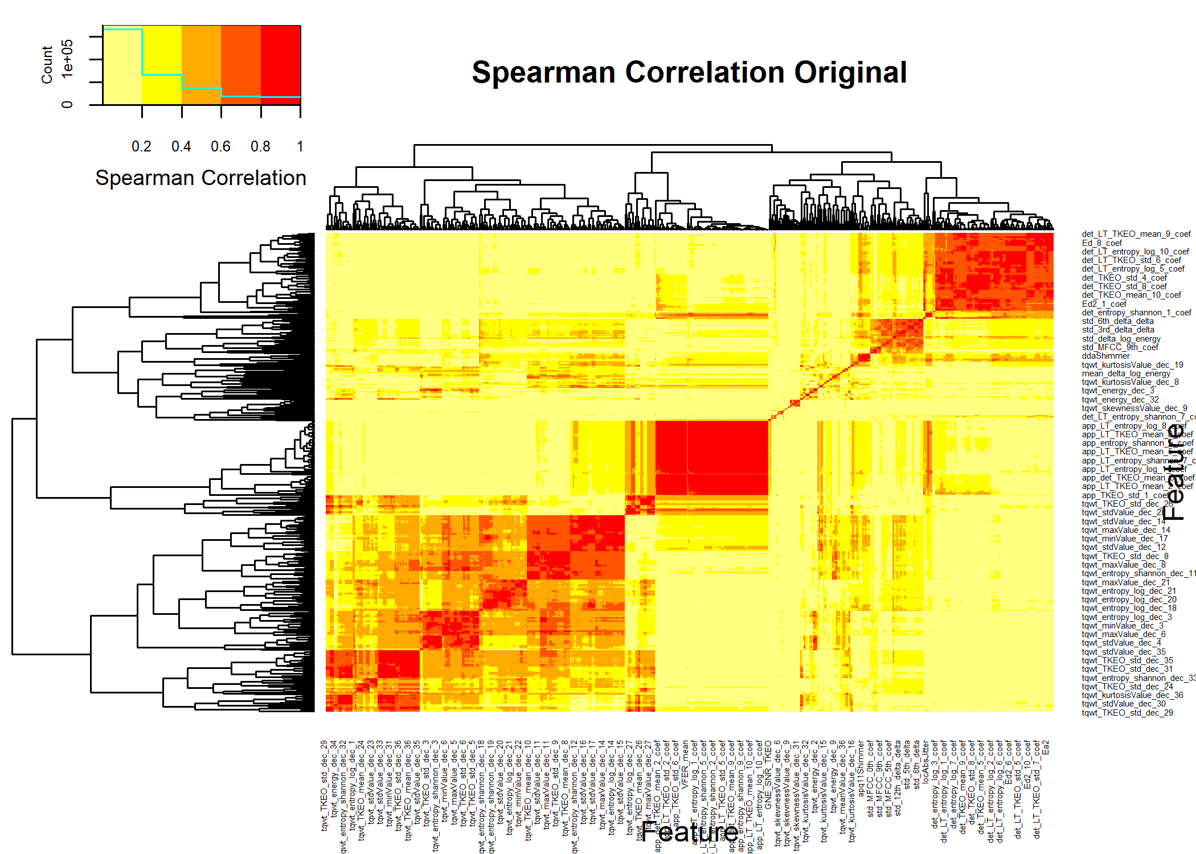

cormat <- cor(DEdataframe[,colnames(demat)],method="spearman")  
cormat[is.na(cormat)] <- 0  
gplots::heatmap.2(abs(cormat),  
 trace = "none",  
# scale = "none",  
 mar = c(5,5),  
 col=rev(heat.colors(5)),  
 main = "Spearman Correlation: After GDSTM",  
 cexRow = 0.35,  
 cexCol = 0.35,  
 key.title=NA,  
 key.xlab="Spearman Correlation",  
 xlab="Feature", ylab="Feature")

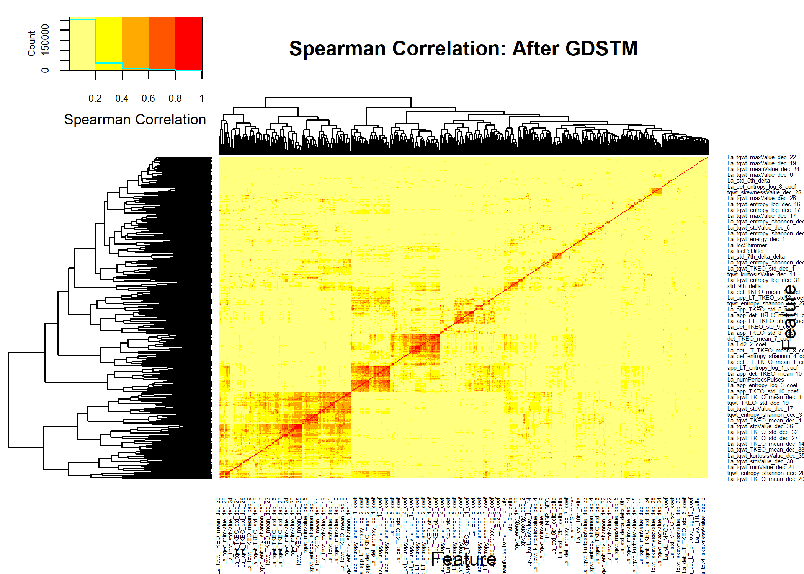

par(op)

## Univariate Decorrelated

univarDe <- uniRankVar(varlistDe,  
 paste(outcome,"~1"),  
 outcome,  
 DEdataframe,  
 categorizationType = "Raw",  
 type = "LOGIT",  
 rankingTest = "AUC",  
 cateGroups = c(0.1, 0.9),  
 raw.dataFrame = NULL,  
 description = ".",  
 uniType = "Binary")

100 : La_std_MFCC_1st_coef 200 : La_app_entropy_shannon_10_coef 300 : La_app_LT_entropy_log_9_coef 400 : La_tqwt_entropy_log_dec_7 500 : La_tqwt_TKEO_std_dec_35  
600 : La_tqwt_stdValue_dec_27 700 : tqwt_skewnessValue_dec_19

pander::pander(univarDe$orderframe[1:20,univariate_columns])

|  | caseMean | caseStd | controlMean | controlStd | controlKSP | ROCAUC | WilcoxRes.p | FRes.p |
| --- | --- | --- | --- | --- | --- | --- | --- | --- |
| **std_delta_log_energy** | 4.20e-02 | 2.76e-02 | 2.43e-02 | 1.23e-02 | 1.73e-01 | 0.794 | 5.93e-11 | 2.89e-15 |
| **La_tqwt_entropy_log_dec_33** | -2.53e+02 | 2.32e+02 | 6.61e+01 | 3.72e+02 | 5.55e-01 | 0.792 | 9.17e-16 | 0.00e+00 |
| **std_9th_delta** | 3.94e-02 | 1.01e-02 | 3.08e-02 | 5.80e-03 | 1.17e-01 | 0.764 | 7.85e-09 | 9.93e-12 |
| **mean_MFCC_2nd_coef** | 1.65e+00 | 1.37e+00 | 1.27e-01 | 1.71e+00 | 9.59e-01 | 0.753 | 5.17e-11 | 5.16e-14 |
| **La_tqwt_kurtosisValue_dec_33** | 2.42e+00 | 3.33e+00 | -3.33e-01 | 4.52e+00 | 9.49e-03 | 0.749 | 3.03e-10 | 1.10e-11 |
| **tqwt_minValue_dec_13** | -1.60e-01 | 1.26e-01 | -2.92e-01 | 1.68e-01 | 6.80e-01 | 0.746 | 1.11e-12 | 8.76e-11 |
| **La_std_delta_delta_log_energy** | 3.48e-03 | 3.09e-03 | 1.84e-03 | 1.64e-03 | 8.73e-02 | 0.744 | 1.99e-07 | 2.28e-06 |
| **La_apq11Shimmer** | 1.38e-02 | 1.45e-02 | 4.49e-03 | 9.78e-03 | 3.25e-02 | 0.731 | 4.41e-07 | 6.24e-08 |
| **tqwt_kurtosisValue_dec_20** | 2.55e+00 | 7.90e-01 | 2.09e+00 | 4.00e-01 | 2.44e-01 | 0.727 | 5.86e-07 | 6.25e-09 |
| **La_std_6th_delta** | 9.37e-03 | 7.37e-03 | 5.06e-03 | 3.64e-03 | 7.46e-01 | 0.726 | 2.39e-07 | 3.34e-05 |
| **tqwt_energy_dec_26** | 7.22e-02 | 8.33e-02 | 2.92e-02 | 5.56e-02 | 1.34e-05 | 0.726 | 9.12e-05 | 5.30e-06 |
| **tqwt_energy_dec_27** | 5.24e-02 | 9.45e-02 | 1.30e-02 | 3.57e-02 | 7.68e-08 | 0.725 | 3.58e-03 | 1.52e-04 |
| **La_tqwt_entropy_shannon_dec_33** | -5.89e-01 | 1.60e+00 | 6.74e-01 | 3.68e+00 | 3.36e-06 | 0.720 | 7.00e-07 | 4.49e-06 |
| **tqwt_energy_dec_12** | 3.68e-03 | 7.60e-03 | 1.27e-02 | 1.66e-02 | 2.80e-03 | 0.717 | 4.38e-15 | 2.09e-09 |
| **La_GNE_std** | -7.89e-02 | 6.02e-02 | -1.27e-01 | 6.85e-02 | 9.30e-01 | 0.714 | 6.01e-09 | 3.99e-09 |
| **tqwt_entropy_log_dec_10** | -2.63e+05 | 5.18e+04 | -2.29e+05 | 3.92e+04 | 2.37e-01 | 0.713 | 1.87e-06 | 2.15e-07 |
| **rapJitter** | 7.04e-04 | 9.87e-04 | 3.14e-04 | 3.46e-04 | 6.25e-03 | 0.711 | 4.60e-04 | 3.73e-06 |
| **DFA** | 7.13e-01 | 6.33e-02 | 6.64e-01 | 6.16e-02 | 8.65e-01 | 0.711 | 4.83e-07 | 3.82e-08 |
| **tqwt_entropy_shannon_dec_17** | 5.94e+02 | 4.67e+02 | 9.44e+02 | 4.14e+02 | 2.96e-01 | 0.709 | 6.78e-06 | 1.77e-07 |
| **tqwt_energy_dec_28** | 2.28e-02 | 5.50e-02 | 6.13e-03 | 2.34e-02 | 6.81e-11 | 0.709 | 3.51e-01 | 5.47e-03 |

### Comparing Decorrelation vs Original

pthr <- 0.20/(ncol(dataframe)-1)  
  
topDecorNames <- rownames(univarDe$orderframe[univarDe$orderframe$FRes.p<pthr,])  
topDecorNames <- unique(c(topDecorNames,rownames(univarDe$orderframe[1:5,])))  
  
#topDecorNames <- rownames(univarDe$orderframe[univarDe$orderframe$FRes.p<1.0e-5,])  
dc <- getLatentCoefficients(DEdataframe)  
### 2a Get only the ones that in the top features  
deNames_in_dc <- topDecorNames[topDecorNames %in% names(dc)]  
selectedlist <- dc[deNames_in_dc]  
theDeFormulas <- selectedlist  
  
rawuniv <- univariate_Wilcoxon(dataframe,outcome,limit=-1)  
deuniv <- univariate_Wilcoxon(DEdataframe,outcome,limit=-1)  
matsize <- (ncol(dataframe)-1)^2  
nocorrelated <- ncol(dataframe) - 1 - ncol(demat)  
pander::pander(c(sparse_Fraction=(sum(demat != 0) + nocorrelated)/matsize))

| sparse_Fraction |
| --- |
| 0.00243 |

pander::pander(c(raw=length(rawuniv),decor=length(deuniv)))

| raw | decor |
| --- | --- |
| 505 | 382 |

pander::pander(c(Number_Latent=length(dc)))

| Number_Latent |
| --- |
| 461 |

pander::pander(c(meanSize=mean(sapply(dc,length))))

| meanSize |
| --- |
| 2.35 |

## CV ROC Analysis

par(op)  
par(mfrow=c(1,2),cex=0.9)  
fraction <-0.70  
repetitions <- 100  
  
fcout <- round(fraction*nrow(dataframe)/15+1.0)  
pander::pander(c(NumberofFeatures=fcout))

| NumberofFeatures |
| --- |
| 13 |

cvRaw <- randomCV(dataframe,  
 outcome,  
 fittingFunction= filteredFit,  
 classSamplingType = "Pro",  
 trainFraction = fraction,  
 repetitions = repetitions,  
# fitmethod= glm,  
 fitmethod= KNN_method,  
 filtermethod=mRMR.classic_FRESA,  
 filtermethod.control=list(feature_count= fcout),  
# family="binomial"  
)

……….10 Tested: 245 Avg. Selected: 13 Min Tests: 1 Max Tests: 7 Mean Tests: 3.142857 . MAD: 0.2509653 ……….20 Tested: 252 Avg. Selected: 13 Min Tests: 2 Max Tests: 11 Mean Tests: 6.111111 . MAD: 0.2382728 ……….30 Tested: 252 Avg. Selected: 13 Min Tests: 3 Max Tests: 15 Mean Tests: 9.166667 . MAD: 0.239055 ……….40 Tested: 252 Avg. Selected: 13 Min Tests: 3 Max Tests: 21 Mean Tests: 12.22222 . MAD: 0.2425997 ……….50 Tested: 252 Avg. Selected: 13 Min Tests: 5 Max Tests: 25 Mean Tests: 15.27778 . MAD: 0.2425135 ……….60 Tested: 252 Avg. Selected: 13 Min Tests: 8 Max Tests: 29 Mean Tests: 18.33333 . MAD: 0.2400018 ……….70 Tested: 252 Avg. Selected: 13 Min Tests: 10 Max Tests: 31 Mean Tests: 21.38889 . MAD: 0.2391212 ……….80 Tested: 252 Avg. Selected: 13 Min Tests: 14 Max Tests: 35 Mean Tests: 24.44444 . MAD: 0.2390908 ……….90 Tested: 252 Avg. Selected: 13 Min Tests: 16 Max Tests: 40 Mean Tests: 27.5 . MAD: 0.2382716 ……….100 Tested: 252 Avg. Selected: 13 Min Tests: 20 Max Tests: 44 Mean Tests: 30.55556 . MAD: 0.2371827

bpraw <- predictionStats_binary(cvRaw$medianTest,"RAW",cex=0.75)

RAW

pander::pander(bpraw$CM.analysis$tab)

|  | Outcome + | Outcome - | Total |
| --- | --- | --- | --- |
| **Test +** | 182 | 37 | 219 |
| **Test -** | 6 | 27 | 33 |
| **Total** | 188 | 64 | 252 |

pander::pander(bpraw$accc)

| est | lower | upper |
| --- | --- | --- |
| 0.829 | 0.777 | 0.874 |

pander::pander(bpraw$aucs)

| est | lower | upper |
| --- | --- | --- |
| 0.836 | 0.779 | 0.894 |

pander::pander(bpraw$berror)

| 50% | 2.5% | 97.5% |
| --- | --- | --- |
| 0.306 | 0.243 | 0.369 |

cvDe <- randomCV(DEdataframe,  
 outcome,  
 fittingFunction= filteredFit,  
 trainSampleSets= cvRaw$trainSamplesSets,  
# fitmethod= glm,  
 fitmethod= KNN_method,  
 filtermethod=mRMR.classic_FRESA,  
 filtermethod.control=list(feature_count= fcout),  
# family="binomial"  
)

……….10 Tested: 245 Avg. Selected: 13 Min Tests: 1 Max Tests: 7 Mean Tests: 3.142857 . MAD: 0.2347805 ……….20 Tested: 252 Avg. Selected: 13 Min Tests: 2 Max Tests: 11 Mean Tests: 6.111111 . MAD: 0.2198956 ……….30 Tested: 252 Avg. Selected: 13 Min Tests: 3 Max Tests: 15 Mean Tests: 9.166667 . MAD: 0.2176886 ……….40 Tested: 252 Avg. Selected: 13 Min Tests: 3 Max Tests: 21 Mean Tests: 12.22222 . MAD: 0.2184067 ……….50 Tested: 252 Avg. Selected: 13 Min Tests: 5 Max Tests: 25 Mean Tests: 15.27778 . MAD: 0.2180351 ……….60 Tested: 252 Avg. Selected: 13 Min Tests: 8 Max Tests: 29 Mean Tests: 18.33333 . MAD: 0.217454 ……….70 Tested: 252 Avg. Selected: 13 Min Tests: 10 Max Tests: 31 Mean Tests: 21.38889 . MAD: 0.2168934 ……….80 Tested: 252 Avg. Selected: 13 Min Tests: 14 Max Tests: 35 Mean Tests: 24.44444 . MAD: 0.2169344 ……….90 Tested: 252 Avg. Selected: 13 Min Tests: 16 Max Tests: 40 Mean Tests: 27.5 . MAD: 0.2193547 ……….100 Tested: 252 Avg. Selected: 13 Min Tests: 20 Max Tests: 44 Mean Tests: 30.55556 . MAD: 0.2189055

bpDecor <- predictionStats_binary(cvDe$medianTest,"Decorrelated",cex=0.75)

Decorrelated 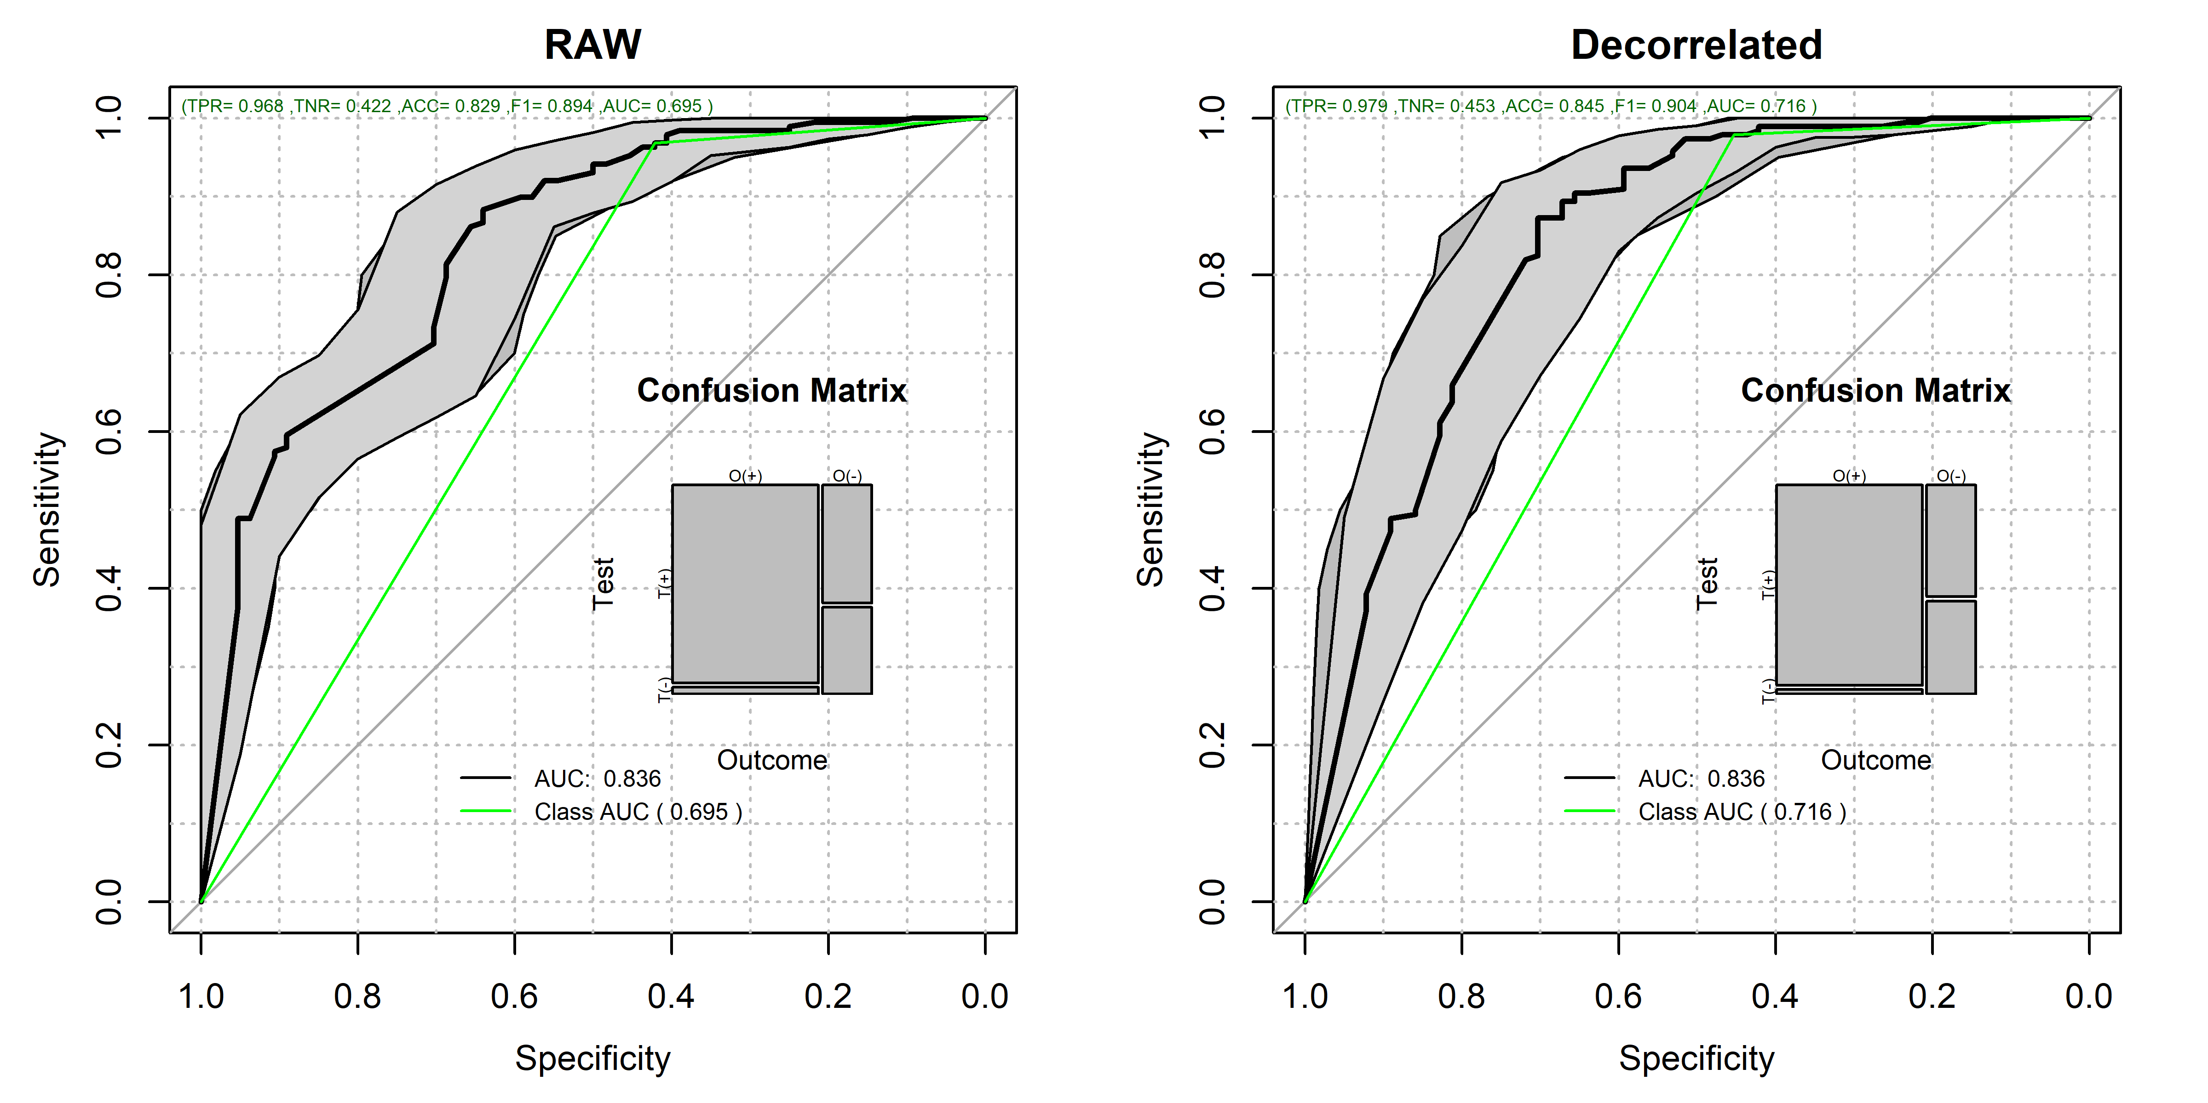

par(op)  
  
pander::pander(bpDecor$CM.analysis$tab)

|  | Outcome + | Outcome - | Total |
| --- | --- | --- | --- |
| **Test +** | 184 | 35 | 219 |
| **Test -** | 4 | 29 | 33 |
| **Total** | 188 | 64 | 252 |

pander::pander(bpDecor$accc)

| est | lower | upper |
| --- | --- | --- |
| 0.845 | 0.795 | 0.888 |

pander::pander(bpDecor$aucs)

| est | lower | upper |
| --- | --- | --- |
| 0.836 | 0.772 | 0.899 |

pander::pander(bpDecor$berror)

| 50% | 2.5% | 97.5% |
| --- | --- | --- |
| 0.283 | 0.219 | 0.344 |

### Here we compute the probability that the outcome-driven decorrelation ROC is superior to the RAW ROC.   
pander::pander(roc.test(bpDecor$ROC.analysis$roc.predictor,bpraw$ROC.analysis$roc.predictor,alternative = "greater"))

DeLong’s test for two correlated ROC curves: bpDecor$ROC.analysis$roc.predictor and bpraw$ROC.analysis$roc.predictor

| Test statistic | P value | Alternative hypothesis | AUC of roc1 | AUC of roc2 |
| --- | --- | --- | --- | --- |
| -0.0457 | 0.518 | greater | 0.836 | 0.836 |

## Feature Frequency Plots

par(mfrow=c(2,1),cex=0.9,cex.axis=0.8)  
  
rawtopf <- cvRaw$featureFrequency/repetitions  
crawtopf <- rawtopf  
  
if (length(rawtopf) > 30)  
{  
 rawtopf <- rawtopf[1:30]  
}  
barplot(100*rawtopf,las=2,main="Raw Features",ylim=c(0,100.0),cex.names = 0.35,cex.axis = 0.35,ylab="Sel. %")  
  
detopf <- cvDe$featureFrequency/repetitions  
cdetopf <- detopf  
names(cdetopf) <- str_remove_all(names(cdetopf),"Ba_")  
names(cdetopf) <- str_remove_all(names(cdetopf),"La_")  
if (length(detopf) > 30)  
{  
 detopf <- detopf[1:30]  
}  
  
barplot(100*detopf,las=2,main="Decorrelated Features",ylim=c(0,100.0),cex.names = 0.35,cex.axis = 0.35,ylab="Sel. %")

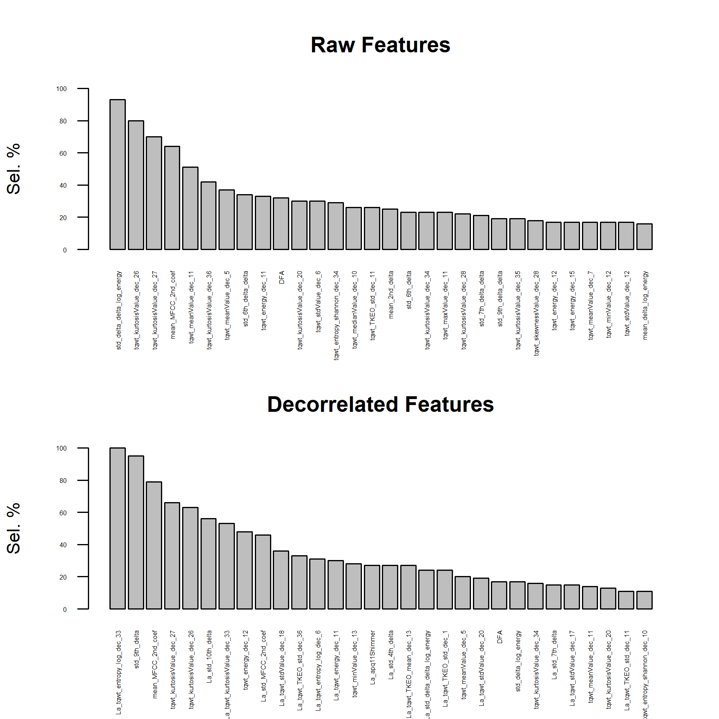

par(op)

### Final Table

unlistdecorr <- selectedlist  
names(unlistdecorr) <- NULL  
unlistdecorr <- unique(names(unlist(unlistdecorr)))  
  
finalTableDe <- univarDe$orderframe[deNames_in_dc,univariate_columns]  
  
finalTableOr <- univar$orderframe[unique(c(topfiveOrg,unlistdecorr,names(crawtopf)[1:2],names(cdetopf)[1:2])),univariate_columns]  
  
finalTable <- rbind(finalTableOr,finalTableDe)  
  
deFromula <- character(length(theDeFormulas))  
names(deFromula) <- names(theDeFormulas)  
  
for (dx in names(deFromula))  
{  
 coef <- theDeFormulas[[dx]]  
 cname <- names(theDeFormulas[[dx]])  
 names(cname) <- cname  
 for (cf in names(coef))  
 {  
 if (cf != dx)  
 {  
 if (coef[cf]>0)  
 {  
 deFromula[dx] <- paste(deFromula[dx],  
 sprintf("+ %5.3f*%s",coef[cf],cname[cf]))  
 }  
 else  
 {  
 deFromula[dx] <- paste(deFromula[dx],  
 sprintf("%5.3f*%s",coef[cf],cname[cf]))  
 }  
 }  
 }  
}  
  
orgnamez <- rownames(finalTable)  
orgnamez <- str_remove_all(orgnamez,"Ba_")  
orgnamez <- str_remove_all(orgnamez,"La_")  
finalTable$uAUC <- univar$orderframe[orgnamez,"ROCAUC"]  
finalTable$raw_Freq <- crawtopf[orgnamez]  
finalTable$La_Freq <- cdetopf[orgnamez]  
finalTable$DecorFormula <- deFromula[rownames(finalTable)]  
fscores <- attr(DEdataframe,"fscore")  
finalTable$fscores <- fscores[rownames(finalTable)]  
  
finalTable <- finalTable[order(-finalTable$ROCAUC),]  
  
pander::pander(finalTable)

|  | caseMean | caseStd | controlMean | controlStd | controlKSP | ROCAUC | WilcoxRes.p | FRes.p | uAUC | raw_Freq | La_Freq | DecorFormula | fscores |
| --- | --- | --- | --- | --- | --- | --- | --- | --- | --- | --- | --- | --- | --- |
| **std_delta_delta_log_energy** | 1.56e-02 | 8.19e-03 | 8.83e-03 | 4.35e-03 | 1.52e-01 | 0.798 | 2.91e-11 | 4.44e-16 | 0.798 | 0.93 | 0.24 | NA | NA |
| **std_delta_log_energy** | 4.20e-02 | 2.76e-02 | 2.43e-02 | 1.23e-02 | 1.73e-01 | 0.794 | 5.93e-11 | 2.89e-15 | 0.794 | 0.02 | 0.17 | NA | 4 |
| **La_tqwt_entropy_log_dec_33** | -2.53e+02 | 2.32e+02 | 6.61e+01 | 3.72e+02 | 5.55e-01 | 0.792 | 9.17e-16 | 0.00e+00 | 0.644 | 0.03 | 1.00 | -0.693*tqwt_entropy_log_dec_31 + 1.000*tqwt_entropy_log_dec_33 | -1 |
| **std_9th_delta_delta** | 1.89e-02 | 4.69e-03 | 1.46e-02 | 2.48e-03 | 4.48e-01 | 0.787 | 1.72e-10 | 1.26e-13 | 0.787 | 0.19 | NA | NA | NA |
| **std_8th_delta_delta** | 1.94e-02 | 4.73e-03 | 1.51e-02 | 2.23e-03 | 9.08e-01 | 0.780 | 1.39e-09 | 2.39e-12 | 0.780 | 0.08 | NA | NA | NA |
| **std_7th_delta_delta** | 2.10e-02 | 5.62e-03 | 1.60e-02 | 2.94e-03 | 8.30e-01 | 0.776 | 4.53e-10 | 1.26e-12 | 0.776 | 0.21 | NA | NA | NA |
| **tqwt_entropy_log_dec_12** | -1.68e+05 | 3.86e+04 | -1.32e+05 | 3.25e+04 | 3.62e-01 | 0.770 | 3.44e-11 | 3.09e-13 | 0.770 | 0.01 | 0.02 | NA | NA |
| **std_8th_delta** | 4.09e-02 | 1.02e-02 | 3.20e-02 | 5.14e-03 | 9.60e-01 | 0.767 | 1.08e-08 | 1.04e-11 | 0.767 | 0.05 | 0.02 | NA | NA |
| **std_9th_delta** | 3.94e-02 | 1.01e-02 | 3.08e-02 | 5.80e-03 | 1.17e-01 | 0.764 | 7.85e-09 | 9.93e-12 | 0.764 | NA | 0.95 | NA | 3 |
| **tqwt_entropy_shannon_dec_12** | 6.13e+01 | 1.43e+02 | 2.18e+02 | 2.52e+02 | 1.36e-02 | 0.763 | 7.98e-17 | 3.78e-11 | 0.763 | NA | NA | NA | NA |
| **tqwt_stdValue_dec_12** | 1.81e-02 | 2.10e-02 | 4.45e-02 | 3.45e-02 | 2.92e-01 | 0.763 | 9.69e-16 | 3.45e-13 | 0.763 | 0.17 | 0.02 | NA | NA |
| **std_7th_delta** | 4.41e-02 | 1.21e-02 | 3.41e-02 | 6.99e-03 | 7.49e-01 | 0.760 | 4.85e-09 | 1.88e-11 | 0.760 | 0.02 | 0.15 | NA | NA |
| **tqwt_entropy_log_dec_11** | -2.21e+05 | 4.22e+04 | -1.86e+05 | 3.69e+04 | 3.21e-01 | 0.754 | 9.01e-10 | 3.73e-11 | 0.754 | NA | 0.05 | NA | NA |
| **tqwt_TKEO_mean_dec_13** | 5.74e-03 | 1.91e-02 | 1.77e-02 | 2.51e-02 | 9.85e-04 | 0.753 | 1.92e-16 | 7.27e-07 | 0.753 | NA | 0.27 | NA | NA |
| **tqwt_minValue_dec_12** | -9.07e-02 | 6.74e-02 | -1.77e-01 | 1.08e-01 | 4.04e-01 | 0.752 | 1.48e-13 | 2.49e-13 | 0.752 | 0.17 | 0.03 | NA | NA |
| **std_6th_delta** | 4.75e-02 | 1.36e-02 | 3.66e-02 | 6.86e-03 | 3.36e-01 | 0.749 | 2.69e-08 | 2.35e-10 | 0.749 | 0.23 | NA | NA | NA |
| **La_tqwt_kurtosisValue_dec_33** | 2.42e+00 | 3.33e+00 | -3.33e-01 | 4.52e+00 | 9.49e-03 | 0.749 | 3.03e-10 | 1.10e-11 | 0.628 | NA | 0.53 | -0.872*tqwt_kurtosisValue_dec_32 + 1.000*tqwt_kurtosisValue_dec_33 | -1 |
| **std_10th_delta** | 3.89e-02 | 1.05e-02 | 3.07e-02 | 5.57e-03 | 8.51e-01 | 0.746 | 4.51e-08 | 1.07e-09 | 0.746 | NA | 0.56 | NA | NA |
| **tqwt_minValue_dec_13** | -1.60e-01 | 1.26e-01 | -2.92e-01 | 1.68e-01 | 6.80e-01 | 0.746 | 1.11e-12 | 8.76e-11 | 0.746 | NA | 0.28 | NA | 4 |
| **La_std_delta_delta_log_energy** | 3.48e-03 | 3.09e-03 | 1.84e-03 | 1.64e-03 | 8.73e-02 | 0.744 | 1.99e-07 | 2.28e-06 | 0.798 | 0.93 | 0.24 | -0.288*std_delta_log_energy + 1.000*std_delta_delta_log_energy | -1 |
| **tqwt_entropy_shannon_dec_11** | 2.52e+01 | 4.42e+01 | 8.76e+01 | 1.07e+02 | 2.71e-03 | 0.744 | 1.64e-14 | 7.60e-11 | 0.744 | 0.01 | 0.03 | NA | NA |
| **tqwt_TKEO_std_dec_11** | 4.46e-04 | 7.61e-04 | 1.84e-03 | 2.70e-03 | 5.42e-04 | 0.741 | 5.12e-15 | 9.27e-12 | 0.741 | 0.26 | 0.11 | NA | NA |
| **std_12th_delta** | 3.46e-02 | 8.43e-03 | 2.85e-02 | 5.98e-03 | 7.23e-02 | 0.734 | 2.75e-07 | 8.71e-09 | 0.734 | NA | 0.04 | NA | NA |
| **La_apq11Shimmer** | 1.38e-02 | 1.45e-02 | 4.49e-03 | 9.78e-03 | 3.25e-02 | 0.731 | 4.41e-07 | 6.24e-08 | 0.713 | NA | 0.27 | -1.278*apq3Shimmer + 1.000*apq11Shimmer | -1 |
| **tqwt_TKEO_mean_dec_11** | 2.93e-04 | 6.22e-04 | 1.19e-03 | 1.99e-03 | 8.06e-05 | 0.731 | 2.01e-14 | 7.40e-09 | 0.731 | 0.04 | NA | NA | NA |
| **La_std_6th_delta** | 9.37e-03 | 7.37e-03 | 5.06e-03 | 3.64e-03 | 7.46e-01 | 0.726 | 2.39e-07 | 3.34e-05 | 0.749 | 0.23 | NA | -0.106*std_MFCC_6th_coef + 1.000*std_6th_delta | 0 |
| **tqwt_TKEO_std_dec_14** | 1.49e-02 | 2.25e-02 | 3.41e-02 | 3.25e-02 | 4.85e-02 | 0.723 | 1.05e-11 | 2.23e-07 | 0.723 | NA | 0.02 | NA | NA |
| **tqwt_entropy_log_dec_14** | -8.08e+04 | 2.54e+04 | -6.34e+04 | 1.80e+04 | 2.28e-01 | 0.720 | 1.10e-06 | 3.29e-08 | 0.720 | NA | NA | NA | NA |
| **La_tqwt_entropy_shannon_dec_33** | -5.89e-01 | 1.60e+00 | 6.74e-01 | 3.68e+00 | 3.36e-06 | 0.720 | 7.00e-07 | 4.49e-06 | 0.621 | NA | 0.03 | -0.725*tqwt_entropy_shannon_dec_32 + 1.000*tqwt_entropy_shannon_dec_33 | 0 |
| **tqwt_entropy_shannon_dec_14** | 3.39e+02 | 3.73e+02 | 6.62e+02 | 4.76e+02 | 6.14e-01 | 0.718 | 2.77e-09 | 6.36e-08 | 0.718 | NA | NA | NA | NA |
| **tqwt_TKEO_mean_dec_14** | 1.70e-02 | 2.93e-02 | 3.77e-02 | 3.92e-02 | 2.81e-02 | 0.717 | 1.98e-11 | 5.96e-06 | 0.717 | NA | NA | NA | NA |
| **La_GNE_std** | -7.89e-02 | 6.02e-02 | -1.27e-01 | 6.85e-02 | 9.30e-01 | 0.714 | 6.01e-09 | 3.99e-09 | 0.574 | NA | 0.07 | -0.280*GNE_mean + 1.000*GNE_std | -1 |
| **tqwt_TKEO_mean_dec_7** | 7.32e-05 | 1.35e-04 | 2.14e-04 | 4.83e-04 | 1.09e-06 | 0.713 | 4.77e-11 | 1.36e-05 | 0.713 | 0.02 | NA | NA | NA |
| **apq11Shimmer** | 5.99e-02 | 2.83e-02 | 4.21e-02 | 2.52e-02 | 1.21e-01 | 0.713 | 6.99e-06 | 6.42e-08 | 0.713 | NA | 0.27 | NA | NA |
| **tqwt_entropy_log_dec_10** | -2.63e+05 | 5.18e+04 | -2.29e+05 | 3.92e+04 | 2.37e-01 | 0.713 | 1.87e-06 | 2.15e-07 | 0.713 | NA | NA | NA | 3 |
| **tqwt_entropy_shannon_dec_7** | 1.50e+01 | 2.31e+01 | 3.74e+01 | 6.26e+01 | 7.68e-05 | 0.712 | 1.39e-09 | 3.79e-06 | 0.712 | 0.08 | NA | NA | NA |
| **La_std_4th_delta** | 3.30e-03 | 6.70e-03 | -8.40e-04 | 5.55e-03 | 2.35e-01 | 0.708 | 1.40e-07 | 2.01e-05 | 0.679 | NA | 0.27 | -0.127*std_MFCC_4th_coef + 1.000*std_4th_delta | 0 |
| **La_tqwt_stdValue_dec_20** | -5.08e-03 | 2.95e-02 | 1.48e-02 | 2.73e-02 | 7.96e-01 | 0.708 | 1.00e-07 | 6.15e-07 | 0.607 | NA | 0.19 | + 1.000*tqwt_stdValue_dec_20 + 0.387*tqwt_minValue_dec_20 | -1 |
| **tqwt_entropy_shannon_dec_8** | 2.47e+01 | 3.70e+01 | 5.61e+01 | 7.74e+01 | 1.14e-03 | 0.707 | 1.08e-10 | 6.87e-06 | 0.707 | NA | NA | NA | NA |
| **std_MFCC_8th_coef** | 2.98e-01 | 7.30e-02 | 2.50e-01 | 4.52e-02 | 5.49e-01 | 0.705 | 6.26e-06 | 2.88e-07 | 0.705 | NA | 0.01 | NA | 1 |
| **La_std_10th_delta** | 7.38e-05 | 4.44e-03 | -3.02e-03 | 4.24e-03 | 6.82e-01 | 0.704 | 7.65e-08 | 2.07e-06 | 0.746 | NA | 0.56 | -0.138*std_MFCC_10th_coef + 1.000*std_10th_delta | 0 |
| **tqwt_TKEO_mean_dec_8** | 1.71e-04 | 3.35e-04 | 4.65e-04 | 9.80e-04 | 4.47e-06 | 0.704 | 3.70e-12 | 4.69e-05 | 0.704 | NA | NA | NA | NA |
| **La_tqwt_stdValue_dec_12** | 9.45e-03 | 6.50e-03 | 1.38e-02 | 7.53e-03 | 2.10e-01 | 0.703 | 1.41e-06 | 5.17e-08 | 0.763 | 0.17 | 0.02 | -0.000*tqwt_entropy_shannon_dec_12 + 1.000*tqwt_stdValue_dec_12 | -1 |
| **La_app_LT_entropy_log_2_coef** | 3.76e+01 | 2.92e-01 | 3.74e+01 | 1.86e-01 | 3.16e-01 | 0.702 | 5.60e-06 | 1.30e-05 | 0.647 | NA | 0.03 | -0.576*app_LT_entropy_log_1_coef + 1.000*app_LT_entropy_log_2_coef | -1 |
| **tqwt_entropy_shannon_dec_10** | 3.15e+01 | 4.17e+01 | 7.27e+01 | 7.84e+01 | 7.70e-03 | 0.701 | 1.70e-09 | 2.07e-07 | 0.701 | NA | 0.11 | NA | 6 |
| **La_std_MFCC_2nd_coef** | 7.08e-02 | 7.17e-02 | 1.17e-01 | 7.21e-02 | 1.33e-01 | 0.701 | 1.54e-07 | 7.54e-06 | 0.508 | NA | 0.46 | + 1.000*std_MFCC_2nd_coef -6.424*std_2nd_delta | -1 |
| **La_app_LT_TKEO_std_6_coef** | 8.33e+00 | 2.22e+00 | 7.42e+00 | 1.89e+00 | 5.59e-02 | 0.701 | 1.50e-06 | 1.64e-04 | 0.685 | NA | 0.02 | + 0.651*app_entropy_log_1_coef -2.238*app_LT_entropy_log_1_coef + 2.761*app_LT_entropy_log_8_coef -11.719*app_LT_TKEO_mean_3_coef -3.019*app_LT_TKEO_mean_6_coef + 1.000*app_LT_TKEO_std_6_coef | -3 |
| **tqwt_stdValue_dec_6** | 3.93e-03 | 3.84e-03 | 7.10e-03 | 7.26e-03 | 2.39e-02 | 0.701 | 1.14e-07 | 1.37e-05 | 0.701 | 0.30 | 0.02 | NA | NA |
| **La_tqwt_minValue_dec_33** | 8.67e-03 | 3.58e-02 | -1.28e-02 | 5.90e-02 | 2.59e-03 | 0.698 | 6.66e-14 | 5.84e-05 | 0.608 | NA | 0.04 | -0.902*tqwt_minValue_dec_32 + 1.000*tqwt_minValue_dec_33 | 0 |
| **tqwt_entropy_log_dec_6** | -6.73e+05 | 1.48e+05 | -5.90e+05 | 8.41e+04 | 3.13e-01 | 0.696 | 1.35e-05 | 2.86e-06 | 0.696 | NA | 0.31 | NA | NA |
| **app_LT_TKEO_mean_3_coef** | 1.10e+01 | 1.21e+00 | 1.18e+01 | 1.30e+00 | 5.60e-01 | 0.690 | 4.62e-07 | 3.77e-06 | 0.690 | 0.01 | NA | NA | NA |
| **La_std_7th_delta** | 1.71e-03 | 5.22e-03 | -1.80e-03 | 5.30e-03 | 2.38e-01 | 0.689 | 9.55e-07 | 2.45e-06 | 0.760 | 0.02 | 0.15 | -0.131*std_MFCC_7th_coef + 1.000*std_7th_delta | 0 |
| **La_tqwt_entropy_log_dec_31** | -8.33e+02 | 4.83e+02 | -1.28e+03 | 8.06e+02 | 9.64e-01 | 0.689 | 1.25e-07 | 8.81e-11 | 0.548 | NA | 0.05 | + 1.000*tqwt_entropy_log_dec_31 -1.241*tqwt_entropy_log_dec_34 | 2 |
| **La_app_LT_entropy_log_9_coef** | 1.04e+01 | 5.50e-05 | 1.04e+01 | 4.09e-05 | 7.58e-01 | 0.688 | 7.71e-06 | 1.12e-04 | 0.682 | NA | 0.01 | -0.001*det_LT_TKEO_mean_9_coef -1.000*app_LT_entropy_log_8_coef + 1.000*app_LT_entropy_log_9_coef | -2 |
| **app_LT_TKEO_mean_2_coef** | 3.44e+00 | 4.35e-01 | 3.67e+00 | 4.13e-01 | 7.30e-01 | 0.687 | 5.25e-07 | 1.66e-05 | 0.687 | NA | NA | NA | NA |
| **La_std_8th_delta** | 3.40e-03 | 4.74e-03 | 4.95e-04 | 3.88e-03 | 5.33e-01 | 0.687 | 6.26e-06 | 1.65e-05 | 0.767 | 0.05 | 0.02 | -0.126*std_MFCC_8th_coef + 1.000*std_8th_delta | 0 |
| **app_entropy_shannon_8_coef** | -1.85e+09 | 1.02e+09 | -2.74e+09 | 1.59e+09 | 5.08e-01 | 0.686 | 5.83e-09 | 2.22e-07 | 0.686 | 0.01 | 0.01 | NA | NA |
| **app_entropy_shannon_9_coef** | -3.87e+09 | 2.13e+09 | -5.71e+09 | 3.31e+09 | 5.12e-01 | 0.686 | 5.95e-09 | 2.21e-07 | 0.686 | NA | 0.03 | NA | NA |
| **La_tqwt_TKEO_std_dec_11** | 6.29e-05 | 2.22e-04 | 2.83e-04 | 7.06e-04 | 1.06e-03 | 0.686 | 3.55e-13 | 2.04e-07 | 0.741 | 0.26 | 0.11 | -1.309*tqwt_TKEO_mean_dec_11 + 1.000*tqwt_TKEO_std_dec_11 | -1 |
| **La_app_LT_entropy_log_4_coef** | 5.00e+01 | 2.21e-01 | 5.01e+01 | 2.24e-01 | 8.31e-03 | 0.686 | 2.20e-04 | 1.21e-05 | 0.654 | NA | NA | + 0.185*app_entropy_log_1_coef -0.337*app_entropy_log_2_coef -0.201*app_LT_entropy_log_1_coef + 1.000*app_LT_entropy_log_4_coef | -2 |
| **La_tqwt_TKEO_mean_dec_8** | -9.68e-05 | 1.02e-04 | -1.43e-04 | 2.44e-04 | 1.09e-04 | 0.685 | 5.01e-06 | 1.40e-04 | 0.704 | NA | NA | -0.000*tqwt_entropy_shannon_dec_8 + 1.000*tqwt_TKEO_mean_dec_8 | 0 |
| **La_tqwt_entropy_shannon_dec_7** | 5.00e+00 | 6.06e+00 | 8.10e+00 | 9.42e+00 | 1.89e-02 | 0.685 | 7.91e-08 | 2.15e-04 | 0.712 | 0.08 | NA | + 1.000*tqwt_entropy_shannon_dec_7 -137039.733*tqwt_TKEO_mean_dec_7 | -1 |
| **app_LT_TKEO_std_6_coef** | 5.52e+02 | 5.38e+01 | 5.89e+02 | 6.38e+01 | 4.77e-01 | 0.685 | 1.48e-06 | 7.50e-07 | 0.685 | NA | 0.02 | NA | NA |
| **app_LT_TKEO_mean_6_coef** | 1.96e+02 | 1.91e+01 | 2.09e+02 | 2.26e+01 | 4.66e-01 | 0.684 | 1.81e-06 | 5.58e-07 | 0.684 | NA | NA | NA | NA |
| **La_std_12th_delta** | 1.86e-03 | 4.45e-03 | -9.07e-04 | 4.00e-03 | 7.47e-01 | 0.683 | 4.39e-06 | 1.50e-05 | 0.734 | NA | 0.04 | -0.130*std_MFCC_12th_coef + 1.000*std_12th_delta | 0 |
| **La_tqwt_stdValue_dec_17** | 1.00e-01 | 5.93e-02 | 1.36e-01 | 3.76e-02 | 8.45e-01 | 0.683 | 3.54e-05 | 1.51e-06 | 0.681 | NA | 0.15 | -0.929*tqwt_TKEO_mean_dec_17 + 1.000*tqwt_stdValue_dec_17 | 0 |
| **app_LT_entropy_log_8_coef** | 1.32e+02 | 1.48e+00 | 1.33e+02 | 1.68e+00 | 3.53e-01 | 0.682 | 8.64e-06 | 1.86e-06 | 0.682 | NA | NA | NA | 34 |
| **app_LT_entropy_log_9_coef** | 1.42e+02 | 1.48e+00 | 1.43e+02 | 1.68e+00 | 3.53e-01 | 0.682 | 8.61e-06 | 1.86e-06 | 0.682 | NA | 0.01 | NA | NA |
| **La_app_entropy_log_4_coef** | -1.69e+02 | 8.14e-01 | -1.69e+02 | 1.17e+00 | 1.21e-01 | 0.681 | 1.28e-07 | 7.70e-06 | 0.668 | NA | 0.01 | + 0.213*app_entropy_log_1_coef + 1.000*app_entropy_log_4_coef + 0.005*app_LT_entropy_shannon_1_coef -0.733*app_LT_entropy_log_1_coef -2.529*app_LT_entropy_log_8_coef | -1 |
| **tqwt_stdValue_dec_17** | 2.03e-01 | 1.53e-01 | 2.85e-01 | 1.18e-01 | 6.10e-01 | 0.681 | 2.20e-05 | 3.10e-04 | 0.681 | NA | 0.15 | NA | NA |
| **app_LT_TKEO_mean_1_coef** | 9.79e-01 | 1.44e-01 | 1.04e+00 | 1.23e-01 | 8.21e-01 | 0.681 | 9.92e-07 | 9.84e-05 | 0.681 | 0.01 | NA | NA | NA |
| **tqwt_entropy_log_dec_34** | -3.29e+03 | 7.69e+02 | -2.76e+03 | 7.75e+02 | 8.66e-01 | 0.681 | 4.44e-05 | 3.86e-06 | 0.681 | 0.05 | 0.10 | NA | 3 |
| **La_tqwt_stdValue_dec_18** | -3.59e-02 | 4.70e-02 | -7.00e-03 | 4.16e-02 | 9.79e-02 | 0.680 | 1.40e-05 | 1.58e-05 | 0.628 | NA | 0.36 | + 1.000*tqwt_stdValue_dec_18 + 0.427*tqwt_minValue_dec_18 | -1 |
| **La_app_LT_TKEO_mean_2_coef** | -8.86e-01 | 3.87e-02 | -8.69e-01 | 5.57e-02 | 6.10e-05 | 0.680 | 1.20e-06 | 4.72e-05 | 0.687 | NA | NA | -0.003*app_LT_entropy_log_1_coef -3.057*app_LT_TKEO_mean_1_coef + 1.000*app_LT_TKEO_mean_2_coef | -2 |
| **La_tqwt_entropy_log_dec_6** | 8.31e+04 | 5.84e+04 | 1.25e+05 | 6.34e+04 | 9.43e-01 | 0.679 | 5.18e-06 | 3.98e-07 | 0.696 | NA | 0.31 | -0.483*tqwt_entropy_log_dec_2 + 1.000*tqwt_entropy_log_dec_6 | -1 |
| **std_4th_delta** | 5.32e-02 | 1.81e-02 | 4.17e-02 | 7.95e-03 | 8.94e-01 | 0.679 | 4.36e-05 | 1.38e-06 | 0.679 | NA | 0.27 | NA | NA |
| **std_MFCC_7th_coef** | 3.22e-01 | 8.30e-02 | 2.73e-01 | 5.74e-02 | 5.26e-01 | 0.679 | 8.75e-05 | 6.08e-06 | 0.679 | NA | NA | NA | NA |
| **La_app_entropy_shannon_9_coef** | 3.59e+08 | 1.24e+06 | 3.58e+08 | 1.69e+06 | 6.00e-01 | 0.678 | 9.96e-07 | 6.35e-07 | 0.686 | NA | 0.03 | -2.076*app_entropy_shannon_8_coef + 1.000*app_entropy_shannon_9_coef + 2864300.369*app_LT_entropy_log_8_coef | -1 |
| **app_det_TKEO_mean_3_coef** | 1.35e+04 | 7.24e+03 | 1.94e+04 | 1.22e+04 | 1.55e-01 | 0.677 | 2.15e-08 | 2.88e-06 | 0.677 | 0.11 | NA | NA | NA |
| **tqwt_TKEO_mean_dec_17** | 1.11e-01 | 1.57e-01 | 1.60e-01 | 1.12e-01 | 4.26e-01 | 0.677 | 4.59e-06 | 3.07e-02 | 0.677 | NA | NA | NA | 2 |
| **La_app_det_TKEO_mean_2_coef** | -4.58e+02 | 5.02e+02 | -6.56e+02 | 1.10e+03 | 4.36e-06 | 0.676 | 1.11e-05 | 6.37e-05 | 0.666 | NA | NA | + 1.000*app_det_TKEO_mean_2_coef -0.358*app_det_TKEO_mean_3_coef | 0 |
| **tqwt_kurtosisValue_dec_26** | 6.92e+00 | 1.73e+01 | 4.18e+01 | 6.40e+01 | 7.62e-06 | 0.675 | 1.07e-14 | 4.27e-11 | 0.675 | 0.80 | 0.63 | NA | NA |
| **La_app_LT_TKEO_mean_1_coef** | 2.73e+00 | 4.39e-02 | 2.71e+00 | 3.45e-02 | 9.80e-04 | 0.673 | 5.06e-04 | 2.00e-04 | 0.681 | 0.01 | NA | -0.006*app_entropy_log_1_coef + 0.021*app_LT_entropy_log_1_coef + 1.000*app_LT_TKEO_mean_1_coef | 1 |
| **std_MFCC_6th_coef** | 3.62e-01 | 1.14e-01 | 2.98e-01 | 5.83e-02 | 8.19e-01 | 0.672 | 1.08e-04 | 7.68e-06 | 0.672 | NA | 0.01 | NA | 3 |
| **app_LT_entropy_shannon_1_coef** | -2.20e+04 | 2.87e+03 | -2.39e+04 | 3.28e+03 | 3.63e-01 | 0.672 | 6.70e-06 | 1.81e-06 | 0.672 | NA | NA | NA | NA |
| **tqwt_energy_dec_11** | 1.18e-03 | 1.80e-03 | 5.04e-03 | 1.04e-02 | 3.63e-06 | 0.672 | 8.36e-13 | 4.30e-10 | 0.672 | 0.33 | 0.30 | NA | NA |
| **La_tqwt_entropy_log_dec_32** | 1.01e+02 | 2.08e+02 | 2.39e+02 | 2.28e+02 | 6.95e-01 | 0.671 | 1.99e-05 | 9.76e-07 | 0.577 | NA | NA | -0.859*tqwt_entropy_log_dec_31 + 1.000*tqwt_entropy_log_dec_32 | -1 |
| **La_tqwt_TKEO_std_dec_36** | 1.41e-03 | 1.84e-02 | -9.37e-03 | 2.43e-02 | 1.18e-05 | 0.669 | 6.24e-11 | 6.33e-06 | 0.637 | NA | 0.33 | -1.941*tqwt_TKEO_mean_dec_36 + 1.000*tqwt_TKEO_std_dec_36 | -1 |
| **app_entropy_log_4_coef** | 3.36e+02 | 1.49e+01 | 3.44e+02 | 1.57e+01 | 2.94e-01 | 0.668 | 3.06e-05 | 6.18e-06 | 0.668 | NA | 0.01 | NA | NA |
| **La_tqwt_TKEO_std_dec_1** | 6.36e-06 | 1.83e-05 | 1.81e-05 | 2.95e-05 | 1.34e-02 | 0.667 | 5.77e-08 | 1.59e-04 | 0.611 | NA | 0.24 | -0.000*tqwt_entropy_shannon_dec_1 + 1.000*tqwt_TKEO_std_dec_1 | -1 |
| **tqwt_TKEO_mean_dec_36** | 1.35e-02 | 4.02e-02 | 2.65e-02 | 6.11e-02 | 8.30e-07 | 0.666 | 4.68e-10 | 3.15e-02 | 0.666 | NA | NA | NA | 2 |
| **app_det_TKEO_mean_2_coef** | 4.36e+03 | 2.51e+03 | 6.27e+03 | 4.77e+03 | 8.55e-03 | 0.666 | 7.65e-08 | 3.12e-05 | 0.666 | NA | NA | NA | NA |
| **La_tqwt_TKEO_std_dec_20** | 4.87e-03 | 3.16e-02 | -7.49e-03 | 2.33e-02 | 7.21e-01 | 0.666 | 1.39e-07 | 1.80e-04 | 0.542 | NA | 0.05 | -0.709*tqwt_TKEO_mean_dec_20 + 1.000*tqwt_TKEO_std_dec_20 | -1 |
| **La_tqwt_stdValue_dec_6** | -3.72e-04 | 2.35e-03 | 8.30e-04 | 2.43e-03 | 5.37e-02 | 0.665 | 1.42e-06 | 1.47e-04 | 0.701 | 0.30 | 0.02 | + 1.000*tqwt_stdValue_dec_6 + 0.114*tqwt_minValue_dec_5 | 0 |
| **std_MFCC_10th_coef** | 2.81e-01 | 6.76e-02 | 2.45e-01 | 4.89e-02 | 5.30e-01 | 0.665 | 3.32e-04 | 2.57e-05 | 0.665 | NA | NA | NA | 1 |
| **La_tqwt_entropy_shannon_dec_14** | 1.36e+02 | 1.44e+02 | 2.11e+02 | 1.44e+02 | 7.24e-01 | 0.664 | 1.25e-04 | 2.60e-05 | 0.718 | NA | NA | + 1.000*tqwt_entropy_shannon_dec_14 -11956.752*tqwt_TKEO_mean_dec_14 | 0 |
| **La_locShimmer** | 2.87e-03 | 6.68e-03 | -5.43e-04 | 5.51e-03 | 8.32e-03 | 0.664 | 2.09e-04 | 6.63e-05 | 0.663 | NA | 0.01 | + 1.000*locShimmer -1.905*apq3Shimmer | 0 |
| **La_std_MFCC_3rd_coef** | 5.32e-02 | 5.24e-02 | 8.34e-02 | 6.18e-02 | 2.62e-02 | 0.664 | 3.74e-06 | 1.91e-04 | 0.448 | NA | 0.06 | + 1.000*std_MFCC_3rd_coef -6.522*std_3rd_delta | -1 |
| **locShimmer** | 7.15e-02 | 3.71e-02 | 5.56e-02 | 3.69e-02 | 3.38e-02 | 0.663 | 2.99e-03 | 2.15e-04 | 0.663 | NA | 0.01 | NA | NA |
| **La_tqwt_stdValue_dec_4** | 1.56e-03 | 1.57e-03 | 2.46e-03 | 2.08e-03 | 2.44e-02 | 0.660 | 1.32e-05 | 2.30e-04 | 0.624 | NA | 0.06 | -0.000*tqwt_entropy_shannon_dec_3 + 1.000*tqwt_stdValue_dec_4 | -1 |
| **app_entropy_log_1_coef** | 1.17e+03 | 7.50e+01 | 1.20e+03 | 7.08e+01 | 2.53e-01 | 0.659 | 8.93e-05 | 1.86e-05 | 0.659 | NA | 0.01 | NA | NA |
| **La_tqwt_entropy_log_dec_12** | -5.34e+04 | 1.84e+04 | -4.20e+04 | 2.06e+04 | 7.81e-01 | 0.659 | 1.59e-05 | 1.15e-05 | 0.770 | 0.01 | 0.02 | + 1.000*tqwt_entropy_log_dec_12 -1.415*tqwt_entropy_log_dec_14 | 0 |
| **app_entropy_log_2_coef** | 7.03e+02 | 4.09e+01 | 7.22e+02 | 3.93e+01 | 2.73e-01 | 0.658 | 9.28e-05 | 1.87e-05 | 0.658 | NA | NA | NA | NA |
| **La_det_LT_entropy_log_2_coef** | -4.95e+01 | 3.53e+00 | -5.14e+01 | 4.72e+00 | 6.04e-01 | 0.657 | 1.70e-05 | 2.04e-04 | 0.618 | NA | NA | + 0.511*det_entropy_log_1_coef -0.989*det_entropy_log_2_coef -0.518*det_LT_entropy_log_1_coef + 1.000*det_LT_entropy_log_2_coef | -2 |
| **app_LT_entropy_log_4_coef** | 1.56e+02 | 4.35e+00 | 1.58e+02 | 3.67e+00 | 1.68e-01 | 0.654 | 4.86e-04 | 1.24e-04 | 0.654 | NA | NA | NA | NA |
| **std_MFCC_12th_coef** | 2.52e-01 | 5.37e-02 | 2.27e-01 | 4.99e-02 | 1.91e-01 | 0.652 | 7.72e-04 | 1.90e-04 | 0.652 | NA | NA | NA | 1 |
| **La_tqwt_entropy_log_dec_11** | -1.05e+04 | 1.42e+04 | -2.50e+03 | 1.60e+04 | 7.44e-01 | 0.651 | 2.43e-05 | 6.14e-05 | 0.754 | NA | 0.05 | -0.803*tqwt_entropy_log_dec_10 + 1.000*tqwt_entropy_log_dec_11 | -1 |
| **app_LT_entropy_log_1_coef** | 4.24e+02 | 2.18e+01 | 4.30e+02 | 1.71e+01 | 8.99e-02 | 0.650 | 8.21e-04 | 2.61e-04 | 0.650 | NA | NA | NA | 7 |
| **tqwt_minValue_dec_5** | -3.78e-02 | 3.25e-02 | -5.52e-02 | 5.37e-02 | 8.11e-04 | 0.648 | 6.83e-06 | 2.47e-03 | 0.648 | NA | 0.01 | NA | 5 |
| **app_LT_entropy_log_2_coef** | 2.82e+02 | 1.26e+01 | 2.85e+02 | 9.78e+00 | 8.10e-02 | 0.647 | 1.19e-03 | 3.92e-04 | 0.647 | NA | 0.03 | NA | NA |
| **std_3rd_delta** | 5.74e-02 | 2.19e-02 | 4.58e-02 | 9.83e-03 | 8.81e-01 | 0.645 | 1.35e-03 | 3.71e-05 | 0.645 | NA | NA | NA | 3 |
| **tqwt_entropy_log_dec_33** | -3.66e+03 | 8.44e+02 | -3.20e+03 | 8.47e+02 | 3.63e-01 | 0.644 | 5.04e-04 | 1.66e-04 | 0.644 | 0.03 | 1.00 | NA | NA |
| **La_tqwt_TKEO_mean_dec_13** | -7.35e-04 | 6.02e-03 | -5.28e-03 | 1.02e-02 | 3.78e-03 | 0.640 | 3.61e-13 | 5.44e-09 | 0.753 | NA | 0.27 | -0.000*tqwt_entropy_shannon_dec_12 + 1.000*tqwt_TKEO_mean_dec_13 | -1 |
| **tqwt_TKEO_std_dec_36** | 2.76e-02 | 8.95e-02 | 4.20e-02 | 1.02e-01 | 4.32e-07 | 0.637 | 1.91e-09 | 1.60e-01 | 0.637 | NA | 0.33 | NA | NA |
| **La_tqwt_TKEO_std_dec_14** | 1.75e-03 | 6.13e-03 | 5.01e-03 | 9.56e-03 | 9.27e-02 | 0.634 | 1.00e-07 | 1.38e-04 | 0.723 | NA | 0.02 | -0.772*tqwt_TKEO_mean_dec_14 + 1.000*tqwt_TKEO_std_dec_14 | -1 |
| **La_tqwt_energy_dec_11** | -1.44e-04 | 1.34e-03 | 1.32e-03 | 3.70e-03 | 1.67e-03 | 0.632 | 1.30e-12 | 4.40e-07 | 0.672 | 0.33 | 0.30 | -0.883*tqwt_energy_dec_10 + 1.000*tqwt_energy_dec_11 | -1 |
| **apq3Shimmer** | 3.60e-02 | 1.93e-02 | 2.95e-02 | 1.92e-02 | 4.90e-02 | 0.630 | 2.56e-02 | 3.75e-03 | 0.630 | NA | NA | NA | 6 |
| **std_2nd_delta** | 6.19e-02 | 2.09e-02 | 5.32e-02 | 1.59e-02 | 1.06e-01 | 0.630 | 1.02e-02 | 8.66e-04 | 0.630 | NA | NA | NA | 2 |
| **tqwt_kurtosisValue_dec_33** | 1.35e+01 | 1.42e+01 | 9.02e+00 | 1.00e+01 | 1.10e-04 | 0.628 | 2.15e-01 | 7.90e-03 | 0.628 | NA | 0.53 | NA | NA |
| **tqwt_stdValue_dec_18** | 2.31e-01 | 1.66e-01 | 2.95e-01 | 1.51e-01 | 4.47e-01 | 0.628 | 7.51e-04 | 7.29e-03 | 0.628 | NA | 0.36 | NA | NA |
| **tqwt_energy_dec_10** | 1.50e-03 | 1.72e-03 | 4.21e-03 | 1.11e-02 | 1.09e-07 | 0.626 | 1.67e-06 | 1.35e-05 | 0.626 | NA | 0.02 | NA | 2 |
| **tqwt_stdValue_dec_4** | 3.06e-03 | 3.55e-03 | 3.93e-03 | 3.57e-03 | 4.92e-02 | 0.624 | 1.63e-04 | 6.52e-02 | 0.624 | NA | 0.06 | NA | NA |
| **tqwt_entropy_shannon_dec_33** | 1.74e+00 | 3.46e+00 | 7.50e-01 | 3.60e+01 | 7.15e-14 | 0.621 | 9.97e-01 | 2.95e-01 | 0.621 | NA | 0.03 | NA | NA |
| **La_tqwt_entropy_shannon_dec_11** | -7.77e+00 | 3.15e+01 | 1.15e+01 | 5.68e+01 | 2.90e-02 | 0.619 | 3.11e-09 | 4.80e-05 | 0.744 | 0.01 | 0.03 | -1.047*tqwt_entropy_shannon_dec_10 + 1.000*tqwt_entropy_shannon_dec_11 | 2 |
| **det_LT_entropy_log_2_coef** | -7.70e+02 | 1.10e+02 | -8.12e+02 | 6.37e+01 | 1.60e-01 | 0.618 | 2.53e-02 | 1.58e-03 | 0.618 | NA | NA | NA | NA |
| **La_tqwt_kurtosisValue_dec_31** | 5.12e-01 | 4.76e+00 | 3.80e+00 | 7.32e+00 | 1.51e-03 | 0.615 | 8.54e-07 | 9.37e-06 | 0.490 | NA | 0.05 | + 1.000*tqwt_kurtosisValue_dec_31 -1.025*tqwt_kurtosisValue_dec_32 | -1 |
| **GNE_mean** | 1.06e+00 | 2.46e-01 | 1.20e+00 | 4.67e-01 | 2.91e-02 | 0.611 | 1.21e-04 | 1.39e-03 | 0.611 | NA | NA | NA | 1 |
| **tqwt_TKEO_std_dec_1** | 2.71e-05 | 3.77e-05 | 4.15e-05 | 6.66e-05 | 1.16e-04 | 0.611 | 1.54e-05 | 1.96e-02 | 0.611 | NA | 0.24 | NA | NA |
| **tqwt_TKEO_mean_dec_20** | 6.29e-02 | 1.02e-01 | 7.04e-02 | 6.22e-02 | 1.90e-01 | 0.610 | 3.86e-05 | 3.38e-01 | 0.610 | NA | NA | NA | NA |
| **tqwt_minValue_dec_33** | -8.81e-02 | 1.02e-01 | -1.53e-01 | 2.19e-01 | 1.26e-04 | 0.608 | 1.45e-05 | 7.25e-04 | 0.608 | NA | 0.04 | NA | NA |
| **tqwt_entropy_shannon_dec_3** | 8.81e+00 | 1.97e+01 | 8.67e+00 | 1.32e+01 | 4.44e-05 | 0.608 | 1.00e+00 | 4.82e-01 | 0.608 | NA | NA | NA | 6 |
| **tqwt_stdValue_dec_20** | 1.60e-01 | 1.11e-01 | 1.85e-01 | 8.02e-02 | 7.22e-01 | 0.607 | 1.90e-03 | 8.21e-02 | 0.607 | NA | 0.19 | NA | NA |
| **det_LT_entropy_log_1_coef** | -1.67e+03 | 2.04e+02 | -1.75e+03 | 1.19e+02 | 1.57e-01 | 0.603 | 5.37e-02 | 1.54e-03 | 0.603 | NA | NA | NA | 3 |
| **std_MFCC_4th_coef** | 3.92e-01 | 1.33e-01 | 3.34e-01 | 6.58e-02 | 5.63e-01 | 0.601 | 1.49e-02 | 1.67e-03 | 0.601 | NA | NA | NA | 1 |
| **tqwt_entropy_log_dec_2** | -1.57e+06 | 2.82e+05 | -1.48e+06 | 1.53e+05 | 6.54e-01 | 0.598 | 2.22e-02 | 1.82e-02 | 0.598 | NA | NA | NA | 4 |
| **tqwt_entropy_log_dec_32** | -4.12e+03 | 1.03e+03 | -3.81e+03 | 1.00e+03 | 3.99e-01 | 0.577 | 3.66e-02 | 2.10e-02 | 0.577 | NA | NA | NA | NA |
| **det_LT_TKEO_mean_9_coef** | 4.75e-02 | 1.44e-01 | 3.57e-02 | 1.08e-01 | 8.05e-10 | 0.576 | 1.00e+00 | 2.81e-01 | 0.576 | NA | NA | NA | 7 |
| **GNE_std** | 2.17e-01 | 9.70e-02 | 2.08e-01 | 1.47e-01 | 4.23e-02 | 0.574 | 3.70e-01 | 2.28e-01 | 0.574 | NA | 0.07 | NA | NA |
| **tqwt_minValue_dec_18** | -6.26e-01 | 3.83e-01 | -7.07e-01 | 3.16e-01 | 5.07e-01 | 0.572 | 4.11e-02 | 8.53e-02 | 0.572 | NA | NA | NA | 4 |
| **La_tqwt_minValue_dec_12** | -1.17e-03 | 2.06e-02 | -1.42e-02 | 4.27e-02 | 2.05e-02 | 0.569 | 4.67e-04 | 9.51e-05 | 0.752 | 0.17 | 0.03 | + 1.000*tqwt_minValue_dec_12 -0.558*tqwt_minValue_dec_13 | 0 |
| **tqwt_entropy_shannon_dec_32** | 3.21e+00 | 5.58e+00 | 1.06e-01 | 4.90e+01 | 2.52e-14 | 0.562 | 9.46e-01 | 1.49e-01 | 0.562 | NA | NA | NA | NA |
| **tqwt_kurtosisValue_dec_32** | 1.27e+01 | 1.53e+01 | 1.07e+01 | 1.25e+01 | 3.53e-04 | 0.559 | 8.77e-01 | 1.80e-01 | 0.559 | NA | NA | NA | 2 |
| **tqwt_minValue_dec_32** | -1.07e-01 | 1.13e-01 | -1.56e-01 | 2.26e-01 | 7.11e-05 | 0.559 | 7.42e-04 | 1.12e-02 | 0.559 | NA | NA | NA | 5 |
| **tqwt_entropy_log_dec_31** | -4.91e+03 | 1.16e+03 | -4.71e+03 | 1.19e+03 | 8.85e-01 | 0.548 | 1.18e-01 | 1.18e-01 | 0.548 | NA | 0.05 | NA | NA |
| **tqwt_minValue_dec_20** | -4.26e-01 | 2.77e-01 | -4.40e-01 | 1.91e-01 | 9.69e-01 | 0.544 | 8.54e-02 | 3.79e-01 | 0.544 | NA | NA | NA | 3 |
| **tqwt_TKEO_std_dec_20** | 4.95e-02 | 8.14e-02 | 4.25e-02 | 3.86e-02 | 8.33e-02 | 0.542 | 9.65e-01 | 2.85e-01 | 0.542 | NA | 0.05 | NA | NA |
| **std_MFCC_2nd_coef** | 4.68e-01 | 1.54e-01 | 4.59e-01 | 1.34e-01 | 5.43e-01 | 0.508 | 6.57e-01 | 3.40e-01 | 0.508 | NA | 0.46 | NA | NA |
| **tqwt_kurtosisValue_dec_31** | 1.36e+01 | 1.54e+01 | 1.48e+01 | 1.79e+01 | 4.54e-04 | 0.490 | 3.95e-02 | 2.90e-01 | 0.490 | NA | 0.05 | NA | NA |
| **det_entropy_log_1_coef** | -5.77e+02 | 1.99e+02 | -6.20e+02 | 1.48e+02 | 4.87e-01 | 0.479 | 4.89e-01 | 6.69e-02 | 0.479 | NA | NA | NA | NA |
| **tqwt_entropy_shannon_dec_1** | 5.29e+00 | 9.66e+00 | 5.96e+00 | 1.30e+01 | 3.98e-07 | 0.471 | 3.27e-04 | 3.17e-01 | 0.471 | NA | NA | NA | 3 |
| **det_entropy_log_2_coef** | -1.52e+02 | 1.08e+02 | -1.76e+02 | 7.73e+01 | 7.38e-01 | 0.468 | 3.73e-01 | 6.69e-02 | 0.468 | NA | NA | NA | NA |
| **std_MFCC_3rd_coef** | 4.28e-01 | 1.56e-01 | 3.82e-01 | 9.15e-02 | 4.58e-01 | 0.448 | 2.31e-01 | 2.53e-02 | 0.448 | NA | 0.06 | NA | NA |