CUSTOMS INFORMATION PACKAGE
Project 7526 — Used Lenovo Monitor Shipment
Technical specifications, product identification, photographs, and serial-number annex
Prepared for | Sunset Transportation / Mexican customs classification team
Shipment | One-time shipment from the United States to Mexico
Inventory basis | 190 client-owned used Lenovo monitors
Working unit value | USD $75.00 per monitor
Working total value | USD $14,250.00
Document date | July 27, 2026

FINAL SIGN-OFF REQUIRED: Confirm the importer-of-record/invoice entity and the country of origin for T2254pC, T22i-20, and P24h-30 before customs submission.

1. Executive shipment summary
This package responds to the technical-information request for Mexican tariff classification and NOM review. All 190 physical units have an assigned model and serial value for working-ledger purposes.
Manufacturer | Series | Type/Model | MTM | FRU | Qty.
Lenovo | ThinkVision T2254pC | T2254pC | 60E1-MAR2-WW | 00PC018 | 151
Lenovo | ThinkVision T22i-10 | A16215FT0 | 61A9-MAR1-WW | 00PC160 | 25
Lenovo | ThinkVision T22i-20 | D20215FT0 | 61FE-MAR6-WW | 5D10Y48252 | 5
Lenovo | ThinkVision P24h-30 | D22238QP0 | 63B3-GAR6-WW | 5D11J31074 | 9

2. Commercial product description
Used Lenovo ThinkVision flat-panel computer monitors, client-owned, non-hazardous, without batteries. Mixed models and production years. Intended for reuse as computer display equipment.
- Quantity: 190 units
- Working unit value: USD $75.00
- Working extended value: USD $14,250.00
- Shipment origin: United States
- Destination: Mexico
- Final commercial invoice seller/exporter, consignee and importer-of-record: pending confirmation

3. Model specifications and documentation

ThinkVision T2254pC — T2254pC
Manufacturer | Lenovo
Model / part identifiers | ThinkVision T2254pC; Type/Model T2254pC; MTM 60E1-MAR2-WW; FRU 00PC018
Quantity | 151
Technical description | 22-inch widescreen LED monitor; TN panel; 1680 × 1050; 16:10; VGA, HDMI 1.4 and DisplayPort 1.2; VESA 100 × 100 mm.
Country of origin | Pending manufacturer or product-label confirmation
Specification sheet | https://psref.lenovo.com/syspool/Sys/PDF/ThinkVision/ThinkVision_T2254p/ThinkVision_T2254p_Spec.PDF
User manual / support | https://support.lenovo.com/ng/en/solutions/pd500342-thinkvision-t2254p-22inch-led-61ba-monitor-overview-and-service-parts

ThinkVision T22i-10 — A16215FT0
Manufacturer | Lenovo
Model / part identifiers | ThinkVision T22i-10; Type/Model A16215FT0; MTM 61A9-MAR1-WW; FRU 00PC160
Quantity | 25
Technical description | 21.5-inch IPS monitor; 1920 × 1080 Full HD; 16:9; VGA, HDMI 1.4 and DisplayPort; four USB 3.0 ports; VESA 100 × 100 mm.
Country of origin | China — confirmed on representative product label
Specification sheet | https://psref.lenovo.com/syspool/Sys/PDF/ThinkVision/ThinkVision_T22i_10/ThinkVision_T22i_Spec.pdf
User manual / support | https://support.lenovo.com/gb/en/solutions/t22i_10/

ThinkVision T22i-20 — D20215FT0
Manufacturer | Lenovo
Model / part identifiers | ThinkVision T22i-20; Type/Model D20215FT0; MTM 61FE-MAR6-WW; FRU 5D10Y48252
Quantity | 5
Technical description | 21.5-inch IPS monitor; 1920 × 1080 Full HD; 16:9; VGA, HDMI 1.4 and DisplayPort 1.2; USB hub; VESA 100 × 100 mm.
Country of origin | Pending manufacturer or product-label confirmation
Specification sheet | https://psref.lenovo.com/syspool/Sys/PDF/ThinkVision/ThinkVision_T22i_20/ThinkVision_T22i_20_Spec.PDF
User manual / support | https://support.lenovo.com/sr/en/solutions/pd500410/

ThinkVision P24h-30 — D22238QP0
Manufacturer | Lenovo
Model / part identifiers | ThinkVision P24h-30; Type/Model D22238QP0; MTM 63B3-GAR6-WW; FRU 5D11J31074
Quantity | 9
Technical description | 23.8-inch IPS monitor; 2560 × 1440 QHD; 16:9; USB-C docking with power delivery, HDMI 2.0, DisplayPort 1.4, DisplayPort out, USB hub and Ethernet.
Country of origin | Pending manufacturer or product-label confirmation
Specification sheet | https://psref.lenovo.com/syspool/Sys/PDF/ThinkVision/ThinkVision_P24h_30/ThinkVision_P24h_30_Spec.PDF
User manual / support | https://support.lenovo.com/in/en/solutions/pd500607-thinkvision-p24h-30-lcd-monitor-overview

4. Representative product-label photographs
The photographs below show representative physical units from the inventory and provide model, part and serial-number evidence.

ThinkVision T2254pC — representative label (IMG_6448.JPG)
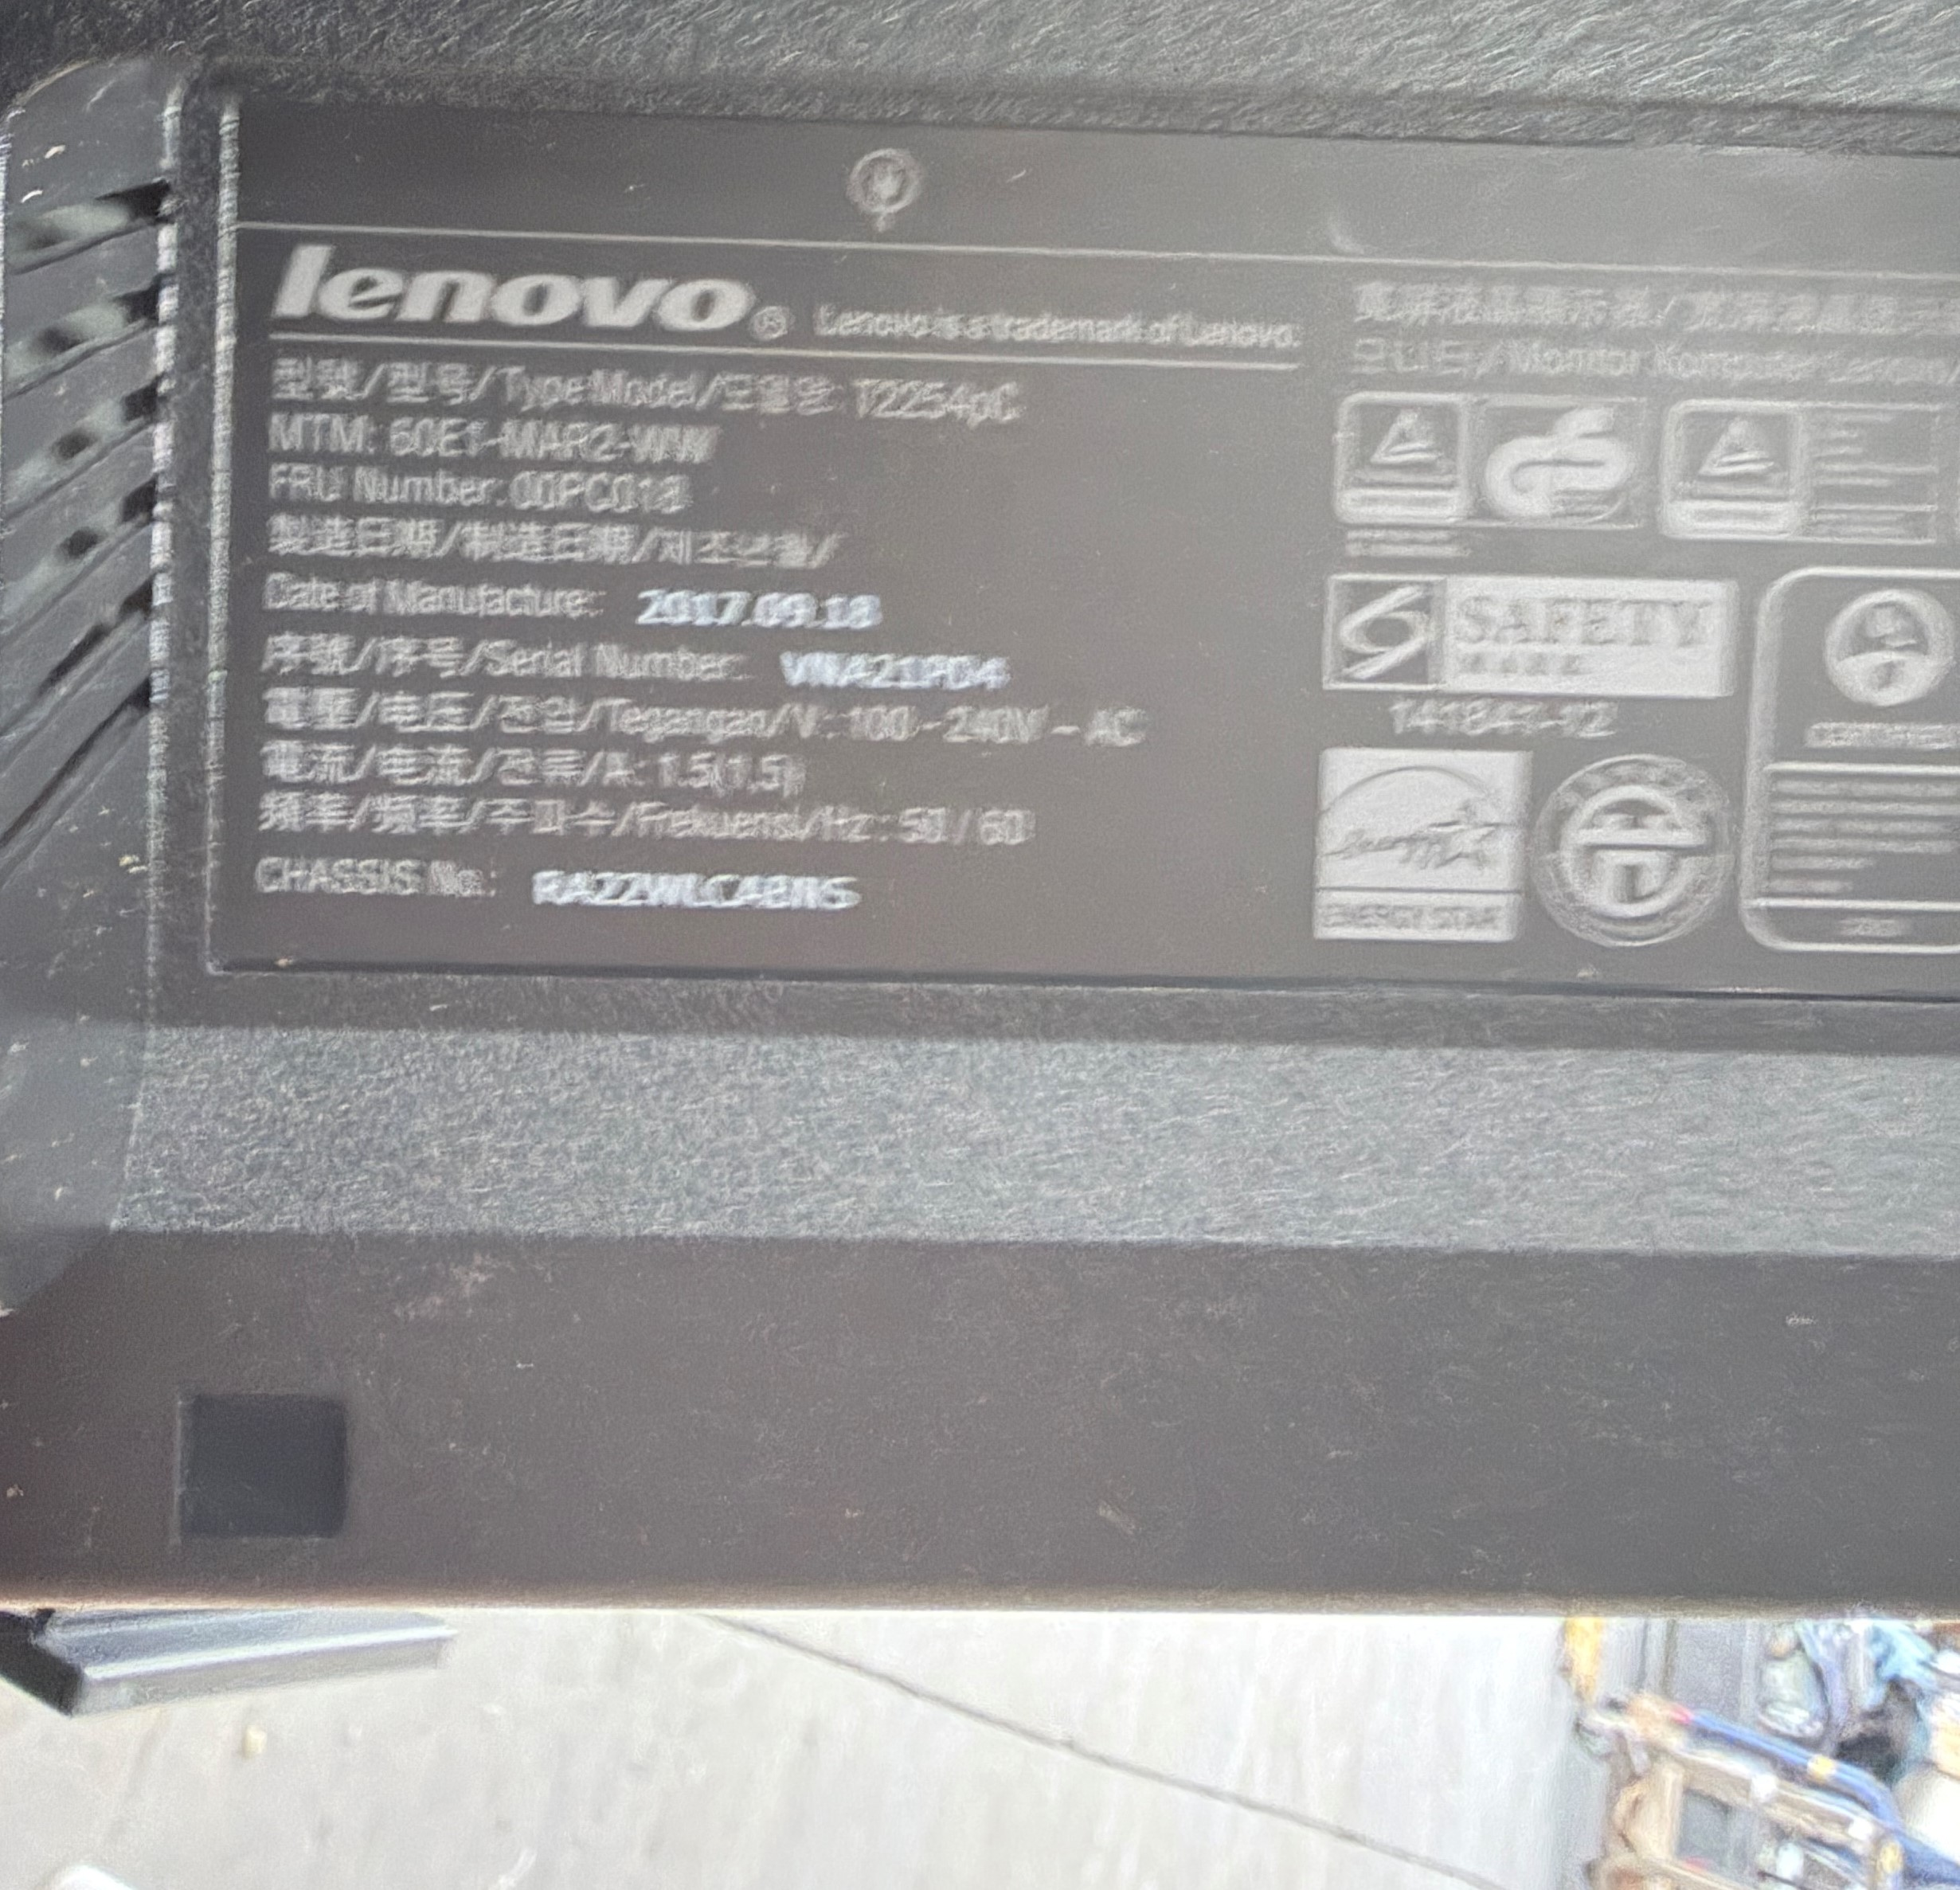
Type/Model: T2254pC | MTM: 60E1-MAR2-WW | FRU: 00PC018

ThinkVision T22i-10 — representative label (IMG_6251.JPG)
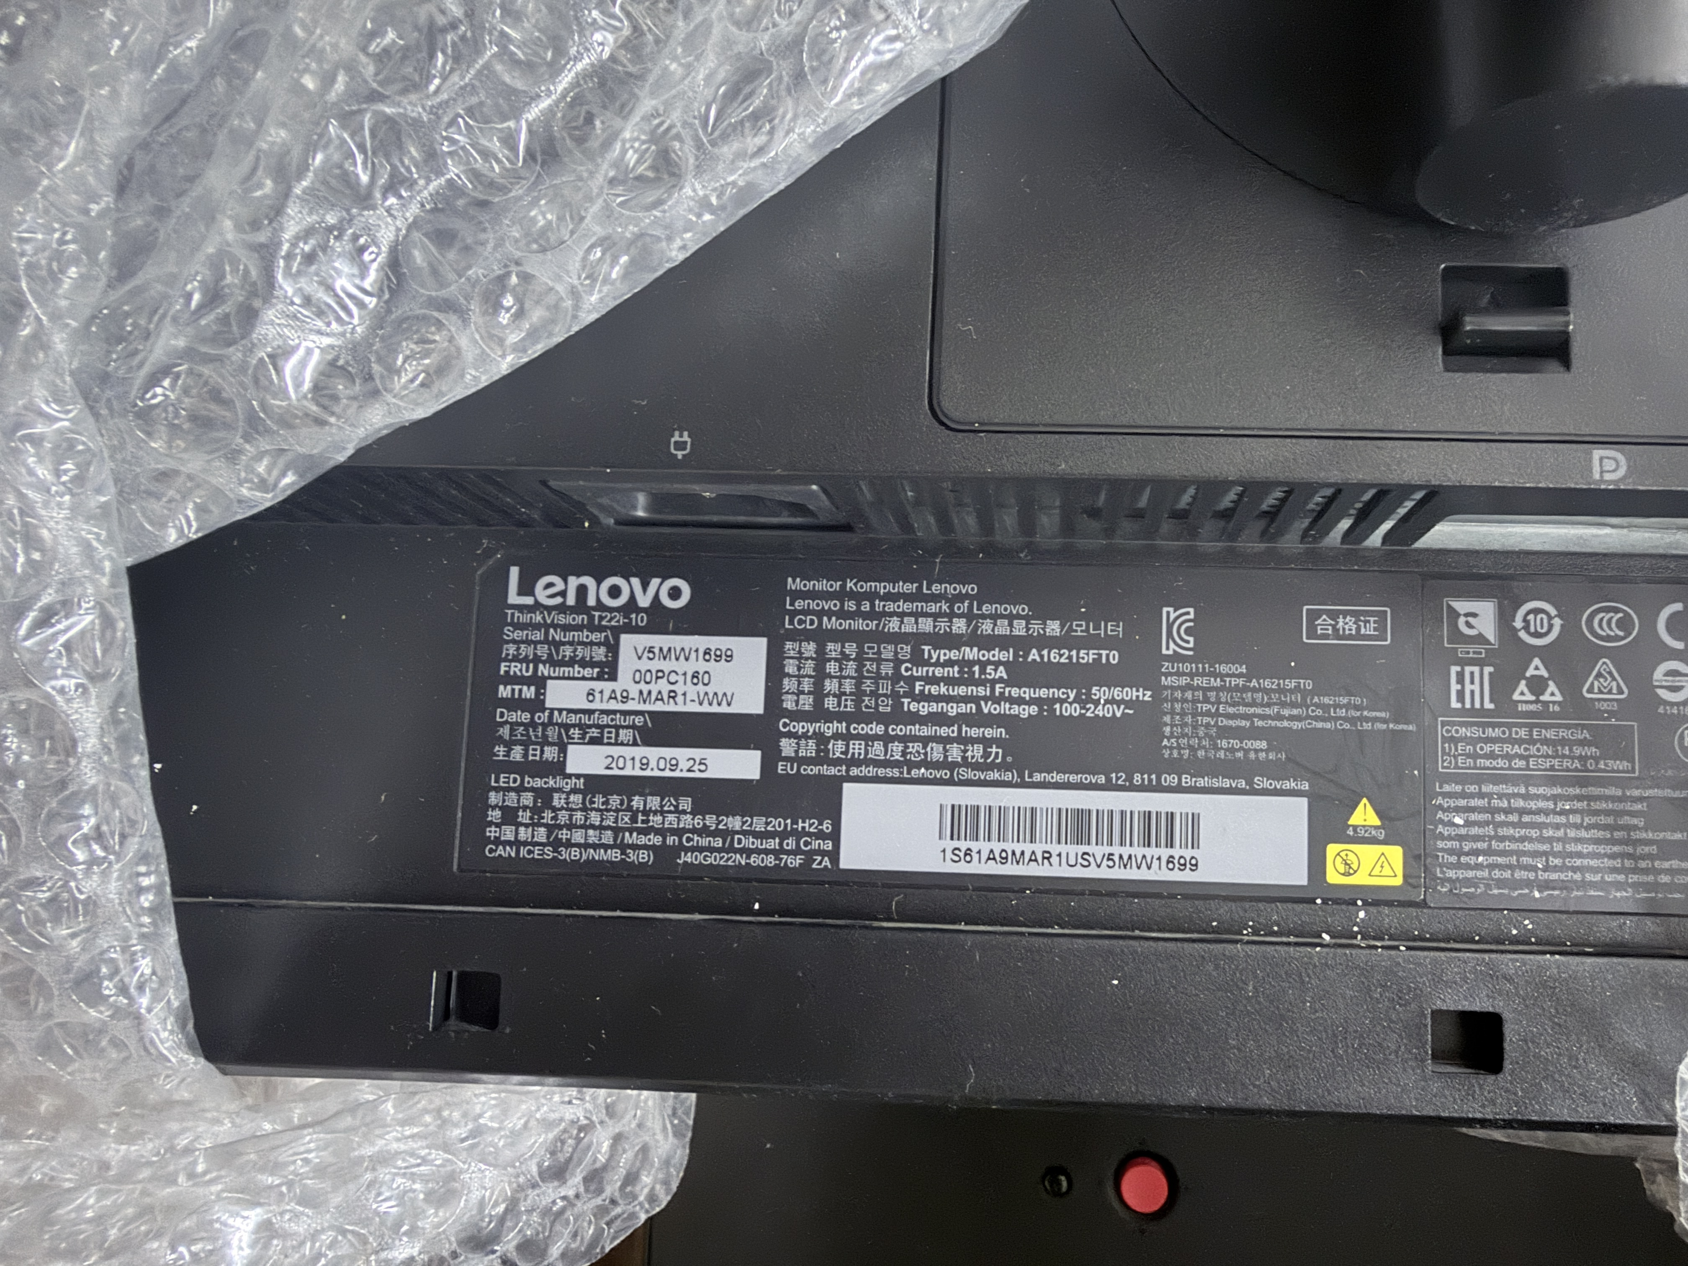
Type/Model: A16215FT0 | MTM: 61A9-MAR1-WW | FRU: 00PC160

ThinkVision T22i-20 — representative label (IMG_6347.JPG)
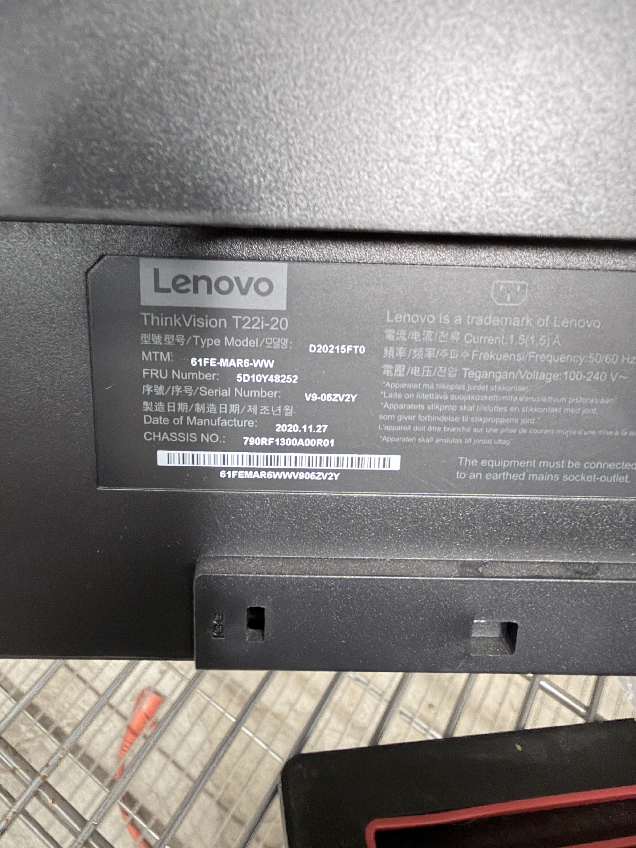
Type/Model: D20215FT0 | MTM: 61FE-MAR6-WW | FRU: 5D10Y48252

ThinkVision P24h-30 — representative label (IMG_6253.JPG)
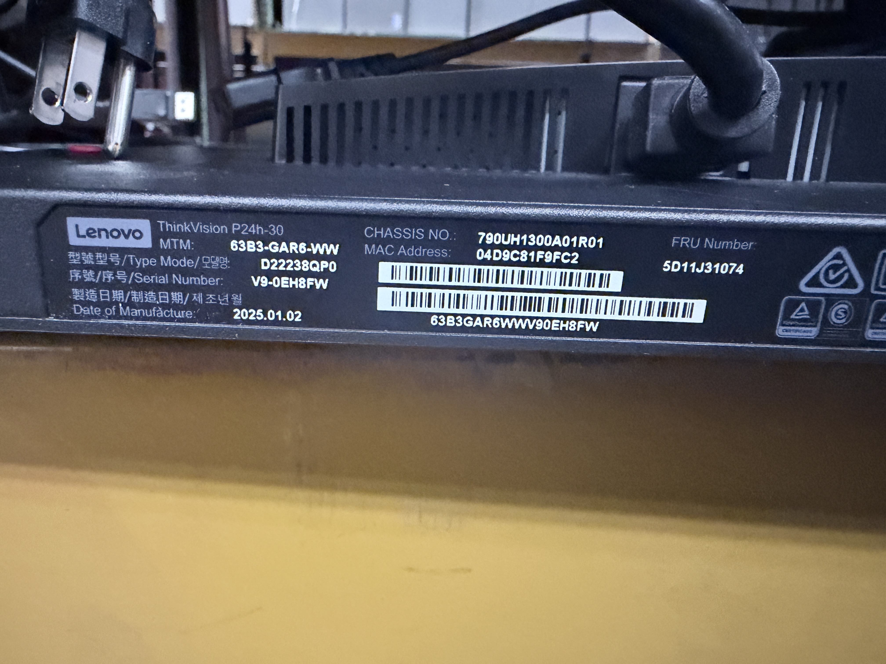
Type/Model: D22238QP0 | MTM: 63B3-GAR6-WW | FRU: 5D11J31074

5. Country-of-origin evidence status
Model | Country of origin | Evidence status
ThinkVision T2254pC | Pending | Manufacturer declaration or legible COO label required
ThinkVision T22i-10 | China | Confirmed on representative product label
ThinkVision T22i-20 | Pending | Manufacturer declaration or legible COO label required
ThinkVision P24h-30 | Pending | Manufacturer declaration or legible COO label required

6. Submission checklist
- Technical specification sheets: supplied by official Lenovo links for all four models.
- Manufacturer/model/part numbers: included in the model summary and specification sections.
- User manuals: supplied through official Lenovo support links.
- Product-label photographs: supplied for all four models.
- Complete serial-number list: Appendix A.
- Commercial description and working value: included; final invoice parties require confirmation.
- Country of origin: T22i-10 confirmed as China; three model groups remain pending.
- Mexican tariff classification, HTS determination and NOM applicability: to be completed by the customs broker/importer using this technical package.

Appendix A — Complete 190-unit serial and model ledger
All serial values are treated as accepted for purposes of this package, per project direction. Source-photo filenames are retained for audit traceability.
No. | Source Photo | Series | Type/Model | Serial Number
1 | IMG_6251.JPG | ThinkVision T22i-10 | A16215FT0 | V5MW1699
2 | IMG_6253.JPG | ThinkVision P24h-30 | D22238QP0 | V9-OEH8FW
3 | IMG_6255.JPG | ThinkVision T2254pC | T2254pC | VNA21PDV
4 | IMG_6256.JPG | ThinkVision T2254pC | T2254pC | VNA21PCB
5 | IMG_6258.JPG | ThinkVision T2254pC | T2254pC | VNA20MK9
6 | IMG_6260.JPG | ThinkVision T2254pC | T2254pC | VNA21PDB
7 | IMG_6261.JPG | ThinkVision T2254pC | T2254pC | VNA20GR9
8 | IMG_6262.JPG | ThinkVision T2254pC | T2254pC | VNA21PDD
9 | IMG_6263.JPG | ThinkVision T2254pC | T2254pC | VNA21P80
10 | IMG_6264.JPG | ThinkVision P24h-30 | D22238QP0 | V9-0EEKC2
11 | IMG_6265.JPG | ThinkVision T2254pC | T2254pC | VNA21PD9
12 | IMG_6266.JPG | ThinkVision T2254pC | T2254pC | VNA21P77
13 | IMG_6267.JPG | ThinkVision T2254pC | T2254pC | VNA20MK4
14 | IMG_6268.JPG | ThinkVision T2254pC | T2254pC | VNA21P7C
15 | IMG_6269.JPG | ThinkVision T2254pC | T2254pC | VNA21PMA
16 | IMG_6270.JPG | ThinkVision T2254pC | T2254pC | VNA20NYK
17 | IMG_6271.JPG | ThinkVision T2254pC | T2254pC | VNA199FV
18 | IMG_6273.JPG | ThinkVision T2254pC | T2254pC | VNA20ML4
19 | IMG_6274.JPG | ThinkVision T2254pC | T2254pC | VNA20MKM
20 | IMG_6278.JPG | ThinkVision T2254pC | T2254pC | VNA21PF7
21 | IMG_6280.JPG | ThinkVision T2254pC | T2254pC | VNA21PDX
22 | IMG_6281.JPG | ThinkVision T2254pC | T2254pC | VNA21PGZ
23 | IMG_6282.JPG | ThinkVision T2254pC | T2254pC | VNA20MKO
24 | IMG_6283.JPG | ThinkVision T2254pC | T2254pC | VNA21PCL
25 | IMG_6284.JPG | ThinkVision T2254pC | T2254pC | VNA20HBC
26 | IMG_6285.JPG | ThinkVision T2254pC | T2254pC | VNA21NNV
27 | IMG_6286.JPG | ThinkVision T2254pC | T2254pC | VNA21PHM
28 | IMG_6287.JPG | ThinkVision T2254pC | T2254pC | VNA20RL6
29 | IMG_6288.JPG | ThinkVision T2254pC | T2254pC | VNA20MYR
30 | IMG_6289.JPG | ThinkVision T2254pC | T2254pC | VNA20MYW
31 | IMG_6290.JPG | ThinkVision T2254pC | T2254pC | VNA20MK7
32 | IMG_6291.JPG | ThinkVision T2254pC | T2254pC | VNA21PGV
33 | IMG_6292.JPG | ThinkVision T2254pC | T2254pC | VNA21PF5
34 | IMG_6293.JPG | ThinkVision T22i-10 | A16215FT0 | V5MV8915
35 | IMG_6294.JPG | ThinkVision T2254pC | T2254pC | VNA20MLO
36 | IMG_6296.JPG | ThinkVision T2254pC | T2254pC | VNA20MKA
37 | IMG_6297.JPG | ThinkVision T22i-10 | A16215FT0 | V5HX1908
38 | IMG_6298.JPG | ThinkVision T2254pC | T2254pC | VNA21PGW
39 | IMG_6299.JPG | ThinkVision T2254pC | T2254pC | VNA21PHP
40 | IMG_6300.JPG | ThinkVision T22i-10 | A16215FT0 | V5HH1349
41 | IMG_6301.JPG | ThinkVision P24h-30 | D22238QP0 | V9-0D39VR
42 | IMG_6302.JPG | ThinkVision P24h-30 | D22238QP0 | V9-OEYA9B
43 | IMG_6303.JPG | ThinkVision T2254pC | T2254pC | VNA21P7D
44 | IMG_6304.JPG | ThinkVision T2254pC | T2254pC | VNA21PCR
45 | IMG_6305.JPG | ThinkVision T2254pC | T2254pC | VNA21P7Y
46 | IMG_6306.JPG | ThinkVision T22i-10 | A16215FT0 | V5MV8924
47 | IMG_6307.JPG | ThinkVision T2254pC | T2254pC | VNA21PMX
48 | IMG_6308.JPG | ThinkVision T22i-10 | A16215FT0 | V5MV8918
49 | IMG_6309.JPG | ThinkVision T2254pC | T2254pC | VNA21PGR
50 | IMG_6310.JPG | ThinkVision T22i-10 | A16215FT0 | V5LA0533
51 | IMG_6311.JPG | ThinkVision T2254pC | T2254pC | VNA21PHT
52 | IMG_6312.JPG | ThinkVision T2254pC | T2254pC | VNA21PCX
53 | IMG_6313.JPG | ThinkVision T2254pC | T2254pC | VNA21P7K
54 | IMG_6314.JPG | ThinkVision T2254pC | T2254pC | VNA21P7V
55 | IMG_6315.JPG | ThinkVision T2254pC | T2254pC | VNA21PHV
56 | IMG_6316.JPG | ThinkVision T2254pC | T2254pC | VNA20HBB
57 | IMG_6317.JPG | ThinkVision T2254pC | T2254pC | VNA21PCW
58 | IMG_6318.JPG | ThinkVision T2254pC | T2254pC | VNA21PD8
59 | IMG_6319.JPG | ThinkVision T2254pC | T2254pC | VNA26G8H
60 | IMG_6321.JPG | ThinkVision T2254pC | T2254pC | VNA20ML9
61 | IMG_6322.JPG | ThinkVision T2254pC | T2254pC | VNA20MKZ
62 | IMG_6323.JPG | ThinkVision T2254pC | T2254pC | VNA21PMR
63 | IMG_6324.JPG | ThinkVision T2254pC | T2254pC | VNA21PHC
64 | IMG_6325.JPG | ThinkVision T2254pC | T2254pC | VNA21PH9
65 | IMG_6326.JPG | ThinkVision T2254pC | T2254pC | VNA1H63AK
66 | IMG_6327.JPG | ThinkVision T2254pC | T2254pC | VNA21PF6
67 | IMG_6328.JPG | ThinkVision T2254pC | T2254pC | VNA21PMP
68 | IMG_6329.JPG | ThinkVision T2254pC | T2254pC | VNA21PD2
69 | IMG_6330.JPG | ThinkVision T2254pC | T2254pC | VNA21N96
70 | IMG_6331.JPG | ThinkVision T2254pC | T2254pC | VNA20MK8
71 | IMG_6332.JPG | ThinkVision T2254pC | T2254pC | VNA21PDY
72 | IMG_6333.JPG | ThinkVision T2254pC | T2254pC | VNA21NDX
73 | IMG_6334.JPG | ThinkVision T2254pC | T2254pC | VNA21PHN
74 | IMG_6336.JPG | ThinkVision T22i-10 | A16215FT0 | V5MV8684
75 | IMG_6337.JPG | ThinkVision T2254pC | T2254pC | VNA20MKF
76 | IMG_6338.JPG | ThinkVision T2254pC | T2254pC | VNA21PDW
77 | IMG_6339.JPG | ThinkVision T2254pC | T2254pC | VNA21PMZ
78 | IMG_6340.JPG | ThinkVision T2254pC | T2254pC | VNA21P7X
79 | IMG_6341.JPG | ThinkVision T2254pC | T2254pC | VNA21N98
80 | IMG_6343.JPG | ThinkVision T22i-10 | A16215FT0 | V5LA0093
81 | IMG_6345.JPG | ThinkVision T2254pC | T2254pC | VNA21PGN
82 | IMG_6347.JPG | ThinkVision T22i-20 | D20215FT0 | V9-06ZV2Y
83 | IMG_6348.JPG | ThinkVision T22i-20 | D20215FT0 | V9-070Z51
84 | IMG_6349.JPG | ThinkVision T2254pC | T2254pC | VNA20ML5
85 | IMG_6350.JPG | ThinkVision T2254pC | T2254pC | VNA21PH7
86 | IMG_6353.JPG | ThinkVision T22i-10 | A16215FT0 | V5Z21014
87 | IMG_6354.JPG | ThinkVision T22i-10 | A16215FT0 | V5Z20759
88 | IMG_6357.jpg | ThinkVision T2254pC | T2254pC | VNA20HAN
89 | IMG_6358.JPG | ThinkVision T2254pC | T2254pC | VNA21PHL
90 | IMG_6359.JPG | ThinkVision T2254pC | T2254pC | VNA21P7Z
91 | IMG_6361.JPG | ThinkVision T2254pC | T2254pC | VNA21P7G
92 | IMG_6362.JPG | ThinkVision T2254pC | T2254pC | VNA21P7M
93 | IMG_6363.JPG | ThinkVision T2254pC | T2254pC | VNA21PCP
94 | IMG_6365.JPG | ThinkVision T22i-20 | D20215FT0 | V9-06ZV2V
95 | IMG_6366.JPG | ThinkVision T2254pC | T2254pC | VNA21P7A
96 | IMG_6367.JPG | ThinkVision T2254pC | T2254pC | VNA21PGY
97 | IMG_6368.JPG | ThinkVision T2254pC | T2254pC | VNA21PHA
98 | IMG_6369.JPG | ThinkVision T2254pC | T2254pC | VNA21P7F
99 | IMG_6370.JPG | ThinkVision T2254pC | T2254pC | VNA26Y62
100 | IMG_6371.JPG | ThinkVision T2254pC | T2254pC | VNA21PMH
101 | IMG_6372.JPG | ThinkVision T2254pC | T2254pC | VNA21P7H
102 | IMG_6373.JPG | ThinkVision T22i-10 | A16215FT0 | V5WN8184
103 | IMG_6374.JPG | ThinkVision T22i-20 | D20215FT0 | V9-06ZV35
104 | IMG_6375.JPG | ThinkVision T2254pC | T2254pC | VNA20MYX
105 | IMG_6376.JPG | ThinkVision T2254pC | T2254pC | VNA21PQ1
106 | IMG_6377.JPG | ThinkVision T2254pC | T2254pC | VNA21PDZ
107 | IMG_6378.JPG | ThinkVision T2254pC | T2254pC | VNA20MK2
108 | IMG_6379.JPG | ThinkVision T2254pC | T2254pC | VNA21PN9
109 | IMG_6380.JPG | ThinkVision T22i-10 | A16215FT0 | V5KB8973
110 | IMG_6381.JPG | ThinkVision T2254pC | T2254pC | VNA21PMK
111 | IMG_6382.JPG | ThinkVision T2254pC | T2254pC | VNA21P7W
112 | IMG_6383.JPG | ThinkVision T2254pC | T2254pC | VNA21P7P
113 | IMG_6384.JPG | ThinkVision T2254pC | T2254pC | VNA263ZZ
114 | IMG_6386.JPG | ThinkVision T2254pC | T2254pC | VNA21P79
115 | IMG_6387.JPG | ThinkVision T22i-10 | A16215FT0 | V5LA0027
116 | IMG_6388.JPG | ThinkVision T22i-10 | A16215FT0 | V5Z21017
117 | IMG_6389.JPG | ThinkVision T2254pC | T2254pC | VNA21PQV
118 | IMG_6390.JPG | ThinkVision T2254pC | T2254pC | VNA21PH8
119 | IMG_6393.JPG | ThinkVision T2254pC | T2254pC | VNA21POY
120 | IMG_6394.JPG | ThinkVision T2254pC | T2254pC | VNA26G93
121 | IMG_6396.JPG | ThinkVision P24h-30 | D22238QP0 | V9-OEYAL9
122 | IMG_6397.JPG | ThinkVision T2254pC | T2254pC | VNA20MRL
123 | IMG_6398.JPG | ThinkVision T2254pC | T2254pC | VNA21PH6
124 | IMG_6399.JPG | ThinkVision T2254pC | T2254pC | VNA21NN7
125 | IMG_6400.JPG | ThinkVision T2254pC | T2254pC | VNA21P7B
126 | IMG_6401.JPG | ThinkVision T2254pC | T2254pC | VNA21PN1
127 | IMG_6402.JPG | ThinkVision T2254pC | T2254pC | VNA26FMM
128 | IMG_6403.JPG | ThinkVision T2254pC | T2254pC | VNA20MKP
129 | IMG_6404.JPG | ThinkVision T2254pC | T2254pC | VNA21N77
130 | IMG_6405.JPG | ThinkVision T2254pC | T2254pC | VNA21PC7
131 | IMG_6407.JPG | ThinkVision T2254pC | T2254pC | VNA20MKG
132 | IMG_6408.JPG | ThinkVision T2254pC | T2254pC | VNA2PHF
133 | IMG_6409.JPG | ThinkVision T2254pC | T2254pC | VNA20MK3
134 | IMG_6410.JPG | ThinkVision T2254pC | T2254pC | VNA21PA9
135 | IMG_6411.JPG | ThinkVision T2254pC | T2254pC | VNA26G98
136 | IMG_6412.JPG | ThinkVision T22i-10 | A16215FT0 | V5LA0103
137 | IMG_6413.JPG | ThinkVision T22i-10 | A16215FT0 | V5LA0117
138 | IMG_6416.JPG | ThinkVision T2254pC | T2254pC | VNA21PMN
139 | IMG_6417.JPG | ThinkVision T2254pC | T2254pC | VNA20MKX
140 | IMG_6418.JPG | ThinkVision T2254pC | T2254pC | VNA21PH4
141 | IMG_6419.JPG | ThinkVision T2254pC | T2254pC | VNA21PH1
142 | IMG_6420.JPG | ThinkVision T2254pC | T2254pC | VNA20HBH
143 | IMG_6421.JPG | ThinkVision T22i-20 | D20215FT0 | V9-06ZGY6
144 | IMG_6422.JPG | ThinkVision T2254pC | T2254pC | VNA20MYM
145 | IMG_6423.JPG | ThinkVision T2254pC | T2254pC | VNA21PD7
146 | IMG_6424.JPG | ThinkVision T2254pC | T2254pC | VNA21PCK
147 | IMG_6425.JPG | ThinkVision T2254pC | T2254pC | VNA21PGP
148 | IMG_6426.JPG | ThinkVision T2254pC | T2254pC | VNA20MYG
149 | IMG_6427.JPG | ThinkVision T2254pC | T2254pC | VNA21PMW
150 | IMG_6429.jpg | ThinkVision T22i-10 | A16215FT0 | V5WN8159
151 | IMG_6430.jpg | ThinkVision T2254pC | T2254pC | VNA21PH3
152 | IMG_6431.JPG | ThinkVision T2254pC | T2254pC | VNA21PMO
153 | IMG_6432.JPG | ThinkVision T2254pC | T2254pC | VNA21PMG
154 | IMG_6433.JPG | ThinkVision T2254pC | T2254pC | VNA20MYH
155 | IMG_6435.JPG | ThinkVision T22i-10 | A16215FT0 | V5LA0111
156 | IMG_6436.JPG | ThinkVision T22i-10 | A16215FT0 | V5Z20752
157 | IMG_6437.JPG | ThinkVision T2254pC | T2254pC | VNA21P81
158 | IMG_6438.JPG | ThinkVision T2254pC | T2254pC | VNA21PGX
159 | IMG_6439.JPG | ThinkVision T2254pC | T2254pC | VNA21PDC
160 | IMG_6440.JPG | ThinkVision T2254pC | T2254pC | VNA21P7L
161 | IMG_6441.JPG | ThinkVision T2254pC | T2254pC | VNA21PND
162 | IMG_6442.JPG | ThinkVision T2254pC | T2254pC | VNA21PHD
163 | IMG_6443.JPG | ThinkVision T2254pC | T2254pC | VNA20MLX
164 | IMG_6444.JPG | ThinkVision T2254pC | T2254pC | VNA21PM2
165 | IMG_6445.JPG | ThinkVision T2254pC | T2254pC | VNA20MK6
166 | IMG_6446.jpg | ThinkVision T2254pC | T2254pC | VNA21PN3
167 | IMG_6447.jpg | ThinkVision T2254pC | T2254pC | VNA21PM3
168 | IMG_6448.JPG | ThinkVision T2254pC | T2254pC | VNA21PD4
169 | IMG_6449.JPG | ThinkVision T22i-10 | A16215FT0 | V5MV8921
170 | IMG_6450.JPG | ThinkVision T2254pC | T2254pC | VNA20MK5
171 | IMG_6451.JPG | ThinkVision T2254pC | T2254pC | VNA21PM4
172 | IMG_6452.JPG | ThinkVision T2254pC | T2254pC | VNA21PDO
173 | IMG_6453.JPG | ThinkVision T2254pC | T2254pC | VNA21PMB
174 | IMG_6454.jpg | ThinkVision T22i-10 | A16215FT0 | V5MV8927
175 | IMG_6455.jpg | ThinkVision T2254pC | T2254pC | VNA21NCG
176 | IMG_6456.JPG | ThinkVision T2254pC | T2254pC | VNA21PCD
177 | IMG_6457.JPG | ThinkVision T2254pC | T2254pC | VNA26Y5F
178 | IMG_6458.JPG | ThinkVision T2254pC | T2254pC | VNA21PHB
179 | IMG_6459.JPG | ThinkVision T22i-10 | A16215FT0 | V5Z20744
180 | IMG_6460.JPG | ThinkVision T2254pC | T2254pC | VNA21PH5
181 | IMG_6461.JPG | ThinkVision T2254pC | T2254pC | VNA20MYT
182 | IMG_6462.jpg | ThinkVision T22i-10 | A16215FT0 | V5MV8686
183 | IMG_6463.JPG | ThinkVision T2254pC | T2254pC | VNA21PQ2
184 | IMG_6464.JPG | ThinkVision T2254pC | T2254pC | VNA21PGT
185 | IMG_6465.JPG | ThinkVision T2254pC | T2254pC | VNA20MKT
186 | IMG_6466.JPG | ThinkVision T22i-10 | A16215FT0 | V5LA0109
187 | IMG_6467.JPG | ThinkVision P24h-30 | D22238QP0 | V9-0EF8HV
188 | IMG_6468.JPG | ThinkVision P24h-30 | D22238QP0 | V9-0EF8HM
189 | IMG_6469.JPG | ThinkVision P24h-30 | D22238QP0 | V9-OEF8HN
190 | IMG_E6295.JPG | ThinkVision P24h-30 | D22238QP0 | V9-0EH8FC
End of package.

