Homework , SIE 330R, Spring 202180

Homework must be readable!

Do not just send in numbers or charts. You must explain the homework answers

Preferred to receive homework in Word doc format with any excel or Minitab results pasted into word document. You may choose to use pdf which is also OK. Put answers to all questions in one document NOT in separate documents.

Use Minitab. If Minitab cannot produce some of the requested information then note that on your answers. Montgomery uses Minitab but he also uses Design Expert and Design Expert produces output that Minitab does not. Answer the questions as best you can.

* Homework #11 Chapter 9 Prob. 9.4, (Due April 3)
* **9.4.** An experiment is run in a chemical process using a 32 factorial design. The design factors are temperature and pressure, and the response variable is yield. The data that result from this experiment are shown below.

|  |  |  |  |
| --- | --- | --- | --- |
|  | Pressure, psig | | |
| Temperature, °C | 100 | 120 | 140 |
| 80 | 47.58, 48.77 | 64.97, 69.22 | 80.92, 72.60 |
| 90 | 51.86, 82.43 | 88.47, 84.23 | 93.95, 88.54 |
| 100 | 71.18, 92.77 | 96.57, 88.72 | 76.58, 83.04 |

* You may need to use the Regression tab instead of the DOE tab to solve this problem!!

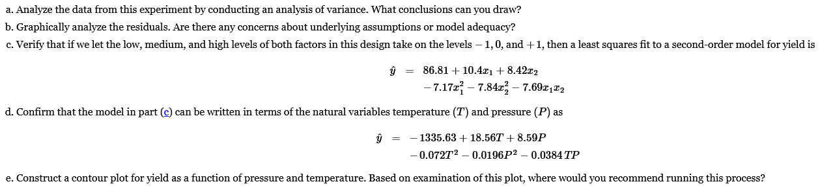

a)

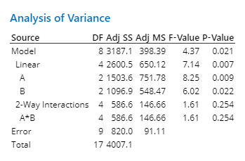

The first major conclusion we can make is that the data for the model is not statistically significant, given that our model’s p-value is less than 0.05. We can also infer that temperature(A), yields a higher value than B, given the higher Adj. SS. We can also conclude that the interaction between A and B (temperature and Pressure) is significant.

b)

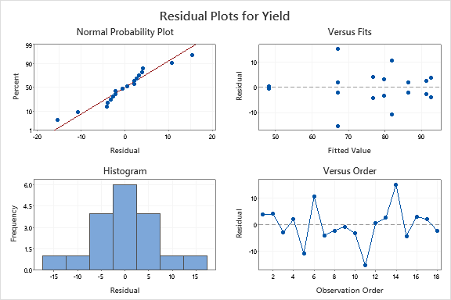

The only worrying residual result is the versus fit, which is too varied to be considered a good and consistent fit. The normal probability plot is solid, which generally alleviates concerns.

c)

Done by changing the A and B values to -1. 0 and 1, then running a regression analysis with the -1 and 1 coded coefficients.

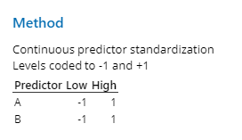

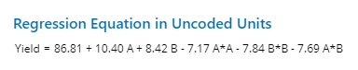

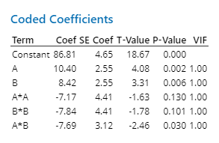

d)

The same process applies with the original values and we get the following results:

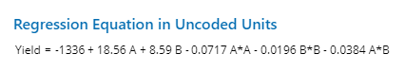

e)

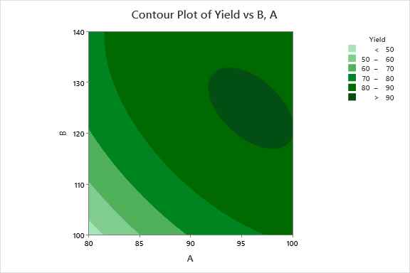

The greatest yield is around a temperature of 95 and a pressure of 130, so that would be ideal. However, if we had to stick to the given parameters, I would recommend 100 temperature and 120 pressure.