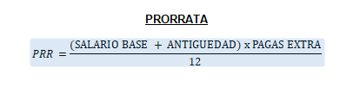

BCP
BCP=BCC + HORAS EXTRA

