**Team Name:** ui-awesomenauts

**Team Members:**

Rotem David: rd2499,

Jose Rodriguez: jgr2128,

Robert Tolda: rmt2131,

Philip Liou: pl2486

**User Manual**

1. Search for Businesses to Tag

To search for businesses to tag, enter your search terms and location in the search and location fields, respectively, at the top of the home page. Hit “Search for places” to execute the search.

**Search box and User Manual.**

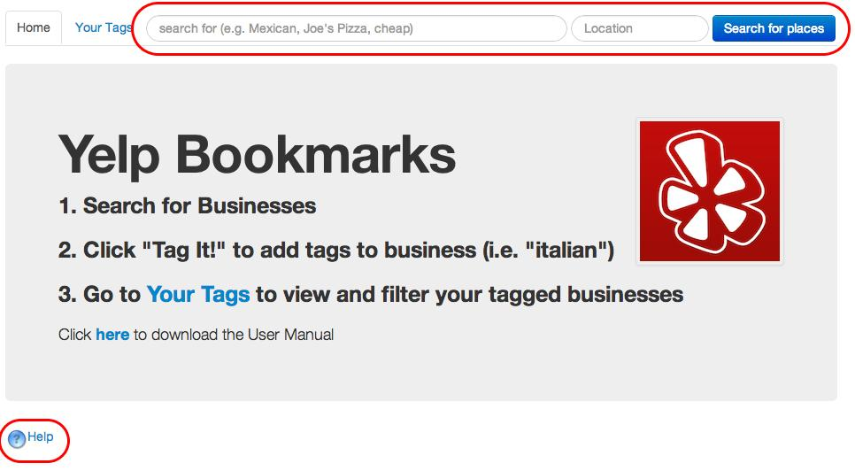

**Enter search terms and location.**

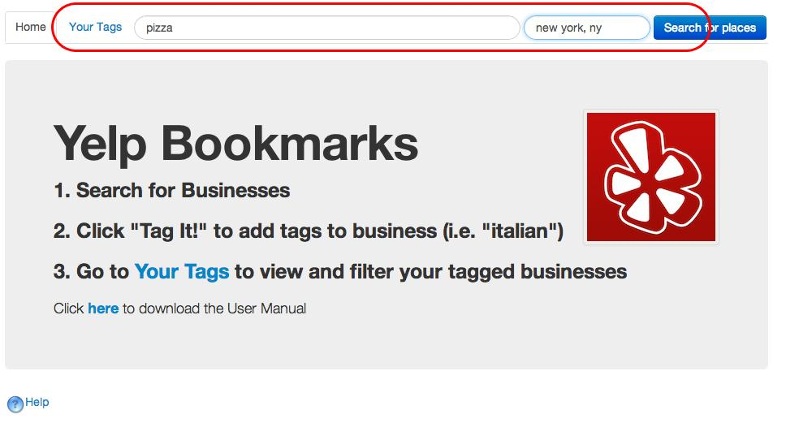

The application then returns Yelp businesses that match your search criteria. Basic business information is displayed, along with a “Tag It” button for you to add custom tags for each business.

**Search Results Displayed.**

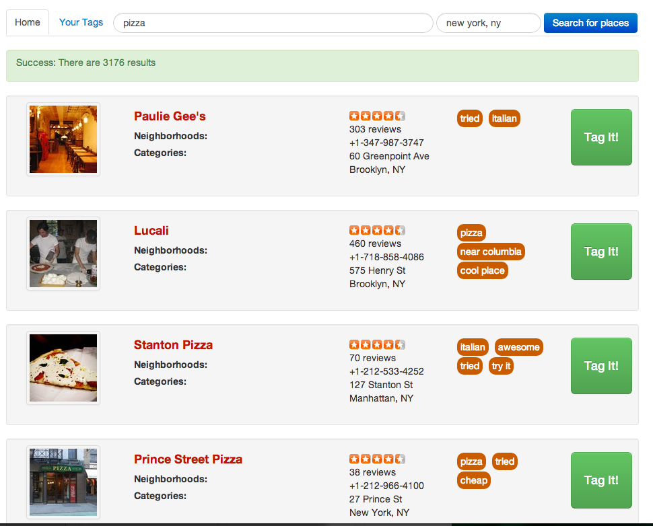

2. Tagging Businesses

To add your own tags to each business, simply click the green “Tag It” button on the far right of each business. A pop-up window will appear that will allow you to select tags you want to associate with this business.

**Tag It pop-up.**

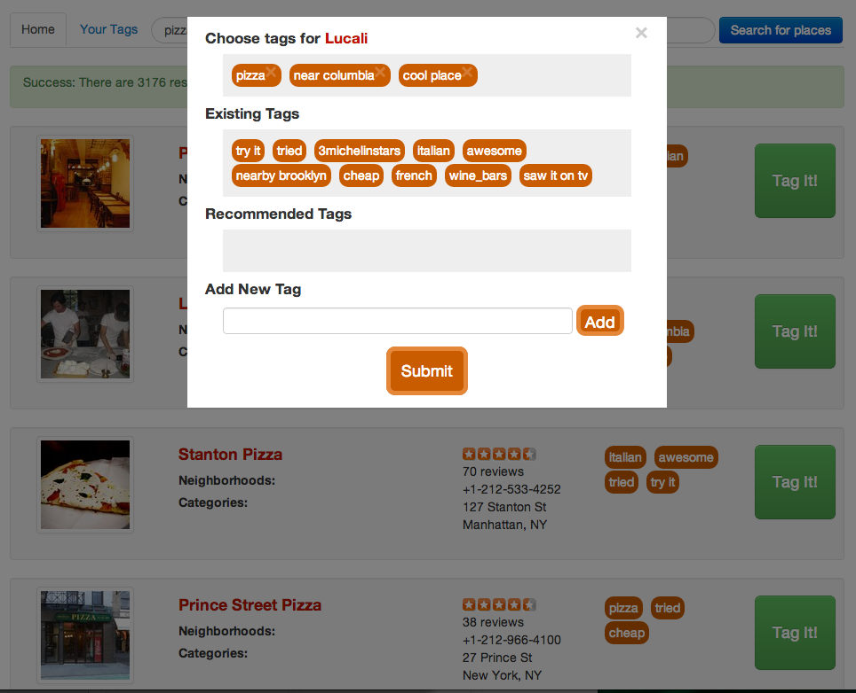

From the pop-up box, you will find the following sections:

* **Chosen Tags:** these are tags that you have selected to tag the business with.
  + To remove a tag, simply click on the tag and it will go back to the section it came from (i.e. “Existing Tags” or “Recommended Tags”).
* **Existing Tags:** these are all the tags that you have ever used
  + To add one of these tags, click on the tag to move it to the “Chosen Tags” section.
* **Recommended Tags:** these are tags that the system recommends for this business. Typically, these tags will be related to the business category, such as “Italian” or “Entertainment.”
  + To add one of these tags, click on the tag to move it to the “Chosen Tags” section.

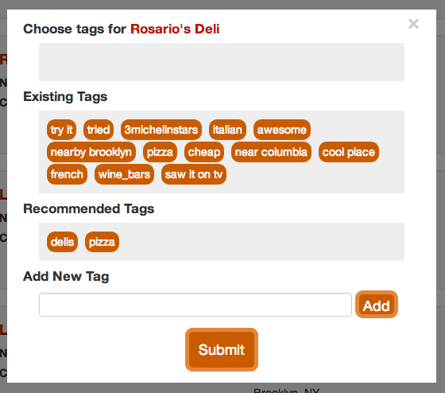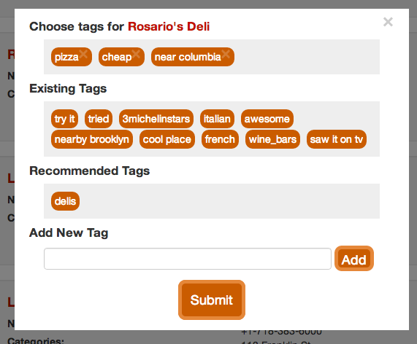

After you have selected all the tags you want to use, click on “Submit” to save the tags. The tags will now show up next to the business.

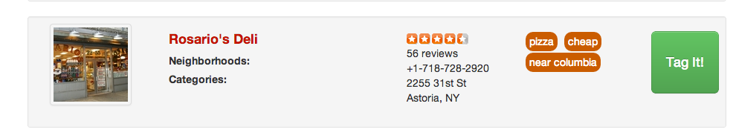

3. Viewing Your Tagged Businesses

To view all the businesses you have tagged, click on the “Your Tags” link at the top of the home page. When you arrive at the page, all your tagged businesses will appear on the right. Every tag that you have used appears on the left-hand side column, labeled “Your Tags”.

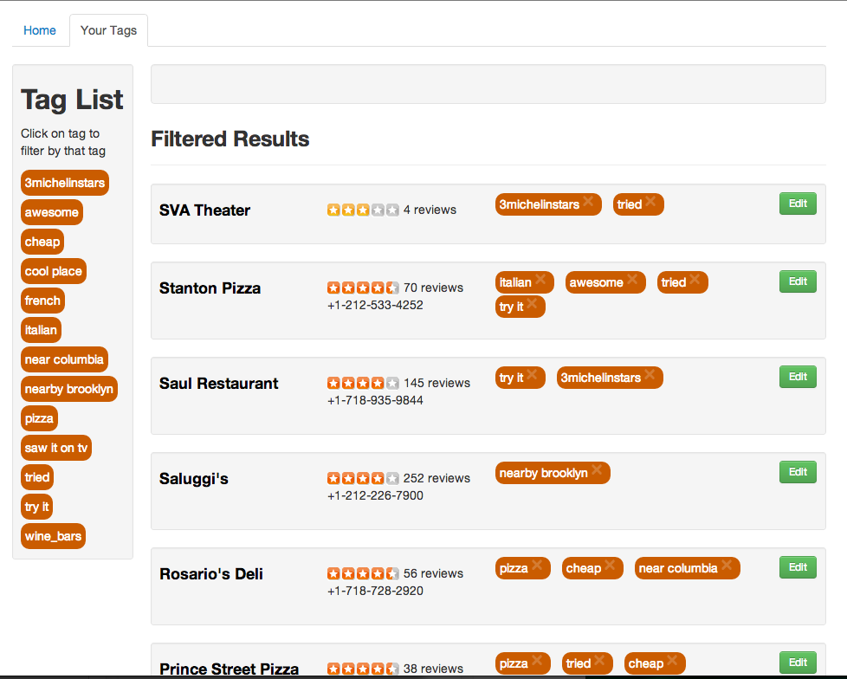

4. Filtering Through Your Tagged Businesses

To filter your tagged businesses, simply click on a tag in “Your Tags” to move it to the “Filter” section. All the businesses that have the selected tag(s) will appear below. You can select as many tags as you like, and only businesses that contain *all* of the tags will be shown.

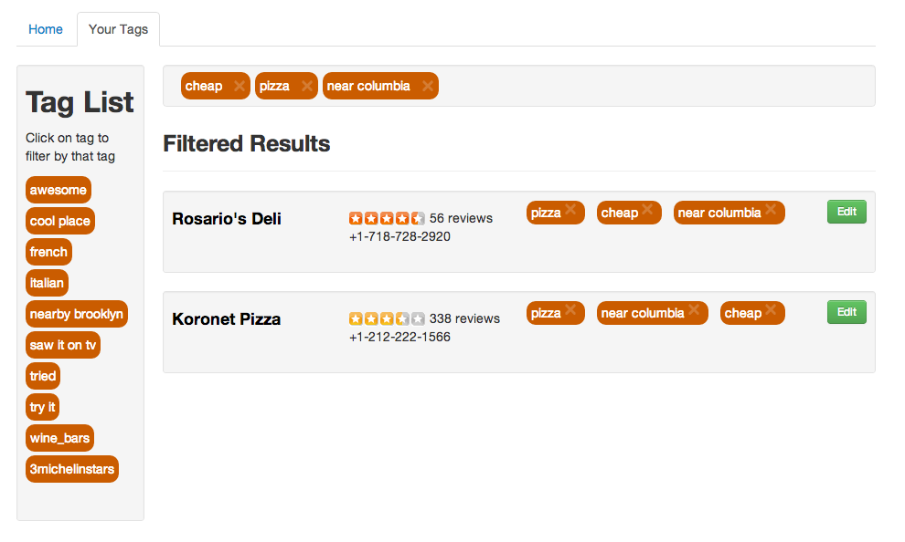

**Instructions to Run Application**

1. Open “search-results.html” in local server to start application