ASSIGNMENT NO: 2
Network Lab Experiments
Name: Jose Bijoy
Class: S5, CSE A
Roll No: 41
Date: 08/08/2026

Experiment 1: Hello – Client/Server Communication

Aim
To create a simple TCP-based client and server in C where the client establishes a connection, transmits a greeting, and receives a response from the server.
Commands Used
gcc server.c -o server
gcc client.c -o client
./server (run in Terminal 1)
./client (run in Terminal 2)
Procedure
Client Code
#include <stdio.h>
#include <stdlib.h>
#include <string.h>
#include <unistd.h>
#include <arpa/inet.h>
#include <sys/socket.h>
#define PORT 8080
#define BUFFER_SIZE 1024
#define SERVER_IP "127.0.0.1"
int main() {
int client_fd;
struct sockaddr_in server_addr;
char buffer[BUFFER_SIZE] = {0};
const char *message = "Hello Server";
client_fd = socket(AF_INET, SOCK_STREAM, 0);
if (client_fd < 0) {
perror("socket failed");
exit(EXIT_FAILURE);
}
server_addr.sin_family = AF_INET;
server_addr.sin_port = htons(PORT);
if (inet_pton(AF_INET, SERVER_IP, &server_addr.sin_addr) <= 0) {
perror("invalid address");
close(client_fd);
exit(EXIT_FAILURE);
}
if (connect(client_fd, (struct sockaddr *)&server_addr, sizeof(server_addr)) < 0) {
perror("connect failed");
close(client_fd);
exit(EXIT_FAILURE);
}
printf("Connected to server %s:%d\n", SERVER_IP, PORT);
send(client_fd, message, strlen(message), 0);
printf("Sent to server: %s\n", message);
ssize_t bytes_received = recv(client_fd, buffer, BUFFER_SIZE - 1, 0);
if (bytes_received > 0) {
buffer[bytes_received] = '\0';
printf("Received from server: %s\n", buffer);
}
close(client_fd);
return 0;
}

Server Code
#include <stdio.h>
#include <stdlib.h>
#include <string.h>
#include <unistd.h>
#include <arpa/inet.h>
#include <sys/socket.h>
#define PORT 8080
#define BUFFER_SIZE 1024
int main() {
int server_fd, client_fd;
struct sockaddr_in server_addr, client_addr;
socklen_t client_len = sizeof(client_addr);
char buffer[BUFFER_SIZE] = {0};
const char *reply = "Hello Client";
server_fd = socket(AF_INET, SOCK_STREAM, 0);
if (server_fd < 0) {
perror("socket failed");
exit(EXIT_FAILURE);
}
int opt = 1;
setsockopt(server_fd, SOL_SOCKET, SO_REUSEADDR, &opt, sizeof(opt));
server_addr.sin_family = AF_INET;
server_addr.sin_addr.s_addr = INADDR_ANY;
server_addr.sin_port = htons(PORT);
if (bind(server_fd, (struct sockaddr *)&server_addr, sizeof(server_addr)) < 0) {
perror("bind failed");
close(server_fd);
exit(EXIT_FAILURE);
}
if (listen(server_fd, 3) < 0) {
perror("listen failed");
close(server_fd);
exit(EXIT_FAILURE);
}
printf("Server listening on port %d...\n", PORT);
client_fd = accept(server_fd, (struct sockaddr *)&client_addr, &client_len);
if (client_fd < 0) {
perror("accept failed");
close(server_fd);
exit(EXIT_FAILURE);
}
printf("Client connected: %s:%d\n",
inet_ntoa(client_addr.sin_addr),
ntohs(client_addr.sin_port));
ssize_t bytes_received = recv(client_fd, buffer, BUFFER_SIZE - 1, 0);
if (bytes_received > 0) {
buffer[bytes_received] = '\0';
printf("Received from client: %s\n", buffer);
}
send(client_fd, reply, strlen(reply), 0);
printf("Sent to client: %s\n", reply);
close(client_fd);
close(server_fd);
return 0;
}

Output
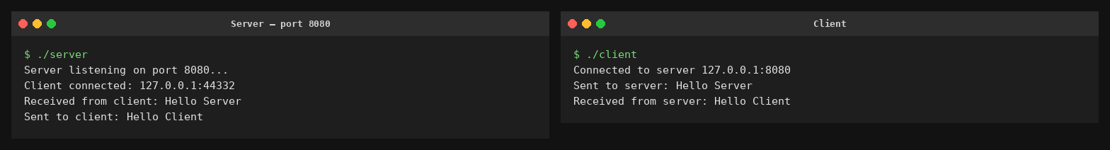
Conclusion
The TCP client and server were successfully executed. The client connected through port 8080, transmitted "Hello Server", and obtained "Hello Client" in return, showing that communication between both ends worked correctly.

Experiment 2: Arithmetic Server

Aim
To develop a client–server program where two integer values are sent by the client and the server calculates their addition, subtraction, multiplication, and division before sending the results back.
Commands Used
gcc server.c -o server
gcc client.c -o client
./server (run in Terminal 1)
./client (run in Terminal 2)
Procedure
Client Code
#include <stdio.h>
#include <stdlib.h>
#include <string.h>
#include <unistd.h>
#include <arpa/inet.h>
#include <sys/socket.h>
#define PORT 8081
#define BUFFER_SIZE 1024
#define SERVER_IP "127.0.0.1"
int main() {
int client_fd;
struct sockaddr_in server_addr;
char buffer[BUFFER_SIZE] = {0};
char message[BUFFER_SIZE] = {0};
int a, b;
client_fd = socket(AF_INET, SOCK_STREAM, 0);
server_addr.sin_family = AF_INET;
server_addr.sin_port = htons(PORT);
inet_pton(AF_INET, SERVER_IP, &server_addr.sin_addr);
connect(client_fd, (struct sockaddr *)&server_addr, sizeof(server_addr));
printf("Connected to server %s:%d\n", SERVER_IP, PORT);
printf("Enter first integer: ");
scanf("%d", &a);
printf("Enter second integer: ");
scanf("%d", &b);
snprintf(message, BUFFER_SIZE, "%d %d", a, b);
send(client_fd, message, strlen(message), 0);
printf("Sent to server: %s\n", message);
int n = recv(client_fd, buffer, BUFFER_SIZE - 1, 0);
buffer[n] = '\0';
printf("Results received from server:\n%s\n", buffer);
close(client_fd);
return 0;
}

Server Code
#include <stdio.h>
#include <stdlib.h>
#include <string.h>
#include <unistd.h>
#include <arpa/inet.h>
#include <sys/socket.h>
#define PORT 8081
#define BUFFER_SIZE 1024
int main() {
int server_fd, client_fd;
struct sockaddr_in server_addr, client_addr;
socklen_t client_len = sizeof(client_addr);
char buffer[BUFFER_SIZE] = {0};
char result[BUFFER_SIZE] = {0};
server_fd = socket(AF_INET, SOCK_STREAM, 0);
int opt = 1;
setsockopt(server_fd, SOL_SOCKET, SO_REUSEADDR, &opt, sizeof(opt));
server_addr.sin_family = AF_INET;
server_addr.sin_addr.s_addr = INADDR_ANY;
server_addr.sin_port = htons(PORT);
bind(server_fd, (struct sockaddr *)&server_addr, sizeof(server_addr));
listen(server_fd, 3);
printf("Server listening on port %d...\n", PORT);
client_fd = accept(server_fd, (struct sockaddr *)&client_addr, &client_len);
printf("Client connected: %s:%d\n",
inet_ntoa(client_addr.sin_addr), ntohs(client_addr.sin_port));
int n = recv(client_fd, buffer, BUFFER_SIZE - 1, 0);
buffer[n] = '\0';
printf("Received from client: %s\n", buffer);
int a, b;
sscanf(buffer, "%d %d", &a, &b);
int sum = a + b;
int diff = a - b;
int prod = a * b;
if (b != 0) {
double quo = (double)a / b;
snprintf(result, BUFFER_SIZE,
"Sum = %d\nDifference = %d\nProduct = %d\nQuotient = %.2f",
sum, diff, prod, quo);
} else {
snprintf(result, BUFFER_SIZE,
"Sum = %d\nDifference = %d\nProduct = %d\nQuotient = Undefined (division by zero)",
sum, diff, prod);
}
send(client_fd, result, strlen(result), 0);
printf("Sent results to client:\n%s\n", result);
close(client_fd);
close(server_fd);
return 0;
}

Output
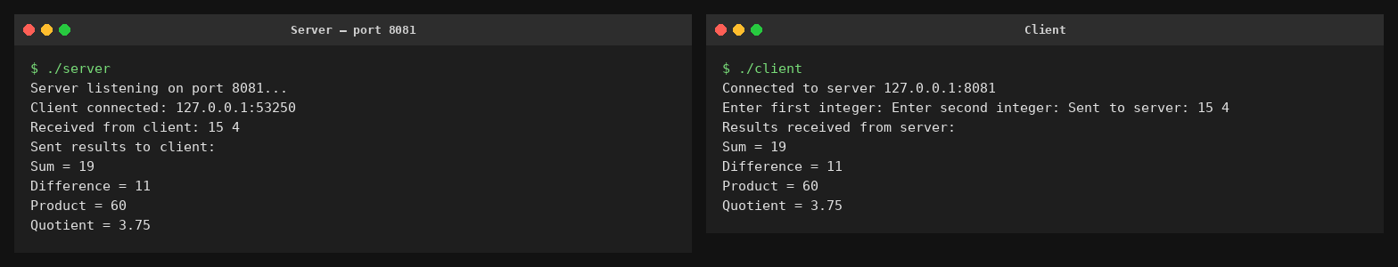
Conclusion
The arithmetic client–server system worked as expected. With 15 and 4 as inputs, it produced 19 for the sum, 11 for the difference, 60 for the product, and 3.75 for the quotient, then delivered these values to the client.

Experiment 3: String Processing Server

Aim
To build a socket-based string processing program where the client sends text and the server finds its length, changes it to uppercase, reverses the characters, and sends the processed information back.
Commands Used
gcc server.c -o server
gcc client.c -o client
./server (run in Terminal 1)
./client (run in Terminal 2)
Procedure
Client Code
#include <stdio.h>
#include <stdlib.h>
#include <string.h>
#include <unistd.h>
#include <arpa/inet.h>
#include <sys/socket.h>
#define PORT 8082
#define BUFFER_SIZE 1024
#define SERVER_IP "127.0.0.1"
int main() {
int client_fd;
struct sockaddr_in server_addr;
char buffer[BUFFER_SIZE] = {0};
char input[BUFFER_SIZE];
client_fd = socket(AF_INET, SOCK_STREAM, 0);
server_addr.sin_family = AF_INET;
server_addr.sin_port = htons(PORT);
inet_pton(AF_INET, SERVER_IP, &server_addr.sin_addr);
connect(client_fd, (struct sockaddr *)&server_addr, sizeof(server_addr));
printf("Connected to server %s:%d\n", SERVER_IP, PORT);
printf("Enter a string: ");
fgets(input, BUFFER_SIZE, stdin);
input[strcspn(input, "\n")] = '\0';
send(client_fd, input, strlen(input), 0);
printf("Sent to server: %s\n", input);
int n = recv(client_fd, buffer, BUFFER_SIZE - 1, 0);
buffer[n] = '\0';
printf("Results received from server:\n%s\n", buffer);
close(client_fd);
return 0;
}

Server Code
#include <stdio.h>
#include <stdlib.h>
#include <string.h>
#include <ctype.h>
#include <unistd.h>
#include <arpa/inet.h>
#include <sys/socket.h>
#define PORT 8082
#define BUFFER_SIZE 1024
int main() {
int server_fd, client_fd;
struct sockaddr_in server_addr, client_addr;
socklen_t client_len = sizeof(client_addr);
char buffer[BUFFER_SIZE] = {0};
char upper[BUFFER_SIZE] = {0};
char reversed[BUFFER_SIZE] = {0};
char result[BUFFER_SIZE * 3] = {0};
server_fd = socket(AF_INET, SOCK_STREAM, 0);
int opt = 1;
setsockopt(server_fd, SOL_SOCKET, SO_REUSEADDR, &opt, sizeof(opt));
server_addr.sin_family = AF_INET;
server_addr.sin_addr.s_addr = INADDR_ANY;
server_addr.sin_port = htons(PORT);
bind(server_fd, (struct sockaddr *)&server_addr, sizeof(server_addr));
listen(server_fd, 3);
printf("Server listening on port %d...\n", PORT);
client_fd = accept(server_fd, (struct sockaddr *)&client_addr, &client_len);
printf("Client connected: %s:%d\n",
inet_ntoa(client_addr.sin_addr), ntohs(client_addr.sin_port));
int n = recv(client_fd, buffer, BUFFER_SIZE - 1, 0);
buffer[n] = '\0';
printf("Received from client: %s\n", buffer);
int len = strlen(buffer);
for (int i = 0; i < len; i++)
upper[i] = toupper(buffer[i]);
upper[len] = '\0';
for (int i = 0; i < len; i++)
reversed[i] = buffer[len - 1 - i];
reversed[len] = '\0';
snprintf(result, sizeof(result),
"Length = %d\nUppercase = %s\nReversed = %s",
len, upper, reversed);
send(client_fd, result, strlen(result), 0);
printf("Sent results to client:\n%s\n", result);
close(client_fd);
close(server_fd);
return 0;
}

Output
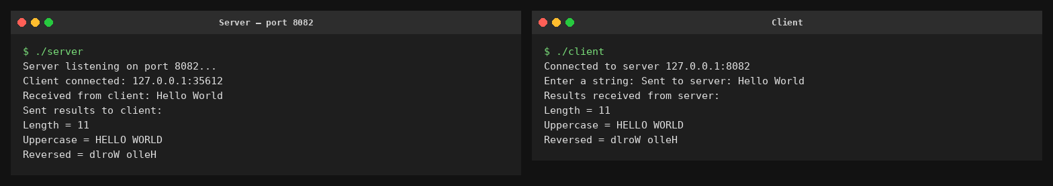
Conclusion
The string server was tested using "Hello World" and produced the expected length of 11, the uppercase form HELLO WORLD, and the reverse dlroW olleH. This confirms that the required string operations were performed correctly through the socket connection.

Experiment 4: Array Processing Server

Aim
To design a client–server application that transfers N integer values from the client to the server, where the server determines the total, mean, largest value, and smallest value.
Commands Used
gcc server.c -o server
gcc client.c -o client
./server (run in Terminal 1)
./client (run in Terminal 2)
Procedure
Client Code
#include <stdio.h>
#include <stdlib.h>
#include <string.h>
#include <unistd.h>
#include <arpa/inet.h>
#include <sys/socket.h>

#define PORT 8083
#define BUFFER_SIZE 1024
#define SERVER_IP "127.0.0.1"

int main() {
int client_fd;
struct sockaddr_in server_addr;
char buffer[BUFFER_SIZE] = {0};
char message[BUFFER_SIZE] = {0};
int arr[100], N;

client_fd = socket(AF_INET, SOCK_STREAM, 0);

server_addr.sin_family = AF_INET;
server_addr.sin_port = htons(PORT);
inet_pton(AF_INET, SERVER_IP, &server_addr.sin_addr);

connect(client_fd, (struct sockaddr *)&server_addr, sizeof(server_addr));
printf("Connected to server %s:%d\n", SERVER_IP, PORT);
printf("Enter number of elements (N): ");
scanf("%d", &N);
printf("Enter %d integers:\n", N);

char temp[16];
snprintf(message, BUFFER_SIZE, "%d", N);
for (int i = 0; i < N; i++) {
scanf("%d", &arr[i]);
snprintf(temp, sizeof(temp), " %d", arr[i]);
strcat(message, temp);
}

send(client_fd, message, strlen(message), 0);
printf("Sent to server: %s\n", message);

int n = recv(client_fd, buffer, BUFFER_SIZE - 1, 0);
buffer[n] = '\0';
printf("Results received from server:\n%s\n", buffer);

close(client_fd);
return 0;
}

Server Code
#include <stdio.h>
#include <stdlib.h>
#include <string.h>
#include <unistd.h>
#include <arpa/inet.h>
#include <sys/socket.h>
#define PORT 8083
#define BUFFER_SIZE 1024
int main() {
int server_fd, client_fd;
struct sockaddr_in server_addr, client_addr;
socklen_t client_len = sizeof(client_addr);
char buffer[BUFFER_SIZE] = {0};
char result[BUFFER_SIZE] = {0};
server_fd = socket(AF_INET, SOCK_STREAM, 0);
int opt = 1;
setsockopt(server_fd, SOL_SOCKET, SO_REUSEADDR, &opt, sizeof(opt));
server_addr.sin_family = AF_INET;
server_addr.sin_addr.s_addr = INADDR_ANY;
server_addr.sin_port = htons(PORT);
bind(server_fd, (struct sockaddr *)&server_addr, sizeof(server_addr));
listen(server_fd, 3);
printf("Server listening on port %d...\n", PORT);
client_fd = accept(server_fd, (struct sockaddr *)&client_addr, &client_len);
printf("Client connected: %s:%d\n",
inet_ntoa(client_addr.sin_addr), ntohs(client_addr.sin_port));
int n = recv(client_fd, buffer, BUFFER_SIZE - 1, 0);
buffer[n] = '\0';
printf("Received from client: %s\n", buffer);
int arr[100], count = 0;
char *token = strtok(buffer, " ");
int N = atoi(token);
token = strtok(NULL, " ");
while (token != NULL && count < N) {
arr[count++] = atoi(token);
token = strtok(NULL, " ");
}
int sum = 0, max = arr[0], min = arr[0];
for (int i = 0; i < count; i++) {
sum += arr[i];
if (arr[i] > max) max = arr[i];
if (arr[i] < min) min = arr[i];
}
double avg = (double)sum / count;
snprintf(result, BUFFER_SIZE,
"Sum = %d\nAverage = %.2f\nMaximum = %d\nMinimum = %d",
sum, avg, max, min);
send(client_fd, result, strlen(result), 0);
printf("Sent results to client:\n%s\n", result);
close(client_fd);
close(server_fd);
return 0;
}

Output
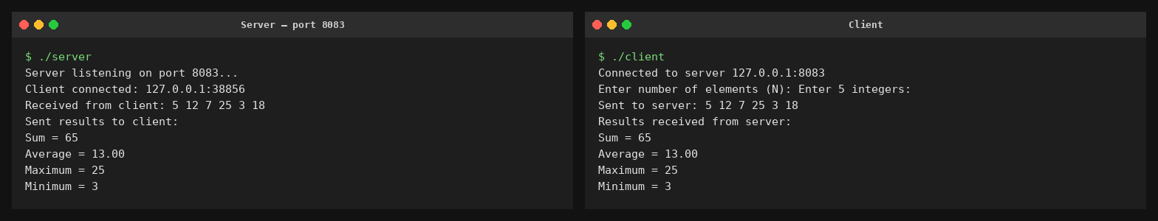
Conclusion
Testing the array server with {12, 7, 25, 3, 18} gave a total of 65, an average of 13.00, a maximum of 25, and a minimum of 3. The results show that the array was processed correctly using the client–server approach.

Experiment 5: Matrix Analyzer

Aim
To create a client–server program that sends a square matrix to the server, identifies whether it is diagonal, upper triangular, lower triangular, or general, and calculates both the element sum and trace.
Commands Used
gcc server.c -o server
gcc client.c -o client
./server (run in Terminal 1)
./client (run in Terminal 2)
Procedure
Client Code
#include <stdio.h>
#include <stdlib.h>
#include <string.h>
#include <unistd.h>
#include <arpa/inet.h>
#include <sys/socket.h>
#define PORT 8084
#define BUFFER_SIZE 4096
#define SERVER_IP "127.0.0.1"
#define MAXN 20
int main() {
int client_fd;
struct sockaddr_in server_addr;
char buffer[BUFFER_SIZE] = {0};
char message[BUFFER_SIZE] = {0};
int mat[MAXN][MAXN], N;
client_fd = socket(AF_INET, SOCK_STREAM, 0);
server_addr.sin_family = AF_INET;
server_addr.sin_port = htons(PORT);
inet_pton(AF_INET, SERVER_IP, &server_addr.sin_addr);
connect(client_fd, (struct sockaddr *)&server_addr, sizeof(server_addr));
printf("Connected to server %s:%d\n", SERVER_IP, PORT);
printf("Enter order of square matrix (N): ");
scanf("%d", &N);
printf("Enter %d x %d matrix elements:\n", N, N);
char temp[16];
snprintf(message, BUFFER_SIZE, "%d", N);
for (int i = 0; i < N; i++) {
for (int j = 0; j < N; j++) {
scanf("%d", &mat[i][j]);
snprintf(temp, sizeof(temp), " %d", mat[i][j]);
strcat(message, temp);
}
}
send(client_fd, message, strlen(message), 0);
printf("Sent to server: %s\n", message);
int n = recv(client_fd, buffer, BUFFER_SIZE - 1, 0);
buffer[n] = '\0';
printf("Results received from server:\n%s\n", buffer);
close(client_fd);
return 0;
}

Server Code
#include <stdio.h>
#include <stdlib.h>
#include <string.h>
#include <unistd.h>
#include <arpa/inet.h>
#include <sys/socket.h>
#define PORT 8084
#define BUFFER_SIZE 4096
#define MAXN 20
int main() {
int server_fd, client_fd;
struct sockaddr_in server_addr, client_addr;
socklen_t client_len = sizeof(client_addr);
char buffer[BUFFER_SIZE] = {0};
char result[BUFFER_SIZE] = {0};
int mat[MAXN][MAXN];
server_fd = socket(AF_INET, SOCK_STREAM, 0);
int opt = 1;
setsockopt(server_fd, SOL_SOCKET, SO_REUSEADDR, &opt, sizeof(opt));
server_addr.sin_family = AF_INET;
server_addr.sin_addr.s_addr = INADDR_ANY;
server_addr.sin_port = htons(PORT);
bind(server_fd, (struct sockaddr *)&server_addr, sizeof(server_addr));
listen(server_fd, 3);
printf("Server listening on port %d...\n", PORT);
client_fd = accept(server_fd, (struct sockaddr *)&client_addr, &client_len);
printf("Client connected: %s:%d\n",
inet_ntoa(client_addr.sin_addr), ntohs(client_addr.sin_port));
int n = recv(client_fd, buffer, BUFFER_SIZE - 1, 0);
buffer[n] = '\0';
printf("Received from client: %s\n", buffer);
char *token = strtok(buffer, " ");
int N = atoi(token);
for (int i = 0; i < N; i++) {
for (int j = 0; j < N; j++) {
token = strtok(NULL, " ");
mat[i][j] = atoi(token);
}
}
int isDiagonal = 1, isUpper = 1, isLower = 1;
for (int i = 0; i < N; i++) {
for (int j = 0; j < N; j++) {
if (i != j && mat[i][j] != 0) isDiagonal = 0;
if (i > j && mat[i][j] != 0) isUpper = 0;
if (i < j && mat[i][j] != 0) isLower = 0;
}
}
char type[32];
if (isDiagonal)
strcpy(type, "Diagonal Matrix");
else if (isUpper)
strcpy(type, "Upper Triangular Matrix");
else if (isLower)
strcpy(type, "Lower Triangular Matrix");
else
strcpy(type, "General Matrix");
int sum = 0, trace = 0;
for (int i = 0; i < N; i++) {
for (int j = 0; j < N; j++) {
sum += mat[i][j];
}
trace += mat[i][i];
}
snprintf(result, BUFFER_SIZE,
"Matrix Type = %s\nSum of Elements = %d\nTrace = %d",
type, sum, trace);
send(client_fd, result, strlen(result), 0);
printf("Sent results to client:\n%s\n", result);
close(client_fd);
close(server_fd);
return 0;
}

Output
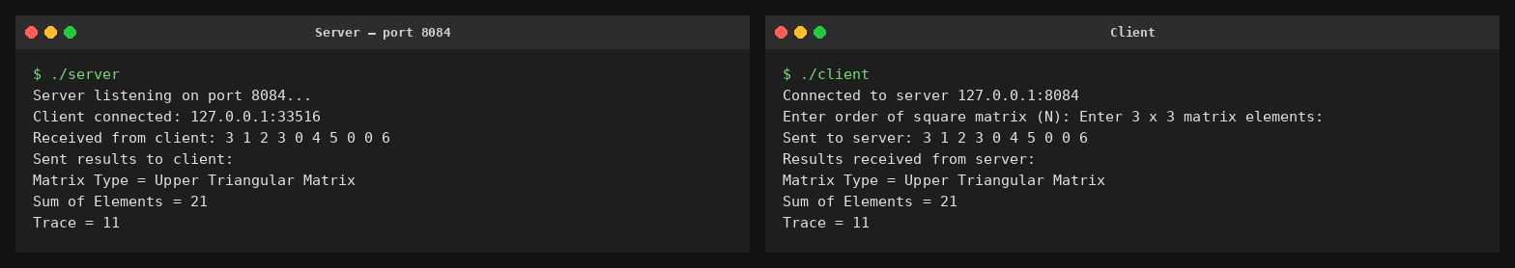
Conclusion
The matrix analyzer was tested with a 3×3 upper triangular matrix. It correctly classified the matrix as "Upper Triangular Matrix", with a total element sum of 21 and a trace of 11, showing that the matrix analysis was completed successfully over the socket connection.

