**PRÁCTICA CALIFICADA PYTHON**

1. Resuelva los siguientes casos lógicos:

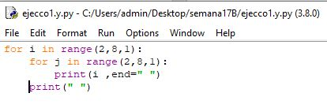

|  |  |  |  |  |  |
| --- | --- | --- | --- | --- | --- |
| 2 | 2 | 2 | 2 | 2 | 2 |
| 3 | 3 | 3 | 3 | 3 | 3 |
| 4 | 4 | 4 | 4 | 4 | 4 |
| 5 | 5 | 5 | 5 | 5 | 5 |
| 6 | 6 | 6 | 6 | 6 | 6 |
| 7 | 7 | 7 | 7 | 7 | 7 |

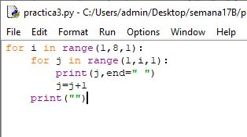

|  |  |  |  |  |  |
| --- | --- | --- | --- | --- | --- |
| 1 |  |  |  |  |  |
| 1 | 2 |  |  |  |  |
| 1 | 2 | 3 |  |  |  |
| 1 | 2 | 3 | 4 |  |  |
| 1 | 2 | 3 | 4 | 5 |  |
| 1 | 2 | 3 | 4 | 5 | 6 |

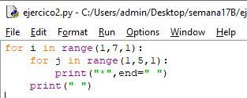

|  |  |  |  |  |  |
| --- | --- | --- | --- | --- | --- |
| * | * | * | * |  |  |
| * | * | * | * |  |  |
| * | * | * | * |  |  |
| * | * | * | * |  |  |
| * | * | * | * |  |  |
| * | * | * | * |  |  |

Nombres: José Carlos

Apellidos: Cortez Kubelka

1. Realice el dibujo de los siguientes códigos:

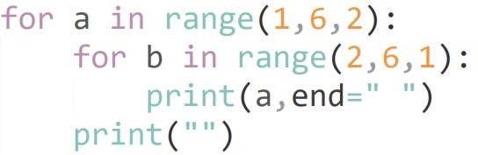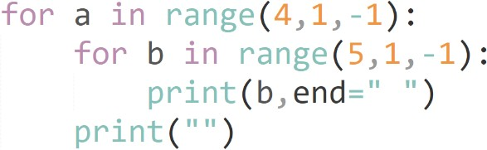

|  |  |  |  |  |  |
| --- | --- | --- | --- | --- | --- |
| 1 | 1 | 1 | 1 |  |  |
| 6 | 6 | 6 | 6 |  |  |
| 2 | 2 | 2 | 2 |  |  |
|  |  |  |  |  |  |
|  |  |  |  |  |  |
|  |  |  |  |  |  |

|  |  |  |  |  |  |
| --- | --- | --- | --- | --- | --- |
| 5 | 4 | 3 | 2 |  |  |
| 5 | 4 | 3 | 2 |  |  |
| 5 | 4 | 3 | 2 |  |  |
|  |  |  |  |  |  |
|  |  |  |  |  |  |
|  |  |  |  |  |  |

Nombres: José Carlos

Apellidos: Cortez Kubelka