Business Performance Review: Footwear Distribution Company

Comprehensive Analysis | January 2021 – April 2023

Table of Contents
1. Revenue Growth & Volume Dynamics
2. Channel Economics & Mix Evolution
3. Product Lifecycle Architecture
4. New Entrant Model Durability
5. Entry-Tier Risk Profile
6. Wholesale Client Dynamics & Cohort Health
7. Client Basket Composition & Lifecycle Risk
8. Wholesale NE Revenue Structure: Breakout vs. Trickle
9. Executive Summary

Section 1: Revenue Growth & Volume Dynamics

Rapid Top-Line Expansion Driven Entirely by Volume
Period | Revenue (EUR M) | YoY Growth | Volume Effect | Price/Mix Effect
FY2021 | 16.71 | — | — | —
FY2022 | 32.83 | +96.5% | +92.6% | +7.4%
LTM23 (May 22–Apr 23) | 36.14 | +66.1% | +102.5% | –2.5%
CAGR (2.25 years) | — | — | ~+39% | —

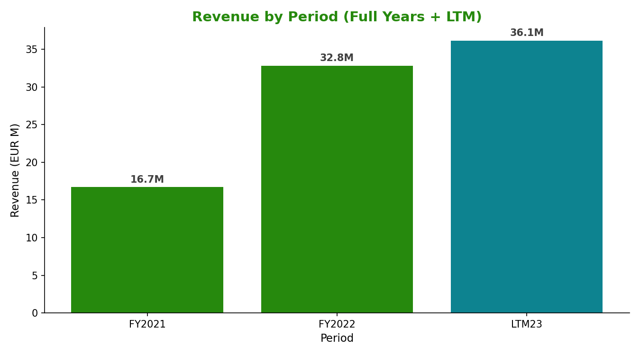
The company expanded from EUR 16.7M to a LTM run-rate of EUR 36.1M over 28 months — a CAGR of approximately 39%. Both growth periods are structurally volume-driven: the FY2021-to-FY2022 surge of +96.5% was attributable 92.6% to unit volume expansion and only 7.4% to pricing and mix improvement. In the subsequent LTM period, the volume effect actually exceeded 100% of the revenue delta, while price/mix turned marginally negative (–2.5%), confirming that blended average selling prices are compressing as the business scales into lower-value accounts and distributes more extensively through wholesale.
This dynamic is consistent with a market-penetration phase rather than a value-extraction phase. The absence of pricing power, combined with the declining average selling price, means that sustaining revenue growth depends entirely on continuous volume expansion — either through new model introductions, new client acquisition, or deeper penetration of existing accounts.
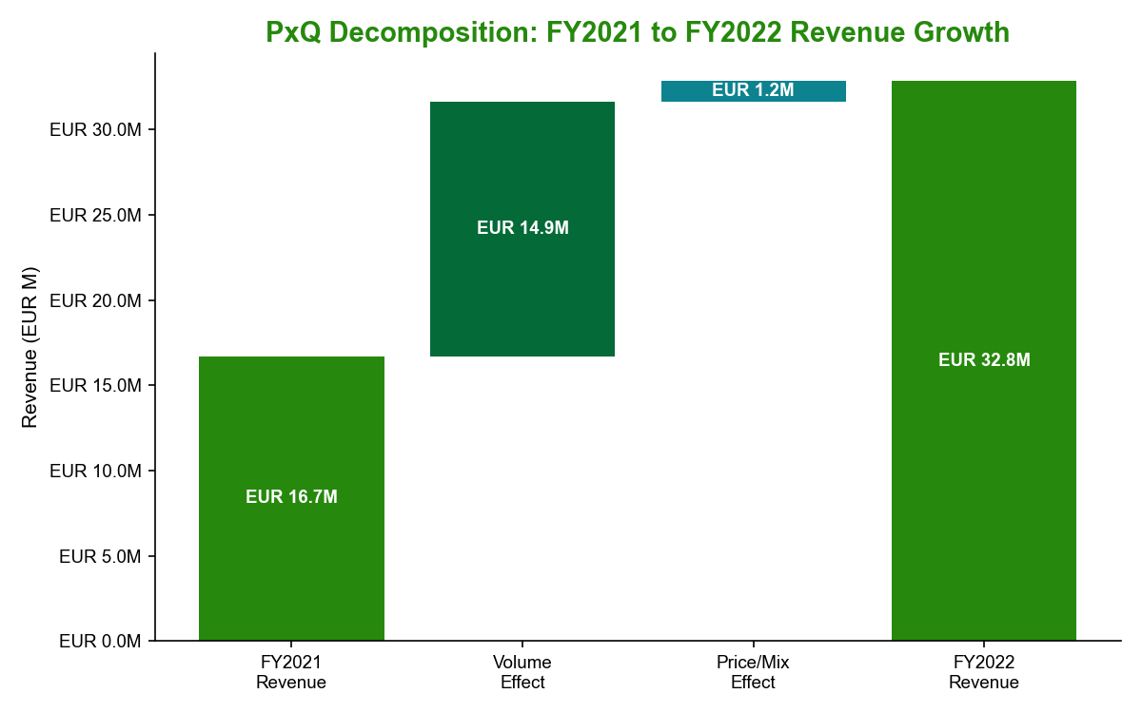

Section 2: Channel Economics & Mix Evolution

Three Structurally Distinct Channels with Diverging Trajectories
Channel | FY2021 Revenue | FY2022 Revenue | LTM23 Revenue | Share LTM23 | AOV LTM23
Wholesale | EUR 10.90M | EUR 20.12M | EUR 21.43M | 59.3% | EUR 816
Online | EUR 4.69M | EUR 7.19M | EUR 7.83M | 21.7% | EUR 3,958
Retail | EUR 1.13M | EUR 5.52M | EUR 6.88M | 19.0% | EUR 373
**Total** | **EUR 16.71M** | **EUR 32.83M** | **EUR 36.14M** | **100%** | —

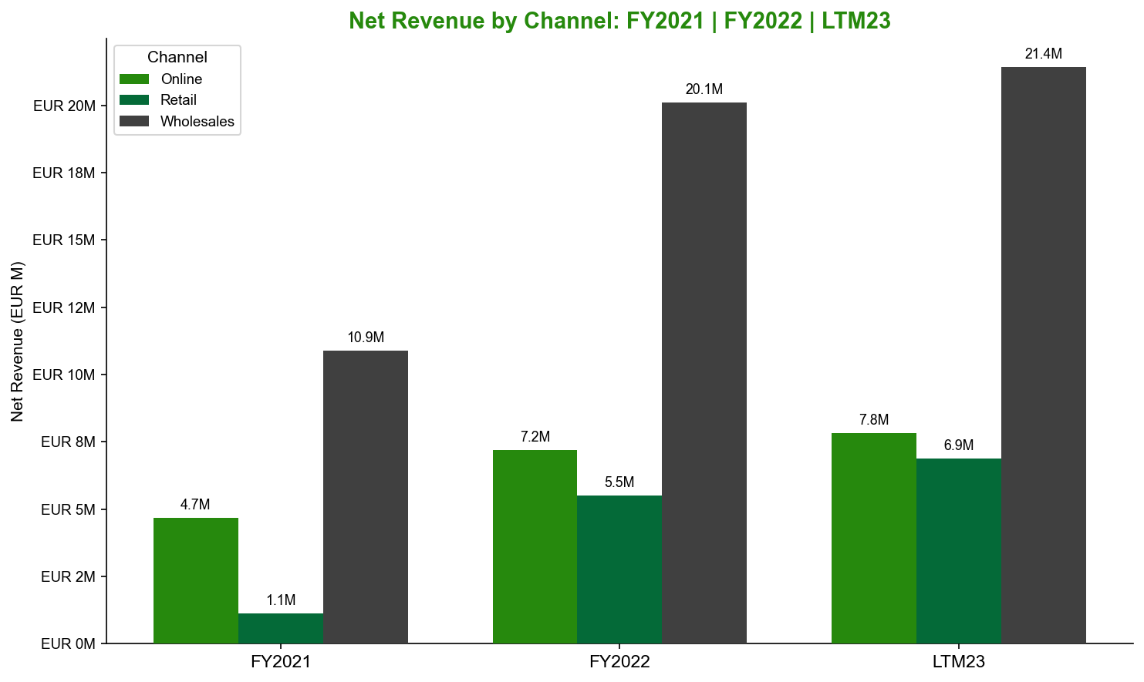
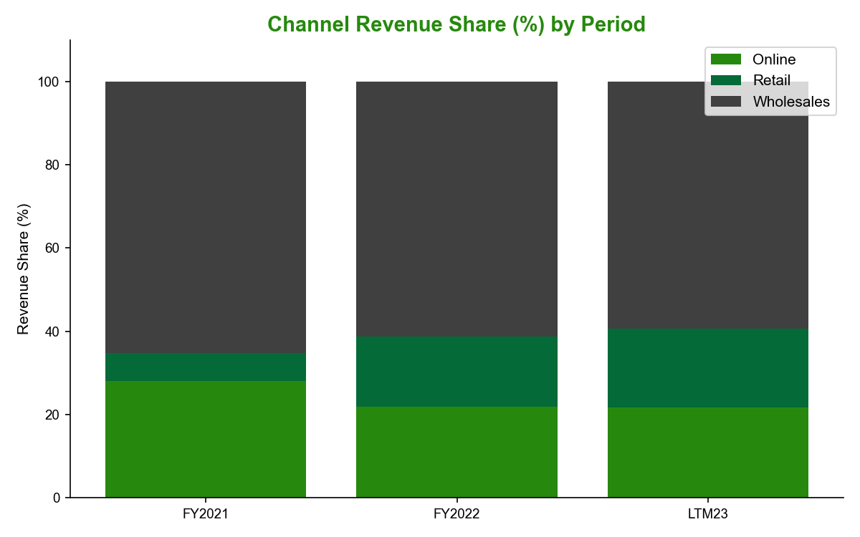
Wholesale — representing 59–65% of revenue across all periods — is the commercial backbone of the business. Average order value has improved from EUR 633 (FY2021) to EUR 816 (LTM23), reflecting larger basket sizes among established accounts. Wholesale's revenue share has modestly declined from 65.2% to 59.3% as other channels grow faster, though it remains the dominant route to market.
Online operates as a single-client channel — most likely a marketplace or aggregator — with an AOV of EUR 3,958 in LTM23, approximately 4.8× the wholesale equivalent and 10.6× Retail. Despite this premium economics profile, Online's revenue share declined 6.4 percentage points to 21.7%. The single-client concentration in this channel represents an unquantified but material dependency risk; a relationship disruption would remove roughly EUR 7.8M from the top line with no near-term alternative.
Retail is the fastest-growing channel by client count (4 clients in FY2021 to 63 in LTM23, CAGR +240.5%), with revenue expanding from EUR 1.1M to EUR 6.9M. However, this growth is accompanied by severe AOV compression — from EUR 1,091 to EUR 373 — as the client base broadens from a small number of flagship accounts to a much larger pool of lower-volume points of sale. The headline revenue growth flatters the underlying economics.
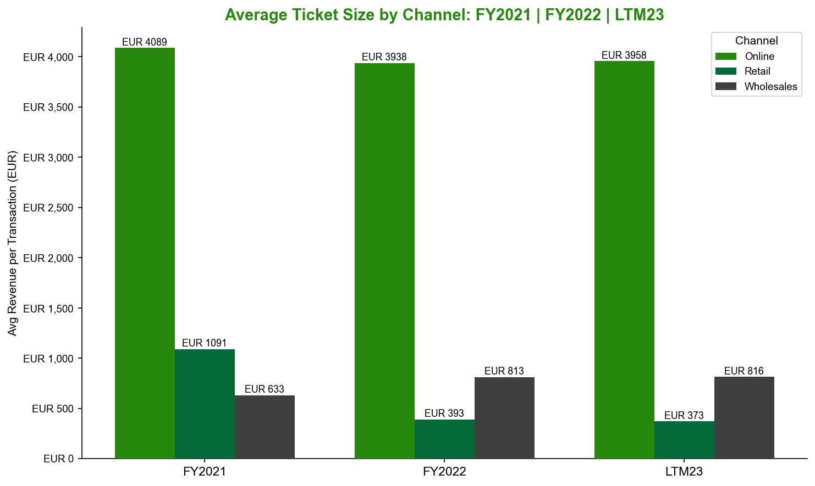
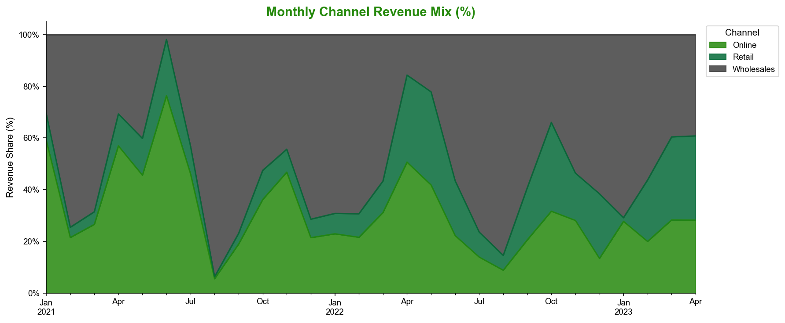

Section 3: Product Lifecycle Architecture

A Portfolio in Continuous Rotation: New Entrant Models Now Dominate Revenue
Lifecycle Bucket | LTM22 Revenue | LTM23 Revenue | LTM23 Share | # SKUs
New Entrant | EUR ~0.57M | EUR 18.40M | 50–55% | 109–123
Stable | EUR ~8.70M | EUR 15.60M | 27–43% | 39–77
Bust | EUR 8.45M | EUR 2.13M | ~6% | 113
**Total** | **EUR 21.76M** | **EUR 36.14M** | **100%** | **398**

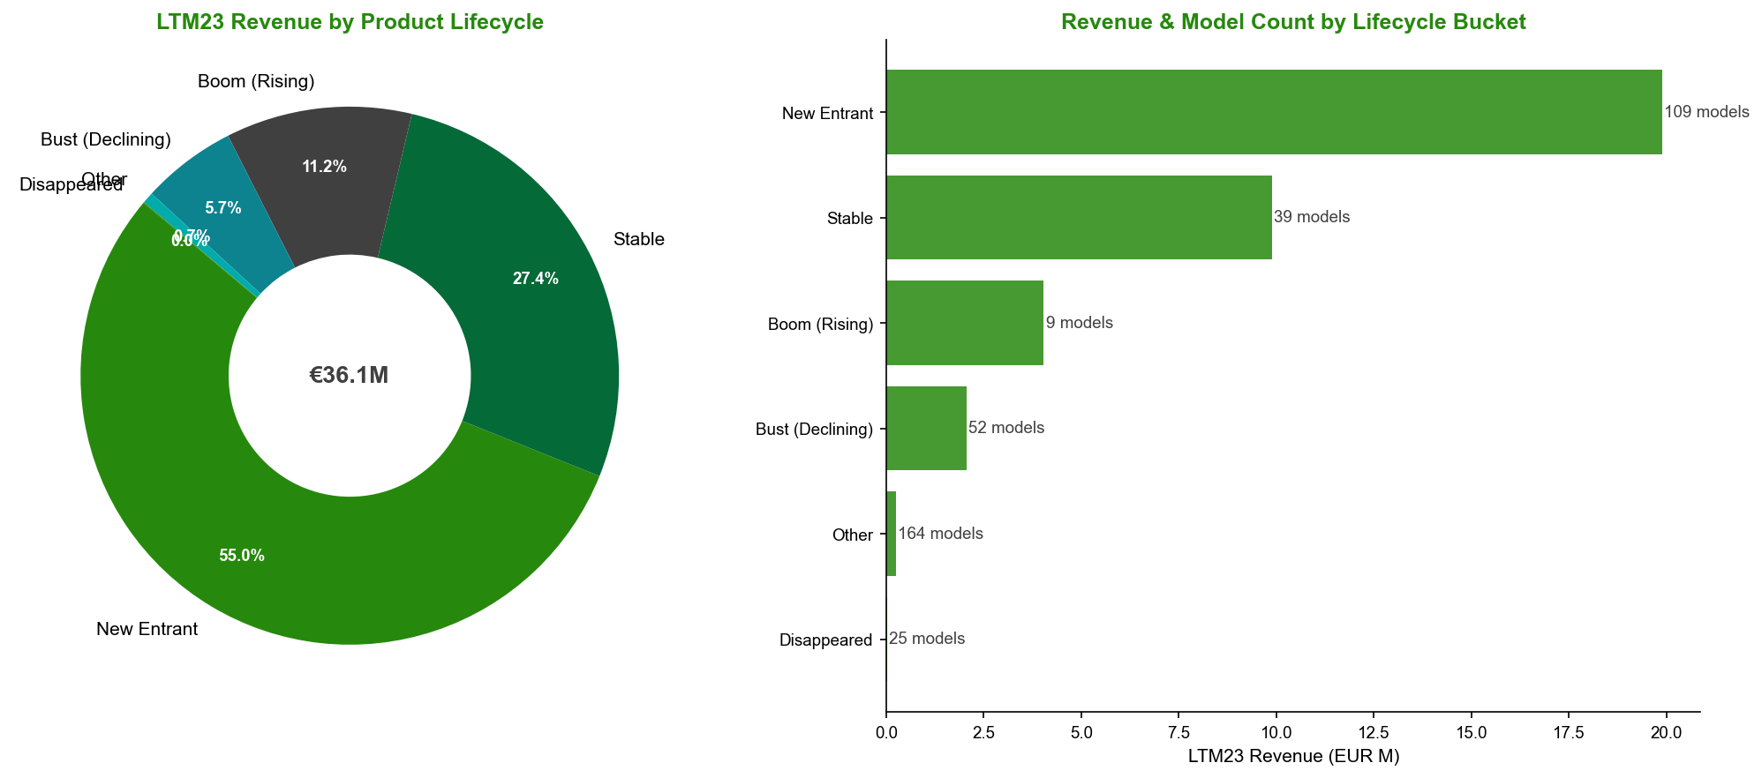
The portfolio has undergone near-complete lifecycle rotation in 12 months. The Bust cohort — models whose revenue peaked and subsequently declined sharply — contracted from EUR 8.45M to EUR 2.13M, a EUR 6.4M headwind. This erosion was more than offset by New Entrant model launches, which expanded from negligible revenue to EUR 18.4M, becoming the single largest lifecycle bucket. Stable models (those sustaining revenue across multiple periods) contribute EUR 15.6M and represent the structural floor of the business.
The top 20 models account for 39% of LTM23 revenue, and no single model holds more than 3.8% share. Across a portfolio of 398 models, this breadth is a material risk-diversification feature at the SKU level, though it does not eliminate the systemic risk inherent in the heavy reliance on New Entrant flows.
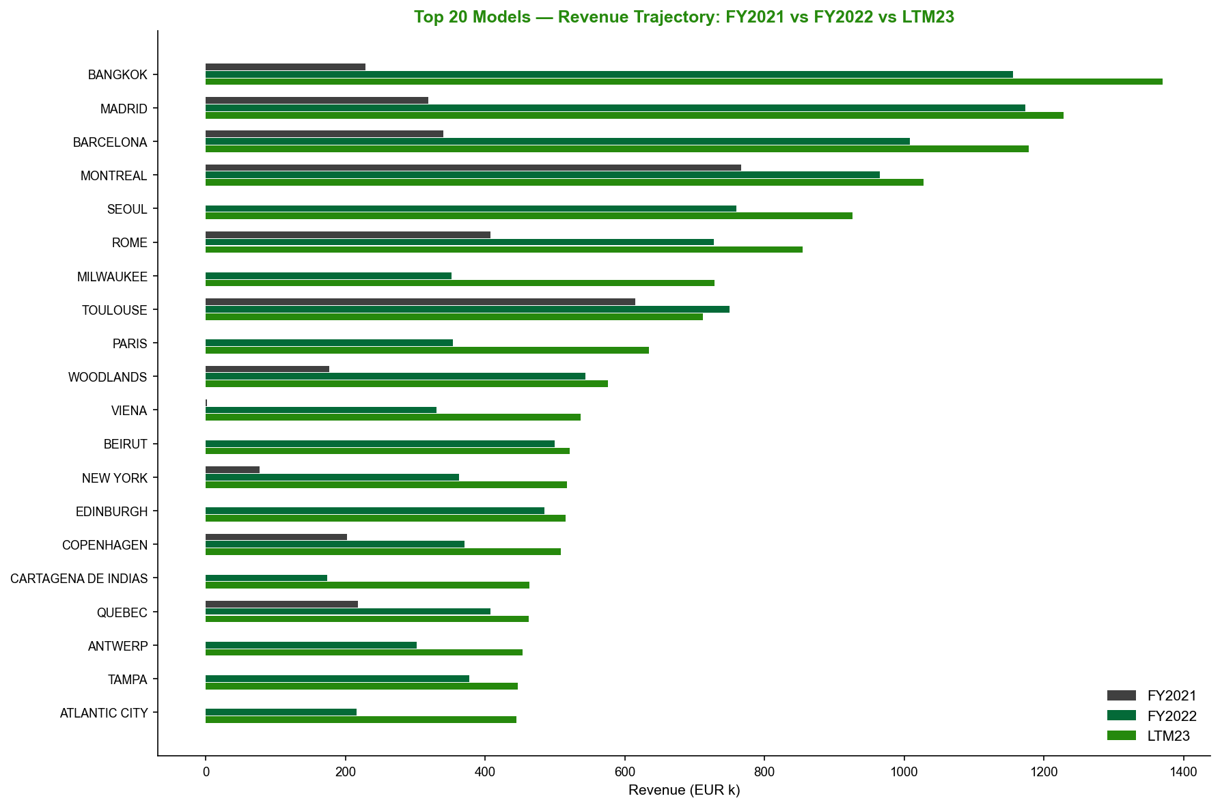

New Entrant Models Peak Rapidly and Fade Quickly
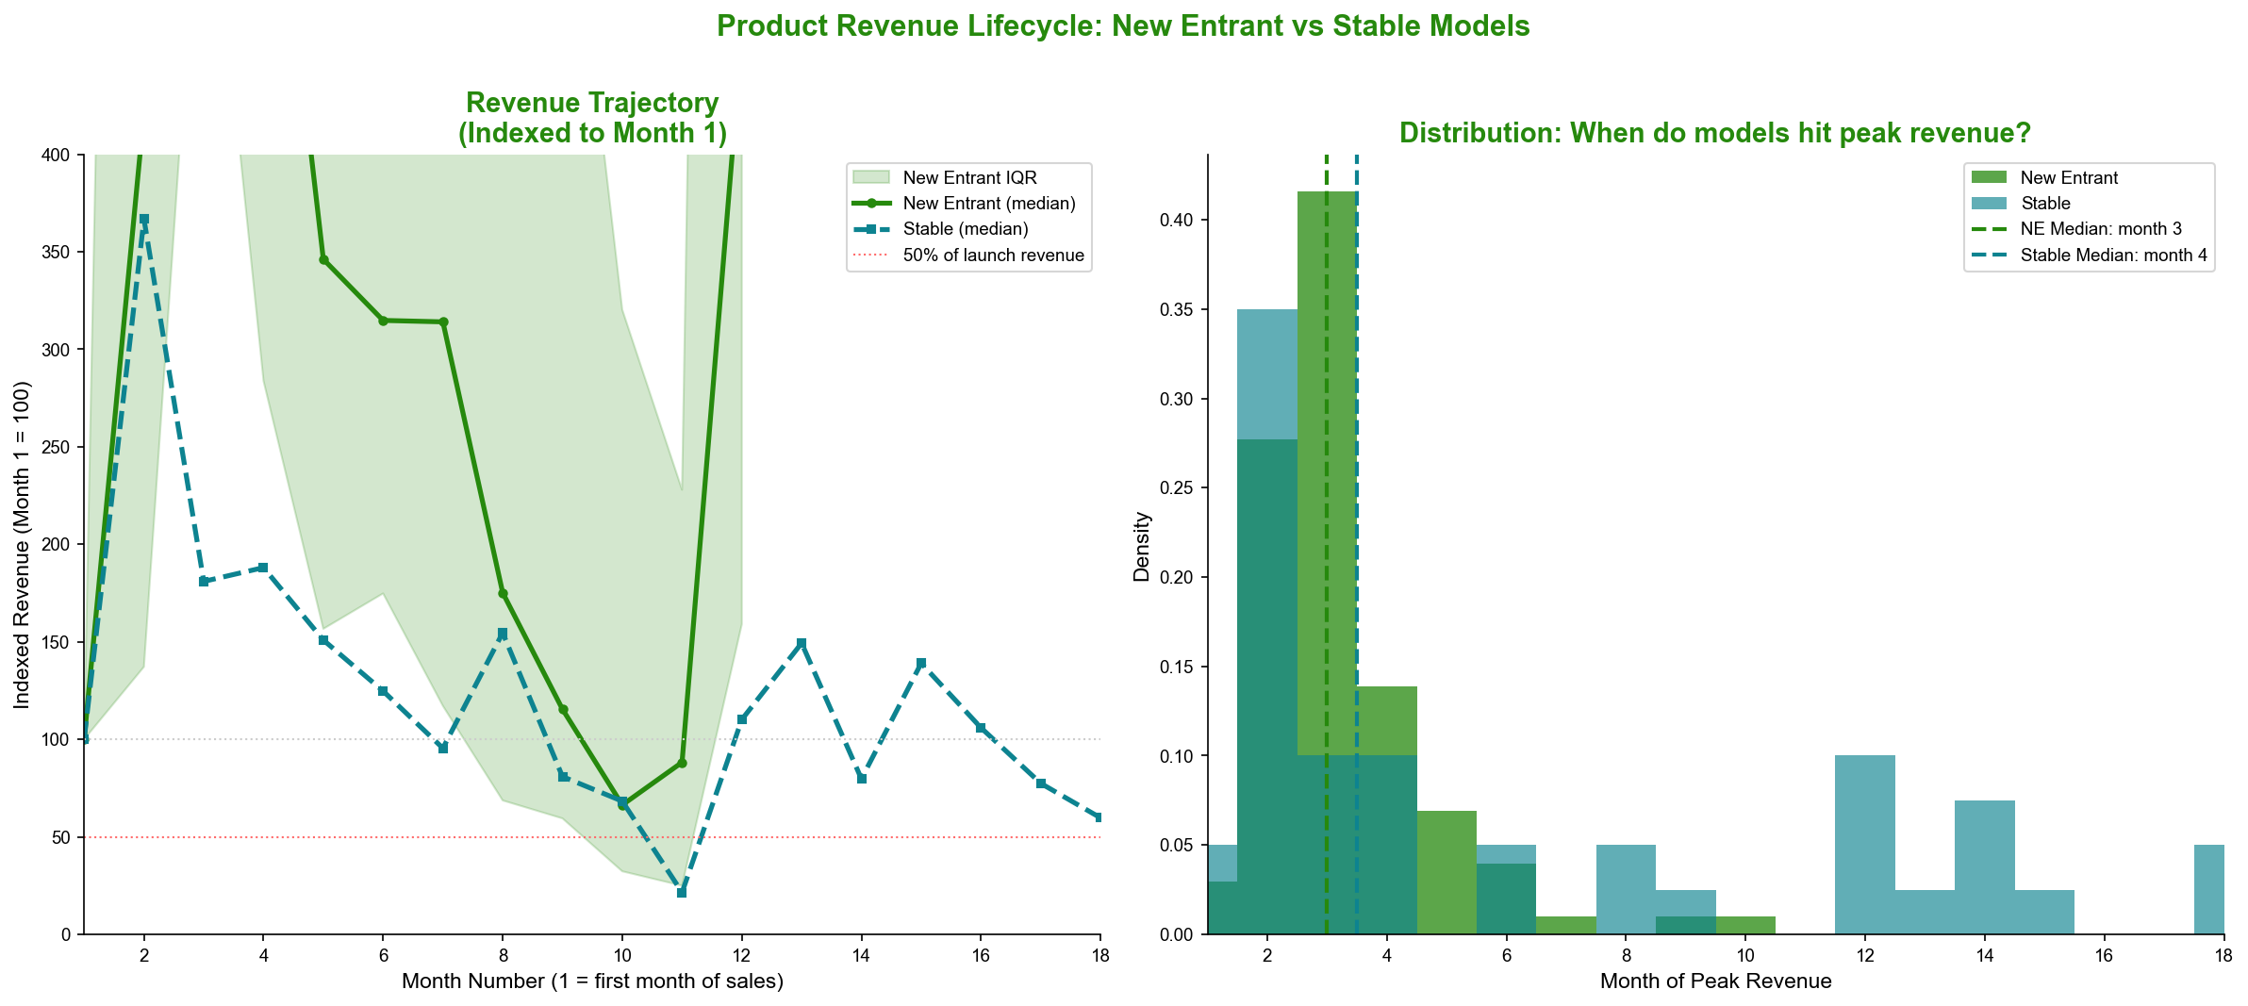
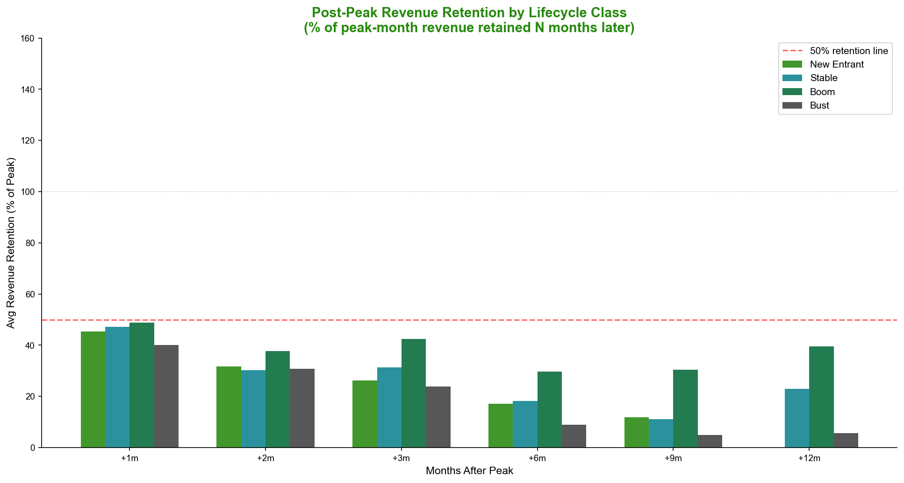
Lifecycle velocity analysis confirms that New Entrant models peak at a median of month 3 post-launch, and 97% have already passed their revenue peak within the LTM observation window. Post-peak retention deteriorates sharply:
Months Post-Peak | NE Retention | Stable Model Benchmark
+1 month | 45% | ~80%+
+2 months | 32% | ~75%
+3 months | 26% | ~65%
+6 months | 17% | ~50%

Only 4.4% of New Entrant models retain more than 50% of their peak revenue at the +6-month mark. Stable models, by contrast, show compounding revenue curves extending to month 25, reflecting genuine repeat purchasing and structural demand. The Bust cohort mirrors the New Entrant decay pattern precisely — confirming that a proportion of today's New Entrants will migrate into Bust classification as the observation window extends.
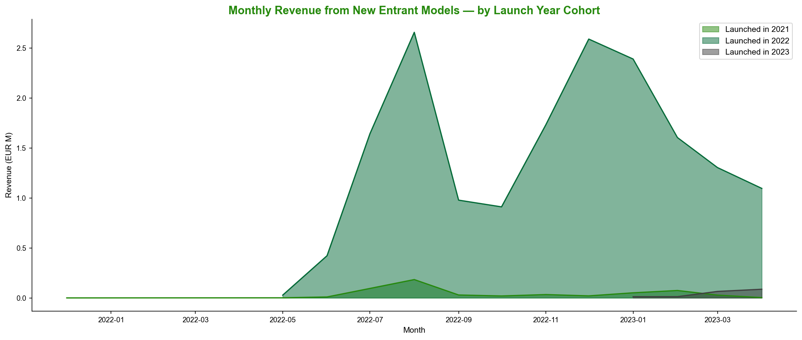

Section 4: New Entrant Model Durability

Most New Models Are Transient; Durability Is Not Predicted by Price or Launch Momentum
Of the 97 New Entrant models with sufficient post-peak retention data, fewer than one in five qualifies as durable:
Durability Class | # Models | % of NE | LTM23 Revenue | Avg Retention at +3m
Durable (≥40% retention at +3m) | 18 | 18.6% | EUR 4.60M | ~55%+
Mid-tier (20–40% retention) | 32 | 33.0% | EUR 6.17M | ~29%
Transient (<20% retention) | 47 | 48.5% | EUR 6.27M | ~12%

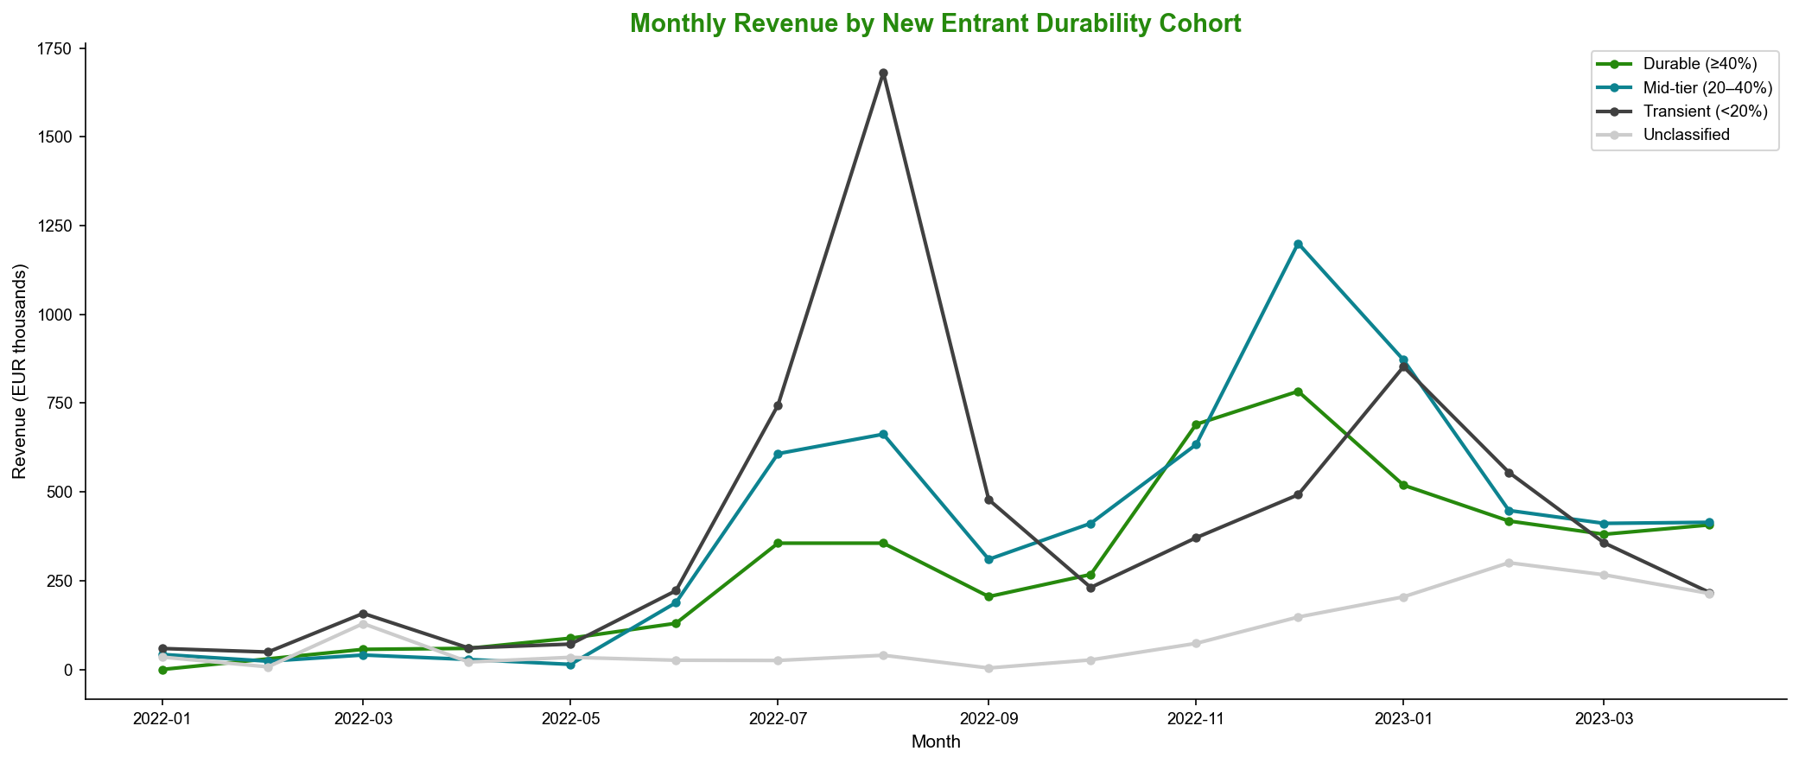
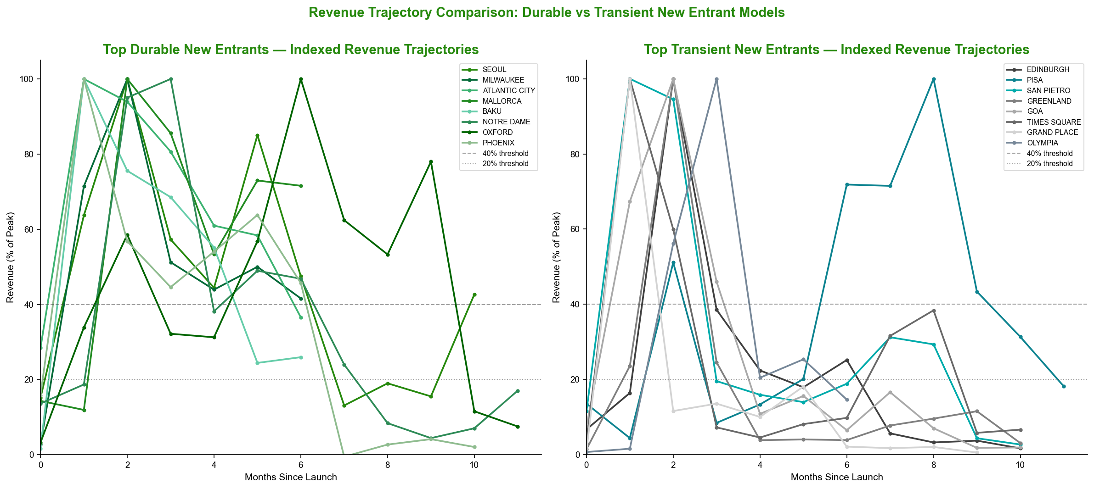
A critical strategic finding is that neither launch price nor initial sales momentum provides a reliable signal of durability. Launch ASP correlates negatively with retention (r = –0.087), and launch-month revenue velocity correlates only weakly positively (r = +0.119) — both are commercially negligible. Counterintuitively, the lowest ASP quartile (average EUR 23) yields a 36% Durable rate, while the highest ASP quartile (average EUR 60) produces only a 16.7% Durable rate.
ASP Quartile | Avg Launch ASP | % Durable | Avg Retention at +3m
Q1 — Lowest | EUR 23 | 36.0% | 34.7%
Q2 | EUR 39 | 8.3% | 26.0%
Q3 | EUR 44 | 12.5% | 20.4%
Q4 — Highest | EUR 60 | 16.7% | 22.0%

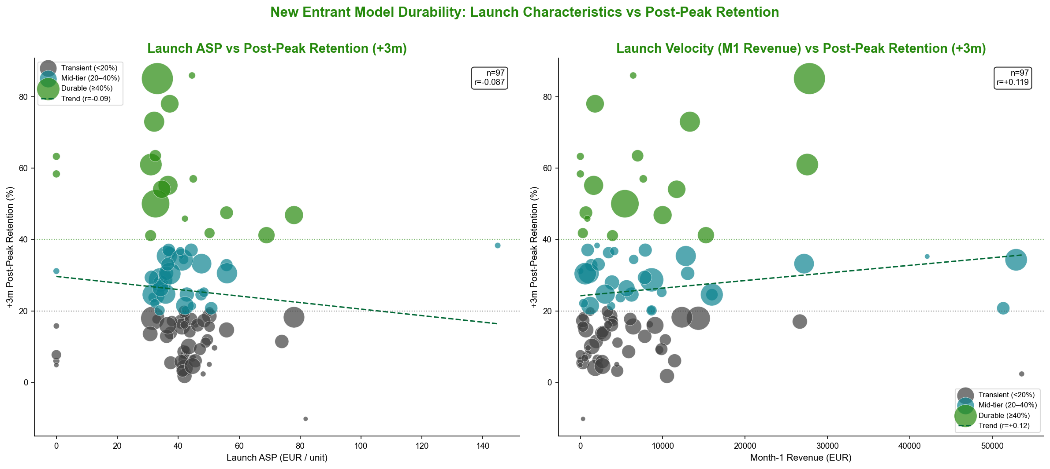
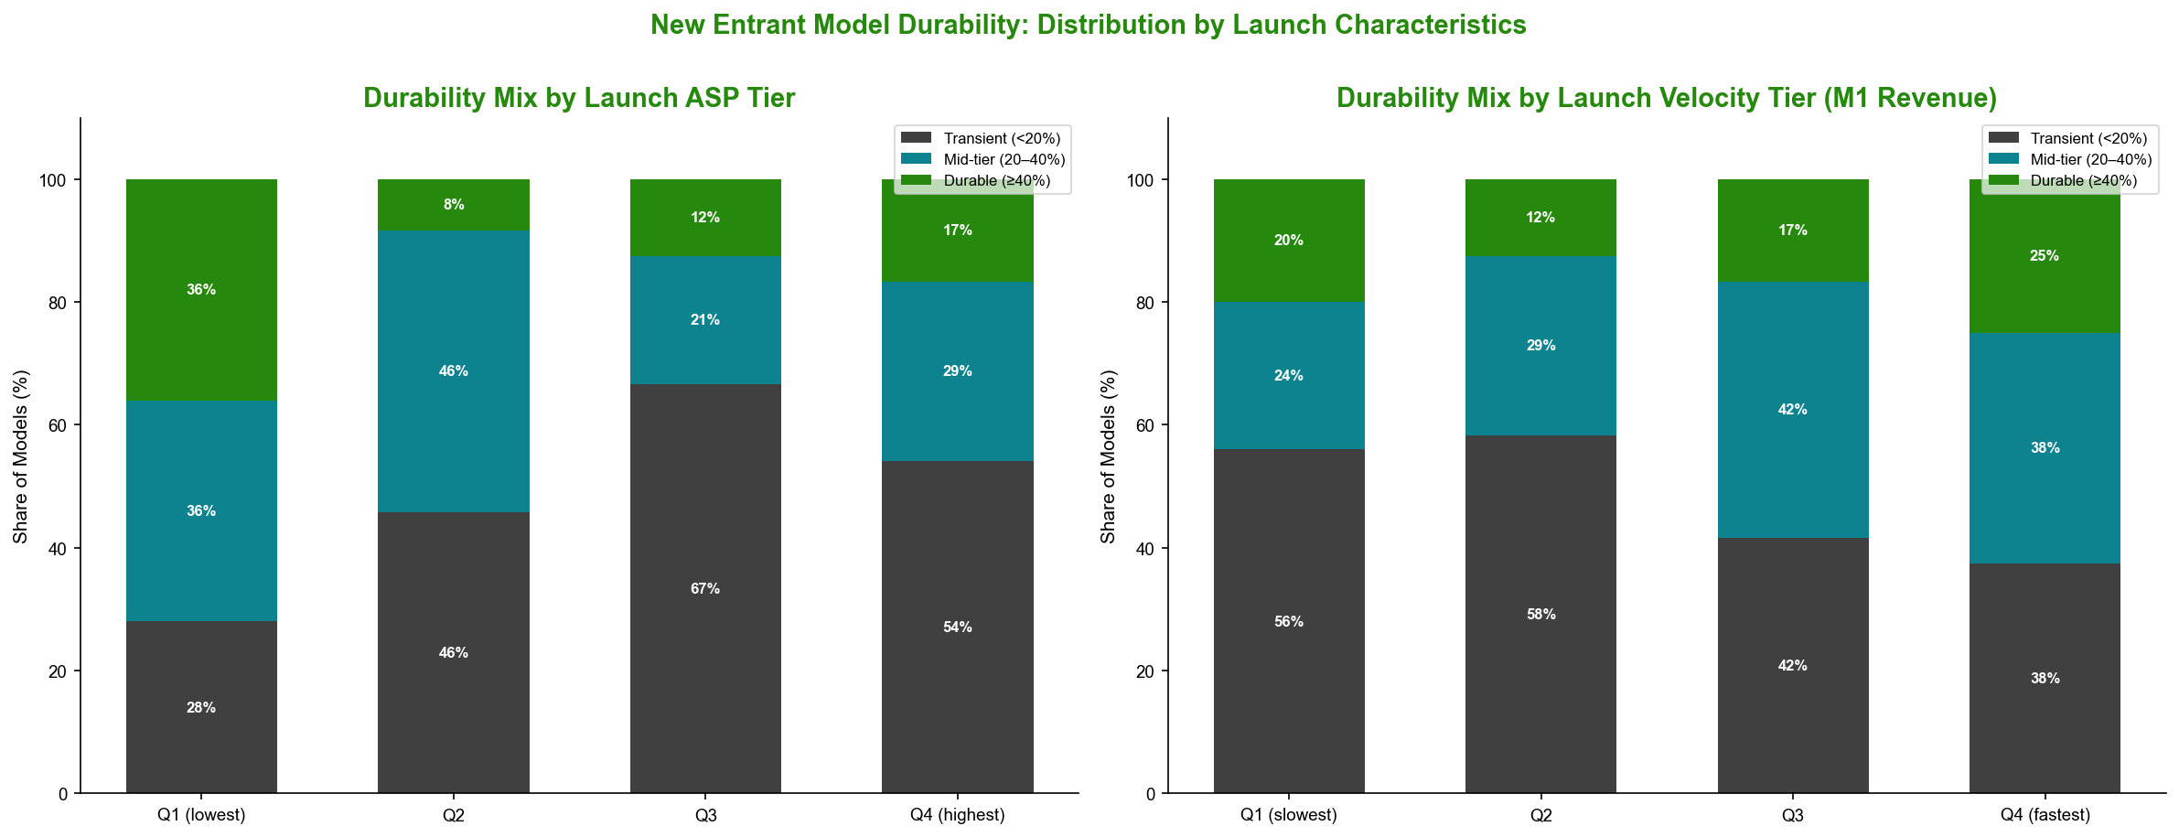
The top-performing Durable New Entrant models — SEOUL (a low-to-mid-ASP model generating EUR 926K in LTM with 85% retention at +3 months), MILWAUKEE (EUR 729K), and ATLANTIC CITY (EUR 445K) — are clustered in the EUR 31–37 ASP range. The leading Transient models — EDINBURGH (EUR 516K, 18% retention at +3 months), GREENLAND (EUR 247K, 4%), and GRAND PLACE (EUR 227K, 10%) — demonstrate how high initial revenues are not self-sustaining.
This inability to predict durability from observable launch characteristics is a fundamental management challenge: the business currently has no reliable ex-ante screen for distinguishing models that will sustain versus those that will fade, making forward revenue planning structurally uncertain.

Section 5: Entry-Tier Risk Profile

The Engine of Volume Growth Carries Elevated Structural Risk
Entry-tier models (average selling price below EUR 48) represent the largest ASP segment by revenue:
Segment | FY2021 Revenue | FY2022 Revenue | LTM23 Revenue | Channel Mix (WS%)
NE Entry (<EUR 48, New Entrant) | EUR 0 | EUR 5.60M | EUR 8.84M | 73.4%
Stable Entry (<EUR 48) | EUR 1.96M | EUR 3.95M | EUR 4.90M | 66.7%
Premium (>EUR 65, all lifecycle) | — | — | EUR ~5.0M | 20.2%

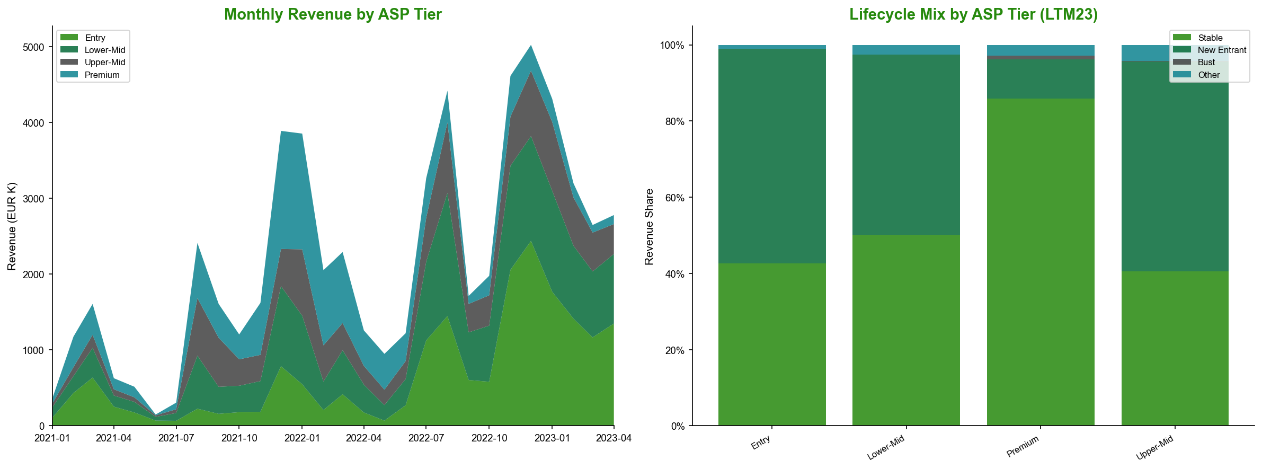
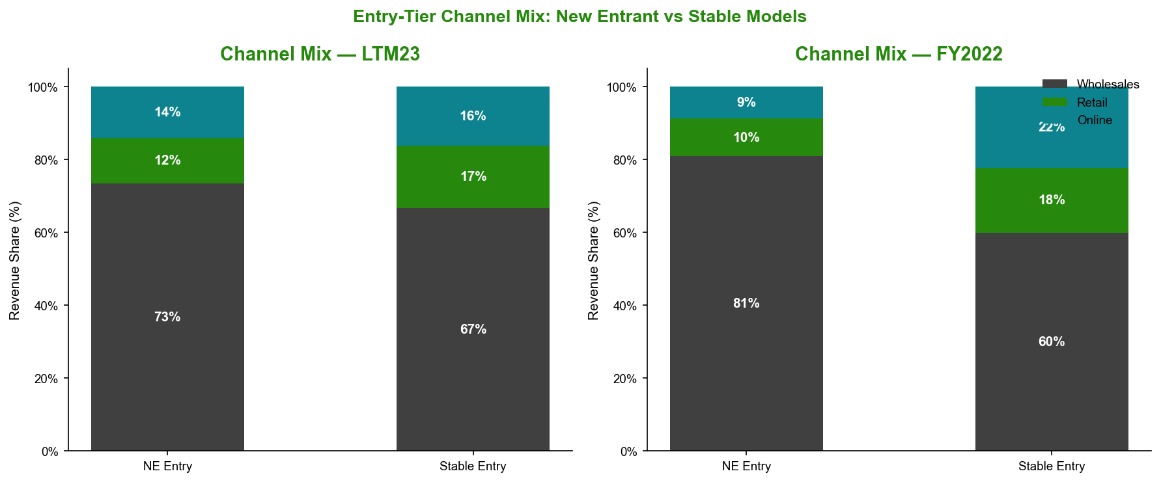
The inversion — New Entrant Entry models generating 80% more revenue than their Stable Entry counterparts — is anomalous by the standards of this portfolio. In the Premium tier, the relationship reverses as expected, with Stable models (EUR 3.2M) far exceeding New Entrant models (EUR 383K). This structural inversion in the Entry tier reflects the wholesale sell-in dynamic: distributors stock new low-price models in bulk at launch, producing large initial revenues that do not necessarily reflect end-consumer demand. The 80.8% wholesale dependency of Entry NE models in FY2022 (declining modestly to 73.4% in LTM23) confirms this pattern.
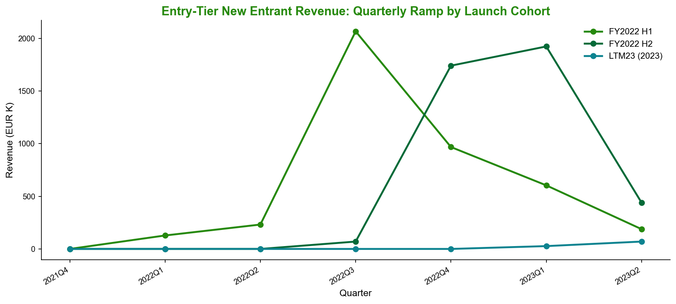
The cohort-level evidence is unambiguous: FY2022 H1-launched Entry NE models peaked at EUR 2.1M in Q3 2022 and decayed to EUR 188K by Q2 2023, a –91% contraction within four quarters. The FY2022 H2 cohort replicated this spike-and-decay profile. This rolling substitution model — where each new cohort briefly replaces the prior one — functions only so long as a continuous pipeline of new launches is maintained.
A critical forward risk: only 3 new Entry-tier NE models were launched in LTM23, compared to 32 in FY2022. If the launch cadence does not recover, there is no incoming cohort to replace the revenue erosion from current LTM23 New Entrant models as they complete their natural decay cycle.
Period | NE Entry Models Launched | Peak Quarter Revenue
FY2022 H1 | ~18 | EUR 2.1M (Q3 2022)
FY2022 H2 | ~14 | Spike-then-decay
LTM23 (to Apr 2023) | 3 | —

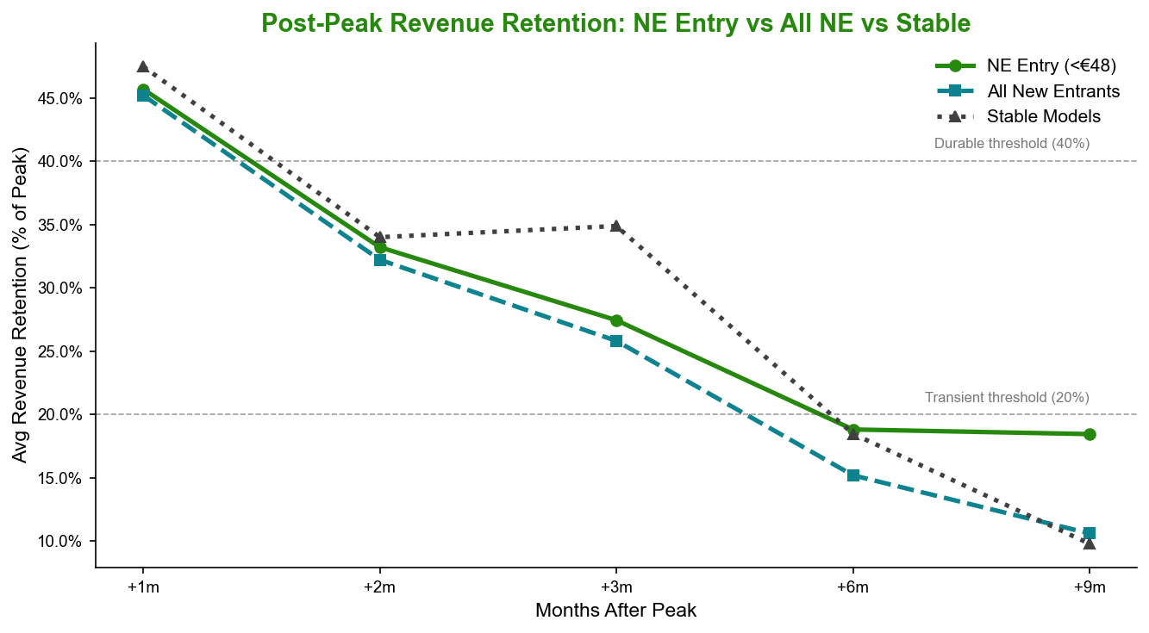
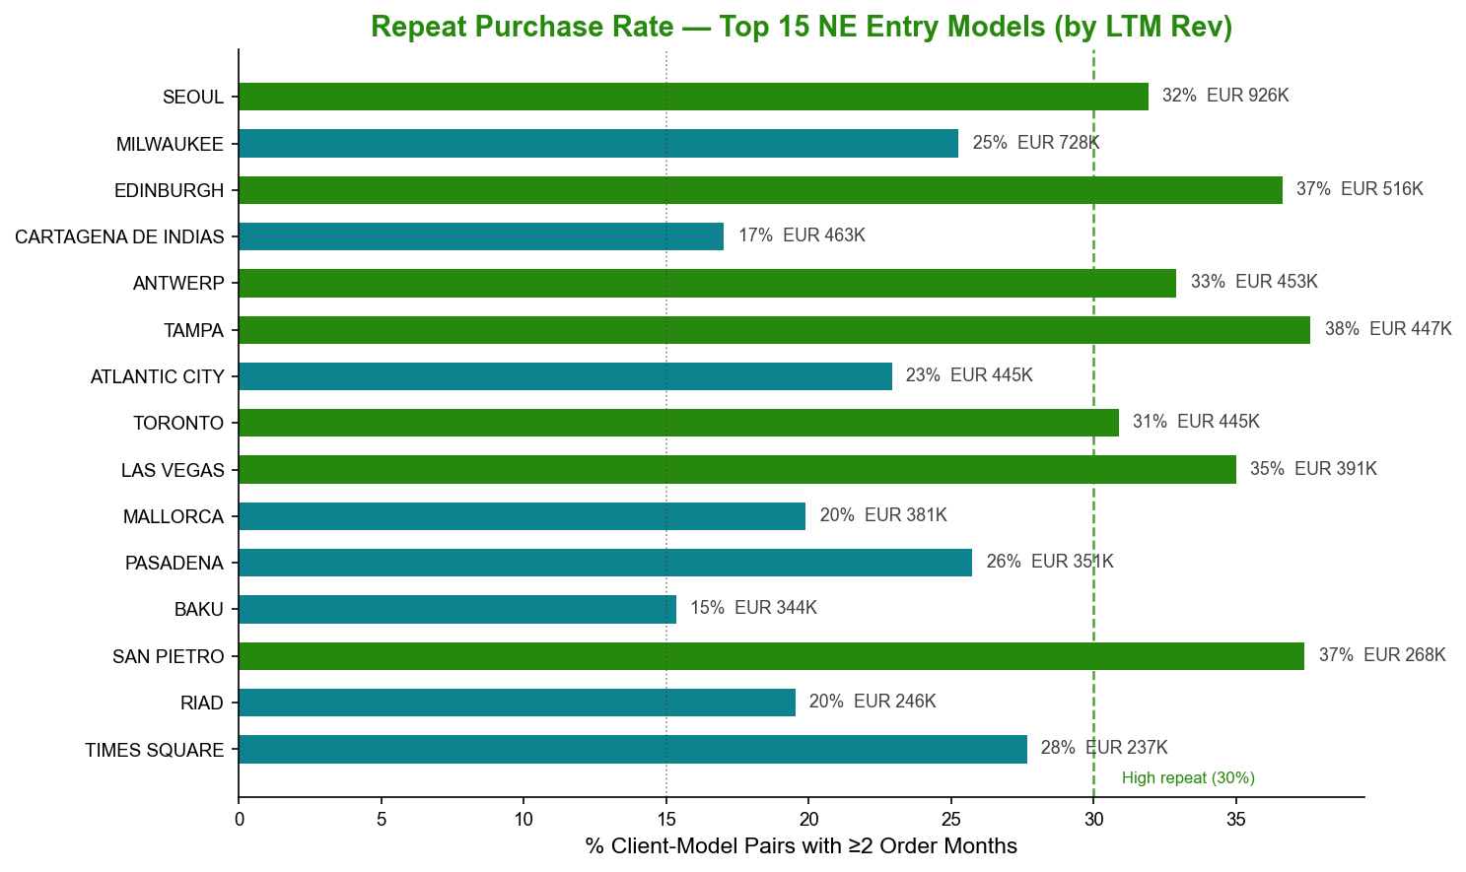
Repeat client ordering patterns reinforce the structural fragility: NE Entry models show a 26.2% repeat client rate versus 36.9% for Stable Entry, and average ordering frequency of 1.45 months versus 1.95 months. Of the 15 Transient NE Entry models (EUR 2.69M in LTM23 revenue), the low repeat rates imply that a meaningful proportion of that revenue reflects initial distributor stocking rather than sustained consumer demand.

Section 6: Wholesale Client Dynamics & Cohort Health

Quality of Growth Deteriorated Sharply from FY2022 to LTM23
Metric | FY2021 | FY2022 | LTM23
WS Revenue (EUR M) | 10.90 | 20.12 | 21.43
YoY WS Revenue Growth | — | +84.6% | +6.5%
Unique WS Clients | 996 | 1,284 | 1,690
New Clients Onboarded | — | 507 | 525
Avg Revenue / New Client (EUR) | — | 6,883 | 3,810
Returning Client LfL Growth | — | +62.1% | –1.6%
CAGR (client count) | — | — | +26.5%

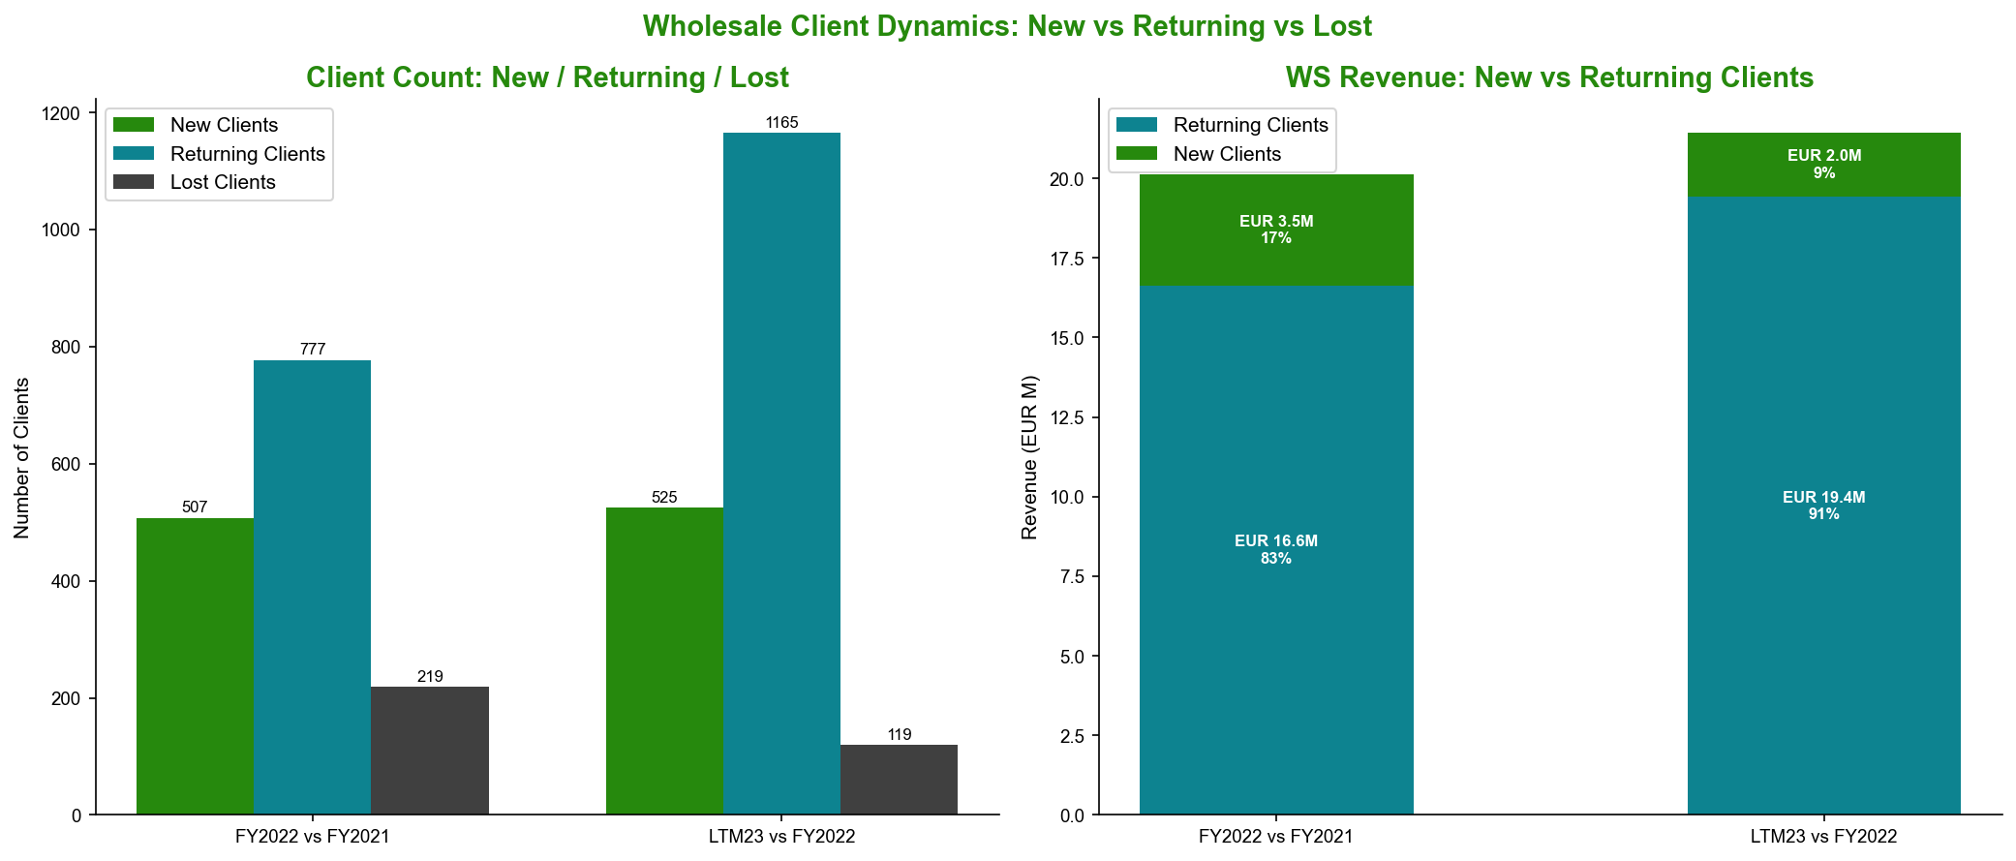
The contrast between the two growth periods could not be more pronounced. In FY2021 to FY2022, wholesale revenue grew EUR 9.2M (+84.6%), with existing clients (777 returning accounts) expanding their spend organically by +62.1% — high-quality, relationship-driven growth. Lost-client churn was only EUR 0.64M, indicating strong account retention. In LTM23, wholesale growth decelerated to EUR +1.3M (+6.5%), and the entire increment is attributable to new client acquisition (525 new accounts contributing EUR 2.0M). Returning clients contracted –1.6% on a like-for-like basis, a sharp reversal from the prior-period dynamic.
This structural shift — from LfL-organic to acquisition-dependent growth — is a significant quality deterioration. New clients are also arriving at materially lower average spend (EUR 3,810 vs EUR 6,883), suggesting the platform is onboarding smaller, lower-tier distributors as the addressable market of premium-tier accounts is increasingly saturated.
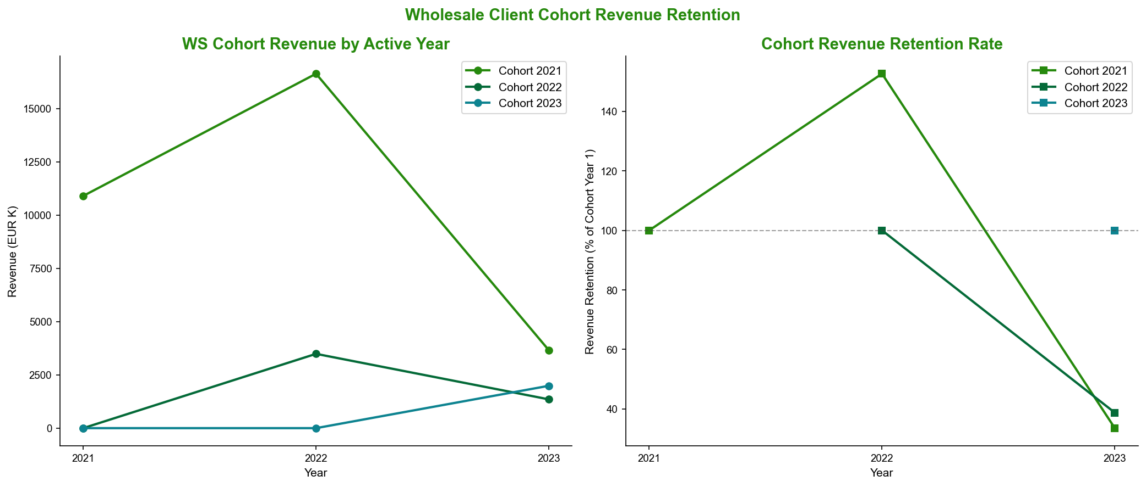
Client retention is also weakening over time. The 2021 client cohort retained 78% of its accounts in FY2022, declining to 53% by LTM23. This accelerating attrition — from the most mature and presumably highest-quality cohort — warrants active monitoring, as it implies that organic client relationships are degrading even as new accounts are being added.
2021 Cohort Retention | FY2021 | FY2022 | LTM23
Clients active | 996 | ~777 (78%) | ~527 (53%)

Wholesale Concentration: Distributed but Top-Heavy
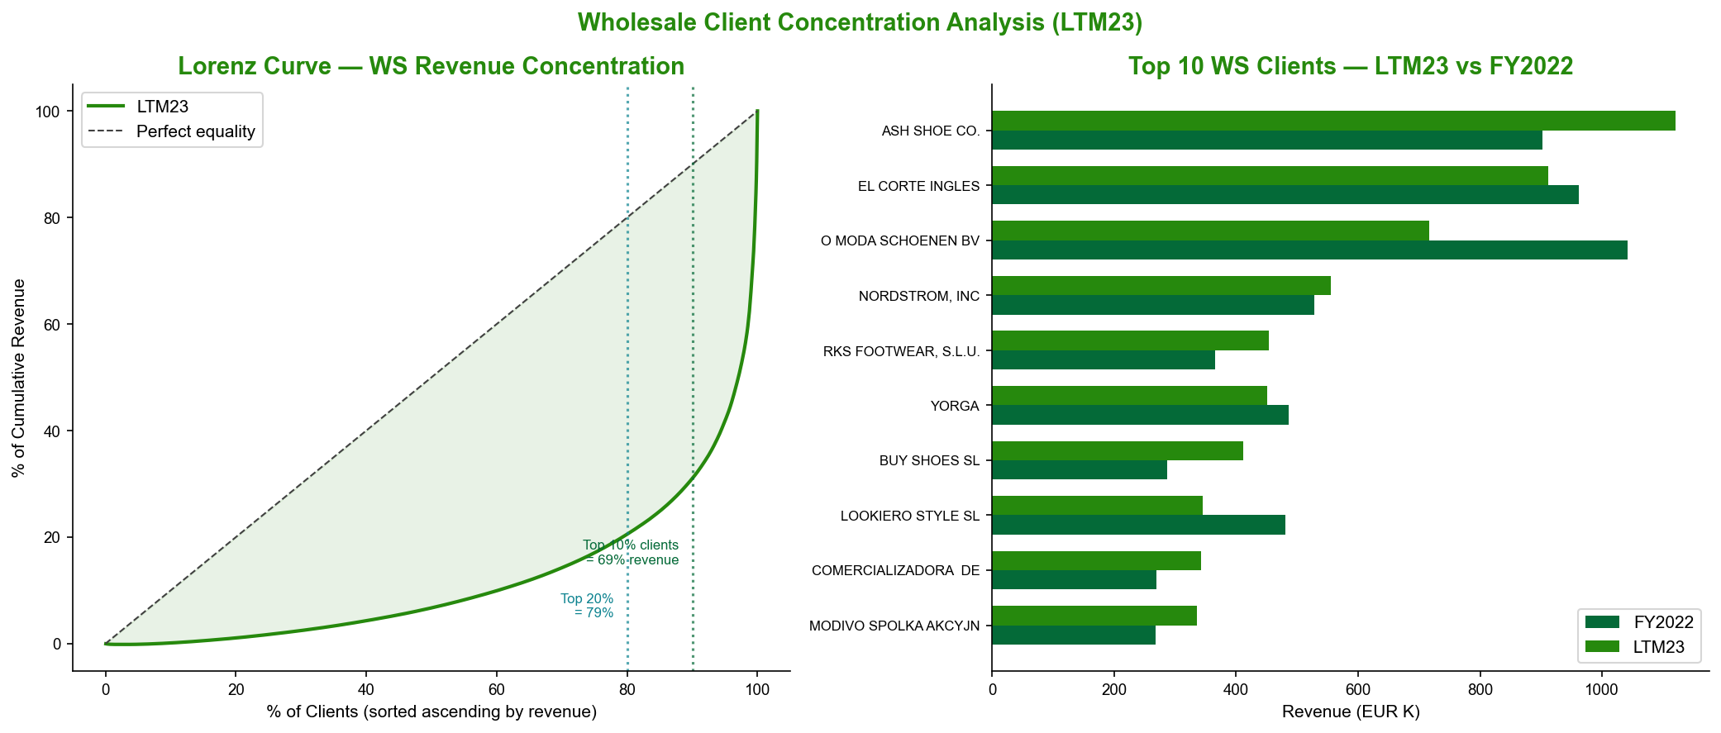
Concentration Metric | FY2021 | FY2022 | LTM23
HHI | 0.0140 | — | 0.0106
Top 10% of clients (rev share) | — | — | 69% (EUR 14.78M)
Top 20 clients (rev share) | 38.0% | 39.4% | ~35–38%

The Herfindahl-Hirschman Index (HHI) has declined from 0.0140 to 0.0106, reflecting a genuinely more distributed client base — no single account represents a catastrophic concentration risk. However, the top decile (169 clients) accounts for 69% of wholesale revenue, meaning the commercial priority set remains narrow relative to the client count.
Within the top 20, a performance bifurcation has emerged: growing accounts — including ASH SHOE CO. (+24.2%), BUY SHOES SL (+43.6%), and MODIVO (+25.6%) — tend to carry a more Stable-model-weighted basket (avg Stable% = 45.7%, NE% = 52.2%). Declining accounts — including O MODA SCHOENEN BV (–31.2%), LOOKIERO STYLE SL (–28.0%), and FALABELLA RETAIL (–25.4%) — carry baskets weighted more heavily toward NE models (avg NE% = 69.9%, Stable% = 29.9%). This divergence is a leading indicator: basket quality predicts account health.

Section 7: Client Basket Composition & Lifecycle Risk

Stable-Model Exposure Is the Strongest Predictor of Client Revenue Growth
Analysis of 794 returning wholesale clients reveals a monotonic relationship between portfolio composition and revenue performance:
Stable% Quartile | Stable% Range | Weighted YoY Revenue
Q1 — Lowest | 0–18% | –21.2%
Q2 | 18–28% | +31.7%
Q3 | 28–39% | +39.4%
Q4 — Highest | 39–100% | +63.0%

Conversely, high NE model dependency correlates inversely with performance:
NE% Quartile | NE% Range | Weighted YoY Revenue
Q1 — Lowest | 0–60% | +67.8%
Q2 | 60–75% | +37.8%
Q3 | 75–81% | +19.9%
Q4 — Highest | 81–124% | –20.7%

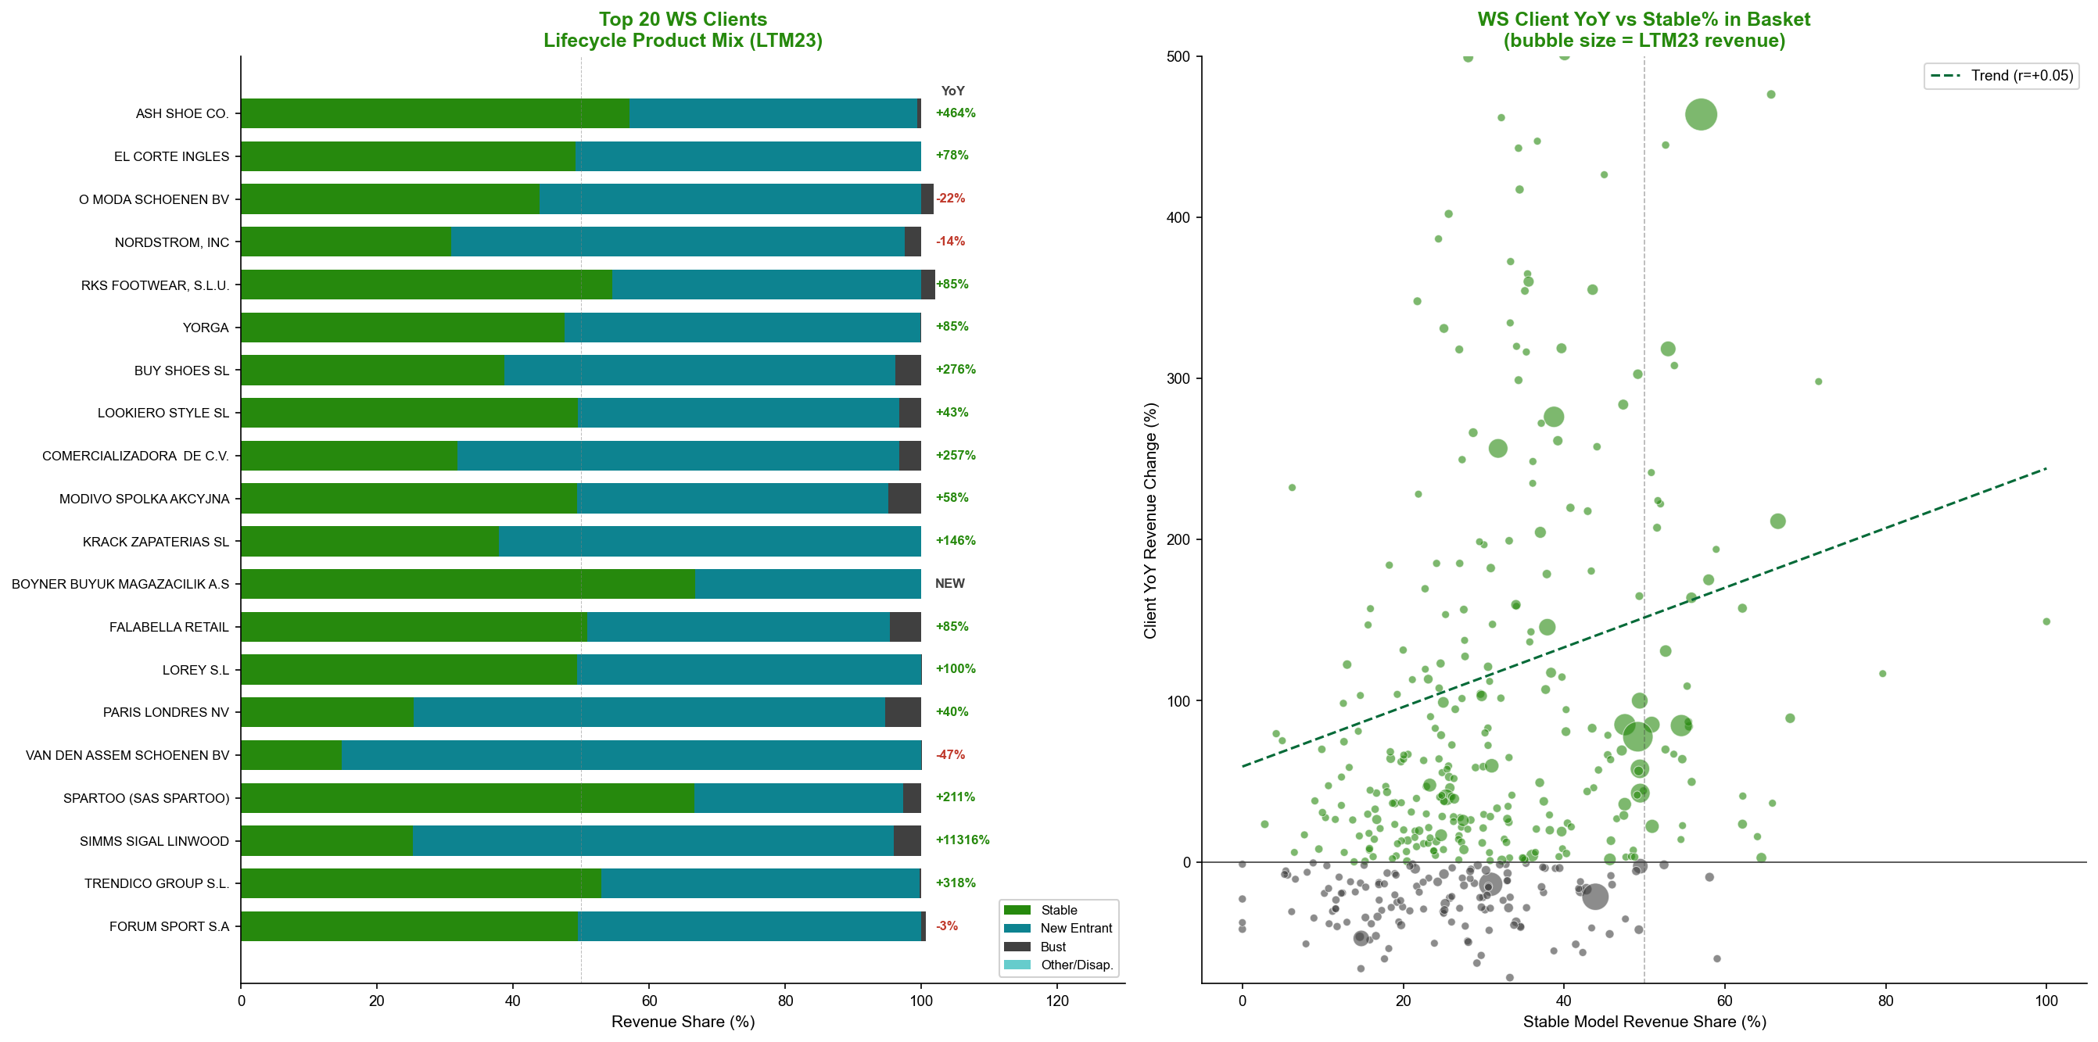
[Graph not found: iter9_ws_lifecycle_bridge.png]
This monotonic gradient — entirely consistent across four quartiles in both directions — is the clearest analytical signal in the dataset. Clients with strong Stable-model anchors in their basket grow reliably; clients over-concentrated in NE models underperform and, in the highest-NE quartile, decline in aggregate.
Additional cohort characterization reinforces this finding:
Client Cohort | # Clients | Avg YoY | % Growing
Bust-heavy (>50% Bust) | 4 | –19.6% | 0%
NE-led (>60% NE) | 638 | +76.3% mean / +3.9% median | Mixed
Stable-led (>40% Stable) | 89 | +75.1% | 64%

The NE-led cohort's mean/median divergence (+76.3% mean vs. +3.9% median) signals that the apparent dynamism in this group is driven by a small number of outlier accounts rather than broad-based momentum. Stable-led clients, at 64% growing and a mean of +75.1%, represent a more reliable and consistently positive growth engine.
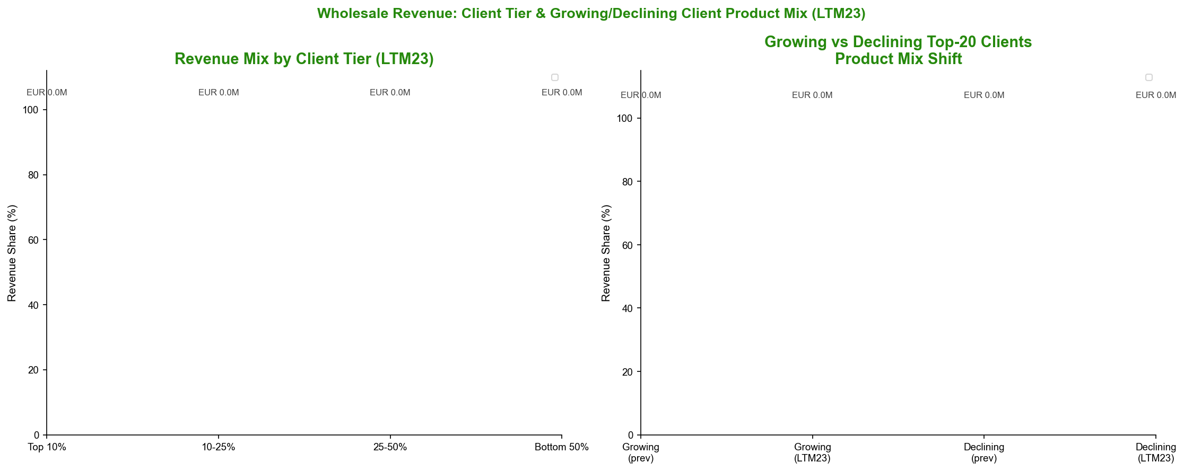

Section 8: Wholesale NE Revenue Structure — Breakout vs. Trickle Models

Growth Is Powered by a Large Volume of Small Models, Not a Few Breakout Hits
A common assumption in fashion-driven businesses is that revenue growth concentrates around a small number of "breakout" models. The data disconfirms this hypothesis:
NE Model Category | # Models | WS LTM23 Revenue | Share of WS NE
Breakout (≥EUR 500K WS) | 2 | EUR 1.21M | 9.5%
Trickle (<EUR 500K WS) | 113 | EUR 11.44M | 90.5%
**Total** | **115** | **EUR 12.65M** | **100%**

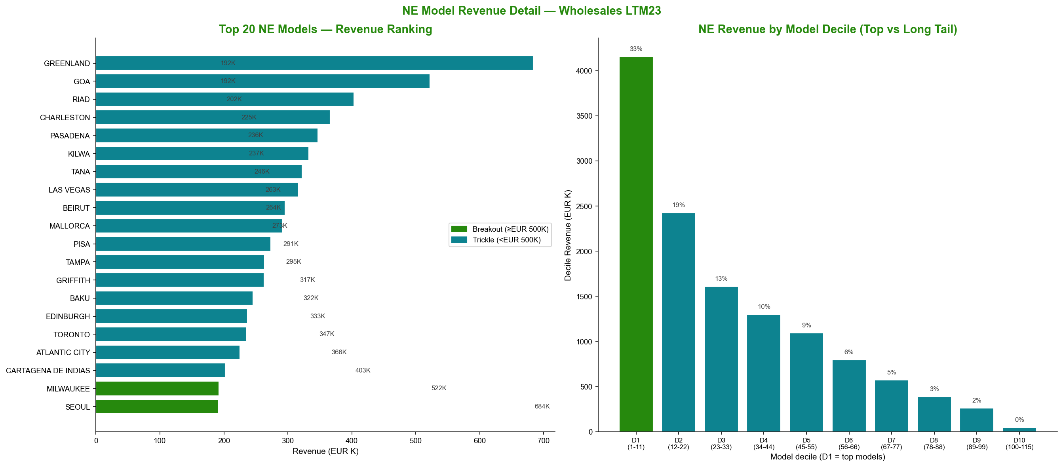
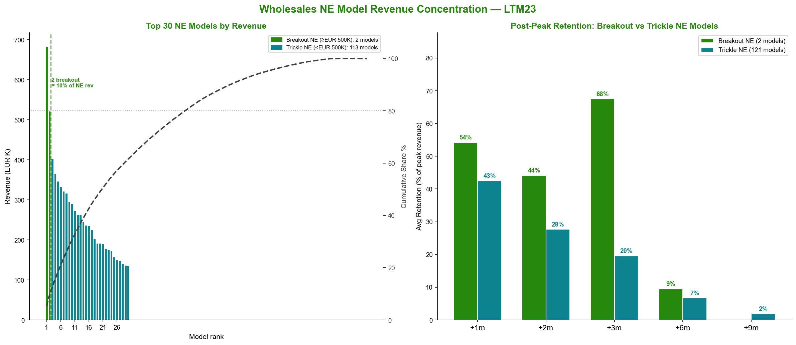
Only two New Entrant models qualify as breakouts — SEOUL (EUR 684K in wholesale LTM23) and MILWAUKEE (EUR 522K) — together representing 9.5% of wholesale NE revenue. The remaining EUR 11.4M is distributed across 113 lower-revenue "trickle" models, with 21 models required to reach the 50% cumulative revenue threshold and 51 models for 80%.
Post-peak retention by model type reveals an important asymmetry:
Retention Window | Breakout Models | Trickle Models
+3 months | 67.5% | 19.6%
+6 months | 9.5% | 6.7%
+9 months | 0% | ~5%

Breakout models exhibit superior short-term retention (+3m: 67.5% vs. 19.6%) but collapse sharply thereafter — reaching near-zero by +9 months. Trickle models are weaker in the short term but more distributed in risk. Critically, SEOUL and MILWAUKEE entered the LTM23 period from zero revenue — they carry no demonstrated durability track record beyond their initial launch window and cannot be extrapolated as reliable revenue contributors.
The actual engine of wholesale NE growth is the trickle model portfolio. Of 741 returning wholesale clients, 718 (97%) fall into the High-NE / Low-Breakout group — accounts ordering predominantly trickle NE models. This group generates EUR 16.64M in LTM23 revenue at a weighted YoY growth of +38.1%, with 56.3% of accounts growing. The business's NE revenue is structurally fragmented by design, not by accident.
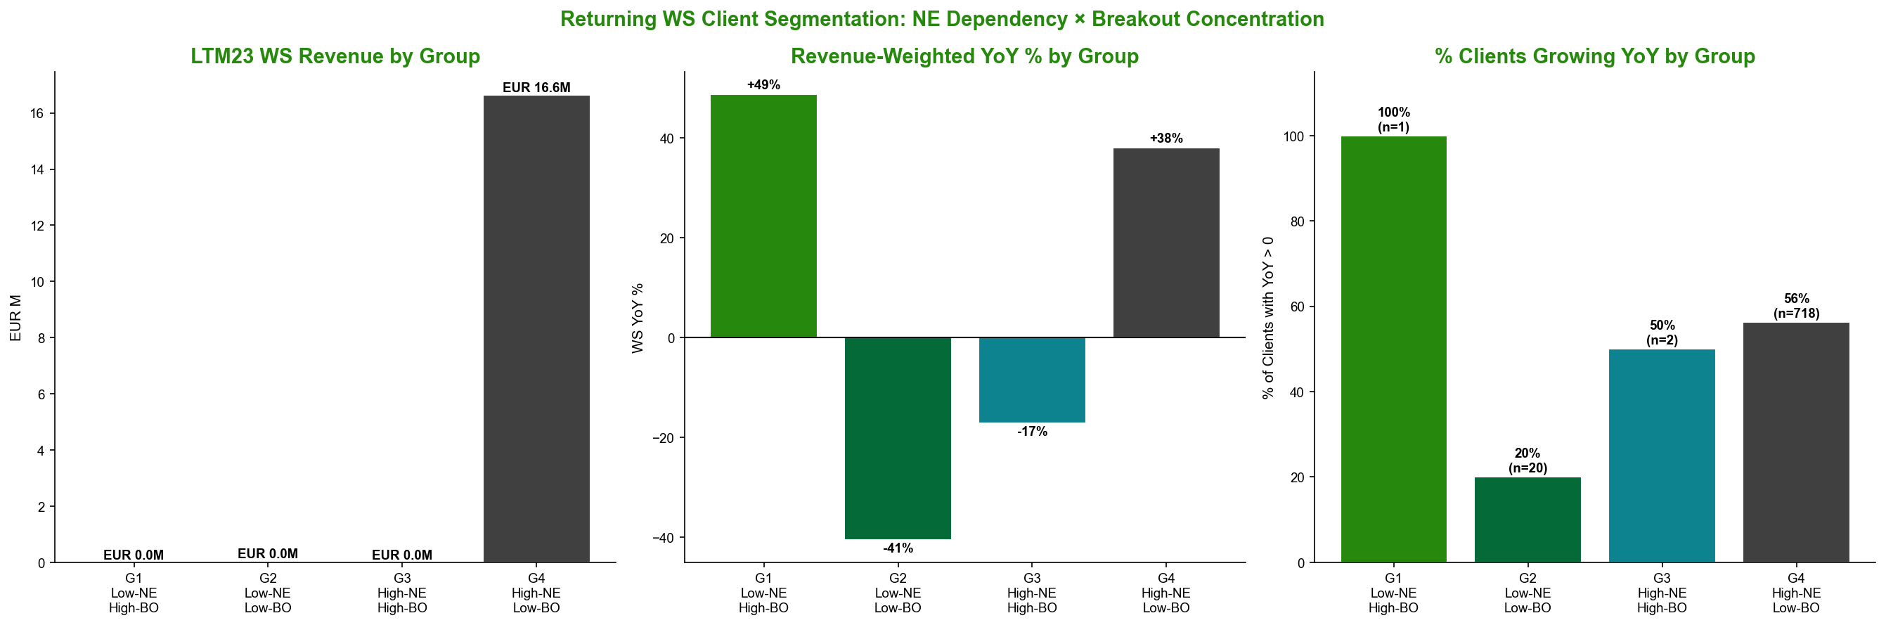

Executive Summary

The Five to Seven Things a Senior Stakeholder Must Know About This Business
1. The business has grown at a ~39% CAGR over 28 months, but the growth is structurally fragile.
Revenue expanded from EUR 16.7M (FY2021) to a EUR 36.1M LTM run-rate — impressive headline growth driven almost entirely by unit volume. Pricing has contributed negligibly (+7.4% of growth in FY2022, turning negative in LTM23). The business has no demonstrated pricing power, and sustaining growth requires continuous volume acceleration.
2. Over half of revenue now depends on New Entrant models that peak within three months and retain less than 20% of peak revenue after six months.
New Entrant models represent 50–55% of LTM23 revenue (EUR 18–20M). Of these, 48.5% are classified as Transient (less than 20% retention at +3 months post-peak). The Bust cohort — which mirrors this exact decay pattern — collapsed from EUR 8.45M to EUR 2.13M in one year. This is not a theoretical risk; it is a documented, recurring pattern that has already destroyed EUR 6.4M in annual revenue from the prior generation of New Entrant models.
3. The forward revenue pipeline faces a critical supply-side risk: new model launches have collapsed.
The Entry-tier cohort model — where each wave of new models replaces the prior wave's decaying revenue — requires a continuous launch cadence. FY2022 introduced 32 new Entry-tier models; LTM23 introduced only 3. If this slowdown persists, there is no incoming cohort to offset the natural decay of current New Entrants. The revenue gap will emerge within two to three quarters.
4. Wholesale like-for-like growth has already turned negative, and the quality of new client acquisition is declining.
FY2022 wholesale growth was driven by existing clients deepening their spend (+62.1% LfL) — high-quality, relationship-based growth. In LTM23, returning clients contracted –1.6%, and the entire EUR 1.3M wholesale increment came from 525 new accounts at an average of EUR 3,810 per account, versus EUR 6,883 for the prior new-client cohort. The addressable market for premium-tier wholesale accounts appears increasingly saturated.
5. Stable-model exposure is the single most reliable predictor of account health — and the business has a structural deficit in stable product depth.
A monotonic analytical gradient confirms that wholesale accounts in the highest Stable-model quartile grow at +63% YoY; those in the highest NE-model quartile decline at –20.7%. Stable models represent only 27.4% of LTM23 revenue and 39 SKUs — far fewer than the 109+ New Entrant SKUs currently active. Building the Stable model base is the most structurally durable path to revenue quality improvement.
6. No observable launch characteristic reliably predicts whether a New Entrant model will become durable.
Price (r = –0.087) and launch velocity (r = +0.119) are both negligible predictors of post-peak retention. The absence of a reliable durability screen means the business cannot systematically distinguish SEOUL-type models (85% retention at +3 months) from EDINBURGH-type models (18% retention) prior to launch. This is a structural planning and inventory-risk challenge that requires the development of new qualitative or operational screening criteria.
7. The Online channel represents a single-client EUR 7.8M revenue dependency, and Retail's growth flatters underlying economics.
The Online channel — almost certainly a marketplace or aggregator — has a single client across all periods. A relationship disruption would eliminate 21.7% of total revenue with limited near-term substitution options. Retail's quadrupling in revenue (EUR 1.1M to EUR 6.9M) has been accompanied by a 66% compression in average order value (EUR 1,091 to EUR 373), indicating that headline channel growth is being achieved through account breadth rather than account quality.

*Report prepared on the basis of transaction data covering January 2021 through April 2023. All monetary figures in EUR. LTM denotes Last Twelve Months ending April 2023; PLTM denotes the equivalent prior twelve-month period. CAGR calculated over 2.25 years.*

