1a. select first_name, last_name from actor;

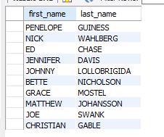

1b. SELECT Concat(first_name , ' ' , last_name) AS ActorName

FROM actor;

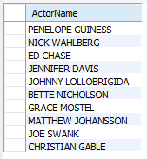

2a. select actor_id, first_name, last_name

from actor

where first_name = 'Joe';



2b. select last_name

from actor

where last_name like '%GEN%'

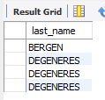

2c. select last_name, first_name

from actor

where last_name like '%LI%'

order by last_name;

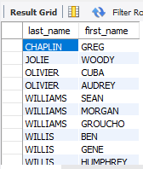

2d. select country_id, country

from country

where country in ('Afghanistan','Bangladesh','China');

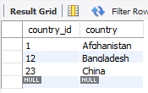

3a. alter table actor add middle_name varchar(60) after first_name;

select* from actor;

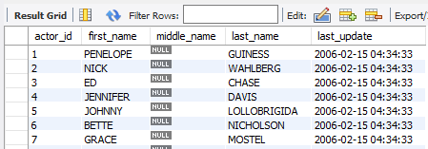

3b. alter table actor

alter column middle_name type bytea using middle_name

3c. alter table actor

drop middle_name;

select*from actor;

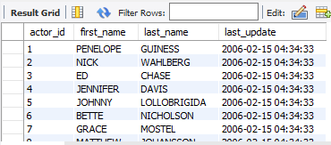

4a. select last_name,count(last_name) from actor

group by last_name

order by count(last_name) desc;

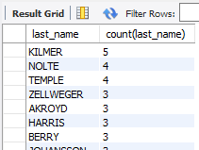

4b. select last_name,count(last_name) from actor

group by last_name

having count(last_name) >= 2

order by count(last_name) desc

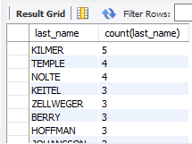

4c. update actor

set first_name = 'HARPO'

where first_name = 'GROUCHO'

and last_name = 'WILLIAMS';

select* from actor where last_name = 'williams'

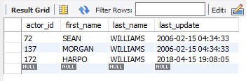

4d. I didn’t understand what was needed here.

5a. describe address

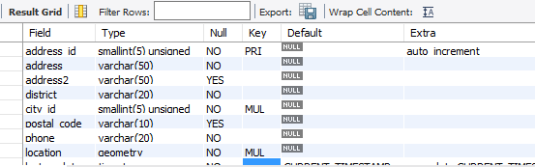

6a. select first_name, last_name, address

from staff s, address a

where s.address_id = a.address_id

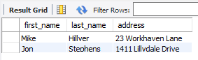

6b. select first_name, last_name, sum(p.amount) as total from staff s, payment p

where s.staff_id = p.staff_id

group by s.first_name, s.last_name;

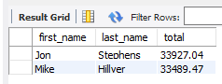

6c. select f.title, count(fa.actor_id) as total

from film_actor fa, film f

where fa.film_id = f.film_id

group by f.title

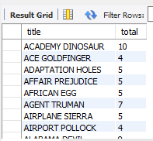

6d. select count(f.title) as Copies, f.title

from film f, inventory i

where f.film_id = i.film_id

and f.title = 'Hunchback Impossible'

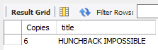

6e. select c.first_name, c.last_name, sum(p.amount) as total

from payment p, customer c

where p.customer_id = c.customer_id

group by c.last_name asc

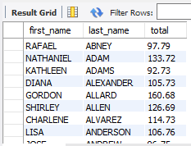

7a. select f.title, l.name

from film f, language l

where f.language_id = l.language_id

and f.title like 'k%' or f.title like'Q%'

and l.name = 'English';



7b. select first_name, last_name from actor where actor_id in

(select actor_id from film_actor where film_id in

(select film_id from film where title = 'Alone Trip'));

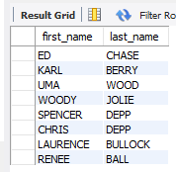

Or:

select first_name, last_name, title

from actor a, film_actor fa, film f

where a.actor_id = fa.actor_id

and fa.film_id = f.film_id

and f.title = 'Alone Trip'

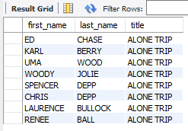

7c. select cu.first_name, cu.last_name, cu.email, co.country

from customer cu, address a, city ci, country co

where cu.address_id = a.address_id

and a.city_id = ci.city_id

and ci.country_id = co.country_id

and co.country = 'Canada'

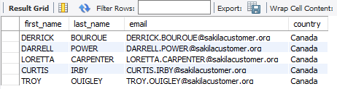

7d. select f.title, c.name

from film f, film_category fc, category c

where f.film_id = fc.film_id

and fc.category_id = c.category_id

and c.name = 'Family'

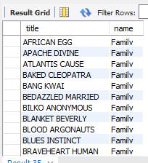

7e. select f.title, count(f.film_id) Most_Rented_Movie

from film f, inventory i, rental r

where f.film_id = i.film_id

and i.inventory_id = r.inventory_id

group by f.title

order by Most_Rented_Movie desc;



7f. select s.store_id, sum(p.amount) as Total_Store_Amount

from payment p, staff s

where p.staff_id = s.staff_id

group by s.store_id

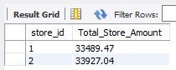

7g. select s.store_id, c.city, co.country

from store s, address a, city c, country co

where s.address_id = a.address_id

and a.city_id = c.city_id

and c.country_id = co.country_id

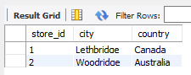

7h. select c.name, sum(p.amount) as Total_Gross_Rev

from category c, film_category fc, inventory i, rental r, payment p

where c.category_id = fc.category_id

and fc.film_id = i.film_id

and i.inventory_id = r.inventory_id

and r.rental_id = p.rental_id

group by c.name

order by Total_Gross_Rev

limit 5;

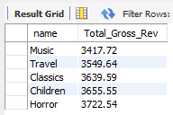

8a. create view Top_Five_Genres as

select c.name, sum(p.amount) as Total_Gross_Rev

from category c, film_category fc, inventory i, rental r, payment p

where c.category_id = fc.category_id

and fc.film_id = i.film_id

and i.inventory_id = r.inventory_id

and r.rental_id = p.rental_id

group by c.name

order by Total_Gross_Rev

limit 5;



8b. select* from Top_Five_Genres

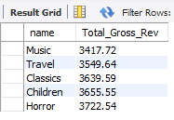

8c. drop view Top_Five_Genres;



Or:

