Name: _JOSE DANIEL LEONETT______
CSE 212 Data Structure “Cheat Sheet”

Note: This document should contain your own work. It is a violation of the BYU-Idaho honor code to share this document or copy in whole or in part from another.

Data Structure | Graphic | Purpose and Example | Time Complexity of Common Operations
 |  |  | Insert | Access
Dynamic Array | 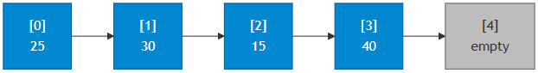 | A dynamic array automatically grows when more space is needed. It provides fast random access by index and efficient end operations. Use a dynamic array when you need to store a list of items that may grow over time, like a shopping cart that customers add items to. | At the beginning: O(n)  At the end: O(1) amortized | Find by value: O(n)  Find by index: O(1)
Linked List (Doubly-linked) |  | consists of nodes containing data and pointers to next/previous nodes. It allows efficient insertion/deletion at known positions without shifting elements. Use a doubly-linked list for maintaining a browser history where users can navigate forward and backward through visited pages. | At the beginning: O(1)  At the end: O(1) if tail pointer available | Find by value: O(n)  Find by index: O(n)
Stack | 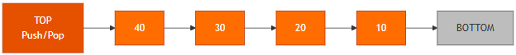 | Follows Last-In-First-Out (LIFO) - the last item added is the first removed. It's perfect for undo functionality in applications (each action is pushed, and undo pops the most recent action). | O(1) | The top: O(1),  Find by value: O(n)
Queue | 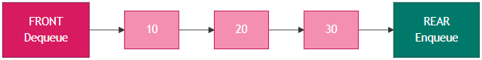 | Follows First-In-First-Out (FIFO) - items are added at the rear and removed from the front. Use a queue to manage customer service representatives handling incoming calls in order of arrival. | O(1) | The front: O(1),  Find by value: O(n)
Map | 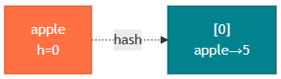  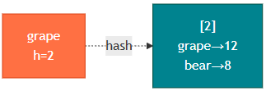  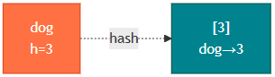 | A map stores key-value pairs and uses a hash function for quick lookups. Use a map to store student IDs as keys and their grades/information as values for O(1) average lookup time. | O(1) average, O(n) worst case | O(1) average, O(n) worst case
Balanced BST | 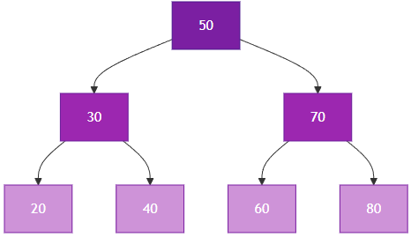 | A balanced BST maintains sorted data with logarithmic search time through automatic balancing. Use a balanced BST to maintain employee records sorted by ID where you need fast searches and need items to stay sorted. | O(log n) | O(log n)

