DataOps Workbench
Quick Start - get the environment running in under 30 minutes

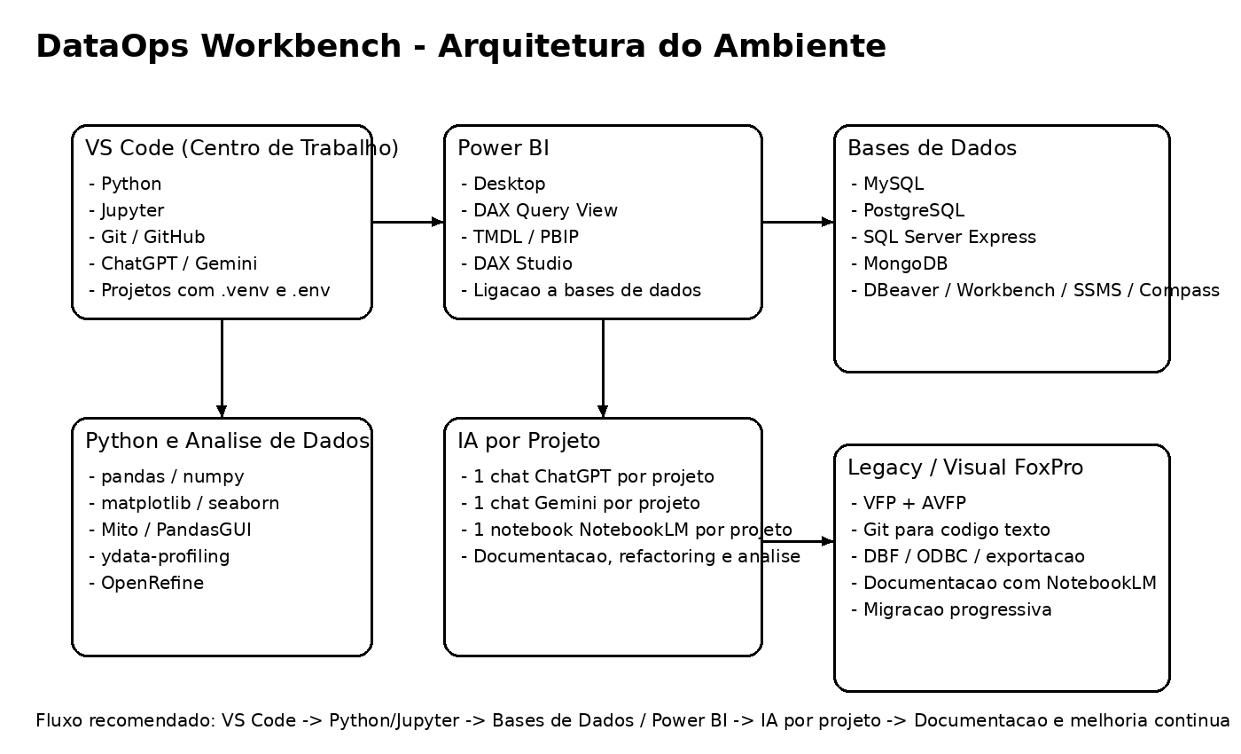
Condensed edition

1. Install
- Python - https://www.python.org/downloads/
- VS Code - https://code.visualstudio.com/
- Git - https://git-scm.com/downloads
- DBeaver - https://dbeaver.io/
- Power BI Desktop - Microsoft

2. Create a project
python -m venv .venv
.\.venv\Scripts\Activate.ps1
pip install pandas jupyter matplotlib seaborn ipykernel python-dotenv

3. Structure
data/
notebooks/
scripts/
docs/
.env
requirements.txt
README.md

4. First notebook
import pandas as pd
print("Environment OK")

5. First commit
git init
git add .
git commit -m "Initial commit"

6. First database test
SELECT 1;

7. First Power BI test
Import a simple CSV, create one visual and one DAX measure.

8. AI by project
- 1 ChatGPT/Codex conversation
- 1 Gemini conversation
- 1 NotebookLM notebook

