DIGITAL TRANSFORMATION  
PLAYBOOK



# Introduction

This playbook outlines a comprehensive digital transformation strategy for a mid-size regional telecommunications provider ('TeleConnect') seeking to modernize operations, enhance customer experience, and compete with national carriers through data-driven and cloud-based innovation.

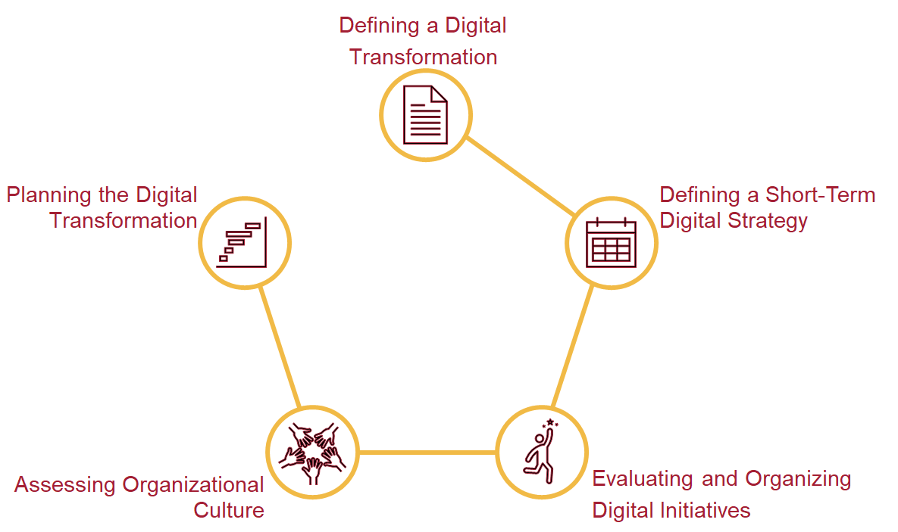

# Playbook Part 1: Defining A Digital Transformation

|  |  |  |  |
| --- | --- | --- | --- |
| **Clipboard Mixed outline** | **Task:**  Define the four phases of a digital transformation. | **Checkbox Checked outline** | **Completion Requirement:**  Answer all the guiding questions in the playbook template. |
| **Bullseye outline** | **Purpose:**  Defining the phases of your digital transformation is the first step to formulating a digital strategy. Completing this assignment will help you define your digital strategy. | **Stopwatch 33% outline** | **Suggested Time:**  30 minutes |

### Step 1: Articulate your organization’s overall strategy

* What is your organization’s overall strategy?

|  |
| --- |
| TeleConnect aspires to establish itself as a digital-first telecommunications provider by utilizing cloud technologies, enhancing customer experience, and augmenting service delivery agility. |

### Step 2: Assess the impacts of the overall organizational strategy on your digital strategy

Module 1

Module 2

Module 3

Module 4

Module 5

Module 6

* How rigid or flexible is your organization’s overall strategy?
* To what extent will your digital strategy drive or be driven by your organization’s overall strategy?

|  |
| --- |
| The strategy is moderately flexible, enabling the digital strategy to guide technology investments and innovation while aligning with core business objectives, including customer retention and operational efficiency. |

### Step 3: Define your long-term goals

* Go back to your collection of digital initiative candidates and examine them in light of the relationship between your digital strategy and overall organizational strategy. Think about what success looks like for individual initiatives and the strategy as a whole in the long term.
* What are your long-term goals for digital transformation?

|  |
| --- |
| * Deliver personalized customer experiences * Achieve a 20% reduction in operational costs * Migrate modernizing and transforming the core systems to cloud infrastructure * Build a predictive analytics platform for churn and network performance |

### Step 4: Analyze the strengths and weaknesses of your organization

* Examine your potential initiatives for clues on what your organization is currently doing and where it will need help. Consider your environment and competition to assess your advantages and disadvantages.
* What are the existing strengths that your digital strategy will build on?
* What does your organization currently lack and need to achieve?

|  |
| --- |
| * Strengths:   + Strong regional brand presence   + Loyal customer base * Weaknesses:   + Legacy OSS/BSS systems   + Limited internal cloud and data expertise |

### Step 5: Define strategic goals for digital transformation

* Based on the analysis above, what are your strategic goals for digital transformation?

|  |
| --- |
| * Modernize IT infrastructure, progressing to the cloud and network management * Enhance digital channels and self-service capabilities * Empower staff through digital upskilling |

# Playbook Part 2: Defining Short-Term Digital Strategy

|  |  |  |  |
| --- | --- | --- | --- |
| **Clipboard Mixed outline** | **Task:**  Determine whether your organization needs short-term digital strategies. If so, define the short-term digital strategies and articulate their rationales. | **Checkbox Checked outline** | **Completion Requirement:**  Indicate whether your organization needs short-term digital strategies. If the answer is yes, define at least one short-term strategic goal and explain the rationale behind it. |
| **Bullseye outline** | **Purpose:**  Short-term digital strategies pave the way for accomplishing long-term digital strategic goals. | **Stopwatch 33% outline** | **Suggested Time:**  10 minutes |

* Does your organization need short-term digital strategies? Explain why or why not.

|  |
| --- |
| Yes, short-term digital strategies are necessary to secure initial successes and validate the transformation vision.  Example: Launching an AI-powered chatbot to improve support efficiency and customer satisfaction. |

# Playbook Part 3: Evaluating and Organizing Digital Initiatives

|  |  |  |  |
| --- | --- | --- | --- |
| **Clipboard Mixed outline** | **Task:**  Analyze one digital initiative. Based on the analysis, discuss how to include it in a digital transformation. | **Checkbox Checked outline** | **Completion Requirement:**  Evaluate at least one digital initiative. Clearly articulate how to include the initiative in the digital transformation road map and why you should. |
| **Bullseye outline** | **Purpose:**  Evaluating, selecting, and sequencing digital initiatives are the key steps to building a digital transformation. | **Stopwatch 33% outline** | **Suggested Time:**  30 minutes |

|  |  |  |
| --- | --- | --- |
| **Summary of Digital Initiative** | | **Your Answers** |
| Analysis | * Alignment with the long-term and short-term digital strategy * Risks involved in the strategy * Impacts on the organization’s overall strategy, needs, and constraints | * Alignment: Strongly supports both short-term agility and long-term scalability goals. * Risks: Integration complexity and downtime * Impacts: Enables automation, cost reduction, faster rollout |
| Whether you would include this initiative in your digital transformation (also provide reasoning) | * Yes, I would include this initiative in my digital transformation. * No, I would not include this initiative in my digital transformation. | * Yes, foundational to other modernization efforts. |

# Playbook Part 4: Assessing Organizational Culture

|  |  |  |  |
| --- | --- | --- | --- |
| **Clipboard Mixed outline** | **Task:**  Quickly assess your organizational culture using the questions provided in the playbook template. Based on the answers, summarize the strengths and weaknesses of the culture. Consider the root causes of the weaknesses and how you may address them. | **Checkbox Checked outline** | **Completion Requirement:**  Answer all the assessment questions. Identify at least one weakness in your organizational culture and articulate its root cause. List at least one action you could take to address the weakness. |
| **Bullseye outline** | **Purpose:**  Cultivating a culture supportive of digitally driven innovations is crucial for digital transformation. | **Stopwatch 33% outline** | **Suggested Time:**  30 minutes |

**Assessing organizational culture**

* Quickly jot down your answers to the following question in the right column. Based on your answers, summarize the strengths and weaknesses of your organization's culture. Identify the root causes of the weaknesses and list a few actions you may take to address them.

|  |  |
| --- | --- |
| **Question for Assessing Your Organization's Culture** | **Your Answer** |
| Are employees afraid to say, “I don’t know” when faced with a new situation? | Employees are hesitant to admit uncertainty |
| Are employees concerned about how they will be perceived publicly if they take a wrong point of view? | Risk-averse, with slow experimentation adoption |
| How often do employees say, “Let’s find out what the customer thinks”? | Rarely reference customer feedback |
| How fast does the organization kill new initiatives that do not deliver on their promise? | Fail-fast initiatives are limited |
| How often are employees celebrated for trying to do things differently and better? | Low celebration of innovation attempts |

* Based on your answers to the questions above, what are the strengths and weaknesses of your organization's culture?

|  |  |
| --- | --- |
| **Strengths** | **Weaknesses** |
| * Operational discipline | * Innovation inertia * Fear of failure |

* What are the root causes of the weaknesses?
* What can you do to address the weaknesses of your organization's culture?

|  |
| --- |
| Root Cause: Legacy mindset and hierarchical decision-making Action: Leadership modeling, internal innovation awards, customer feedback integration |

# Playbook Part 5: Planning the Digital Transformation

|  |  |  |  |
| --- | --- | --- | --- |
| **Clipboard Mixed outline** | **Task:**  Describe the four phases of digital transformation: problem definition, prototyping, implementation, and monitoring and improvements. | **Checkbox Checked outline** | **Completion Requirement:**  Evaluate one digital transformation by assessing its four phases. |
| **Bullseye outline** | **Purpose:**  This framework will help you understand the process you need to follow to successfully implement a digital transformation. | **Stopwatch 33% outline** | **Suggested Time:**  30 minutes |

**Step 1: Use everything you have completed until now to describe the four phases of your digital transformation in depth.**

|  |  |
| --- | --- |
| **Phase 1: Problem Definition** | **Phase 2: Modeling and Prototyping** |
| * **Identify infrastructure limitations and user pain points** * **Interview stakeholders to define priority areas** | * **Develop MVPs for chatbot and analytics dashboards** * **Run pilot of cloud-based billing system** |
| **Phase 3: Development and Implementation** | **Phase 4: Monitoring and Improvements** |
| * **Roll out full OSS/BSS migration** * **Automate NOC operations** * **Launch unified digital portal** | * **Track KPIs: NPS, churn, time-to-market** * **Hold monthly improvement retrospectives** * **Evolve dashboards and feedback loops** |

**Step 2: Based on this analysis, how do you expect your organizational characteristics to contribute to the digital transformation?**

|  |
| --- |
| * **Existing cross-functional teams can adapt to agile workflows** * **Investment readiness supports system modernization** * **Gaps in cloud knowledge may slow implementation, addressed via targeted upskilling** |