**Fast and Curious**

Development of a low-cost traffic flow measurement system

The aim of Fast and Curious is to develop a low-cost traffic measurement system, which counts, categorize and estimates the speed of each passing vehicle. As a distributed system of devices, it is also intended to make a statistical statement about the driving behaviour of the recorder traffic in a defined regional area. The entire system should be operated intuitively and can be operated in an energy-efficient manner over extended periods of time in any weather conditions.

The system was realized with a battery powered NanoPi Neo and a USB camera. The device is mounted at a height of 6m parallel to a maximum two-lane road. The drivers are temporarily stored by video recording. Vehicles are extracted from the background, counted and classified into categories with OpenCV from the videos. This data and the location are used to reconstruct the traffic flow in the area. This is done by matching the travel times and the measured times between the individual devices.

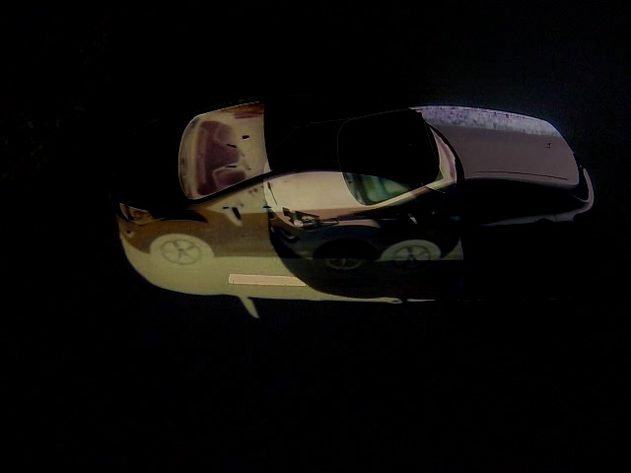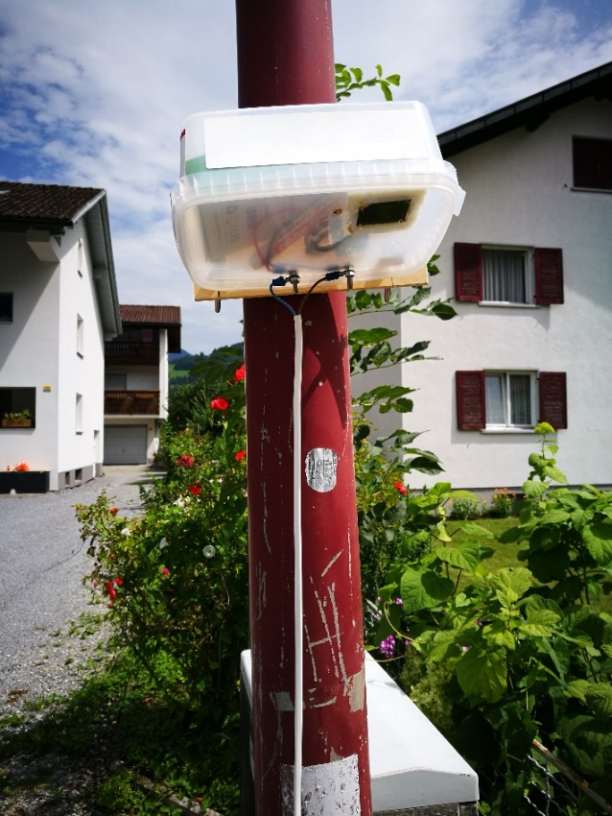In addition to the speed and category, traffic flow is an important parameter that can be used by traffic planners for future decisions.

Student: Josef Böckle

Daniel Lüchinger

Instructor: Prof. Dr. Klaus Frick

Co-instructor: Prof. Dr. Tindaro Pittorino

Industry partner: Adlos AG