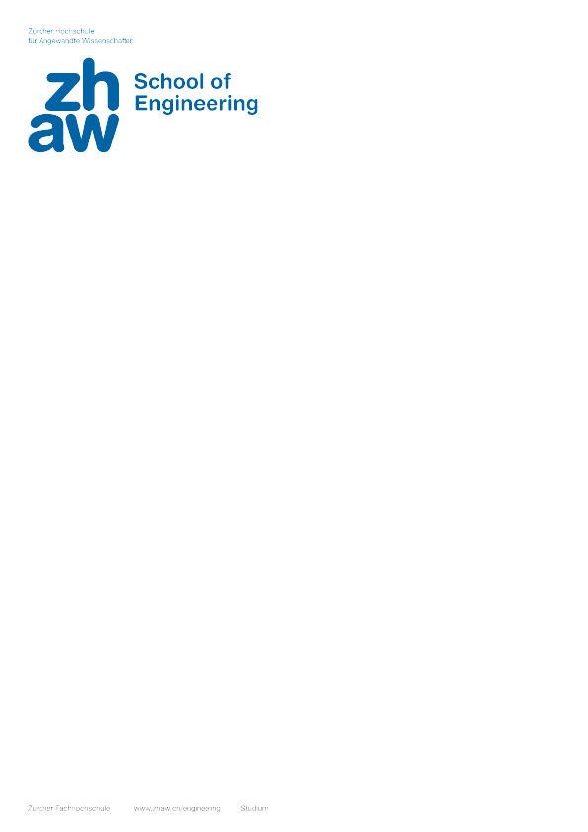

Bachelor‘s Thesis, BSc in Computer Science
Linked data-driven UI for task-based computing

Autoren |  | Josef Erben
Hauptbetreuung |  | Philipp Hofmann
Nebenbetreuung |  | Alain Lafon
Industriepartner |  | M. Nieminen Consulting
Datum |  | 07.06.2019

