  - Polynomial Regression

Matlab-Code

clear all;
close all;

load('linearregression_homework.mat');

l = 0:6;

calculate_plot( l,x_train,y_train );
calculate_plot( l,x_test,y_test,y_test_nonoise );

function calculate_plot( l,x,y,y_nonoise )
x_length = length(x);
mse = l;
for degree = l
X_matrix = ones(x_length, degree+1);
for exponent = 0:degree
X_matrix(:,exponent+1) = x .^ exponent;
end
W = (X_matrix' * X_matrix)^-1 * X_matrix' * y;
y_calc = X_matrix * W;
mse(degree+1) = sum((y_calc - y) .^ 2) / x_length

figure;
plot(x, y, '.b');
hold all;
plot(x, y_calc, '-r');

titles = ['input', 'approximated'];
if nargin == 4
plot(x, y_nonoise, '-g');
legend('input', 'approximated', 'input without noise');
else
legend('input', 'approximated');
end
xlabel('x');
ylabel('y');
end
figure;
plot(l,mse);
title('Mean squared error as a function of the degree.');

end

Which value of l would you choose?

We will choose the value 2 for l.
Plots

Training data-points

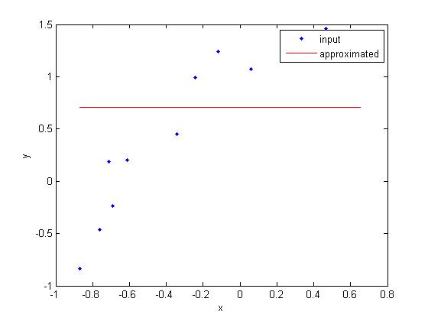
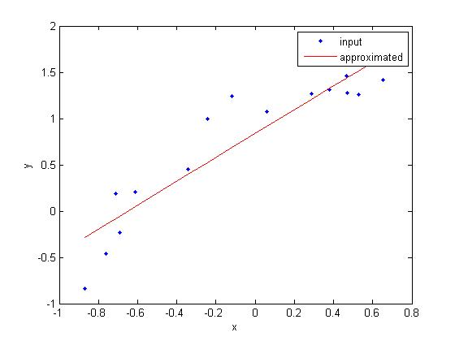

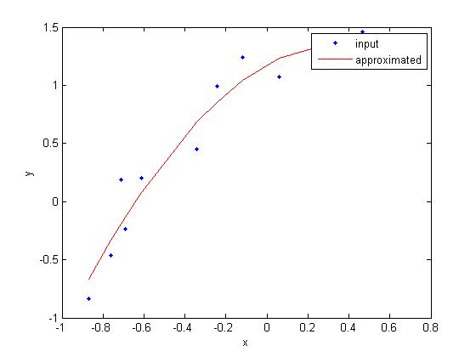
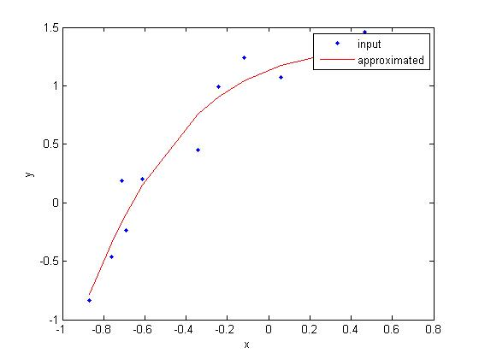

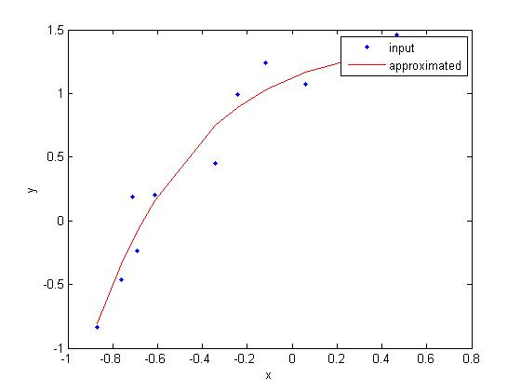
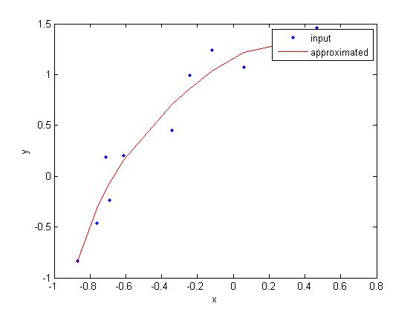
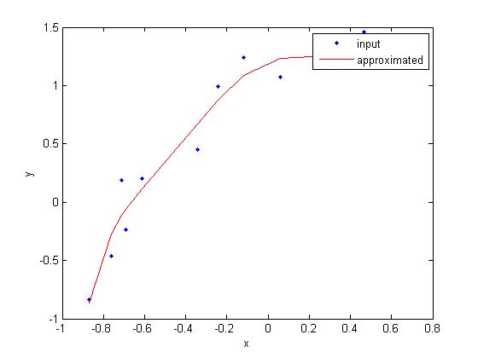
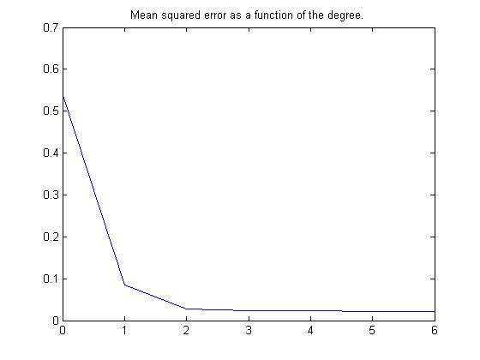
Test data-points
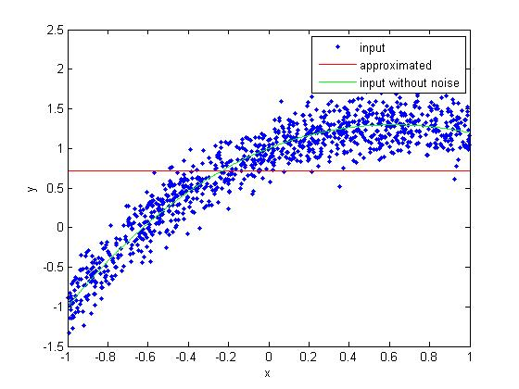
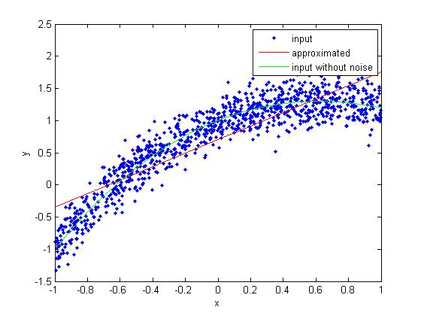

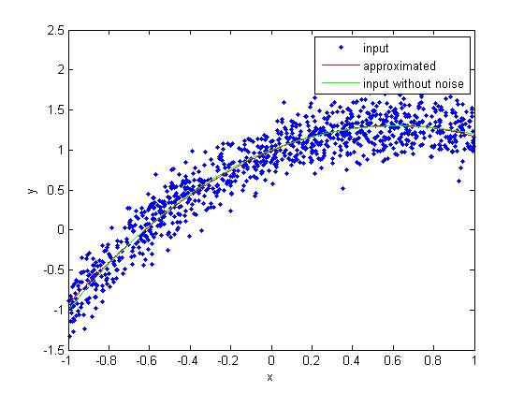
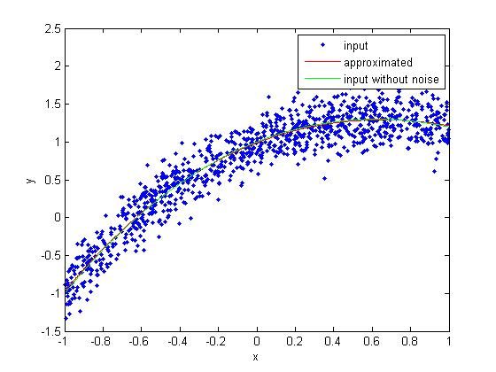

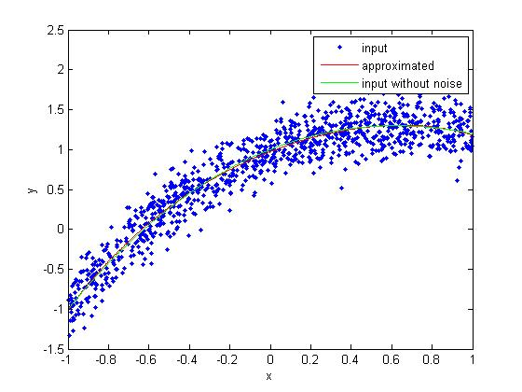
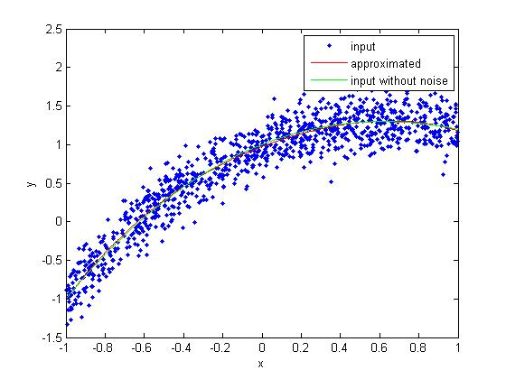

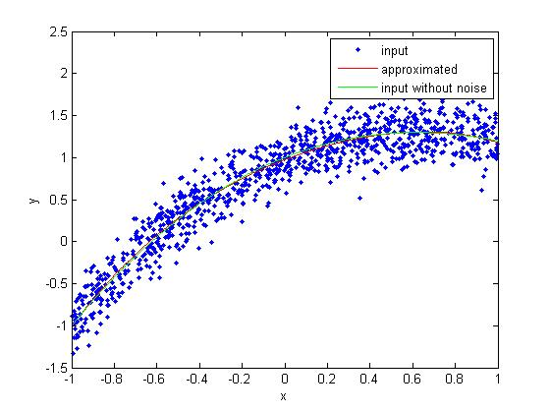
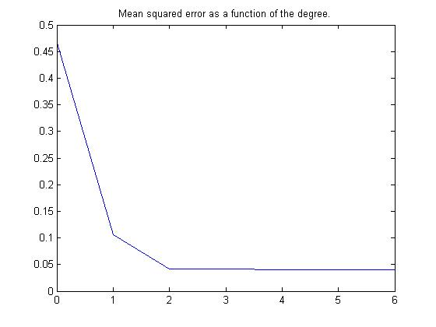

  - Regularized Polynomial Regression

Matlab-Code

clear all;
close all;

load('linearregression_homework.mat');
degree = 10;
space = logspace(-3, 0, 10);
train_plot_style = 'b-';
test_plot_style = 'm-';

figure;
[calc_y_train, mse_train, w_train] = plot_mse_alpha(x_train, y_train, space, degree, train_plot_style);
hold on;
[calc_y_test, mse_test, w_test] = plot_mse_alpha(x_test, y_test, space, degree, test_plot_style);
legend('training data', 'test data');
hold off;

lowest_alpha_index = 1;
highest_alpha_index = length(space);

figure;
hold on;

[min_mse, best_alpha_index] = min(mse_train);

handle = plot(x_train, calc_y_train(lowest_alpha_index, :), 'b-');
set(handle, 'linewidth', 3);
plot(x_train, calc_y_train(highest_alpha_index, :), 'g-');
plot(x_train, calc_y_train(best_alpha_index, :), 'r-');

plot(x_train, y_train, 'co');
plot(x_test, y_test_nonoise, 'm-');

xlabel('x');
ylabel('y');
legend('y for lowest alpha', 'y for highest alpha', 'y for best alpha', 'training points', 'target function');
title('y for different alphas');
hold off;

w_mean = zeros(length(space), 1);
for index = 1:length(space)
w = w_train(index, :)
w_mean(index) = mean(abs(w));
end

figure;
semilogx(space, w_mean);
title('mean absolute weight values');

function [y_calc, mse, w] = plot_mse_alpha(x, y, space, degree, plot_style)
x_length = length(x);
X = ones(x_length, degree+1);
for exponent = 0:degree
X(:,exponent+1) = x .^ exponent;
end

space_length = length(space);
mse = zeros(space_length, 1);
y_calc = zeros(space_length, x_length);
w = zeros(space_length, degree+1);
for index = 1:length(space)
alpha = space(index);
current_w = calculate_weight( alpha, X, y, degree );

current_y_calc = X * current_w;

w(index, :) = current_w;
y_calc(index, :) = current_y_calc;

mse(index) = sum((current_y_calc - y) .^ 2) / x_length;
end

semilogx(space, mse, plot_style);
xlabel('alpha');
ylabel('mean squared error');
end

function [ w ] = calculate_weight( alpha, X, y, degree )
N = length(y);

w = inv(alpha^2*eye(degree+1) + (X' * X) / N) * ((X'*y)/N);
end

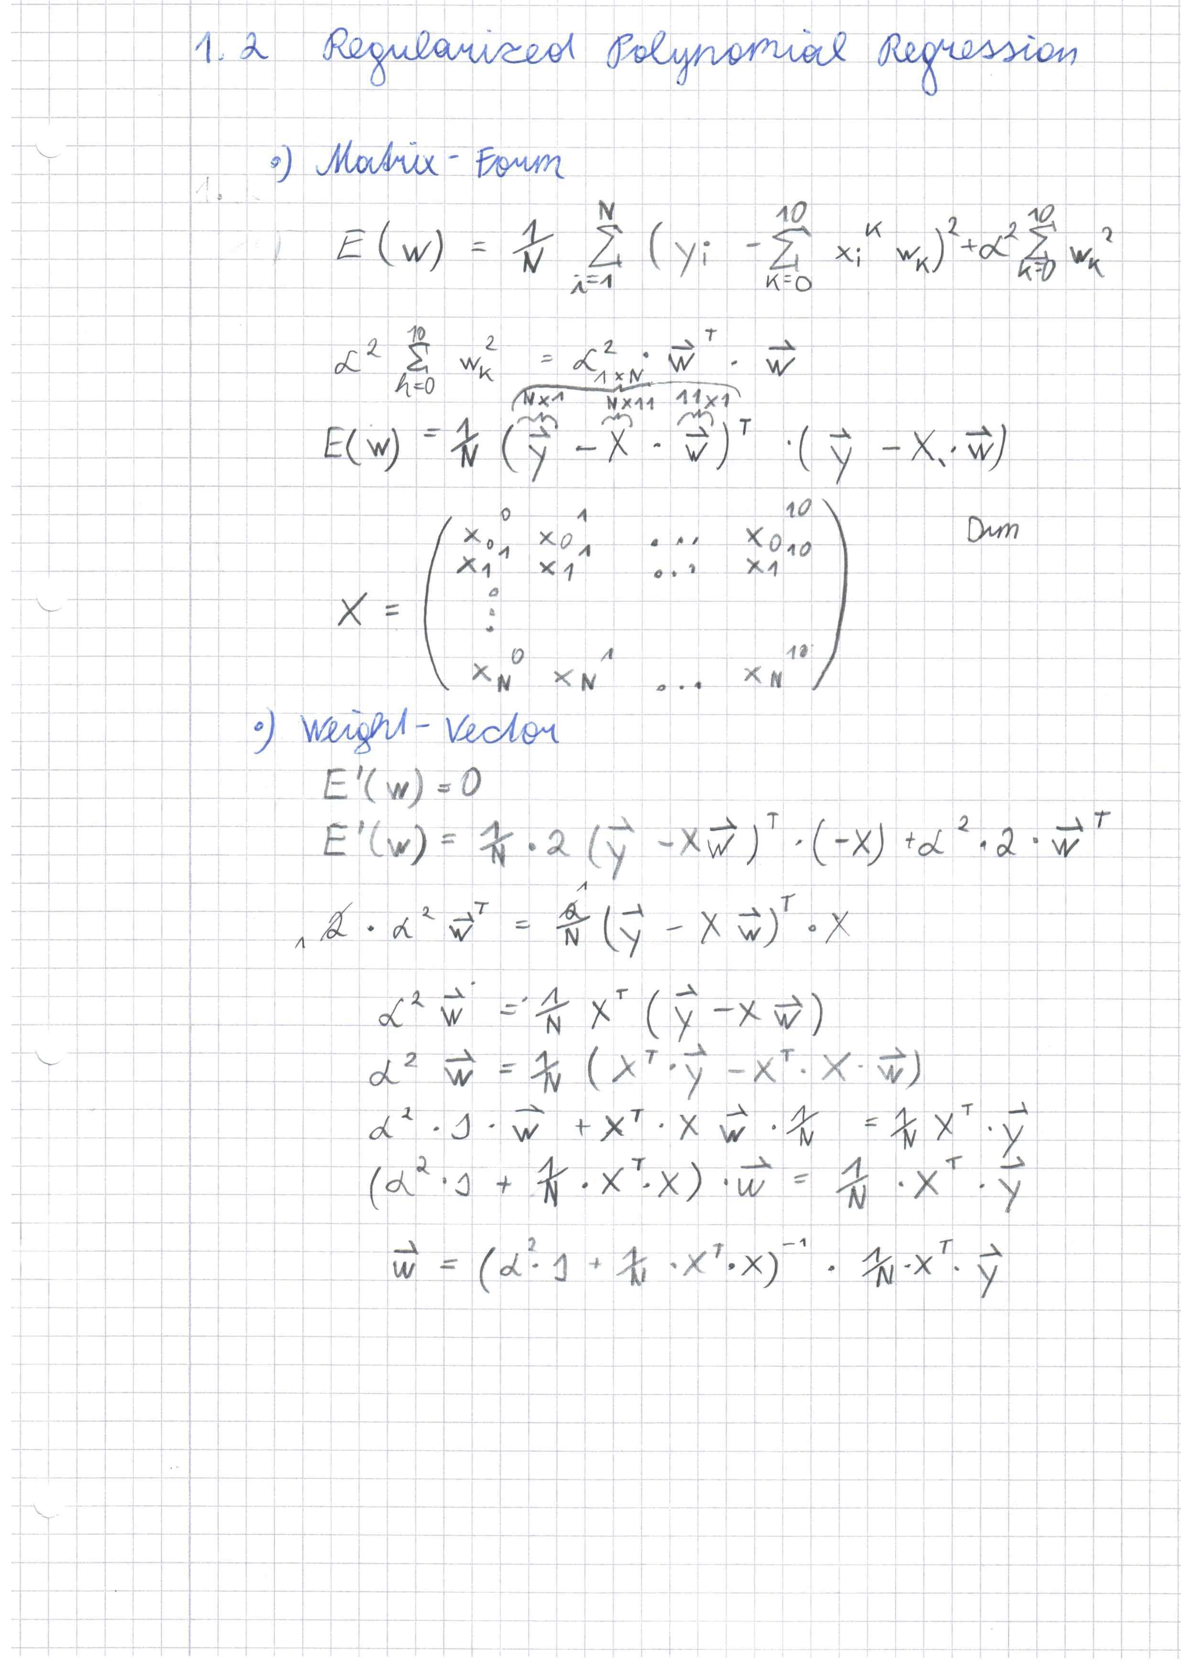
Plots

Mean squared error of the training and of the test set for the given alphas.
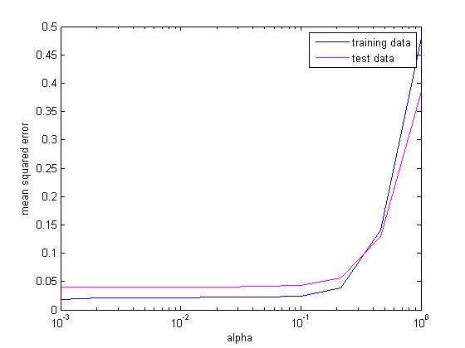
What is the best alpha?

Learned functions for the lowest, the highest and the best alpha.
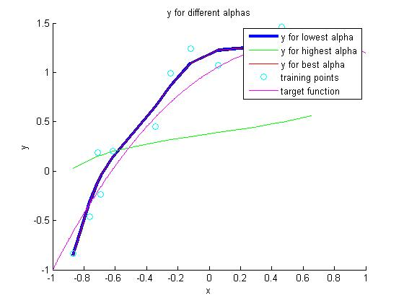

Mean absolute weight values for the given alpha.

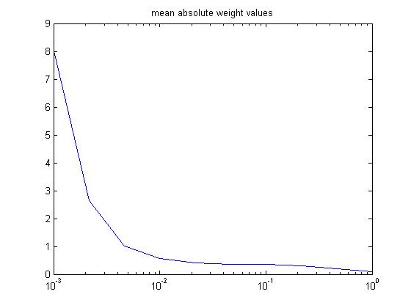
Interpretation:

  - Decomposition into structural and approximation error

Matlab-Code:

clear all;
close all;

load('linearregression_homework_10.mat');

nDataSets = length(x_train);

% Calculate optimal w
% This can be calculated with the big dataset (x_true, y_true
degree = 10;
X_true = calculate_matrix(x_true, degree);

nr_alphas = 25;
alphas = logspace(-2, 2, nr_alphas);
structure_errors = zeros(nr_alphas, 1);
approx_errors = zeros(nr_alphas, 1);
for i = 1:nr_alphas
alpha = alphas(i);
w_opt = calculate_weight(alpha, X_true, y_true, degree );
structure_errors(i) = mean((y_true - X_true * w_opt) .^ 2);

approx_error = zeros(nDataSets, 1);
for j = 1:nDataSets
X_train = calculate_matrix(x_train{j}, degree);
w = calculate_weight(alpha, X_train, y_train{j}, degree);
approx_error(j) = mean((X_true * w - X_true * w_opt) .^ 2);
end

approx_errors(i) = mean(approx_error);

end

expected_errors = structure_errors + approx_errors;

figure;
semilogx(alphas, structure_errors, 'c-');
hold on;
semilogx(alphas, approx_errors, 'r-');
semilogx(alphas, expected_errors, 'b-');
hold off;
legend('Structure Error', 'Approximation Error', 'Expected Error');

function [ w ] = calculate_weight( alpha, X, y, degree )
N = length(y);
w = inv(alpha^2*eye(degree+1) + (X' * X) / N) * ((X'*y)/N);
end

function [ X ] = calculate_matrix( x, degree )
x_length = length(x);
X = ones(x_length, degree+1);
for exponent = 0:degree
X(:,exponent+1) = x .^ exponent;
end
end
Plots

Compare your results to the previous example. Is there a difference in the best value? If
so, why?

