Codebook for Indicators of Contestation and Inclusiveness
by Michael Coppedge, Angel Alvarez, and Claudia Maldonado

This dataset contains several versions of two indicators that measure Robert Dahl’s two dimensions of polyarchy: contestation and inclusiveness. For complete documentation of the analysis that identifies these two dimensions, see the published article: Michael Coppedge, Angel Alvarez, and Claudia Maldonado, “Two Persistent Dimensions of Democracy: Contestation and Inclusiveness,” Journal of Politics 70:3 (July 2008): 632-647.

Briefly, however, these variables are the first (and usually, only) two principal component scores obtained when analyzing a dozen or more of the most commonly used indicators of democracy. A principal components analysis (PCA) was done separately for each year, 1950-2000. The mix of variables changed over time, but the mix was fixed in three partially overlapping intervals: 1950-1971, 1972-1988, and 1982-2000. Tables 1-3 report the variables used in each sample, summarize their component weights, and give other statistics about each PCA.

In order to make these scores comparable over time, they were standardized. Because these estimates are constrained to have a mean of zero and a standard deviation of one, they do not reflect the changes in the mean levels of contestation or inclusiveness, or their dispersion, that occur during waves of democratization or authoritarianism. We therefore calculated versions of our component scores that do reflect these trends. First we repeated the PCA using each of the samples (1950-1971, 1972-1988, and 1981-2000) with all the years in each sample pooled together. We then generated the component scores for each year within each of the three samples, based on these pooled estimates. Then we calculated the mean and standard deviation of these pooled-sample contestation and inclusiveness components for each year. Finally, we adjusted the original component scores so that their annual means and standard deviations would be the same as those of the pooled-sample estimates. Therefore, the new “standardized” component scores are defined as
CONTEST’ = σ_{CONTEST},_{t}*CONTEST + μ_{CONTEST},_{t}
INCLUS’ = σ_{INCLUS},_{t}*INCLUS + μ_{INCLUS},_{t}

where CONTEST and INCLUS are the component scores estimated with annual samples, and σ_{CONTEST},_{t} and μ_{CONTEST},_{t} are the standard deviation and mean in year t of the contestation component scores estimated with the pooled sample; the same goes for INCLUS’. The 1972-1988 pooled sample is used as a baseline. Standardized scores for 1989-2000 are chained forward from 1988 based on changes in the later sample, or the average of changes in both samples, where they overlap.

This adjustment yields mean scores that reflect the wave of authoritarianism of the 1960s and 1970s and the third wave of democratization:

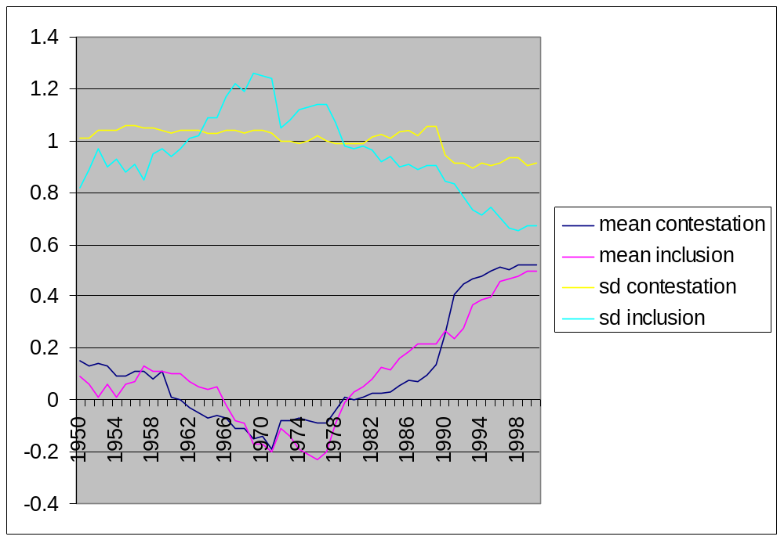
It also shows homogenization of levels of inclusiveness after 1970. This procedure for adjusting the component scores yields data with greater face validity. Nevertheless, the adjustments are not very large: the correlations between the original and standardized component scores are .97 for Contestation and .96 for Inclusiveness.

Information about each variable
cname: Country Name.

abbr: country abbreviation.

year: Year.

yr: abbreviated year.

CONTEST: Contestation (pooled years). This series combines the component scores from all three samples. For the years of overlap (1982-1988), the 1972-1988 estimates are used.

INCLUS: Inclusiveness (pooled years). This series combines the component scores from all three samples. For the years of overlap (1982-1988), the 1972-1988 estimates are used.

CONTESTstd: Contestation standardized to be comparable across years. See explanation on the first page.

INCLUSstd: Inclusiveness standardized to be comparable across years. See explanation on the first page.

ContestationA: Contestation (1950-71 estimate). These are estimates from each annual cross-section, pooled.

INCLUSA: Inclusiveness (1950-71 estimate). These are estimates from each annual cross-section, pooled.

CONTESTB: Contestation (1972-88 estimates). These are estimates from each annual cross-section, pooled.

INCLUSB: Inclusiveness (1972-88 estimates). These are estimates from each annual cross-section, pooled.

CONTESTC: Contestation (1990-2000 estimates). These are estimates from each annual cross-section, pooled.

INCLUSC: Inclusiveness (1990-2000 estimates). These are estimates from each annual cross-section, pooled.

CRSUFF: Coppedge-Reinicke (1990) suffrage.
1 Full suffrage
2 Suffrage with minor restrictions
3 Suffrage with major restrictions
4 No suffrage

FAIRELT: Coppedge-Reinicke (1990) Fair elections.
1 Elections without significant or routine fraud or coercion.
2 Elections with significant fraud or coercion whether or not it changes the outcome of the election.
3 No meaningful elections: i.e., elections without choice of candidates or parties, or no elections at all.

FREEORG: Coppedge-Reinicke (1990) Freedom of Organization.
1 Some trade union or interest groups may be harassed or banned but there are no restrictions on purely political organization. Permits may be required but are not used to limit opposition activities.
2 Some political parties are banned and trade unions or interest groups are harassed or banned, but membership in some alternatives to official organizations is permitted. Permits may be required and are used to limit opposition activities.
3 The only relatively independent organizations that are allowed to exist are nonpolitical.
4 No independent organizations are allowed. All organizations are banned or controlled by the government or the party.

FREXP: Coppedge-Reinicke (1990) Freedom of Expression
1 Citizens express their views on all topics without fear of punishment.
2 Dissent is discouraged, whether by informal pressure or by systematic censorship, but control is incomplete. The extent of control may range from selective punishment of dissidents on a limited number of issues to a situation in which only determined critics manage to make themselves heard, yet they sometimes can sway public opinion. There is some freedom of private discussion.
3 All open dissent is forbidden and effectively suppressed, though a few citizens may express dissent publicly in covert ways. Citizens are wary of criticizing the government even privately.

ALTINF: Coppedge-Reinicke (1990) Alternative Sources of Information
1 Alternative sources of information exist and are protected by law. If there is significant government ownership of the media, they are effectively controlled by truly independent or multi-party bodies.
2 Alternative sources of information are widely available but government versions are presented in preferential fashion. This may be the result of partiality in and greater availability of government-controlled media; selective closure, punishment, harassment, or censorship of dissident reporters, publishers, or broadcasters; or mild self-censorship resulting from any of these.
3 The government or ruling party dominates the diffusion of information to such a degree that alternative sources exist only for nonpolitical issues, for short periods of time, or for small segments of the population. The media are either mostly controlled directly by the government or party or restricted by routine prior censorship, near-certain punishment of dissident reporters, publishers, and broadcasters, or pervasive self-censorship. Foreign media or the Internet may be available to a small segment of the population without restrictions.
4 There is no public alternative to official information. All sources of information are official organs or completely subservient private sources. The media are considered instruments of indoctrination. Foreign publications and the Internet are usually unavailable or censored, and foreign broadcasts may be jammed.

POLY: Coppedge-Reinicke (1990) Polyarchy Scale. The sum of FAIRELT, FREORG, FREXP, and ALTINF minus 4.

ccode: Country Code Numeric

ccodecow: Country Code (from Correlates of War)

ccodealp: 3-letter Country Code (from Alvarez, Limongi, and Przeworski)

ccodewb: Country Code (from World Bank)

f1mean: mean contestation score for this year in pooled analysis

f2mean: mean inclusiveness score for this year in pooled analysis

f1sd: mean std dev of contestation for this year in pooled analysis

f2sd: mean std dev of inclusiveness for this year in pooled analysis

Table 1: Variables and Component Weights for the 1972-1988 Sample
 |  | Component 1 |  |  | Component 2
Source | Variable | Mean | Min | Max | Mean | Min | Max
Freedom House | Civil Liberties | -0.975 | -0.993 | -0.949 | 0.135 | 0.062 | 0.213
Freedom House | Political Rights | -0.950 | -0.975 | -0.931 | 0.004 | -0.033 | 0.050
Polity | The Competitiveness of Participation | 0.926 | 0.900 | 0.965 | -0.047 | -0.090 | -0.023
Vanhanen | Index of Competition | 0.923 | 0.879 | 0.948 | 0.019 | -0.012 | 0.048
Cheibub & Gandhi | Type of Regime | -0.910 | -0.934 | -0.876 | 0.043 | -0.006 | 0.072
Polity | Executive Constraints | 0.885 | 0.838 | 0.927 | 0.024 | -0.074 | 0.113
Banks | Party Legitimacy | 0.883 | 0.850 | 0.915 | 0.037 | 0.002 | 0.078
Polity | Competitiveness of Executive Recruitment | 0.830 | 0.749 | 0.900 | 0.109 | -0.003 | 0.251
Banks | Legislative Effectiveness | 0.720 | 0.667 | 0.786 | 0.306 | 0.207 | 0.384
Polity | Competitive Nomination Process | 0.531 | 0.465 | 0.580 | 0.509 | 0.425 | 0.578
Banks | Legislative Selection | -0.007 | -0.068 | 0.061 | 0.887 | 0.803 | 0.919
Bollen et al. | Adult Suffrage (%) | -0.014 | -0.056 | 0.071 | 0.857 | 0.807 | 0.904
Banks | Effective Executive Selection | -0.112 | -0.169 | -0.055 | 0.790 | 0.719 | 0.890
Vanhanen | Index of Participation | 0.208 | 0.144 | 0.296 | 0.616 | 0.505 | 0.685
Polity | Openness of Executive Recruitment | 0.158 | -0.009 | 0.323 | 0.593 | 0.373 | 0.874
 | KMO | 0.916 | 0.906 | 0.925
 | Eigenvalue | 9.41 | 9.13 | 9.91 | 1.98 | 1.92 | 2.10
 | % Variance | 62.8 | 60.9 | 66.1 | 13.2 | 12.8 | 14.0
 | Correlation between components |  |  |  | 0.496 | 0.455 | 0.556
Mean component weights with an absolute value greater than .500 are in bold.
Table 2: Variables and Component Weights for the 1950-1971 Sample
 |  | Component 1 |  |  | Component 2
Source | Variable | mean | min | max | mean | min | max
Cheibub & Gandhi | Type of Regime | -0.930 | -0.967 | -0.876 | 0.092 | 0.010 | 0.142
Vanhanen | Index of Competition | 0.924 | 0.876 | 0.959 | -0.026 | -0.075 | 0.036
Banks | Party Legitimacy | 0.921 | 0.867 | 0.972 | -0.031 | -0.108 | 0.049
Polity | Competitiveness of Participation | 0.905 | 0.843 | 0.985 | -0.146 | -0.239 | -0.084
Polity | Executive Constraints | 0.865 | 0.832 | 0.889 | 0.037 | -0.021 | 0.096
Polity | Competitiveness of Executive Recruitment | 0.856 | 0.750 | 0.957 | 0.075 | -0.097 | 0.201
Banks | Legislative Effectiveness | 0.793 | 0.653 | 0.881 | 0.228 | 0.109 | 0.394
Banks | legef*legsel | 0.786 | 0.650 | 0.869 | 0.246 | 0.127 | 0.399
Banks | Competitive Nomination Process | 0.654 | 0.493 | 0.794 | 0.329 | 0.164 | 0.498
Bollen et al. | Adult Suffrage (%) | -0.065 | -0.124 | 0.008 | 0.845 | 0.768 | 0.916
Banks | Legislative Selection | 0.026 | -0.080 | 0.156 | 0.844 | 0.690 | 0.973
Polity | Openness of Executive Recruitment | 0.043 | -0.039 | 0.132 | 0.755 | 0.515 | 0.871
Vanhanen | Index of Participation | 0.075 | -0.030 | 0.147 | 0.714 | 0.632 | 0.827
 | KMO | 0.888 | 0.85 | 0.91
 | Eigenvalue | 8.09 | 7.64 | 8.57 | 1.74 | 1.5 | 2
 | % Variance | 62.2 | 58.8 | 66 | 13.4 | 11.6 | 15.4
 | correlation between components |  |  |  | 0.477 | 0.403 | 0.575

Mean component weights with an absolute value greater than .500 are in bold.

Table 3: Variables and Component Weights for the 1981-2000 Sample
 |  | Component 1 |  |  | Component 2
Source | Variable | Mean | Min | Max | Mean | Min | Max
Freedom House | Political Rights | -0.922 | -0.976 | -0.862 | -0.008 | -0.087 | 0.071
Freedom House | Civil Liberties | -0.916 | -0.979 | -0.824 | 0.047 | -0.075 | 0.128
Polity | Competitiveness of Participation | 0.870 | 0.802 | 0.932 | 0.041 | -0.034 | 0.117
Polity | Executive Constraints | 0.868 | 0.769 | 0.971 | 0.059 | -0.097 | 0.204
Cheibub & Gandhi | Type of Regime | -0.855 | -0.898 | -0.788 | -0.004 | -0.085 | 0.065
CIRI | Freedom of speech | 0.838 | 0.651 | 0.938 | -0.123 | -0.244 | 0.080
Vanhanen | Index of Competition | 0.832 | 0.702 | 0.936 | 0.091 | -0.027 | 0.220
CIRI | Freedom of assembly and association | 0.817 | 0.696 | 0.874 | 0.002 | -0.103 | 0.110
CIRI | Political participation | 0.802 | 0.608 | 0.917 | 0.085 | -0.045 | 0.320
Polity | Competitiveness of Executive Recruitment | 0.794 | 0.627 | 0.913 | 0.144 | -0.063 | 0.373
Bollen et al. | Adult Suffrage (%) | -0.039 | -0.145 | 0.085 | 0.861 | 0.763 | 0.938
CIRI | Women's political rights | -0.015 | -0.196 | 0.422 | 0.724 | 0.120 | 0.851
Vanhanen | Index of Participation | 0.281 | 0.161 | 0.516 | 0.591 | 0.369 | 0.707
Polity | Openness of Executive Recruitment | 0.197 | 0.028 | 0.461 | 0.573 | 0.227 | 0.892
 | KMO | 0.918 | 0.910 | 0.927
 | Eigenvalue | 8.60 | 8.23 | 8.91 | 1.35 | 1.08 | 1.69
 | % Variance | 61.4 | 58.8 | 63.6 | 9.6 | 7.7 | 12.1
 | Correlation between components |  |  |  | 0.503 | 0.390 | 0.601
Mean component weights with an absolute value greater than .500 are in bold. CIRI is Cingranelli and Richards (2004).
Sources

Alvarez, Michael, José Antonio Cheibub, Fernando Limongi, and Adam Przeworski. 1996. “Classifying Political Regimes.” Studies in Comparative International Development 31(2): 3-36.
Banks, Arthur. 1979. Cross-National Time-Series Data Archive Users' Manual. Binghamton, NY: Center for Social Analysis, State University of New York.
Bollen, Kenneth A. 1998. “Cross-National Indicators of Liberal Democracy, 1950-1990” [computer file]. 2nd ICPSR version. Chapel Hill, NC: University of North Carolina (producer); Ann Arbor, Michigan: ICPSR (distributor).
Cheibub, José Antonio and Jennifer Gandhi. 2004. “A Six-Fold Measure of Democracies and Dictatorships.” Presented at the Annual Meeting of the American Political Science Association, Chicago.
Cingranelli, David and David Richards. 2004. “The Cingranelli-Richards (CIRI) Human Rights Database Coding Manual.” http://ciri.binghamton.edu/documentaiton/web_version_7_31_04_ciri_coding_guide.pdf (January 9, 2007).
Coppedge, Michael and Wolfgang Reinicke. 1990. “Measuring Polyarchy.” Studies in Comparative International Development 25(1): 51-72.
Gastil, Raymond, D., ed. various. Freedom in the World: Political Rights and Civil Liberties. New York: Freedom House.
Gurr, Ted Robert. 1997. Polity II: Political Structures and Regime Change, 1800-1986. Boulder, CO: Center for Comparative Politics [producer]. Ann Arbor, MI: Inter-university Consortium for Political and Social Research [distributor].
McColm, R. Bruce. 1990. Freedom in the World: Political Rights and Civil Liberties, 1989-1990. New York: Freedom House.
Norris, Pippa. 2005. “Democracy Indicators Cross-national Time-Series Dataset” Release 1.0. <http://ksghome.harvard.edu/~pnorris/Data/Data.htm> (September 2005).
Teorell, Jan, Sören Holmberg, and Bo Rothstein. 2006. “The Quality of Government Dataset.” Göteborg University: The Quality of Government Institute. http://www.qog.pol.gu.se (November 15, 2006).
Vanhanen, Tatu. 1990. The Process of Democratization. New York: Crane Russak.

