

Weekly Lubricants Tank Reconciliation Report

May 6th, 2026

Time frame of Report:
From April 30th to May 6th, 2026

Workshops lubes consolidated table
Site | Opening Stock | Deliveries | Transactions | Calculated Stock | Net Stock Change | Closing Stock | Variance | %
S4CX30 | 16.576 | 11.417 | 8.718 | 19.275 | 2.342 | 18.918 | -357 | -4,09%
15W40 | 23.843 | 0 | 3.317 | 20.526 | -3.272 | 20.571 | 45 | 1,36%
S5CFDM60 | 4.218 | 3.683 | 1.630 | 6.271 | 1.887 | 6.105 | -166 | -10,18%
Tellus S3M46 | 3.980 | 4.225 | 1.658 | 6.547 | 2.392 | 6.372 | -175 | -10,55%
Table 1. Workshops lubes consolidated table from April 30th to May 6th, 2026.

- Reconciliation

The SPIRAX S4CX30 tank reconciliation for the period April 30th to May 6th, 2026, has a total variance of -4,09%.

Considerations:
- Delivery volume has been corrected to match the ticket volume.
- It is recommended to carry out research into deliveries with this product, especially because the consumption projection does not correspond to what is felt, this can be observed from the Storage graphs.

Site | Opening Stock | Deliveries | Transactions | Calculated Stock | Net Stock Change | Closing Stock | Variance | %
S4CX30 | 16.576 | 11.417 | 8.718 | 19.275 | 2.342 | 18.918 | -357 | -4,09%
Table 2. Reconciliation of the product S4CX30 from April 30th to May 6th, 2026.
The table below shows the reconciliation data with SOL delivery tickets.

- As depicted in Figure 1. Confirmed deliveries, product SPIRAX S4CX30. Two confirmed deliveries from April 30th to May 6th, 2026. Average Variance across confirmed deliveries is -3,7%.

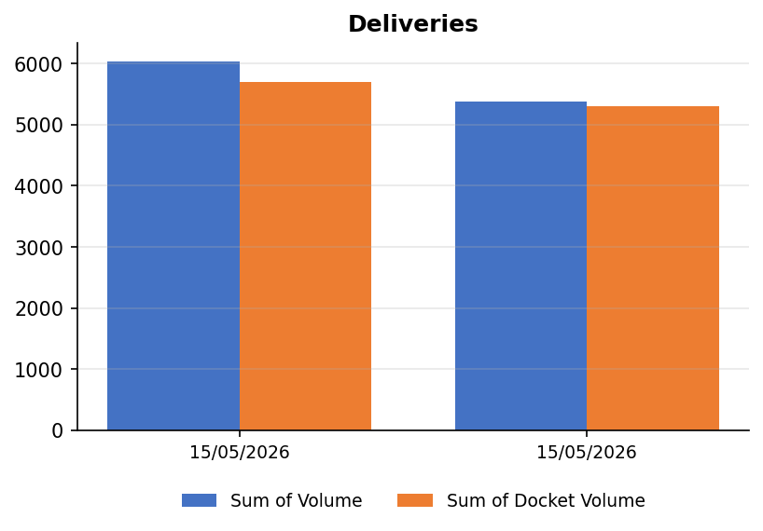
Figure 1. tank reconciliation data with SOL tickets from April 30th to May 6th, 2026.
Date | Sum of  Volume | Sum of  Docket Volume | Variance | Delivery Variance %
15/05/2026 | 6.040 | 5.700 | -340 | -6,0%
15/05/2026 | 5.377 | 5.300 | -77 | -1,5%
Grand Total | 11.417 | 11.000 | -417 | -3,8%
  - Reconciliation

The Rimula R4X15W40 tank reconciliation for the period April 30th to May 6th, 2026, has a total variance of 1,36%.

Considerations:

- Delivery volume has been corrected to match the ticket volume.
- The value is assigned as 0% because there is no inlet flowmeter.
- In service trucks lube tanks distribution may have changed, we cannot know with certainty the sensed volume that corresponds to a certain lube.
- Overfilling the tank above the safe fill level is causing erroneous data to be considered for reconciliation.

Site | Opening Stock | Deliveries | Transactions | Calculated Stock | Net Stock Change | Closing Stock | Variance | %
15W40 | 23.843 | 0 | 3.317 | 20.526 | -3.272 | 20.571 | 45 | 1,36%
Table 3. Reconciliation of the product 15W40 from April 30th to May 6th, 2026.

The table below shows the reconciliation data with SOL delivery tickets.

- As depicted in Figure 2. Confirmed deliveries, product Rimula R4X15W40. One confirmed delivery from April 30th to May 6th, 2026. Average Variance across confirmed delivery is 0,0%.

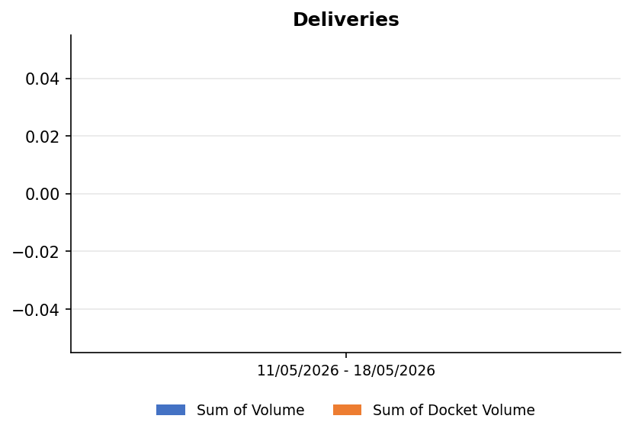
Figure 2. GMS tank reconciliation data with SOL tickets from April 30th to May 6th, 2026.
Date | Sum of  Volume | Sum of  Docket Volume | Variance | Delivery Variance %
11/05/2026 - 18/05/2026 | 0 | 0 | 0 | 0,0%
Grand Total | 0 | 0 | 0 | 0,0%

  - Reconciliation

The Spirax S5CFDM60 tank reconciliation for the period April 30th to May 6th, 2026, has a total variance of -10,18%.

Considerations:

- Delivery volume has been corrected to match the ticket volume.
- The value is assigned as 0% because there is no inlet flowmeter.
- In service trucks lube tanks distribution may have changed, we cannot know with certainty the sensed volume that corresponds to a certain lube.
- Overfilling the tank above the safe fill level is causing erroneous data to be considered for reconciliation.

Site | Opening Stock | Deliveries | Transactions | Calculated Stock | Net Stock Change | Closing Stock | Variance | %
S5CFDM60 | 4.218 | 3.683 | 1.630 | 6.271 | 1.887 | 6.105 | -166 | -10,18%
Table 4. Reconciliation of the product S5CFDM60 from April 30th to May 6th, 2026.

The table below shows the reconciliation data with SOL delivery tickets.

- As depicted in Figure 3. Confirmed deliveries, product Spirax S5CFDM60. One confirmed delivery from April 30th to May 6th, 2026. Average Variance across confirmed delivery is -5,2%.

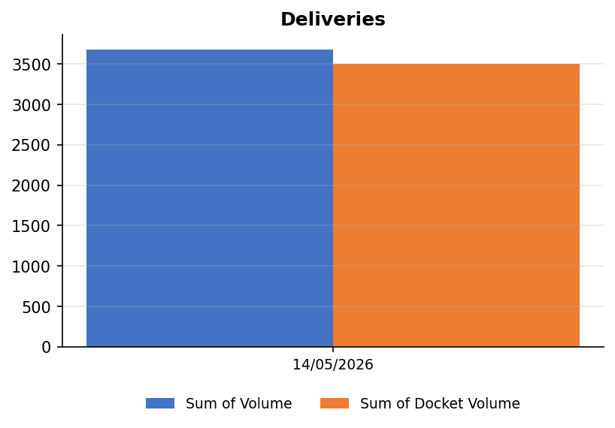
Figure 3. GMS tank reconciliation data with SOL tickets from April 30th to May 6th, 2026.
Date | Sum of  Volume | Sum of  Docket Volume | Variance | Delivery Variance %
14/05/2026 | 3.683 | 3.500 | -183 | -5,2%
Grand Total | 3.683 | 3.500 | -183 | -5,2%

  - Reconciliation

The Hydraulic Fluid - Tellus S3M46 tank reconciliation for the period April 30th to May 6th, 2026, has a total variance of -10,55%.

Considerations:

- Delivery volume has been corrected to match the ticket volume.
- The value is assigned as 0% because there is no inlet flowmeter.
- In service trucks lube tanks distribution may have changed, we cannot know with certainty the sensed volume that corresponds to a certain lube.
- Overfilling the tank above the safe fill level is causing erroneous data to be considered for reconciliation.

Site | Opening Stock | Deliveries | Transactions | Calculated Stock | Net Stock Change | Closing Stock | Variance | %
Tellus S3M46 | 3.980 | 4.225 | 1.658 | 6.547 | 2.392 | 6.372 | -175 | -10,55%
Table 5. Reconciliation of the product Tellus S3M46 from April 30th to May 6th, 2026.

The table below shows the reconciliation data with SOL delivery tickets.

- As depicted in Figure 4. Confirmed deliveries, product Hydraulic Fluid - Tellus S3M46. One confirmed delivery from April 30th to May 6th, 2026. Average Variance across confirmed delivery is -5,6%.

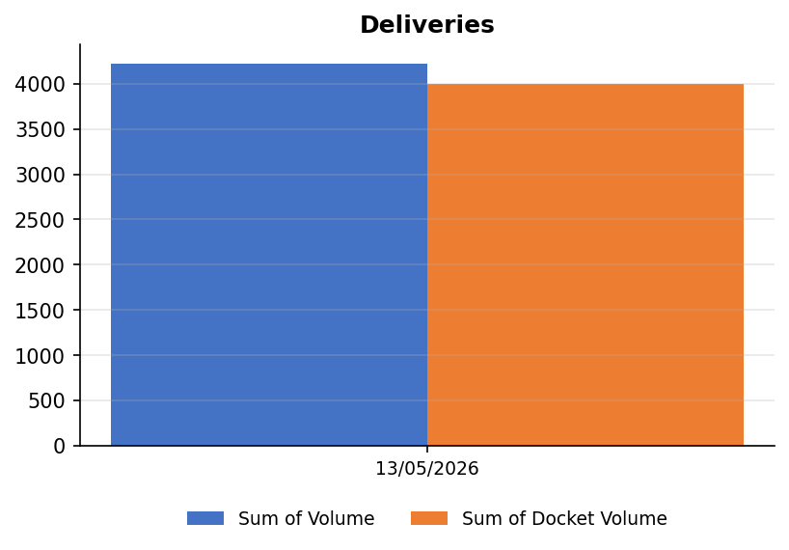
Figure 4. GMS tank reconciliation data with SOL tickets from April 30th to May 6th, 2026.
Date | Sum of  Volume | Sum of  Docket Volume | Variance | Delivery Variance %
13/05/2026 | 4.225 | 4.000 | -225 | -5,6%
Grand Total | 4.225 | 4.000 | -225 | -5,6%

- Dispensing Data

The Newmont Fleet is updated as requested in each of the forms received.

Dispensing to Equipment is the Volume dispensed from Workshops.
Dispensing to other equipment is the Volume of unauthorized transactions.
Transfers is the Volume dispensed to Service Trucks.

  - Issued product SPIRAX S4CX30.

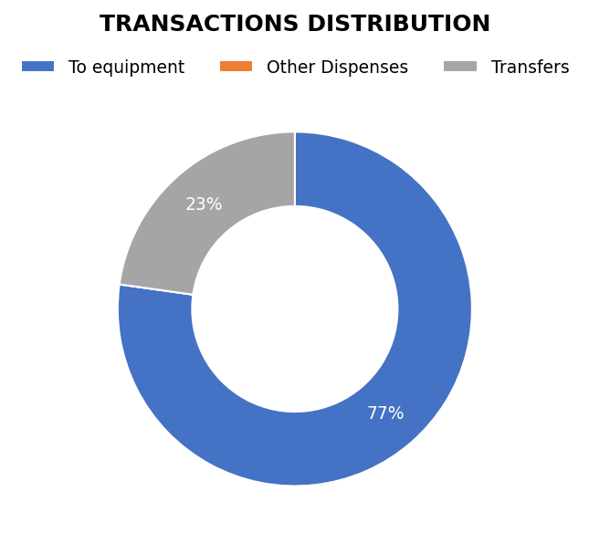
Figure 5. Transaction distribution for product SPIRAX S4CX30 – from April 30th to May 6th, 2026.
A total Transactions of 8.718 L was reported.

- Dispensing to Equipment: 6.732 L.
- Dispensing to other equipment 0 L.
- Transfers (Service Trucks) of 1.986 L.

  - Issued product Rimula R4X15W40.

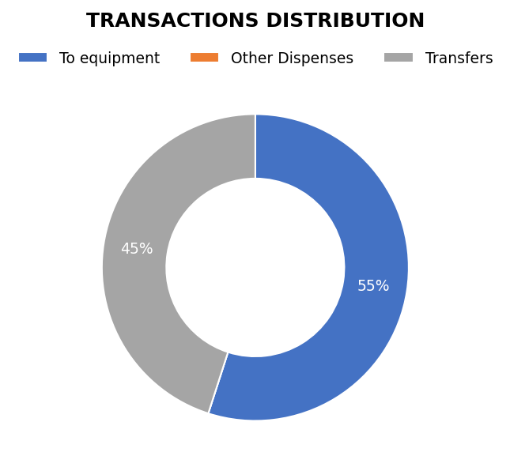
Figure 6. Transaction distribution for product Rimula R4X15W40 – from April 30th to May 6th, 2026.
A total Transactions of 3.317 L was reported.

- Dispensing to Equipment: 1.823 L.
- Dispensing to other equipment 0 L.
- Transfers (Service Trucks) of 1.494 L.

  - Issued product Spirax S5CFDM60.

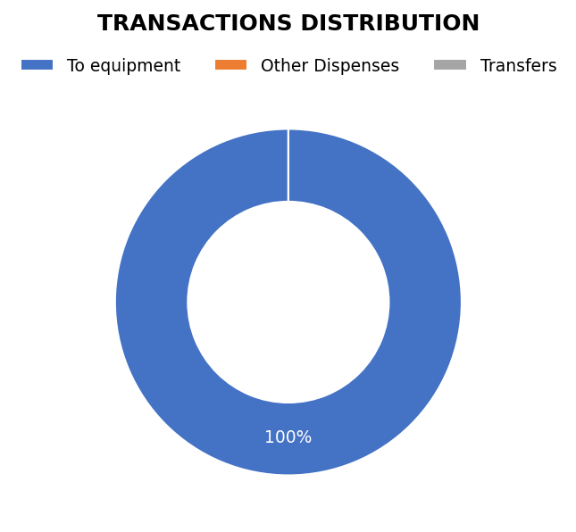
Figure 7. Transaction distribution for product Spirax S5CFDM60– from April 30th to May 6th, 2026.
A total Transactions of 1.630 L was reported.

- Dispensing to Equipment: 1.630 L.
- Dispensing to other equipment 0 L.
- Transfers (Service Trucks) of 0 L.

  - Issued product Hydraulic Fluid - Tellus S3M46.

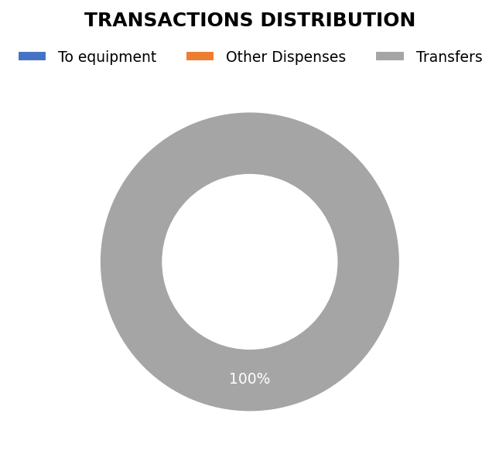
Figure 8. Transaction distribution for product Tellus S3M46 – from April 30th to May 6th, 2026.
A total Transactions of 1.658 L was reported.

- Dispensing to Equipment: 0 L.
- Dispensing to other equipment 0 L.
- Transfers (Service Trucks) of 1.658 L.

- Summary of tank Levels.

  - Tank log Spirax S4CX30

Figure 9. Spirax S4CX30 Tank Log.

Figure 10. Reconciliation for the product S4CX30.

  - Tank log Spirax S4CX10W (S4CX30W)

Figure 11. S4CX10W Tank Log.

Figure 12. Reconciliation for the product S4CX30.

  - Tank log Rimula R4X15W40

Figure 13. Rimula 15W40 Tank Log.

Figure 14. Reconciliation for the product Rimula 15W40.

  - Tank log Spirax S5CFDM60

Figure 15. S5CFDM60 Tank Log.

Figure 16. Reconciliation for the product S5CFDM60.

  - Tank log Tellus S3M46

Figure 17. Tellus S3M46 Tank Log.

Figure 18. Reconciliation for the product Tellus S3M46.

- Actions below are pending items to be taken.

- As part of integrated governance for FMS, a procedure should take place regarding tank limits or lube dispensing restrictions.

- There are two tanks which have the same lube SPIRAX S4CX30 that is not contemplated in the current FMS configuration. It is expected by the Mine Maintenance department to confirm lube allocations so that the FMS configuration can be adapted to the new operating requirements.

- Pressure switches must be verified for pressure ranges for each lubricant. Adjustments need to be made.

- Keep these points in mind for continuous improvement in the process.

- As good practice, our team has been supporting lubricant deliveries.

- To improve the consistency and accuracy of measurements of IBCs, it is suggested to standardize the sizes of the tanks used for lubricants in workshops. This standardization will facilitate the calibration of sensors and allow for better comparison and analysis of data over time.

- Full lube dispensing data available.

- The Pump (CX 30) 121-PP-30 was inspected recently; it does not seem to work on "Auto mode". And on the pump (Tellus 46) 121-PP-26, it was replaced the Pressure Relief Valve, however, still the system does not work in "Auto mode". Follow up is being done with the MME team for further troubleshooting. Coolant pump is tripping when switch is on auto position

- Tasks carried out in the week.

In Table 6, there is a summary of all tasks performed at the workshop area.

Table6. Summary of tasks carried out in the week.

