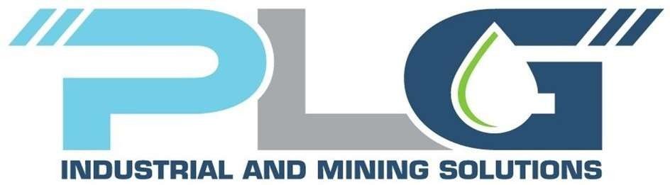

FMS Diesel Fuel Monthly Report
April 30th, 2026

Time frame of Report:
From 1st April to 30th 2026
- Reconciliation

The tank reconciliation for the period from 1st April to 30th 2026 has a total variance of -0,17%. To have a better understanding of how reconciliation comes about, we will introduce you to some terms and instruments used in this report.

Considerations:

- All fuel coming into the Storage tanks from Sol through the LFO Lane 1 inlet meters is categorized as Deliveries.
- All fuel dispensed from outlet meters or dispensers into equipment is categorized as Transaction.
- Opening stock corresponds to the sum of the Main Tank and Virtual Tank volumes at the date and time marking the start of the reconciliation period.
- Closing stock corresponds to the sum of the Main Tank and Virtual Tank volumes at the date and time marking the end of the reconciliation period.

Site | Opening Stock | Deliveries | Transactions | Calculated Stock | Net Stock Change | Closing Stock | Variance | %
LFO | 879.250,31 | 4.263.438,10 | 4.214.579 | 928.109,81 | 41.656,36 | 920.906,67 | -7.203,14 | -0,17%
Reconciliation table of Diesel for April 2026.

- Deliveries Summary.

- 109 confirmed deliveries. 77 deliveries of these are below the -0,50% threshold.

- 107 deliveries were between -1,0% and 0%.

The chart shows the Sum of inlet deliveries during the month and comparison with delivery tickets.
- DETAILED INLET DELIVERIES VS DELIVERY TICKETS COMPARISON

The average variance is -0,43%, with minimum variances of -0,68% and maximum variances of 0,21%. The average daily volume was 142.115 liters.

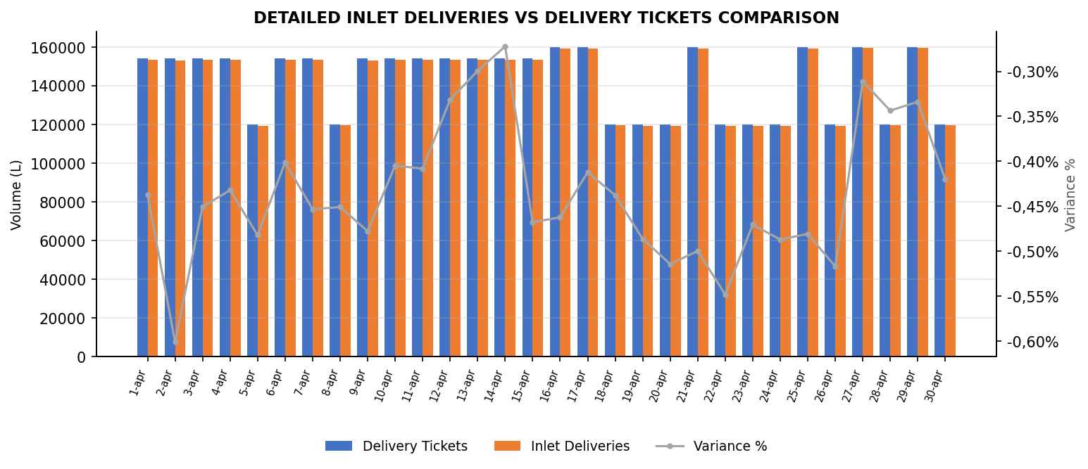
Inlet vs Delivery tickets for April 2026.

Delivery tickets vs Inlet Deliveries comparison table
 | Delivery Tickets | Inlet Deliveries | Sum of Variance | Variance %
1-apr | 154.000 | 153.327 | -673 | -0,44%
2-apr | 154.000 | 153.075 | -925 | -0,60%
3-apr | 154.000 | 153.306 | -694 | -0,45%
4-apr | 154.000 | 153.334 | -666 | -0,43%
5-apr | 120.000 | 119.422 | -578 | -0,48%
6-apr | 154.000 | 153.382 | -618 | -0,40%
7-apr | 154.000 | 153.302 | -698 | -0,45%
8-apr | 120.000 | 119.459 | -541 | -0,45%
9-apr | 154.000 | 153.264 | -736 | -0,48%
10-apr | 154.000 | 153.377 | -623 | -0,40%
11-apr | 154.000 | 153.371 | -629 | -0,41%
12-apr | 154.000 | 153.490 | -510 | -0,33%
13-apr | 154.000 | 153.539 | -461 | -0,30%
14-apr | 154.000 | 153.581 | -419 | -0,27%
15-apr | 154.000 | 153.280 | -720 | -0,47%
16-apr | 160.000 | 159.260 | -740 | -0,46%
17-apr | 160.000 | 159.340 | -660 | -0,41%
18-apr | 120.000 | 119.475 | -525 | -0,44%
19-apr | 120.000 | 119.416 | -584 | -0,49%
20-apr | 120.000 | 119.383 | -617 | -0,51%
21-apr | 160.000 | 159.200 | -800 | -0,50%
22-apr | 120.000 | 119.342 | -658 | -0,55%
23-apr | 120.000 | 119.435 | -565 | -0,47%
24-apr | 120.000 | 119.416 | -584 | -0,49%
25-apr | 160.000 | 159.231 | -769 | -0,48%
26-apr | 120.000 | 119.380 | -620 | -0,52%
27-apr | 160.000 | 159.502 | -498 | -0,31%
28-apr | 120.000 | 119.588 | -412 | -0,34%
29-apr | 160.000 | 159.466 | -534 | -0,33%
30-apr | 120.000 | 119.496 | -504 | -0,42%
Total general | 4.282.000 | 4.263.438 | -18.562 | -0,43%

SERVICE TRUCK INFLOW – OUTFLOW DISTRIBUTION

The next table below shows the Inflow – Outflow Service Truck Data in liters.
Site | Deliveries | Transactions
TFL0846 | 789.604 | 814.735
TFL0847 | 816.310 | 830.035
TFL0848 | 8.039 | 14.471

DISPENSING DATA

- Working on contractors' data to upload to AdaptIQ.
    - Process to tag rental LVs.
    - Process to install tags on Site Services Fleet
- Pending items.
    - Tag all contractor’s fleet.

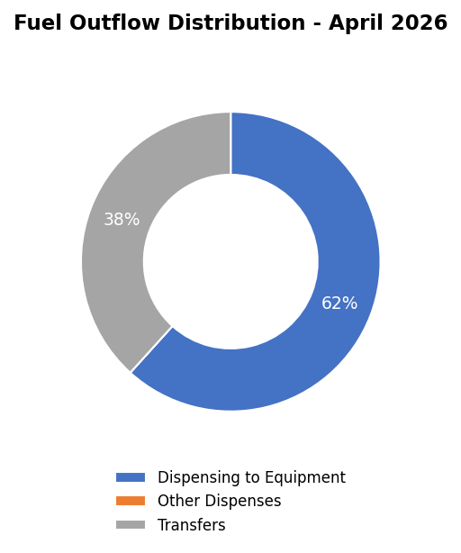
Fuel Outflow Distribution - April 2026.

To Equipment: Volume dispensed from L1, L2 & L3.
Other Dispenses: Volume of unauthorized transactions.
Transfers: Volume dispensed to Service Trucks.

A total Transactions of 4.214.579 L were reported.

- Dispensing to Equipment: 2.600.625 L.
- Dispensing to other equipment 0 L.
- Transfers (Service Trucks) of 1.613.953 L.
- Tank Levels Sumapry.

  - Diesel Tank Log

Daily Diesel Tank Log
The chart shows a stable and cyclical trend. Throughout this period, the diesel volume consistently oscillates in a regular pattern, suggesting a recurring cycle of diesel consumption and replenishment. The stock volume remains within a predictable range, typically fluctuating between approximately 850.000 and 1.000.000 Liters, and consistently stays well below the indicated Safe Fill Level of 1,091,295.00 L.

The chart below represents the Reconciliation Variance historical data from April 2026 (Closer to 0.0 is better). There is a clear uptrend in the variance. It is expected that it dropped as we progressed with the scheduled calibration of all dispensing points.

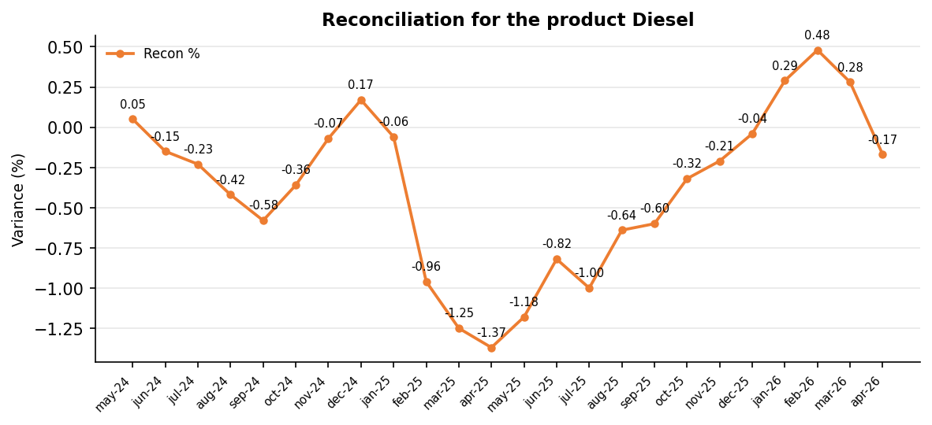
Reconciliation for the product Diesel.

Weekly Transactions overview

- Transaction: The average within the analyzed range is 899.784 L.
- To equipment: The average within the analyzed range is 556.250 L.
- Distribution of other Dispenses: The average within the analyzed range is 0 L.
- Distribution Transfers: The average for this category is 343.535 L.

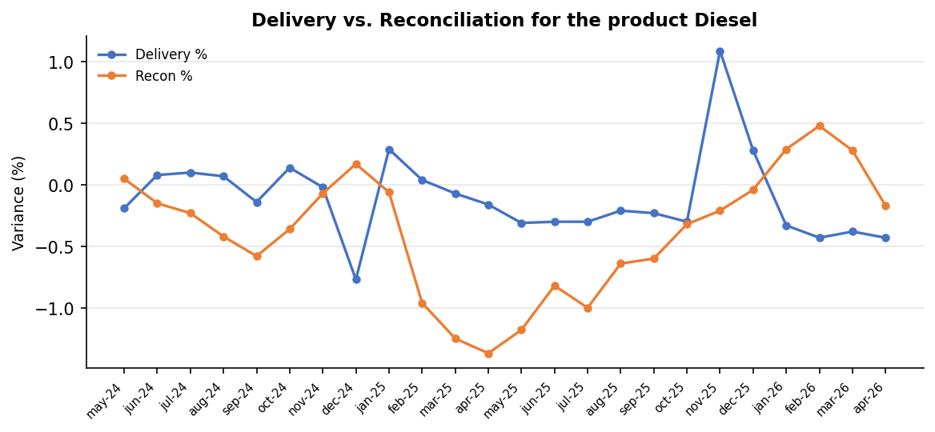

This table shows the outflow data by Transaction, To Equipment, and Distribution Transfers for each week of the reported month. Consumption decreased notably in the las period of the Month.
Week | Date | Transactions | To Equipment | Transfers
1 | 06/04/26 | 1.005.485 | 643.584 | 361.901
2 | 13/04/26 | 1.038.618 | 630.490 | 408.128
3 | 20/04/26 | 985.103 | 585.522 | 399.581
4 | 27/04/26 | 924.931 | 587.920 | 337.011
5 | 30/04/26 | 544.785 | 333.732 | 211.053

.
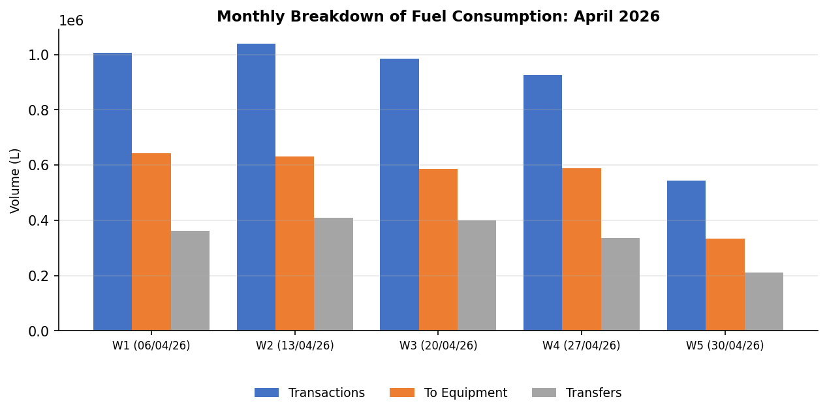
Monthly Breakdown of Fuel Consumption: 2026.

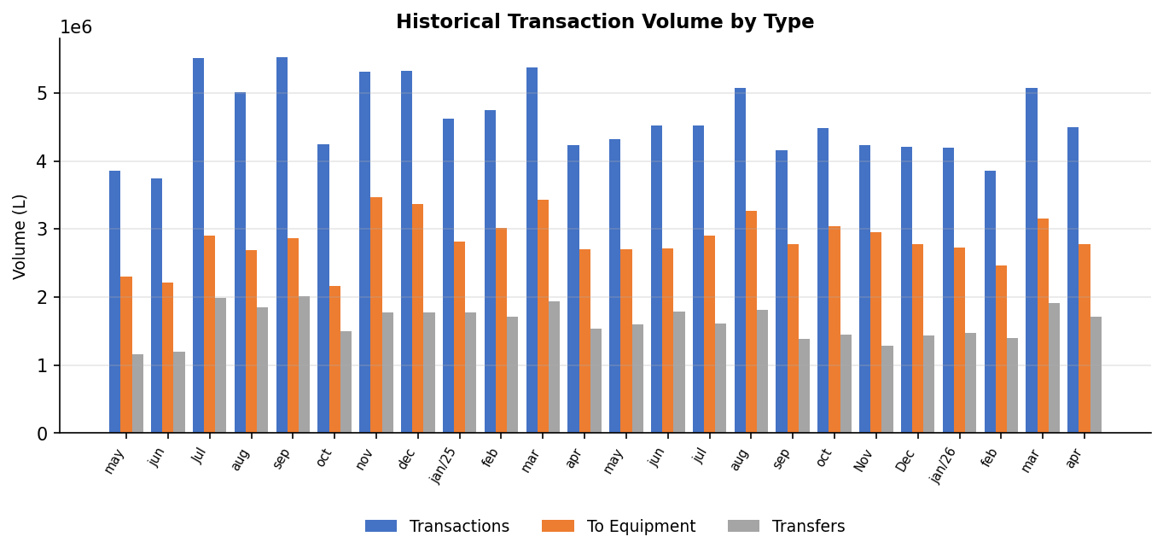
Historical Transaction Volume by Type
- Actions below are pending items to be taken.

- SCM and SCC are being informed daily of fuel deliveries and quantities.

- The current automatic reconciliation value is -1.5%. And the suggested monthly limit is 1%. The threshold may change based on the historical offloading data and instructions given by SCM.

- Tagging process is Completed for Newmont assets and Business partner’s fleet. Note that some BPs are fueling via a visitor authorization form which are not accounted for tagged equipment.

- One SOP (Service truck preventive maintenance) needs to be changed to STP before approval from Mine Maintenance and document control process.

- Project Punch List progress is 91.4%. We have only three outstanding items, first service truck’s SOP, secondly the lube inlet flowmeter installation and thirdly, the remote fueling project.

- Three fuel trucks (SEMC 3143, Haukes 12-117 and Soeltan SET-201) have Newmont Merian’s Fuel Management System. These BP fuel truck fleets are monitored since 5/5/26.

- Keep these points in mind for continuous improvement in the process.

- Fuel stocks were stable throughout the month.

- LFO Bay availability during April was 100%.

- Water checks on fuel delivery trucks were carried out with typical results. A log can be provided when required.

- Tasks carried out in February.

In Table 3, there is a summary of all tasks performed at the workshop area during April.

Summary of tasks carried out in April.

- Recent findings summary

In Table 4, there are findings pending to close and each status.

Figure | Description | Responsible | Status
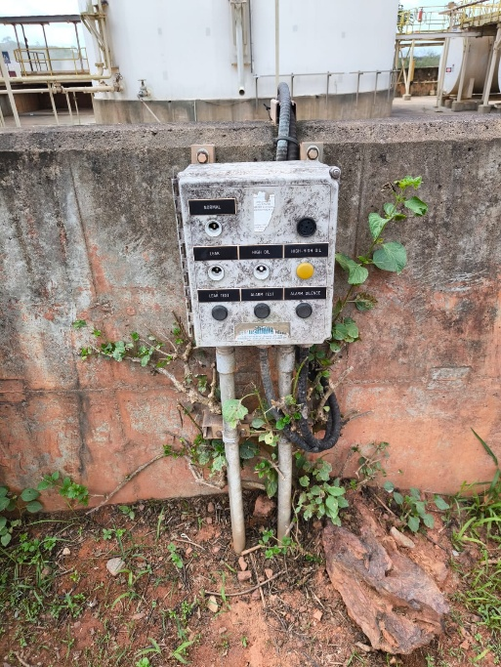 | Bund wall, Oil Alarm Box Light Cover Missing | Newmont | Completed
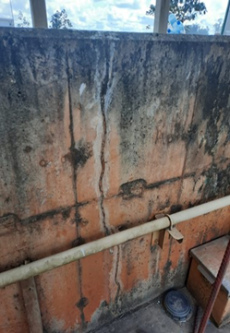 | Bund wall cracks. | Newmont | Monitor
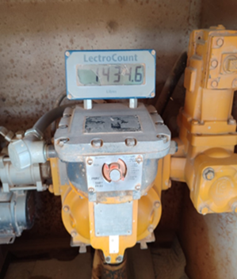 | LC meter screen crack LFO Lane 3. | PLG | Monitor
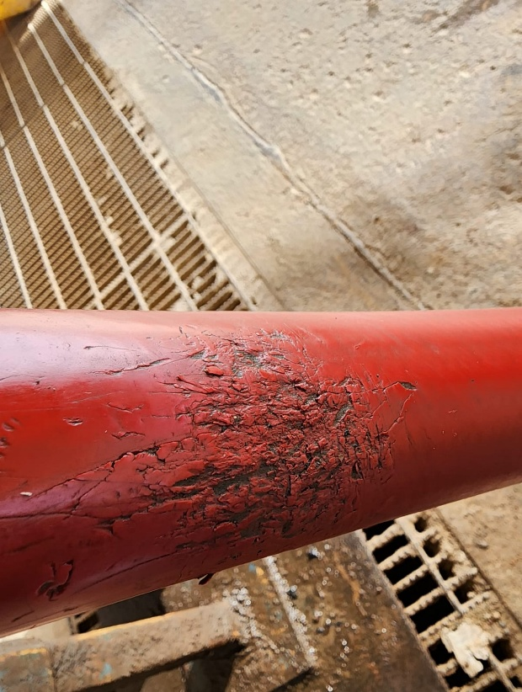 | Lane 3 HF under monitoring | PLG | Monitor
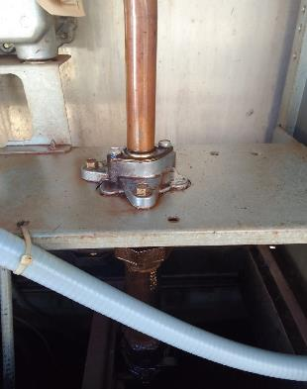 | lan2 LF dispenser slight leak union | PLG | Monitor
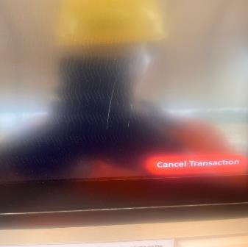 | Lane 3 FMS have some scratch | PLG | Monitor
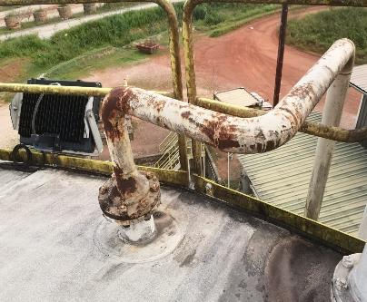 | transfer pump pipe have some corrosion | PLG | Monitor
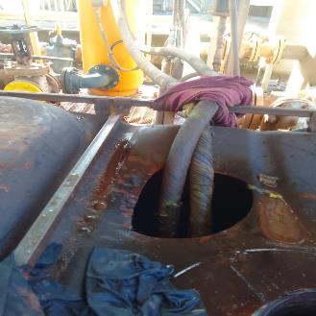 | Delivery Facilities (Air Eliminator Hose Damage) | Newmont/PLG | Monitor
 | Lane 1 dispensing sign of wear | PLG | Monitor
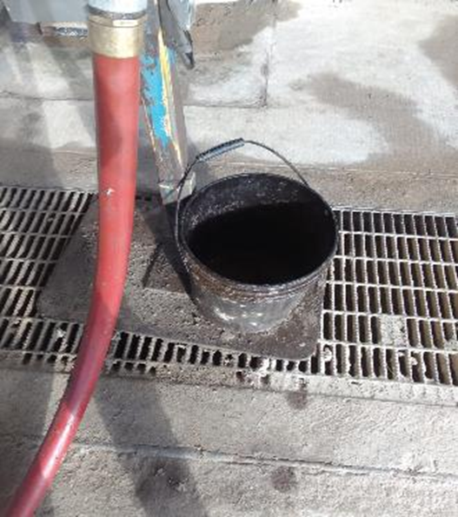 | Lane 3, Inadequate Drip Tray | PLG | In progress
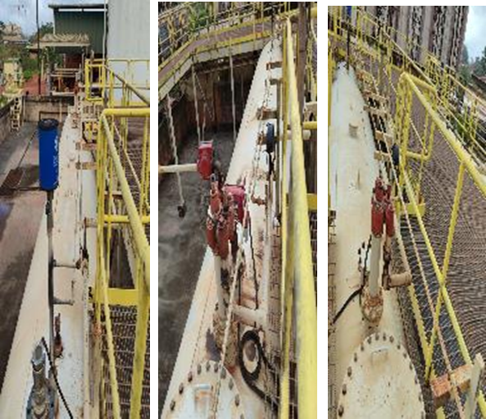 | Daily tank Pipe Line/Corrosion | PLG/Newmont | Monitor
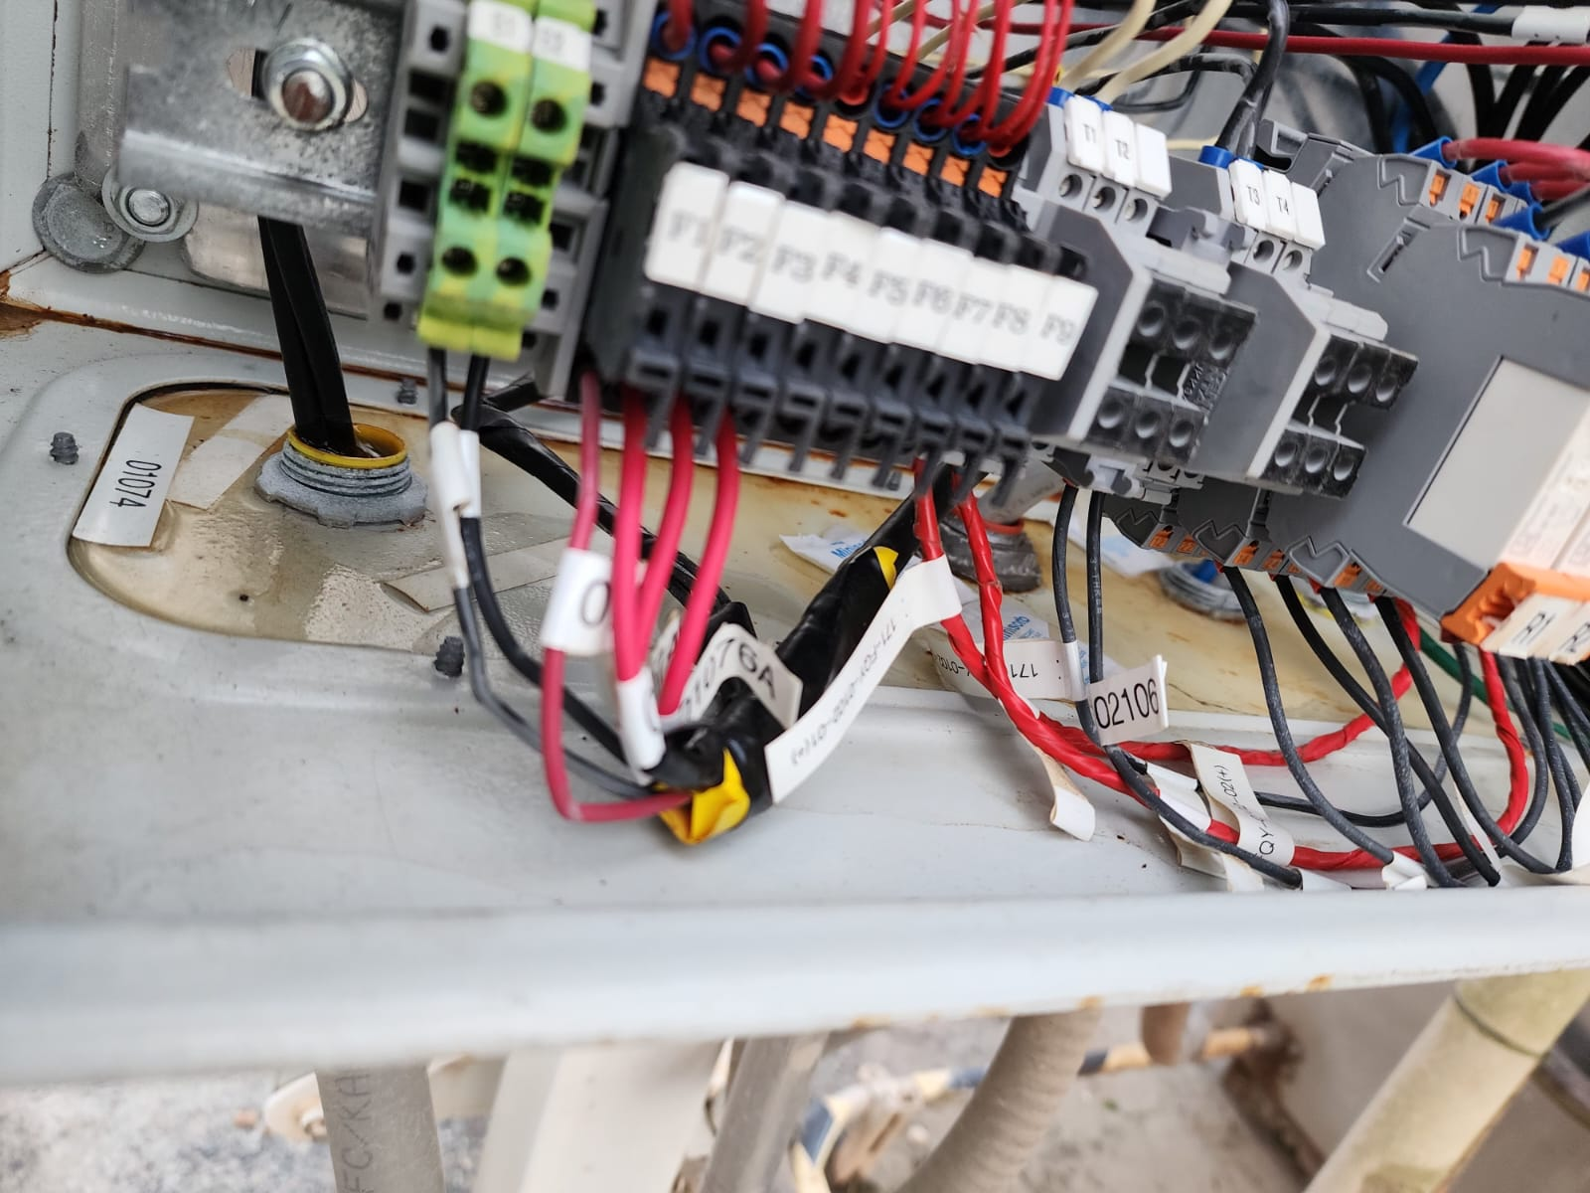 | Water inside the control panel LFO2 | PLG | Monitor
Finding action tasks.

