Rural-Urban health and mortality differentials in Brazil, 2010-2013
Abstract
Urbanization and economic development in developed countries fostered the debate of rural vs. urban health and mortality differentials. Low and middle-income countries experience uneven urbanization processes that result in an urban mortality penalty. Brazil is an example of this scenario of rural mortality advantage, despite the limited access to health services by rural residents. This paper assesses health and mortality differentials of rural and urban areas using morbidity prevalence data from the Brazilian National Health Survey of 2013 and the mortality information from the Brazilian National Census of 2010. The results show that urban residents display higher prevalence rates of diabetes and heart diseases, whereas rural residents display higher prevalence rates of osteoarticular diseases and physical incapacities. Indeed, adult individuals of rural areas presented better mortality indicators than those from urban areas. However, we verified that a significant share of rural individual's life co-occurs with physical and musculoskeletal related morbidities. These differences between urban and rural spaces need to be considered when making health policy decisions.
Keywords: Mortality, Health, Rural-Urban Differentials, life expectancy, Brazil.

Resumè
L'urbanisation et le développement économique dans les pays à revenu élevé ont favorisé un débat sur les différences entre la santé et la mortalité dans les zones rurales et urbaines. Les pays à revenu faible et intermédiaire connaissent des processus d'urbanisation inégaux qui se traduisent par une pénalité de mortalité urbaine. Le Brésil est un exemple de ce scénario d'avantage de mortalité rurale, malgré l'accès limité aux services de santé par les habitants des zones rurales. Cet article évalue les écarts de santé et de mortalité dans les zones rurales et urbaines à l'aide des données sur la prévalence de la morbidité tirées de l'Enquête nationale sur la santé de 2013 et des informations sur la mortalité du recensement national de 2010. Les résultats montrent que les résidents urbains ont des taux de prévalence du diabète et maladie cardiaque plus élevée, tandis que les résidents ruraux ont une prévalence plus élevée de maladies ostéoarticulaires et d'incapacités physiques. En fait, les adultes des zones rurales avaient de meilleurs indicateurs de mortalité que ceux des zones urbaines. Cependant, nous avons constaté qu'une partie importante de la vie de l'individu rural coexiste avec des morbidités physiques et musculo-squelettiques. Ces différences entre les espaces urbains et ruraux doivent être prises en compte lors de la prise de décisions en matière de politique de santé.

Mots clés: Mortalité, Santé, Différentiels rural-urbain, espérance de vie, Brésil.

1. Introduction
By the time of urbanization and industrialization processes in Western countries, residents of urban areas used to exhibit higher mortality rates than their rural counterparts (Woods 2003). Indeed, living conditions improved in Western cities through socio-economic development and economic growth (Deaton 2003). Nevertheless, unequal regional socio-economic development led to health and mortality differentials within countries (Allan, Williamson, and Kulu 2017). In the United States, for example, rural and non-metropolitan residents are more likely to experience lack of access to health equipment, health illiteracy and other kinds of socio-economic deprivation which result in a disadvantaged position regarding life expectancy and health indicators in general (Chen et al. 2019; Henning-Smith et al. 2019).
The debate over urban and rural mortality differentials in developing countries follows two approaches: infant/child mortality and adult mortality (Garcia 2020; Menashe-Oren and Stecklov 2018). Infant and child mortality are more impacted by community-level characteristics and socio-economic situations (Garcia 2020). In Brazil, urban areas exhibit an under-five mortality advantage in comparison to the country’s rural areas, as a result of its better socio-economic status such as higher schooling levels and more increased access to sanitation and public services in general (Sastry 1997).
Despite the urban advantaged observed in child and infant mortality levels, most studies documented lower adult mortality rates in rural areas of low-income countries (Menashe-Oren and Stecklov 2018). Metropolitan regions in developing countries present high within-urban mortality gaps among social groups due to unequal access to essential public services (health equipment, education, and sanitation) as a consequence of a rapid urbanization process. Living conditions in these developing urbanized centers deteriorate individuals’ health and expose them to higher mortality risks compared to their rural counterparts in a similar way as observed in the past for more developed countries, resulting in an urban death penalty (Fink, Günther, and Hill 2016).
It is a feature of Brazilian mortality differentials. The advantage of urban environments regarding mortality in Brazil prevails in some specific conditions. Carvalho and Wood (1978) showed that urban-rural life expectancy differentials favored the urban areas of wealthier social strata. In contrast, we observe the opposite in impoverished regions of the country in the 1960-70 period. Using the 2010 National Census mortality data, Albuquerque (2019) verified a mortality advantage for rural areas, especially for the males. He estimated 73.6 and 69.3 life expectancy at birth for the rural and urban male population, respectively, and 77.8 and 77.1 years for females. Pereira (2020) disentangled these findings by looking into social groups of different urban areas. He compared Brazilian mortality levels of urban residents from slums and from out of slums with rural resident’s mortality levels and verified an urban penalty for those living in these marginalized urban environments. The urban periphery of Brazilian metropolitan areas is known for its low urban assets and damaged social conditions, presenting high violence and crime rates and deprivation of public assets such as public sanitation (Rodella 2015). The result of this scenario is a worsened health and mortality status of the urban periphery adult population of the country (Pereira 2018; Pereira and Queiroz 2016).
Rural life expectancy advantage expressed in the Brazilian national census of 2010 (Albuquerque 2019) may not reflect a real disease-free life expectancy or healthy life expectancy advantage, e. g., people from rural areas might live for more extended periods. Still, they would have to live with disabilities that can mitigate their capacity to develop daily activities. In this sense, this paper aims to investigate urban-rural mortality and health disparities across regions in Brazil.

2. Materials and Methods

2.1 Data source
We use data from 2010’s Brazilian national census of 2010 and 2013’s Brazilian national health survey (PNS) to estimate mortality age profiles and implement further extensions on these functions to estimate health life expectancy. Both household inquiries are conducted by the Brazilian Bureau of National Statistics (IBGE).
PNS collects information on access and use of health services, preventive health behavior, and sociodemographic characteristics (IBGE 2013). The 2010 Population Census provides an alternative to study mortality differentials by inquiring about household deaths over a defined time, also including information on the age and sex of the deceased (IBGE 2010). It allows one to study and analyze mortality differentials that are not possible using the national mortality information system data from the Ministry of Health since this system data does not provide important information about the deceased socio-economic characteristics (Queiroz and Sawyer 2012). In addition to limitations in the completeness of reporting, one should be careful about limitations in age declaration of population and the deceased, specially at older ages (Nepomuceno and Turra 2020).

2.2 Data analysis
To answer our main research question, we developed a four-stage methodology: 1) estimation of essential life table functions for each population group (urban and rural residents) from 2010 national census mortality data, that involves adjustment for under-reporting of death counts (Queiroz and Sawyer 2012); 2) estimation and analysis of disease and disability age-specific prevalence data from PNS and national census data on disease and disability prevalence; 3) construction of disease/disability-free life expectancy indicators (also known as health expectancy) for each population group and 4) decomposition of health expectancy differentials among rural and urban populations in terms of overall mortality profiles contribution and specific morbidity profiles contribution.

2.3 Correction of mortality levels
Brazilian 2010 national census mortality information has completeness of death ennumeration rates ranging from 80-85% (Queiroz and Sawyer 2012). Since death registry coverage is sensitive to regional inequalities (Queiroz et al. 2017), census mortality data might also exhibit this pattern and is likely to present differences between rural and urban households. We first estimate completeness of death counts enumeration for each of these settings by applying synthetic extinct generations (SEG) (Bennett and Horiuchi 1984), generalized growth balance (GGB) (Hill 1987) and adjusted synthetic extinct generations (SEG-adjusted) (Hill, You, and Choi 2009) methods built in the R package DDM (Death Registration Coverage Estimation) (Riffe, Lima, and Queiroz 2017).
We assume that regional inequalities in completeness of death enumeration may already account to some extent for urban-rural differences in death coverage, mainly because the regions with lower coverage (North and Northeast regions) are the ones with higher proportions of the population living in low-density areas. Afterward, we estimated regional death coverage rates (DCR) using the SEG-adjusted method by sex for the five Brazilian regions (North, Northeast, Central-West, Southeast, South). Census death counts were then corrected for each region by dividing the observed death counts by respective DCR. With the adjusted death counts by age and sex for each area, we used standard life-tables methods to calculate life expectancy.

2.4 Morbidity-free life expectancy estimation by Sullivan method
The second step was to estimate disability-free life expectancy. We use the Sullivan method to use data from disease prevalence to construct a single index of mortality and morbidity (Sullivan 1971). The index provides an estimate of years of life free of disability that a member of the cohort would experience if the current age-specific rates of mortality and disease/disability prevalence prevailed throughout the cohort’s lifetime (Sullivan 1971).
The primary inputs of the method are the age-specific mortality rates for life table functions estimation and age-specific disease or disability (morbidity) prevalence ($P_{x}$). After the estimation of life table functions using mortality rates as inputs, the complement of the morbidity prevalence (morbidity-free prevalence) are multiplied by the person-years lived ($L_{x}$) for each age group (Equation 1). Therefore, the life expectancy computed by the Sullivan method ($e_{x}^{SUL}$ or $h_{x}$) is an estimate of the morbidity-free life expectancy of the respective age-group
$\left(1\right)L_{x}^{SUL}\underset{n}{=}L_{x}∗\left(1\underset{n}{−}P_{x}\right)$
We evaluate the morbidity prevalence and compute morbidity-free life expectancy for some specific sets of morbidities grouped in 4 categories: cardiovascular diseases; diabetes; osteoarticular diseases (e.g., arthritis, rheumatism and back pain), and incapacity/disabilities: to walk, see or listen (restricted to severe or total incapacity).
Since differences in urban-rural mortality are expected to favor rural residents (Albuquerque 2019), we compare both populations also by a relative measure of morbidity-free life expectancy. That is, we compute the proportion of life expectancy that the synthetic cohort is expected to live free from each related morbidity (${h_{x}}/{e_{x}}$ ratio). We adopt this strategy to compare relative measures and avoid distortions that might come from absolute values. We focus our attention on adult mortality differentials (15-69 age-groups) because PNS had disease prevalence data available only for the adult population (18+).

2.5 Decomposition of rural-urban DFLE differentials
In our final stage, we apply decomposition methods developed by (Andreev, Shkolnikov, and Begun 2002). The estimation of person-years lived in good health, in Equation 1, requires two-variable vectors: person-years lived by age group ($L_{x}$), derived from age-specific mortality rates vector ($M_{x}$), and age-specific healthy condition or morbidity-free prevalence vectors ($Π_{x}$). Then, the health expectancy ($h_{x}$) at age x can be stated as a function of age-specific mortality rates and age-specific health prevalence (Equation 2).
$\left(2\right)h_{x}=h_{x}\left(M_{x},Π_{x}\right)$
The urban-rural differences for health expectancy can be decomposed into two components computed by applying the stepwise replacement algorithm. The algorithm’s rationale lies behind the transformation of one population group vector of health expectancy ($h_{x}^{rur}$, for example) into the other population group vector of health expectancy ($h_{x}^{urb}$ in our case). Considering the components of $h_{x}$ function (Equation 2),we can obtain rural health expectancy vector estimates out of urban health expectancy vector by transforming each of its elements $M_{x}^{rur}$ and $Π_{x}^{rur}$ into $M_{x}^{urb}$ and $Π_{x}^{urb}$ which is performed in an age-by-age replacement mode: $M^{x}$ and $Π^{x}$ are the mortality and morbidity-free prevalence rates vectors composed by rates $m_{y}^{rur}$ and $π_{y}^{rur}$ at ages $x<y$ and $m_{y}^{urb}$ and $π_{y}^{urb}$ at ages $x≥y$, respectively (Andreev, Shkolnikov, and Begun 2002).
Therefore, the difference $h_{x}^{rur}−h_{x}^{urb}$ is the sum of two components: 1) $γ_{x}^{rur−urb}$ (Equation 3), component of $h_{x}$ difference due to difference in mortality rates at age x, and 2) $λ_{x}^{rur−urb}$ (Equation 4), component of $h_{x}$ difference due to difference in morbidity-free prevalence at age x.
$\left(3\right)γ_{x}^{rur−urb}=\frac{1}{2}\left[\left[h_{x}\left(M^{x+1},Π^{x}\right)−h_{x}\left(M^{x},Π^{x}\right)\right]+\left[h_{x}\left(M^{x+1},Π^{x+1}\right)−h_{x}\left(M^{x},Π^{x+1}\right)\right]\right]$
$\left(4\right)λ_{x}^{rur−urb}=\frac{1}{2}\left[\left[h_{x}\left(M^{x},Π^{x+1}\right)−h_{x}\left(M^{x},Π^{x}\right)\right]+\left[h_{x}\left(M^{x+1},Π^{x+1}\right)−h_{x}\left(M^{x+1},Π^{x}\right)\right]\right]$

3. Results
Figure 1 presents age-specific mortality rates by place of residence. We observe that infant and child mortality rates are higher in rural areas than in urban areas, and rural adult mortality rates are lower than urban adult mortality rates. This compensatory effect of rural adult mortality advantage concerning lower under-five mortality indicators results in higher life expectancy estimates for rural populations (Table 1). The estimated rural life expectancy advantage is more pronounced in males than in females, and it gets higher for older ages. Higher levels of adult mortality by external causes of deaths in urban areas (violence and accidents) might explain the large differences observed (Malta et al. 2017).
Figure 1: Rural and urban age-specific mortality rates by sex - Brazil, 2010. Source: 2010 Brazilian National Census.
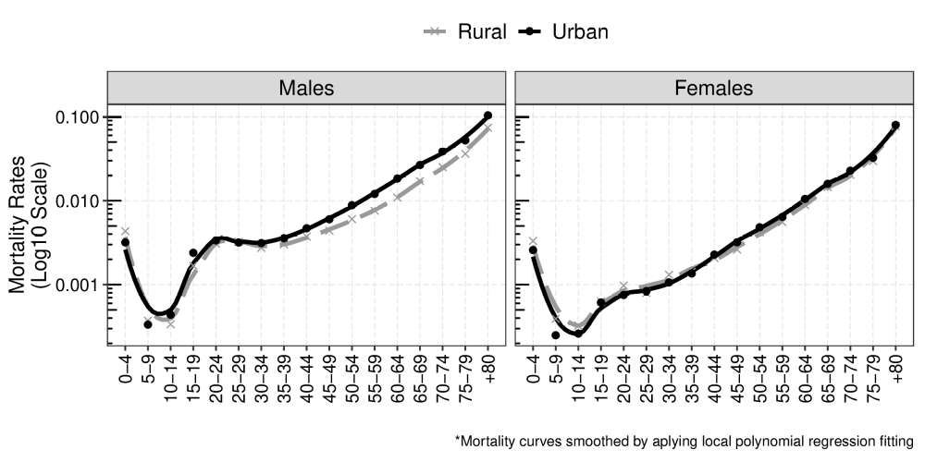

Table 1: Rural and urban life expectancy estimates by sex and age - Brazil, 2010. Source: 2010 Brazilian National Census.
 | Males |  |  | Females |  |  | Sex differentials  (Females-Males)
Age | Rural | Urban | Difference  (Rural-Urban) | Rural | Urban | Difference  (Rural-Urban) | Rural | Urban
0 | 74.5 | 70.6 | 3.9 | 78.9 | 78.6 | 0.3 | 4.4 | 8.0
20 | 56.9 | 52.6 | 4.3 | 60.8 | 60.0 | 0.8 | 3.9 | 7.4
40 | 39.8 | 35.5 | 4.3 | 41.9 | 41.0 | 0.9 | 2.1 | 5.5
60 | 23.1 | 19.6 | 3.5 | 24.2 | 23.5 | 0.7 | 1.1 | 3.9

Concerning estimates of disease and disability prevalence, Figure 2 presents results by age and regions of residence. For the adult population, there are rural penalties (higher rural-urban prevalence ratios) in the prevalence of osteoarticular diseases and physical incapacity for males and of cardiovascular diseases and physical incapacity for females. Also, adult women from rural environments had higher prevalence rates of all morbidities investigated. We present the prevalence rates estimated in the PNS survey of 2013 for cardiovascular diseases, diabetes, and osteoarticular diseases and the national census of 2010 for physical incapacity and their respective smoothed estimates. The smoothing methods were used to minimize the high variability of prevalence rates, especially for PNS lower counts of rural residents. Smoothing of incapacity prevalence for census information is presented, but the original prevalence rates were used for Sullivan method estimation of the next section since they showed very low variability.

Figure 2: Rural and urban disease and disability prevalence by sex and age - Brazil, 2010-2013. Source: 2010 Brazilian National Census 2010 and 2013 National Health Survey.
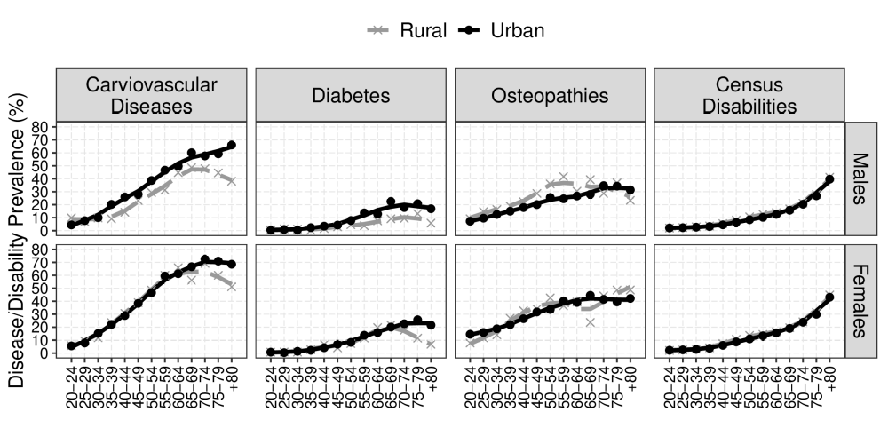

Table 2 presents the results of morbidity-free life expectancy or health expectancy ($h_{x}$) estimates for males and females of rural and urban areas at birth, at 20 years old, at 40 years old, and at 60 years old. For males, rural-urban disease-free life expectancy ratios show a continuous increase in the rural-urban gap through advanced ages. Indeed, these results corroborate the idea of an existing urban mortality penalty in lower-income countries and also announces a morbidity penalty for the urban elderly. These absolute values present worse scenarios in urban areas for life expectancy without cardiovascular diseases and diabetes estimates. These two groups of diseases exhibited a higher prevalence for the urban population for the adult and the older age groups. Female absolute values estimates reported negligible differences between urban and rural areas, even though a slight rural advantage was observed for diabetes-free life expectancy at ages 40 and 60.

Table 2: Rural and urban health expectancy estimates (h_{x}) and health expectancy to life expectancy ratios (h_{x} / e_{x}) by sex and age - Brazil, 2010-2013. Source: Brazilian National Census 2010 and National Health Survey 2013.
 | Males |  | Females
 | Rural | Urban | Rural | Urban
Cardiovascular diseases
Age | h_{x} (h_{x} / e_{x}) | h_{x} (h_{x} / e_{x}) | h_{x} (h_{x} / e_{x}) | h_{x} (h_{x} / e_{x})
20 | 43.5 (0.74) | 35.7 (0.67) | 37.8 (0.60) | 35.6 (0.58)
40 | 27.5 (0.65) | 19.6 (0.54) | 21.0 (0.48) | 18.6 (0.43)
60 | 14.6 (0.57) | 8.5 (0.41) | 10.9 (0.41) | 8.2 (0.32)
Diabetes
Age | h_{x} (h_{x} / e_{x}) | h_{x} (h_{x} / e_{x}) | h_{x} (h_{x} / e_{x}) | h_{x} (h_{x} / e_{x})
20 | 56.4 (0.96) | 48.9 (0.92) | 57.8 (0.92) | 55.1 (0.89)
40 | 39.5 (0.94) | 31.8 (0.88) | 39.2 (0.89) | 36.3 (0.85)
60 | 23.5 (0.92) | 16.8 (0.82) | 22.9 (0.87) | 20.1 (0.79)
Osteoarticular diseases
Age | h_{x} (h_{x} / e_{x}) | h_{x} (h_{x} / e_{x}) | h_{x} (h_{x} / e_{x}) | h_{x} (h_{x} / e_{x})
20 | 43.9 (0.74) | 42.3 (0.79) | 42.8 (0.68) | 42.6 (0.69)
40 | 29.0 (0.69) | 26.8 (0.74) | 26.6 (0.60) | 26.8 (0.63)
60 | 17.6 (0.69) | 14.2 (0.69) | 15.2 (0.58) | 15.0 (0.59)
Census disabilities
Age | h_{x} (h_{x} / e_{x}) | h_{x} (h_{x} / e_{x}) | h_{x} (h_{x} / e_{x}) | h_{x} (h_{x} / e_{x})
20 | 51.1 (0.87) | 47.7 (0.89) | 52.8 (0.84) | 52.8 (0.85)
40 | 34.2 (0.81) | 30.8 (0.85) | 34.4 (0.78) | 34.2 (0.80)
60 | 18.8 (0.73) | 15.7 (0.77) | 18.5 (0.70) | 18.2 (0.71)

Figure 3 presents the results of the decomposition of differences in health expectancy from rural and urban settings by related morbidity. For males, positive values of mortality contribution to rural-urban health expectancy differentials show that the overall mortality curve differences among rural and urban populations favor the first ones. However, as expected by morbidity prevalence curves, osteopaths and physical disabilities have negative impacts on the health expectancy differences between rural and urban populations. These differences are, however, lower than the differences in the overall mortality shape. Hence, positive differences in rural-urban health differentials are still evident even though some morbidities act towards the reduction of rural advantages. Estimated differences from rural to urban morbidity-free life expectancy at 20 years old of these two morbidities resulted in a 0.5 difference for osteoarticular diseases and 2.4 for physical disabilities. Of osteoarticular illnesses, the disease prevalence profiles difference accounted for -2.4 of the estimated difference, and the mortality shape differences accounted for 2.9 of the differences. Therefore, musculoskeletal and physical morbidities are responsible for slowing down the rural mortality curve advantaged condition. For census reported disabilities, the difference in morbidity profiles accounted for -0.5 of rural-urban health expectancy difference, much lower than morbidity contribution of osteoarticular diseases, but also in the opposite direction of the mortality profiles difference contribution.

Figure 3: Decomposition of rural-urban health expectancy differentials by sex and age - Brazil, 2010-2013. Source: 2010 Brazilian National Census and 2013 National Health Survey.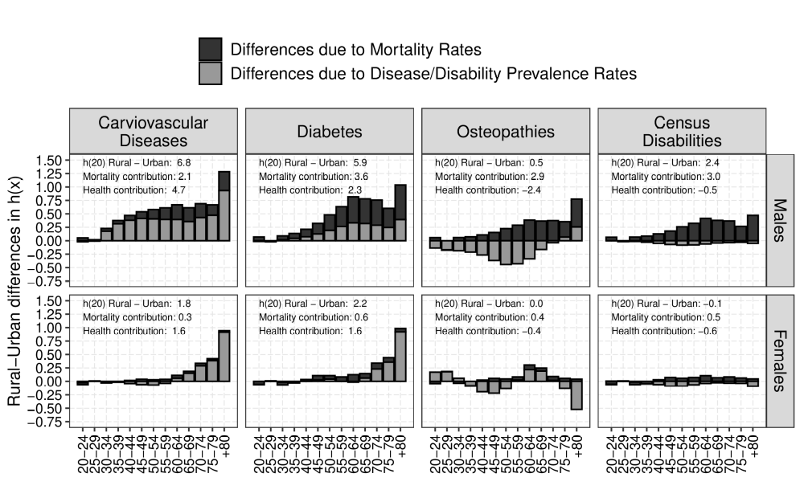

4. Discussion
Over the last 30 years, Brazil has experienced substantial changes in its public health policy represented by the implementation and consolidation of the country’s unified health system (SUS, from Portuguese Sistema Único de Saúde) (Castro et al. 2019). SUS guaranteed a massive expansion of health care assistance for the most vulnerable social groups through a universal and free of charge health services.
Gradual implementation of the family health strategy (ESF, from Portuguese Estratégia de Saúde da Família) - a public health policy approach focused on primary care at the community level - provided several positive outcomes such as the reduction of infant mortality rates (Macinko, Guanais, and Souza 2006), reduction of maternal mortality rates (Bhalotra, Rocha, and Soares 2020) and decrease in hospitalizations due to causes sensitive to primary care (Pimenta et al. 2018). ESF policy approach is oriented towards the needs of the poorest regions and most vulnerable social groups. Therefore, its positive outcomes were mostly visible in regions and areas of the country with worsened health and socio-economic conditions (Guimarães 2018).
Changes in health policy in Brazil impact on different aspects of the urban-rural differential, and we will discuss each of them below.

4.1 Urban-Rural mortality differentials
Mortality differentials have already been addressed in previous research (Albuquerque 2019; Carvalho and Wood 1978; Pereira 2020), and our results reflect those earlier findings. Adjusted mortality rates yield different life expectancy estimates from Albuquerque (2019). The author used the official life tables estimated for Brazil from IBGE for 2010 as a reference to adjust the observed deaths from the 2010 census while we used the SEG-adjusted method taking into account regional differences in death coverage completeness. In this sense, our estimates resulted in higher life expectancy at birth values, since two of the three most populated regions (Southeast - the most populated and South - the third most populated) have census death coverage rates close to completeness (100%). Also, IBGE life tables present higher life expectancy values for Northeast states because its death coverage estimates are lower for these areas than when other death distribution methods such as generalized growth balance (GGB) and SEG-adjusted are applied (Queiroz et al. n.d.).
The sex differentials in mortality also favor females for Brazilian rural areas according to 2010 census data. Nevertheless, the female advantage in rural areas is lower than the urban female mortality advantage. Large differences from male/female mortality ratios are observed between rural and urban areas, especially for adult ages. In this sense, the male mortality excess observed in Brazilian young adult males is more evident in urban areas and, in particular, in disadvantaged and suburban areas of cities (Malta et al. 2017; Pereira 2018; Pereira and Queiroz 2016).

4.2 Urban-rural health conditions
Urban and rural environments shape the lifestyles and types of work performed by each population. These environmental differences have direct impacts on workers’ health (Moreira et al. 2015). Disadvantages in self-reported health conditions have been observed in rural populations in addition to their socio-economic and transportation penalties to access public health equipment (Arruda, Maia, and Alves 2018). The difficulties of accessing health equipment due to distance or lack of resources were mentioned by 56% of rural residents who did not access health services and needed to against 17% of urban residents in the PNS survey of 2013. Urban residents mostly did not access health services when they needed to because of the long waiting time (28% against 8% of rural population). Thus, these differentials in access to health services may incur lower disease diagnosis. Indeed, PNS data shows that the rural population had a higher percentage of people that never had measured their glycemic levels (21% against 10% for urban residents) or blood pressure (6% against 3% for urban residents). This scenario could have been worse if the Family Health Strategy of the Brazilian Ministry of Health was not successful in reaching remote communities of the countryside of Brazil (Bhalotra, Rocha, and Soares 2020; Lima et al. 2019; Malta 2016). Even though rural residents showed lower diagnosis rates than urban residents, we still had sufficient data to evaluate disease prevalence of urban and rural populations.
For women, there is no clear pattern due to high data variability for rural residents. In the opposite direction, rural men are in a better off situation regarding diabetes prevalence rates, which presented a wide gap for advanced ages, and also for cardiovascular disease prevalence rates, which showed a small but continuous gap from the age group 30-34 and above. Female prevalence curves for diabetes did not present any significant gap, while the prevalence curves of cardiovascular diseases for women in rural areas exhibited higher rates than urban curves. For both males and females, the prevalence rates of physical disabilities declared in the national census of 2010 were slightly higher in rural settings. Hence, results conform with previous analysis performed for rural workers in Brazil (Moreira et al. 2015). Significant decreases observed in PNS morbidities prevalence for the elderly may be related to poor disease diagnostic of this age-group in rural populations.

4.3 Morbidity-free life expectancy
Absolute differences highlight rural advantages in mortality and morbidity indicators. We now turn our attention to relative differences in healthy life expectancy estimates, e. g.; we evaluate the ratio of morbidity-free life expectancy by life expectancy (${h_{x}}/{e_{x}}$ ratio). This ratio can be interpreted as a proxy of the proportion of life expected to be lived free from morbidity for a synthetic cohort with a set of age-specific morbidity prevalence rates and age-specific mortality rates. Relative estimates of health expectancy change the rural advantage observed for all groups of morbidity so far. The rural advantage prevails only for cardiovascular diseases and diabetes, whereas a relative urban advantage is observed for osteoarticular diseases and physical disabilities. These results confirm that rural residents are more prone to develop physical incapacity and disabilities and suffer from musculoskeletal pain due to the physically demanding labor required in agriculture (Maia 2010; Moreira et al. 2015). The absolute advantages observed in health expectancy numbers may not reflect in actually better living conditions in terms of life span relative measures. Therefore, we decompose differences in health expectancy into its mortality and morbidity components to investigate positive or negative contributions and provide further evidence on what might seem as a mortality exclusive advantage or mortality and morbidity advantage of rural residents.

4.4 Decomposition of health expectancy
This decomposition exercise highlights that health expectancy differences observed between rural and urban populations are not only due to overall mortality difference but also related to differences in age-specific morbidity prevalence. The results align with the bibliographic review, which shows that cardiovascular diseases and diabetes are city-related morbidities and physical disabilities, and osteoarticular diseases are rural related morbidities that result from physically harming work performed at rural areas. Hence, rural residents present a double advantage (in mortality and morbidity) when we compare health expectancy for cardiovascular diseases and diabetes. However, this advantage becomes a mortality profile advantage exclusively when we decompose differences for osteoarticular diseases and physical disabilities.
Rural populations observe a higher prevalence of specific disabilities, and diseases such as chronic pains, back pains, arthritis, and urban populations are usually more susceptible to diabetes, high blood pressure, heart diseases, and depression (Camarano 2002). Further, rural residents are more prone to report worsened health status (Arruda, Maia, and Alves 2018; Camarano 2002; Maia 2010). Moreira et al. (2015) found that back pain, rheumatism, arthritis and high blood pressure were associated to the agricultural activities and results from intense physical effort in work. The difference in social status also plays a key role in the self-perception of health state (Viacava et al. 2019). Then, rural populations usually declare poor health conditions than urban ones (Arruda, Maia, and Alves 2018; Maia 2010). However, looking into social groups, rural residents from lower social strata have a higher probability of referring to a good state of health than their identicals from urban areas (Maia 2010).
ESF expansion provides diagnosis and follow-up of chronic diseases in rural populations and provides an enhancement of its health literacy, which might also have contributed to further mortality improvements of these groups (Bhalotra, Rocha, and Soares 2020; Rocha and Soares 2010). Also, lower exposition to urban-related mortality causes such as violence and accidents is likely to play a key role in lower mortality observed in rural areas (Pereira 2020). Moreover, the results of this work support the efforts of family health strategy towards health coverage of most vulnerable and remote areas of the country (Guimarães 2018).
In 2013, 54.4% of Brazilian households were registered in the local family health unit, 74.9% of rural households, and 50.6% of urban households (Malta 2016). This higher ESF coverage and primary care assistance in rural areas might account for the favorable results of rural residents concerning mortality and cardiovascular diseases and diabetes morbidity differentials, since ESF professionals provide not only health care support, but also health information, enhancing health literacy levels of local communities.
Such as in the case of USA, Brazilian rural residents experience higher deprivation in access to services and health facilities and usually report worse health status conditions and are in the worse economic situation than urban residents (Arruda, Maia, and Alves 2018; Camarano 2002; Soares et al. 2016). This scenario echos the higher vulnerability condition of rural areas and other territories with lower economic integration (Soares et al. 2016; Viacava et al. 2019). The distance of health equipment, lack of resources to pay for transportation, the lack of health professionals, or unavailability of higher complexity health services are barriers to the access of public health systems by the rural population (Viacava et al. 2019). This situation is worsened for the elderly, population group with higher demand for such services.
This paper’s results have some limitations. As mentioned, the rural population’s lower access to health services reflects in lower diagnostic rates of health indicators such as glycemic level and blood pressure. Then, prevalence rates for rural groups might be underestimated due to a lack of diagnosis. Despite this important detail, the data collected is robust enough, and the results agree with previous studies on rural and urban health and mortality differentials. We verified the existence of an urban adult mortality penalty and also in an urban adult morbidity penalty for cardiovascular diseases and diabetes. Finally, we verified a rural morbidity penalty related to physical disabilities (to walk, see, and listen) and osteoarticular diseases. This penalty contributes to lower health expectancy differences about these two morbidities, but the rural mortality advantage compensates it. Therefore, rural residents exhibit higher life expectancies, but a significant share of this life expectancy co-occur with physical and musculoskeletal related morbidities.

5. References
Albuquerque, F.R.P.C. (2019). Tábuas de Mortalidade segundo a situação do domicílio utilizando-se o Censo Demográfico de 2010. Informe de Previdência Social. Ministério da Economia. Brasília, Brazil.
Allan, R., Williamson, P., and Kulu, H. (2017). Unravelling urban–rural health disparities in England. Population, Space and Place 23(8). doi:10.1002/psp.2073.
Andreev, E.M., Shkolnikov, V.M., and Begun, A. (2002). Algorithm for decomposition of differences between aggregate demographic measures and its application to life expectancies, healthy life expectancies, parity-progression ratios and total fertility rates. Demographic Research 7(14):499–522. doi:10.4054/DemRes.2002.7.14.
Arruda, N.M., Maia, A.G., and Alves, L.C. (2018). Desigualdade no acesso à saúde entre as áreas urbanas e rurais do Brasil: uma decomposição de fatores entre 1998 a 2008. Cadernos de Saúde Pública 34.
Bennett, N.G. and Horiuchi, S. (1984). Mortality estimation from registered deaths in less developed countries. Demography 21(2):217–233.
Bhalotra, S., Rocha, R., and Soares, R.R. (2020). Can Universalization of Health Work? Evidence from Health Systems Restructuring and Expansion in Brazil. Working Paper 3. Instituto de Estudos para Políticas de Saúde. São Paulo, Brazil. https://ieps.org.br/wp-content/uploads/2020/02/WPS3.pdf.
Camarano, A.A. (2002). Brazilian population ageing: differences in well-being by rural and urban areas. Texto para Discussão 878. Instituto de Pesquisa Econômica e Aplicada. Rio de Janeiro, Brazil.
Carvalho, J.A.M. and Wood, C.H. (1978). Mortality, Income Distribution, and Rural-Urban Residence in Brazil. Population and Development Review 4(3):405–420.
Castro, M.C., Massuda, A., Almeida, G., Menezes-Filho, N.A., Andrade, M.V., Souza Noronha], K.V.M. [de, Rocha, R., Macinko, J., Hone, T., Tasca, R., Giovanella, L., Malik, A.M., Werneck, H., Fachini, L.A., and Atun, R. (2019). Brazil’s unified health system: The first 30 years and prospects for the future. The Lancet 394(10195):345–356. doi:https://doi.org/10.1016/S0140-6736(19)31243-7.
Chen, X., Orom, H., Hay, J.L., Waters, E.A., Schofield, E., Li, Y., and Kiviniemi, M.T. (2019). Differences in rural and urban health information access and use. The Journal of Rural Health 35(3):405–417.
Deaton, A. (2003). Health, Inequality, and Economic Development. Journal of Economic Literature 41(1):113–158.
Fink, G., Günther, I., and Hill, K. (2016). Urban Mortality Transitions: The Role of Slums. In: Ramiro Fariñas, D. and Oris, M. (eds.). New Approaches to Death in Cities During the Health Transition. Cham: Springer International Publishing: 197–216.
Garcia, J. (2020). Urban–rural differentials in Latin American infant mortality. Demographic Research 42(8):203–244. doi:10.4054/DemRes.2020.42.8.
Guimarães, R.M. (2018). A teoria da equidade reversa se aplica na atenção primária à saúde? Evidências de 5 564 municípios brasileiros. Revista Panamericana de Salud Pública [online] 42. doi:10.26633/RPSP.2018.128.
Henning-Smith, C., Prasad, S., Casey, M., Kozhimannil, K., and Moscovice, I. (2019). Rural-urban differences in medicare quality scores persist after adjusting for sociodemographic and environmental characteristics. The Journal of Rural Health 35(1):58–67.
Hill, K. (1987). Estimating census and death registration completeness. Asian Pac Popul Forum East-West Popul 1(3):23–24.
Hill, K., You, D., and Choi, Y. (2009). Death distribution methods for estimating adult mortality: Sensitivity analysis with simulated data errors. Demographic Research 21(9):235–254.
Instituto Brasileiro de Geografia e Estatística (IBGE) (2010). Censo Demográfico.
Instituto Brasileiro de Geografia e Estatística (IBGE) (2013). Pesquisa Nacional de Saúde.
Lima, Â.R.A., Dias, N.S., Lopes, L.B., and Heck, R.M. (2019). Health needs of the rural population: How can health professionals contribute? Saúde debate 43(122).
Macinko, J., Guanais, F.C., and Souza, F.M. de (2006). Evaluation of the impact of the family health program on infant mortality in brazil, 19902002. Journal of Epidemiology & Community Health 60(1):13–19. doi:10.1136/jech.2005.038323.
Maia, C.G., Alexandre Gori and Rodrigues (2010). Saúde e mercado de trabalho no Brasil: diferenciais entre ocupados agrícolas e não agrícolas. Revista de Economia e Sociologia Rural 48:737–765. http://www.scielo.br/scielo.php?script=sci_arttext&pid=S0103-20032010000400010&nrm=iso.
Malta, D.C., Minayo, M.C. de S., Soares Filho, A.M., Silva, M.M.A. da, Montenegro, M. de M.S., Ladeira, R.M., Morais Neto, O.L. de, Melo, A.P., Mooney, M., and Naghavi, M. (2017). Mortality and years of life lost by interpersonal violence and self-harm: in Brazil and Brazilian states: analysis of the estimates of the Global Burden of Disease Study, 1990 and 2015. Revista Brasileira de Epidemiologia 20:142–156.
Malta, M.A.S.A.S., Deborah Carvalho AND Santos (2016). Family Health Strategy Coverage in Brazil, according to the National Health Survey, 2013. Ciência & Saúde Coletiva 21:327–338. http://www.scielo.br/scielo.php?script=sci_arttext&pid=S1413-81232016000200327&nrm=iso.
Menashe-Oren, A. and Stecklov, G. (2018). Urban–rural disparities in adult mortality in sub-saharan africa. Demographic Research 39:136–176.
Moreira, J.P.L., Oliveira, B.L.C.A. de, Muzi, C.D., Cunha, C.L.F., Brito, A. dos S., and Luiz, R.R. (2015). A saúde dos trabalhadores da atividade rural no Brasil. Cadernos de Saúde Pública 31:1698–1708.
Nepomuceno, M.R. and Turra, C.M. (2020). The population of centenarians in brazil: Historical estimates from 1900 to 2000. Population and Development Review n/a(n/a). doi:10.1111/padr.12355.
Pereira, F.N.A. (2018). Geografia é Destino? Diferenciais de Mortalidade Por Local de Moradia No Brasil Dentre Moradores de áreas Urbanas de Favela E Não Favela. Poços de Caldas, Brasil: Associação Brasileira de Estudos Populacionais.
Pereira, F.N.A. (2020). Penalidade urbana na mortalidade por local de moradia no Brasil: Diferenciais de mortalidade entre moradores de áreas urbanas em favelas, fora de favelas e de áreas rurais. [PhD thesis]. Belo Horizonte: Centro de Desenvolvimento e Planejamento Regional, Faculdade de Ciências Econômicas - UFMG.
Pereira, F.N.A. and Queiroz, B.L. (2016). Differences in mortality in Brazilian youth: The importance of household socioeconomic factors and living conditions in Brazilian municipalities and states. Cadernos de Saúde Pública 32(9).
Pimenta, L., Dutra, V.G.P., de Castro, A.L.B. and Guimarães, R.M. (2018). Analysis of conditions sensitive to primary care in a successful experience of primary healthcare expansion in brazil, 1998–2015. Public Health 162:32–40. doi:https://doi.org/10.1016/j.puhe.2018.05.011.
Queiroz, B.L., Freire, F.H.M. de A., Gonzaga, M.R., and Lima, E.E.C. de (2017). Estimativas do grau de cobertura e da mortalidade adulta (45q15) para as unidades da federação no Brasil entre 1980 e 2010. Revista Brasileira de Epidemiologia 20:21–33.
Queiroz, B.L., Gonzaga, M.R., Vasconcelos, A.M.N., Lopes, B.T., and Abreu, D.M.X. (forthcoming). Comparative analysis of completeness of death registration, adult mortality and life expectancy at birth in Brazil at the subnational level. Population Health Metrics.
Queiroz, B.L. and Sawyer, D.O.T. (2012). O que os dados de mortalidade do Censo de 2010 podem nos dizer? Revista Brasileira de Estudos de População 29:225–238.
Riffe, T., Lima, E., and Queiroz, B. (2017). DDM: Death Registration Coverage Estimation.
Rocha, R. and Soares, R.R. (2010). Evaluating the impact of community-based health interventions: Evidence from brazil’s family health program. Health Economics 19(S1):126–158. doi:10.1002/hec.1607.
Rodella, A.-S. (2015). Poverty and Shared Prosperity in Brazil’s Metropolitan Regions: Taking Stock and Identifying Priorities. World Bank Group.: pages.
Sastry, N. (1997). What explains rural-urban differentials in child mortality in Brazil? Social Science & Medicine 44(7):989–1002.
Soares, S., Souza, L.R., Silva, W.J., Silveira, F.G., and Campos, A. (2016). Poverty Profile: The Rural North and Northeast of Brazil. Working Paper 50. International Policy Centre for Inclusive Growth. https://ipcig.org/pub/eng/PRB50_Poverty_profile_the_rural_North_Northeast_regions_of_Brazil.pdf.
Sullivan, D.F. (1971). A single index of mortality and morbidity. HSMHA Health Reports 86(4):347–354.
Viacava, F., Porto, S.M., Carvalho, C. de C., and Bellido, J.G. (2019). Health inequalities by region and social group based on data from household surveys (Brazil, 1998-2013). Ciência & Saúde Coletiva 24:2745–2760.
Woods, R. (2003). Urban-rural mortality differentials: An unresolved debate. Population and Development Review 29(1):29–46.

Package is available at: https://cran.r-project.org/web/packages/DDM/index.html.
Even though PNS had prevalence data available only for adults aged over 18 years old, we considered the prevalence distribution of diseases for age group 15-19 equal to the rates observed for the age group 18-19. For age groups 0-14 the prevalence rates for PNS survey were considered equal to 0 in order to get estimates of morbidity-free life expectancy at birth.
Prevalence rates of diseases and disabilities were smoothed by apply the localy estimated scatter plot smoothing method (LOESS).

