Educational Pairings and Fertility Decline in Brazil: An Analysis Through Cohort Fertility

Abstract

BACKGROUND
The fertility transition in Brazil was the result of multiple socioeconomic transformations that initiated from 1930s on-wards. The education expansion plays an important role in this process by promoting changes in social norms and in assortative matching profiles.

OBJECTIVE
This paper estimates effects of male partners’ education on reproductive behavior of couples for Brazil and its regions during the process of fertility transition, taking into account the effects of changes in educational pairings composition.

METHODS
We compute cohort fertility rates (CFRs) for groups of educational pairings, considering the female cohorts born between the years 1925-1969. The CFRs decline were decomposed between compositional and rate effects using Das Gupta (1993) decomposition methods.

RESULTS
In the country, the couple’s CFR fell from 6.30 to 2.94 between the analyzed cohorts. Educational pairing composition accounted for approximately 30% of these changes in cohort fertility. Increases in male schooling, especially the jump from incomplete to complete primary education, resulted in significant CFRs reductions, even controlling for female schooling levels.

CONCLUSIONS
Results suggest that males’ education does affect family size, especially considering older cohorts couples. Additionally, we argue that to a certain extent, a slower male educational expansion might have restrained the pace of fertility transition in some regions of the country.

CONTRIBUTION
The cohort analysis and male schooling influences on family size represent good tools to understand Brazilian fertility transition, and it also provides new perspectives of analyses for other Latin American countries that have experienced a similar reproductive decline process.

1. Introduction
Brazil observed a significant reduction of its total fertility rates since 1960s (Merrick and Berquó 1983) and by 2010-2015 the country was already under below-replacement fertility levels (Berquó and Cavenaghi 2014; Castanheira and Kohler 2015; Lima et al. 2018; Rios-Neto, Miranda-Ribeiro, and Miranda-Ribeiro 2018). The country’s fertility transition was marked by heterogeneous starting, timing and pace across its regions and socioeconomic strata (Potter et al. 2010).
The pioneers of the fertility decline were social groups with higher socioeconomic status, especially those living in urban and industrialized areas of South and Southeast of the country; they were forerunners in the practice of birth control, which took place before the beginning of the generalized decline of fertility in the 1960s (Gonçalves et al. 2019; Guzmán and Rodríguez 1993; Merrick and Berquó 1983). In opposition to the steady and gradual fertility transition seen in developed nations, the acceptance of modern contraceptive methods rapidly spread from higher social status groups to lower socioeconomic strata of Northern and Northeastern parts of Brazil (Berquó and Cavenaghi 2014; Carvalho and Wong 1992; Perpétuo and Wajnman 1998). To illustrate, in these two regions, social groups of lower schooling levels and lower household income started to experience a fertility decline by the 1980s, but at a much-accelerated pace than similar groups from other regions, where the fertility decline commenced twenty years earlier (Potter et al. 2010; Potter, Schmertmann, and Cavenaghi 2002).
Several factors explain the converging fertility regimes among social groups and, thus, the fast pace of fertility transition in Brazil. We can mention industrialization and urbanization, changes in labor market and productive structures, reduction of infant mortality rates, higher access to formal schooling followed by a higher rates of female participation in the labor market, changes in gender relations, expansion of consumer society and communication systems among other factors related to socioeconomic and technological development (Alves 1994; Castanheira and Kohler 2017; Faria 1989; Lam, Sedlacek, and Duryea 1992; Martine 1996; Merrick and Berquó 1983; Oliveira 1989; Paiva 1987; Potter, Schmertmann, and Cavenaghi 2002; Rios-Neto, Miranda-Ribeiro, and Miranda-Ribeiro 2018). Notwithstanding, the difference in paces and periods that each region experienced the fertility transition can be attributed to an uneven spread of these processes through the country, resulting in non-negligible demographic inequalities (Carvalho and Brito 2005; Patarra and Oliveira 1988; Wong and Carvalho 2006; Wood and Carvalho 1988).
Despite the relevance of all these variables, we may argue that the expansion of population’s access to education was one of the main drivers of the fertility transition in Brazil (Carvalho and Wong 1992; Lam, Sedlacek, and Duryea 1992; Merrick and Berquó 1983), especially in more recent periods. Education exerts direct and indirect influences on demographic processes by shaping the life course of individuals through human capital formation (Lutz 2010). For instance, recent trends in rising female educational attainment favored more female participation in the labor market and fostered the postponement of childbearing (Neels et al. 2017). Recent rising educational attainment movements throughout the globe also promoted changes in the composition of conjugal markets and assortative mating profiles of countries (Esteve and McCaa 2007; Mare 1991; Ribeiro and Silva 2009). At last, education plays an important role regarding individual’s social and gender norms, encouraging new ideals of family size and cooperation between partners in the household realm (Adserà 2018; Esping-Andersen 2009; Jejeebhoy 1995; McDonald 2000).
Recently, demography scholars have been exploring cohort and male fertility as tools to study fertility trends in the context of postponement of childbearing (Neels et al. 2017; Rosero-Bixby, Castro-Martin, and Martin-Garcia 2009; Sobotka 2004), rising of female schooling (Esping-Andersen 2009; Neels et al. 2017; Van Bavel, Schwartz, and Esteve 2018) and its effects on changing gender norms, family commitment and reproductive behavior (Adserà 2018; Esping-Andersen 2009; Goldscheider, Bernhardt, and Lappegård 2015; McDonald 2000). Yet, neither of these approaches have been broadly explored for the Brazilian fertility context.
In this work, we estimate cohort fertility levels in Brazil using census data, because the country does not dispose of longitudinal data to track down life course demographic processes. With the information of respondent’s age and the inquiry reference date of multiple Brazilian national censuses (1970, 1980, 1991, 2000 and 2010), we reconstruct birth cohorts and reproductive indicators (mean children ever born) and make associations with schooling expansion processes that took place in the country throughout the second half of the XX century. Afterwards, by linking female’s reproductive data with the schooling level of their partners, we assess the associations between male education and cohort fertility during the country’s fertility transition. In addition, our analysis also reports regional cohort fertility trends.
This work fosters important discussions and make valuable contributions for Brazilian fertility transition studies, because few studies evaluate cohort fertility trends throughout the process of educational expansion in the country. Additionally, this work also incorporates the discussion of partners’ education contribution to completed fertility levels of couples (Nitsche et al. 2018; Thomson 1997; Van Bavel 2017). In this sense, this analysis shed light on processes of fertility transition that have been promoting changes in gender norms and in family structure for several generations. Merging the perspectives of cohort changes and partners’ education to fertility analysis might provide new insights and spark new research questions in Brazilian fertility transition studies.

2. Background

2.1 Fertility decline and school expansion in Brazil
The fertility transition in Brazil have been well documented by several studies. This process was marked by contrasting fertility regimes among distinguished socioeconomic groups, as for example, highly educated social groups already adopted birth control practices prior to the onset of a generalized decline of the country’s fertility levels (Merrick and Berquó 1983). A second noteworthy characteristic is that, compared to more developed regions, the fertility rates from different social strata converged into replacement fertility levels in a short period of time (Berquó and Cavenaghi 2014) and, more recently, the overall TFR reached below population replacement levels (Castanheira and Kohler 2015).

The diffusion of new contraceptive methods - in particular, female sterilization and the contraceptive pill - contributed for the rapid transition and the fertility convergence processes (Martine 1996; Merrick and Berquó 1983; Perpétuo and Wajnman 1998; Perpétuo and Wong 2009). There were, however, differences in contraceptive access and knowledge between social groups that illustrate the social inequalities within the access to family planning (Carvalho and Brito 2005). Groups of lower socioeconomic status had access to more harmful contraceptive methods (sterilization and clandestine abortion), whereas wealthier families could consume other safer options, and opted for female sterilization only when their family size goals was achieved (Faria 1997; Martine 1996; Perpétuo and Wajnman 1998; Perpétuo and Wong 2009). Nowadays, despite similar fertility levels, these social groups differ in fertility timing, for example, females with lower schooling levels display younger mean ages at first child and fertility postponement is more common among women with completed higher education (Lima et al. 2018; Rios-Neto, Miranda-Ribeiro, and Miranda-Ribeiro 2018).
In common, these studies show how education has become one and, if not, the most important key element to determine fertility outcomes in Brazil. Schooling acts as a strong determinant of reproductive behavior of women through several mechanisms (Jejeebhoy 1995). Moreover, formal education affects females’ exposure to childbearing by shaping both labor market participation and conjugal decisions (Castro-Martin and Juarez 1995; Neels et al. 2017). Additionally, education also helps to provide the accomplishment of reproductive intentions, by promoting the access to information on modern contraceptive methods and other relevant scientific knowledge (Cleland and Wilson 1987; Jejeebhoy 1995).

By the time of fertility transition started in Brazil, its educational system expansion was already ongoing, fomented by a shift in the economic and production model adopted by the country (Romanelli 1986). The rupture between dominant political classes promoted a gradual transformation in the country’s economy and social environment (Merrick and Graham 1981; Paiva 1987). In time, Brazil’s productive model shifted from an economy based on exports of agricultural goods to an economic model partially based on urban centers growing service sector and import substitution industries which fomented the urbanization of the country and, in particular, of the Southeastern state of São Paulo [Merrick and Graham (1981);singer1973].

The main transformations in the educational policy from 1930 to 1960 were targeted to expand the educational system to provide productive and consumption capacity for an urban-industrial economic model (Romanelli 1986). This movement began with the foundation of Ministry of Education and Health in 1931, followed by the creation of the National Institute of Pedagogy (which now is the National Institute for Educational Studies and Research “Anísio Teixeira”), the National Institute of Geography and Statistics (responsible for country’s statistics and national censuses), and national services of industrial and commercial education (Marcílio 2014). In 1961, the first Law of Directives and Bases of National Education, reviewed in 1971, set up the obligation of basic education to the whole population, and established the bases of the current educational system of the country, composed by primary and secondary compulsory schooling (Marcílio 2014). From 1970 to 2000, Brazil experienced relevant increases in enrollment rates across all educational levels (Komatsu et al. 2017), and in the 1990s the country finally achieved universal primary schooling enrollment (Castro 1998).
The Brazilian formal schooling expansion occurred, however, at a slower pace than in other South American countries and was not evenly distributed across educational levels (Komatsu et al. 2017). For example, primary education has received lower investments for its expansion than secondary or tertiary education (Kang 2006; Komatsu et al. 2017; Romanelli 1986). This was partly explained by the adopted education administration structure between government entities. The administration of primary educational systems was under states and municipal accountability, while the financial resources were centralized at federal government level (Kang 2011), which was also responsible for the regulation of the tertiary education system. Therefore, urbanized industrial municipalities (in the South and Southeast) had more resources to invest in primary education than underfunded areas (from North and Northeast), which later reflected in structural inequalities that are still visible in the country to this day (Barros and Mendonça 1995; Komatsu et al. 2017; Merrick and Graham 1981; Wood and Carvalho 1988).
The educational composition of the Brazilian population also changed over the course of the XX century, in particular, women were significantly affected by the country’s educational expansion (Fígoli 2006). At first, females benefited from schooling gains through a gender-stratified educational system, in which they received instruction to operate in specific labor sectors such as health, hospitality and education (Besse 1999). This process affected the female labor market structure and status, creating persisting wage inequalities between men and women, but it also fostered women the opportunity to leave their household and to participate more in the public spheres of the society (public spaces such as commerce and labor market) (Azevedo and Ferreira 2006; Maluf and Mott 1998).
In sum, female schooling resulted in the reversion of male educational advantages (Beltrão and Alves 2009), and it has promoted important transformations in gender relations and social norms of the country through the course of the XX century (Itaboraí 2015). As a result, we saw an increasing participation of women in the labor market (Scorzafave and Menezes-Filho 2001) and a larger female attendance in secondary and tertiary education (Godinho et al. 2006). In the course of the country’s fertility transition women achieved higher educational gains than men (Beltrão and Alves 2009; Ribeiro and Silva 2009), leading to a decrease in educational hypergamy - conjugal profiles in which male partners have higher educational attainment level than their female partners (Ribeiro and Silva 2009).

2.2 Assortative mating trends in Brazil
The population’s assortative mating patterns depends to a great extent on the heterogeneity of social characteristics of its individuals (Blau and Schwartz 1997). Conjugal unions represent an opportunity of social interaction between distinct social groups, but this interaction depends on the conjugal market’s composition and the size of each group (Kalmijn 1998). In this context, educational composition of conjugal markets plays an important role and are usually analyzed by demographers due to some important advantages over other socioeconomic indicators such as income. Besides its importance in shaping an individual’s life course, preferences and professional realizations, education attainment is usually stable over time for adults. Individual income, on the other hand, is volatile and sensitive to macroeconomic fluctuations (Esteve, Garcia-Román, and Permanyer 2012; Kalmijn 1998; Mare 1991; Warren 1966).
In addition, schools are the environment that shapes social networks among individuals and in which union formation generally takes place (Eckland 1968; Warren 1966). Therefore, the massification of formal education is one of the drivers of the biased (and sometimes unconscious) allocation of couples in conjugal formation. In general, unions take place between people of similar educational levels, due to closer social contact of school classmates and the shared human capital formation (Kalmijn 1998). College-educated couples are a good example of high homogamy (unions of individuals with similar characteristics) rates around the world, since these individuals have spent most of their youth in the educational system with similar peers (Mare 1991), favoring a posterior conjugal union.
The educational composition changes in Brazilian society were not only responsible for fertility decline (Lam, Sedlacek, and Duryea 1992), but it had also major effects on the country’s assortative mating trends (Ribeiro and Silva 2009). Both educational hypogamy (couples in which females have higher education level than their partners) and educational hypergamy (couples in which females have lower education level than their partners) increased expressively from 1970 to 2010. Although, educational hypogamy increased at a higher pace due to female accelerated educational gains in the same period considered (Esteve, Garcia-Román, and Permanyer 2012; Esteve and McCaa 2007; Ribeiro and Silva 2009). The prevalence of educational homogamy (couples with the same educational level), on the other hand, has decreased over the time (Esteve and McCaa 2007; Ribeiro and Silva 2009).
In Brazil, homogamous mating profiles have historically shown a major prevalence between lower educated social groups and its reduction can be attributed to the expansion of the country’s educational system (Ribeiro and Silva 2009). On the other hand, highly educated couples also show high educational homogamy rates (Esteve and McCaa 2007; Ribeiro and Silva 2009), and that fact shed light on the existing societal barriers in detriment of the social interactions between groups of different educational backgrounds (Torche 2010). For this reason, assessing educational levels of both partners and its relationship with couples reproduction, within a context of changing gender norms and diversifying assortative mating profiles, could provide new insights for fertility studies (Nitsche et al. 2018).

2.3 Reproductive decision making and family conflicts
Despite its relevant role in population reproduction, male and female interactions in fertility decision making have been scarcely analyzed in demography (Nitsche et al. 2018). Generally, in reproductive studies, males are left out of fertility analysis (Goldscheider and Kaufman 1996; Oliveira, Bilac, and Muszkat 1994; Van Bavel 2017). It happens due to the lack of information on male’s reproductive intentions and behavior in most data sources (Schoumaker 2019). However, one can argue that males interfere in family size, because of their important role on resource allocation inside the household and in family planning decisions (Thomson 1997). In addition, evaluating and studying male’s role in couples reproduction gained importance in a period of changes in gender relations, cultural norms, family relations and assortative mating patterns.
The Western trend of female schooling expansion, followed by an increased demand for female labor force, was well as the reduction of the social costs of reproduction, led to the first phase of the Gender Revolution (Goldscheider, Bernhardt, and Lappegård 2015). This phase is marked by the increased participation of women in public life and institutional spheres (England 2010; Esping-Andersen 2009; Goldin 2006). The second phase of this still ongoing revolution would be guided by an increase in men’s participation in the private sphere, e.g. in household chores and childbearing decisions (Esping-Andersen 2009). An optimistic view of this second phase expects a new balance of gender relations in the near future, with lower constraints to female reproduction and greater commitment of male partners to childbearing and domestic activities (Goldscheider, Bernhardt, and Lappegård 2015; Myrskylä, Kohler, and Billari 2011). Yet, neither the increments in female participation in public spaces nor the higher achieved female schooling levels achieved have led to improvements in division of labor by gender within families (England 2010).
Female participation in the Brazilian labor market resulted in a double burden, especially for the most vulnerable social classes that are unable to acquire domestic and child rearing services in the private market (Guedes 2015; Itaboraí 2016). Moreover, these social constraints have induced women to undertake different strategies to conciliate their labor activities with social motherhood responsibilities (household chores and childbearing). For example, they often choose to work part-time jobs (England 2010; Guedes 2015) or they either leave formal labor or opt for jobs in the informal market (Teixeira 2014). In contrast to this group of females, women from higher socioeconomic strata dedicate lesser time to household chores, because they have easier access to home care services in the private sector, or due to the fact that highly educated male partners tend to be generally more active and cooperative in domestic activities (Itaboraí 2016).
Taking all that into consideration, in the next sections, we will analyze past Brazilian cohort fertility trends, using couples’ educational pairings as a tool to capture the association of male educational levels on the completed fertility of couples.

3. Data and Methods

3.1 Data
We use data collected via IPUMS-International from Brazilian National Censuses of 1970, 1980, 1991, 2000 and 2010, conducted by the Brazilian Institute of Geography and Statistics (IBGE, from Portuguese Instituto Brasileiro de Geografia e Estatística). The IPUMS data is harmonized in time and space, which allows for the comparison of different demographic scenarios and areas without the need for compatibilization (Esteve and Sobek 2003; Minnesota Population Center 2019).
For the construction of educational pairings and for computing the mean number of children ever born or cohort fertility of each pairing we used the following variables (Minnesota Population Center 2019):
- Household serial number (SERIAL);
- Person weight (PERWT) - to compute accurate statistics for the population;
- Relationship to household head (RELATE) - to identify women and its respective partners;
- Marital status (MARST) - to identify couples married or in union;
- Age (AGE);
- Children ever born (CHBORN); and,
- Educational attainment, international recode - available in four levels at IPUMS (besides unknown or not in universe codes): 1) Less than Primary Education (LP), 2) Complete Primary Education (P), 3) Complete Secondary Education (S) and 4) Complete Tertiary Education (T).
We chose to evaluate either formal or consensual unions, because cohabitation has, historically, spread across different social groups in Brazil and it corresponds to a relevant share of observed fertility levels (Esteve, Garcia-Román, and Permanyer 2012; Laplante et al. 2015; Vieira 2016). Despite the formal matrimonial and the consensual unions display different age-specific fertility profiles (Vieira and Alves 2016), as well as different fertility levels (Vieira 2016), they do not exhibit significant differentials in terms of assortative mating patterns (Esteve and McCaa 2007).
By taking the difference between census reference period and the age of women, we were able to estimate cohort fertility rates (CFR) for Brazil and selected regions. We limited the female age range to 40 to 69 years old, and the male ones to 40 to 99. We considered that, by the age of 40 years old, women would already have completed or would be close to complete their reproductive lifespan. This makes it possible to reconstruct fertility from cohorts born between 1901 and 1970.
We restrict our analysis to the cohorts born in the period between 1925-1969, because of data quality issues related to older women memory misstatements on the correct number of children ever born (Brass et al. 1968), and due to data contiguity issues among educational groups of these older cohorts (Monteiro da Silva 2019). Regarding men, we have chosen a broader age range to increase the number of couples’ observations, allowing men to be older than their female partners, and that is usually common among Brazilian couples (Vieira and Alves 2016).

Finally, we also analyzed cohort fertility, taking into account the regional socioeconomic disparities of the country, grouping the CRFs into 3 regions: 1) Midwest, 2) South-Southeast and 3) North-Northeast. These groups were chosen based on similar socioeconomic characteristics, shared characteristics of cohort fertility, as well as the assortative mating verified in previous analysis (Monteiro da Silva 2019). This regional aggregation facilitates managing issues of small sample sizes in regions of lower population density and lower population counts of some educational groups. Notwithstanding, the general Brazilian fertility decline also followed this regional grouping (Gonçalves et al. 2019).
We provide more details on the sample size and data treatments in the appendix A.

3.2 Cohort fertility trends of educational pairings
Assuming the mentioned conditions and the educational categories, we estimated cohort fertility rates for each educational pairing profile by
$CFR_{F,M}^{t}=\frac{CHBORN_{F,M}^{t}}{W_{F,M}^{t}},$
Where,
- $CFR_{F,M}^{t}$: Cohort Fertility Rates for cohorts of women born in time t with an educational attainment level F married/in-union with a partner that reached an educational attainment level M;
- $CHBORN_{F,M}^{t}$: Children Ever Born to cohorts of women born in time t with an educational attainment level F married/in-union with a partner that reached an educational attainment level M;
- $W_{F,M}^{t}$: Total number of women from the cohort born in time t with an educational attainment level F married/in-union with a partner that reached an educational attainment level M.
We compute CFRs in two ways for different methodological evaluations. First, we estimate CFRs for each educational pairing of women born cohorts, ranging from the years 1925-1969, grouped in five-year age groups and educational levels LP, P and S+ (secondary or tertiary education completed). The last two educational levels were grouped together to avoid small sample size problems and noisy CFRs estimates, due to few people with tertiary educational attainment levels from older cohorts, and to account for limitations of census educational data that shall be discussed in the section 3.4 (Nepomuceno and Turra 2020).
The CFR trends were then evaluated in terms of both males’ and females’ educational attainment levels, as a means to visualize how each partner’s level of schooling influences the development of regional fertility in Brazil.

3.3 Decomposition of CFRs by educational pairing
As second analysis, we have computed CFR for three female cohorts corresponding to a 15-year time interval. We have divided these cohorts according to phases of schooling expansion, for men and women, and their correspondent fertility transition phase as described below:
- Cohorts born between the years 1925-39: older female cohorts, forerunners of the processes of fertility decline in the country which experienced the intensification of female schooling (Azevedo and Ferreira 2006);
- Cohorts born between the years 1940-54: women born in a period of educational system expansion and who still presented lower schooling levels than men (Beltrão and Alves 2009). These women, however, were responsible for a large share of the fertility decline, which took place in the period of 1960-80, driven by the diffusion of modern contraceptive methods (Carvalho and Wong 1992; Goldin and Katz 2002; Merrick and Berquó 1983);
- Cohorts born between the years 1955-1969: younger female cohorts that have achieved higher schooling levels than men, and have experienced higher labor market participation rates than previous female cohorts (Beltrão and Alves 2009; Lam, Sedlacek, and Duryea 1992; Scorzafave and Menezes-Filho 2001).
After computing prevalence rates of educational pairings and CFRs for each educational pairing for the three female birth cohorts mentioned above, we decomposed the differences of CFR observed between younger and older cohorts. We apply the Kitagawa’s demographic decomposition method (Das Gupta 1993; Kitagawa 1955), implemented by Yoo (2014), to assess both influence of educational pairings composition changes (composition/structure effects) and cohort changes (rate effects) on observed cohort fertility decline ($ CFR $).
$ΔCFR$
The overall CFR for a given period T is computed by
$CFR^{T}=\sum_{i}^{ep}{C}FR_{ep}^{T}P_{ep}^{T}.$
Further, the differences in CFR from time T1 to time T2 are given by
$ΔCFR_{12}=CFR^{T1}−CFR^{T2}=\sum_{i}^{ep}{C}FR_{ep}^{T1}P_{ep}^{T1}−\sum_{i}^{ep}{C}FR_{ep}^{T2}P_{ep}^{T2},$
Where,
- $T$ is the female cohort birth period that assume 3 cohort intervals: T = {1925-39, 1940-54, 1955-69};
- $ep$ is the educational pairing profile, which assumes 9 possible combinations of female and male educational levels (F,M): $ep$ = {(LP,LP), (LP,P), (LP,S+), (P,LP), (P,P), (P,S+), (S+,LP), (S+,P), (S+,S+)};
- $P_{ep}^{T}$ is the proportion of education paired couples for female cohort $T$ with an $ep$ profile.
The cohort fertility differences are estimated pairwise, i.e. between female cohorts born in 1925-39 and 1940-54, between 1940-54 and 1955-69 cohorts, and between 1925-39 and 1955-69 cohorts. These cohort fertility differentials can be decomposed in compositional effects of conjugal markets, which are related to changes in educational pairings distribution, and rate effects, related to changes in CFR specific for each educational pairing (see Das Gupta (1993:37) for more details on decomposition of rates as functions of two vector-factors). Therefore:
$ΔCFR_{1,2}=ΔCFR_{1,2}^{\text{effect}}+ΔP_{1,2}^{\text{effect}}$
We evaluate compositional differences in terms of changing conjugal educational profiles among female cohorts and other unobserved effects that affect CFRs among each educational profile of couples.

3.4 Limitations of analysis
The national census data impose some limitations onto our methodological approach. Firstly, they do not provide information about the duration of past unions and their influence on reproductive levels of women. As such, we assume that women conceived all the declared children (or most of them) within the conjugal unions reported at the time of the census inquiries. An increase in the number of divorces (or re-marriages) over time in Brazil is likely to influence our estimates (Camarano 2014:146). On the other hand, the union dissolution rates in the country have been considerably stable at the low values of 0.5 and 1%, from the 1980s until the beginning of the 2000s (IBGE 2014), which, in turn, could cause little harm to our analyses.
Secondly, only cohabiting couples from the same household are considered in the estimates, because the Brazilian censuses do not allow the construction of family ties from different households. Therefore, usually for economic reasons, couples may live apart, a feature commonly observed in the Brazilian Northeast (Maluf and Mott 1998), and we may miss some reproductive information of women whose partners were not living in the same household at the time of the census inquiries. As a matter of fact, this migration effect in lower-developed areas is higher for cohorts born in periods of intense migration flows, from the North/Northeast towards the Southeastern regions of the country, as a result of the industrialization process (Singer 1973). We tried to reduce this migration effect by grouping the geographical areas into big regions. Notwithstanding, the period of intense migration flow from the rural Northern to the urban Southern areas of the country all but ended by 1960 (Baeninger 2012), affecting mostly the older cohorts born in the period of 1925-39. Nevertheless, these last cohorts are, as expected, still presenting the highest levels of fertility in the North-Northeast regions compared to the rest of the country, meaning that migration might affect the fertility education pairing estimates, but this effect is not substantial.
Finally, recent findings have brought attention to important inconsistencies of demographic measures using educational variables of Brazilian censuses. Nepomuceno and Turra (2020) analyzed survival advantages among educational groups using Brazilian census data and their results provide evidence of educational level or years of schooling misreporting. When the variable years of schooling was grouped into broader categories, such as 0-3, 4-8, 9-11 and 12+, this problem was attenuated, but implausible results for survival advantages are still remained. In our analysis, we used the broader harmonized educational categories provided by IPUMS (Minnesota Population Center 2019). The complete primary education (P) category, for instance, accounts for at least 6 years of schooling. Furthermore, we merged the two highest educational categories (complete secondary and complete tertiary) due to the small sample of people with tertiary schooling (especially in older cohorts), which also attenuates misreporting effects of these two groups (Nepomuceno and Turra 2020).

4. Results

4.1 Assortative mating trends in Brazil
Earlier findings have already accounted for changes in assortative mating trends in Brazil (Esteve and McCaa 2007; Ribeiro and Silva 2009). In this section, we briefly present the trends in educational pairings composition by female birth cohorts. Figure 1, shows that both hypergamic (male with higher educational attainment level than female partner) and hypogamic couples (female with higher educational attainment level than male partner) have increased among cohorts. Hypogamic couples have been increasing in a faster pace due to females’ higher educational gains relative to males’ over the last decades (Beltrão and Alves 2009). On the other hand, prevalence rates of homogamic couples (partners with the same educational attainment level) among cohorts have been experiencing a steady decline, which is driven by the reduction of proportion of couples in which both partners did not complete primary school (see Table 1). Nevertheless, the homogamic couples are still the most prevalent in the country with prevalence rates of approximately 65% among females born in 1965-1969 period. These trends have been observed in all regions of the country at distinguished levels, but with similar paces.
Figure 1. Prevalence rates of heterogamic educational pairings composition for female birth cohorts grouped in five-year intervals for Brazil and regions. Source: Brazilian national censuses 1970, 1980, 1991, 2000, 2010. 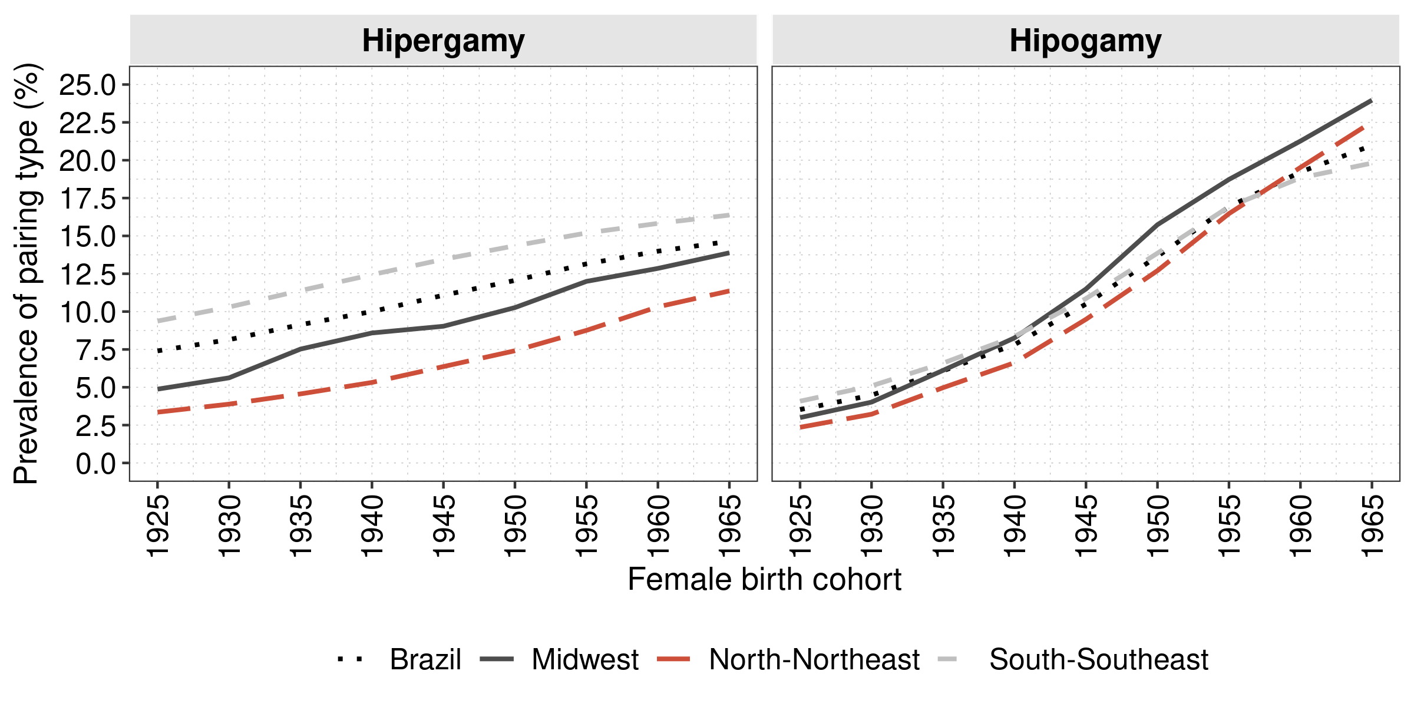
Figure 2. Prevalence rates of homogamic educational pairings composition for female birth cohorts grouped in five-year intervals for Brazil and regions. Source: Brazilian national censuses 1970, 1980, 1991, 2000, 2010. 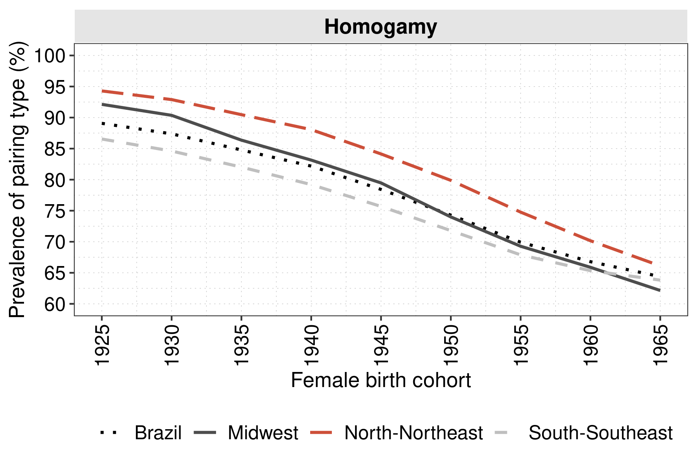

4.2 Educational pairings cohort fertility trends in Brazil
We now turn our attention to analyze cohort fertility trends of educational pairings, following the CFRs of five-year grouped female cohorts for Brazil (Figure 3). Each panel of Figure 3 presents the variation between male educational categories for each fixed female educational attainment level. CFR estimates are also shown for all females and for all females in union by educational attainment level. Graphical results for the three regions of the country are presented in the appendix B.
We observed significant reductions in CFR for women from all educational groups. The decline was steeper among females without complete primary education - from around 5.5 and 6 for 1925-1929 female cohorts to around 3 for 1965-1969 cohorts.
For the country, we observed marked fertility differentials for both male and female partners. For older female born cohorts, couples with at least one partner without complete primary school presented higher fertility levels than other pairings. We speculate that male partners’ low educational levels could have limited the pace of the fertility transition in Brazil. On the other hand, higher female educational attainment seems less affected by males’ educational category, since education increases bargaining power and autonomy of women in family decision making (Jejeebhoy 1995). Therefore, high schooled women have reproductive profiles less attached to their husband’s educational characteristics and more related to females own socioeconomic status and perceived opportunity costs of reproduction (Becker 1993).
Figure 3. Educational pairings cohort fertility trends for female birth cohorts grouped in five-year intervals for Brazil. Source: Brazilian national censuses 1970, 1980, 1991, 2000, 2010. 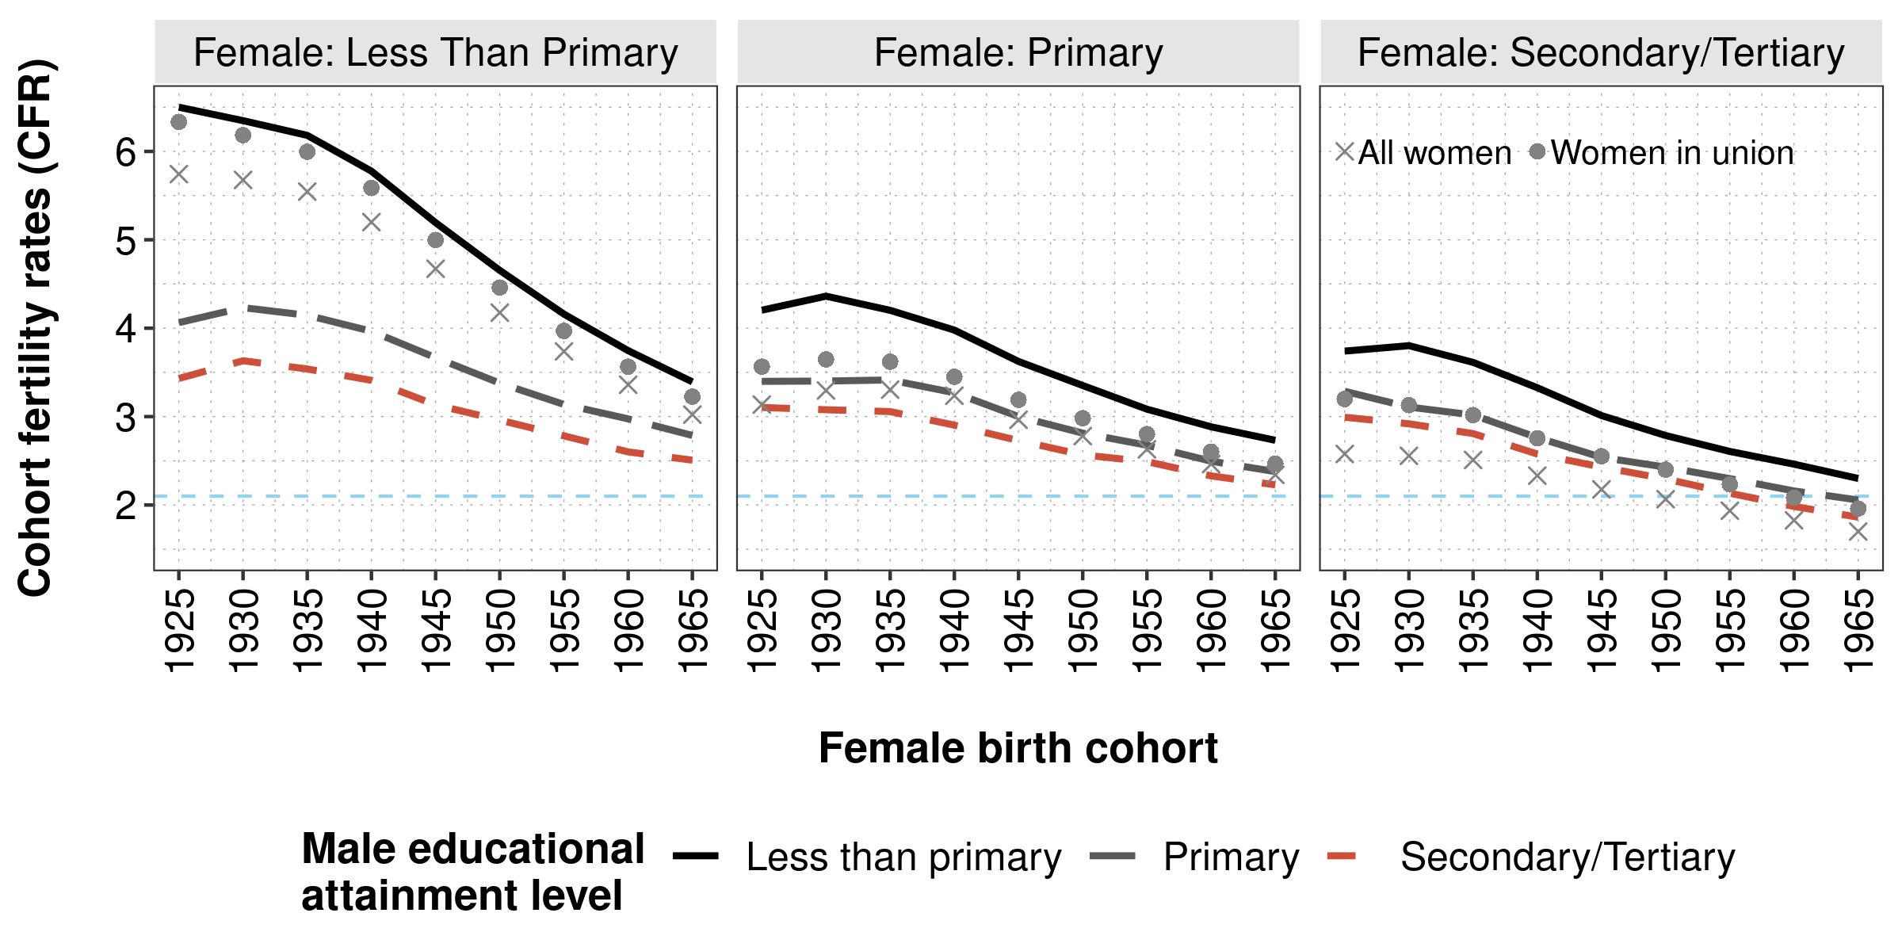 Next, we will decompose the differences in CFR between older and younger cohorts to compute the share of structure effects of educational pairings composition and the share of rate effects. Hence,

4.2 Decomposition of cohort fertility rates
Table 1 present the prevalence rates of each educational pairing and the estimated CFR for female cohorts born in 1925-39, 1940-54 and 1955-69 for Brazil. Results for the three selected regions are presented in the appendix B.

Table 1: Educational pairings prevalence rates and cohort fertility rates for female cohorts born in 1925-39, 1940-54 and 1955-69 - Brazil. Source: Brazilian National Censuses, 1970, 1980, 1991, 2000, 2010.
Education |  | Prevalence (%) |  |  | CFR
Female | Male | 1925-1939 | 1940-1954 | 1955-1969 | 1925-1939 | 1940-1954 | 1955-1969
LP | LP | 80.87 | 62.17 | 36.59 | 6.84 | 5.52 | 3.87
LP | P | 4.01 | 5.47 | 6.65 | 4.61 | 3.85 | 2.99
LP | S | 1.70 | 2.22 | 2.28 | 4.13 | 3.47 | 2.67
LP | T | 0.56 | 0.48 | 0.26 | 3.91 | 3.28 | 2.47
P | LP | 2.34 | 5.08 | 8.60 | 4.68 | 3.76 | 2.91
P | P | 1.95 | 4.22 | 9.57 | 3.85 | 3.12 | 2.51
P | S | 1.18 | 2.17 | 4.02 | 3.64 | 2.95 | 2.38
P | T | 0.84 | 0.86 | 0.77 | 3.45 | 2.85 | 2.22
S | LP | 1.20 | 2.56 | 3.76 | 4.31 | 3.25 | 2.50
S | P | 0.82 | 1.92 | 4.46 | 3.54 | 2.76 | 2.20
S | S | 1.49 | 4.06 | 9.15 | 3.39 | 2.64 | 2.09
S | T | 1.43 | 2.60 | 2.97 | 3.54 | 2.69 | 2.06
T | LP | 0.21 | 0.59 | 0.79 | 3.71 | 2.67 | 2.23
T | P | 0.19 | 0.67 | 1.31 | 3.07 | 2.42 | 1.98
T | S | 0.33 | 1.50 | 3.21 | 3.18 | 2.36 | 1.86
T | T | 0.88 | 3.45 | 5.60 | 3.29 | 2.45 | 1.86

As already seen, we verify that educational homogamy reduced its share in all regions of the country. The reasons are linked to decreases in prevalence rates of $LP_{male}$-$LP_{female}$ educational pairings. For women born in 1925-39, approximately 81% were from the lowest schooling level and married with males from this same educational level. This number declined to 37% for females from 1955-69 birth cohorts, as an effect of compositional changes in population’s education (Fígoli 2006). On the other hand, educational homogamy has increased among couples with complete secondary education, from less than 5% in 1925-39 cohorts to 21% in 1955-69 birth cohorts. Therefore, educational pairings in the country dispersed among higher education categories as the educational expansion was taking place.

Figure 4 presents the results of the decomposition between CFR observed for older and younger cohorts. overall CFR for these three cohorts for each region and also the results of the decomposition exercises. Brazilian couple’s estimated CFR dropped from 5.79 for 1925-1939 female cohorts to 2.95 for women born in 1955-1969. The highest decrease was observed in North-Northeast regions, which we observe an expressive reduction in CFR across female birth cohorts, from 7.45 to 3.83. Yet, they started their fertility transition process from higher levels and later than other areas, hence, they still presented the highest CFR for younger cohorts - 3.83 children/women estimated for 1955-1969 cohorts compared to 2.87 for Midwest and 2.56 for South-Southeast regions (see Figures C1, C2 and C3 in appendix C for regional decomposition results).
Figure 4: Decomposition of CFR in Rate and and Educational Pairing Structure effects for female birth cohorts born in 1925-39, 1940-54, 1955-69 - Brazil. Source: Brazilian National Censuses, 1970, 1980, 1991, 2000, 2010. 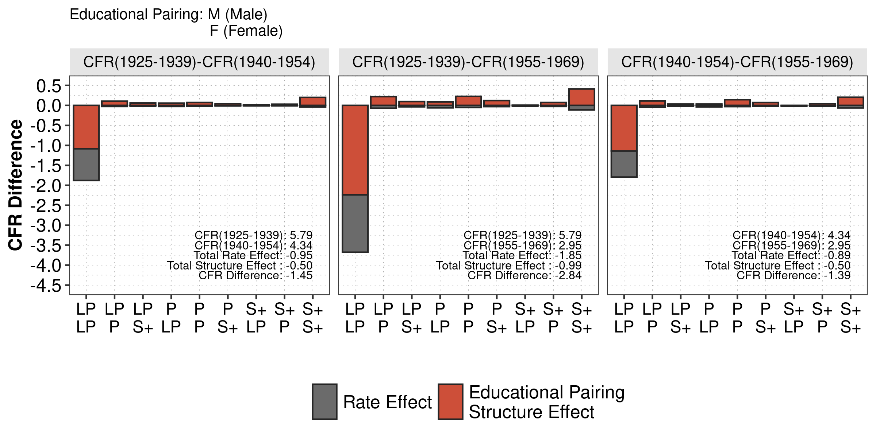 In general, for Brazil and its regions, most of the reduction of conjugal CFR was driven by the rate effect (between 66 and 70% of CFR differences). The remaining share of CFR decline between older and younger cohorts is attributed to the educational pairing composition change. In this sense, the cohort fertility decline in Brazil was associated with structural changes in conjugal markets pushed by educational expansion efforts of the country that increased levels of schooling for men and women.
This structural effects of educational pairing changes are to great extent explained by the reduction of homogamous couples without complete primary education. Between 1955-1969 and 1925-1939 cohorts, the change in prevalence rates of LP-LP couples accounted for 2 out of the 2.44 observed difference in CFR. Also, the rate effect for LP-LP couples was approximately 1.5, which indicates significant declines of CFR within the lower educated couples.

5. Discussion and conclusions
Cohort fertility rates display educational pairing differentials between male and female educational categories. In particular, the couples composed by parents with low education, they present the highest cohort fertility levels, especially for older female cohorts. These CFRs’ values diminished along female cohorts and between males’ educational categories, even controlling for the female’s educational levels. Thus, we observed significant evidence that the male partner’s education effects on fertility are not negligible, and it influenced the general reduction of cohort fertility levels of the country.
In addition, these fertility differentials among educational categories of men and women diminishes among young female cohorts. We argue that this converging fertility trend is a result of multiple factors. First, the reduction of illiteracy (Fígoli 2006) itself plays a key role in reproductive control adoption (Castro-Martin and Juarez 1995; Perpétuo and Wajnman 1998; Perpétuo and Wong 2009), however, it does not necessarily result in individuals finishing primary school. Second, unexpected effects of institutional reforms of the Brazilian state, between 1970-1990 decades, fostered changes in social and cultural norms of the Brazilian society, which in turn increased female autonomy in family planning (Faria 1989, 1997; Martine 1996). This transformations in Brazilian society were related to the development of a communications system infrastructure, which connected distant regions of the country and contributed for the diffusion of higher social strata reproductive behavior through soap operas (Faria and Potter 1999; La Ferrara, Chong, and Duryea 2012), and to the medicalization of female population, which led to higher adoption of contraceptive methods, even by the most vulnerable social groups (Faria 1997; Martine 1996; Perpétuo and Wajnman 1998; Perpétuo and Wong 2009).
The regional disparities we observed follows the historical patterns of socioeconomic inequalities. North-Northeast regions showed the highest CFR levels among all educational pairings. For instance, they also presented higher and steady differentials among educational pairings, even for higher educated women. We speculate that female reproductive autonomy in these regions are lower or they present lower opportunity costs to reproductive control (Becker 1993; Jejeebhoy 1995), and thus, the partner’s education acts as an important driver of fertility control inside the family by a higher involvement of educated males in family planning decisions (Oliveira, Bilac, and Muszkat 2002). Furthermore, the converging trends of fertility levels of pairings with lower educated males is weaker in these areas. A possible explanation is that these regions were not completely integrated to the new urban-industrial economy that was established in São Paulo, due to their export-agricultural roots and ruling local elites (Merrick and Graham 1981; Singer 1973). In this sense, we observe lower formal labor market engagement of women in these areas (Barbosa 2014; Gonçalves, Perez, and Wajnman 2004), which resulted in lower social constraints to reproduction (Patarra and Oliveira 1988). We may say that the North and Northeast were under influence of a patriarchal family model (Aguiar 2000), characterized by lower participation of women in the public sphere of society and lower autonomy in family planning decisions, consequently resulting in higher fertility levels (Becker 1993; Folbre 1994).
On the other hand, Southern regions exhibited the lowest CFR levels and the lowest differentials among educational pairings for all cohorts. The differences between educational pairings CFRs were even smaller for couples with higher educated females, which converged faster towards replacement fertility levels. This seems to be a result of school expansion (reduction of illiteracy) and faster transition of economy to the urban-industrial model, centered in the São Paulo area, which demanded more educated labor force and female participation in the labor market (Romanelli 1986; Singer 1973). As these processes took off in São Paulo state, these areas of the country were the first ones to experience fertility decline due to new rising social norms of urban centers (Gonçalves et al. 2019; Guzmán and Rodríguez 1993). Additionally, for the lower educational level groups, the years of schooling range from 0 to 8. Since Southern areas present the lowest illiteracy rates of the country for older cohorts (Castro 1998), the lower CFR levels are reflected in higher literacy rates in these regions. Finally, younger female cohorts with complete secondary school show below replacement fertility levels, independently of the partner’s educational level, once more supporting the argument that education favors female reproductive autonomy (Jejeebhoy 1995).
In addition, the educational pairing composition changed significantly through cohorts. Homogamy was high in the past, because of the overall lower levels of education of the population (Esteve and McCaa 2007; Ribeiro and Silva 2009). Additionally, as women benefited the most from educational expansion (Beltrão and Alves 2009), Brazil observed considerable compositional changes in population education levels (Fígoli 2006), and the prevalence of hypogamic couples rose significantly over the period as hypergamy showed a steady decline (Esteve et al. 2016). As a consequence, the disparities in terms of educational pairing among Northern and Southern regions kept marked. The Southern area was a forerunner of the educational expansion in the country, because it experienced first the industrialization process of Brazil (Komatsu et al. 2017; Romanelli 1986). The industrial labor market was male-dominated (Teixeira 2014) and it required technical skills achieved through professional education (Romanelli 1986). Hence, the highly educated male population of the Southern regions resulted in the later process of hypogamy increase.
The slow pace of decreasing low education homogamic couples, common in the North-Northeast regions, was the result of a belated educational expansion. However, these areas also displayed a faster transition towards hypogamy than others. In these regions, there was a lower market demand for schooling of the usually male workers in the primary industrial sector who, due to income inequalities, had few alternatives rather than working in the informal lower paid markets (Merrick and Graham 1981; Romanelli 1986; Wood and Carvalho 1988). On the other hand, women had easier access to schooling, since they usually performed household or professional activities that were more compatible with formal education, such as teacher formation schools (Azevedo and Ferreira 2006; Guedes 2015).
In a decomposition exercise, we estimated that 30% of the cohort fertility decline between forerunners of fertility transition cohorts (female cohorts born in 1925-39) and medium-low fertility cohorts (female cohorts born in 1955-69) were a result of changes in educational pairing composition. For this reason, we argue that educational attainment contributes for both males and females attitudes towards family planning and fertility control. In this sense, male’s educational attainment also contributes for fertility reduction, since higher education means more commitment of men to household activities (Esping-Andersen 2009; McDonald 2000), and this lowers in turn constraints to female reproduction and promotes the fulfillment of fertility intentions (Folbre 1994). In regions where the education expansion of males lagged in relation to others (as example the North-Northeastern parts of the country), the fertility transition was slower and females reproductive autonomy was also weaker, due to cultural aspects and prevailing patriarchal social norms of the region in the past (Aguiar 2000; Folbre 1983). In sum, we may say that the slower educational expansion for men in the less developed areas of the country might have delayed the fertility transition in the country, especially in locations where men lagged in educational attainment levels in relation to women.
It is important to mention that the lack of information of union histories lead to the main limitation of our analysis: all children reported by women are linked to current unions’ partners. Also, CFRs are likely to be underestimated due to differential mortality among educational categories (Silva, Freire, and Pereira 2016). Yet, this work brings major contributions to Brazilian fertility analysis and provides important insights on men’s role in the fertility transition process. First of all, the use of a cohort approach is novel in demographic analysis of the country. In addition, we address male’s educational characteristics within couples and we take into account the regional differences in terms of educational expansion and economic development. We expect this paper foments new studies on male’s role in reproductive intentions and behavior of Brazilian families.

References
Adserà, A. (2018). The future fertility of highly educated women: the role of educational composition shifts and labor market barriers. Vienna Yearbook of Population Research 15(1):19–25.
Aguiar, N. (2000). Patriarcado, sociedade e patrimonialismo. Sociedade e Estado 15:303–330.
Alves, J.E.D. (1994). Transição da fecundidade e relações de gênero no Brasil. [PhD thesis]. Belo Horizonte: Centro de Desenvolvimento e Planejamento Regional, Universidade Federal de Minas Gerais.

Azevedo, N. and Ferreira, L.O. (2006). Modernização, políticas públicas e sistema de gênero no Brasil: educação e profissionalização feminina entre as décadas de 1920 e 1940. Cadernos Pagu 27:213–254.
Baeninger, R. (2012). Rotatividade migratórria: um novo olhar para as migrações internas no Brasil. REMHU: Revista Interdisciplinar da Mobilidade Humana 20:77–100.
Barbosa, A.L.N.H. (2014). Participação Feminina no Mercado de Trabalho Brasileiro. IPEA, Instituto de Pesquisa Econômica Aplicada.: pages.
Barros, R.P. and Mendonça, R.S.P. (1995). Os Determinantes da desigualdade no Brasil. IPEA, Instituto de Pesquisa Econômica Aplicada.: pages.
Becker, G. (1993). A treatise on the family. Cambridge, Massachusetts: Harvard University Press.
Beltrão, K.I. and Alves, J.E.D. (2009). A reversão do hiato de gênero na educação Brasileira no século XX. Cadernos de Pesquisa 39(136):125–156.
Berquó, E. and Cavenaghi, S.M. (2014). Notas sobre os diferenciais educacionais e econômicos da fecundidade no Brasil. Revista Brasileira de Estudos de População 31(2):471–482.
Besse, S.K. (1999). Modernizando a desigualdade: reestruturação da ideologia de gênero no Brasil, 1914-1940. São Paulo: Edusp.
Blau, P.M. and Schwartz, J.E. (1997). Crosscutting Social Circles. New York: Routledge.

Brass, W., Coale, A.J., Demeny, P., Heisel, D.F., Lorimer, F., Romaniuk, A., and Walle, E.V.D. (1968). Demography of Tropical Africa. Princeton University Press.

Camarano, A.A. (2014). Novo Regime Demográfico: uma nova relação entre população e desenvolvimento? Rio de Janeiro, Brasil: IPEA, Instituto de Pesquisa Econômica e Aplicada.
Carvalho, J.A.M. and Brito, F. (2005). A demografia Brasileira e o declínio da fecundidade no Brasil: contribuições, equívocos e silêncios. Revista Brasileira de Estudos de População 22(2):351–369.
Carvalho, J.A.M. and Wong, L.R. (1992). La transición de la fecundidad en Brasil: causas y consecuencias. Notas de Población.
Castanheira, H.C. and Kohler, H.P. (2015). It is Lower Than You Think it is: Recent Total Fertility Rates in Brazil and Possibly Other Latin American Countries. PSC Working PaperSeries(63).
Castanheira, H.C. and Kohler, H.-P. (2017). Social Determinants of Low Fertility in Brazil. Journal of Biosocial Science 49(S1):S131–S155.
Castro, M.H.G. (1998). Avaliação do sistema educacional Brasileiro: tendências e perspectivas. Instituto Nacional de Estudos e Pesquisas Educacionais (INEP).: pages.
Castro-Martin, T. and Juarez, F. (1995). The Impact of Women’s Education on Fertility in Latin America: Searching for Explanations. International Family Planning Perspectives 2(21):52–57.

Cleland, J. and Wilson, C. (1987). Demand Theories of the Fertility Transition: An Iconoclastic View. Population Studies 41(1):5–30.
Das Gupta, P. (1993). Standardization and Decomposition of Rates: A User’s Manual. United States Census Bureau.: pages. https://www.census.gov/library/publications/1993/demo/p23-186.html.
Eckland, B.K. (1968). Theories of mate selection. Eugenics Quarterly 15(2):71–84.
England, P. (2010). The Gender Revolution: Uneven and Stalled. Gender and Society 24(2):149–166.
Esping-Andersen, G. (2009). Incomplete Revolution: Adapting Welfare States to Women’s New Roles. Cambridge: Polity Press.
Esteve, A., Garcia-Román, J., and Permanyer, I. (2012). The gender-gap reversal in education and its effect on union formation: The end of hypergamy? Population and Development Review 3(38):535–546.
Esteve, A. and McCaa, R. (2007). Homogamia educacional en México y Brasil, 1970-2000: Pautas y tendencias. Latin American Research Review 42(2):56–85.
Esteve, A., Schwartz, C.R., Val Bavel, J., Permanyer, I., Klesment, M., and García-Román, J. (2016). The End of Hypergamy: Global Trends and Implications. Population and Development Review 42(4):615–625.
Esteve, A. and Sobek, M. (2003). Challenges and Methods of International Census Harmonization. Historical Methods: A Journal of Quantitative and Interdisciplinary History 36(2):66–79.
Faria, V.E. (1989). Políticas de governo e regulação da fecundidade: Consequências não antecipadas e efeitos perversos. Ciências Sociais Hoje(5):62–103.
Faria, V.E. (1997). Government policy and fertility regulation: unintended consequences and perverse effects. Revista Brasileira de Estudos de População(1):179–205.
Faria, V.E. and Potter, J.E. (1999). Television, Telenovelas, and Fertility change in North-East Brazil. In: Leete, R. (ed.). Dynamics of Values in Fertility Change. Oxford: Oxford University Press.
Fígoli, M.G.B. (2006). Evolução da educação no Brasil: uma análise das taxas entre 1970 e 2000 segundo o grau da última série concluída. Revista Brasileira de Estudos de População 23(1):129–150.
Folbre, N. (1983). Of Patriarchy Born: The Political Economy of Fertility Decisions. Feminist Studies 9(2):261–284.
Folbre, N. (1994). Who Pays for the Kids? Gender and the Structures of Constraint. New York: Routledge.
Godinho, T., Ristoff, D., Fontes, Â., Xavier, I.M., and Sampaio, C.E.M. (2006). Trajetória da Mulher na Educação Brasileira, 1996-2003. Brasília: Inep/MEC – Instituto Nacional de Estudos e Pesquisas Educacionais Anísio Teixeira.
Goldin, C. (2006). The Quiet Revolution That Transformed Women’s Employment, Education, and Family. American Economic Review 96(2):1–21.
Goldin, C. and Katz, L.F. (2002). The power of the pill: Oral contraceptives and women’s career and marriage decisions. Journal of Political Economy 110(4):730–770.
Goldscheider, F., Bernhardt, E., and Lappegård, T. (2015). The Gender Revolution: A Framework for Understanding Changing Family and Demographic Behavior. Population and Development Review 41(2):207–239.
Goldscheider, F.K. and Kaufman, G. (1996). Fertility and Commitment: Bringing Men Back In. Population and Development Review 22:87–99.
Gonçalves, G.Q., Carvalho, J.A.M., Wong, L.L.R., and Turra, C.M. (2019). A transição da fecundidade no Brasil ao longo do século XX – uma perspectiva regional. Revista Brasileira de Estudos de População 36.
Gonçalves, M., Perez, E., and Wajnman, S. (2004). Taxas de participação (formal e informal) feminina no mercado de trabalho das regiões Sudeste e Nordeste: uma análise a partir das PNADs 1992-2002. In: XIV Encontro Nacional de Estudos Populacionais. Caxambu.
Guedes, M.C. (2015). Heterogeneização da mão-de-obra feminina: o que mudou no período recente? Gênero 15(2):139–154.
Guzmán, J.M. and Rodríguez, J. (1993). La Fecundidad Pre-Transicional en América Latina: Un Capítulo Olvidado. Notas de Población(57):217–235.
IBGE (2014). Estatísticas do Registro Civil. Instituto Brasileiro de Geografia e Estatística.: pages.
Itaboraí, N.R. (2015). Mudanças nas famílias Brasileiras (1976-2012): uma perspectiva de classe e gênero. [PhD thesis]. Rio de Janeiro: Instituto de Estudos Sociais e Políticos, Universidade do Estado do Rio de Janeiro.
Itaboraí, N.R. (2016). Temporalidades plurais: desigualdades de gênero e classe nos usos do tempo das famílias Brasileiras. In: Fontoura, N. and Araújo, C. (eds.). Uso Do Tempo E Gênero. Rio de Janeiro: UERJ, Universidade do Estado do Rio de Janeiro: 101–138.
Jejeebhoy, S. (1995). Women’s Education, Autonomy, and Reproductive Behaviour: Experience from Developing Countries. Oxford: Clarendon Press.
Kalmijn, M. (1998). Intermarriage and Homogamy: Causes, Patterns, Trends. Annual Review of Sociology 24(1):395–421.
Kang, T.H. (2006). Educação para as elites, financiamento e ensino primário no Brasil, 1930–1964. Latin American Research Review 1(52):35–49. doi:https://doi.org/10.25222/larr.42.
Kang, T.H. (2011). Descentralização e financiamento da educação brasileira: uma análise comparativa, 1930-1964. Estudos Econômicos (São Paulo) 41(3):573–598. http://www.scielo.br/scielo.php?script=sci_arttext&pid=S0101-41612011000300004&nrm=iso.
Kitagawa, E.M. (1955). Components of a difference between two rates. Journal of the American Statistical Associatio 50:1168–1194. doi:https://doi.org/10.2307/2281213.
Komatsu, B., Menezes-Filho, N., Oliveira, P., and Viotti, L. (2017). A História da Educação e as Origens da Desigualdade Regional no Brasil. Insper (Instituto de Ensino e Pesquisa) - Centro de Políticas Públicas (CPP).: pages.
La Ferrara, E., Chong, A., and Duryea, S. (2012). Soap Operas and Fertility: Evidence from Brazil. American Economic Journal: Applied Economics 4(4):1–31.
Lam, D., Sedlacek, G., and Duryea, S. (1992). Increase in women´s education and fertility decline in Brazil. Anais do VIII Encontro Nacional de Estudos Populacionais 1.
Laplante, B., Castro-Martin, T., Cortina, C., and Martin-Garcia, T. (2015). Childbearing within Marriage and Consensual Union in Latin America, 1980–2010. Population and Development Review 1(41):85–108.
Lima, E.E.C., Zeman, K., Sobotka, T., Nathan, M., and Castro, R. (2018). The Emergence of Bimodal Fertility Profiles in Latin America. Population and Development Review 44(4):723–743.
Lutz, W. (2010). Education will be at the heart of 21st century demography. Vienna Yearbook of Population Research(8):8–16.
Maluf, M. and Mott, M.L. (1998). Recônditos do mundo feminino. In: Novais, F. A. (ed.). História da Vida Privada no Brasil, 3: República: da belle époque à era do rádio. São Paulo: Companhia das Letras: 367–421.
Marcílio, M.L. (2014). História da Escola em São Paulo e no Brasil. São Paulo: Instituto Fernand Braudel de Economia Mundial.
Mare, R.D. (1991). Five Decades of Educational Assortative Mating. American Sociological Review 56(1):15–32.
Martine, G. (1996). Brazil’s Fertility Decline, 1965-95: A Fresh Look at Key Factors. Population and Development Review 22(1):47–75.
McDonald, P. (2000). Gender Equity in Theories of Fertility Transition. Population and Development Review 26(3):427–439.
Merrick, T. and Berquó, E. (1983). The determinants of Brazil´s recent rapid decline in fertility. Washington: National Academy.
Merrick, T.W. and Graham, D.H. (1981). População e Desenvolvimento Econômico no Brasil de 1800 até a atualidade. Rio de Janeiro: Zahar.
Minnesota Population Center (2019). Integrated Public Use Microdata Series, International: Version 7.2 [dataset]. Minneapolis, MN: IPUMS. doi:doi.org/10.18128/D020.V7.2.
Monteiro da Silva, J.H.C. (2019). Fertility and educational pairing in Brazil: a cohort analysis. [Master’s thesis]. Campinas: Institute of Philosophy; the Humanities, University of Campinas. http://repositorio.unicamp.br/jspui/bitstream/REPOSIP/333826/1/Silva_JoseHenriqueCostaMonteiroDa_M.pdf.
Moultrie, T., Dorrington, R., Hill, A., Hill, K., Timæus, I., and Zaba, B. (2013). Tools for Demographic Estimation. Paris: International Union for the Scientific Study of Population (IUSSP).
Myrskylä, M., Kohler, H.-P., and Billari, F.C. (2011). High development and fertility: fertility at older reproductive ages and gender equality explain the positive link. Max Planck Institute for Demographic Research, Rostock, Germany.: pages.
Neels, K., Murphy, M., Bhrolcháin, M.N., and Beaujouan, É. (2017). Rising educational participation and the trend to later childbearing. Population and Development Review 43(4):667–693.
Nepomuceno, M.R. and Turra, C.M. (2020). Assessing the quality of education reporting in brazilian censuses. Demographic Research 42(15):441–460.
Nitsche, N., Matysiak, A., Van Bavel, J., and Vignoli, D. (2018). Partners’ Educational Pairings and Fertility Across Europe. Demography 55(4):1195–1232.
Oliveira, M.C.F.A. (1989). Trabalho, família e condição feminina: considerações sobre a demanda por filhos. Revista Brasileira de Estudos de População 6(1):25–33.
Oliveira, M.C.F.A., Bilac, E.D., and Muszkat, M. (1994). Os Homens, esses desconhecidos... Revista Brasileira de Estudos de População 11(1):89–93.
Oliveira, M.C.F.A., Bilac, E., and Muszkat, M. (2002). Homens e anticoncepção: duas gerações de camadas médias no Brasil. Cahiers des Amériques Latines 39:59–82.
Paiva, P.T.A. (1987). O processo de proletarização e a transição da fecundidade no Brasil. Revista Brasileira de Economia 41(4):383–414.
Patarra, N.L. and Oliveira, M.C.F.A. (1988). Transição, transições. In: VI Encontro Nacional de Estudos Populacionais. Olinda, Pernambuco.
Perpétuo, I.H.O. and Wajnman, S. (1998). Socioeconomic correlates of female sterilization in Brazil. In: CICRED-Isunam Seminar on Poverty, Fertility and Family Planning. Mexico City, Mexico.
Perpétuo, I.H.O. and Wong, L.R. (2009). Desigualdade socioeconômica na utilização de métodos anticoncepcionais no Brasil: uma análise comparativa com base nas PNDS 1996 e 2006. In: CEBRAP (ed.). Pesquisa Nacional de Demografia E Saúde Da Criança E Da Mulher – Pnds 2006: Dimensões Do Processo Reprodutivo E Da Saúde Da Criança. Brasília: Ministério da Saúde: 85–104.
Potter, J.E., Schmertmann, C.P., Assunção, R.M., and Cavenaghi, S.M. (2010). Mapping the Timing, Pace, and Scale of the Fertility Transition in Brazil. Population and Development Review 36(2):283–307.
Potter, J.E., Schmertmann, C.P., and Cavenaghi, S. (2002). Fertility and Development: Evidence from Brazil. Demography 4(39):739–761.
Ribeiro, C.A.C. and Silva, N.V. (2009). Cor, educação e casamento: tendências da seletividade marital no Brasil, 1960 a 2000. Dados - Revista de Ciências Sociais 52:7–51.
Rios-Neto, E.L.G., Miranda-Ribeiro, A., and Miranda-Ribeiro, P. (2018). Fertility Differentials by Education in Brazil: From the Conclusion of Fertility to the Onset of Postponement Transition. Population and Development Review 44(3):489–517.
Romanelli, O.O. (1986). História Da Educação No Brasil (1930/1970). Petrópolis: Editora Vozes.
Rosero-Bixby, L., Castro-Martin, T., and Martin-Garcia, T. (2009). Is Latin America starting to retreat from early and universal childbearing? Demographic Research(20):169–194.
Schoumaker, B. (2019). Male fertility around the world and over time: How different is it from female fertility? Population and Development Review 45(3):459–487. doi:10.1111/padr.12273.
Scorzafave, L.G. and Menezes-Filho, N.A. (2001). Participação feminina no mercado de trabalho Brasileiro: evolução e determinantes. Pesquisa e Planejamento Econômico 31(3).
Silva, L.E. da, Freire, F.H.M. de A., and Pereira, R.H.M. (2016). Diferenciais de mortalidade por escolaridade da população adulta brasileira, em 2010. Cadernos de Saúde Pública 32.
Singer, P. (1973). Economia Política da Urbanização. São Paulo: Editora Brasiliense.
Sobotka, T. (2004). Is Lowest-Low Fertility in Europe Explained by the Postponement of Childbearing? Population and Development Review 30(2):195–220.
Teixeira, M.O. (2014). Formalização do emprego e permanência das desigualdades de gênero. Brasil: FES, Fundação Friedrich Ebert.: pages.
Thomson, E. (1997). Couple childbearing desires, intentions, and births. Demography 34(3):343–354.
Torche, F. (2010). Educational assortative mating and economic inequality: A comparative analysis of three latin american countries. Demography 47(2):481–502.
Van Bavel, J. (2017). What do men want? The growing importance of men’s characteristics for fertility. Vienna Yearbook of Population Research 15:41–47.
Van Bavel, J., Schwartz, C.R., and Esteve, A. (2018). The Reversal of the Gender Gap in Education and its Consequences for Family Life. Annual Review of Sociology 44(1):null.
Vieira, J.M. (2016). Diferenciales en la fecundidad Brasileña según la naturaleza de la unión: algunas reflexiones sobre decisiones reproductivas y convivencia. Notas de Población(102):67–94.
Vieira, J.M. and Alves, L.C. (2016). O comportamento da idade média à união e ao casamento no Brasil em 2000 e 2010. Revista Latinoamericana de Población(19):107–126.
Warren, B.L. (1966). A multiple variable approach to the assortative mating phenomenon. Eugenics Quarterly 13(4):285–290.
Wong, L.L.R. and Carvalho, J.A.M. (2006). O rápido processo de envelhecimento populacional do Brasil: sérios desafios para as políticas públicas. Revista Brasileira de Estudos de População 23(1):5–26.
Wood, C.H. and Carvalho, J.A.M. (1988). The Demography of Inequality in Brazil. Cambridge: Cambridge University Press.
Yoo, S.H. (2014). Educational differentials in cohort fertility during the fertility transition in South Korea. Demographic Research 30(53):1463–1494. doi:10.4054/DemRes.2014.30.53.

Appendix A
Table A1 presents the sample size of each birth cohort (1925-1969) for each census year. Previous findings have shown that by overlapping cohorts from subsequent census provide reliable information of CFR by educational strata, even though the estimates for most recent census are underestimated by differential mortality between social groups (Monteiro da Silva 2019). Therefore, we merged birth cohorts from different censuses to enhance statistical capacity and sample size.
[TABLE A1 here - sample size of each birth cohort and each census]
We did not make use of imputation for missing variables, since it was not a major issue in the evaluated censues, as can be seen in Table A2. Missing values for the educational attainment (EDATTAIN) variable represented less than 0.25 % of the sample in all census years for all regions. Missing values for marital status (MARST) were higher in 1980 census, but still represented less than 2% of the sample for that year. In regard to children ever born (CHBORN), the missing values share was higher for the North-Northeast region in the 1991 census, responding for 7.09% of the couples in the sample. For other census years, however, this value was not higher than 2%. It is important to acknowledge that for the 2000 and 2010 national censuses, all the variables presented 0% of missing variables because they were treated by the Brazilian national statistics office. Therefore, since the missing values did not account for a significant share in the composition of the five national censuses, we just excluded the observations with missing values from our analysis.
[Table A2 - missing values for Brazil and regions for variables MARST, EDATTAIN, CHBORN]
Improbable and unreliable statements on the number of children ever born were also addressed prior to the estimation of CFRs. Hence, we assumed that women can bear only one living child every 18 months, starting from age 12 (Moultrie et al. 2013). Following this rule of thumb, at the age of 15 years old, it is expected that women have no more than two children; at 20 years of age, they may have given birth to a maximum of five children, and so on. Thus, when the stated number of children ever born exceeded this threshold expected parity, for a given woman’s age, we set its value to the maximum expected number of offspring, according to the expected mother’s age, following this rule of thumb. After the application of this approach, a small share of women had their parity counts modified (Table A3). In this sense, these improbable parities does not seem to impact negatively our estimates, since they only account for 0.52% of the couples at the most, in North-Northeast for women inquired in the 1970 census.
[Table A3 - % of improbable pairings imputation]

Appendix B
In this appendix B section we present the graphical results and a brief discussion of CFR trends for the three Brazilian regions - Midwest, North-Northeast and South-Southeast.
The Midwest region (Figure B1) presented a CFR transition similar to the one observed for the whole country. In this region, male schooling displayed significant fertility differentials for older female cohorts. Younger cohorts exhibit similar CFR values for all educational categories of the partner and convergence towards population replacement levels.
Figure B1. Educational pairings cohort fertility trends for female birth cohorts grouped in five-year intervals for Midwest region, Brazil. Source: Brazilian national censuses 1970, 1980, 1991, 2000, 2010. 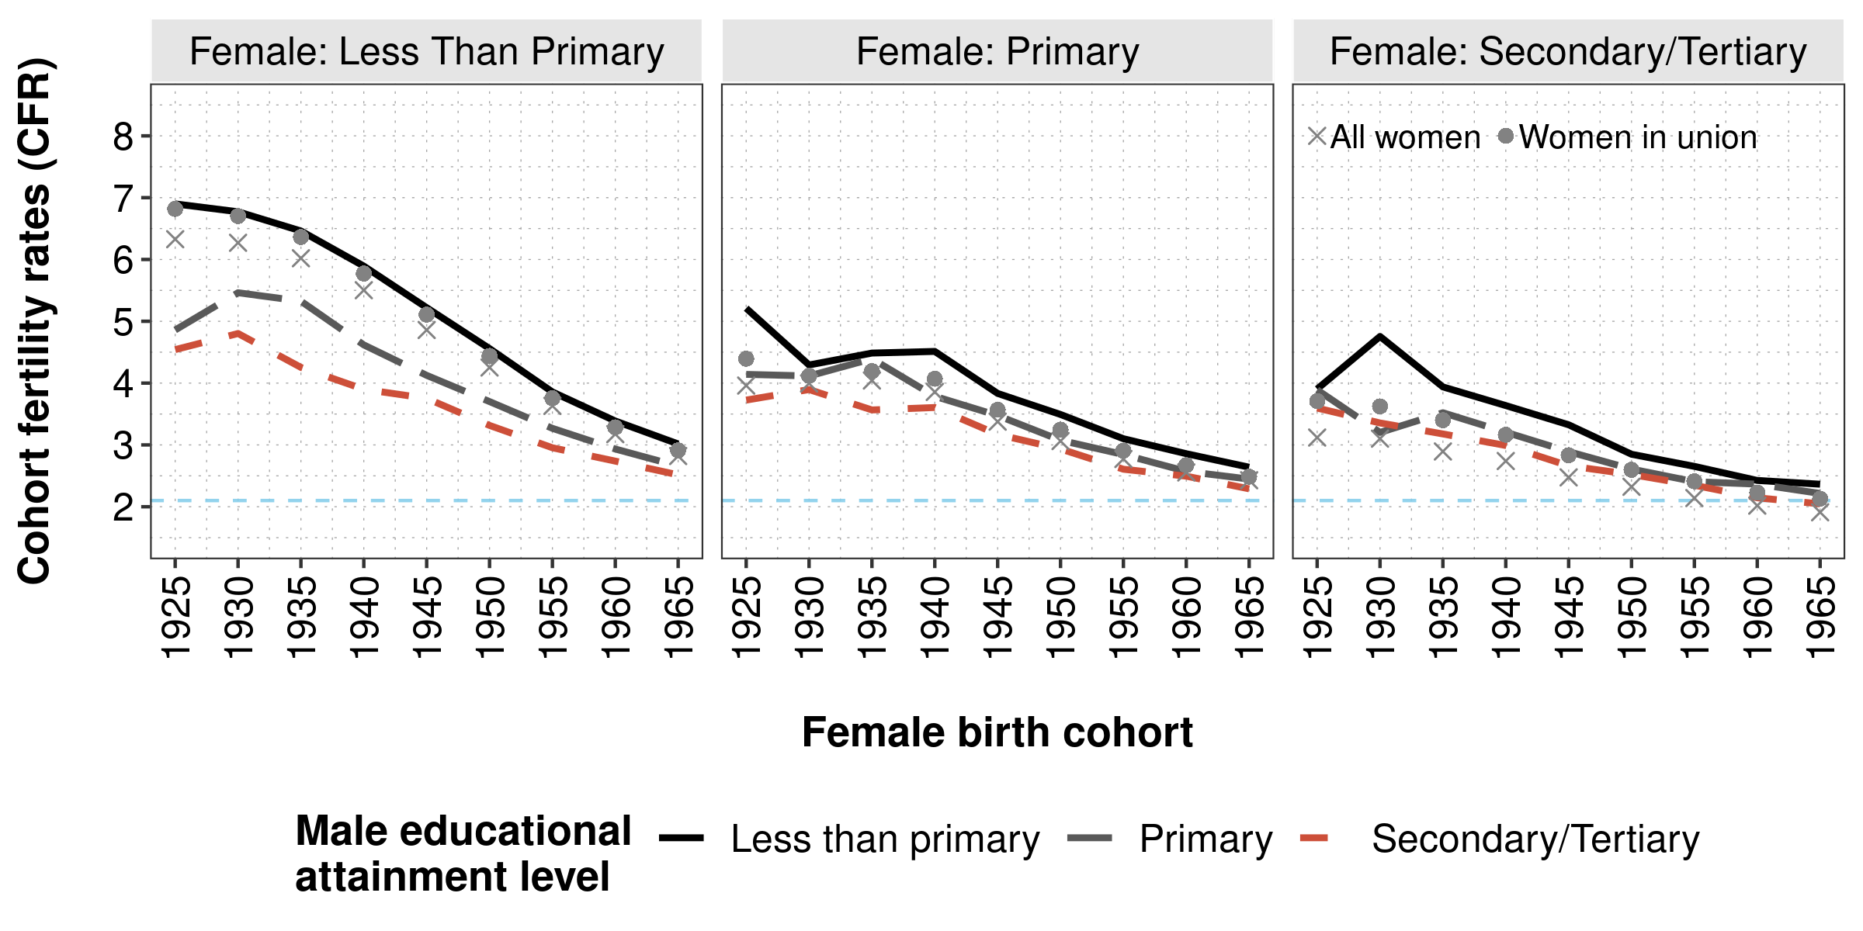
In the North and Northeast regions, cohorts started their CFR reductions from rates near to 8 children per woman for groups in the lower educational strata. In these regions, we observed important differentials between male’s educational categories, in especial between those with and without complete primary education.
Figure B2. Educational pairings cohort fertility trends for female birth cohorts grouped in five-year intervals for North-Northeast regions, Brazil. Source: Brazilian national censuses 1970, 1980, 1991, 2000, 2010. 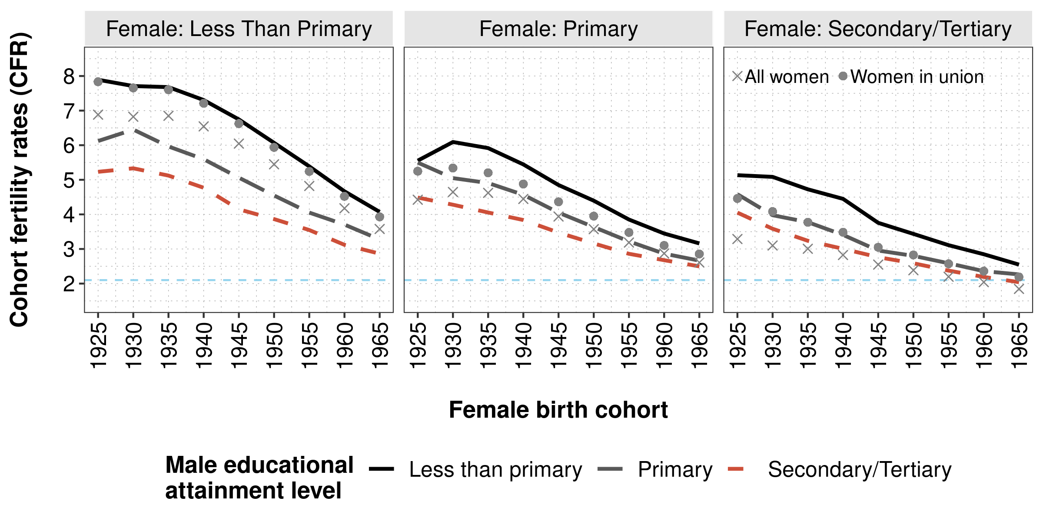
Figure B3. Educational pairings cohort fertility trends for female birth cohorts grouped in five-year intervals for South-Southeast regions, Brazil. Source: Brazilian national censuses 1970, 1980, 1991, 2000, 2010. 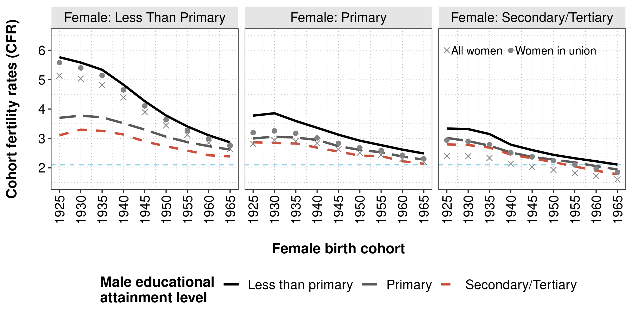
South and Southeast regions started their cohort fertility transition from lower CFR levels relative to other areas of the country. i.e. the rates show less than 6 children per woman for those with incomplete primary education. In contrast to lesser developed regions of the country, these areas exhibit lower CFR differentials between male educational categories. These areas have also shown the most marked CFR convergent trend towards replacement levels. For instance, for younger cohorts, born in 1965-1969, all couples with females without complete primary schooling reported bearing on average less than 3 children.
Table B1: Educational pairings prevalence rates and cohort fertility rates for female cohorts born in 1925-39, 1940-54 and 1955-69 - Midwest region, Brazil. Source: Brazilian National Censuses, 1970, 1980, 1991, 2000, 2010.
Education |  | Prevalence (%) |  |  | CFR
Female | Male | 1925-1939 | 1940-1954 | 1955-1969 | 1925-1939 | 1940-1954 | 1955-1969
LP | LP | 83.70 | 62.63 | 34.89 | 7.15 | 5.45 | 3.54
LP | P | 2.90 | 4.73 | 6.21 | 5.75 | 4.21 | 3.00
LP | S | 1.16 | 1.73 | 1.93 | 4.83 | 3.83 | 2.74
LP | T | 0.40 | 0.38 | 0.25 | 4.29 | 3.81 | 2.69
P | LP | 2.28 | 5.66 | 9.42 | 4.82 | 3.91 | 2.88
P | P | 1.67 | 3.91 | 9.44 | 4.52 | 3.42 | 2.61
P | S | 0.94 | 1.92 | 3.75 | 4.38 | 3.36 | 2.51
P | T | 0.81 | 0.68 | 0.77 | 3.99 | 3.12 | 2.39
S | LP | 1.11 | 2.98 | 4.41 | 4.72 | 3.38 | 2.51
S | P | 0.72 | 2.06 | 4.80 | 4.16 | 3.01 | 2.33
S | S | 1.15 | 3.84 | 8.63 | 3.94 | 2.90 | 2.26
S | T | 1.39 | 2.55 | 3.05 | 3.68 | 2.90 | 2.22
T | LP | 0.22 | 0.67 | 1.09 | 3.87 | 2.88 | 2.32
T | P | 0.21 | 0.79 | 1.63 | 2.86 | 2.68 | 2.19
T | S | 0.32 | 1.65 | 3.57 | 3.72 | 2.58 | 2.06
T | T | 1.02 | 3.82 | 6.17 | 3.35 | 2.63 | 2.08
Table B2: Educational pairings prevalence rates and cohort fertility rates for female cohorts born in 1925-39, 1940-54 and 1955-69 - North-Northeast regions, Brazil. Source: Brazilian National Censuses, 1970, 1980, 1991, 2000, 2010.
Education |  | Prevalence (%) |  |  | CFR
Female | Male | 1925-1939 | 1940-1954 | 1955-1969 | 1925-1939 | 1940-1954 | 1955-1969
LP | LP | 89.30 | 73.99 | 48.47 | 8.36 | 7.07 | 4.85
LP | P | 2.02 | 3.38 | 5.10 | 6.59 | 5.18 | 3.68
LP | S | 0.78 | 1.27 | 1.67 | 5.91 | 4.56 | 3.22
LP | T | 0.22 | 0.18 | 0.15 | 5.22 | 4.39 | 2.88
P | LP | 1.78 | 4.43 | 8.76 | 6.34 | 4.93 | 3.48
P | P | 1.02 | 2.40 | 6.61 | 5.63 | 4.11 | 2.89
P | S | 0.62 | 1.26 | 2.79 | 4.80 | 3.68 | 2.70
P | T | 0.33 | 0.31 | 0.40 | 4.33 | 3.49 | 2.42
S | LP | 1.01 | 2.79 | 4.54 | 5.51 | 4.04 | 2.86
S | P | 0.54 | 1.58 | 4.08 | 4.42 | 3.23 | 2.40
S | S | 0.87 | 3.17 | 7.96 | 4.26 | 3.01 | 2.26
S | T | 0.64 | 1.33 | 1.84 | 3.99 | 3.07 | 2.28
T | LP | 0.15 | 0.48 | 0.92 | 5.21 | 3.25 | 2.59
T | P | 0.11 | 0.44 | 1.07 | 3.78 | 2.73 | 2.24
T | S | 0.20 | 1.13 | 2.42 | 3.62 | 2.65 | 2.06
T | T | 0.40 | 1.85 | 3.23 | 3.54 | 2.78 | 2.07
Table B3: Educational pairings prevalence rates and cohort fertility rates for female cohorts born in 1925-39, 1940-54 and 1955-69 - South-Southeast regions, Brazil. Source: Brazilian National Censuses, 1970, 1980, 1991, 2000, 2010.
Education |  | Prevalence (%) |  |  | CFR
Female | Male | 1925-1939 | 1940-1954 | 1955-1969 | 1925-1939 | 1940-1954 | 1955-1969
LP | LP | 76.80 | 56.61 | 31.32 | 6.01 | 4.59 | 3.22
LP | P | 5.00 | 6.52 | 7.42 | 4.20 | 3.50 | 2.77
LP | S | 2.16 | 2.71 | 2.61 | 3.81 | 3.21 | 2.50
LP | T | 0.73 | 0.63 | 0.32 | 3.71 | 3.09 | 2.37
P | LP | 2.60 | 5.33 | 8.44 | 4.16 | 3.29 | 2.65
P | P | 2.39 | 5.10 | 10.95 | 3.47 | 2.88 | 2.40
P | S | 1.45 | 2.61 | 4.61 | 3.37 | 2.76 | 2.28
P | T | 1.07 | 1.13 | 0.94 | 3.29 | 2.75 | 2.16
S | LP | 1.30 | 2.41 | 3.32 | 3.85 | 2.81 | 2.27
S | P | 0.96 | 2.07 | 4.60 | 3.27 | 2.56 | 2.10
S | S | 1.81 | 4.49 | 9.76 | 3.17 | 2.49 | 2.00
S | T | 1.79 | 3.20 | 3.48 | 3.46 | 2.60 | 1.99
T | LP | 0.23 | 0.63 | 0.70 | 3.25 | 2.44 | 1.99
T | P | 0.23 | 0.76 | 1.39 | 2.93 | 2.31 | 1.86
T | S | 0.39 | 1.66 | 3.53 | 3.04 | 2.25 | 1.77
T | T | 1.09 | 4.16 | 6.62 | 3.24 | 2.37 | 1.79

Appendix C
Figure C1: Decomposition of CFR in Rate and and Educational Pairing Structure effects for female birth cohorts born in 1925-39, 1940-54, 1955-69 - Midwest region, Brazil. Source: Brazilian National Censuses, 1970, 1980, 1991, 2000, 2010. 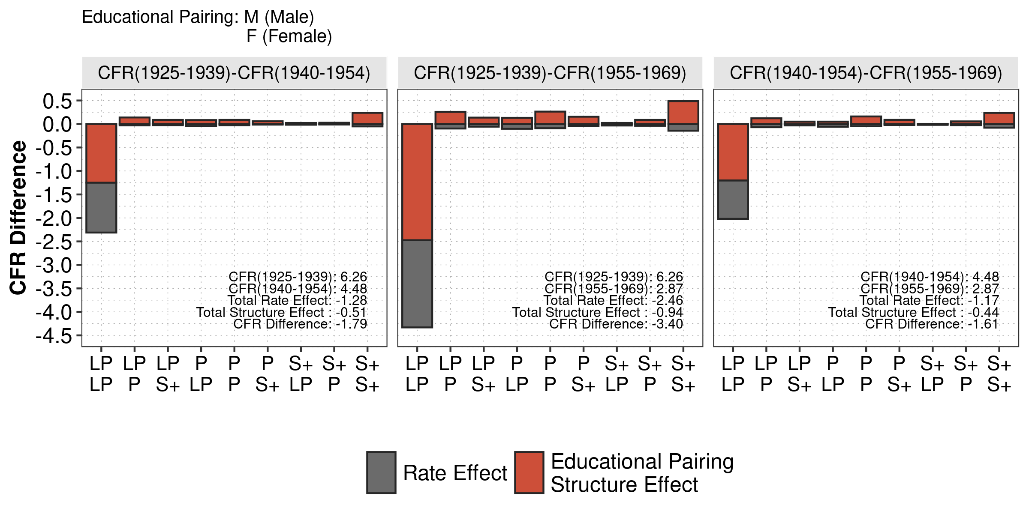
Figure C2: Decomposition of CFR in Rate and and Educational Pairing Structure effects for female birth cohorts born in 1925-39, 1940-54, 1955-69 - North-Northeast regions, Brazil. Source: Brazilian National Censuses, 1970, 1980, 1991, 2000, 2010. 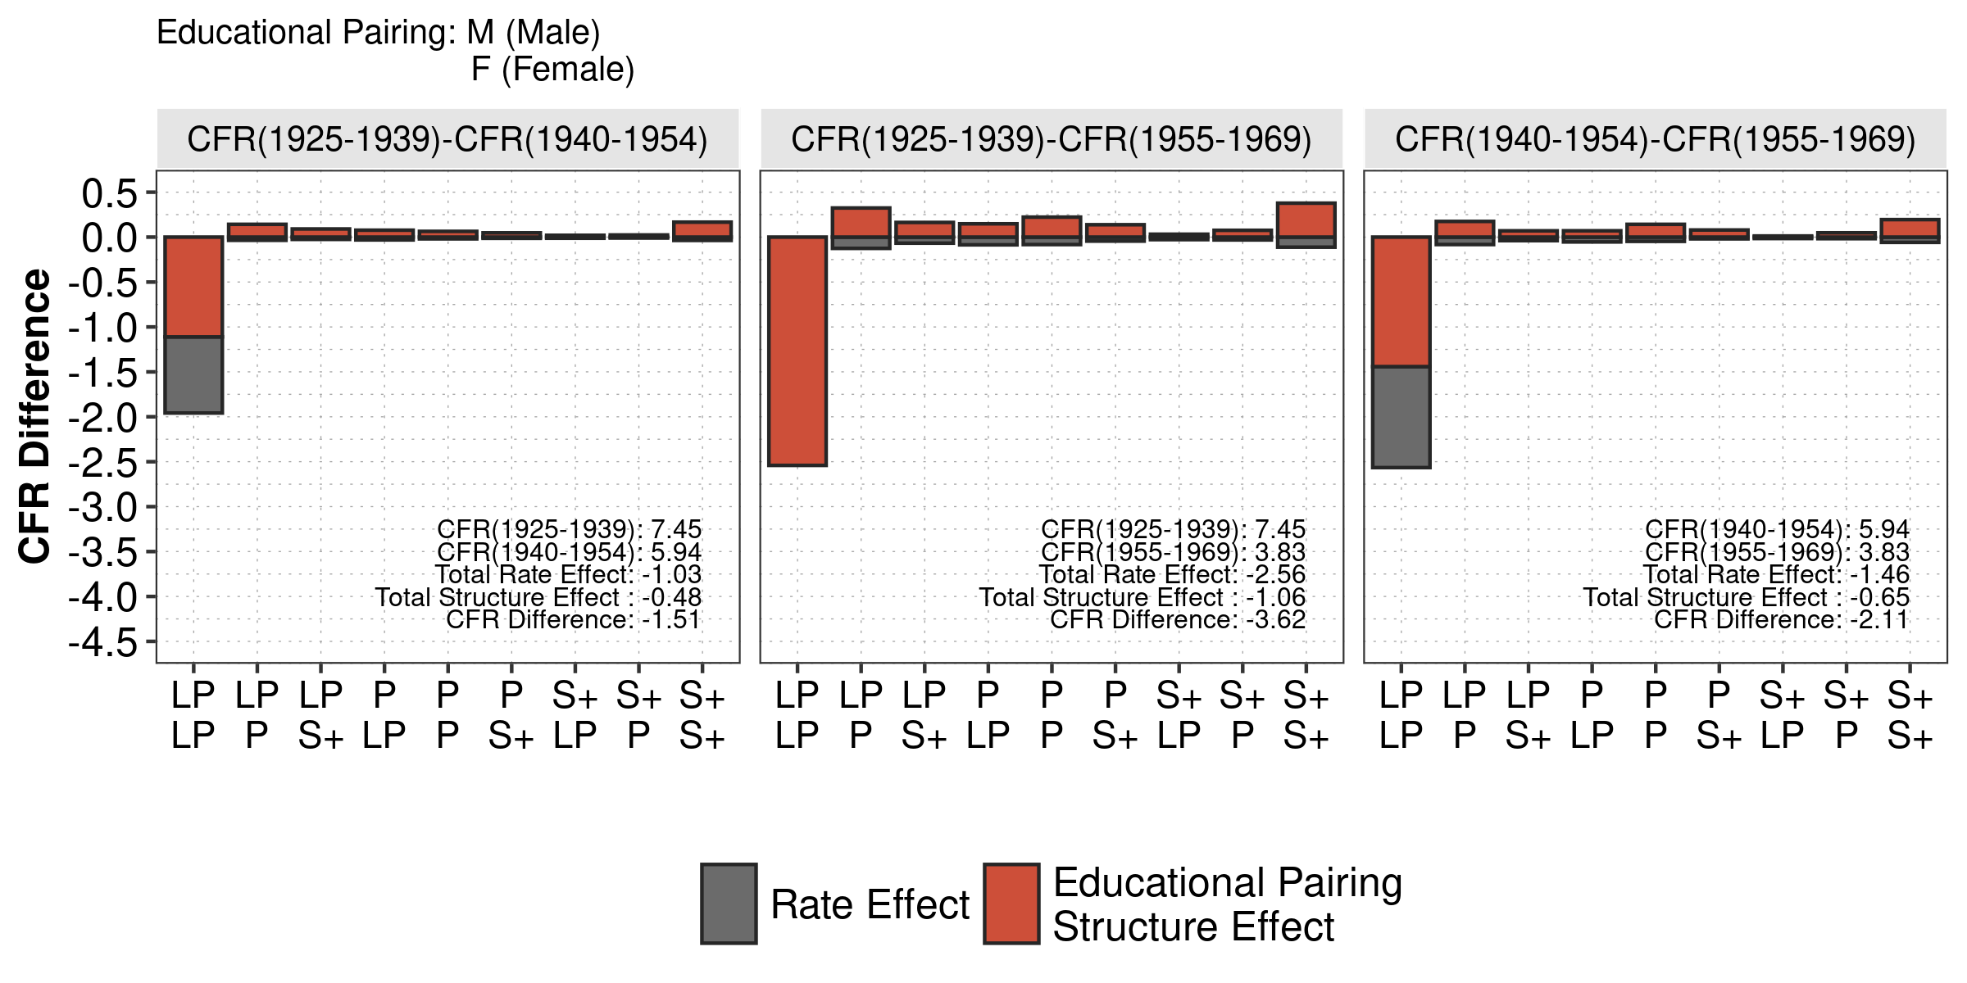
Figure C3: Decomposition of CFR in Rate and and Educational Pairing Structure effects for female birth cohorts born in 1925-39, 1940-54, 1955-69 - South-Southeast regions, Brazil. Source: Brazilian National Censuses, 1970, 1980, 1991, 2000, 2010. 