COMPRE 2026 RECITATION

HYDRAULICS
- A cube of wood 600 mm to a side float in fresh water with two faces horizontal and the other four faces vertical. If its specific gravity is 0.80, obtain the submerged depth of the wood.
- A triangular gate having a horizontal base 1.0 m long and an altitude of 1.5 m is inclined at 45° from the vertical with the vertex pointing upward. The vertex of the gate is 2.4 m vertically below the surface of the water.
What normal force, in kN, must be applied at the vertex of the gate to open it if it is hinged at the base?
- What is the atmospheric pressure in kapa at the base of a mountain if a mercury barometer reads 700 mm at that location?
- Determine the diameter of pipe will carry 300 liters per minute with a loss of head of 0.50 m in 300 m. The friction factor is 0.025.
- An irrigation canal with trapezoidal cross section has the following dimensions: Bottom width = 2.50 m, depth of water = 0.90 m, side slope = 1.5 horizontal to 1 vertical, slope of the canal bed = 0.001, coefficient of roughness = 0.025. The canal will serve clay loam Riceland for which the duty of water per hectare is 3.0 liters/sec. Using Manning’s Formula:
Number of hectares served by the irrigation canal.
- A liquid is discharged from a container through a circular orifice having a diameter of 10 mm that is located h meters from the liquid surface to the center of the orifice.
If the container is open to the atmosphere, obtain the theoretical discharge through the orifice in liters/sec when h=9.
- A water tank has a sloping inclined at 45 degrees with the horizontal. The total depth of water in the tank is 8 m. A water jet issues from an orifice located on the inclined side of the tank under a hydrostatic head of 5 m or that orifice is located 3 m vertically above the bottom of the tank. Coefficient of velocity is 1.0. Neglecting air resistance on the jet.
Evaluate the vertical height in meters that the jet rises above the level of the orifice.
- If a container containing water 0.40 m deep is carried inside an elevator that accelerates at 2 m/sec², evaluate the pressure, in kPa exerted by the water at the base of the container if the elevator is travelling downward.
- An open cylindrical vessel is 1.2 m in diameter and 2.1 high is 2/3 full of water. Determine the amount of water in liters that will be spilled out if the vessel is rotated about the vertical axis at a constant angular speed of 87 rpm.
- In a bakery, water enters a mixing chamber at the rate of 150 liters per sec. Through pipe A, while cooking oil with specific gravity of 0.80 is forced in at 30 liters per sec through pipe B. Assuming the liquids are in-compressible and form a homogeneous mixture of oil globules in water, evaluate the density of the mixture in kg/m³ leaving through a pipe C of diameter 300mm.
GEOTECHNICAL AND FOUNDATION ENGINEERING
- Given the following properties:
Field unit weight of the soil = $1800$ $kg/m^{3}$
Saturated unit weight = $2000 kg/m^{3}$
Moisture content = 12%
Determine:
The degree of saturation.
- Evaluate the plastic settlement, in meters, on a layer of a plastic clay due to an increase of pressure caused by loads above it under the following conditions:
Initial intergranular pressure = 200 kPa
Increase in intergranular pressure = 150 kPa
Thickness of the clay layer = 10 m
Coefficient of consolidation = 0.315
Void ratio of the clay = 1.5
- The following are the result of two direct shear test on a normally consolidated clay:
Diameter of specimen = 50 mm
Test no. | Normal Force (N) | Shear Force at failure (N)
1 | 265 | 130
2 | 410 | 185
Determine:
The cohesion of the soil in kPa.
- Evaluate the resisting capacity against axial load due to skin friction on the following conditions:
Size of pile = 0.35 m average diameter
Depth of penetration into the soil = 20 m
Unconfined compression strength = 110 kPa
- An impervious layer underlies 4 layers of permeable soil. The thickness and the coefficient of permeability of each layer, from top to bottom, are:
Layer | k (cm/sec) | Thickness (m)
1 | $2×{10}^{-4}$ | 3
2 | $1×{10}^{-5}$ | 3
3 | $2×{10}^{-3}$ | 3
4 | $1×{10}^{-3}$ | 3
Determine:
The rate of flow per meter of the deposit, in cubic centimeters per second if the hydraulic gradient for the soil formation is 0.70.
- A 7.6 m thick clay layer is underlain by 15.2 m of sand to the ground. The water table is level with the ground surface. The saturated unit weight of sand is 21.2 $kN/m^{3}$ and its dry unit weight is 18.2 $kN/m^{3}$. The saturated unit weight of clay is 18.8 $kN/m^{3}$. The water table is lowered to 7.6 m below the ground and the sand above the water table have degree of saturation decreased by 20%. Determine:
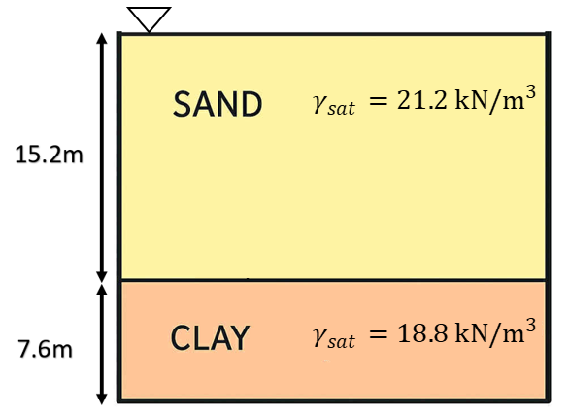
The effective pressure at the mid-height of the clay layer after lowering the water table.
- A 300 mm diameter well penetrates 27 m below the static water table. After 24 hours of pumping 69 liters per second, the water table in two observation wells located 35 m and 95 m from the well showed drawdowns of 1.1 m and 0.5 m respectively. Determine:
The transmissivity of the soil in $m^{2}/day$.
- According to the Westerguard Theory, the vertical stress at a point below the surface of a semi-infinite, homogeneous, isotropic soil mass due to a point load applied at the ground surface is given by the equation:
$P=\frac{0.318QN}{z^{2}}$
where
$N=\frac{1}{{\left[1+2{\left(\frac{r}{z}\right)}^{2}\right]}^{1.5}}$
$r$=horizontal distance of the point from the vertical line of application of the load
$z$=depth of point below ground surface
Evaluate the vertical stress in kPa at a point below the ground for Q=1500 kN if:
The point is 6 m directly below the load but 3 m horizontally from the application of the load.
- A square footing 0.90 m on a side is embedded 1.0 m into a cohesionless soil deposit. The unit weight of the soil is 18 $kN/m^{3}$ and the angle of internal friction is 30°.
$N_{c}=37.16$
$N_{q}=22.46$
$N_{γ}=19.13$
Determine:
The concentric load in kN that the footing can safely support using a factor of safety of 3.0 against bearing capacity failure.
- In accordance with Rankine’s theory for active earth pressure on a retaining wall, with horizontal backfill, what angle of internal friction in degrees results in a coefficient of lateral earth pressure equal to 0.50?

