COMPRE 2026 RECITATION

HYDRAULICS
- A wooden buoy having a specific gravity of 0.75 floats in a liquid having a specific gravity of 0.85.
What is the weight of the wooden buoy if the volume exposed above the liquid is 0.045 $m^{3}$?
- A vertical triangular gate 0.9 m high have its 2m base flushed with the surface.
Determine the location of the center of pressure from the top.
- (Nov 2018) In order to provide water from a nearby spring, a triangular flume of efficient cross section was provided on a slope of 0.15 percent. Assuming the roughness coefficient of the channel equal to 0.020, obtain the depth of flow in meter(s) of the water in the flume if it is discharging at the rate of 2 cu.m./sec. Utilize the formula $V=\frac{1}{n}R^{\frac{2}{3}} S^{\frac{1}{2}}$ , for the velocity of flow.
- (Nov 2018) Into a bakery dough mixing chamber water enters at the rate of 200 liters per sec through pipe A. Cooking oil with specific gravity of 0.80 is forced in at 50 liters per sec through pipe B. Assuming the liquids are incompressible and form a homogeneous mixture of oil globules in water, evaluate the average velocity of the mixture leaving through a pipe C of diameter 300 mm in m/sec.
- (Nov 2018) An open cylindrical tank 1 meter diameter contains water to a depth of 3.56 m.
If the tank is 4 meter tall and is rotated at 120 rpm, obtain how much water will be spilled out, in liters
- (Nov 2018) In order to provide irrigation, water has to be pumped to an elevation 120 m through a 600-mm pipe where the pressure required at the higher elevation is 172 kPa. The source of the water and the discharge point are at atmospheric pressure. Irrigation requirements dictate that water must be pumped at the rate of $1m^{3}/sec$. The loss of head due to friction and other factors is estimated to be 2.45 m.
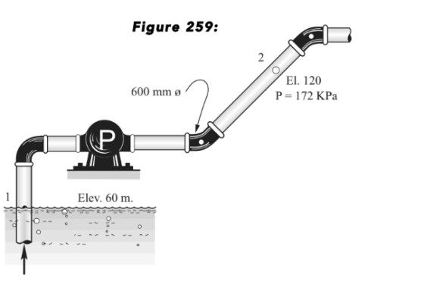
The rating of the pump in horsepower of it is only 80% efficient.
- (May 2018) A bucket in an elevator contains 0.5 m of water. Obtain the pressure at the bottom of the bucket when the elevator accelerates downward at 2 $m/s^{2}$.
- Storm water lows at the rate of 2 $m^{3}/s$ in a triagular canal with vertex angle of 60°. obtain the critical depth of flow in meters.
- (May 2018) A cylindrical tank 4m in diameter and 3m tall is full of water. Obtain the time in minutes to drain the tank through a 50 mm diameter orifice at the tank bottom Assume C= 1.0
- (Nov 2018) Given the unit weight of air to be constant at 12 $N/m^{3}$, determine the approximate height of a mountain, in meters, if a mercury barometer at its base reads 750 mm and at the same instant another barometer at the top of the mountain reads 300 mm.
GEOTECHNICAL AND FOUNDATION ENGINEERING
- (Nov 2018) Given that the field unit weight of a soil sample is 1650 $kg/m^{3}$, the unit weight of the soil grains 2550 $kg/m^{3}$, and the moisture content of the soil is 15%. Determine:
The degree of saturation in percent.
- The initial void ratio of a layer of soft clay that is 6 m thick is 0.4. Under a pressure of surcharge load above it, the void ratio decreased by one-half. Evaluate the reduction in the thickness of the clay layer in meter.
- (May 2018) A triaxial test is performed on a cohesionless soil. The soil fails under the following conditions:
Confining pressure = 250 kPa
Deviator stress = 450 kPa
Determine:
The shearing stress at the failure plane.
- (May 2018) Given the following data of a circular footing:
Footing diameter = 10 m
Depth of footing = 2 m
Unit weight of soil = 16 $kN/m^{3}$
Soil cohesion = 0
Angle of internal friction = 20°
$$N_{c}=17.69$$
$$N_{q}=7.44$$
$$N_{γ}=3.64$$
Determine:
The gross allowable pressure if the factor of safety is 3.0.
- (Nov 2018) Evaluate the resisting capacity in kN against axial load due to skin friction of a concrete pile embedded into a layer of plastic clay given the following conditions:
Size of pile = 0.4 m square
Depth of penetration into the clay layer = 25 m
Unconfined compression strength of the clay = 210 kPa
- An 8.2 m thick clay layer is overlain by a 15.2 m thick sand layer. The top of the sand layer is at the ground surface. The sand layer has a dry unit weight of 18.2 $kN/m^{3}$, saturated unit weight of 21.2 $kN/m^{3}$, and degree of saturation of 30%. The clay layer has saturated unit weight of 18.78 $kN/m^{3}$. Determine:
The effective pressure at the mid-height of the clay if the ground water table is located 7.6 m below the surface.
- (Nov 2018) A retaining wall 12 m high has a horizontal backfill on its vertical face to its base. Under normal conditions, the backfill has a water content of 12% and a void ratio of 0.45. The specific gravity of the soil grains is 2.65 and the angle of internal friction is 20°. When the backfill is fully saturated with rain water, determine:
How many times would the horizontal lateral force be increased if the backfill is fully saturated with rain water compared to its normal conditions.
- (Nov 2018) After 24 hours of pumping at 40 liters/sec, the water level in an observation well at a distance 100 m from the test well is lowered 0.5 m. At another observation well located 50 m from the test well, the water level dropped by 1.0 m. Thickness of aquifer is 27 m. Determine:
The coefficient of permeability of the aquifer in meter per day.
- The hydraulic conductivity of a confined aquifer is 50 m/day with a porosity of 25%. The piezometric surface in the two observation wells 1000 m apart are at elevation 75 m and 65 m respectively from the common datum. The aquifer has an average thickness of 30 m and an average width of 4 km. Determine:
The rate of flow of water through the aquifer in cubic meters per day.
- A masonry wall weighing 7.2 kN per linear meter is carried by a wall footing 0.60 m wide. Determine:
The stress at a depth of 2 m and a horizontal distance 3 m from the line of load.

