AI-102 Episode 2 Expansion Implementation Plan and Code Review
High-End Restaurant Generative AI Concierge
https://learn.microsoft.com/en-us/shows/exam-readiness-zone/preparing-for-ai-102-01-fy25
https://learn.microsoft.com/en-us/shows/exam-readiness-zone/preparing-for-ai-102-02-fy25
https://learn.microsoft.com/en-us/shows/exam-readiness-zone/preparing-for-ai-102-03-fy25
https://learn.microsoft.com/en-us/shows/exam-readiness-zone/preparing-for-ai-102-04-fy25
https://learn.microsoft.com/en-us/shows/exam-readiness-zone/preparing-for-ai-102-05-fy25
https://learn.microsoft.com/en-us/shows/exam-readiness-zone/preparing-for-ai-102-06-fy25

Target local project directory: /Users/josekurian/AzureTemplate/OpenAI/HighEndRestaurantAIAutomation
Purpose: Expand the existing hands-on project so it covers the additional Episode 2 generative AI objectives shown in the uploaded images: fine-tuning, prompt flow, assistants, multimodal models, model reflection, containers, multi-model orchestration, and full operationalization.

Verification basis and scope
This document was prepared from the uploaded Episode 2 images, the current Microsoft Learn AI-102 study guide, the uploaded AI-102_Study_Guide.docx, and a code review of the current project ZIP. The Microsoft Learn study guide lists Implement generative AI solutions as an AI-102 skill area and includes objectives for Foundry, Azure OpenAI, RAG, evaluations, SDK integration, prompt templates, DALL-E, multimodal models, monitoring, tracing, model reflection, containers, orchestration, prompt engineering, and fine-tuning.
- Microsoft Learn AI-102 study guide: https://learn.microsoft.com/en-us/credentials/certifications/resources/study-guides/ai-102
- Microsoft Learn RAG and indexes in Microsoft Foundry: https://learn.microsoft.com/en-us/azure/foundry/concepts/retrieval-augmented-generation
- Microsoft Learn Azure OpenAI fine-tuning: https://learn.microsoft.com/en-us/azure/foundry/openai/how-to/fine-tuning
- Microsoft Learn tracing AI applications in Foundry classic: https://learn.microsoft.com/en-us/azure/foundry-classic/how-to/develop/trace-application
- Uploaded AI-102_Study_Guide.docx prepared for Jose Kurian, May 22, 2026.

Executive summary: what must be added
- The existing project is a good scaffold but not yet a complete Episode 2 implementation. Several service adapters intentionally raise NotImplementedError in real mode, and the advanced generative AI capabilities are not present yet.
- The highest-value additions are telemetry, content safety hardening, RAG upgrade, prompt flow runner, reflection, feedback, multimodal and DALL-E endpoints, model router, and fine-tuning experiment pipeline.
- The implementation should remain modular and exam-aligned: every new service and endpoint should map to a Microsoft Learn objective and have tests, acceptance criteria, and rollback notes.
- Fine-tuning should be implemented as an experiment with strong evaluation and governance, not as the default answer to factuality problems. Current restaurant facts should stay in RAG.

Code review of the current project scaffold
Reviewed source: /mnt/data/HighEndRestaurantAIAutomation_with_OpenAI_Codex_Tuning.zip. The project appears to target FastAPI with Azure AI service adapter classes and mock mode. The following review focuses on Episode 2 readiness and implementation gaps.
Type | Area | Finding
Strength | FastAPI scaffold | app/main.py exposes core endpoints for chat, reservations, safety, translation, document, vision, and speech.
Strength | Modular service adapters | app/services separates OpenAI, Search, Content Safety, Language, Translator, Document Intelligence, Vision, Speech, Face, and Custom Vision.
Strength | Mock mode | .env/config supports mock_mode, enabling local and CI testing without Azure calls.
Gap | Document Intelligence not implemented | app/services/document_intelligence_client.py raises NotImplementedError in real mode.
Gap | Speech not implemented | app/services/speech_client.py lacks real STT/TTS implementation and raises NotImplementedError in real mode.
Gap | Vision not implemented | app/services/vision_client.py lacks real Azure AI Vision calls.
Gap | No Episode 2 fine-tuning workflow | No dataset validation, fine-tuning scripts, model registry, evaluation gate, or release plan exists.
Gap | No prompt flow implementation | The project has prompt docs but no executable prompt-flow style pipeline or traceable workflow runner.
Gap | No DALL-E/image generation | There is no DALL-E service or endpoint for generating menu/event imagery.
Gap | No multimodal endpoint | There is no image+text model endpoint for guest inspiration photos or event design analysis.
Gap | No Assistant/agent adapter | Bot adapter is a placeholder; no Assistant-style stateful tool orchestration exists.
Gap | No model reflection | Current chat returns the first generated answer after output safety but does not self-check groundedness, policy compliance, or citation completeness.
Gap | No feedback API | No /feedback endpoint or Application Insights trace span integration exists.
Gap | Basic RAG only | Search adapter uses keyword-style search only; no chunking pipeline, embeddings, vector/hybrid retrieval, reranking, or citation field design.
Gap | Content Safety incomplete | Mock prompt injection check exists, but real prompt shields, blocklists, thresholds, and document attack detection are not implemented.
Gap | Monitoring incomplete | No middleware for request IDs, trace IDs, token usage, model latency, safety decisions, or user feedback correlation.

Prioritized implementation backlog for Codex
Priority | Location | Required work
P0 | app/telemetry/tracing.py | Add OpenTelemetry/Application Insights tracing with correlation IDs, model latency, token counts, retrieval time, safety decision, and feedback ID.
P0 | app/services/content_safety_client.py | Implement real Text Analyze, Prompt Shields user attacks, document attack detection for retrieved chunks, custom blocklists, and thresholds.
P0 | app/rag/* | Add chunker, metadata enricher, embedding generator, index schema, ingestion script, vector/hybrid search, and citation-preserving retrieval.
P1 | app/services/foundry_project_client.py | Add Foundry project/connection abstractions for connection string based integration where appropriate.
P1 | app/orchestrators/prompt_flow_runner.py | Implement traceable workflow: classify, safety precheck, retrieve, generate, reflect, safety postcheck, log feedback context.
P1 | app/services/reflection_client.py | Add model reflection with rubric: groundedness, safety, tone, completeness, escalation need, JSON/schema validity.
P1 | app/api/feedback.py | Add endpoint for user rating, corrected answer, issue tags, and write telemetry to App Insights or a feedback store.
P1 | app/services/dalle_client.py | Generate event mood boards, menu card imagery, and private dining concept images using image-generation models with safety review.
P1 | app/services/multimodal_client.py | Support image+text reasoning for guest-uploaded event inspiration photos or plate-quality inspection.
P2 | app/services/assistant_client.py | Add Assistant-style stateful workflows for private dining planning, tool calls, and escalation.
P2 | app/orchestrators/model_router.py | Route tasks to cheapest sufficient model/service: small model for classification, embedding model for RAG, high-quality model for final answer.
P2 | evals/fine_tuning/* | Add training/validation examples, validation script, baseline comparison, fine-tune job script, and deployment gate.
P2 | infra/bicep/* | Add model deployments, update policies, quotas, diagnostic settings, Application Insights, Log Analytics, Container Apps/AKS, and RBAC assignments.
P3 | containers/edge/* | Add local/edge container profile with limited features, offline mock data, and clear separation from cloud-only AI services.

Proposed new project files and directories
- app/api/feedback.py - feedback collection endpoint and schema integration
- app/api/images.py - DALL-E and multimodal image endpoints
- app/api/evals.py - evaluation run endpoint for local/admin use
- app/rag/chunker.py - restaurant document chunking strategies
- app/rag/enrich.py - metadata enrichment for title, section, source, policy type, allergen flags
- app/rag/index_schema.py - Azure AI Search vector/hybrid index definition
- app/rag/retriever.py - hybrid search, vector search, filters, reranking, citation packaging
- app/services/foundry_project_client.py - project connection and SDK integration
- app/services/dalle_client.py - image generation for event and menu concepts
- app/services/multimodal_client.py - image plus text reasoning
- app/services/assistant_client.py - Assistant-style multi-step workflows
- app/services/reflection_client.py - draft answer evaluation and correction
- app/orchestrators/prompt_flow_runner.py - workflow orchestration and tracing
- app/orchestrators/model_router.py - model/service selection policy
- app/telemetry/tracing.py - OpenTelemetry/Application Insights setup
- evals/fine_tuning/train.jsonl - approved training examples
- evals/fine_tuning/validation.jsonl - holdout validation examples
- scripts/validate_finetune_dataset.py - JSONL and safety validation
- scripts/run_finetune.py - fine-tuning job script
- scripts/evaluate_candidate_model.py - baseline versus candidate model evaluation
- docs/episode2_feature_traceability.md - objective-to-file mapping

Image 48 - Fine-tune an Azure OpenAI model
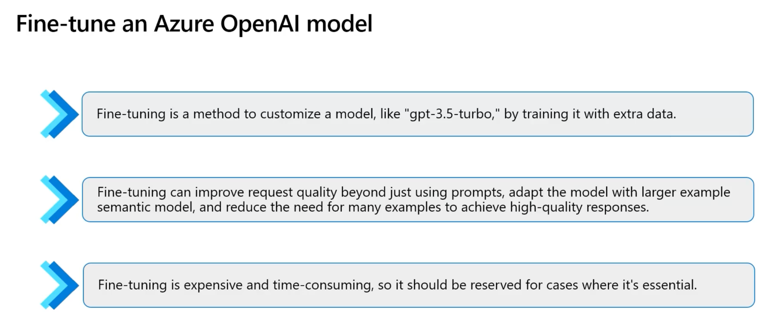

Deep explanation and exam focus
- Fine-tuning customizes a supported base model using representative training examples, but it should not be the first solution for every quality problem.
- For AI-102, decide in this order: improve prompt design, add RAG grounding, tune parameters, evaluate outputs, then consider fine-tuning only if consistent style or task behavior still cannot be achieved.
- Fine-tuning is most useful when the restaurant concierge must consistently follow a unique brand voice, classify specialized internal intents, or produce highly structured responses from repeated examples.
- Fine-tuning is not a replacement for current restaurant facts, menu items, wine inventory, private dining rules, or policies; those belong in Azure AI Search RAG indexes because they change often.
- Good fine-tuning data must be high-quality, consistent, reviewed, and formatted according to the model requirements; poor examples teach the model poor behavior.
- A safe fine-tuning workflow includes a baseline model, training dataset, validation dataset, evaluation metrics, red-team tests, deployment approval, rollback plan, and cost review.
- Fine-tuned models can reduce the number of few-shot examples needed in prompts, which may reduce prompt tokens, but training and hosting costs must be justified.
- The expected exam answer is often not fine-tuning when the need is to answer from private or current data; the correct answer is usually RAG with Azure AI Search and Azure OpenAI.
- Fine-tuning should be versioned like application code: dataset version, model version, deployment name, evaluation report, and release notes should be captured.
- For the restaurant project, create a fine-tuning experiment only for tone and structured response format; keep factual knowledge in Search and keep safety behavior in Content Safety and system prompts.

20 sample questions and answers
Q1. What is fine-tuning in Azure OpenAI?
Answer: It is the process of training a supported base model on additional examples so the model better follows a target style, task pattern, or output format. It changes model behavior, while RAG changes the context supplied to the model at runtime.
Q2. When should fine-tuning be considered for the restaurant concierge?
Answer: Consider it when prompt engineering and RAG still cannot reliably produce the required restaurant brand voice, structured JSON output, or specialized concierge responses across a large set of cases.
Q3. When should fine-tuning not be used?
Answer: Do not use fine-tuning merely to add current facts such as menus, hours, wine inventory, or cancellation policy. Use RAG with Azure AI Search for changing business knowledge.
Q4. Why is fine-tuning expensive compared with prompt engineering?
Answer: Fine-tuning requires curated datasets, training jobs, evaluation, deployment, monitoring, and possibly a separately hosted model deployment. Prompt changes are faster and cheaper to iterate.
Q5. What is the safest first step before fine-tuning?
Answer: Create a baseline evaluation against the existing deployed model using representative restaurant scenarios, including success criteria for answer quality, safety, groundedness, latency, and cost.
Q6. What data should be included in a fine-tuning dataset?
Answer: Include approved examples of guest requests and ideal answers that reflect the restaurant tone, escalation rules, structured output schema, multilingual examples if needed, and refusal/escalation patterns.
Q7. What data should be excluded from fine-tuning?
Answer: Exclude personal data, payment data, secrets, proprietary employee-only data not needed for the behavior, inconsistent answers, outdated policy content, and unreviewed generated examples.
Q8. How does fine-tuning affect prompt length?
Answer: If the fine-tuned model internalizes common style and format behavior, prompts may need fewer examples. However, system instructions and grounding context are still required for safety and factual accuracy.
Q9. What is the relationship between fine-tuning and RAG?
Answer: They solve different problems. Fine-tuning improves behavior learned from examples; RAG supplies fresh private knowledge retrieved at request time. Production systems often combine both.
Q10. How should a fine-tuned model be released?
Answer: Release through a controlled deployment process with a new deployment name, canary traffic, evaluation gates, content safety checks, telemetry, and rollback to the previous deployment.
Q11. What metric helps decide whether fine-tuning succeeded?
Answer: Use task-specific evaluation metrics such as schema-valid output rate, tone adherence, grounded answer rate, human preference score, safety pass rate, and reduced prompt-token usage.
Q12. What is a common exam trap about fine-tuning?
Answer: The exam may describe a need to answer from private or frequently changing data. That is usually a RAG scenario, not a fine-tuning scenario.
Q13. How should the restaurant project store fine-tuning artifacts?
Answer: Store datasets under evals/fine_tuning, training job metadata under docs/model_registry, and deployment configuration under infra/model_deployments or environment-specific settings.
Q14. How can fine-tuning introduce risk?
Answer: A model can learn biased, unsafe, outdated, or inconsistent behavior from flawed examples. It may also appear confident even when RAG evidence is missing, so grounding rules must remain enforced.
Q15. What should the implementation plan add for fine-tuning?
Answer: Add scripts to validate JSONL examples, run a training job, register the model version, deploy it to a non-production endpoint, evaluate it, and promote it only after approval.
Q16. How do you compare prompt engineering and fine-tuning?
Answer: Prompt engineering is fast and appropriate for instructions and examples. Fine-tuning is slower and appropriate when many prompts fail consistently despite good instructions and examples.
Q17. Should fine-tuning replace content filters?
Answer: No. Content filters, Content Safety checks, prompt shields, and output moderation remain required regardless of whether the model is base or fine-tuned.
Q18. What is the expected restaurant fine-tuning sample use case?
Answer: Train on approved concierge response examples so answers consistently sound premium, concise, empathetic, and policy-aware while still citing RAG sources for factual claims.
Q19. How should model regressions be detected after fine-tuning?
Answer: Run automated evaluation sets and compare against the baseline for accuracy, groundedness, latency, token cost, refusal behavior, and safety results before promotion.
Q20. What should Codex implement first?
Answer: Codex should implement the evaluation harness and dataset validation before training. Without a reliable evaluator, the team cannot know whether fine-tuning improved the system.

Image 49 - Other skills in implementing generative AI solutions
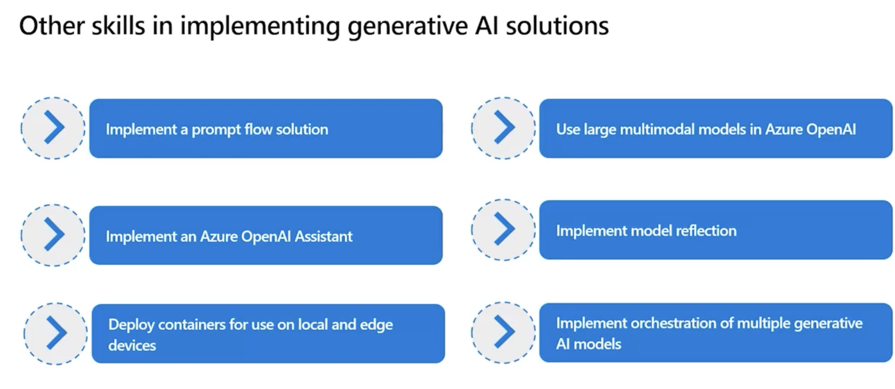

Deep explanation and exam focus
- Prompt flow is a repeatable workflow for chaining prompts, tools, data retrieval, evaluations, and deployment steps in a traceable way.
- Azure OpenAI Assistants or agent-like patterns help manage multi-step conversations, tool use, retrieval, and state for complex concierge tasks.
- Large multimodal models allow the app to process text plus images, such as guest-uploaded event inspiration photos, plate-quality images, or menu screenshots.
- Model reflection means adding a second-pass review step where a model critiques, validates, or improves its own draft before the final response is returned.
- Containers support reproducible deployment on local developer machines, Azure Container Apps, AKS, and edge or on-premises scenarios.
- Multiple-model orchestration routes different tasks to different models: fast model for classification, reasoning model for planning, embedding model for RAG, image model for DALL-E, and vision model for images.
- For AI-102, orchestration should include production controls: safety, tracing, monitoring, retry policy, fallbacks, model versioning, and cost limits.
- Assistants and prompt flow are useful when tasks are multi-step, but simple deterministic service calls should stay simple to reduce cost and complexity.
- A high-end restaurant solution benefits from multimodal and orchestration features: image-based menu inspiration, event planning documents, voice reservations, multilingual answers, and sommelier recommendations.
- The implementation should be modular so Codex can add services without breaking the current FastAPI endpoints and existing mock-mode tests.

20 sample questions and answers
Q1. What is prompt flow used for?
Answer: Prompt flow is used to design, chain, test, evaluate, and deploy prompt-based workflows that may include model calls, retrieval, custom code, and evaluation steps.
Q2. Why add prompt flow to the restaurant project?
Answer: It creates a repeatable path for concierge responses: classify request, retrieve context, generate answer, run safety checks, reflect on quality, and log feedback.
Q3. What is an Azure OpenAI Assistant-style capability?
Answer: It is a conversational orchestration pattern that can maintain instructions, use tools, retrieve files, and handle multi-turn task execution for complex workflows.
Q4. What restaurant use case fits an Assistant?
Answer: Private dining planning fits well because it requires multiple steps: capture guest needs, check policy, retrieve event packages, draft menu options, and escalate to a human.
Q5. What are large multimodal models used for?
Answer: They process inputs that combine text and other modalities such as images, allowing the app to reason about a guest-uploaded plate image, event inspiration photo, or scanned menu.
Q6. What is model reflection?
Answer: Model reflection is a second-pass quality-control step where the model checks whether a draft answer followed instructions, used sources, avoided unsupported claims, and remained safe.
Q7. Why deploy containers for local and edge devices?
Answer: Containers package the application and dependencies consistently, enabling reproducible local testing and deployment to Azure Container Apps, AKS, or edge environments.
Q8. What is multiple-model orchestration?
Answer: It is routing tasks to the best model or service for each subtask instead of using one expensive model for everything.
Q9. Which tasks should use deterministic services instead of generative models?
Answer: Translation, PII detection, sentiment, speech-to-text, invoice extraction, OCR, and content moderation should use dedicated Azure AI services when they meet the requirement.
Q10. How should orchestration handle failures?
Answer: It should use retries with backoff, circuit breakers, fallback models, human escalation, and telemetry to avoid unsafe or silent failures.
Q11. How do prompt flow and Assistants differ?
Answer: Prompt flow focuses on traceable workflow composition and evaluation, while Assistants focus on stateful conversational tool use. A solution can use both when appropriate.
Q12. What should Codex add for model reflection?
Answer: Add a reflection service that receives the draft answer, the user request, safety results, and retrieved sources, then returns a pass/fail decision and correction suggestions.
Q13. How should multimodal input be secured?
Answer: Run image and text content safety checks, validate file types and sizes, avoid storing unnecessary personal images, and log consent or business purpose when applicable.
Q14. What endpoint should support feedback collection?
Answer: Add a /feedback endpoint that accepts answer ID, rating, reason, tags, user role, and optional corrected answer, then logs the payload to Application Insights or a database.
Q15. What is the exam risk of overusing agents or orchestration?
Answer: The exam often rewards the least complex correct service. Use orchestration only when the scenario truly requires multiple steps or tools.
Q16. What model router rules should the project use?
Answer: Use fast/low-cost models for classification, embeddings for retrieval, high-quality chat models for final concierge answers, DALL-E for images, and vision models for image analysis.
Q17. How should the app choose between RAG and fine-tuning?
Answer: Use RAG for restaurant facts and current data; use fine-tuning only for persistent behavior such as brand tone or output structure.
Q18. What makes a container deployment exam-ready?
Answer: It should include Dockerfile, health checks, environment configuration, managed identity, logging, and a target deployment such as Azure Container Apps or AKS.
Q19. What should be included in implementation evidence?
Answer: Include architecture diagram, service-selection rationale, source-controlled prompts, test data, evaluation results, traces, logs, and responsible AI risk register.
Q20. Which additional code modules are needed?
Answer: Add Foundry project integration, prompt flow runner, assistants adapter, multimodal image handler, DALL-E generator, reflection service, model router, feedback API, and telemetry middleware.

Image 50 - Recap: Skills Measured 2
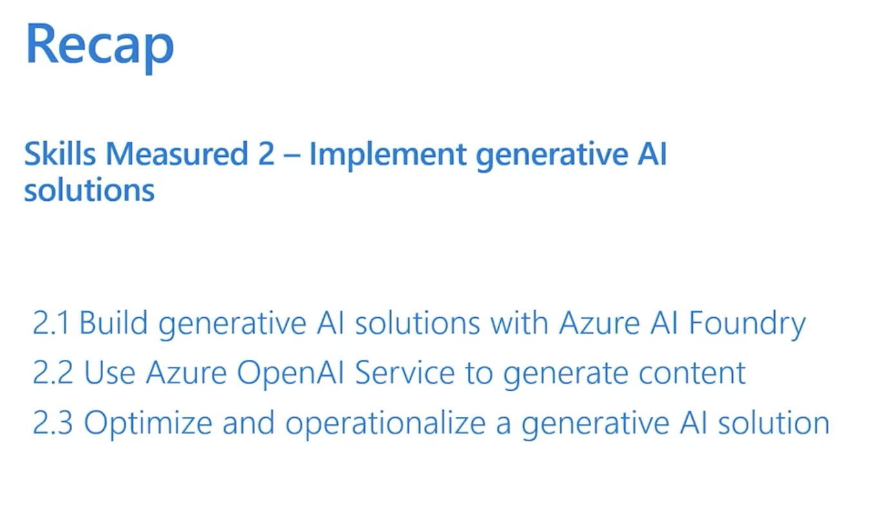

Deep explanation and exam focus
- The recap image summarizes Skills Measured 2: Implement generative AI solutions.
- This domain is a major AI-102 focus area, currently weighted at 15-20 percent in the Microsoft Learn study guide.
- Subdomain 2.1 focuses on building generative AI solutions with Microsoft Foundry or Azure AI Foundry concepts.
- Subdomain 2.2 focuses on using Azure OpenAI in Foundry Models to generate text, code, images, and multimodal responses.
- Subdomain 2.3 focuses on optimization and operationalization: parameters, diagnostics, resource management, tracing, reflection, containers, orchestration, prompt engineering, and fine-tuning.
- A high score requires knowing not only what each feature is but when to choose it over alternatives.
- Hands-on readiness means being able to provision resources, deploy models, call them from code, ground them with RAG, evaluate outputs, and monitor cost and performance.
- The restaurant sample should demonstrate the entire lifecycle: plan, build, test, evaluate, deploy, monitor, and improve.
- The project must prove secure configuration: managed identity, Key Vault, RBAC, and no hardcoded secrets.
- The project should prove responsible AI: content safety, prompt shields, blocklists, feedback, human review, and risk documentation.

20 sample questions and answers
Q1. What are the three main Episode 2 skill groups?
Answer: Build generative AI solutions with Foundry, use Azure OpenAI to generate content, and optimize/operationalize generative AI solutions.
Q2. Why is Episode 2 important for AI-102?
Answer: It tests the practical lifecycle of generative AI applications, including planning, deployment, RAG, evaluation, SDK integration, monitoring, and optimization.
Q3. What does 2.1 emphasize?
Answer: It emphasizes planning and building with Foundry, including hubs/projects, model selection, prompt flow, RAG, evaluations, SDK integration, and prompt templates.
Q4. What does 2.2 emphasize?
Answer: It emphasizes Azure OpenAI content generation: provisioning resources, deploying models, submitting prompts, generating images, app integration, and multimodal models.
Q5. What does 2.3 emphasize?
Answer: It emphasizes operations: tuning parameters, monitoring, deployment optimization, tracing, feedback, reflection, containers, orchestration, prompt engineering, and fine-tuning.
Q6. What is the fastest way to eliminate wrong exam answers?
Answer: Identify whether the requirement is generation, retrieval, extraction, translation, speech, safety, evaluation, or operations, then choose the least complex correct service.
Q7. What does operationalize mean in this context?
Answer: It means making the AI solution production-ready with telemetry, diagnostics, security, scalability, model lifecycle management, cost controls, and rollback.
Q8. How should the restaurant sample prove Episode 2 coverage?
Answer: It should include RAG chat, prompt templates, model deployments, image generation, multimodal analysis, feedback collection, tracing, evaluation, and deployment controls.
Q9. What is a strong hands-on artifact for 2.1?
Answer: A Foundry-style project plan with resource connections, prompt flow design, RAG index design, evaluation dataset, and application SDK integration.
Q10. What is a strong hands-on artifact for 2.2?
Answer: A FastAPI endpoint that calls Azure OpenAI for concierge responses, DALL-E images, and multimodal image-plus-text reasoning with secure authentication.
Q11. What is a strong hands-on artifact for 2.3?
Answer: Dashboards and logs showing latency, token consumption, errors, safety outcomes, feedback, and model version comparisons.
Q12. How does RAG fit Episode 2?
Answer: RAG grounds the model in restaurant knowledge so answers about menus, policies, allergens, hours, and private dining are based on retrieved content.
Q13. How does fine-tuning fit Episode 2?
Answer: Fine-tuning appears as an optimization option when persistent model behavior cannot be achieved through prompts and RAG alone.
Q14. Why does the exam include prompt templates?
Answer: Templates support consistent instructions, reusable variables, safer grounding patterns, and easier testing across scenarios.
Q15. Why does the exam include tracing?
Answer: Tracing lets developers diagnose model calls, tool calls, latency, errors, and user feedback across multi-step generative workflows.
Q16. Why does the exam include containers?
Answer: Containers demonstrate deployment portability, repeatable runtime environments, and local/edge deployment options.
Q17. What is the role of model monitoring?
Answer: It tracks request volume, token usage, latency, errors, content filtering, evaluation trends, and resource consumption.
Q18. What should Codex prioritize for Episode 2?
Answer: Build the missing implementations in a sequence: telemetry, RAG quality, prompt flow, DALL-E, multimodal, reflection, feedback, fine-tuning experiment, and deployment hardening.
Q19. What should be avoided when preparing for AI-102?
Answer: Avoid memorizing portal screenshots only. Understand the decision logic, service boundaries, security, and lifecycle controls behind each screenshot.
Q20. What is the best final study method?
Answer: Build the sample project, map each code feature to one AI-102 objective, run tests, capture evidence, and explain every service choice.

Image 51 - AI-102 episode roadmap
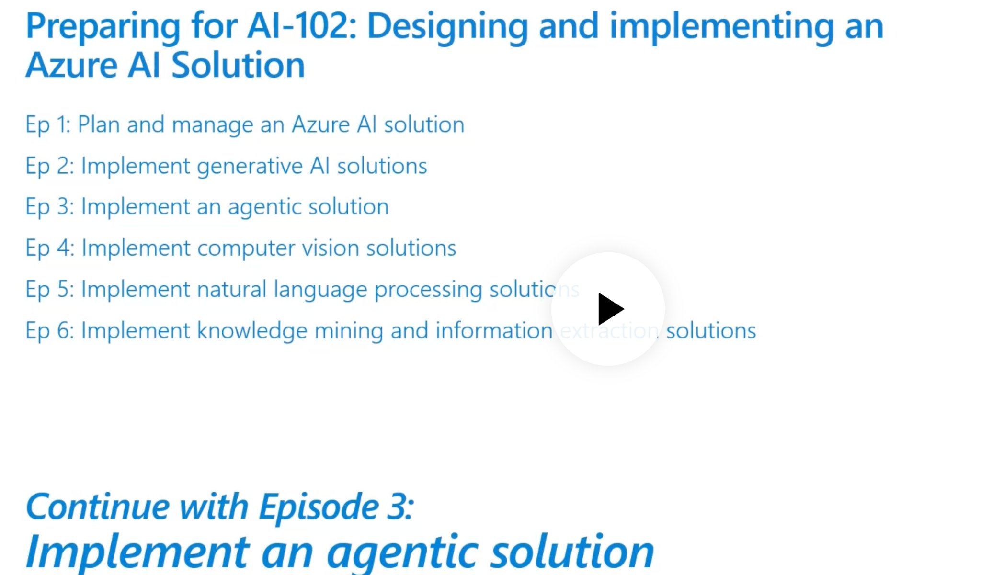

Deep explanation and exam focus
- The roadmap image shows AI-102 preparation as a sequence of episodes: planning, generative AI, agentic solutions, computer vision, NLP, and knowledge mining/information extraction.
- Episode 2 builds on Episode 1 because generative AI solutions still require planning, security, monitoring, cost control, and responsible AI governance.
- Episode 2 prepares for Episode 3 because agents extend generative AI with tool use, autonomy, state, and orchestration.
- Episode 2 also depends on Episode 4 image capabilities when multimodal models or vision-based inputs are used.
- Episode 2 depends on Episode 5 NLP when the app needs PII detection, sentiment analysis, translation, speech, and custom language understanding.
- Episode 2 depends on Episode 6 because RAG requires knowledge mining, AI Search, document processing, chunking, embedding, indexing, and retrieval evaluation.
- The high-end restaurant project is a good capstone because it naturally combines all episodes: concierge chat, reservations, documents, images, speech, translation, and search.
- A strong implementation plan should be phased so each episode adds measurable capabilities without destabilizing existing functionality.
- For hands-on preparation, keep a checklist that maps each endpoint, service adapter, test, evaluation, and dashboard to a Microsoft Learn objective.
- A 100 percent preparation mindset means not just knowing the correct answer but being able to explain why other plausible services are wrong for the scenario.

20 sample questions and answers
Q1. How does Episode 2 connect to Episode 1?
Answer: Generative AI solutions still require resource planning, model deployment choices, secure SDK use, monitoring, cost management, and responsible AI controls from Episode 1.
Q2. How does Episode 2 prepare for agentic solutions?
Answer: Once prompt, RAG, model calls, tools, and tracing are understood, agents become an orchestration layer over these building blocks.
Q3. Why does a generative AI project need computer vision knowledge?
Answer: Modern multimodal applications may process images, screenshots, menus, event photos, or plates in addition to text.
Q4. Why does a generative AI project need NLP knowledge?
Answer: NLP services provide deterministic sentiment, PII detection, key phrase extraction, language detection, and translation that should not always be handled by an LLM.
Q5. Why does a generative AI project need knowledge mining?
Answer: RAG requires indexed private data, chunking, embeddings, retrieval, citation metadata, and evaluation of search quality.
Q6. What makes the restaurant concierge a capstone project?
Answer: It combines chat, RAG, multilingual support, voice, image generation, document extraction, safety, monitoring, and human escalation.
Q7. What is the recommended learning order?
Answer: Master planning and service selection first, then generative AI, then agents, then vision, NLP, and information extraction because later topics feed back into richer applications.
Q8. How should project work be organized by episode?
Answer: Use dedicated docs and backlog items for each episode, with acceptance criteria and tests that prove the Microsoft Learn objectives are implemented.
Q9. What is a useful study artifact?
Answer: A service-to-objective traceability matrix that maps every code file and endpoint to an exam objective and practice checkpoint.
Q10. How should Codex use this roadmap?
Answer: Codex should implement feature branches per episode, run tests after each branch, and update docs/evidence before moving to the next area.
Q11. How does Episode 6 strengthen Episode 2 RAG?
Answer: It supplies document intelligence, AI Search, skillsets, semantic/vector indexes, and content extraction needed for high-quality grounding.
Q12. How does Episode 5 strengthen concierge quality?
Answer: It adds translation, language detection, PII redaction, sentiment analysis, speech, and custom language models for intent routing.
Q13. How does Episode 4 strengthen restaurant operations?
Answer: It supports image analysis for plate presentation, event inspiration images, handwritten notes, and custom vision classifiers.
Q14. How should progress be validated?
Answer: Each phase should include unit tests, integration tests, evaluation datasets, latency measurements, cost measurements, and responsible AI test cases.
Q15. What is the most important exam habit?
Answer: Read the scenario carefully and identify the modality, output requirement, freshness need, security constraint, and operational requirement before choosing a service.
Q16. What should be documented for every feature?
Answer: Document service choice, alternatives rejected, authentication, cost driver, monitoring signal, safety risk, test evidence, and rollback plan.
Q17. What should be avoided in the capstone?
Answer: Avoid making one LLM do every task. Dedicated Azure AI services are often cheaper, faster, safer, and more deterministic.
Q18. Why should the project keep mock mode?
Answer: Mock mode enables local development and CI testing without Azure costs, while real mode can be used for integration and production validation.
Q19. Why should the project add telemetry early?
Answer: Tracing and telemetry are needed to debug multi-step AI behavior, compare model versions, detect cost spikes, and collect evaluation evidence.
Q20. What proves readiness for Episode 2?
Answer: You can explain the slides, implement each feature in code, run a realistic restaurant scenario, evaluate outputs, monitor telemetry, and justify service choices.

Full hands-on implementation plan for the High-End Restaurant Generative AI Concierge
The plan below assumes Codex will implement changes in the local directory shown on the cover page. If the project is not already present on the Mac, extract the latest ZIP and copy it to the target path before starting. Each phase should finish with tests, updated docs, and a small demo script.
Phase | Goal | Definition of done
Phase 1 | Stabilize core | Run tests, add telemetry middleware, fix async/blocking SDK calls, add error handling, and document current endpoints.
Phase 2 | Complete missing service adapters | Implement real Document Intelligence, Speech STT/TTS, Vision Image Analysis, and Content Safety features.
Phase 3 | Upgrade RAG | Build restaurant knowledge ingestion, chunking, metadata enrichment, embeddings, Azure AI Search vector/hybrid index, and retrieval evaluation.
Phase 4 | Implement prompt flow | Create executable workflow runner with templates, trace spans, evaluation hooks, reflection, and fallback logic.
Phase 5 | Add Episode 2 content generation | Add DALL-E endpoint, multimodal endpoint, model-router, parameter tuning controls, and streaming chat response.
Phase 6 | Add feedback and evaluation | Create /feedback endpoint, user feedback schema, evaluation datasets, regression tests, red-team suite, and quality dashboards.
Phase 7 | Fine-tuning experiment | Prepare curated examples, validate data, run baseline, train candidate model, evaluate, canary, and document rollback.
Phase 8 | Deployment hardening | Update Bicep, containers, CI/CD, App Insights, Log Analytics, Key Vault, RBAC, and model update policy.

Feature implementation matrix
Feature | Restaurant use case | Project location | Acceptance criteria
Fine-tuning experiment | Brand-tone concierge responses and structured output consistency | evals/fine_tuning, scripts/run_finetune.py, docs/model_registry | Baseline and candidate eval report; no PII in dataset; rollback documented
Prompt flow runner | Repeatable pipeline for classify -> retrieve -> generate -> reflect -> moderate -> log | app/orchestrators/prompt_flow_runner.py | Trace spans for every step; failure handling; unit tests for routing
Azure OpenAI Assistant | Stateful private-dining planner with tool calls and human escalation | app/services/assistant_client.py | Can draft an event plan and escalation summary without confirming unavailable items
Large multimodal model | Analyze guest uploaded event inspiration images with text instructions | app/services/multimodal_client.py | Returns style tags, constraints, and safe suggestions with file validation
DALL-E image generation | Generate approved event mood board or menu-card concept images | app/services/dalle_client.py | Applies prompt templates and safety review before/after generation
Model reflection | Second-pass answer quality review | app/services/reflection_client.py | Blocks or revises unsupported, unsafe, off-brand, or uncited answers
Multi-model orchestration | Route tasks to the least complex correct model/service | app/orchestrators/model_router.py | Documented routing rules and cost-aware fallback logic
Tracing and feedback | Diagnose latency, tool calls, token usage, and user satisfaction | app/telemetry/tracing.py, app/api/feedback.py | Application Insights traces include request ID, model, tokens, search latency, safety result, feedback
Containers for local and edge | Reproducible runtime and optional edge profile | Dockerfile, docker-compose.yml, containers/edge | Health checks, environment validation, secure config, mock/offline mode

Restaurant-specific architecture details
- Guest channels: web chat, mobile app, phone transcription, concierge dashboard, and optional Teams/Bot channel for staff handoff.
- Knowledge sources: tasting menus, seasonal wine pairings, allergen policies, hours, cancellation rules, private dining packages, event setup guidelines, staff SOPs, and approved brand-voice examples.
- RAG index fields: content, title, source_uri, document_type, section, effective_date, expiry_date, allergens, cuisine_tags, private_dining_flag, policy_severity, and embedding vector.
- Prompt template variables: guest_message, language, occasion, party_size, dietary_constraints, retrieved_context, source_list, safety_policy, escalation_policy, and output_schema.
- Model routing: use deterministic services for translation, PII, OCR, document extraction, and safety; use Azure OpenAI for generation, reasoning, summarization, reflection, and DALL-E image generation.
- Safety controls: pre-moderate user input, detect prompt injection in uploaded documents, run output moderation, use blocklists for prohibited advice/guarantees, and escalate high-impact cases.
- Human-in-the-loop: reservations for large parties, allergy-sensitive recommendations, complaints, refund/cancellation disputes, VIP identification, and any ambiguous safety decision.
- Operational telemetry: log latency, search hit count, citations returned, token usage, model version, content safety result, reflection result, escalation reason, and feedback rating.

Suggested Codex work order
- Open the project at /Users/josekurian/AzureTemplate/OpenAI/HighEndRestaurantAIAutomation and run the existing test suite in mock mode.
- Create a branch named feature/episode2-generative-expansion.
- Add telemetry first so every later feature can be traced and debugged.
- Complete the NotImplemented service adapters for Vision, Speech, and Document Intelligence or create safe mock/real mode separation.
- Implement the RAG upgrade before fine-tuning because RAG is the correct solution for changing restaurant facts.
- Add prompt templates and a prompt-flow runner around the existing RestaurantConcierge.
- Add model reflection and output safety checks as quality gates before returning answers to guests.
- Add DALL-E and multimodal endpoints with strict file validation, safety controls, and usage limits.
- Add feedback collection and evaluation scripts to measure quality improvement.
- Add fine-tuning as an optional experiment after evaluation baselines exist.
- Update infrastructure, CI/CD, docs, and runbooks after application features pass tests.

Implementation user stories
Capability | User story | Acceptance criteria
Guest concierge chat | As a guest, I want accurate answers about menus and policies so that I can plan my visit. | Uses RAG, cites sources, redacts PII, blocks unsafe content, logs trace.
Private dining planner | As an event planner, I want a draft event plan from my preferences and uploaded inspiration images. | Uses multimodal analysis, RAG, generation, reflection, and human escalation.
Sommelier assistant | As a guest, I want wine pairing recommendations based on menu and dietary preference. | Uses RAG, allergy safety, tone prompt, and no medical/health claims.
Menu concept image | As marketing staff, I want DALL-E-generated mood-board images for internal concept review. | Uses image prompt template, safety review, watermark/internal-use label.
Manager feedback loop | As a manager, I want to rate AI answers and supply corrections. | Stores feedback with trace ID and evaluation tags.
Model candidate release | As an AI engineer, I want to compare base and fine-tuned models before promotion. | Automated evals show improvement without safety or cost regression.

Evaluation and test plan
- Create evals/episode2_concierge_cases.json with at least 100 cases: menu Q&A, allergen handling, private dining, multilingual requests, image prompts, unsafe prompts, prompt injection, and edge cases.
- Track metrics: groundedness pass rate, citation accuracy, tone adherence, safety pass rate, prompt shield catch rate, PII redaction rate, schema-valid output rate, latency P95, and token cost per successful answer.
- Add unit tests for each service adapter in mock mode and integration tests gated by environment variables for real Azure resources.
- Add red-team cases for jailbreak attempts, indirect prompt injection in retrieved documents, false menu facts, hallucinated availability, and unsafe allergy advice.
- Add regression gates in CI: no merge if safety pass rate decreases, if schema-valid output drops, if uncited factual claims increase, or if token budget exceeds threshold.
- Use canary deployment for model changes and compare production traces before rolling out to all traffic.

Fine-tuning experiment implementation details
- Goal: improve brand voice and output format, not inject changing restaurant facts.
- Dataset: curated conversations with system, user, and ideal assistant messages; no personal data, payment data, secrets, or stale policy facts.
- Baseline: run current base model against the evaluation set and store quality, safety, latency, and cost metrics.
- Training: run the fine-tuning job only after dataset validation and safety review pass.
- Evaluation: compare base and fine-tuned model against holdout cases and red-team cases; do not evaluate on training examples only.
- Promotion: deploy candidate to staging, route small canary traffic, monitor feedback, and keep previous deployment available for rollback.

Appendix A: Direct mapping to AI-102 Episode 2 objectives
AI-102 objective | Project implementation evidence
Plan and prepare for a generative AI solution | Architecture, service selection, safety/risk plan, data sources, model routing, cost plan
Deploy a hub, project, and resources with Foundry | infra/bicep resources, Foundry/project connection notes, resource connection docs
Deploy appropriate generative AI model | Model router and deployment registry for chat, embeddings, image, multimodal, fine-tuned candidates
Implement prompt flow solution | app/orchestrators/prompt_flow_runner.py
Implement RAG pattern | app/rag pipeline and Azure AI Search vector/hybrid index
Evaluate models and flows | evals datasets, scripts/evaluate_candidate_model.py, CI quality gates
Integrate project with Foundry SDK | app/services/foundry_project_client.py and secure connection handling
Use prompt templates | prompts/restaurant_concierge/*.yaml and template tests
Provision Azure OpenAI resource | infra/bicep and deployment docs
Select and deploy model | model registry, model deployment configs, update policy docs
Submit prompts for code/natural language | OpenAI client and prompt templates
Use DALL-E model | app/services/dalle_client.py and /images/generate endpoint
Integrate Azure OpenAI into application | FastAPI endpoints and service adapters
Use large multimodal models | app/services/multimodal_client.py
Configure parameters | temperature, top_p, max tokens, response format, stop sequences in config
Monitoring and diagnostics | Application Insights, Log Analytics, tracing, dashboards
Optimize resources and model updates | quota, deployment update policy, canary, fallback
Enable tracing and feedback | telemetry/tracing.py and /feedback endpoint
Implement model reflection | reflection_client.py quality gate
Deploy containers | Dockerfile, docker-compose, Container Apps/AKS/edge profile
Orchestrate multiple models | model_router.py and prompt_flow_runner.py
Apply prompt engineering | prompt templates, system messages, few-shot examples, grounding rules
Fine-tune a generative model | evals/fine_tuning and scripts/run_finetune.py

Appendix B: Final readiness checklist
- Every Azure AI service call uses managed identity or Key Vault-backed secrets; no hardcoded keys.
- Every endpoint has mock-mode tests and real-mode integration instructions.
- RAG answers include source citations and do not answer unsupported restaurant facts confidently.
- Content Safety is applied to user input, retrieved documents, and generated output where appropriate.
- Prompt injection is tested through user prompts and malicious retrieved chunks.
- Tracing is enabled with correlation IDs across retrieval, model calls, safety checks, reflection, and feedback.
- Model deployments have version names, update policies, quotas, and rollback guidance.
- Fine-tuning artifacts include dataset review, baseline results, candidate results, and approval notes.
- CI/CD validates Bicep, tests application code, runs evals, and prevents unsafe regressions.
- A human escalation path exists for allergies, large reservations, complaints, VIP/identity, and uncertain answers.

