FPGA configuration

# DE2-115 Altera FPGA

# Connecting FPGA

# System device monitor

The FPGA board is found and listed as a new device named USB-Blaster

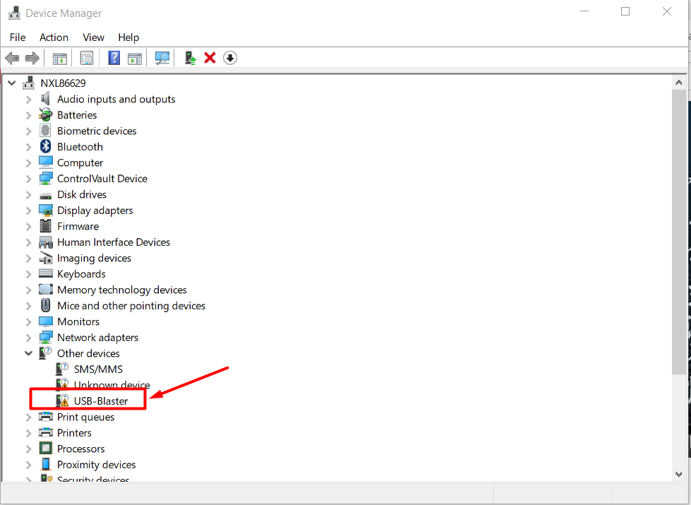

Figure USB-Blaster device

# Installing drivers for FPGA

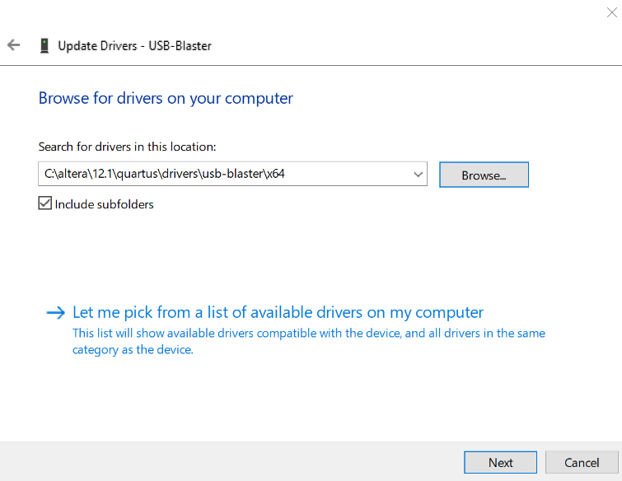

Figure 2 Locating drivers (select usb-blaster folder)

# Already installed driver

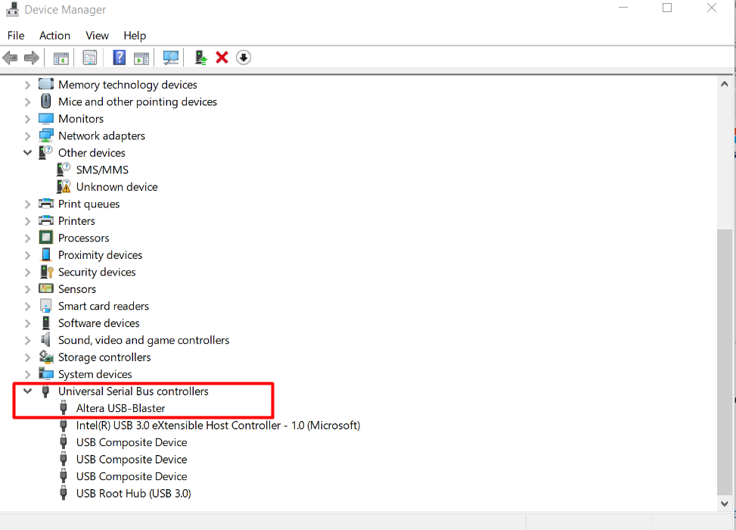

Figure Correct detection

# Reference

## Terasic setup <https://www.youtube.com/watch?v=5R5Tw_zSKZM>

## Terasic driver guide <http://www.terasic.com.tw/wiki/Altera_USB_Blaster_Driver_Installation_Instructions>

## Git <https://git-scm.com/download/win>

## Notepad++ <https://notepad-plus-plus.org/download/v7.6.html>

## Git setup <https://git-scm.com/book/en/v2/Getting-Started-First-Time-Git-Setup>