Meeting Notes 06/15/20

Make a python code that makes a graph for path planning and “intersection heuristics”
Everyone would contribute to this and not have to worry about Gazebo, ROS or even Linux - they can work on any operating system that has python.

The goal would be to create an animation like the one shown below using a plotting library (eg Matplotlib) to show where the robots start, where the finial destinations are and where the obstacles are.
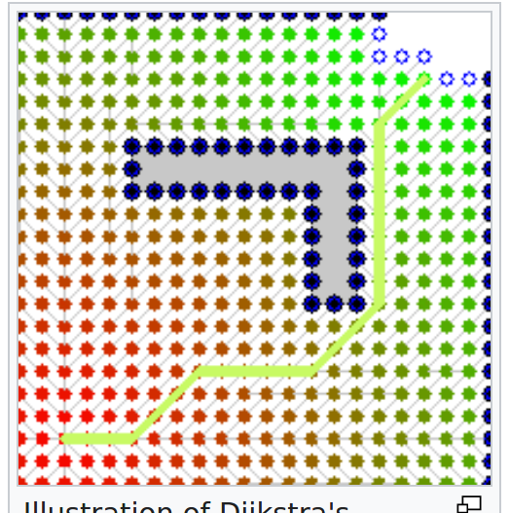
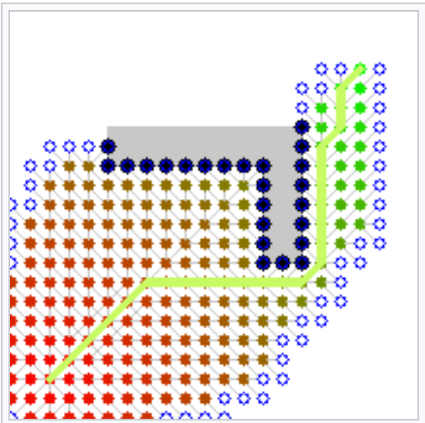
Once we have the path from the python code, we can then use Gazebo & ROS to implement the path plan and show a simulation.

The .py inputs and outputs could connect to Gazebo & ROS

There is some file (eg: .txt) that has starting & final locations for robots. And it
also has the coordinates of all of the obstacles in the Gazebo simulation.

