**LAB 6.2**

**LAB 6.3**



**LAB 6.4**

**LAB 6.5**



**LAB 6.7**

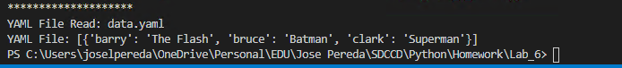

LAB 6.8



LAB 6.9