
Online
Object Oriented Programming
Computer Systems Engineering
José Manuel Rodríguez Cantú
00612676
Activity 2: Analyzing the American Stock Exchange
Module 2: Methods and Standard I/O Streams
José Abdón Espínola González
Date:
July 19, 2026

1. Description of the solution
This activity models a stock from the American Stock Exchange with an object-oriented approach. The program is split into two files: the Stock class, which holds the data and the behavior of a single stock, and a test program that creates one stock and reports its price change.
The Stock class keeps four private data fields: symbol and name (both String), and previousClosingPrice and currentPrice (both double). The constructor receives the symbol and the name when the object is created. The two prices are assigned afterward through setPreviousPrice and setNewPrice. The method getChangePercent applies the formula below, so the result is positive when the price rises and negative when it falls. A getter was added for each field to read the values from outside the class while the fields stay private, which keeps the object properly encapsulated.
getChangePercent = ((currentPrice - previousClosingPrice) / previousClosingPrice) * 100
The test program TestStock creates a Stock for Netflix with the symbol NFLX and the name Netflix Corporation. It sets the previous closing price to 337.5 and the current price to 345.23, and then prints the stock data together with the price-change percentage. With those values the change is ((345.23 - 337.5) / 337.5) * 100 = 2.29%, a small rise that the program also states in words.
2. Source code
Stock.java
/**
* Stock.java
* Models a stock traded on the American Stock Exchange.
* Object Oriented Programming - Module 2, Activity 2.
*/
public class Stock {
// Data fields
private String symbol; // the stock's symbol
private String name; // the stock's name
private double previousClosingPrice; // the stock price for the previous day
private double currentPrice; // the stock price for the current time

/** Constructor that creates a stock with the specified symbol and name. */
public Stock(String symbol, String name) {
this.symbol = symbol;
this.name = name;
}

/** Returns the stock's symbol. */
public String getSymbol() {
return symbol;
}

/** Returns the stock's name. */
public String getName() {
return name;
}

/** Returns the previous closing price. */
public double getPreviousClosingPrice() {
return previousClosingPrice;
}

/** Returns the current price. */
public double getCurrentPrice() {
return currentPrice;
}

/** Sets the value of the data field previousClosingPrice. */
public void setPreviousPrice(double previousClosingPrice) {
this.previousClosingPrice = previousClosingPrice;
}

/** Sets the value of the data field currentPrice. */
public void setNewPrice(double currentPrice) {
this.currentPrice = currentPrice;
}

/**
* Returns the percentage changed from previousClosingPrice to currentPrice.
* Formula: ((currentPrice - previousClosingPrice) / previousClosingPrice) * 100
* The value is positive if the price has gone up and negative if it has gone down.
*/
public double getChangePercent() {
return ((currentPrice - previousClosingPrice) / previousClosingPrice) * 100;
}
}
TestStock.java
/**
* TestStock.java
* Test program for the Stock class.
* Object Oriented Programming - Module 2, Activity 2.
*/
public class TestStock {
public static void main(String[] args) {
// Create a Stock object for Netflix with its symbol and name
Stock netflix = new Stock("NFLX", "Netflix Corporation");

// Set the previous closing price and the new current price
netflix.setPreviousPrice(337.5);
netflix.setNewPrice(345.23);

// Display the stock information
System.out.println("Stock symbol: " + netflix.getSymbol());
System.out.println("Stock name: " + netflix.getName());
System.out.printf("Previous closing price: $%.2f%n", netflix.getPreviousClosingPrice());
System.out.printf("Current price: $%.2f%n", netflix.getCurrentPrice());

// Display the price-change percentage
double change = netflix.getChangePercent();
System.out.printf("Price-change percentage: %.2f%%%n", change);

// Indicate whether the stock went up or down
if (change > 0) {
System.out.println("The stock price has gone up.");
} else if (change < 0) {
System.out.println("The stock price has gone down.");
} else {
System.out.println("The stock price has not changed.");
}
}
}
3. Execution evidence
The two files compile with javac without errors or warnings, and the test program produces the expected output. The screenshot below shows the compilation and the run:
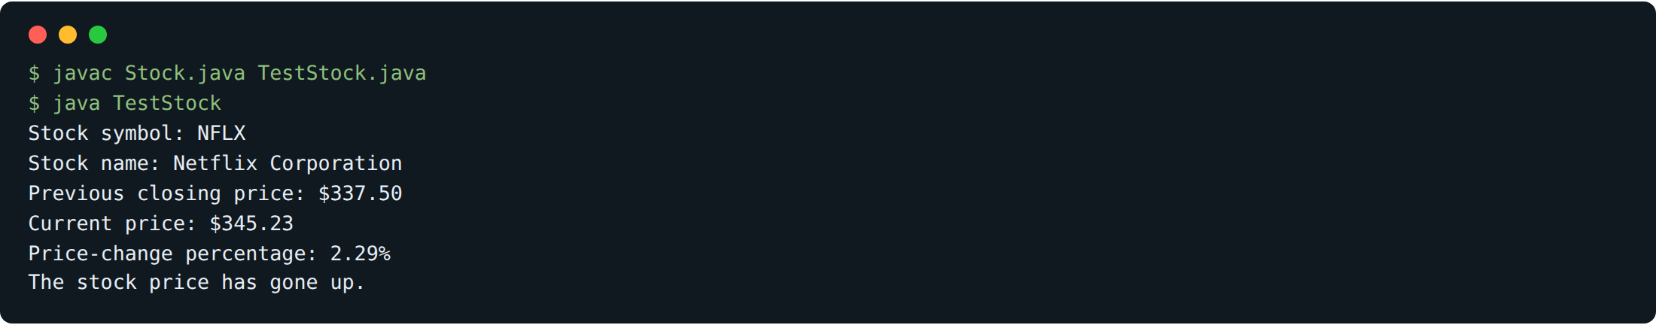
The current price (345.23) is higher than the previous closing price (337.5), so the change is positive: the Netflix stock went up 2.29% from one day to the next.

