
Online
Object Oriented Programming
Computer Systems Engineering
José Manuel Rodríguez Cantú
00612676
Activity 3: Class hierarchy design for a hospital software system
Module 3: Inheritance and Polymorphism
José Abdón Espínola González
Date:
July 24, 2026

1. Description of the solution
This activity models the people of a regional hospital with an object-oriented class hierarchy. The design rests on the three ideas the activity asks for: inheritance, abstraction and overloading. There are five files: the abstract class Person, its three subclasses Doctor, Patient and Guard, and a test program that creates one of each and registers them.
Person is an abstract superclass. It stores the two data fields every person shares, name and age, and exposes them through getName and getAge. It also declares an abstract method, register, with no body. Because the class is abstract it cannot be created on its own; it only serves as the common base for the specific people. That is abstraction: the shared idea of a person lives in one place and each subclass fills in the rest.
Doctor, Patient and Guard extend Person, so they inherit name, age and their getters. Each subclass adds only what makes it different: Doctor adds a department, Patient adds an illness, and Guard adds a shift and an optional phone. Every subclass constructor calls super(name, age), so the shared data is set by the Person constructor instead of being repeated in each class.
Each subclass writes its own register method. When register is called, Java runs the version that belongs to the real object, so a Doctor prints “Welcome Doctor!”, a Patient prints “Welcome Patient!” and a Guard prints “Welcome Guard!”. This is the idea from the learning goal, different people performing the same activity in their own way, and in Java it is called polymorphism.
Guard shows overloading with two constructors: one receives a phone number and the other does not. The shorter constructor calls the longer one with this(name, age, shift, null), so the setup code is written a single time and a guard can be created either way. The test uses John, created without a phone, and Kevin, created with one, to exercise both constructors.
2. Source code
Person.java
/**
* Person.java
* Abstract superclass for every person in the hospital system.
* It keeps the data and behavior shared by doctors, patients and guards,
* so that common code lives in a single place (abstraction + inheritance).
* Object Oriented Programming - Module 3, Activity 3.
*/
public abstract class Person {
// Data fields shared by every person
private String name; // the person's name
private int age; // the person's age in years

/** Constructor that sets the name and age common to every person. */
public Person(String nameP, int ageP) {
this.name = nameP;
this.age = ageP;
}

/** Returns the person's name. */
public String getName() {
return name;
}

/** Returns the person's age. */
public int getAge() {
return age;
}

/**
* Registers the person in the system. Each subclass greets its own kind
* of person in its own way, so the method is abstract and every subclass
* must provide its own version.
*/
public abstract void register();
}
Doctor.java
/**
* Doctor.java
* A doctor is a Person who also belongs to a medical department.
* Object Oriented Programming - Module 3, Activity 3.
*/
public class Doctor extends Person {
private String department; // the department the doctor works in

/** Creates a doctor with a name, an age and a department. */
public Doctor(String nameD, int ageD, String departmentD) {
super(nameD, ageD); // reuse the Person constructor for the shared data
this.department = departmentD;
}

/** Returns the doctor's department. */
public String getDepartment() {
return department;
}

/** Greets the doctor when registering. */
@Override
public void register() {
System.out.println("Welcome Doctor!");
}
}
Patient.java
/**
* Patient.java
* A patient is a Person who is admitted with a certain illness.
* Object Oriented Programming - Module 3, Activity 3.
*/
public class Patient extends Person {
private String illness; // the illness the patient is treated for

/** Creates a patient with a name, an age and an illness. */
public Patient(String nameP, int ageP, String illnessP) {
super(nameP, ageP); // reuse the Person constructor for the shared data
this.illness = illnessP;
}

/** Returns the patient's illness. */
public String getIllness() {
return illness;
}

/** Greets the patient when registering. */
@Override
public void register() {
System.out.println("Welcome Patient!");
}
}
Guard.java
/**
* Guard.java
* A guard is a Person who covers a shift and may have a contact phone.
* This class shows constructor overloading: a guard can be created with or
* without a phone number, and the shorter constructor reuses the longer one.
* Object Oriented Programming - Module 3, Activity 3.
*/
public class Guard extends Person {
private String shift; // the shift the guard covers (for example, Morning)
private String phone; // the guard's contact phone (optional)

/**
* Creates a guard without a phone number. It calls the other constructor
* with null as the phone, so the setup code is written only once.
*/
public Guard(String nameG, int ageG, String shiftG) {
this(nameG, ageG, shiftG, null); // constructor chaining (overloading)
}

/** Creates a guard with a phone number. */
public Guard(String nameG, int ageG, String shiftG, String phoneG) {
super(nameG, ageG); // reuse the Person constructor for the shared data
this.shift = shiftG;
this.phone = phoneG;
}

/** Returns the guard's shift. */
public String getShift() {
return shift;
}

/** Returns the guard's phone, or null if none was provided. */
public String getPhone() {
return phone;
}

/** Greets the guard when registering. */
@Override
public void register() {
System.out.println("Welcome Guard!");
}
}
HospitalTest.java
/**
* HospitalTest.java
* Test program for the hospital class hierarchy. It creates the four people
* requested in the activity and registers each one. The Guard cases show the
* two overloaded constructors: John is created without a phone and Kevin with
* a phone.
* Object Oriented Programming - Module 3, Activity 3.
*/
public class HospitalTest {
public static void main(String[] args) {
// Test data requested in the activity
Doctor doctor = new Doctor("Joseph", 41, "Neurologist");
Patient patient = new Patient("Richard", 78, "Chronic Headache");
Guard guardNoPhone = new Guard("John", 39, "Morning"); // 3-argument constructor
Guard guardWithPhone = new Guard("Kevin", 43, "Afternoon", "+52 232 456345"); // 4-argument constructor

System.out.println("=== Hospital registration system ===");

// Doctor
System.out.println();
System.out.println("Doctor");
System.out.println(" Name: " + doctor.getName());
System.out.println(" Age: " + doctor.getAge());
System.out.println(" Department: " + doctor.getDepartment());
doctor.register();

// Patient
System.out.println();
System.out.println("Patient");
System.out.println(" Name: " + patient.getName());
System.out.println(" Age: " + patient.getAge());
System.out.println(" Illness: " + patient.getIllness());
patient.register();

// Guard created without a phone (shorter overloaded constructor)
System.out.println();
System.out.println("Guard");
System.out.println(" Name: " + guardNoPhone.getName());
System.out.println(" Age: " + guardNoPhone.getAge());
System.out.println(" Shift: " + guardNoPhone.getShift());
System.out.println(" Phone: " + (guardNoPhone.getPhone() == null ? "not provided" : guardNoPhone.getPhone()));
guardNoPhone.register();

// Guard created with a phone (longer overloaded constructor)
System.out.println();
System.out.println("Guard");
System.out.println(" Name: " + guardWithPhone.getName());
System.out.println(" Age: " + guardWithPhone.getAge());
System.out.println(" Shift: " + guardWithPhone.getShift());
System.out.println(" Phone: " + (guardWithPhone.getPhone() == null ? "not provided" : guardWithPhone.getPhone()));
guardWithPhone.register();
}
}
3. Execution evidence
The five files compile with javac without errors or warnings, and the test program prints the data of the four people together with the welcome message produced by each register method. John, built with the three-argument constructor, shows “not provided” as phone, while Kevin, built with the four-argument constructor, shows his number. The screenshot shows the compilation and the run:
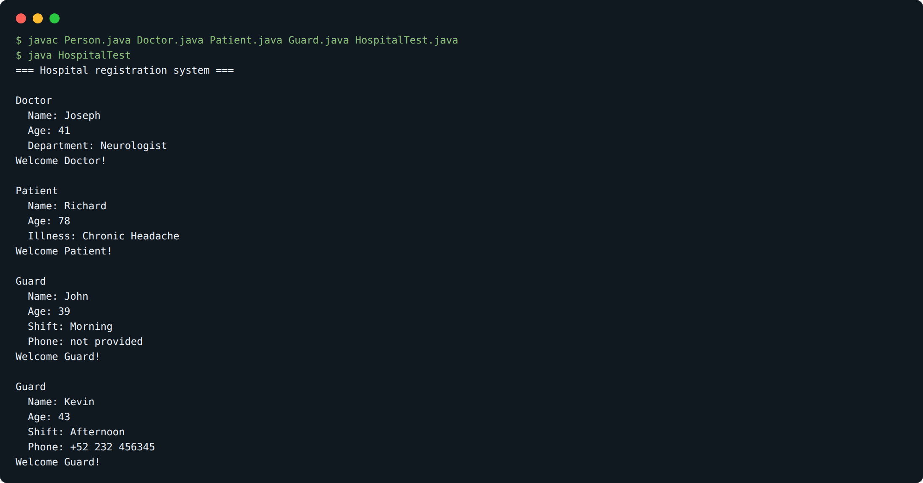
Each person is registered through its own register method, so the same call produces a different greeting depending on the object. The two Guard objects confirm that both overloaded constructors work: the one without a phone falls back to “not provided” and the one with a phone keeps the number.

