**Topologia de Rede**

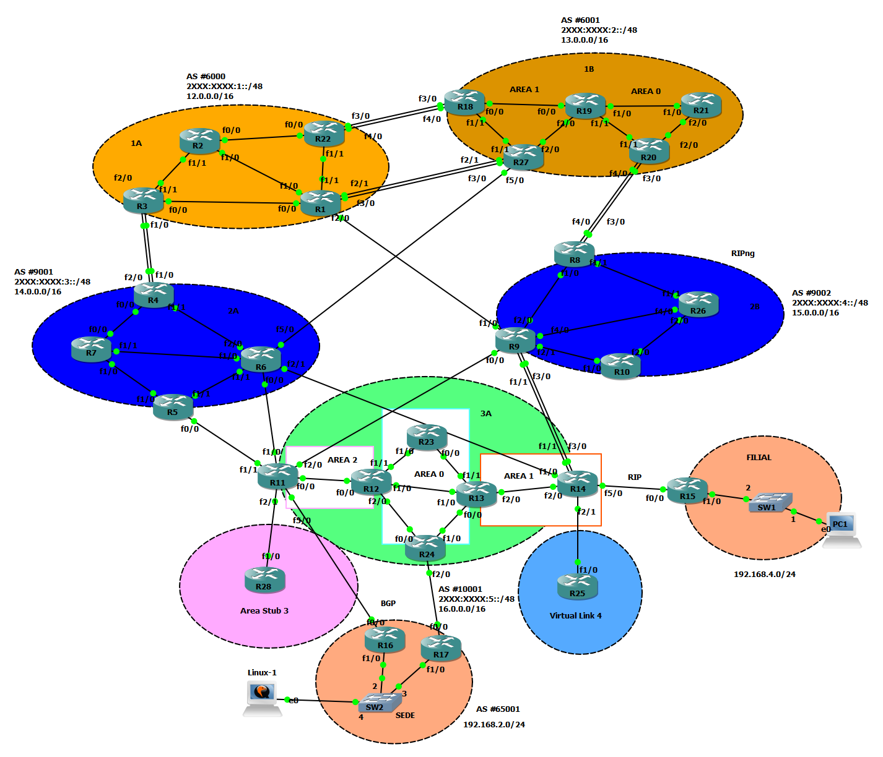

**Tabela de Encaminhamento**

|  |  |  |  |  |  |
| --- | --- | --- | --- | --- | --- |
| Router | Interface | IPv4 | IPv6 |  | Tier |
| 1 | f0/0 | 12.1.0.1/30 | 2221:2947:1:1::1/64 |  | 1A |
| f1/0 | 12.1.0.5/30 | 2221:2947:1:2::1/64 |  | 1B |
| f1/1 | 12.1.0.9/30 | 2221:2947:1:3::1/64 |  | 2A |
| f2/0 | 12.1.0.33/30 | 2221:2947:1:9::1/64 |  | 2B |
| f3/0 | 12.1.0.45/30 | 2221:2947:1:C::1/64 |  | 3A |
| f2/1 | 12.1.0.13/30 | 2221:2947:1:8::1/64 |  | Sede |
| Loopback | 12.0.0.1/32 | 2221:2947:1:0::1/128 |  | Sair da Area |
| 2 | f0/0 | 12.1.0.17/30 | 2221:2947:1:5::1/64 |  | Link Local |
| f1/0 | 12.1.0.6/30 | 2221:2947:1:2::2/64 |  | FE80::nºRouter |
| f1/1 | 12.1.0.21/30 | 2221:2947:1:4::2/64 |  | Filial |
| Loopback | 12.0.0.2/32 | 2221:2947:1:0::2/128 |  |  |
| 3 | f0/0 | 12.1.0.2/30 | 2221:2947:1:1::2/64 |  |  |
| f1/0 | 12.1.0.29/30 | 2221:2947:1:A::1/64 |  |  |
| f1/1 | 12.1.0.22/30 | 2221:2947:1:4::1/64 |  |  |
| f2/0 | 12.1.0.25/30 | 2221:2947:1:B::1/64 |  |  |
| Loopback | 12.0.0.3/32 | 2221:2947:1:0::3/128 |  |  |
| 4 | f0/0 | 14.1.0.5/30 | 2221:2947:3:1::1/64 |  |  |
| f1/0 | 12.1.0.30/30 | 2221:2947:1:A::2/64 |  |  |
| f1/1 | 14.1.0.1/30 | 2221:2947:3:2::1/64 |  |  |
| f2/0 | 12.1.0.26/30 | 2221:2947:1:B::2/64 |  |  |
| Loopback | 14.0.0.4/32 | 2221:2947:3:0::4/128 |  |  |
| 5 | f0/0 | 14.1.0.25/30 | 2221:2947:3:9::1/64 |  |  |
| f1/0 | 14.1.0.14/30 | 2221:2947:3:4::2/64 |  |  |
| f1/1 | 14.1.0.17/30 | 2221:2947:3:5::1/64 |  |  |
| Loopback | 14.0.0.5/32 | 2221:2947:3:0::5/128 |  |  |
| 6 | f0/0 | 14.1.0.21/30 | 2221:2947:3:6::1/64 |  |  |
| f1/0 | 14.1.0.10/30 | 2221:2947:3:3::2/64 |  |  |
| f1/1 | 14.1.0.18/30 | 2221:2947:3:5::2/64 |  |  |
| f2/0 | 14.1.0.2/30 | 2221:2947:3:2::2/64 |  |  |
| f2/1 | 14.1.0.29/30 | 2221:2947:3:8::1/64 |  |  |
| f5/0 | 14.1.0.33/30 | 2221:2947:3:7::1/64 |  |  |
| Loopback | 14.0.0.6/32 | 2221:2947:3:0::6/128 |  |  |
| 7 | f0/0 | 14.1.0.6/30 | 2221:2947:3:1::2/64 |  |  |
| f1/0 | 14.1.0.13/30 | 2221:2947:3:4::1/64 |  |  |
| f1/1 | 14.1.0.9/30 | 2221:2947:3:3::1/64 |  |  |
| Loopback | 14.0.0.7/32 | 2221:2947:3:0::7/128 |  |  |
| 8 | f1/0 | 15.1.0.5/30 | 2221:2947:4:1::1/64 |  |  |
| f1/1 | 15.1.0.1/30 | 2221:2947:4:2::1/64 |  |  |
| f3/0 | 13.1.0.26/30 | 2221:2947:2:7::2/64 |  |  |
| f4/0 | 13.1.0.30/30 | 2221:2947:2:8::2/64 |  |  |
| Loopback | 15.0.0.8/32 | 2221:2947:4:0::8/128 |  |  |
| 9 | f0/0 | 15.1.0.29/30 | 2221:2947:4:6::1/64 |  |  |
| f1/0 | 12.1.0.34/30 | 2221:2947:1:9::2/64 |  |  |
| f1/1 | 15.1.0.21/30 | 2221:2947:4:A::1/64 |  |  |
| f2/1 | 15.1.0.13/30 | 2221:2947:4:4::1/64 |  |  |
| f3/0 | 15.1.0.25/30 | 2221:2947:4:B::1/64 |  |  |
| f4/0 | 15.1.0.9/30 | 2221:2947:4:3::1/64 |  |  |
| f2/0 | 15.1.0.6/30 | 2221:2947:4:1::2/64 |  |  |
| Loopback | 15.0.0.9/32 | 2221:2947:4:0::9/128 |  |  |
| 10 | f1/0 | 15.1.0.14/30 | 2221:2947:4:4::2/64 |  |  |
| f2/0 | 15.1.0.17/30 | 2221:2947:4:5::1/64 |  |  |
| Loopback | 15.0.0.10/32 | 2221:2947:4:0::10/128 |  |  |
| 11 | f2/0 | 15.1.0.30/30 | 2221:2947:4:6::2/64 |  |  |
| f0/0 | 16.1.0.1/30 | 2221:2947:5:1::1/64 |  |  |
| f2/1 | 16.1.0.5/30 | 2221:2947:5:9::1/64 |  |  |
| f1/0 | 14.1.0.22/30 | 2221:2947:3:6::2/64 |  |  |
| f5/0 | 16.1.0.41/30 | 2221:2947:5:C::1/64 |  |  |
| f1/1 | 14.1.0.26/30 | 2221:2947:3:9::2/64 |  |  |
| Loopback | 16.0.0.11/32 | 2221:2947:5:0::11/128 |  |  |
| 12 | f0/0 | 16.1.0.2/30 | 2221:2947:5:1::2/64 |  |  |
| f1/1 | 16.1.0.13/30 | 2221:2947:5:2::1/64 |  |  |
| f2/0 | 16.1.0.17/30 | 2221:2947:5:4::1/64 |  |  |
| f1/0 | 16.1.0.21/30 | 2221:2947:5:3::1/64 |  |  |
| Loopback | 16.0.0.12/32 | 2221:2947:5:0::12/128 |  |  |
| 13 | f1/1 | 16.1.0.26/30 | 2221:2947:5:5::2/64 |  |  |
| f0/0 | 16.1.0.30/30 | 2221:2947:5:6::2/64 |  |  |
| f2/0 | 16.1.0.33/30 | 2221:2947:5:7::1/64 |  |  |
| f1/0 | 16.1.0.22/30 | 2221:2947:5:3::2/64 |  |  |
| Loopback | 16.0.0.13/32 | 2221:2947:5:0::13/128 |  |  |
| 14 | f1/1 | 15.1.0.22/30 | 2221:2947:4:A::2/64 |  |  |
| f1/0 | 14.1.0.30/30 | 2221:2947:3:8::2/64 |  |  |
| f2/1 | 16.1.0.37/30 | 2221:2947:5:8::1/64 |  |  |
| f3/0 | 15.1.0.26/30 | 2221:2947:4:B::2/64 |  |  |
| f5/0 | 16.1.0.49/30 | 2221:2947:5:E::1/64 |  |  |
| f2/0 | 16.1.0.34/30 | 2221:2947:5:7::2/64 |  |  |
| Loopback | 16.0.0.14/32 | 2221:2947:5:0::14/128 |  |  |
| 15 | f1/0 | 192.168.4.254/24 | x |  |  |
| f0/0 | 16.1.0.50/30 | 2221:2947:5:E::2/64 |  |  |
| 16 | f1/0 | 192.168.2.253/24 | x |  |  |
| f0/0 | 16.1.0.42/30 | 2221:2947:5:C::2/64 |  |  |
| Loopback | 16.0.0.16/32 | 2221:2947:5::16/128 |  |  |
| 17 | f1/0 | 192.168.2.252/24 | x |  |  |
| f0/0 | 16.1.0.46/30 | 2221:2947:5:D::2/64 |  |  |
| Loopback | 16.0.0.17/32 | 2221:2947:5:0::17/128 |  |  |
| 18 | f0/0 | 13.1.0.1/30 | 2221:2947:2:1::1/64 |  |  |
| f1/1 | 13.1.0.5/30 | 2221:2947:2:2::1/64 |  |  |
| f3/0 | 12.1.0.38/30 | 2221:2947:1:6::2/64 |  |  |
| f4/0 | 12.1.0.42/30 | 2221:2947:1:7::2/64 |  |  |
| Loopback | 13.0.0.18/32 | 2221:2947:2:0::18/128 |  |  |
| 19 | f0/0 | 13.1.0.2/30 | 2221:2947:2:1::2/64 |  |  |
| f1/0 | 13.1.0.13/30 | 2221:2947:2:5::1/64 |  |  |
| f1/1 | 13.1.0.17/30 | 2221:2947:2:4::1/64 |  |  |
| f2/0 | 13.1.0.10/30 | 2221:2947:2:3::2/64 |  |  |
| Loopback | 13.0.0.19/32 | 2221:2947:2:0::19/128 |  |  |
| 20 | f1/1 | 13.1.0.18/30 | 2221:2947:2:4::2/64 |  |  |
| f2/0 | 13.1.0.21/30 | 2221:2947:2:6::1/64 |  |  |
| f3/0 | 13.1.0.25/30 | 2221:2947:2:7::1/64 |  |  |
| f4/0 | 13.1.0.29/30 | 2221:2947:2:8::1/64 |  |  |
| Loopback | 13.0.0.20/32 | 2221:2947:2:0::20/128 |  |  |
| 21 | f1/0 | 13.1.0.14/30 | 2221:2947:2:5::2/64 |  |  |
| f2/0 | 13.1.0.22/30 | 2221:2947:2:6::2/64 |  |  |
| Loopback | 13.0.0.21/32 | 2221:2947:2:0::21/128 |  |  |
| 22 | f0/0 | 12.1.0.18/30 | 2221:2947:1:5::2/64 |  |  |
| f1/1 | 12.1.0.10/30 | 2221:2947:1:3::2/64 |  |  |
| f3/0 | 12.1.0.37/30 | 2221:2947:1:6::1/64 |  |  |
| f4/0 | 12.1.0.41/30 | 2221:2947:1:7::1/64 |  |  |
| Loopback | 12.0.0.22/32 | 2221:2947:1:0::22/128 |  |  |
| 23 | f0/0 | 16.1.0.25/30 | 2221:2947:5:5::1/64 |  |  |
| f1/0 | 16.1.0.14/30 | 2221:2947:5:2::2/64 |  |  |
| Loopback | 16.0.0.23/32 | 2221:2947:5:0::23/128 |  |  |
| 24 | f0/0 | 16.1.0.18/30 | 2221:2947:5:4::2/64 |  |  |
| f2/0 | 16.1.0.45/30 | 2221:2947:5:D::1/64 |  |  |
| f1/0 | 16.1.0.29/30 | 2221:2947:5:6::1/64 |  |  |
| Loopback | 16.0.0.24/32 | 2221:2947:5:0::24/128 |  |  |
| 25 | f1/0 | 16.1.0.38/30 | 2221:2947:5:8::2/64 |  |  |
| Loopback | 16.0.0.25/32 | 2221:2947:5:0::25/128 |  |  |
| 26 | f1/1 | 15.1.0.2/30 | 2221:2947:4:2::2/64 |  |  |
| f2/0 | 15.1.0.18/30 | 2221:2947:4:5::2/64 |  |  |
| f4/0 | 15.1.0.10/30 | 2221:2947:4:3::2/64 |  |  |
| Loopback | 15.0.0.26/32 | 2221:2947:4:0::26/128 |  |  |
| 27 | f1/1 | 13.1.0.6/30 | 2221:2947:2:2::2/64 |  |  |
| f2/0 | 13.1.0.9/30 | 2221:2947:2:3::1/64 |  |  |
| f2/1 | 12.1.0.14/30 | 2221:2947:1:8::2/64 |  |  |
| f3/0 | 12.1.0.46/30 | 2221:2947:1:C::2/64 |  |  |
| f5/0 | 14.1.0.34/30 | 2221:2947:3:7::2/64 |  |  |
| Loopback | 13.0.0.27/32 | 2221:2947:2:0::27/128 |  |  |
| 28 | f0/0 | 16.1.0.9/30 | 2221:2947:5:A::1/64 |  |  |
| f1/0 | 16.1.0.6/30 | 2221:2947:5:9::2/64 |  |  |
| Loopback | 16.0.0.28/32 | 2221:2947:5:0::28/128 |  |  |

**Esquema de Endereçamentos**

|  |  |  |
| --- | --- | --- |
|  | | |
| **Rede** | **IPv4** | **IPv6** |
| **R1-R2** | 12.1.0.4/30 | 2221:2947:1:2::/64 |
| **R1-R3** | 12.1.0.0/30 | 2221:2947:1:1::/64 |
| **R1-R22** | 12.1.0.8/30 | 2221:2947:1:3::/64 |
| **R1-R27(1)** | 12.1.0.12/30 | 2221:2947:1:8::/64 |
| **R1-R27(2)** | 12.1.0.44/30 | 2221:2947:1:C::/64 |
| **R1-R9** | 12.1.0.32/30 | 2221:2947:1:9::/64 |
| **R2-R22** | 12.1.0.16/30 | 2221:2947:1:5::/64 |
| **R2-R3** | 12.1.0.20/30 | 2221:2947:1:4::/64 |
| **R3-R4(1)** | 12.1.0.24/30 | 2221:2947:1:B::/64 |
| **R3-R4(2)** | 12.1.0.28/30 | 2221:2947:1:A::/64 |
| **R22-R18(1)** | 12.1.0.36/30 | 2221:2947:1:6::/64 |
| **R22-R18(2)** | 12.1.0.40/30 | 2221:2947:1:7::/64 |
| **R4-R7** | 14.1.0.4/30 | 2221:2947:3:1::/64 |
| **R4-R6** | 14.1.0.0/30 | 2221:2947:3:2::/64 |
| **R5-R6** | 14.1.0.16/30 | 2221:2947:3:5::/64 |
| **R5-R7** | 14.1.0.12/30 | 2221:2947:3:4::/64 |
| **R5-R11** | 14.1.0.24/30 | 2221:2947:3:9::/64 |
| **R6-R27** | 14.1.0.32/30 | 2221:2947:3:7::/64 |
| **R6-R14** | 14.1.0.28/30 | 2221:2947:3:8::/64 |
| **R6-R11** | 14.1.0.20/30 | 2221:2947:3:6::/64 |
| **R11-R9** | 15.1.0.28/30 | 2221:2947:4:6::/64 |
| **R11-R28** | 16.1.0.5/30 | 2221:2947:5:9::/64 |
| **R11-R12** | 16.1.0.0/30 | 2221:2947:5:1::/64 |
| **R12-R23** | 16.1.0.12/30 | 2221:2947:5:2::/64 |
| **R12-R13** | 16.1.0.20/30 | 2221:2947:5:3::/64 |
| **R12-R24** | 16.1.0.16/30 | 2221:2947:5:4::/64 |
| **R13-R23** | 16.1.0.24/30 | 2221:2947:5:5::/64 |
| **R13-R24** | 16.1.0.28/30 | 2221:2947:5:6::/64 |
| **R13-R14** | 16.1.0.32/30 | 2221:2947:5:7::/64 |
| **R14-R25** | 16.1.0.36/30 | 2221:2947:5:8::/64 |
| **R14-R9(1)** | 15.1.0.20/30 | 2221:2947:4:A::/64 |
| **R14-R9(2)** | 15.1.0.24/30 | 2221:2947:4:B::/64 |
| **R8-R9** | 15.1.0.4/30 | 2221:2947:4:1::/64 |
| **R8-R26** | 15.1.0.0/30 | 2221:2947:4:2::/64 |
| **R8-R20(1)** | 13.1.0.24/30 | 2221:2947:2:7:2/64 |
| **R8-R20(2)** | 13.1.0.28/30 | 2221:2947:2:8::/64 |
| **R9-R10** | 15.1.0.12/30 | 2221:2947:4:4::/64 |
| **R9-R26** | 15.1.0.8/30 | 2221:2947:4:3::/64 |
| **R10-R26** | 15.1.0.16/30 | 2221:2947:4:5::/64 |
| **R18-R19** | 13.1.0.0/30 | 2221:2947:2:1::/64 |
| **R14-R15** | 16.1.0.48/30 | 2221:2947:5:E::/64 |
| **R18-R27** | 13.1.0.4/30 | 2221:2947:2:2::/64 |
| **R19-R27** | 13.1.0.8/30 | 2221:2947:2:3::/64 |
| **R19-R20** | 13.1.0.16/30 | 2221:2947:2:4::/64 |
| **R19-R21** | 13.1.0.12/30 | 2221:2947:2:5::1/64 |
| **R20-R21** | 13.1.0.20/30 | 2221:2947:2:6::1/64 |
| **R11-R16** | 16.1.0.40/30 | 2221:2947:5:C::/64 |
| **R24-R17** | 16.1.0.45/30 | 2221:2947:5:D::/64 |
| **PC2-R16** | 192.168.2.0/24 | X |
| **PC2-R17** | 192.168.2.0/24 | X |
| **PC1-R15** | 192.168.4.0/24 | X |

**Configuracoes por protocolo iBGP**

***Tier 1A OSFP-AF Single-Area***

1 area 0 backbone para o OSPF

1 area 0 backbone para o OSPFv3

***Tier 1B OSPF Multi-Area***

OSPF:

1 area 0 backbone

1 area 1 ligada à backbone

OSPFv3:

1 area 0 backbone

1 area 1 ligada à backbone

***Tier 2A OSPF Single-Area***

1 area 0 backbone para o OSPF

1 area 0 backbone para o OSPFv3

***Tier 2B RIP/RIPng***

Um RIP version 2

Um RIPng denominado de RIP

***Tier 3A OSPF Multi-Area***

OSPF:

1 area 0 backbone

1 area 1 ligada à backbone e a área 4 Virtual-link

1 area 2 ligada à backbone e a área 3 Stub

Virtual link entre área 4 e área 1

Area Stub entre a área 3 e área 2

OSPFv3:

1 area 0 backbone

1 area 1 ligada à backbone

1 area 2 ligada à backbone e a área 3 Stub

Virtual link entre área 4 e área 1 e por último Area Stub entre a área 3 e área 2

**Prints de Pings e algumas configurações implementadas**

*Figura 1 – BGP_R1_config*

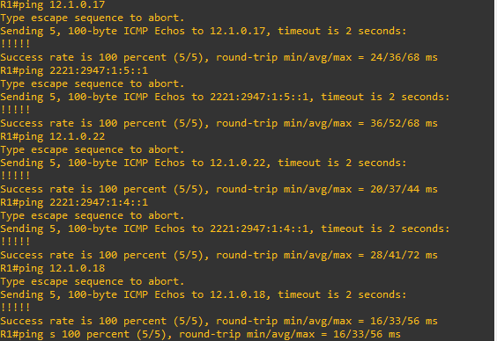

*Figura 2 – R1-mesmaAREA_1A*

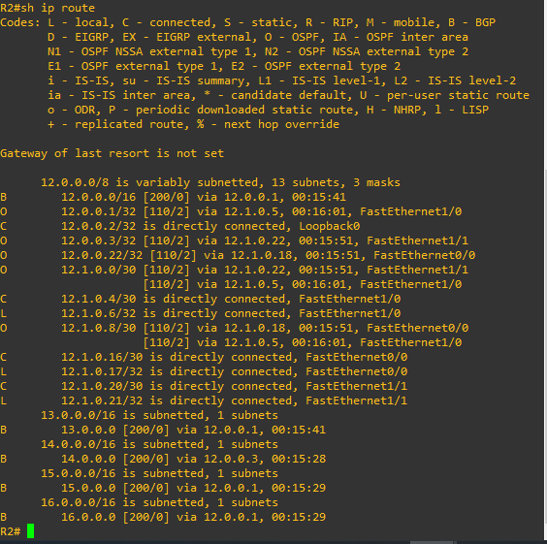

*Figura 3 – r2_shIP_ROUTE*

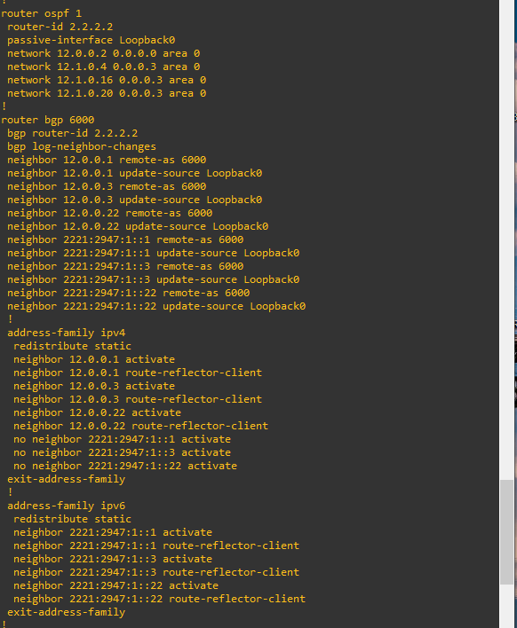

*Figura 4 – R2-config-ospf-bgp*

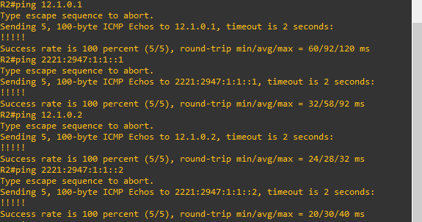

*Figura 5 – R2-mesmaAREA_1A*

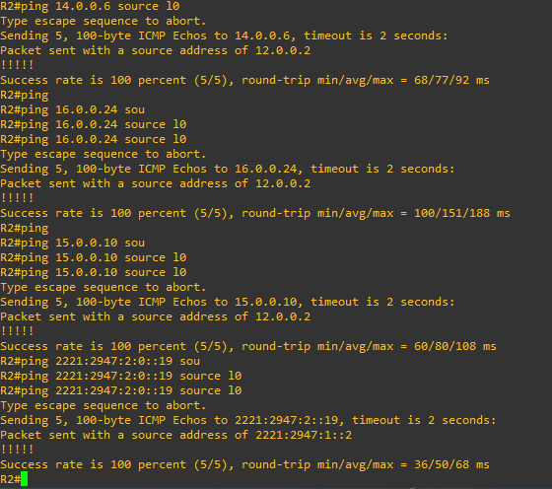

*Figura 6 – R2-PING_DIFERENTES_AREAS*

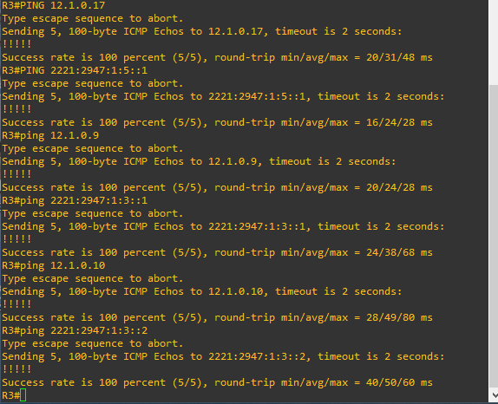

*Figura 7 – R3-mesmaAREA_1A*

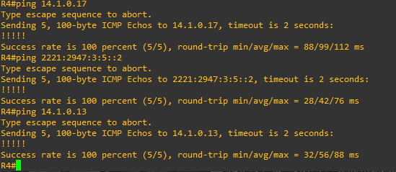

*Figura 8 – R4-mesmaAREA_2A*

*Figura 9 – R4-pings_DIFERENTES_AREAS*

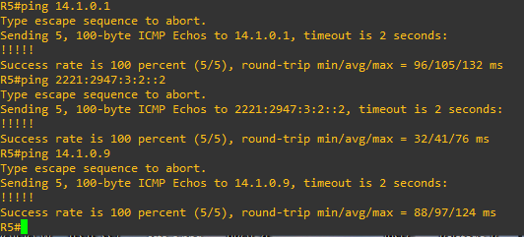

*Figura 10 – R5-mesmaAREA_2A*

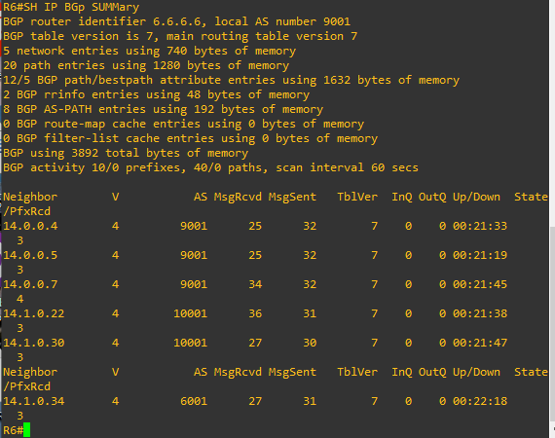

*Figura 11 – R6-config-BGP*

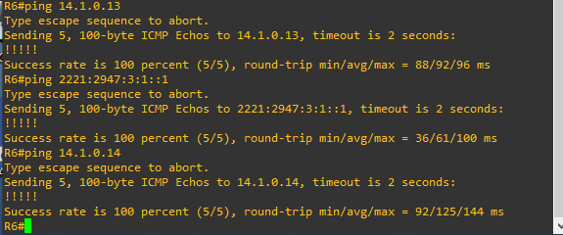

*Figura 12 – R6-mesmaAREA_2A*

*Figura 13– R7-config-ospf*

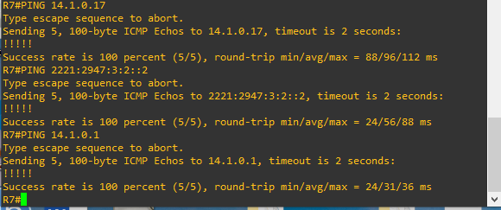

*Figura 14 – R7-mesmaAREA_2A*

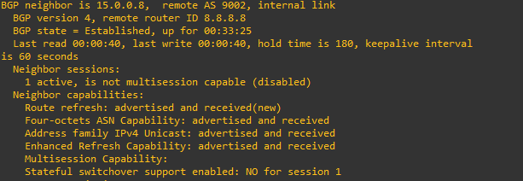

*Figura 15 – R9-BGP-comIPneighboor-2b*

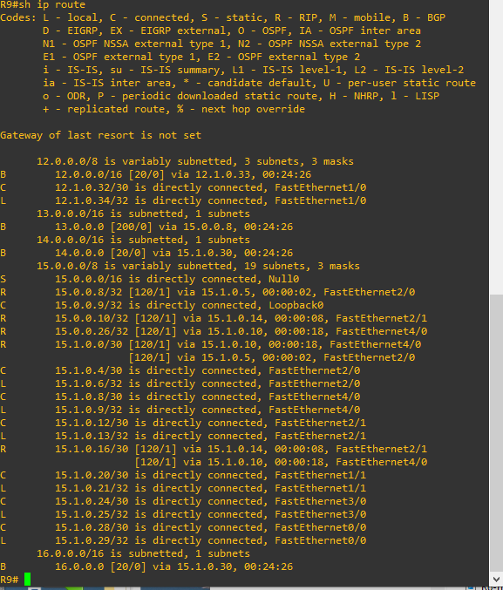

*Figura 16– r9-Shiproute-2b-comRIP*

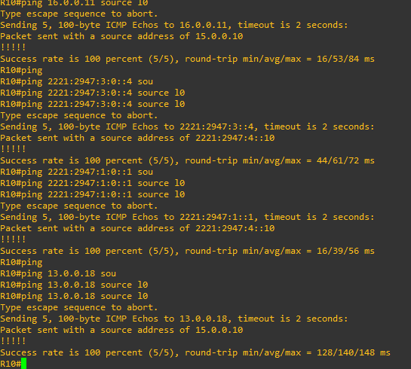

*Figura 17 – R10-AREA_DIF_PING-2B*

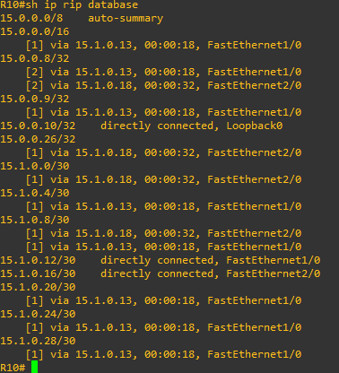

*Figura 18– R10-rip-config-database*

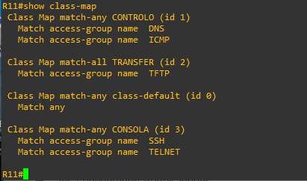

*Figura 19 – R11_classMAP-CONFIG-3A*

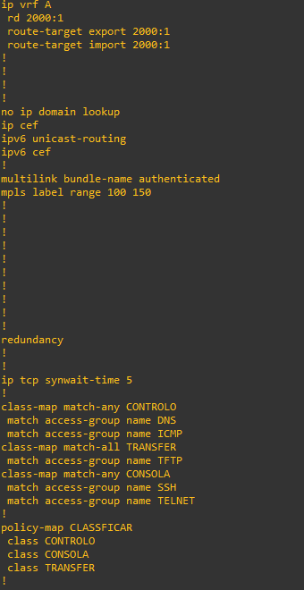

*Figura 20 – R11-config-vpn-e-policyMAP-3A*

*Figura 21 – R12-vpn4-CONFIG*

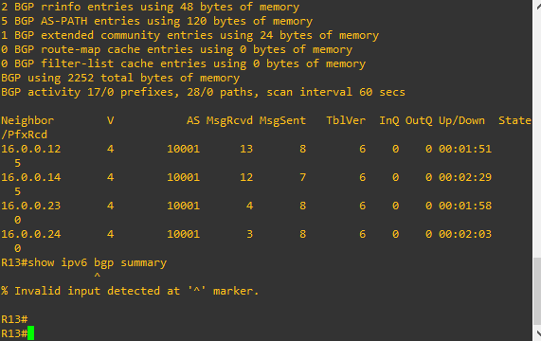

*Figura 22 – R13-IBGP_ON*

*Figura 23 – R14-Config-bgp-UP*

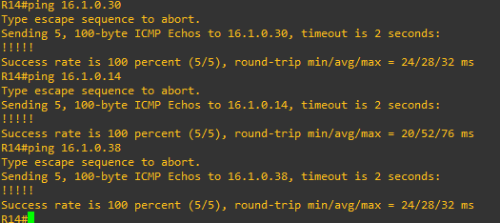

*Figura 24 – r14-ping-sameAREA3A*

*Figura 25 – R15-accesslist-3A*

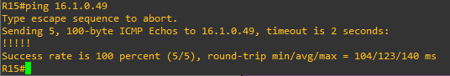

*Figura 26 – r15-ping-area3a_daFILIAL*

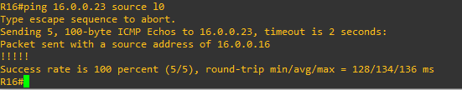

*Figura 27 – R16_sede_ping-AREA3A*

*Figura 28 – r19_bgp_neighbors*

*Figura 29 – R19-mesmaAREA_1B*

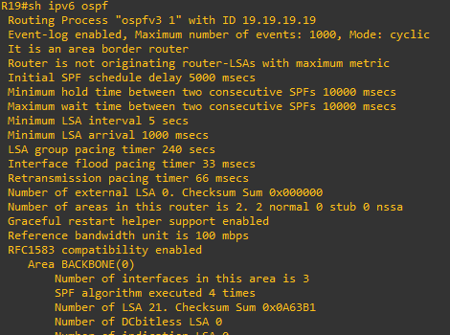

*Figura 30 – R19-ospf-area0e1-1b*

*Figura 31 – R20-ospf-area0-1b*

*Figura 32 – R22-mesmaAREA_1A*

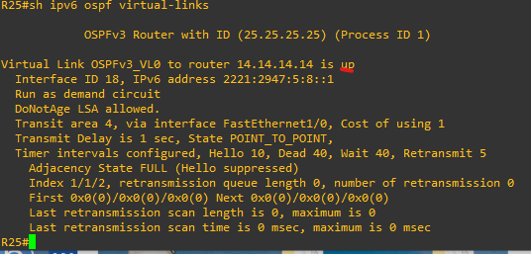

*Figura 33 – R25-virtual-link_UP*

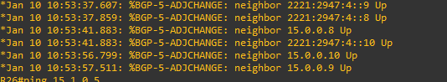

*Figura 34 – R26-bgp-up-2b*

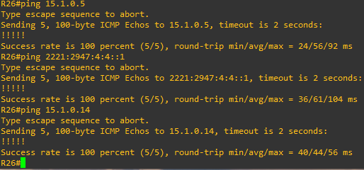

*Figura 35 – R26-mesmaAREA_2B*

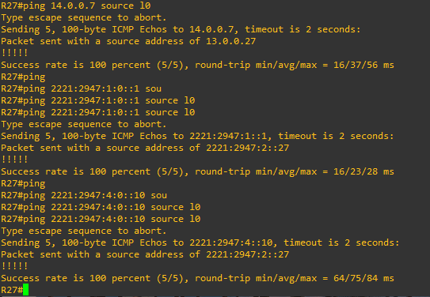

*Figura 36 – R27-DIFERENTES-AREAS-1B*

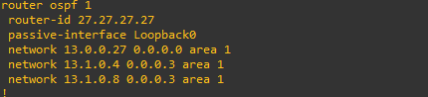

*Figura 37 – r27-ospf-area1-1b*

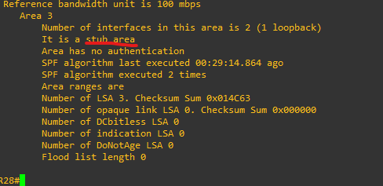

*Figura 38 – R28-configSTUB-3A*