Five ideas and two candidates
  - PAIBS Group 6 27 October 2026
Displayed eCampus deadline: 28 October 2026 at 00:00, the night of 27 October.
The five ideas below are present in the Miro column containing our team names. That visual column is labelled Team 5, while the formal eCampus roster is Group 6. Group 6 is the submission identifier. [C2 and C3]
Idea | User | Different output and main risk
Green Score Filler | OFF contributors | Predict a reference environmental score from ingredients and categories, then support review. Measurable regression target; risk of duplicating category averages.
Green Gains | Athletes comparing protein sources | Compare protein per unit of estimated climate impact. This is a comparison problem; it needs a valid CO2 quantity and unit, not Green Score points as a substitute.
Origin Parser | Importers and supply chain auditors | Extract structured ingredient origins from multilingual text. Evaluate extracted entities against manually checked examples; country of sale is not ingredient origin.
Student Athlete Frontier | Students choosing within a budget | Find Pareto trade offs between observed price, protein and estimated impact. This differs from Green Gains by its budget constraint and optimization output; price coverage is a dependency.
Data Cleaner | OFF editors | Use a trained text model to flag category inconsistencies for review. Begin with category mismatch detection; duplicate matching and nutrition anomalies are later extensions.

Current selection for development: Green Score Filler and Data Cleaner. The first began as missing score estimation; the second tests inconsistencies in existing categories. The first regression experiment did not beat the category baseline, so the final direction below refines Green Score Filler into suggestions for missing categories, with human review. Data Cleaner remains a separate candidate for detecting incorrect existing records. This selection is recorded on 27 October and does not reconstruct the original class vote.

Candidate A Green Score category completion and review
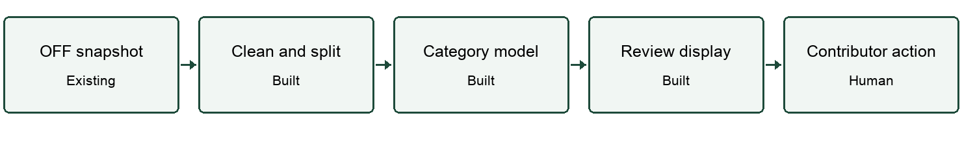
E means an existing component. B means the team is responsible for building it; the status says whether it is implemented. The experience column distinguishes current evidence from prior human experience, which each member must record.
Component | E or B | Implementation and knowledge | Experience and principal risk
OFF snapshot | E | Pinned public Parquet; selected fields and licence recorded. Databases and data handling. | Data access demonstrated. Team member prior experience still to be recorded. Risk: missing labels or unusable inputs.
Preprocessing | B done | Parse multilingual text, remove HTML, preserve zero, exclude not applicable, group exact matches. Programming and data preparation. | Implemented and tested. Risk: unrecognized variants still cross splits.
AI and evaluation | B done | Ingredient text TF IDF and category classifier; held out classification evaluation. Ridge score regression is retained as a negative experiment. ML and statistics. | Implemented. Risk: category shortcut or poor transfer to unlabelled records.
Saved output and interface | B done | Metrics, split audit, prediction CSV and read only local web interface. Software development and visualization. | Implemented. Risk: a suggestion could be mistaken for a verified category.
Contributor decision | Human | Review a category or supporting data; request a label or ingredient list; abstain outside scope. Domain and ethics. | Workflow specified; external contributor benefit not validated. Risk: no actionable correction follows.

Candidate B Category consistency review
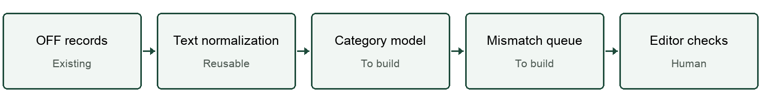
E means an existing component. B means the team is responsible for building it; the status says whether it is implemented. The experience column distinguishes current evidence from prior human experience, which each member must record.
Component | E or B | Implementation and knowledge | Experience and principal risk
OFF data | E | Reuse the same pinned product records and existing category tags. Databases. | Available. Risk: current category tags are noisy labels.
Text processing | B reusable | Reuse language parsing and duplicate grouping; hide category labels from text features. Data preparation. | Existing code can be reused. Prior individual experience to be recorded.
Category consistency model | B next | Train a text classifier or retrieval model and rank disagreement with recorded category. ML and NLP. | Not implemented as a separate candidate. Risk: real rare products look anomalous.
Review queue | B next | Show current category, suggested alternative, evidence and abstention. Visualization and software. | Reuse interface structure. Risk: confidence reflects noise rather than error.
Editor verification | Human | Check a sample of top flagged records and record accepted corrections. Evaluation. | To run with real examples. Critical risk: no reliable labels for actual mistakes.

Challenges and responses
Peer discussion record: the Miro note below our five ideas says discussing with Team 10. The substantive questions and responses must be supplied by the participants before this item is represented as a complete record of received peer feedback. The challenges below are our present technical review and are not attributed to Team 10.
Challenge | Response and test
Why predict a score that OFF already computes? | Compare against a category baseline and inspect which missing cases could benefit. Prefer completing a missing input where that unlocks the official calculation.
What if the category is missing or unsupported? | Audit missing reasons separately. The current interface withholds numeric estimates for missing or unseen categories and absent Agribalyse matches.
What if the model only works on complete labelled products? | Report labelled holdout performance separately, test category removal and compare input coverage. Genuine missing score accuracy remains unknown.
How do we know a flagged record is useful to review? | A text only assisted desk review of 20 cases is documented. Independent contributor checks against photos and taxonomy remain the next validation.
What if the alternative only uses simple validation rules? | Data Cleaner must train and evaluate a category model. Nutrition range checks alone do not satisfy meaningful AI.

Sources
[C1] PAIBS Session 1 Technical Slides
Slides 6 to 20 define the challenge, minimums, sketches and Session 2 preparation.
[C2] PAIBS class Miro board
Read on 27 October 2026. The names and five ideas are under the visual Team 5 column; a note below says discussing with Team 10.
[C3] eCampus Group Definition
Live roster on 27 October: Group 6, Adria Anglada Dolcet, Joan Batllo Rius, Josep Cubedo Macian and Natan Miguel Viejo Evrard.

