Recommending Movies from Sparse Ratings: A Comparison of Neighborhood and Latent-Factor Collaborative Filtering on MovieLens 100K

Manoj Kashyap Ranganath, Onyebuchi Asogwa, Blake Mires, and Jose M. Santiago Echevarria
University of the Cumberlands
PhDAI 732: Fundamentals of AI-Enabled Systems
Dr. Manjunath Paramashivaiah
July 23, 2026

Introduction and Problem Framing
A streaming service only earns from titles its subscribers actually watch, and the home screen has room for about ten of them. The business question is which ten titles a particular subscriber is most likely to enjoy. We cannot observe enjoyment, but we can observe ratings, so we restated that question as a supervised learning problem: given a history of user-movie ratings, predict the rating a user would give a movie they have not seen. The target is a value from 1 to 5, making this a regression task measured with Root Mean Squared Error (RMSE), and ranking those predictions produces the top-ten list. There is no feature matrix here, only a 943 by 1,682 grid that is roughly 94% empty, so every prediction must be borrowed from other users and other movies, the family of methods known as collaborative filtering. Three groups have different interests: subscribers want recommendations that are relevant and varied, the content team needs the licensed long tail to be reachable, and the business needs an accurate estimate of performance before anything reaches a customer. The work reported here is an initial model, built to establish a defensible baseline and to identify which approach is worth developing further, rather than a system ready for deployment.
Dataset Exploration and Preprocessing
We used the MovieLens 100K dataset (Harper & Konstan, 2015), downloaded programmatically from GroupLens so that no data files need to be committed and the notebook runs unchanged in Google Colab or locally. The ratings file has no header, so column names were assigned when it was loaded with pandas (McKinney, 2010), and only the item identifier and title were read from the movie file. All modeling that follows was built on NumPy and scikit-learn (Pedregosa et al., 2011). Inspection confirmed the documented dimensions exactly: 100,000 ratings from 943 users across 1,682 movies.
Rather than assume that a well-known benchmark is clean, our team checked and printed every quality claim. There were no missing values, no duplicated rows, and no repeated item identifiers. There were also no repeated user-movie pairs, the check that matters most for a recommender, because a repeat would mean a user had rated the same film twice. All ratings fell in the expected range of 1 through 5, and every rating matched a movie in the title table, so the join lost nothing. The rating column was converted to float, since a predicted rating is continuous, and the tables were joined on the item identifier, after which no rating was left without a title. The cleaning steps consequently removed zero rows. We kept them deliberately, because they document the standard the data had to meet and keep the notebook safe to re-run against a future extract that may be less tidy.
Exploration produced three facts that shaped the modeling. Ratings are positively skewed, with a mean of 3.5299 and 55.38% being a 4 or a 5, so a model that simply predicts a high number will already score well and has to be compared against that baseline. Participation is long-tailed on both sides, with users submitting a median of 65 ratings against a maximum of 737, and movies receiving a median of 27 against a maximum of 583. Most importantly, the user by movie matrix contains 1,586,126 cells of which only 100,000 are filled, a density of 6.30%. Attention is concentrated accordingly: the top 10% of titles absorb 42.70% of all ratings and the top 20% absorb 64.62%, while 530 movies, or 31.5% of the catalog, have fewer than ten ratings each. That level of sparsity rules out treating the problem as ordinary regression on features. Figure 1 shows all three distributions.
Figure 1
Rating Distribution, Ratings per User, and Ratings per Movie in MovieLens 100K
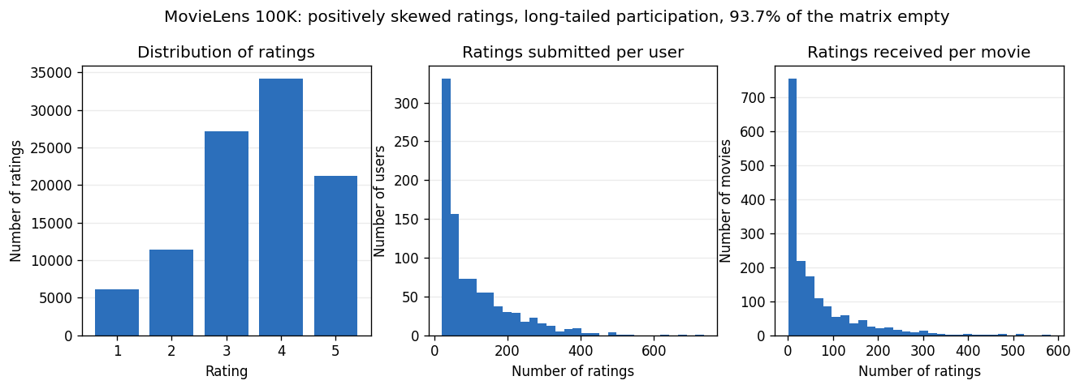
Note. Based on all 100,000 ratings in the dataset.
One exploratory decision became a modeling decision. Ranking movies by average rating is unreliable without a minimum rating count, because the top of the list otherwise fills with films that have a single five-star review, so we required at least 50 ratings before ranking. That is the informal version of regularization, which reappears in the models as a shrinkage term that pulls thinly evidenced averages back toward the global mean, so that a movie rated once is not allowed to outrank a movie rated three hundred times on the strength of a single opinion.
Only the user identifier, item identifier, and rating were retained for modeling. The data was split 80/20 and stratified by user, because an unstratified split could place all of one user's ratings in the test set. All 943 users appear in training as a result. A validation set of 16,000 ratings was carved out of the 80,000 training ratings for tuning, leaving the 20,000-rating test set untouched until one final evaluation, so that no modeling decision was informed by the data used to report performance. Twenty-six movies never appear in training, affecting 28 test rows, and these cold starts fall back to the global mean.
Initial Model Development
Five models were built and tuned on the validation split: a global-mean floor, a regularized bias model, item-based k-nearest-neighbor collaborative filtering on baseline residuals (Sarwar et al., 2001), a truncated singular value decomposition of a filled matrix, and biased matrix factorization trained on observed ratings only (Koren et al., 2009).
Against a global mean of 1.1372, the bias baseline reached an RMSE of 0.9423, k-nearest neighbors 0.9088, the filled decomposition 0.9242, and matrix factorization 0.9119. The best result is 20.08% better than the global mean and 3.56% better than the bias baseline. The results do not support naming a winner: k-nearest neighbors led on the held-out split, while matrix factorization led under cross-validation at 0.9189 against 0.9207, a gap smaller than either model's fold-to-fold standard deviation. As Figure 2 shows, factorizing only observed ratings beat factorizing a filled matrix, 94% of which is invented, because the decomposition otherwise spends its components rebuilding values we supplied.
Figure 2
Test RMSE, Cross-Validated RMSE, and Test MAE for the Five Models
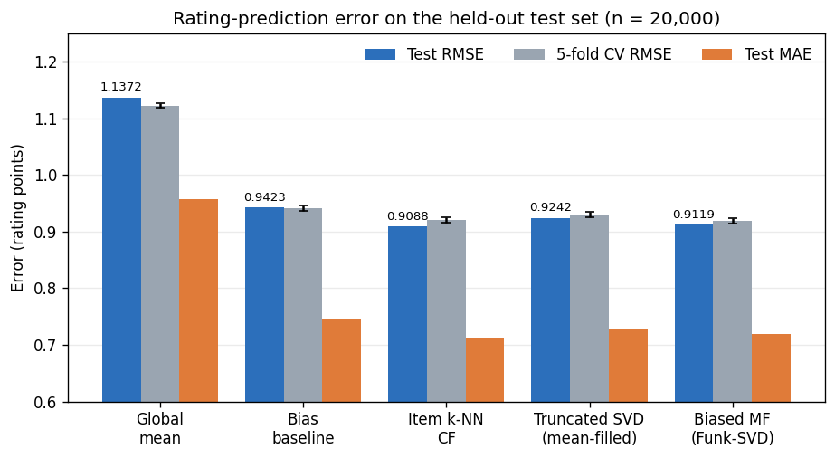
Note. Test values are from the held-out set (n = 20,000). Error bars show one standard deviation across five folds.
Error is unevenly distributed, as Figure 3 shows: from 1.0056 for the least active users to 0.8857 for the most active, and from 1.1539 for the rarest movies to 0.8815 for blockbusters, with 0.8865 for male against 0.9703 for female users.
Figure 3
Root Mean Squared Error by User Activity Quintile and Movie Popularity Quintile
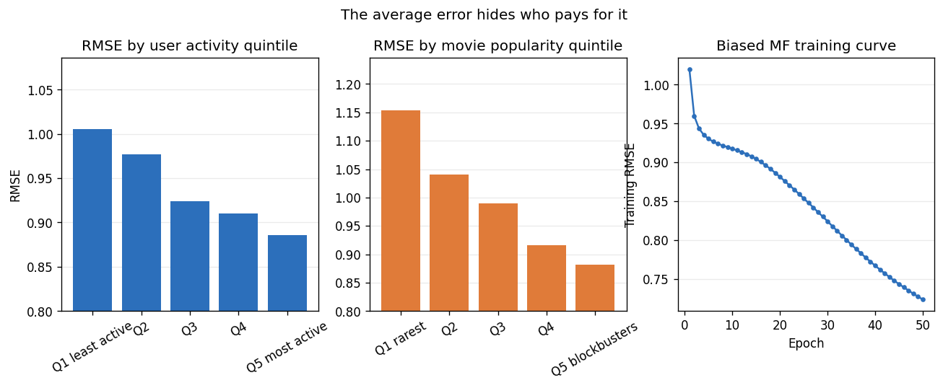
Note. Quintiles are formed from the number of ratings each user gave, or each movie received, during training. The third panel shows the matrix factorization training curve.
The top-ten lists in Figure 4 showed a larger gap. Matrix factorization reached a precision at ten of 0.0574 and 14.39% of the catalog, while a non-personalized list of the ten most-rated films scored 0.0695 and touched only 0.59%. Relevance here is defined by held-out ratings, and users mostly rate films they already chose to watch, so the comparison favors popular titles.
Figure 4
Precision at Ten and Catalog Coverage Against a Non-Personalized Control
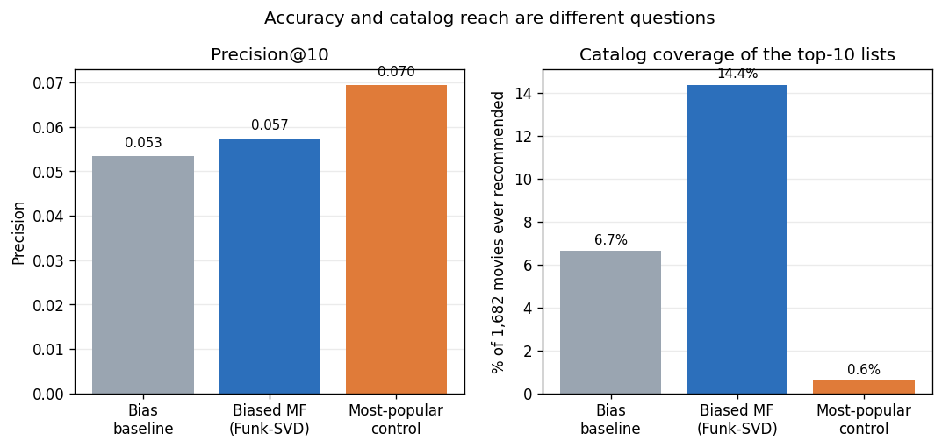
Note. Coverage is the share of the 1,682 movies that ever appear in a top-ten list. Evaluated on the 932 users with at least one held-out rating of 4 or more.
Those differences, the narrow catalog reach, and the re-identification risk of a learned taste vector (Narayanan & Shmatikov, 2008) are the ethical findings. Taken together, the results show where the value actually is. Most of the achievable accuracy came from knowing which films are generally good and which users rate generously rather than from modeling individual taste, and personalization contributed mainly by widening what a subscriber is shown. Because the two leading models finished within noise of each other, and because RMSE and ranking quality disagreed about which was better, the next stage of this project will tune both over a wider hyperparameter search than the deliberately small grids used here and report precision at ten alongside RMSE, so that any improvement has to hold on both measures rather than only the one that is easiest to optimize.
Team Collaboration Process
We divided the work by stage rather than by notebook section. Blake Mires was responsible for data acquisition, quality checks, cleaning, and exploratory analysis. Jose M. Santiago Echevarria was responsible for the evaluation protocol, model implementation, tuning, and the error and ethics analysis. Manoj Kashyap Ranganath and Onyebuchi Asogwa contributed to problem framing and reviewed both halves, as well as the report's verification.
The first half of the notebook ends by producing a three-column table of user identifier, item identifier, and rating with agreed guarantees, which allows modeling to start before cleaning is finished. Coordination was asynchronous: we used Blackboard messaging for day-to-day decisions and GitHub for the code.

References
Harper, F. M., & Konstan, J. A. (2015). The MovieLens datasets: History and context. ACM Transactions on Interactive Intelligent Systems, 5(4), 1-19. https://doi.org/10.1145/2827872
Koren, Y., Bell, R., & Volinsky, C. (2009). Matrix factorization techniques for recommender systems. Computer, 42(8), 30-37. https://doi.org/10.1109/MC.2009.263
McKinney, W. (2010). Data structures for statistical computing in Python. In S. van der Walt & J. Millman (Eds.), Proceedings of the 9th Python in Science Conference (pp. 56-61). https://doi.org/10.25080/Majora-92bf1922-00a
Narayanan, A., & Shmatikov, V. (2008). Robust de-anonymization of large sparse datasets. 2008 IEEE Symposium on Security and Privacy, 111-125. https://doi.org/10.1109/SP.2008.33
Pedregosa, F., Varoquaux, G., Gramfort, A., Michel, V., Thirion, B., Grisel, O., Blondel, M., Prettenhofer, P., Weiss, R., Dubourg, V., Vanderplas, J., Passos, A., Cournapeau, D., Brucher, M., Perrot, M., & Duchesnay, E. (2011). Scikit-learn: Machine learning in Python. Journal of Machine Learning Research, 12, 2825-2830.
Sarwar, B., Karypis, G., Konstan, J., & Riedl, J. (2001). Item-based collaborative filtering recommendation algorithms. Proceedings of the 10th International Conference on World Wide Web, 285-295. https://doi.org/10.1145/371920.372071

