Jose Mugilan D 231901016

Exp no:1

Setting up Hyperledger Fabric Development Environment

Aim
To install and configure the Hyperledger Fabric development environment on a Linux system using Docker, Go, and Fabric binaries, create a blockchain test network, and establish a communication channel between peer organizations

By the end of the experiment:
- Hyperledger Fabric installed
- Docker running
- Fabric binaries downloaded
- A blockchain network running
- A communication channel (mychannel) created between two organizations

Procedure:
- sudo apt install -y git curl jq docker-compose
this command uses administrative privileges to automatically download and install four developer tools—Git, Curl, JQ, and Docker Compose
- Verify the installation
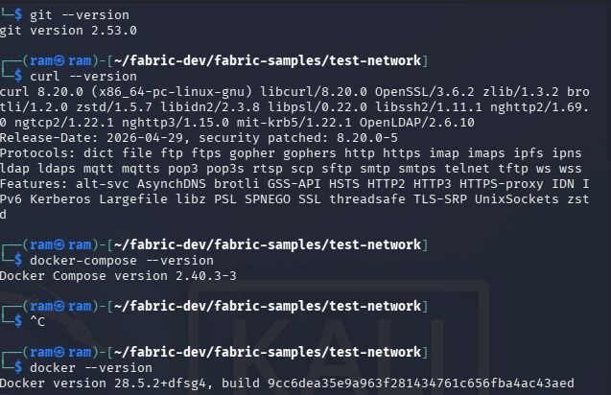
- Start and enable the docker:
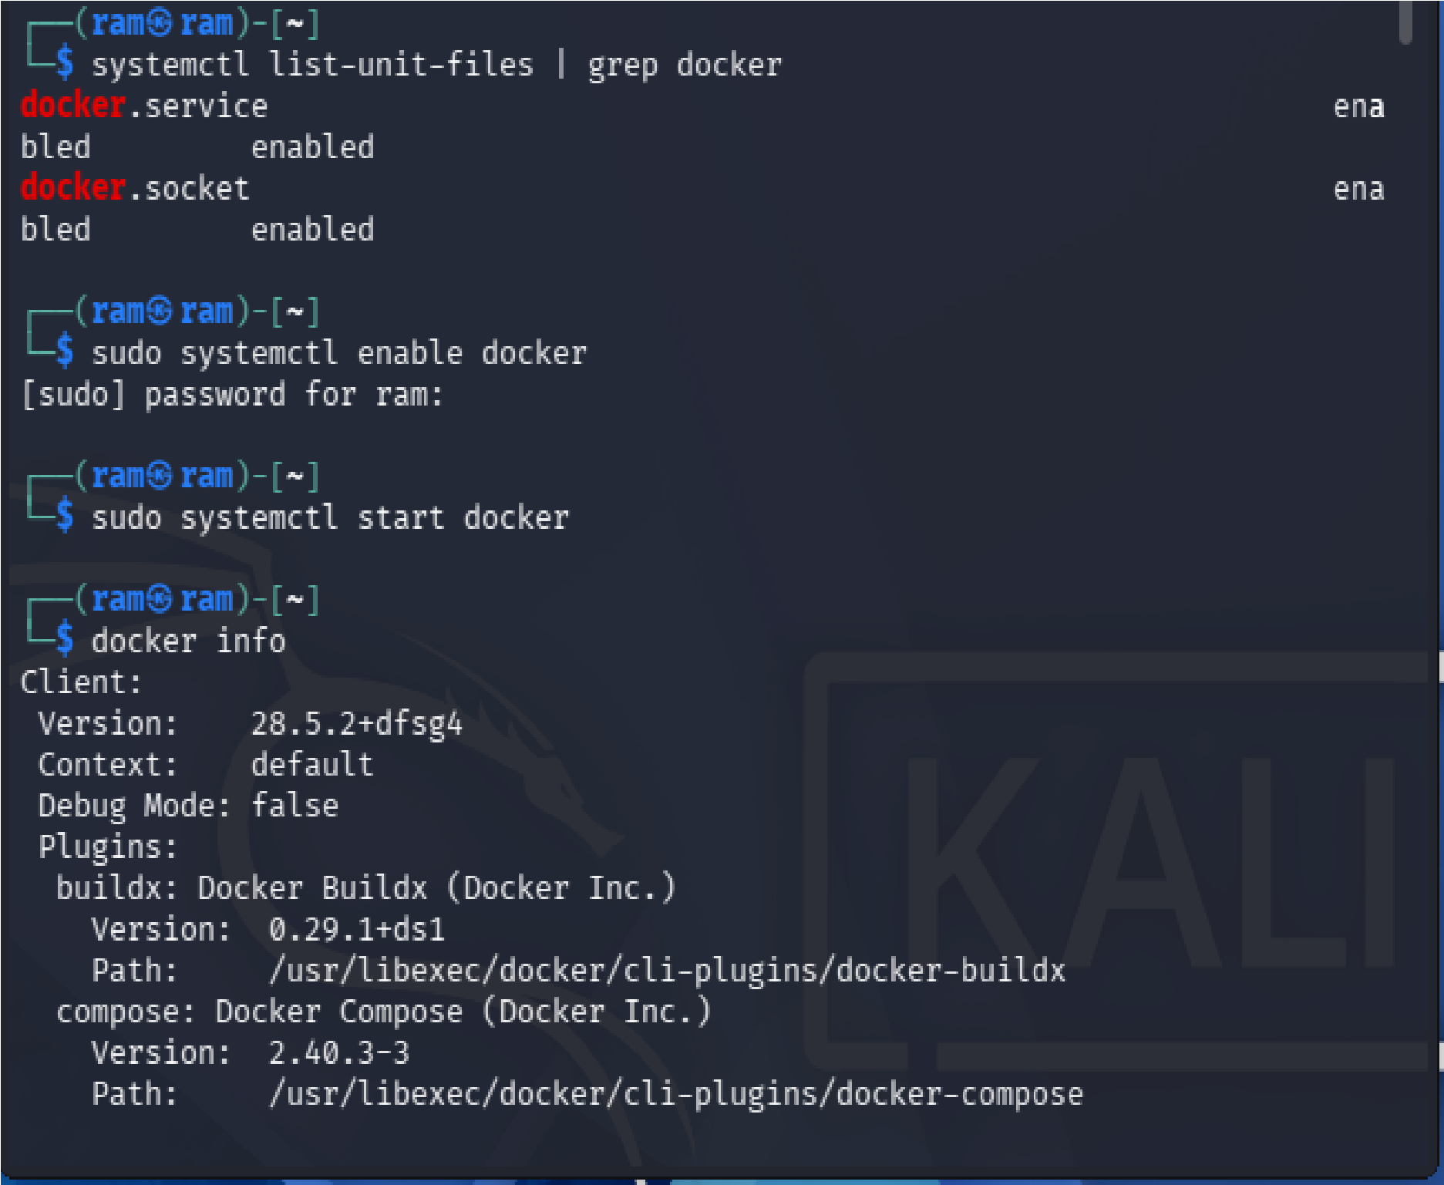

- Add yourself to Docker group sudo usermod -aG docker $USER

- Refresh groups newgrp docker

- Test Docker

docker run hello-world

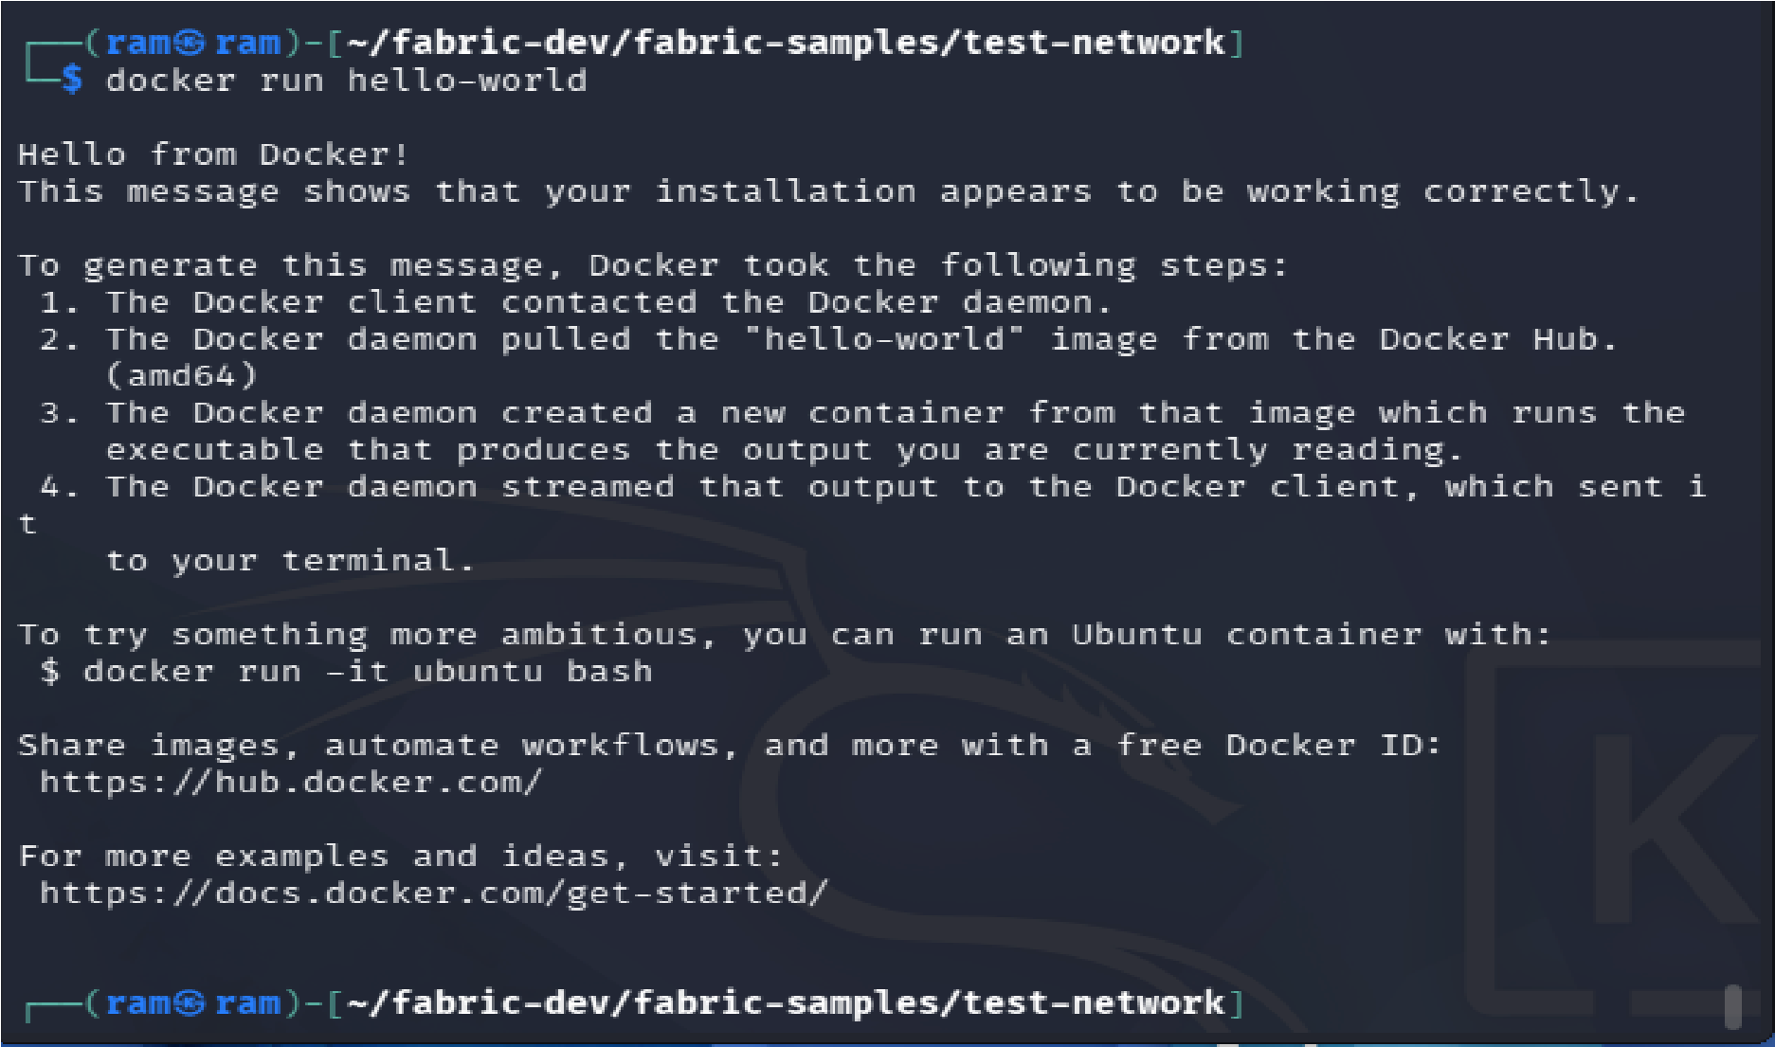
- Check Go
sudo apt install golang-go go version

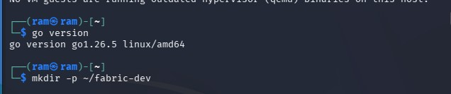

- Download Hyperledger Fabric

curl -sSL https://bit.ly/2ysbOFE | bash -s

This downloads:

Fabric binaries
Docker images
Sample applications

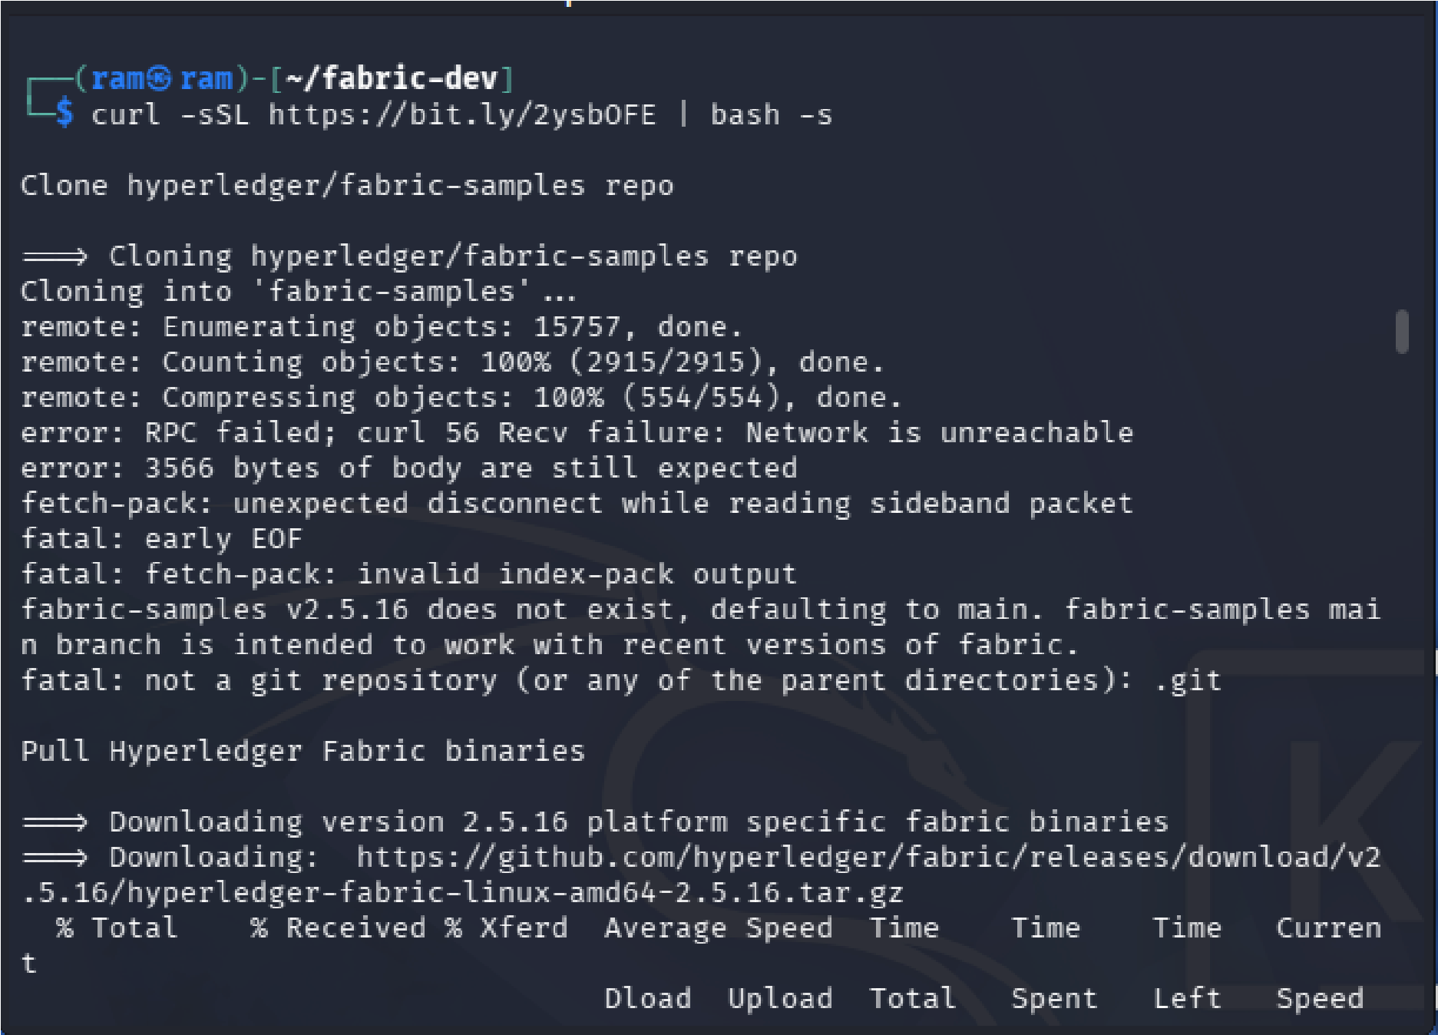

- Enter the Sample Folder cd fabric-samples

- Configure PATH

echo 'export PATH=$PATH:$HOME/fabric-dev/fabric-samples/bin' >> ~/.bashrc source ~/.bashrc

- Verify Installation

Check Peer: peer version

Check Orderer: orderer version

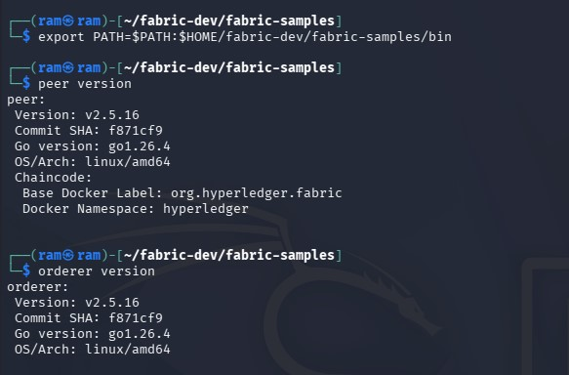

- Start the Blockchain Network

Go into the test network cd ~/fabric-dev/fabric-samples/test-network

- Start it

./network.sh up

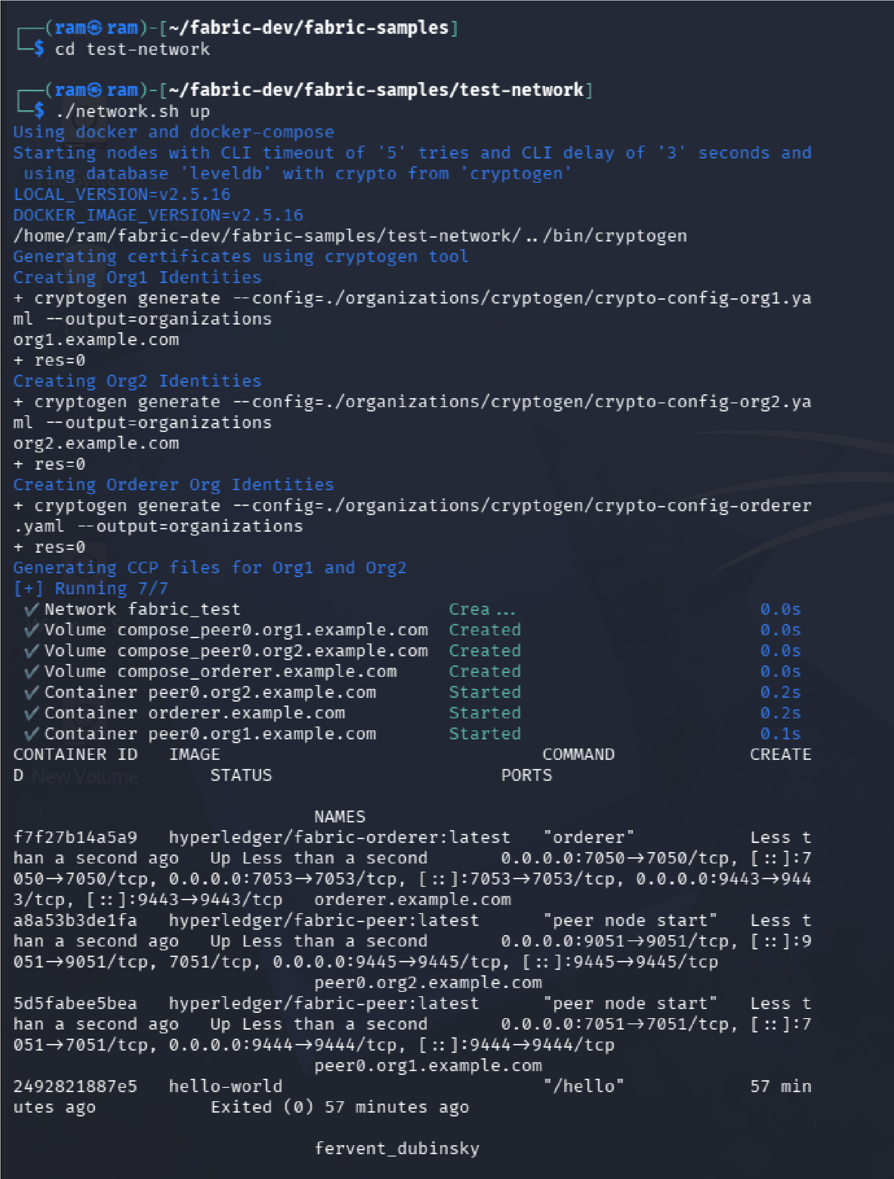

- Create Channel

./network.sh createChannel -c mychannel

This creates a communication channel named mychannel.

It also:
creates the channel joins both organizations configures anchor peers
