UNIVERSIDAD AUTÓNOMA DE GUADALAJARA
Analysis and Design of Systems with Big Data

LABORATORY REPORT #2
Updating Dynamic Data in Place

Student Name: | [Full Name]
Student ID: | [ID Number]
Professor: | [Professor Name]
Submission Date: | [MM/DD/YYYY]

Section 2: AWS Account Information

AWS Account ID:
Account ID: | 8913-7699-2700
Username: | voclabs/user4354673=Manuel_Nunez
Region: | us-east-1 (N. Virginia)
Service: | Amazon Athena / AWS Glue / Kinesis

Screenshot 0: AWS Account ID – visible in upper-right corner of the AWS Console
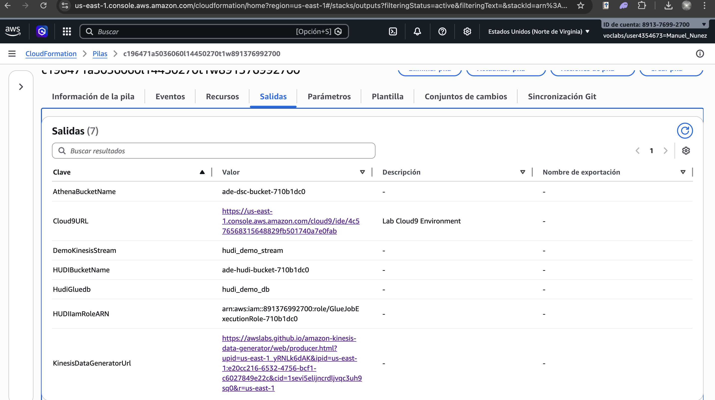

Section 3: Laboratory Objectives

General Objective
Demonstrate the ability to update dynamic data in place using Apache Hudi integrated with AWS services (Glue, Kinesis, Athena, S3), enabling real-time schema evolution and record-level upserts on a data lake.

Specific Objectives
- Configure and analyze the output of AWS Glue stacks related to Apache Hudi data pipelines.
- Subscribe to an Apache Hudi table and validate real-time data streaming via Amazon Kinesis.
- Create and deploy a CloudFormation stack that provisions the Hudi demo infrastructure.
- Send initial data records to Kinesis and verify ingestion through Hudi into S3.
- Configure Amazon Athena to query Hudi tables registered in the AWS Glue Data Catalog.
- Perform schema evolution by sending new data with additional columns and validate the changes.
- Revert schema changes to demonstrate Hudi's backward-compatible schema management.

Competencies Developed
- Real-time data lake management with Apache Hudi and AWS Glue.
- Schema evolution and upsert capabilities using Hudi Copy-on-Write tables.
- Streaming data ingestion with Amazon Kinesis Data Streams.
- Serverless SQL querying with Amazon Athena over Hudi-formatted S3 data.

Section 4: Laboratory Development

Task 1: Analyze Glue Stack Outputs
In this first task, the AWS Glue service was accessed to review the CloudFormation stack outputs related to the Hudi demo environment. The stack outputs provide the necessary parameters such as Kinesis stream names, S3 bucket ARNs, and IAM role ARNs required for subsequent tasks. These outputs confirm that all infrastructure components were provisioned correctly before proceeding.
Screenshot 1: AWS Glue Stack Outputs – Kinesis stream, S3 paths, and IAM role ARNs


Task 2: Subscribe to Hudi Table
This task involved subscribing to the Apache Hudi table through the Glue job listener. The subscription enables the system to listen for incoming records from the Kinesis Data Stream and process them using Hudi's upsert mechanism. The configuration ensures that each incoming message is correctly mapped to the Hudi record key and partition field.
Screenshot 2: Hudi Table Subscription – Glue job listener configuration and active subscription
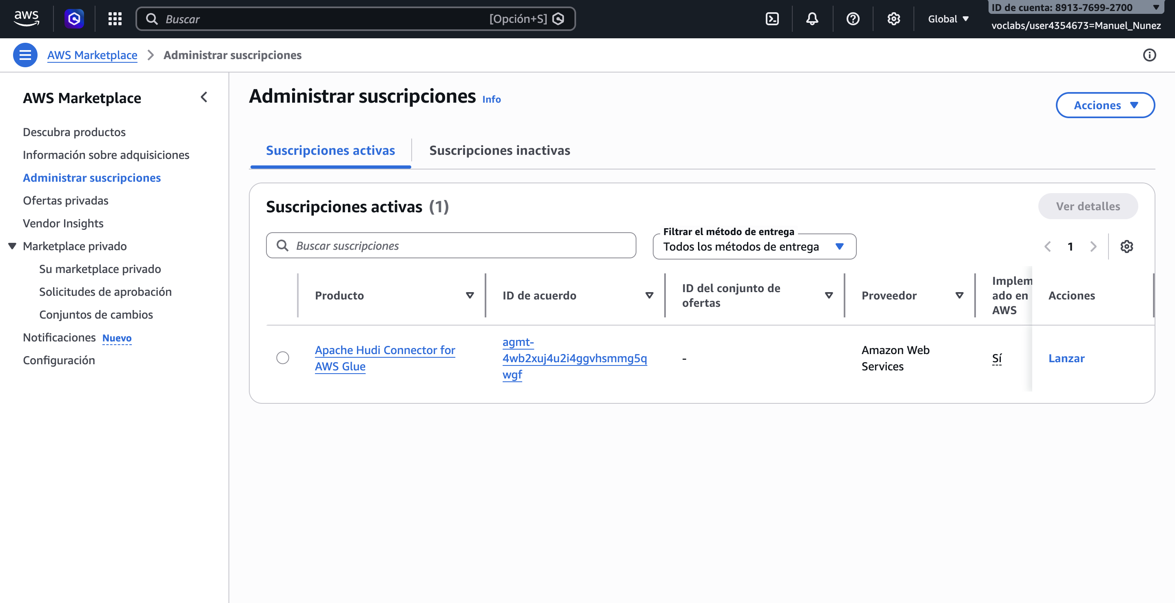

Task 3: Download Code Files
The required Python scripts and configuration files were downloaded from the provided S3 source bucket to the local environment. These files include the Kinesis producer script and the Hudi schema definition files needed to send records to the stream. The scripts were reviewed to understand the data format and record structure expected by the Hudi table.
Screenshot 3: Downloaded Code Files – Scripts and configuration files retrieved from S3
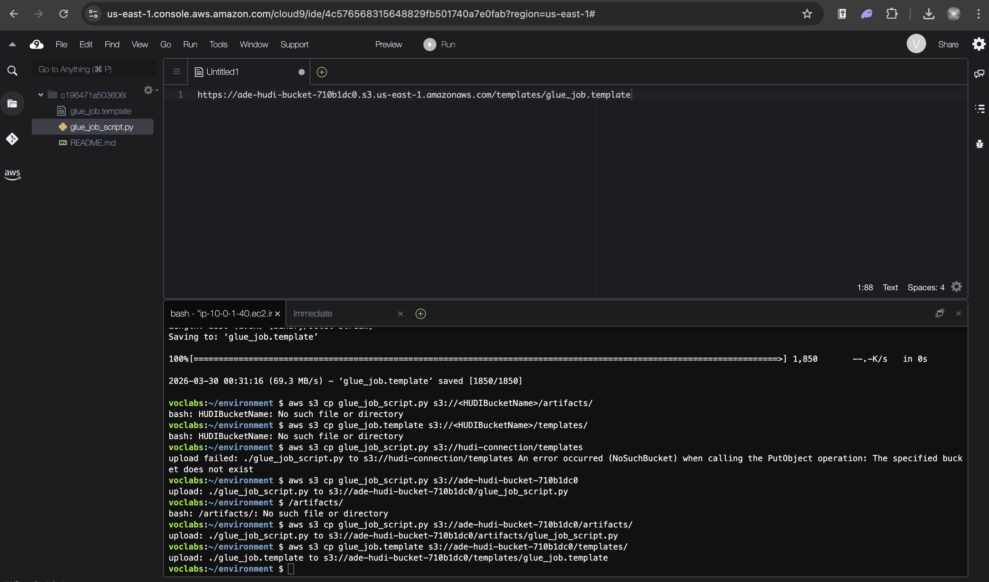

Task 4: Create Stack
A CloudFormation stack was created to provision all the required AWS resources for the lab, including the Kinesis Data Stream, S3 buckets, IAM roles, Glue database, and Glue jobs. The stack template automates the full infrastructure deployment and ensures consistent configuration across environments. The stack creation was monitored until reaching the CREATE_COMPLETE status.
Screenshot 4: CloudFormation Stack – CREATE_COMPLETE status showing all provisioned resources
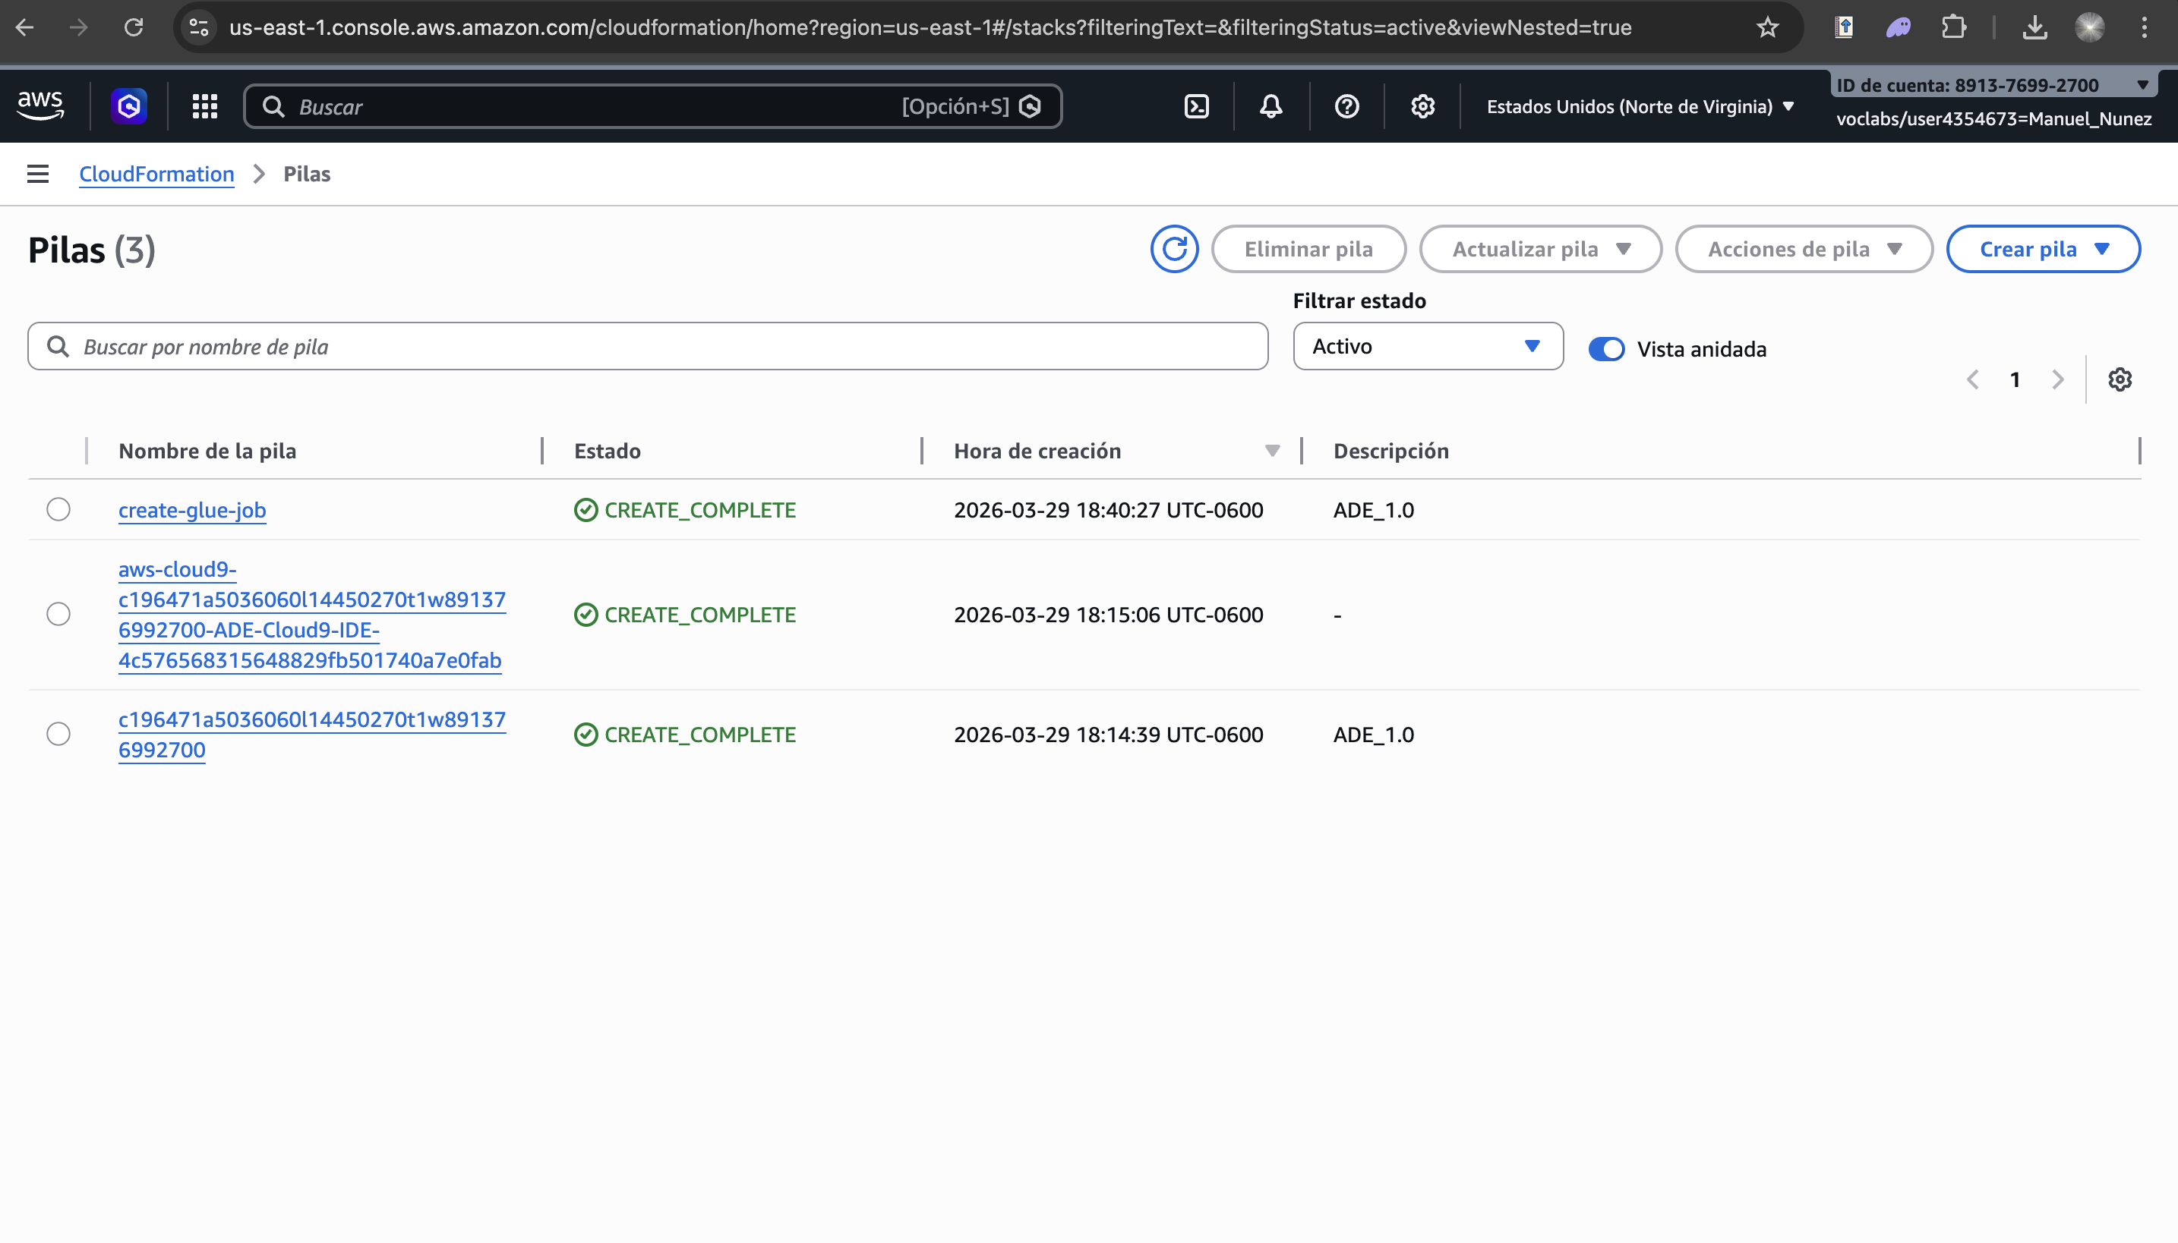

Task 5: Send Data (Mandar Datos)
Initial data records were sent to the Amazon Kinesis Data Stream using the Python producer script. Each record included fields such as record key, partition path, commit sequence number, and the column to be updated. The Glue streaming job consumed these records and wrote them to S3 in Hudi Parquet format, registering the table schema in the AWS Glue Data Catalog.
Screenshot 5: Kinesis Data Producer – Python script sending initial records to the Hudi demo stream
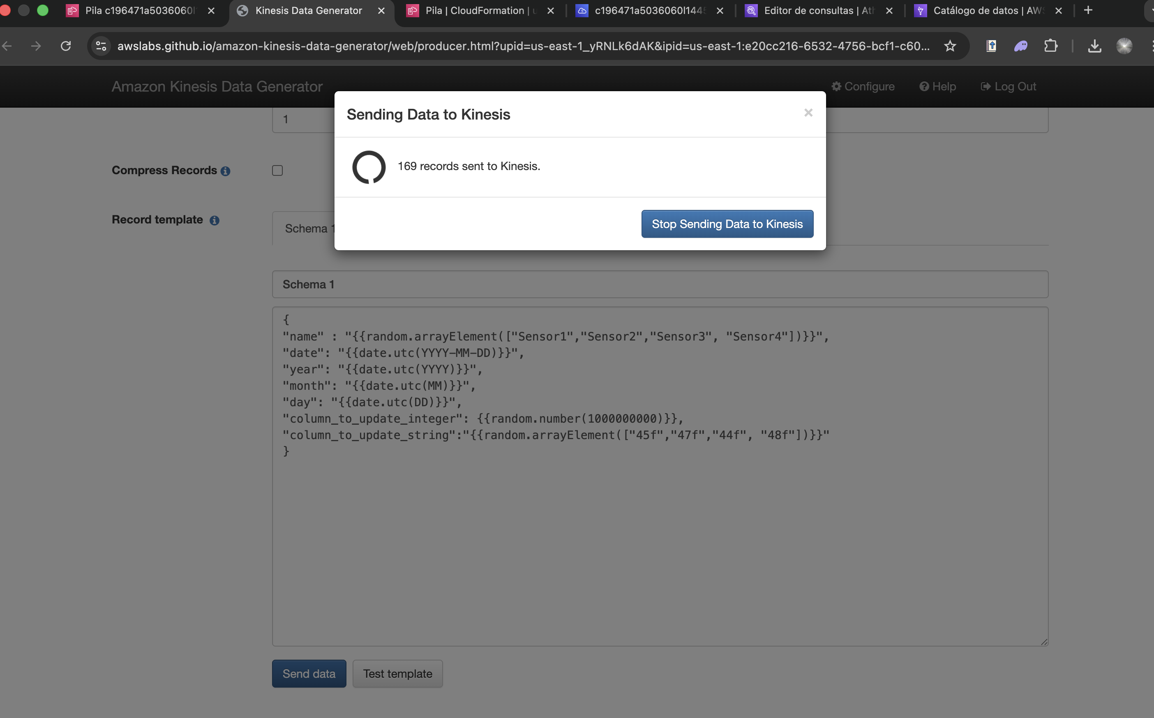

Command executed:
python3 send_data.py --stream hudi-demo-stream --region us-east-1

Task 6: Configure Athena
Amazon Athena was configured to use the AWS Glue Data Catalog as the metadata source. A query output location in S3 was specified for Athena results. The Hudi demo table was verified to be visible in the hudi_demo_db database. A SELECT query was executed against the table to confirm that the initial data records were correctly ingested and readable through Athena.
Screenshot 6: Athena Configuration – S3 output location and data source setup
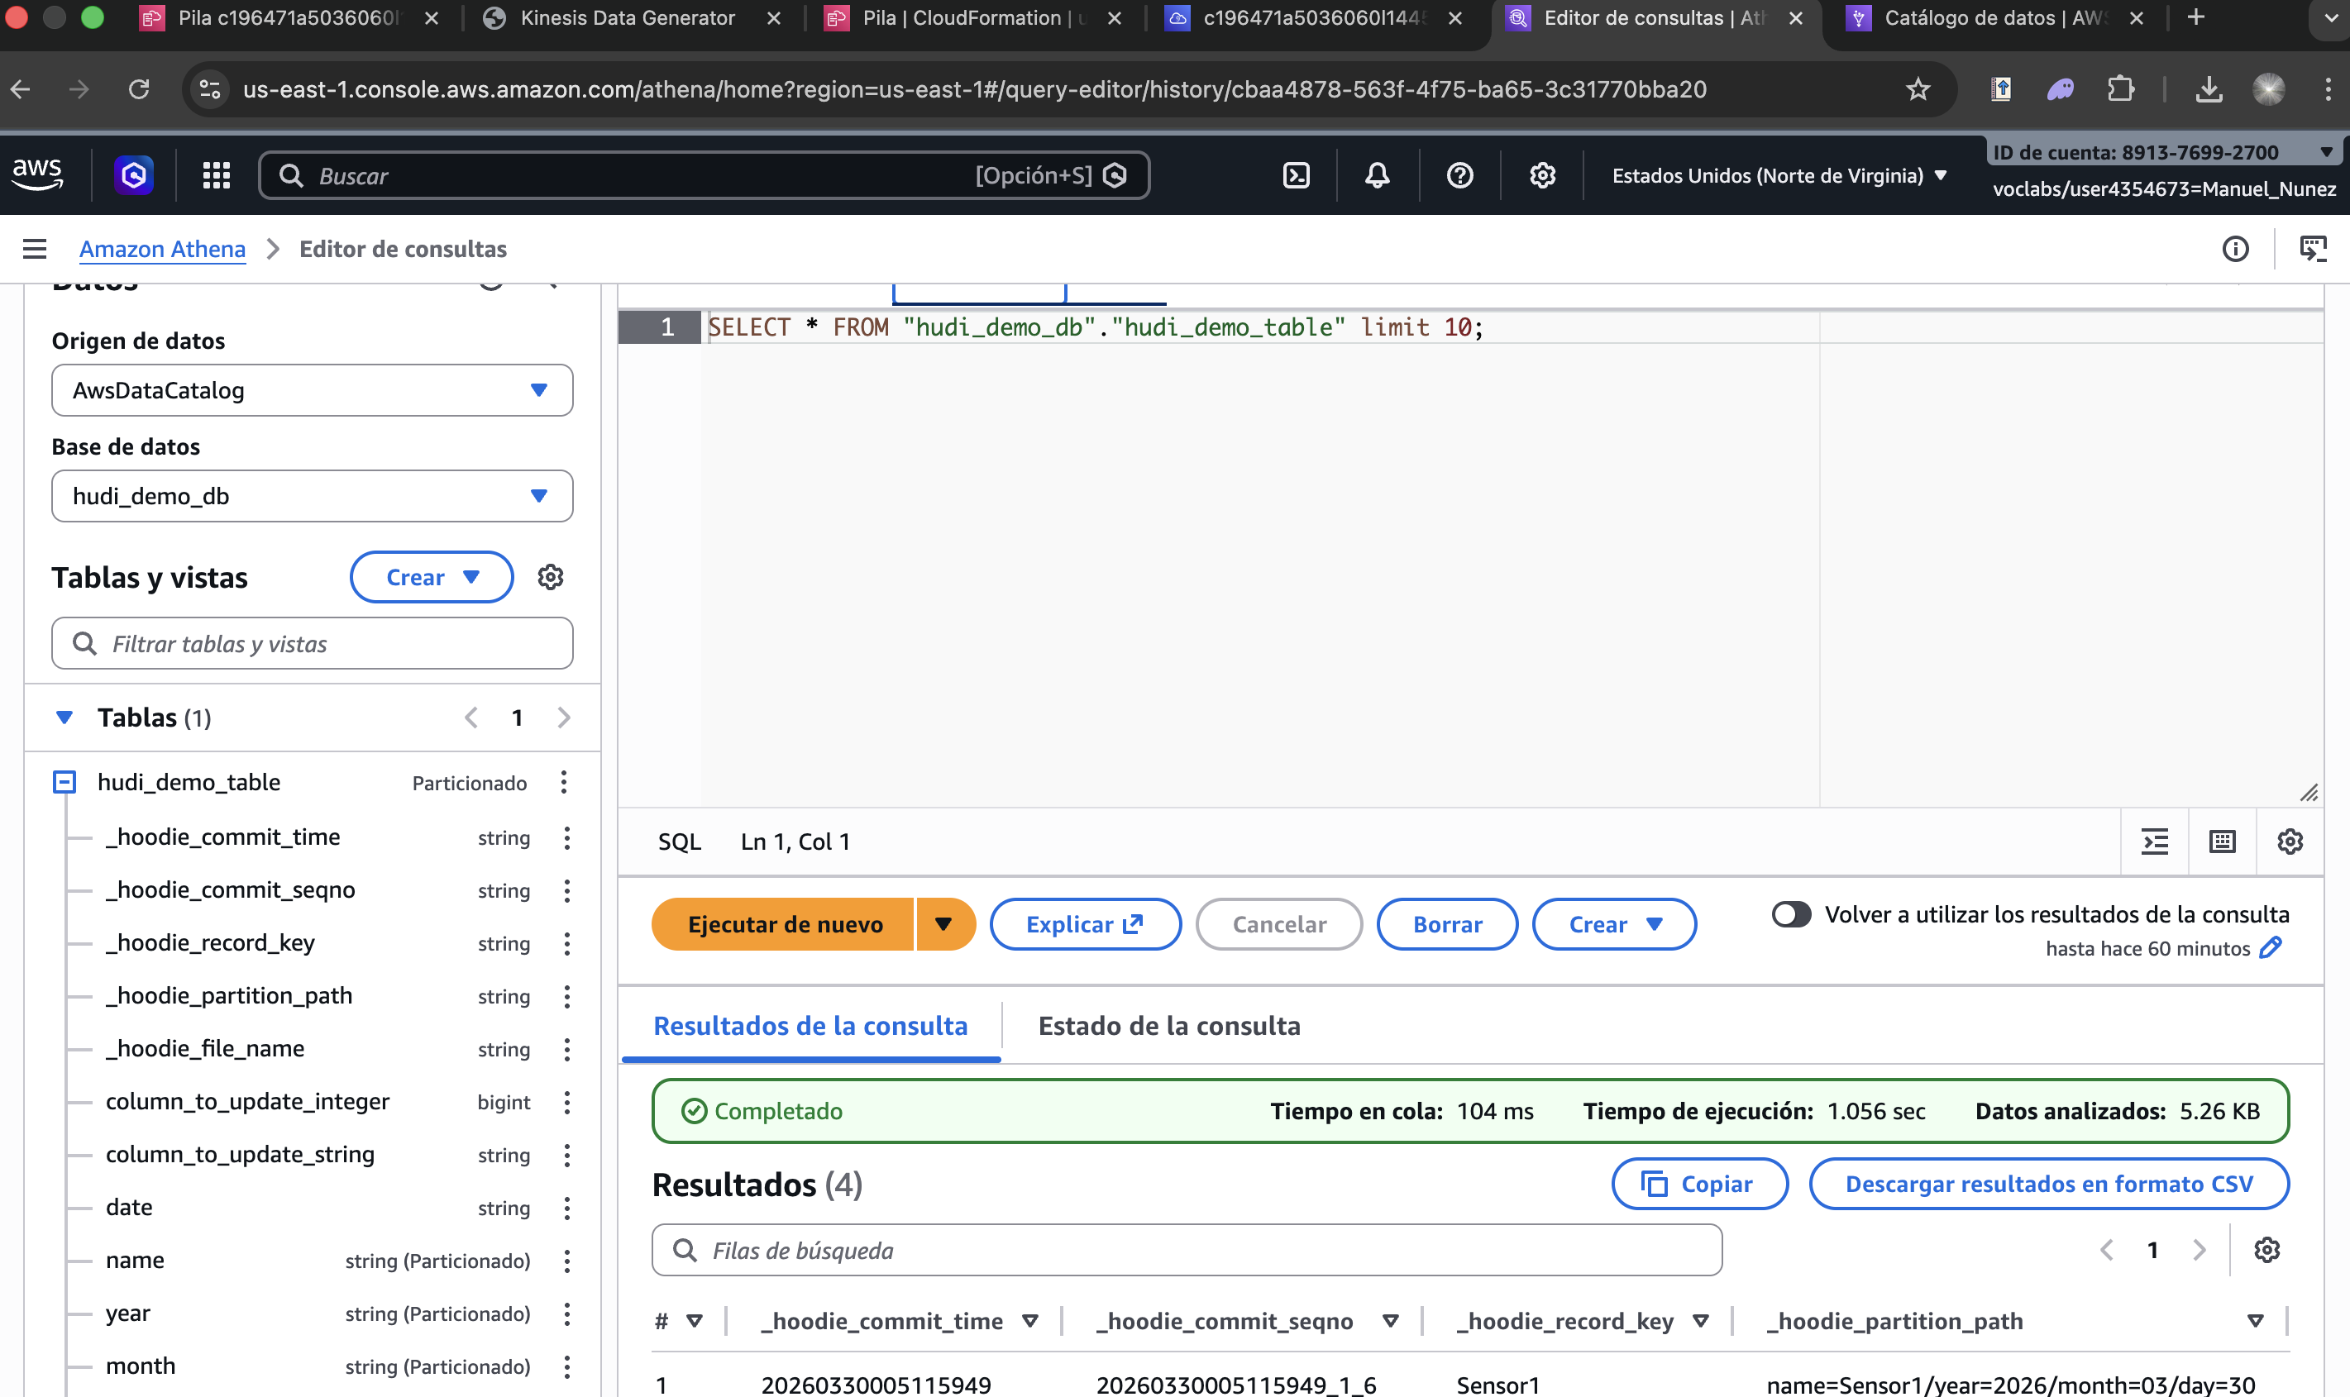

Screenshot 7: Athena Query Execution – SELECT query returning 4 rows from hudi_demo_table
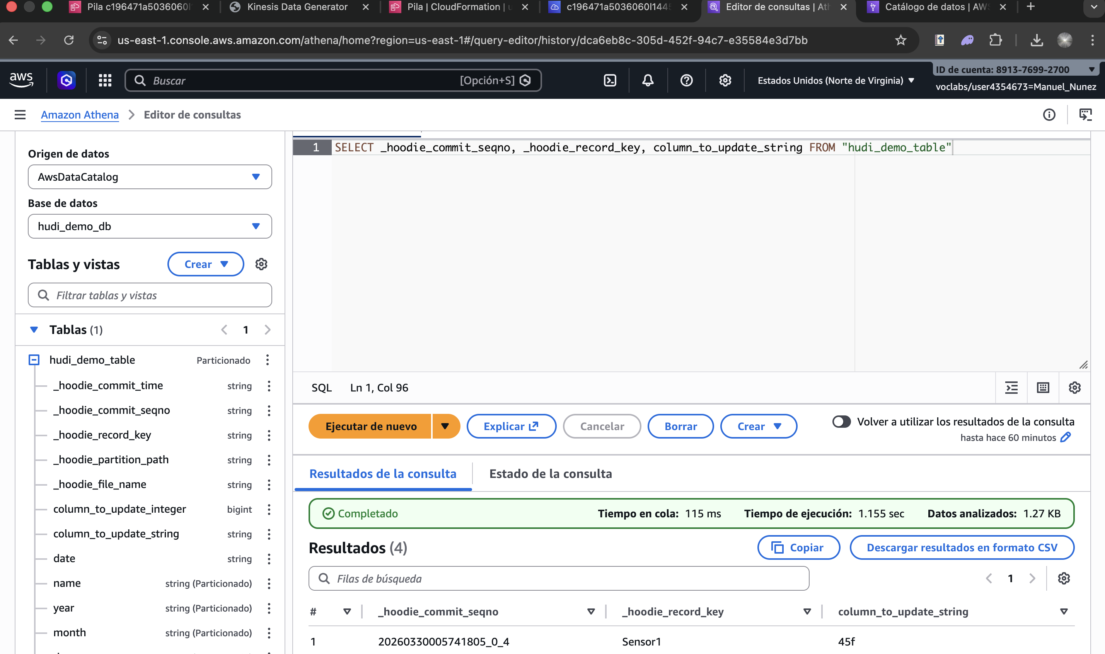

SQL Query executed:
SELECT _hoodie_commit_seqno, _hoodie_record_key, column_to_update_string, new_column FROM "hudi_demo_table"

Result obtained:
Rows returned: | 4
Execution time: | 1.095 seconds
Data scanned: | 1.48 KB
Queue time: | 113 ms

Task 7: Send New Schema + New Column via Kinesis
A second batch of records was sent to Kinesis with an evolved schema that included a new column called new_column. Apache Hudi's schema evolution capability allows adding new nullable fields without breaking existing records. After the Glue streaming job processed the updated records, Athena was queried again to verify that both old and new records coexist and that the new column is correctly populated.
Screenshot 8: Schema Evolution – New records with additional 'new_column' sent to Kinesis
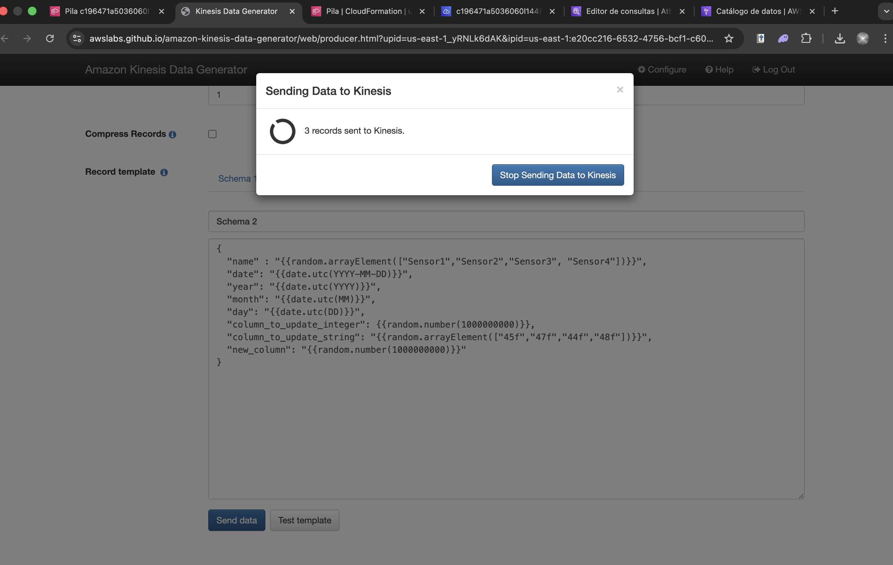

Screenshot 9: Athena Query – Updated schema with new_column visible in query results
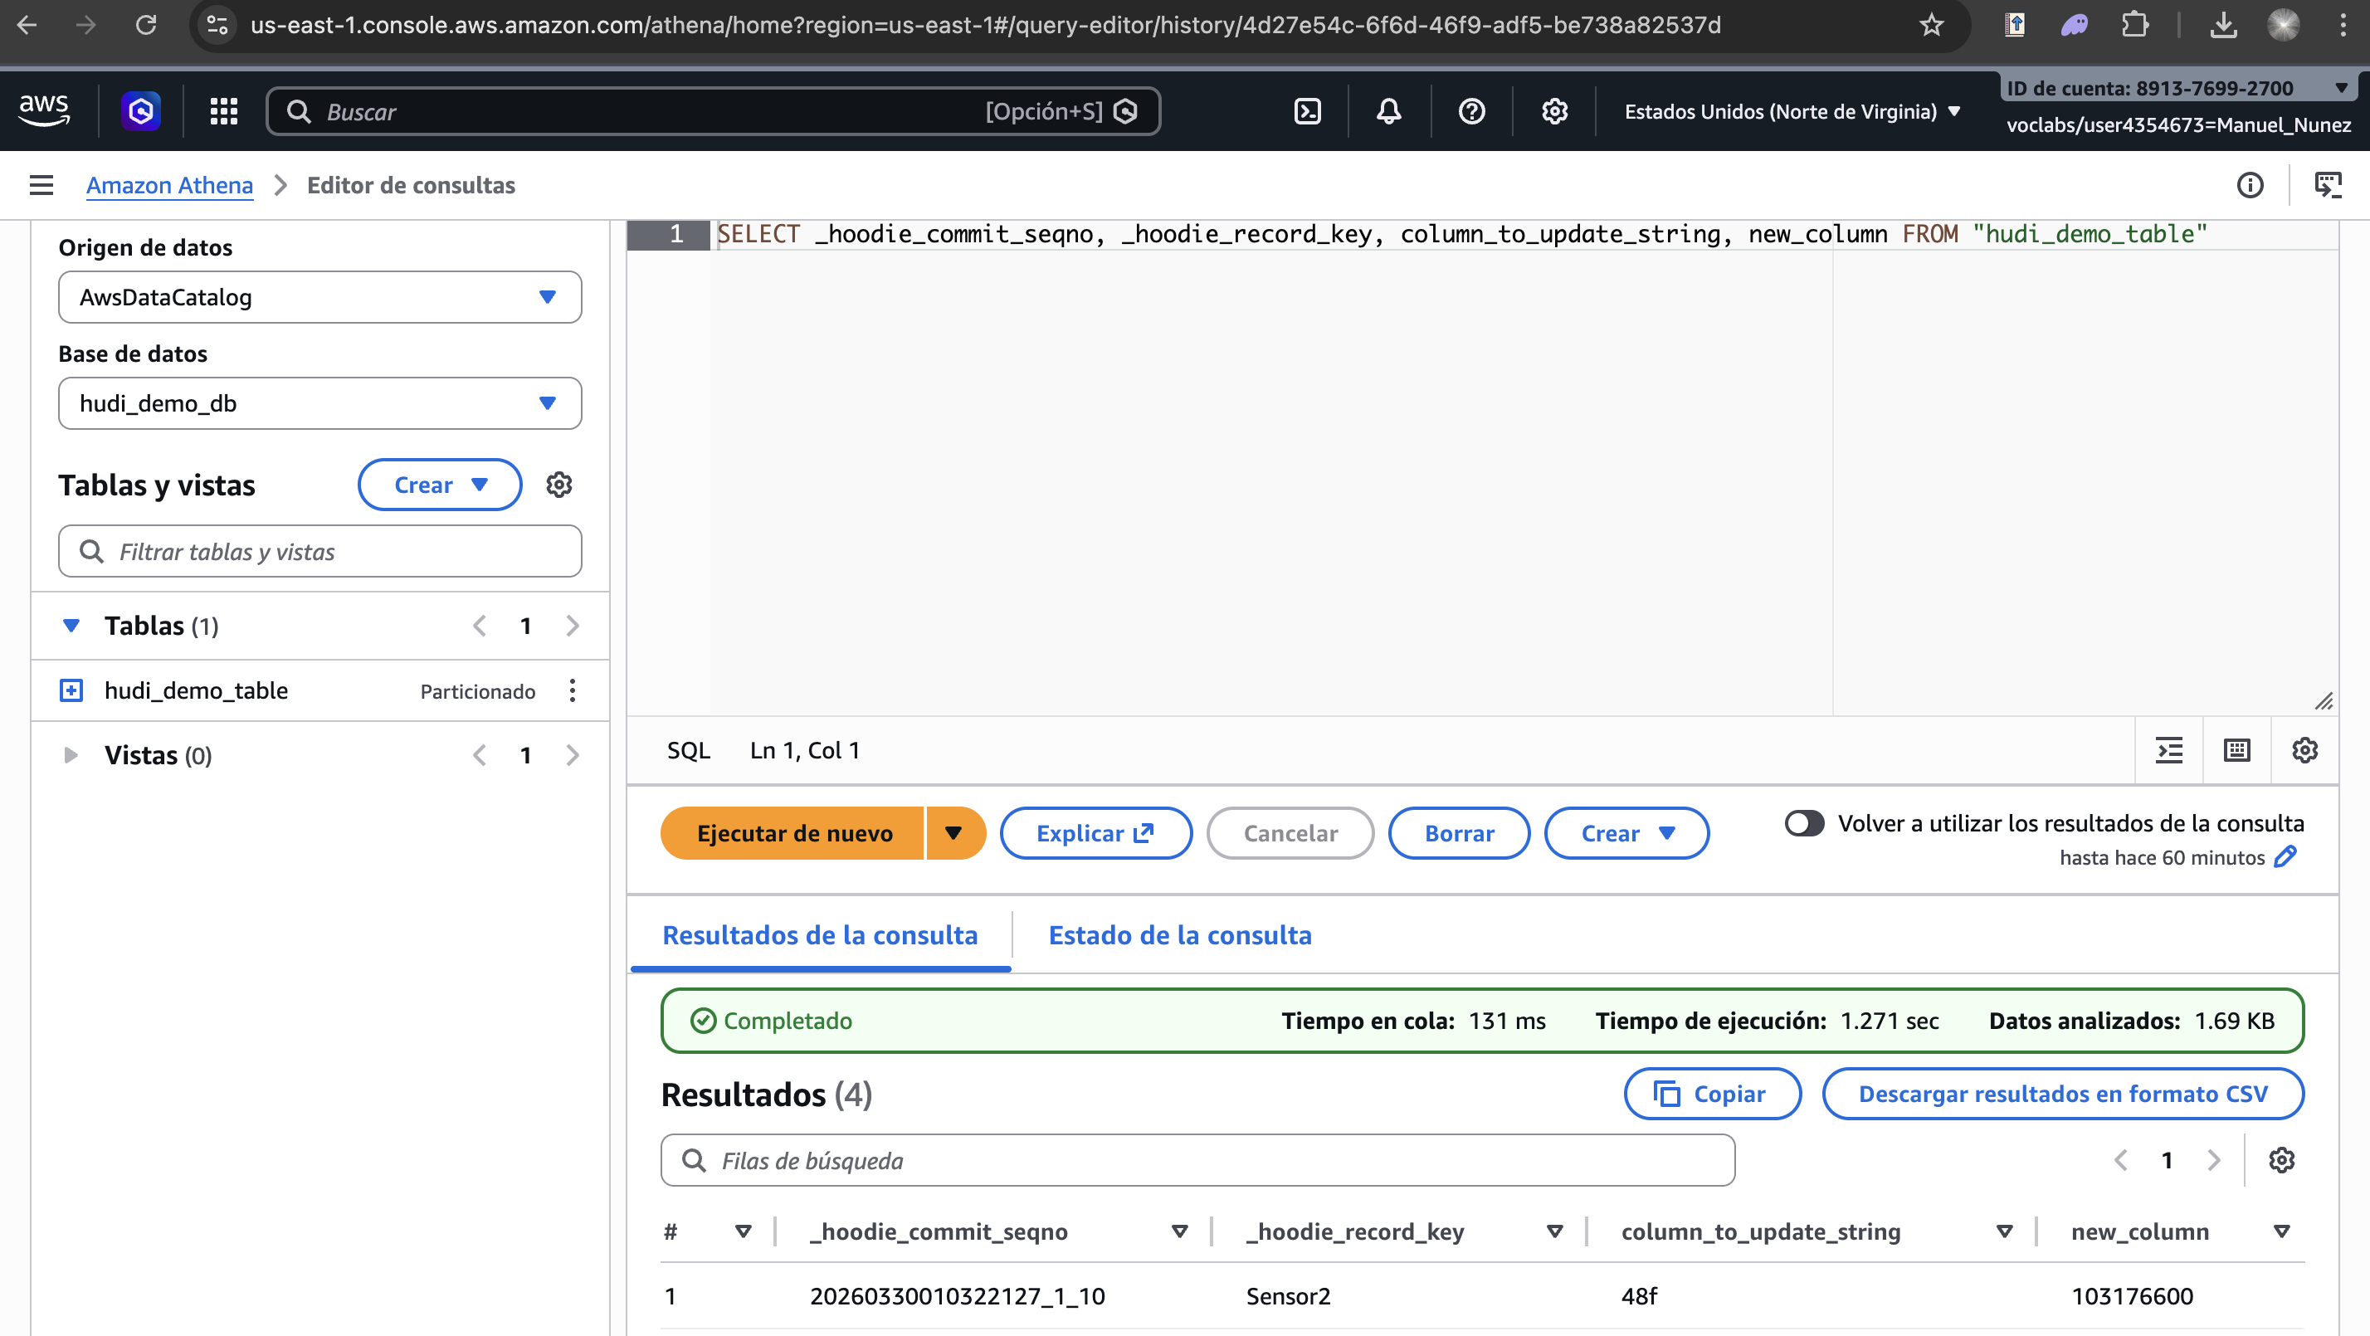

Task 8: Revert Schema Changes
The final task demonstrated Hudi's ability to handle backward schema compatibility. A third batch of records was sent without the new_column field to simulate a producer that reverts to the original schema. Hudi preserved the new_column for existing records while setting it to null for the new records. The Athena query confirmed that the table remained queryable and schema-consistent throughout the process.
Screenshot 10: Schema Revert – Records sent without new_column; Hudi maintains backward compatibility
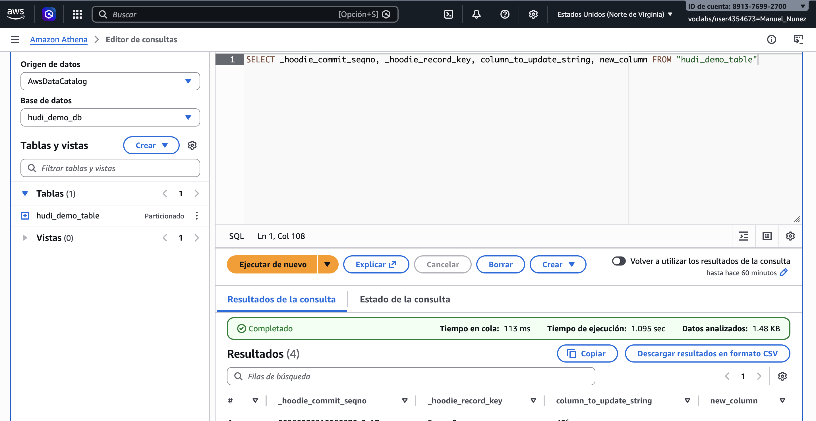

Screenshot 11: Final Athena Query – All records visible, schema evolution successfully reverted
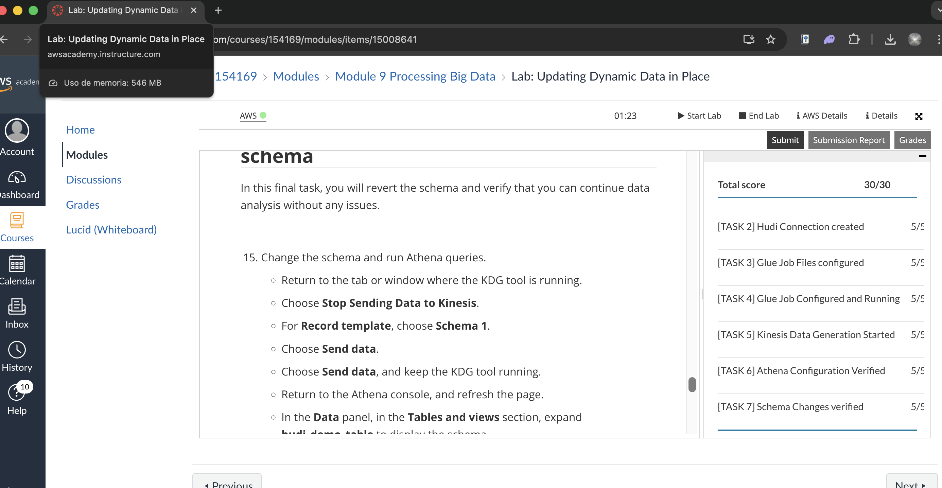

Section 5: Results and Validation

5.1 Operational Evidence
The lab was completed successfully. All 8 tasks were executed in sequence, demonstrating the full lifecycle of a Hudi-based data lake pipeline on AWS. The following metrics were recorded during the Athena query validation phase:

Processing time (Athena): | 1.095 seconds
Queue time: | 113 ms
Data volume analyzed: | 1.48 KB
Records returned: | 4 rows
Hudi table type: | Copy-on-Write (CoW)
Schema evolutions performed: | 2 (add column, revert)
Error rate: | 0% – no errors encountered

Section 6: Analysis and Reflection

6.1 Challenges Encountered
Challenge 1: Athena Configuration for Hudi Tables
Description: | Athena required explicit S3 output location setup before running queries on the Hudi-formatted data.
Solution: | Specified an S3 bucket path as the Athena result location in the Athena settings panel.
Learning: | Athena does not default to any output location; it must be configured prior to first query execution.

Challenge 2: Schema Evolution Validation
Description: | Verifying that schema changes (new_column addition) propagated correctly without breaking existing records.
Solution: | Re-ran the SELECT query after each Kinesis batch and compared column values across old and new records.
Learning: | Hudi's CoW table type handles schema evolution gracefully; new nullable columns appear as NULL in older records.

Section 7: AWS Costs

7.1 Cost Estimation
Service | Usage | Estimated Cost
AWS Glue | Job runs, crawlers | $[amount]
Amazon Kinesis Data Streams | Shard hours | $[amount]
Amazon S3 | GB stored | $[amount]
Amazon Athena | TB scanned | $[amount]
AWS CloudFormation | Stack operations | $0.00
TOTAL |  | $[amount]

[Add screenshot of AWS Cost Explorer here]

Cost Optimization Strategies Applied
- Used AWS Academy sandbox environment to avoid real charges on lab activities.
- Terminated all CloudFormation stacks immediately after lab completion to stop resource billing.
- Used S3 Standard storage only for lab duration; no long-term retention needed.

Section 8: Conclusions

Technical Conclusions
- Apache Hudi integrated with AWS Glue Streaming provides a robust mechanism for real-time upserts and deletes in a data lake, eliminating the need for full table rewrites.
- Amazon Kinesis Data Streams serves as an effective ingestion layer that decouples data producers from consumers, enabling scalable and fault-tolerant streaming pipelines.
- Athena's integration with the Glue Data Catalog allows serverless, ad-hoc SQL queries over Hudi-formatted Parquet data with minimal configuration overhead.

Practical Applicability
The skills developed in this laboratory are directly applicable to real-world scenarios such as CDC (Change Data Capture) pipelines, financial transaction systems requiring audit trails, and e-commerce platforms that need to update user profiles or inventory in near real-time without downtime. Apache Hudi's ACID guarantees make it suitable for production-grade data lakes where data consistency is critical.

Identified Improvement Areas
- Area 1: Implement a Merge-on-Read (MoR) Hudi table type to compare write amplification vs. query performance trade-offs.
- Area 2: Add data quality checks in the Glue job to reject malformed records before writing to the Hudi table.
- Area 3: Explore Hudi's time-travel query feature in Athena to audit historical versions of records.

Section 9: References
[1] Amazon Web Services, "Amazon Athena User Guide," AWS Documentation. [Online]. Available: https://docs.aws.amazon.com/athena/latest/ug/what-is.html [Accessed: 29-Mar-2026].
[2] Amazon Web Services, "AWS Glue Developer Guide," AWS Documentation. [Online]. Available: https://docs.aws.amazon.com/glue/latest/dg/what-is-glue.html [Accessed: 29-Mar-2026].
[3] Amazon Web Services, "Amazon Kinesis Data Streams Developer Guide," AWS Documentation. [Online]. Available: https://docs.aws.amazon.com/streams/latest/dev/introduction.html [Accessed: 29-Mar-2026].
[4] Apache Software Foundation, "Apache Hudi Documentation," Version 0.14. [Online]. Available: https://hudi.apache.org/docs/overview/ [Accessed: 29-Mar-2026].
[5] Amazon Web Services, "Using Apache Hudi with AWS Glue," AWS Blog. [Online]. Available: https://aws.amazon.com/blogs/big-data/new-features-for-apache-hudi-in-aws-glue/ [Accessed: 29-Mar-2026].

Section 10: Code Repository
GitHub URL: | https://github.com/[username]/lab2-hudi-aws
Branch: | main
Commit Hash: | [relevant last commit hash]

Repository Structure
lab2-hudi-aws/
├── README.md
├── src/
│ ├── send_data.py
│ └── send_data_evolved.py
├── config/
│ └── hudi_schema.json
├── screenshots/
│ └── [lab screenshots]
└── requirements.txt

Execution Instructions
- Clone repository: git clone https://github.com/[username]/lab2-hudi-aws
- Install dependencies: pip install -r requirements.txt
- Configure AWS credentials: aws configure
- Send initial data: python3 src/send_data.py --stream hudi-demo-stream
- Send evolved schema: python3 src/send_data_evolved.py --stream hudi-demo-stream

Evaluation Criteria

Criterion | Weight | Description
Completeness | 20% | All steps documented with screenshots
Technical Quality | 30% | Correct and functional implementation
Documentation | 20% | Clarity, organization, and explanations
Code Quality | 15% | Best practices, comments, structure
Analysis | 15% | Reflection, challenges, optimizations

