CURRICULUM VITAE 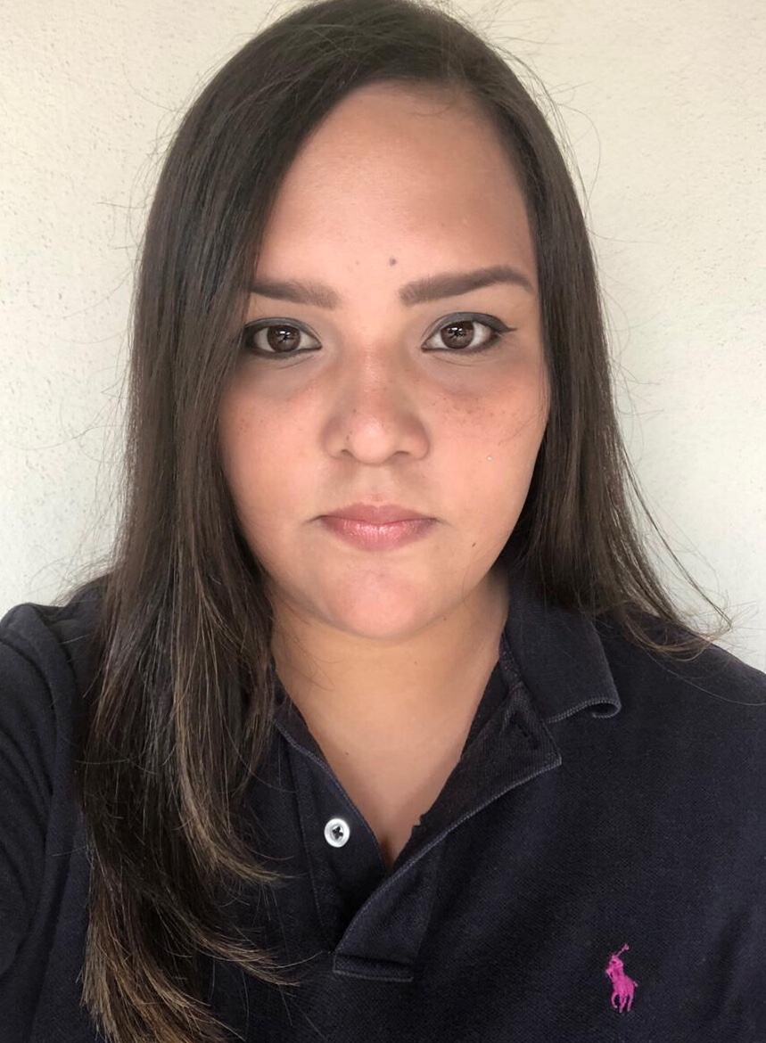

PERSONAL DETAIL

Name : Astrid Cecilia Romero Varela
ID Number : 0501-1993-05824
Place and Date of Birth : San Pedro Sula, May 26th 1993
Sex : Female
Address : Colonia Colvisula House #13 SPS
Maritial Status : Single
Telephone Number : 32327325
Email and Skype : astrid_crv@hotmail.com

EDUCATION

University
Currently student of the career of
Engineering in logistics and management
Universidad Tecnológica Centroamericana (UNITEC)

High School
2007-2011
Royal Teens of America School
Bachelor of Science and Letters

Elementary School
1998-2007
Escuela International Sampedrana (EIS)

OTHER SKILLS
Microsoft Word
Microsoft Excel
Microsoft Power Point

LANGUAGES
Spanish (native)
English (100%)

WORKING EXPERIENCE

Sunny Path School
Teacher
From January 16, 2013 to November 20, 2013

Responsibilities:
Elementary and High School substitute teacher for Reading, spelling, English.

Convergys
Call center agent
January 13, 2014- May 20,2018

Responsibilities:
Customer service, technical support, sales and IT help desk via phone, chat and email.

PERSONAL REFERENCES

Poleth Perdomo
Convergys Manager
Phone:98214960

Zulema Zelaya
Convergys Manager
Phone: 98214960

