RESUME:

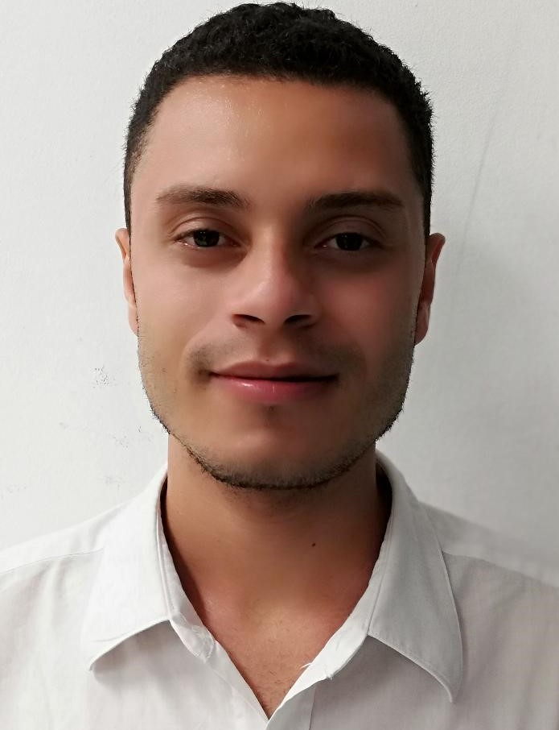
Belonging to:

PAUL CHRISTOPHER HOWELL BUSH

I. PERSONAL INFORMATION

Full name : PAUL CHRISTOPHER HOWELL

Birth place : Utila, Bay island Honduras

Date of birth : 10 of November 1991

Id number : 1104-1991-00043

Marital status : Single

Profession : Bachelor of Science and
letter and computer

Cel number : 98414562

Current residence : Barrio Lozano, Utila,

E-mail: paulhowell527@gmail.com

III. STUDY DONE

- PRIMARY EDUCATION

School : Alton J. Cooper

Year : 2007

Place : Barrio Jerusalén, Calle al Aeropuerto

- SECONDRAY EDUCATION

Institute : Instituto Alton J. Cooper

year : 2008-2010

place : B. Jerusalén, calle al Aeropuerto

- JUNIOR HIGH SCHOOL

Institute : Alton J. Cooper

Year : 2011-2013

Place : B. Jerusalen, Calle al Aeropuerto

Degree earned : Bachelor of Science and letter and
Computer

- Professional experience:

Previous professional practice to the bachelors degree in science and letter and computer technical:
Institute: Municipalidad de Utila
Duration: 1 month
Work done in practice
- Work box: printing and collection of invoices for different taxes
- Tax control: document files
Tax billing
Information update in saft system

- COMPUTER KNOWLEDGE

- Microsoft Word
- Internet Explorer
- Microsoft Excel
- Microsoft Power - Point

- PERSONAL REFERENCES

- María Salgado ( Jefe Control Tributario Municipalidad de Utila CEL. 3298-1538)
- Shanik Ebanks (Cajero - Municipalidad de Utila CEL. 3156-6014)
- Emilia Melara (Centro de buceo Captain Morgans Cel. 33343168)
- Sherly Fox (Centro de buceo Deep Blue Divers Cel. 99251142)

Work Experience:

1. Dive Center: Captain Morgans.

2.Dive Center: Deep Blue

3.Allied Global: agent customer service

4.SOS Smart Outsourcing Solutions: agent collections

5. Concentrix: agent customer service and sales

Direction : Jardines Del Valle 4 street 2 stage

