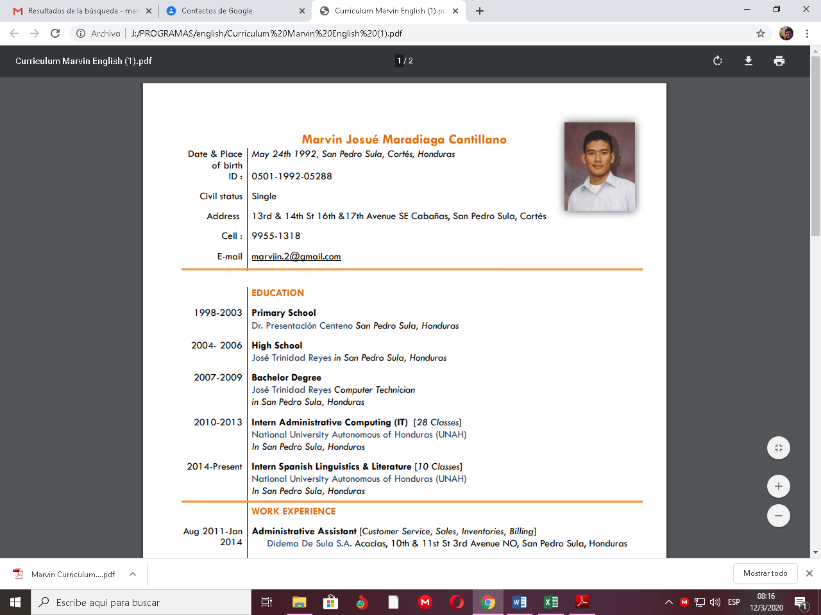Curriculum

Marvin Josué Maradiaga Cantillano

|  |  |
| --- | --- |
| Date & Place of birth | May 24th 1992, San Pedro Sula, Cortés, Honduras |
| ID | 0501-1992-05288 |
| Civil status | Single |
| Address | 13rd & 14th St 16th &17th Avenue SE Cabañas, San Pedro Sula, Cortés |
| Cell | 3306-5039 |
| E-mail | marvjin.2@gmail.com |
|  |  |

|  |  |
| --- | --- |
|  | **EDUCATION** |
| 2007-2009 | Bachelor Degree José Trinidad Reyes  Computer Technician |
| 2010-2013 | Intern Administrative Computing (IT) [28 Classes] National University Autonomous of Honduras (UNAH) In San Pedro Sula, Honduras |
| 2014-2016 | Intern Spanish Linguistics & Literature [10 Classes]  National University Autonomous of Honduras (UNAH) In San Pedro Sula, Honduras |

|  |  |
| --- | --- |
|  | **WORK EXPERIENCE** |
| Aug 2011-Jan 2014 | Administrative Assistant [Customer Service, Sales, Inventories, Billing] Didema De Sula S.A.  Acacias, 10th & 11st St 3rd Avenue NO, San Pedro Sula, Honduras |
| Oct 2016- Dec 2016 | Agent [Customer Care, Sales for AT&T ] Convergys  Altia Business Park Tower 2 Blvd. Armenta, KM2. San Pedro Sula |
| Jan 2018- Jul 2018 | Agent [Customer service, Upsells] KM2 Solutions Altia Bussinessz Park Tower 2 Blvd. Armenta, KM2. San Pedro Sula |
| Oct 2018- May 2019 | Agent [Customer service, Billing ] Zero Variance Altia Business Park Tower 2 Blvd. Armenta, KM2. San Pedro Sula, Honduras |

|  |
| --- |
| **Computer Skills** |
| Microsoft Windows (MS-DOS, XP, Vista, Seven, 8, 10) |
| Office : Microsoft Office, Open Office Design : Adobe Photoshop, Adobe InDesign, Corel Draw, SketchUp Video : Video Studio, Adobe Premiere, Sony Vegas |
| Visual FoxPro, Visual Basic, C++. Microsoft Access |

|  |  |
| --- | --- |
|  | **Laboral References** |
| Cristopher Hernandez (Zero Variance) | 9808-5660 |
|  |  |
|  |  |
|  | **Personal References** |
| Dennis Rodriguez | 9883-3110 |
| Wendy Flores | 9954-1881 |