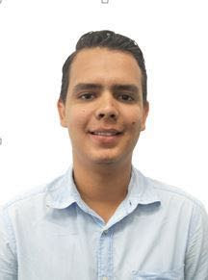CURRICULUM VITAE

Luis Alejandro Aguiluz Barralaga

**Personal Data**

Birthday: April 6, 1998

Place of Birth: La Lima, Cortes

Civil Status: Single

Nationality: Honduran

ID Nº: 0512-1998-00798

Residence: Col Usula, 3rd street. Block 16, house Nº 140

Cellphone: 8849-5494 / 2672-3383

E-mail: Luisaguiluz77@gmail.com

**Objective**

Perform in an organization that offers opportunity for development and continuous progress, applying the knowledge acquired

**Academic** **Data**

University: intern of the carrier of electric engineering (UNAH-VS)

Obtained Title: Bachelor of Science and Letters

High School:Sunshine Christian Bilingual Institute (7º-11º).

Elementary: Sunshine Christian Bilingual School (1º-6º).

**Skills**

Microsoft office Programs

Teamwork

Facility communication

Good interpersonal relations

**Attitudes**

Responsible

Initiative

Honest

Ethical and moral values

**Labor Experience**

Serve5ive Honduras 1year 10months

Simplex group (Orbis Insurance) 1 year to current date

**Personal Reference**

Jorge Eduardo Hernández Deras

Workplace: Ceutec

Phone: 9798-8042

German Rolando Santamaria

Workplace: Standard Fruit Company

Phone: 9663-0243

Raul Ramirez Barralaga

Workplace: Gildan/ Villanueva

Phone: 9769-3924