**RESUME** 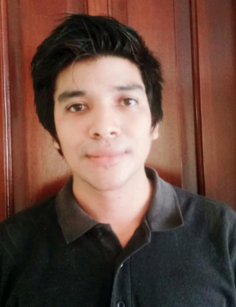

**I.- Personal Details**

**Complete Name:**

**Jose Armando Varela Hernandez**

**Born in : San Pedro Sula /Cortes**

**Date of birth: April 17 1992**

**ID: 0501-1992-03922**

**Matrial status : Single**

**Address : French Key /roatan**

**Email: armandovh2009@yahoo.com**

**Phone: 97265469**

**II.- EDUCATION**

**\*Primary : Happy Days & Freedom School**

**\*Secundary : Mision Evangelica Anna D Bechtold**

**\*Other: Honduras Corea (Computing, Refrigeration)**

**III.-PROFESSIONAL EXPERIENCE**

**Call Medical Reference: February /07/2013 - June /07/2013**

**MEDICAL DATES**

**Allied Global: June/11/2013 - July/ 07/2014**

**Call Center agent**

**Convergys: November /4/2014 - December /11 /2016**

**Supervisor and Customer service experience**

**Star Tek February /03/2017 -May/11/2018**

**Customer Service and Sales**

**Zero Variance July /07/2018 – January /07/2019**

**Sales and customer service**

**Piñas spa & club center**

**May/05/2019- December/10/2019**

**Repcepcionist**

**IV.-LANGUAGE**

**Bilingual:**

**Spanish**

**English**

**V.-SKILLS**

**Certification in SAP systeme**

**Knowledge at user levels asl : Windows, Internet.**

**Text processor : Microsoft Word, Excel , Powerpoint , and other systems**

**Spreadsheets: Excel**

**VI.PERSONALITY**

* **Optimistic - Loyal**
* **Patient**
* **Hard working**
* **Adaptable**
* **Creative**
* **Honest**

**VII- PERSONAL REFFERENCES**

**Kenneth Mulrooney**

**Fantasy island**

**3346-6730**

**Jessica Mejia**

**Hospital Del Valle**

**98468977**

**Cesar Joaquin Lopez**

**Infinity bay**

**87330316**

**Miguel Gerardo arias**

**Las Piñas Spa**

**8754-7753**