Quarterly Board Report
  - Q1 2026 - Northwind Traders Limited

Contents
Executive summary 3
Trading performance 3
Sales by region 3
Costs 3
Staff costs 3
Decisions requested 3
Appendix: capital expenditure 4

Executive summary
Revenue grew by 14% compared with the same quarter last year, driven by the new distribution agreement in Spain. Operating margin improved to 11.2%.
- Revenue: EUR 48.3 million (+14%)
- Gross margin: 38.5% (+1.2 points)
- Net cash: EUR 12.1 million

Trading performance

Sales by region
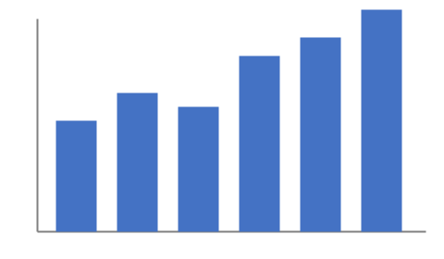
All regions grew in the quarter. The chart shows monthly revenue for the last six months; the strongest month was March, when the first shipments under the new agreement were invoiced. Northern Europe remained broadly flat, while Southern Europe more than offset the seasonal slowdown in the United Kingdom. The pipeline for the second quarter is in line with the budget approved in December.

Costs

Staff costs
Headcount increased from 212 to 231 employees. The main hires were:
- four data engineers for the platform programme;
- eight warehouse staff for the Madrid hub;
- a Head of Compliance.

Decisions requested
The Board is asked to approve the capital expenditure set out in the appendix and to note the risk register.

Appendix: capital expenditure
Project | Owner | Q2 | Q3 | Q4 | Total
Madrid hub expansion | Operations | 1.2 | 0.8 | 0.4 | 2.4
Data platform | Technology | 0.6 | 0.6 | 0.3 | 1.5
Fleet renewal | Logistics | 0.0 | 1.1 | 1.1 | 2.2
Table 1: Capital expenditure by quarter (EUR million)

Operating margin before exceptional items, as defined in the 2025 annual report.
The risk register is circulated separately to Board members.

