ROWLEND STRATEGY DOCUMENT:

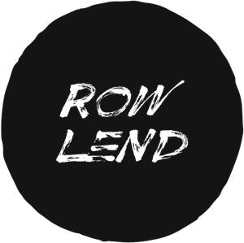

.

|  |  |  |
| --- | --- | --- |
| Business Goals: | User’s Goals: | |
| Get people to use the website.  Enable smaller artists/singers/performers to promote themselves. | Carry out a successful event. | |
| The user is an event organizer who wants to have a successful event | |