EMPATHY MAP

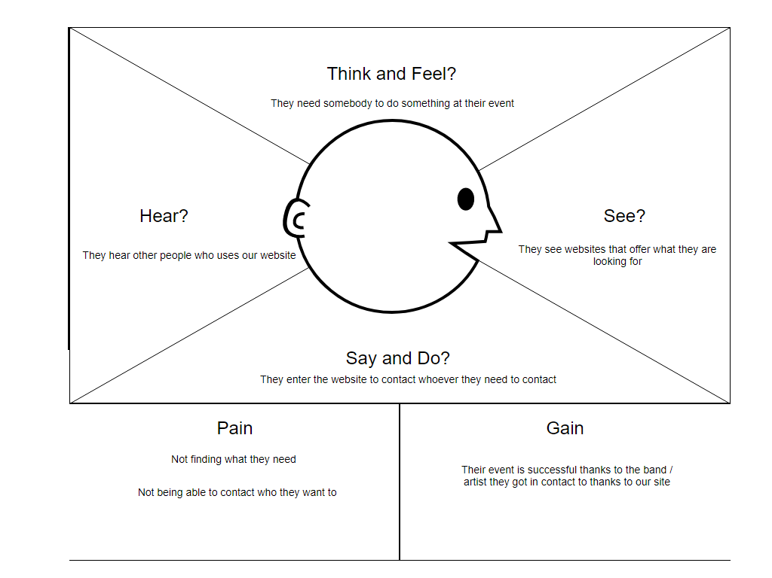

USER RESEARCH

Why do they use the product?:

They use our website to get in contact with professionals who can do something they need them to do.

Behaviours & eviorment:

They organize events.

Goals, needs, motivations:

They need somebody to make their event successful

The user is an event organizer who wants to find a firestarter for their event.

JOURNEY MAP TEMPLATE

