Likelihood computation under TKF91 model for a 3 taxa tree

Problem
Given a 3 taxa phylogenetic tree (Figure 1), where Ω denotes the root node the model parameters θ(substitution rates, insertion rate per link λ and deletion rate per link µ) and an MSA α, the proposed algorithm calculates the likelihood under the TKF91 model. We assume that the root node is the central node and 3 leaves were generated from it.
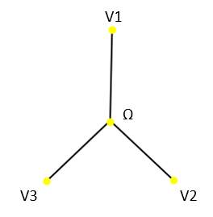Figure 1: 3 taxa tree

Solution
The likelihood under TKF91 can be factorized in this way
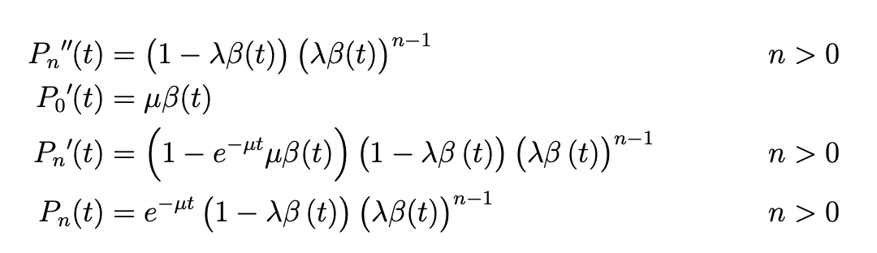
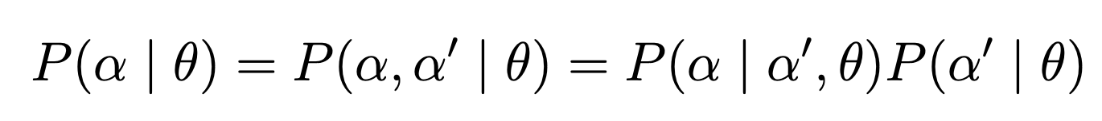
where 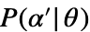 calculates the geometric probability 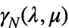 that the ancestral sequence has links and considers only the structure of the MSA , that is insertions and deletions, converting the original MSA into character/gap states (#/-) while 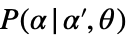 accounts for the substitution process given the MSA structure and the model parameters. Next we describe how to calculate the likelihood .
The likelihood of the MSA structure is composed by the product of the likelihood of each block where is the likelihood of block
The probabilities for the different possible fates of a single link (character) evolving along a tree branch of length are equal to
(for their derivation refer to the original paper ).
The algorithm to compute the Likelihood is explained below:
Step 1: Blocking the MSA
The initial task is to seperate the MSA into blocks. In TKF91 it is convinient to handles the MSA as blocks. Likelihood is computed for each blocks and finally multiplied together to obtain the total likelihood. When a column in MSA containes atleast 2 characters it is obvious that they are homologus and must be from a common ancestor. Thus there should be an ancestor at the root. Once we find all such homologous columns we perform the blocking as below
- Let START = end column index of the MSA and POSITION= end column index of the MSA.
- Check START= first column index of the MSA. If true go to 3 else to 4
- Extract the columns from START to POSITION of the MSA and this is stored as a block. Go to 8
- Check Homologous condition. If True go to 5 else to 6
- we extract the columns from START to POSITION of the MSA and this is stored as a block. Set POSITION= START-1
- START=START-1
- Go to 2
- Stop
V1 | − | # | # | − | # | # | # | −
V2 | − | − | # | # | # | − | # | #
V3 | # | − | − | − | # | − | − | #
The above MSA will be separated into below blocks

− | #
− | −
# | −

# | −
# | #
− | −

# | #
# | −
# | −

#
#
−

−
#
#

Likelihood Computation of a block
For any MSA there are 2 types of block, immortal and mortal. We will handle both of the separately. First let us discuss how to handle a mortal block.
Computing LK for a mortal block
For a mortal block the first column is always homologous and contains a character at the root. For example, consider the below mortal block

# | ?
# | #
# | −
# | −

Since the first column always have more than 2 characters they are always homologous. However, the additional columns in block where there is only one character is present the character has 2 possibilities:
- Has its own parent.
- Was born from an already present root character.
For example, in the above block the character in the column 2 has its own parent meaning it there was a character at the root which survived in leaf v1 but died on both v2 and v3 or was born by the parent character present in column 1.

Case 1:
# | #
# | #
# | −
# | −

Case 2:
# | −
# | #
# | −
# | −
In order to have the complete LK one must consider all these possible ancestral scenarios for a block.
For each block we compute both and

Calculating Indel probability for a mortal block
Let us consider the below block
# | ? | ? | ?
# | # | − | −
# | − | # | −
# | − | − | #

For the above block the 1st column has only one possibility (#) and each of the other 3 columns have 2 possibilities (#/−). Thus in total we have 1*2*2*2 i.e. 8 possibilities. The possible ancestral scenario for this block are:

# | − | − | −
# | − | − | #
# | − | # | −
# | − | # | #
# | # | − | −
# | # | − | #
# | # | # | −
# | # | # | #

It is evident from the example that for a given block the possible ancestral sequences have a pattern. If we replace # with 1 and – with 0 in the above table, we could see that the possible ancestral combinations are the binary form of numbers from decimal of ‘# − − −’ to ‘# # # #’. Refer below table.

1 | 0 | 0 | 0 | 8
1 | 0 | 0 | 1 | 9
1 | 0 | 1 | 0 | 10
1 | 0 | 1 | 1 | 11
1 | 1 | 0 | 0 | 12
1 | 1 | 0 | 1 | 13
1 | 1 | 1 | 0 | 14
1 | 1 | 1 | 1 | 15

We will make use of this relation to accommodate all scenarios for a given block. For each of this possible ancestors we will compute the Indel and substitutional LKs and the product of these will be summed for all scenarios in order to obtain the final block likelihood. We will now calculate the likelihood for 2 of the ancestral scenarios from the above example in detail for an understanding.

For the ancestral sequence ‘1 0 0 0’ at root we can represent the total block as below

Ω | # | − | − | −
V1 | # | # | − | −
V2 | # | − | # | −
V3 | # | − | − | #

In this case we have only 1 ancestral character at column 1 which survived in all the 3 leaves and also give birth to a character in each leaf. The Indel LK for this under TKF91 can be calculated as:

