ARQUITECTURA DE PostgreSQL

PostgreSQL is a progressive open source object-relational database management system invented on 8 July 1996 at the University of California, Berkeley. Since then there are many enhancements done that make PostgreSQL an advanced relational database management system. An active community of developers and volunteers is working together to add new features and fix bugs from PostgreSQL. PostgreSQL Architecture uses the client-server model to receive the request from the end-user and process the request and revert it to the client. PostgreSQL Architecture is the process per-user client/server model in which for each client connection request there will be a new process started and the client request is processed by the PostgreSQL Server process. The PostgreSQL server process performs all operations on behalf of the Client process. The server process is called postgres. This way PostgreSQL maintains the concurrent connection from the client. The Default Port of PostgreSQL is 5432 through which the client makes a read and write request to the PostgreSQL database instance however the default port can be changed using postgresql.conf configuration file.
The following figure represents the process and memory architecture of PostgreSQL.
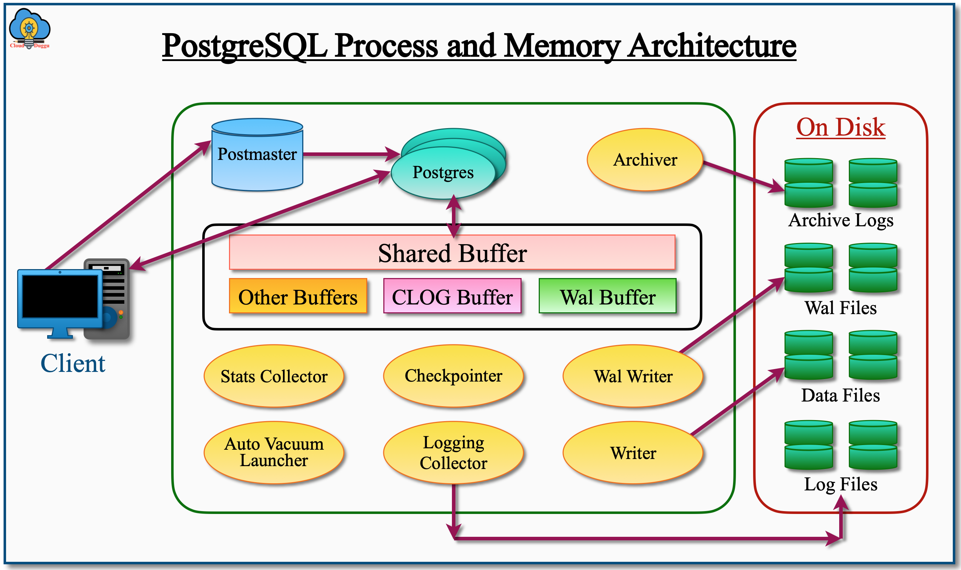

PostgreSQL Architecture Key Components

Let's see each component of the PostgreSQL architecture in the following section.

1. Postmaster Supervisor Process of PostgreSQL
Postmaster works as the Supervisor process in the PostgreSQL architecture and it is the first process that gets started after PostgreSQL start. It works as the Listener and is responsible for authenticating and authorizing the incoming request from the client and assigning a new process called Postgres for each connection. Postmaster also keeps monitoring the process and starts if it is dead.

2. Shared Memory Segments of PostgreSQL
The Shared Memory Segments are the buffer cache in memory that is reserved for transactions and Maintenance activity. There are different Shared Memory segments allocated to perform a different operation. The following are the major shared memory segments.

2.1 Shared Buffer
The Shared Buffer is the memory area in the PostgreSQL instance that is used for any insert, update, delete, or select operation because users can't access the data files directly. The data that are modified or updated is called the Dirty Data and written to the physical data files through the background process called the writer process. The property of Shared Buffer is controlled by the shared_buffer parameter that is present in the postgresql.conf file.

2.2 Wal Buffer
The Wal Buffer also called the Write ahead logs buffer is the Transaction log Buffers which stores the metadata information of the changed data that is used to reconstruct the data during the database recovery operation. The Transaction log Buffers are written to the physical files WAL Segments or Checkpoint Segments by the background process called Wal writer. The property of Wal Buffer is managed by the wal_buffers parameter.

2.3 CLOG Buffer
The PostgreSQL CLOB buffer is the commit logs, the area allocated in the main memory(RAM) to store the status of all transactions. It shows whether a transaction is completed or not. This buffer area is automatically managed by the database engine as there is no specific parameter for that. It is shared by all background servers and users in the PostgreSQL database.

2.4 Work Memory
The PostgreSQL Work Memory area is used when there is a Sort operation that includes Order By, Distinct, Merge join, and hash table operation that includes hash-join, hash-based aggregation, or the IN clause are involved in the database SQL query. The Work Memory is controlled by the work_mem parameter. In a complex SQL query, there could be multiple Sort and Hash operations and for each Sort and Hash operation, there is a memory allocated in RAM, hence it is suggested not to give a big value to this memory area otherwise it can exhaust all RAM space and will create an issue for other processes.

2.5 Maintenance Work Memory
The PostgreSQL Maintenance Work Memory area is used when the maintenance work is performed such as creating the Index, adding the index, adding the foreign key, and so on. It is controlled by the maintenance_work_mem parameter.

2.6 Temp Buffers
The PostgreSQL Temp Buffers area is used while accessing the temporary tables during the large sorting and hashing operations. These buffers are user session-specific.

3. Utility Background Processes of PostgreSQL

The PostgreSQL Background processes are important components of the PostgreSQL database. These processes are used to maintain the consistency between the memory and disk and due to this PostgreSQL database function properly. Each PostgreSQL background process has its role to play.
The following are the list of PostgreSQL background process.
- Background Writer
- Checkpointer
- Autovacuum Launcher
- WAL Writer
- Statistics Collector
- Logging Collector
- Archiver
Let's understand each PostgreSQL database background process in the following section.

3.1 Background Writer
The PostgreSQL Background Writer gets started by the postmaster when the PostgreSQL instance is started. The Background Writer is used to write the Dirty Buffers also called the new or modified shared buffers on the data files so that sufficient buffer space is available for use.
The PostgreSQL Background Writer follows the following three-parameter to write the dirty buffers from Shared Buffers to Data files.
- bgwriter_delay (200ms by default, 10ms – 10s possible):- This parameter is used to define the wait time of two successful execution.
- bgwriter_lru_maxpages (100 pages by default, 0 – 1000 possible):- This parameter is used to define the number of maximum buffers that can be written to data files in each iteration.
- bgwriter_lru_multiplier (2.0 by default, 0-10.0 possible):- This parameter is used to define the number of pages that will be cleaned for incoming dirty pages, and that is based on the count of the last delayed period. For example, if the value is set to 2 and the incoming pages are 10 so in this case, the dirty buffers will be cleaned unless there are 20 buffers that are not reaching.

3.2 Checkpointer
The PostgreSQL Checkpoint is an event that occurs at a specific time or manually by DBA to move Dirty Buffers(changed data or new data) from the memory(shared buffer) to disk(Data Files). The checkpoint is required in case of Crash recovery in which the latest checkpoint in the write-ahead log tells from which position the REDO recovery should start.
But how the changes are done in the database and what is the process? Basically for any DDL and DML statement, PostgreSQL requires the data to be present in the shared_buffers, If the data is not in shared buffers then PostgreSQL brings data from data files into shared buffers and then performs the DDL and DML operations. The modified blocks are called Dirty Pages. Once the commit command is submitted the detail about changes are written to the Write ahead log file on the disk and the Dirty Pages are written on the data files respectively.
The PostgreSQL Checkpoint triggers in the following condition.
- Manually by using the CHECKPOINT command.
- By setting the interval parameter checkpoint_timeout. The default value is 300 seconds.
- When the Online Backup starts the PostgreSQL Checkpoint triggers.
- When the function pg_start_backup executes a post that the PostgreSQL Checkpoint triggers.
- When the function pg_basebackup executes a post that the PostgreSQL Checkpoint triggers.
- When the WAL parameter max_wal_size reaches its maximum limit. The default value is 1 GB.
- When the CREATE DATABASE / DROP DATABASE commands are used to configure the database.
Once the PostgreSQL Checkpoint command triggers the following actions are performed.
- Check all Dirty Pages in the shared buffers.
- Write those Dirty Pages in the respective data files.
- Execute the fsync() function to record all up-to-date data on the disk.

3.3 Autovacuum Launcher
The PostgreSQL Autovacuum Launcher is the background process that is enabled by default and used for automating the execution of ANALYZE and the VACUUM commands. This process is enabled by default in PostgreSQL and runs on every autovacuum_naptime seconds if the autovacuum is set.

3.4 WAL Writer
The PostgreSQL WAL Writer background process is used to write the changed records from the WAL Buffer to the WAL files once the commit is issued.
The following command is used to check the current WAL location file.
postgres=# SELECT Pg_xlogfile_name(Pg_current_xlog_location());

3.5 Statistics Collector
The PostgreSQL Statscollector background is used to collect the stats about the server activity such as the number of records in the table, database details, index, and table access details, and report it to the optimizer dictionary(pg_catalog). This process is optional and by default, it is on. The stats information can be viewed by many views provided by PostgreSQL.
The below command shows all stats-related views in PostgreSQL.
postgres=# \d pg_stat

The following parameters in the PostgreSQL postgresql.conf file defines the details that will be collected by the Stats collector.
- track_activities: This parameter monitors the ongoing command executed by any of the Server processes.
- track_functions: The UDF(User Defined Function) usage is tracked by this parameter.
- track_counts: The number of stats collected on tables and indexes is tracked by this parameter.
- track_io_timing: This parameter will track the number of reads and write blocks.

3.6 Logging Collector
The PostgreSQL Logging Collector background process is used to log the messages in the log file. It works when the following parameter value is set in the postgresql.conf configuration file.
log_destination = 'stderr'
logging_collector = ON
log_directory = 'pg_log'

3.7 Archiver
The PostgreSQL Archiver background process writes the WAL buffers to the WAL files when the database is in Archive.log mode.

4. Physical Files of PostgreSQL

The PostgreSQL Physical Files are used to store the actual data in the form of data files, the changed blocks in the WAL files, the server log details in the log files, the Archive log information, and so on. The data in these files are stored permanently and used for their respective operation.
The following listed are the physical files in the PostgreSQL database.
- Data Files
- Wal Files
- Log Files
- Archive Logs
In the following section, we will see more detail about each PostgreSQL Physical file.

4.1 Data Files
The PostgreSQL Data Files are used to store the actual data. It stores the actual data and no such instruction or any kind of code information. When the user requests the data, PostgreSQL looks for the data in the shared buffer if it is not there then it loads data from the data files in the shared buffer and then processes further.

4.2 Wal Files
The PostgreSQL WAL files are used to store all changes from the WAL Buffer before the commit happens. WAL files are primarily used to maintain durability and consistency during a write operation on database storage.

4.3 Log Files
The PostgreSQL Log files store all logs related to the server, stderr, csvlog, Syslog, error message, warning message, informative message, and so on. It helps the database administrator to debug any issue in detail.

4.4 Archive Logs
The PostgreSQL Archive Log files are used to store the WAL segment on the disk. The Archive logs are used in case there is an unexpected crash that happens due to which the data is lost, in that scenario the Archive logs are used to repair/recover the database.

Resumen de la Arquitectura de PostgreSQL
PostgreSQL es un sistema de gestión de bases de datos objeto-relacional de código abierto que sigue un modelo cliente-servidor. Cada conexión de cliente genera un nuevo proceso en el servidor, llamado postgres, que maneja todas las operaciones para ese cliente. El puerto por defecto es el 5432, aunque puede modificarse.

🔧 Componentes Clave

1. Postmaster
Es el proceso supervisor que se inicia primero. Se encarga de:
- Escuchar conexiones entrantes.
- Autenticar usuarios.
- Lanzar un nuevo proceso postgres por cada conexión.
- Monitorear y reiniciar procesos si fallan.

2. Segmentos de Memoria Compartida
Son áreas en RAM utilizadas para operaciones de lectura/escritura y mantenimiento:
- Shared Buffer: Almacena datos modificados temporalmente (dirty data). Controlado por shared_buffers.
- WAL Buffer: Guarda los registros de transacciones antes de escribirlos en disco. Controlado por wal_buffers.
- CLOG Buffer: Registra el estado de las transacciones (completadas o no).
- Work Memory: Usado para operaciones como ORDER BY, JOIN, DISTINCT. Controlado por work_mem.
- Maintenance Work Memory: Usado para tareas como creación de índices. Controlado por maintenance_work_mem.
- Temp Buffers: Buffers temporales por sesión para tablas temporales.
- Lock Manager: Gestiona bloqueos entre transacciones concurrentes.

3. Procesos en Segundo Plano
PostgreSQL utiliza varios procesos para mantener la integridad y el rendimiento:
- Background Writer: Escribe datos modificados desde los buffers a disco.
- Checkpointer: Realiza puntos de control para recuperación ante fallos.
- Autovacuum Launcher: Ejecuta automáticamente VACUUM y ANALYZE.
limpia filas muertas y actualiza estadísticas automáticamente.
- WAL Writer: Escribe los registros de transacciones (WAL) en disco.
- Statistics Collector: Recoge estadísticas de uso para el optimizador.
- Logging Collector: Registra eventos y errores en archivos de log.
- Archiver: Guarda archivos WAL en modo de archivo para recuperación.

4. Archivos Físicos
PostgreSQL almacena datos en varios tipos de archivos:
- Data Files: Contienen los datos reales de las tablas.
- WAL Files: Guardan los cambios antes del commit para garantizar durabilidad.
- Log Files: Almacenan mensajes de error, advertencias y eventos.
- Archive Logs: Copias de los WAL para recuperación ante desastres.

5. Almacenamiento en disco
- Data Directory: Carpeta donde se almacenan todos los archivos de la base de datos (PGDATA).
- Tablespaces: Permiten almacenar tablas e índices en ubicaciones personalizadas del sistema de archivos.
- Archivos de datos: Organizados en segmentos (normalmente de 1 GB), dentro de directorios por base de datos y OID de tabla.
- WAL (Write-Ahead Log): Archivos secuenciales que registran todos los cambios antes de aplicarse a los datos. Esencial para recuperación ante fallos y replicación.

d. Catálogo del sistema
- Conjunto de tablas del sistema (ej. pg_class, pg_attribute, pg_index) que almacenan metadatos sobre tablas, columnas, índices, etc.

e. MVCC (Multi-Version Concurrency Control)
- PostgreSQL no sobrescribe datos. En lugar de eso, mantiene múltiples versiones de una fila.
- Cada transacción ve una "instantánea" consistente del estado de la base de datos.
- Las filas antiguas (muertas) se eliminan mediante VACUUM.

