KONZUME

MINI PROJECT REPORT SUBMITTED TO MAHATMA GANDHI UNIVERISITY, IN PARTIAL FULFILMENT OF THE REQUIREMENTS FOR THE DEGREE OF BACHELOR OF SCIENCE IN COMPUTER APPLICATIONS.

BY

JOSEPH BENOY

180021089781



DEPT. OF COMPUTER SCIENCE
B.V.M HOLY CROSS COLLEGE
CHERPUNKAL, KOTTAYAM 686 584
February 2021

Contents
- Introduction
  - Project Overview
  - Organization Profile
- System Configuration
  - Hardware Specification
  - Software Specification
- System Analysis
  - Preliminary Investigation
  - Existing System
  - Proposed System
  - Feasibility Analysis
  - Advantages of Proposed System
  - Requirement Specification
- System Design
  - Introduction
  - System Flowchart
  - Database Design
  - Data Flow Diagram
  - Input Design
  - Output Design
- System Development
  - Introduction
  - Menu Level Description
  - Process Specification
- System Testing
  - Testing Methods
  - Test Plan Activities
  - Screen Layouts
- System Implementation
- Conclusion and Scope for Future Enhancement
Bibliography
Appendix (if Any)

Department of Computer Science

BVM HOLY CROSS COLLEGE
Certificate

Certified that the report entitled “ KONZUME – Product review aggregator website” is the bonafide record of the mini project work done by Joseph Benoy (180021089781) under our guidance and supervision and is submitted in partial fulfillment of the Bachelor degree in Computer Applications, awarded by Mahatma Gandhi University, Kerala.

Asha Ramachandhran Binu M B
Project Guide Head of Department

Submitted for Project Evaluation on ------/-----/------

External Examiner
DECLARATION

I here by declare that the mini project work entitled KONZUME – Product review aggregator website submitted in partial fulfillment of the requirements for the award of the Bachelor of degree in Computer Applications from BVM Holy Cross College, Cherpunkal, is record of bonafide work done under the guidance of Ms. Asha, Assistant Proffessor
.

Place:Cherpunkal
Date: Joseph Benoy
180021089781

Acknowledgment
It gives us immense pleasure to express heartful thanks to all those who helped us in the successful completion of this mini project works. It has been said that gratitude is the memory of heart. First of all we would like to thank the God Almighty who has been a constant support in every walk of our life and the source of strength in presenting this project work. Words are boundless to express our sincere thanks to our most respected principal, Rev. Fr. Baby Sebastian Thonikuzhi, whose advice was really an encouragement for us. We are very much thankful to Mr. Binu M. B (Head of Department, Computer Science), for his proper guidance, encouragement and timely suggestions throughout our project work. We also express our special thanks to Ms.Asha Ramachandhran Assistant Professor (Department of Computer Science) and to all teachers in the Department of Computer Science, who has helped us in the completion of this project. And also we wish to express our deep sense of gratitude to our parents and friends for the support and co-operation they rendered to us in making this work ease. And I express our sincere thanks to all who have helped us to complete our project Acknowledgement It gives us immense pleasure to express heartful thanks to all those who helped us in the successful completion of this mini project works. It has been said that gratitude is the memory of heart. First of all we would like to thank the God Almighty who has been a constant support in every walk of our life and the source of strength in presenting this project work. Words are boundless to express our sincere thanks to our most respected principal, Rev. Fr. Baby Sebastian Thonikuzhi, whose advice was really an encouragement for us. We are very much thankful to Mr. Binu M. B (Head of Department, Computer Science), for his proper guidance, encouragement and timely suggestions throughout our project work. We also express our special thanks to Mr. Asha Ramachandhran Assistant Professor (Department of Computer Science) and to all teachers in the Department of Computer Science, who has helped us in the completion of this project. And also we wish to express our deep sense of gratitude to our parents and friends for the support and co-operation they rendered to us in making this work ease. And I express our sincere thanks to all who have helped us to complete our project.

1.INTRODUCTION

PROJECT OVERVIEW

There is a common belief that we people need to change with changing times. But it is human instinct to resist change. The critics who are against change may have their own reasons, but the contemporary person who belief that information technology is here still believes right, for there is incredible change in the way people have been living there lines these days. How many times have not we heard the phrase that “Computers are here to say”, well the machine does have the world at its mercy cause there is no field that do not make use of this incredible machine.
Information technology has a major influence on our society. Our society become more depend on technology mostly because of the obvious shortcuts it given us. In such a society where one can communicate with a person in any corner of the globe in a few seconds, where jets are no longer flown by women, where people have converted their cars into offices, where tiny toddlers want a laptop for a birthday present, because these people who makes and run the world today.
The project is automated electronic and hiring, which every operation done manually. Features of the project are:
- Used to automate manual system. Entire manual operations are converted into computer by the project.
- The user just needs to given the necessary details and the entire operations are performed by the system.
- The chances of errors are reduced in the project.

- The time required for updating different records are reduced by the project.

The project is designed to improve the way user collects reviews of various products before purchasing. All the operations are converted to different blocks of project.

1.2 ORGANIZATION PROFILE
Sometimes it is very difficult to make purchase decision online when there are tons of reviews on popular ecommerce websites like Amazon, Flipkart etc. Many of the reviews are vogue and fake which may lead the upcoming to take wrong purchase decisions. Also searching and analysing for reviews and comments of a products across dozens of websites is a tough nut to crack.

Konzume is a product review analyser and recommendation system that helps the buyers to analyse the thousands of reviews online and make a decision wisely. Konzume will aggregate reviews and comments from multiple ecommerce websites , popular blogs , online news websites etc and provide the users with best possible scores and and authentic reviews. Konzume will sortout authentic ratings and reviews from fake and vogue ones using sentiment analysis method. It will also recommend related similar products based on the rating and buyer’s need.

Modules
User module

- can submit reviews and rating for particular products
- less privilege than admin
- can report inappropriate reviews and ratings

2.SYSTEM CONFIGURATION
System configuration mainly refers to the specification of a given computer system, from its hardware components to the software and various processes that are run within that system. It refers to what types and models of devices are installed and what specific software is being used to run the various parts of the computer system. By extension, system configuration also refers to the specific operating system settings that have been set by default automatically or manually by a given program or the user.

2.1 HARDWARE SPECIFICATION
The selection of hardware is very important in the and proper working of an existence software. When selecting hardware, the size and capacity requirements are also important. Below is some of hardware that is required by the system:
- CPU : INTEL® CORE™ i3-6006U CPU @ 2.00GHz

- RAM : 8 GB

- HDD : 179 GB

- MONITOR : 12.7 INCH LCD MONITOR

- KEYBOARD : 105 KEYBOARD

- MOUSE : 3 BUTTON

- PRINTER : LASER JET PRINTER

2.2 SOFTWARE SPECIFICATION
We require much different software to make the application which is in making to work efficiently. It is very important to select the appropriate software so that the software works properly.
Below are the software that are required to make the new system.
OPERATING SYSTEM : Windows 10 Pro
FRONT END : HTML5 CSS PHP BACK END : MYSQL SERVER 2000 WEB BROWESR : GOOGLE CHROME
Operating system is the software responsible for allocating resources, including memory, processor, timer, disk space and peripheral devices such as printer and monitor. All application programs are using the operating system to gain access to these resources, as they are needed. Popular operating systems are WINDOWS, UNIX, and LINUX etc.
The operating system provides certain services to program and to users of these programs such as program execution, input-output operation, calculation, resources allocation etc.

3.SYSTEM ANALYSIS
System analysis is a general term that refers to an orderly, structure process for identifying and solving problems. We call system analysis process lifecycle methodology, since it relates to four significant phases in the lifecycle of all business information system. It is a process of collecting and interpreting facts, identifying the problems, and decomposition of a system into its components.
System analysis is conducted for the purpose of studying a system or its parts in order to identify its objectives. It is a problem solving technique that improves the system and ensures that all the components of the system work efficiently to accomplish their purpose.
Analysis specifies what the system should do. The lifecycle is divided into four phases. They are:
- Study phase

- Design phase

- Development phase

- Implementation phase

Analysis implies the process of breaking something into parts so that the whole may be understood. The definition of the system analysis includes the process of putting together to form a new whole.
All active associated with each life cycle phase must be performed, managed, and documented. Hence we define system analysis as the performance, management, documentation of the activities related to the life cycle phases of a computer-based business system. In the study phase a detailed study of the project is made and clear picture of the project should be in mind by this time. In the design phase the designing of the input, output and table designs are made.
Development phase is where the physical designing of the input-output screens and coding of the system is done. System implementation actually implements the system by making necessary testing.

PRELIMINARY INVESTIGATION
The first stage of any project, sometimes called the preliminary assessment, is a brief investigation of the system under consideration. This is the critical process of information development.
Preliminary investigation is a problem solving activity that requires intensive communications between the system users and system developers. It does various feasibility LIBRARY MANAGEMENT SOFTWARE Dept. Of Computer Science 6 BVM Holy Cross College, Cherpunkal studies. In these studies, a rough figure of the system activities can be obtained, from which decisions about the strategies to be followed for effective system study and analysis can be taken.
At preliminary investigation an initial picture about the system working is got from the information got from the study, the data collection methods were identified. Right from the investigation about the system many existing drawbacks of the system could be identified, which helped a lot in the later stages of more rigorous study and analysis of the manual system.
The most critical phase of managing system projects is planning. To launch a system investigation, we need a master plan detailing the steps to be taken, the people to be questioned and the outcome expected.

THE EXISTING SYSTEM

- Users have to visit each and every website to check and analyse the product reviews
- Reading vogue and hundreds of reviews and arriving at a purchase decision is
very difficult and time consuming
- It is a tedious task to identify and reject fake and vogue reviews
- Lack of platforms for sharing public reviews which is authentic

3.3PROPOSED SYSTEM

- Users can get authentic reviews about a particular product in a single query
- Summerised review help the user to quicky arrive at a purchase decision
- Users can upvote and downvote reviews
- Report products and reviews which is not upto the mark
- Registered users can post their own reviews about the product

FEATURES OF THE PROPOSED SYSTEM

User friendly

This package is easy to use. This output reports are also available in an easy to understand manner.

Security

Multiple levels of security are provided in the software, so that data remains confidential and tamper proof. After the admin get logged in to the system, he has the privilege to register facultyand students and then they can separately logged into their pages. This is used to prevent the unauthorized access. It also helps to avoid data redundancy and data tampering.

Ease of installation

Being a package solution, it is easy to install. The software is installed in the hard disk.

3.4 FEASIBILITY ANALYSIS
In any project, feasibility analysis is a very important stage: here the project is checked for its feasibility. Any project may face scarcity in resources, time or workforce. Hence all these are to be studied in detail and a conclusion should be drawn whether the project under consideration is feasible or not. This analysis is a test of the proposed project, regarding its workability, impact on users and clients and resource management. Feasibility and risk involved are inversely related to each other. The main objective of the feasibility is to test the technical, social and economic feasibility of a project. System feasibility is a test or evaluation of the completed system plan. Such as evaluation is necessary to define the application area along with its extends and complexity, to provide the scope of computerization together with suggested output and input format and potential benefits.
Feasibility study is carried out to determine whether the proposed system can be developed with available resources. During feasibility analysis for the project the following three primary areas of interest were considered. There are:
- Economic Feasibility
- Technical Feasibility
- Behavioral Feasibility

ECONOMIC FEASIBILITY

It is the most frequent used method for evaluating the efficiency and effectiveness of the candidate system. Here proposed system can be considered of the economically feasible, if it has advantages over other candidate systems and its benefits exceed cost. In this case alternative are to here to use manual systems, to buy a software package, or continue with the existing system, or to develop a new system which suits needs. After considering these candidate systems, it decided to develop a new system that has high benefits rates over cost.
This is judged by comparing the development cost against the income or benefit analysis, which is the basis for the economic justification of a system. In terms of benefits, we have to consider both tangible and intangible benefits. Here it is seen that no new software and hardware is needed for the development of the system. Thus, this project is economically feasible for development in this company.

TECHNICAL FEASIBILITY

Technical feasibility is the most important of all the types of feasibility analysis. An idea from the outline design to system requirements in terms of inputs, outputs, files and procedures is drawn and the type hardware, software and methods required for running the system are analysed. Keeping in mind the above considerations, the resource availability at this organization was observed. It was found that the organization has the sufficient resource to develop the current project; hence the system is technically feasible. Technical feasibility centres around the existing system and to what extend it can support the proposal addition. It involves manual consideration to accommodate technical enhancements. If the budget is serious constraint, then the project is judged not feasible.

BEHAVIORAL FEASIBILITY

People are inherently resistant to the changes and the computers have been made of how strong a reaction the user staff is likely to have towards the development of a computerized system. The hierarchy of the new system is very easier than the existing system. The new system is user friendly and operational cost is bearable. The maintenance and working of the new system needs less effort.

3.5ADVANTAGES OF PROPOSED SYSTEM

- Availability of correct and updated information
- User-friendliness
- Security is ensured
- No time consuming
- Fast information retrieval
- Increased user satisfaction
- Data can verify and update properly
- Data redundancy is avoided by good database design

3.6 REQUIREMENT SPECIFICATION
The software requirement specification is produced at the culmination of the analysis task. The function and performance allocated to software as a part of system engineering and refined by establishing a complete information description, a detailed functional description a representation of system behavioural indication of performance requirements and design constraints, appropriate validation criteria, and other information pertinent to requirements.
The introduction of the software requirements specification states the goal and objectives of the software, describing in the context of the computer-based system. The information description provides a detailed description of the problem that the software must solve. Information content, flow and structure are documented. Hardware, software and human interfaces are described for external system elements and internal software functions.
A description of each function required to solve the problem is presented in the function description. A processing narrative is provided for each function, designs constraints are stated and justified, performance characteristics are stated, and one or more diagrams are included to graphically represent the overall structure of the software and interplay among Software Functions and other system elements.

WINDOWS

Windows is a series of operating systems developed by Microsoft. Each version of Windows includes a graphical user interface, with a desktop that allows users to view files and folders in windows. For the past two decades, Windows has been the most widely used operating system for personal computers PCs.
Microsoft Windows is designed for both home computing and professional purposes. Past versions of Windows home editions include Windows 3.0 (1990), Windows 3.1 (1992), Windows
95 (1995), Windows 98 (1998), Windows Me (2000), Windows XP (2001), and Windows Vista (2006). The current version, Windows 7, was released in 2009.
Windows is designed to run on standard x86 hardware, such as Intel and AMD processors. Therefore, it can be installed on multiple brands of hardware, such as Dell, HP, and Sony computers, as well as home-built PCs. Windows 7 also includes several touchscreen features, that allow the operating system to run on certain tablets and computers with touchscreen displays. Microsoft's mobile operating system, Windows Phone, is designed specifically for smartphones and runs on several brands of phones, including HTC, Nokia, and Samsung.

Features

➢ High Speed
➢ Background Compactable
➢ Lower Hardware Requirements
➢ Safe and Secure
➢ Beautiful User Interface
➢ More improved Search tool
➢ Provides a command prompt

PHP

The PHP Hypertext Preprocessor (PHP) is a programming language that allows web developers to create dynamic content that interacts with databases. PHP is basically used for developing web-based software applications.
PHP is a general-purpose scripting language especially suited to web development. It was originally created by Danish-Canadian programmer Rasmus Lerdorf in 1994. The PHP reference implementation is now produced by The PHP Group. PHP originally stood for Personal Home Page, but it now stands for the recursive initialism PHP: Hypertext Preprocessor.
PHP code is usually processed on a web server by a PHP interpreter implemented as a module or a daemon or as a Common Gateway Interface (CGI) executable. On a web server, the result of the interpreted and executed PHP code – which may be any type of data, such as generated HTML or binary image data – would form the whole or part of an HTTP response. Various web template systems, web content management systems, and web frameworks exist which can be employed to orchestrate or facilitate the generation of that response. Additionally, PHP can be used for many programming tasks outside of the web context, such as standalone graphical applications and robotic drone control. Arbitrary PHP code can also be interpreted and executed via command line Interface (CLI).
The standard PHP interpreter, powered by the Zend Engine, is a free software released under the PHP License. PHP has been widely ported and can be deployed on most web servers on almost every operating system and platform, free of charge.
The PHP language evolved without a written formal specialization or standard until 2014, with the original implementation acting as the de facto standard which other implementations aimed to follow. Since 2014, work has gone on to create a formal PHP specification.

FEATURES

Simple
It is very simple and easy to use, compare to other scripting language it is very simple and easy, this is widely used all over the world.

Interpreted
It is an interpreted language, i.e., there is no need for compilation.

Faster
It is faster than other scripting language e.g., asp and jsp.

Open Source
Open source means you no need to pay for use php, you can free download and use.

Platform Independent
PHP code will be run on every platform, Linux, Unix, Mac OS X, Windows.

Case Sensitive
PHP is case sensitive scripting language at time of variable declaration. In PHP, all keywords (e.g., if, else, while, echo, etc.), classes, functions, and user-defined functions are NOT case-sensitive.

Error Reporting
PHP have some predefined error reporting constants to generate a warning or error notice.

Real-Time Access Monitoring
PHP provides access logging by creating the summary of recent accesses for the user.

Loosely Typed Language
PHP supports variable usage without declaring its data type. It will be taken at the time of the execution based on the type of data it has on its value.

MySQL Server

MySQL is a relational database management system (RDBMS) which is more than 11 million installations. The program runs as a server providing multi-user access to a number of databases.
MySQL is owned and sponsored by a single for profit-firm, the Swedish company MySQL AB, now a subsidiary of Sun Microsystems, which holds the copyright to most of the case base. The project source code is available under terms of the GNU General Public License, as well as under a variety of property agreements.

Uses

MySQL is popular for web applications and acts as the databases component of the LAMP, BAMP, MAMP and WAMP platform and for use with web applications is closely like Bugzilla. Its popularity for use with web applications is closely tied to the popularity of PHP and Ruby on Rails, which are often combined with MySQL. PHP and MySQL are essential components for running popular content management systems such as Drupal, e107, Joomlal, Wordpress and some Bit Torrent trackers. Wikipedia runs on Media Wiki software, which is written in PHP and uses a MySQL database.
MySQL is free and open-source software under the terms of the GNU General Public License and is also available under a variety of proprietary licenses. MySQL was owned and sponsored by the Swedish company MySQL AB, which was bought by Sun Microsystems (now Oracle Corporation). In 2010, when Oracle acquired Sun, Widenius forked the open-source MySQL project to create MariaDB.
MySQL is a component of the LAMP web application software stack (and others), which is an acronym for Linux, Apache, MySQL, Perl/PHP/Python. MySQL is used by many database-driven web applications, including Drupal, Joomla, phpBB, and WordPress. MySQL is also used by many popular websites, including Facebook, Flickr, Media-Wiki, Twitter, and YouTube.

4. SYSTEM DESIGN

4.1 INTRODUCTION
System design is the process of defining the architecture, components, modules, interface and data for a system to satisfy specified requirements. It a solution to an approach compared to system analysis which is It translates these "what is" orientation. System requirements into way of making them operational. The design phase focuses on detailed implementation of the system recommended in the feasibility study.
Planning of system or to replace or complement an existing system. But before this, planning should be done. It must be thoroughly understood about the old system and determine how computers can make its operations more effective. The importance of system design is the quality. Design is the place where quality is fostered in the software development. Design representation of software provides us with that can be assessed for quality.
System design is a transaction from a user-oriented documents to a programmer or database personal. It is a creative activity in both art and technology. It involves the following procedures, they are
- Database Design
- Input Design
- Output Design

4.2 DATABASE DESIGN
A database is a collection of interrelated data stored with minimum redundancy to serve many users quickly and efficiently. It is the process of designing the database file, which is the key source of the information in the system. The general objective of database design is to make the data access easy, storage and it contribute to the overall efficiency of the system.
Database design is one of the important parts on developing software. It is a process of developing the conceptual model of data. It minimizes the artificially embedded in using separate files. It is a definition of the entire information content of the organization and it species a relationship between the data. The primary objective are fast response time to inquiries, more information cost, control of redundancy, clarity and ease of use ,at low program independence, accuracy and integrity of the system, fast recovery and privacy and security of information and availability of powerful end user languages.

Primary key

The key which is to identify records .Also uniquely notify the not null constraints.

Foreign key

The key which reference the primary key, is the data inserted in the primary key column of the table.

Normalization

After the conceptual level, the next level of process of database design to organize to base structure into a good shape called normalization. The normalization simplifies the entries, removing redundancies from the system data and finally builds a data structure, which is both flexible and adaptable to the system.
In the database design, we create a database with different tables that is used to store data. We normalize the data in the table. Database normalization is the process of organizing data.We use fields and tables in a relational database to minimize redundancy and dependency.
Normalization usually involves dividing large tables into smaller tables and defining relationships between them. The objective is to isolate data so that additions, deletions and modifications of a field can be made in just one table and then propagated through the rest of the database via the defined relationships. In the project we have made use of the 3rd normal form (3NF) is a property of database tables. A relation is in 3rd normal form if it in second normal form and there are no functional dependencies between two (or more) non-primary key attributes.
Database is an integrated collection of data. This is the difference between logical and physical data in our project we have made use of tables which are stored in the database named database. Values that are generated by the application.
The tables are used to store the Id and the key constraints of all the tables are shown below in detail:
TABLES
User
Field | Datatype | Width | Description
ID | Int | 5 | User ID
FNAME | varchar | 25 | First name
LNAME | varchar | 25 | Last name
PASS | varbinary | 600 | Password
EMAIL | varchar | 320 | Email

Primary key: ID

Temp_user
Field | Datatype | Width | Description
ID | int | 5 | User ID
EMAIL | varchar | 320 | Email
OTP | int | 4 | OTP
VERIFIED | varchar | 5 | Status

Primary key: ID

Product
Field | Datatype | Width | Description
ID | int | 5 | Product ID
NAME | varchar | 500 | Product name
URL | varchar | 500 | Product URL

Primary key: ID

Reviews
Field | Datatype | Width | Description
ID | int | 5 | Review ID
UID | int | 5 | User ID
PID | int | 5 | Product ID
COMMENT | text | 500 | Comment Text
UPS | int | 10 | Upvotes
DOWNS | int | 10 | Downvotes
STATUS | varchar | 5 | Status

Primary key : ID

Foreign key 1: UID references User(ID)

Foreign key 2: PID references Product(ID)

Messages
Field | Datatype | Width | Description
ID | int | 5 | Message ID
NAME | varchar | 50 | Full name
EMAIL | varchar | 320 | Email
MESSAGE | text | 500 | Message text

Primary key: ID

4.3 INPUT DESIGN
The input design is the link that ties the information system with its uses. Input design consist of developing specific procedures for data preparation and developing steps necessary to put the data in the form that is usable for computer processing. Input design is the process of converting user-oriented input format to a computer-based format. This computer-based format is called as input form or source document.
Input design converts the user-oriented input to computer paste formats which require careful attention and data manipulation. The main data entry form serves the basis for entering data into various forms. This makes the purpose of data entry as easy as possible. The data entry forms must be easily accessible and user friendly. While entering data into the corresponding fields proper validation tests are carried out. Error messages would be generated if duplicate or wrong data is entered. An example to this is the entry of character values in the phone number field.

Objective of Input Design
- Input forms must be complete & accurate.

- There should be not any inconsistency of data in input forms.

- Input forms should be attractive to the user.

- Assuring input meets the intended purpose.

- Input forms must be easy to fill out.

The basic guidelines are:

- Use the similar format throughout.

- The spacing is given in form to avoid crowding.

- Simple and consistent terms are used.

4.4 OUTPUT DESIGN
Computer output is the most important and direct source of information to the user. The validity of the data output by the system depends on the data entered. Efficient and intelligible output design should improve the system relationship with the user and must help in decision making.
A major form of output is the reports. Reports should be reliable and dependable in the case of internal mark management system. Reports should be designed around the output requirements of the user. The output includes reports in specific formats retrieving various fields in the database. All the reports must contain important design elements that make the report easier to read and understand.
Computer output is the most important & direct source of information to the user. The system is accepted by the user only by the quality of its output. If the output is not of good quality, the user is likely to reject the system. Therefore, an effective output design is the major criteria for deciding the overall quality of the system.

Output Design Objectives

- Designing output to serve the intended purpose.

- Designing output to fit the user.

- Delivering the appropriate quantity of output.

- Making sure the output is where it is needed.

- Providing the output on time.

- Choosing the right output method.

The guidelines are:

- Stands controls are used to display output.

- Proper report is used.

- The output is simple and easy to understand.

4.5 DATA FLOW DIAGRAM
The data flow diagram (DFD) is one of the most important tools used by system analysis. A DFD is also known as "Bubble Chart" has the purpose of clarifying system requirements and identifying major transformations that will become programs in system design phase. So, it is the starting point of the design phase that functionally decomposes the requirement specifications down to the lowest level of detail. Data flow diagrams are made up of a number of symbols, which represent system components. Most data flow modeling methods use four kinds of symbols. These symbols used to represent four kinds of the system components.
Processes, data stores, data flows and external entities. Circles in DFD represent processes. Data flow is represented by a thin line in the DFD and each data store has a unique name and square or rectangle represents external entities.

Constructing a DFD

Several rules of thumb are used in drawing a DFD. Process should be named and numbered for easy reference. Each name should be representative of the process.
The direction of flow is from top to bottom and left to right. When a process is exploded into lower-level details, they are numbered. The names of data stores, sources and destinations are written Process and data flow in capital letters. Names have the first letter of each word capitalized.
To construct a, DFD we use,

Arrow

- Circles

- Pen Ended Box

- Squares

An arrow identifies the data flow in motion. It is pipeline through which information is flown like the rectangle in the flow chart. A circle stands for process that converts data into information. An open-ended box represents a data store, data at rest or a

temporary repository of data. A square defines a source or destination of system data.

Five rules for constructing a DFD

  - Arrows should not cross each other
  - Squares, circles and files must be names
  - Decomposed data flow squares and circles can have same names.
  - Choose meaningful names for data flow
  - Draw all data flows around the outside of the diagram.

Symbols used in a DFD
  - An arrow identifies the Data Flow in motion. It is a pipeline through which information is flown like the rectangle in the flowchart.

  - A circle stands for that converts data into information.

  - An open ended box represents a data store, data at test or a temporary repository of data.

  - A square defines a source or destination of system data.

DFD for the project

CONTEXT LEVEL


LEVEL 1 DFD FOR USER


LEVEL 2 DFD FOR USER
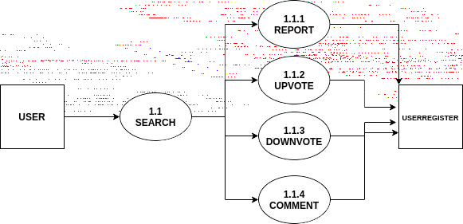

5.SYSTEM DEVELOPMENT

  - INTRODUCTION
Systems development is the process of defining, designing, testing, and implementing a new software application or program. It could include the internal development of customized systems, the creation of database systems, or the acquisition of third party developed software. Written standards and procedures must guide all information systems processing functions. The organization’s management must define and implement standards and adopt an appropriate system development life cycle methodology governing the process of developing, acquiring, implementing, and maintaining computerized information systems and related technology.
Konzume is a product review analyser and recommendation system that helps the buyers to analyse the thousands of reviews online and make a decision wisely. Konzume will aggregate reviews and comments from multiple ecommerce websites , popular blogs , online news websites etc and analyse the data with various algorithms like Vector Machine (SVM) and provide the users with best possible scores and and authentic reviews. Konzume will sortout authentic ratings and reviews from fake and vogue ones using sentiment analysis method. It will also recommend related similar products based on the rating and buyer’s need.

MENU LEVEL DESCRIPTION
The project development to assist the users in minimizing the time and manpower required to manage the data in an organization. This project is a modular template system with the unique distinction of having a simple, user friendly environment. This means users do not need any programming knowledge. A set of templates will be defined in the software to create an initial view, she/he can then use the simple management interface to control the software and perform their own activities.

PROCESS SPECIFICATION
A process specification is a method used to document, analyses and explain the decision-making logic and formulas used to create output data from process input data. Its objective is to flow down and specify regulatory/engineering requirements and procedures. High-quality, consistent data requires clear and complete process specifications.
A process specification reduces ambiguity, allowing an individual or organization to obtain a precise description of executed tasks and accomplishments and validate system design, including the data dictionary and data flow diagrams.

6.SYSTEM TESTING
System testing is the major quality control measures during software development. A series of test cases are generated that is intended to demolish the software that has been built. Testing is a set of activities that can be planned and conducted schematically. Testing begins at the module level and work towards the integration of the attire computer-based systems. Testing is the process of executing a program with the attention of finding an error. A good test case is one that has a higher probability of finding m undiscovered error. Nothing is complete without testing as it the vital success of the system. It is a level of testing that validates the complete and fully integrated software product. The purpose of a system test is to evaluate the end-to- end system specifications. Usually, the software is only one element of a larger computer-based system. Ultimately, the software is interfaced with other software/hardware systems. System Testing is a series of different tests whose sole purpose is to exercise the full computer-based system.

TESTING METHODS
In a software development project, errors can be injected at any stage during the development. Testing performs a very critical role for quality and for ensuring the reliability of software. During testing, the program to be tested is executed with set of test cases, and the output of the program for the test cases is evaluated to determine if the program is performing as it is expected to Testing is vital to the success of the system. System testing makes logical assumption that if all the parts of the system are correct, we have achieved the mission successfully. System testing is the stage of implementing that is aimed at assuring that the system works accurately and efficiently before the live operation commences.
The main objective of testing is to uncover errors from the system. For the uncovering process we have to give proper input data to the system. So, we should have more conscious to give input data. It is important to give correct inputs to efficient testing.

The entire testing process can be divided in to three phases:

- Unit testing
- Integrated testing
- Validation Testing
- Final /System testing

UNIT TESTING

The software was divided into several units and tested individually. Each unit was found to be working satisfactorily. This testing is carried out during the programming stage itself. In this testing step each module is found to be working satisfactorily as regards to the expected output from the module. Using a method called white box testing in which the software tester has knowledge of the inner workings structure and language of the software, or at least its purpose of each module or component of the software is tested individually. In the unit test case we will be testing the separate modules of the software. We will test the components by passing data through it and we will monitor data to find the errors. We will be looking for entry and exit editions of data. We will make sure that all the components work without any troubles.

INTEGRATED TESTING
The entire testing sub modules are integrated to module and module to system. During the process of integration, integrated module are tested ensure that the entire component are working well and produce the desired output. When an error either logical or syntactic occurs, we write the code and make the unit error free.

VALIDATION TESTING
I made the data validation for this project by inserting different types of data to all tables and updating the table contents many ways. Data validation is done to see whether the corresponding entries made in the tables are corrected. Proper validation is done in case of inserting and updating of tables if any search case arises, then proper error message of warming, if any has to be displayed.

The different test cases are:

- Guarantee that all independent parts within a module have been exercised at least one.
- Exercise all logical decisions on their true/false.
- Execute all loops at their boundaries and within their optional bonds.
- Exercise internal data structure to ensure their validity.

FINAL/SYSTEM TESTING

This is final step in this case the entire system was tested as a whole with all forms, code, modules, and class modules. This form of testing is popularity known as black box testing or system testing. Black box testing methods focus on the functional requirements of the software. That is black box testing methods focus on the functional requirements for a program. Black box testing attempts to find errors in the following categories incorrect or missing functions, interface errors, errors in data structure or external database access, performance errors and initialization error termination errors.
The identification of test unit establishes the different level of testing that will be performed in the project. Generally, a number of test units are performed during the testing starting from the lower-level modules, which have to be unit tested. An important factor while forming a unit is the testability of the unit. A unit should be much that can be easily.

6.2 SCREEN LAYOUTS

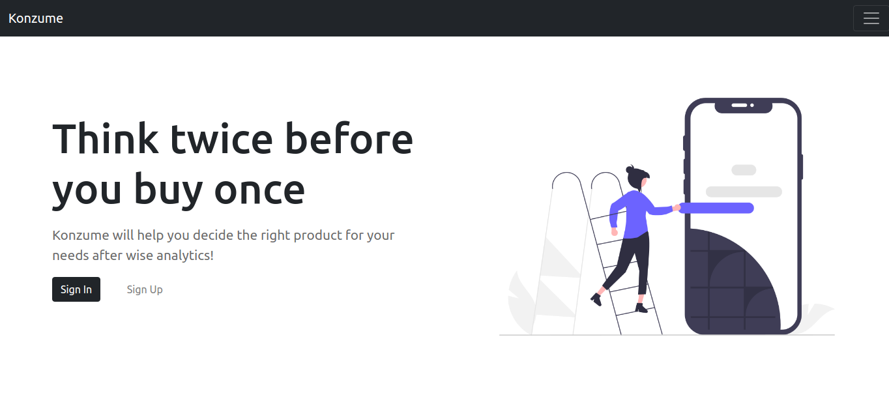
Home

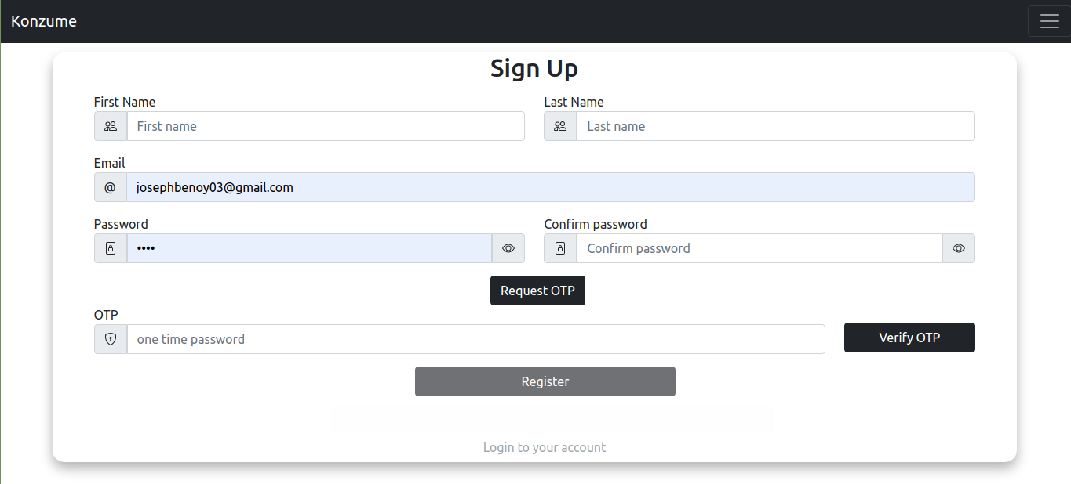
Sign Up

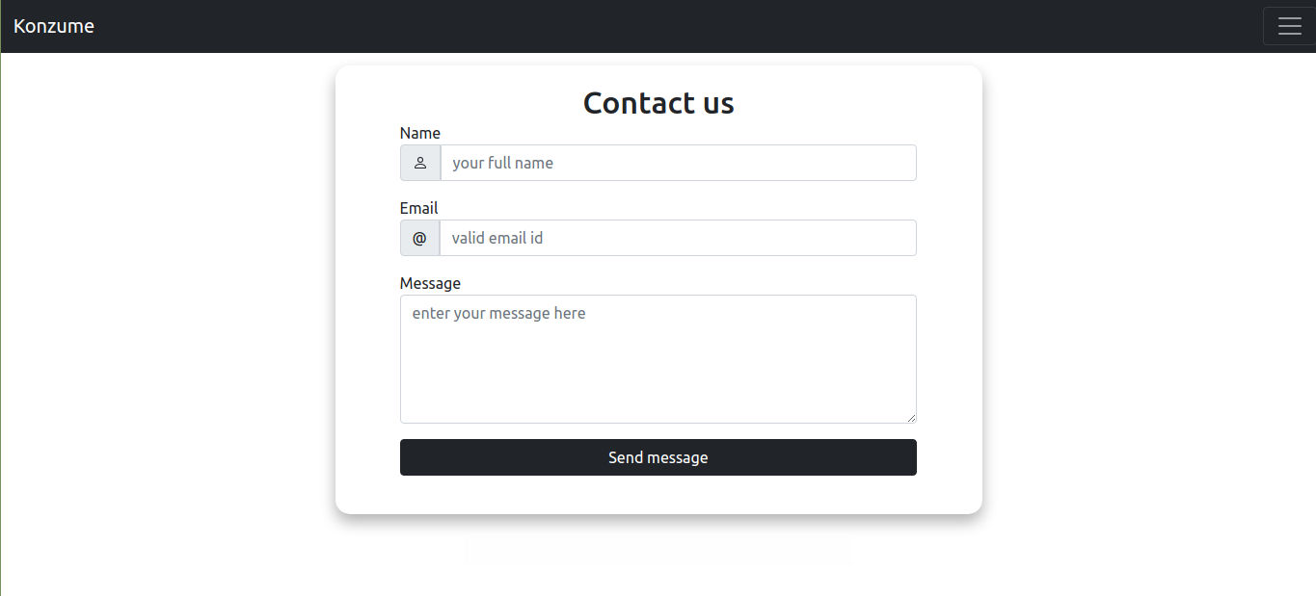
Contact

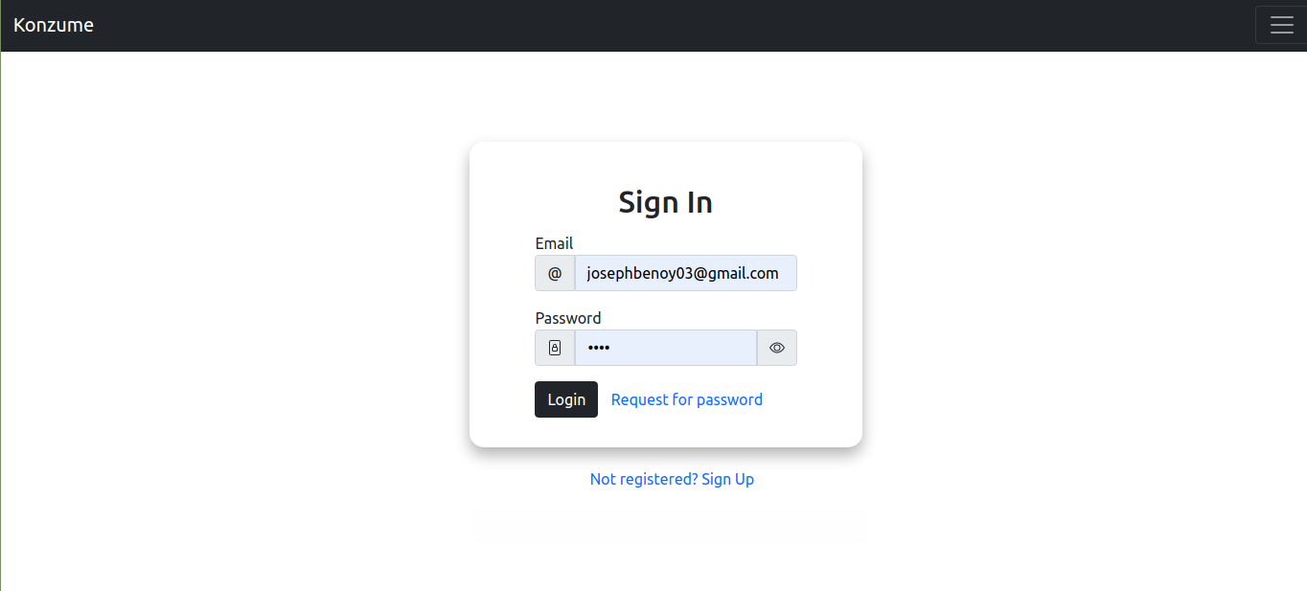
Log In

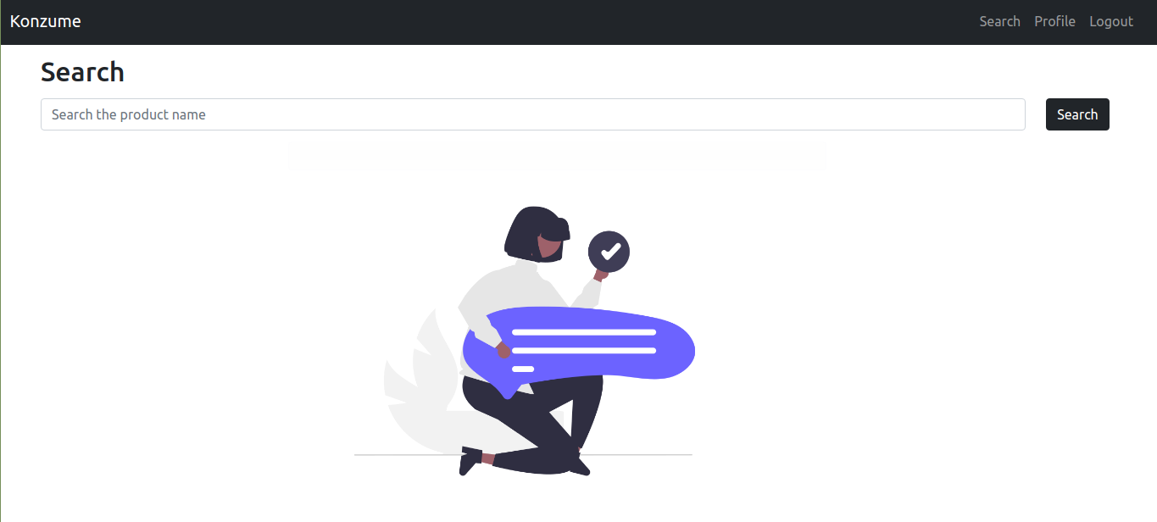
Search

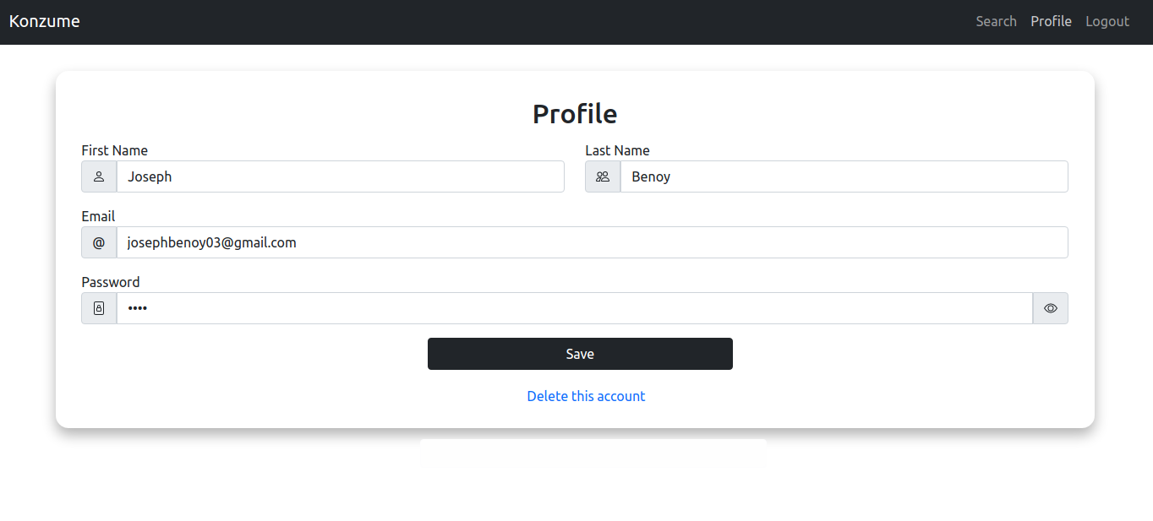
Profile

