Using Frameworks
Software Design & Programming
Object-Oriented Mthd &Pgm I

Joseph DiBiasi
University of Denver College of Professional Studies
11/07/2025
Faculty: Nirav Shah, M.S.
Director: Cathie Wilson, M.S.
Dean: Bobbie Kite, MLS
Introduction
The latest additions to the university parking system are centered around adding support features. Equals and hash code methods have been specifically added to each of the classes to allow better comparisons based on the contents instead of a simple object reference. Helper methods allowing access to customer IDs, permit IDs, and customer specific permit IDs have been added to the parking office class. These changes were all made with the intention of allowing the parking office class better access to the objects it needs to interact with while remaining loosely coupled.
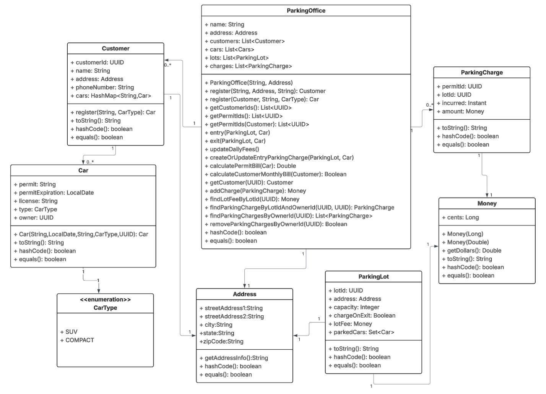
Figure 1. Updated Class Diagram
Class Design Changes
The broad change of overriding equals and hash code methods is needed to facilitate later development of the parking office class. Since we have custom classes with unique individual fields, it will help us to better define our comparison between those class objects. Certain fields could also be ignored if they are not needed for evaluation. Once we override the equals method, we need to override the hash code methods as well to match. Overriding equals and hash code methods will be the default for any new classes within the parking system.
Methods were created to allow the parking office class better access to the customer and permit information while remaining loosely coupled. The method to return customer ids returns a list of all customer IDs when invoked. To allow the parking office class to retrieve permit IDs, two classes were added. The first method returns a list of all permit IDs similar to the customer method, but there is a second overloaded method that takes a customer object and uses the information within to return all permit IDs related to that customer. By defining these three methods within the parking office class, there are more tools to access customer data without tightly coupling the relationship between the parking office and other classes.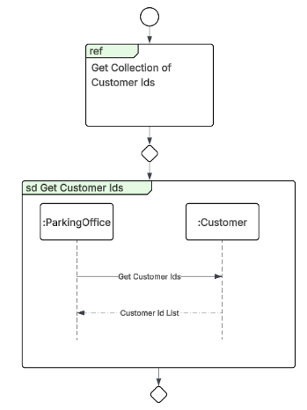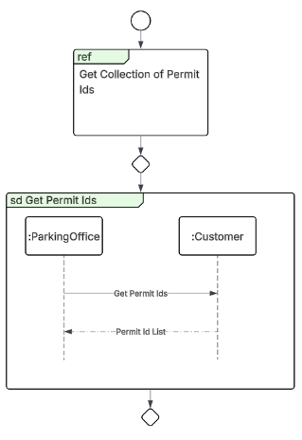 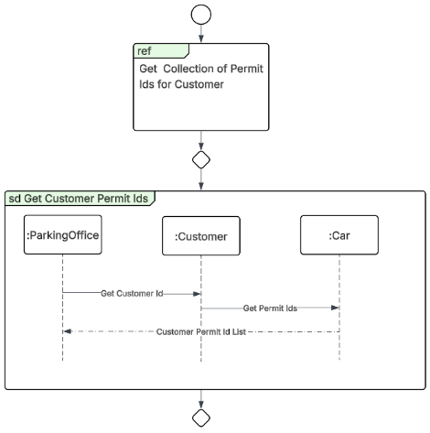
Figure 2. Interaction Diagrams for the Methods Used to Return Lists of Customer or Permit IDs
Boosts and Challenges
The hard work of the development team over the previous weeks working on the university parking system meant that the challenges of this project were few compared to those of past iterations. Boosts were more prevalent as previous tools were reused. The design applications previously utilized to update the class diagrams and interaction diagrams were against essential. The class diagram needed to have additional methods added to it; this was easily done after loading the previous week’s design. The design style for the interaction diagram was developed during a previous exercise and reused. This had the benefits of still being visually clear but now also having some visual consistency with past designs for easy conceptualization of interactions. On a personal note, the applications specifically designed to help out with the design phase were so helpful, it is tempting to utilize them for professional development if I can get approval.
Summary
This iteration felt like a reward for building a strong foundation of development from the beginning. The parking system has expanded from a small series of classes into one with far more functionality, loosely coupled to a central parking office class. This design structure allows the parking office the ability to store and manipulate the data they need to operate on a day-to-day basis while giving them flexibility to change those individual components if needed. Design and planning techniques have been refined after several weeks; the process is now far less painful as a result. Simple design and coding guidelines are essential to a good project, no matter the size.
References
Microsoft Copilot. 2025. “Microsoft Copilot.” Microsoft Copilot. Microsoft. 2025. https://copilot.microsoft.com/.

Appendix A: Code Compilation
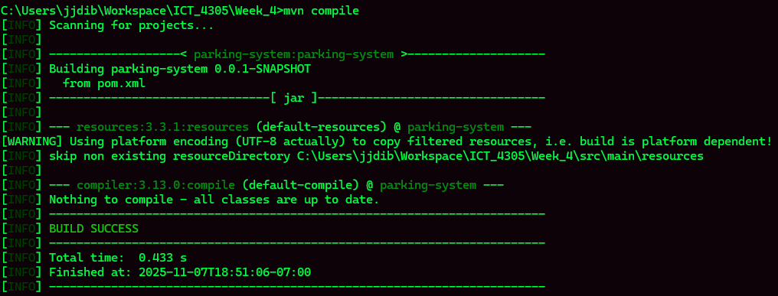

Appendix B: Test Execution
